Supplementary Material

Supplementary Table 1: Gradient elution conditions of HPLC

Table S1 Gradient elution conditions of HPLC
Time (min) | Mobile phase A (acetonitrile) | Mobile phase B (water)
0 | 20 | 80
7.5 | 20 | 80
23 | 24.5 | 73.5
39 | 26 | 74
49 | 37 | 63
58 | 40 | 45
60 | 45 | 55
66 | 90 | 10
68 | 20 | 80
70 | 20 | 80

Supplementary Table 2: Specific primers of strains
Strain | Primer sequence
Fusarium solani (Ye et al., 2019) | F: TCGGTTGTCGCAAAGACT  R: GGGAAGTTGTGTCAGCATT
Ilyonectria mor-panacis (Gao et al., 2020) | F: CAAAATTTTTCACCCACCCTCTATTG  R: GTGAGAGTTAGAATGTGCCAAGTG
Streptomyces drozdowiczii (Li et al., 2012) | F: AGCAGGCCCTTGTGGTG  R: CGAGTTGCAGACCCCAATCCG
Penicillium ortum (Géry et al., 2021) | F: CATTCGCCAAGGATGTTTTC  R: TTGTCTGGACCTGGTGAGTTT
Trichoderma koningi (Saravanakumar et al., 2017) | F: ACGGATCTCTTGGTTCTGGC  R: GGTTGAAATGACGCTCGGAC
Bacillus mycoides (Reiter et al., 2011) | F: TTGCACAAGCATCAGCTCTT  R: AGTCGCACCGCACTCTTTAC

Table S2 Specific primers of strains

Supplementary Table 3: Effects of different water treatments on the biomass of OPPF in 2024 (means ± SDs)

Table S3 Effects of different water treatments on the biomass of OPPF in 2024 (means ± SDs)

Treatment | Leaf aera (cm2) | Chlorophyll (SPAD)
PTh1 | 13.8615 ± 0.73981b | 45.405 ± 0.26924b
PTh2 | 16.4527 ± 0.78399a | 46.655 ± 0.38318a
PTh3 | 16.3445 ± 0.81579a | 45.665 ± 0.23329b
PTh4 | 15.6720 ± 0.611a | 43.9 ± 0.37011c

Treatment | Fresh weight (g) | Fibrous root length (cm)
PTh1 | 1.5039 ± 0.15503a | 8.914 ± 0.25575b
PTh2 | 1.7026 ± 0.11674a | 9.0228 ± 003649b
PTh3 | 1.6541 ± 0.13883a | 8.131 ± 0.41948b
PTh4 | 1.7104 ± 0.15821a | 11.0957 ± 0.45725a

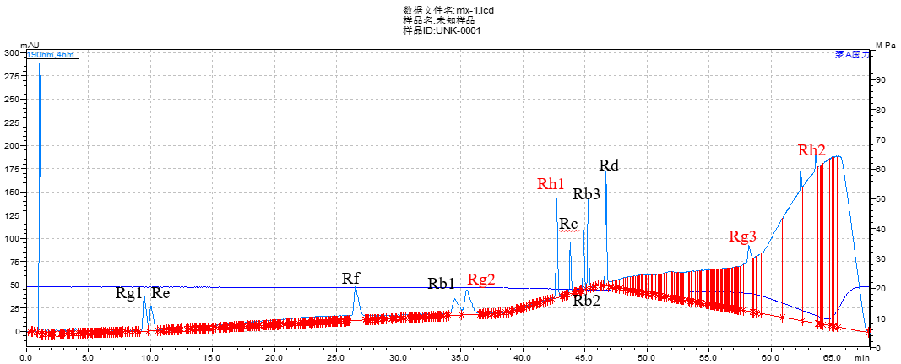

Supplementary Figure 1: Total ion current diagram of reference substance.

Supplementary Figure 2: Effects of different soil moisture treatments on the saponin of OPPF. (A) Saponin in taproot; (B) Saponin in fibrous root; (C) Saponin in root.

Supplementary Figure 3: Correlations between soil moisture and growth, quality, and saponin content. (A) Correlation between soil moisture and growth; (B) correlation between soil moisture and quality; (C) correlation between soil moisture and disease incidence.

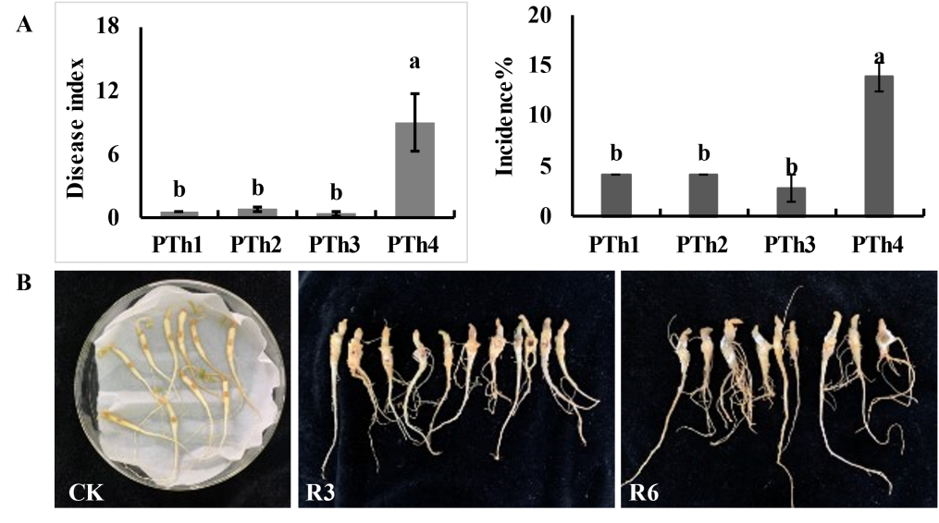
Supplementary Figure 4: Root rot disease in 2024 and pathogenicity test of OPPF. (A) Occurrence of OPPF root rot in 2024; (B) root pathogenicity of R3 and R6.
Supplementary Figure 5: Effect of different soil moisture treatments on microbial community diversity in the rhizosphere of OPPF and the analysis of variance (ANOVA) at the genus level between different treatment groups. (A) PCoA results of bacterial communities. (B–D) Chao index, Shannon index, and Observed species index of bacterial communities. (E) PCoA results of fungal communities. (F–H) Chao index, Shannon index, and Observed species index of fungal communities.
Supplementary Figure 6: Potted verification of beneficial bacterial growth promotion and root rot resistance. (A) OPPF underground root; (B) incidence of single strains and groups of strains; (C) effects of single strains and combinations of strains on the biomass of underground parts of OPPF; (D) effects of single strains and combinations of strains on the biomass of whole OPPF.

