ASSESSMENT OF KNOWLEDGE, ATTITUDES, AND PRACTICES OF VETERINARIANS, PARAVETERINARIANS, AND ANIMAL HERDERS ON INJECTION SITE COMPLICATIONS IN SMALL RUMINANTS IN KUMASI, ASHANTI REGION

SECTION 1: DEMOGRAPHIC INFORMATION
Item | Response
1. Name (Optional) | __________________________
2. Age | ___
3. Gender | ☐ Male ☐ Female
4. Occupation | ☐ Veterinarian ☐ Paraveterinarian ☐ Animal Herder ☐ Other: __________
5. Years of Experience with Small Ruminants | ☐ < 1 year ☐ 1–5 years ☐ 6–10 years ☐ >10 years
6. Location (Community/Town) | __________________________

SECTION 2: KNOWLEDGE
- Awareness of Injection Techniques
Statement | Yes | No
1. Are you aware of the different types of injections (IM, SC, IV)? | ☐ | ☐
2. Do you know the correct anatomical sites for each type of injection in small ruminants? | ☐ | ☐
- Have you received any formal training on administering injections in small ruminants?  If yes what level__________________________ | ☐ | ☐
4. Do you clean the injection site before administration? | ☐ | ☐
5. Do you regularly rotate injection sites to prevent tissue damage? | ☐ | ☐

- Anatomical Knowledge of drug administration
Question | Response Options
1. Do you fully know what SC, IM, and IV represent? | ☐ Yes, fully ☐ Partially ☐ No, not really ☐ Not sure
2. When giving a subcutaneous (SC) injection, do you inject into loose skin? | ☐ Always ☐ Sometimes ☐ Rarely ☐ Never
3. When giving an intramuscular (IM) injection, do you inject around the neck region? | ☐ Always ☐ Sometimes ☐ Rarely ☐ Never
4. When giving an intravenous (IV) injection, do you inject into the jugular groove? | ☐ Always ☐ Sometimes ☐ Rarely ☐ Never

- Knowledge of Complications
Possible Complications | Aware | Not Aware
1. Abscess formation | ☐ | ☐
2. Swelling or edema at injection site | ☐ | ☐
3. Muscle necrosis | ☐ | ☐
4. Nerve damage or lameness | ☐ | ☐
5. Injection site fibrosis | ☐ | ☐
6. Anaphylactic reaction | ☐ | ☐
7. Localized pain or discomfort | ☐ | ☐
8. Contamination leading to infection | ☐ | ☐
9. Improper drug absorption | ☐ | ☐

- Have you observed the following complications after administering VACCINES or ANTIBIOTICS in small ruminants?
(Tick only one that apply in each column)
Complication Type | Vaccines | Antibiotics
Abscess | ☐ | ☐
Swelling/Edema | ☐ | ☐
Damaged skin/muscle | ☐ | ☐
Nerve damage/lameness | ☐ | ☐
Hardened/thick tissue | ☐ | ☐
Anaphylactic reaction | ☐ | ☐
Localized pain/discomfort | ☐ | ☐
Infection/contamination | ☐ | ☐
Improper absorption | ☐ | ☐
Tissue necrosis/death | ☐ | ☐

SECTION 3: ATTITUDES
Attitudes Towards Injection Practices and Meat Quality
Question / Attitude Indicator | Response Options
1. Do you support the use of aseptic techniques when administering injections? | ☐ Strongly agree ☐ Agree ☐ Disagree ☐ Strongly disagree
2. Do you consider observing the withdrawal period after drug administration important? | ☐ Strongly agree ☐ Agree ☐ Disagree ☐ Strongly disagree
3. Are you concerned that improper injections could affect meat quality? | ☐ Strongly agree ☐ Agree ☐ Disagree ☐ Strongly disagree
4. Are you aware that vaccines can cause injection site lesions? | ☐ Strongly agree ☐ Agree ☐ Disagree ☐ Strongly disagree
5. Do you understand that antimicrobial injections can cause injection site lesions? | ☐ Strongly agree ☐ Agree ☐ Disagree ☐ Strongly disagree

SECTION 4: PRACTICE
- Commonly Used Anatomical Injection Sites and Lesion Prevalence
Question | Response Options
1. Which anatomical site do you MOST OFTEN use when administering injections in small ruminants? (Select only one) | ☐ Cervical muscles (Neck) ☐ Forelimb muscles (Shoulder) ☐ Hindlimb muscles (Thigh) ☐ Gluteal muscles
2. In your experience, at which anatomical sites do you MOST OFTEN detect injection site lesions (abscesses, swelling, fibrosis, necrosis, etc.)? (Select only one) | ☐ Hindlimb muscles (Thigh) ☐ Gluteal muscles ☐ Forelimb muscles (Shoulder) ☐ Cervical muscles (Neck)

- Practice Assessment
Practice | Always | Sometimes | Never
1. Use new sterile needles and syringes for each animal | ☐ | ☐ | ☐
2. Use correct injection technique (IM, SC, IV) based on drug instructions | ☐ | ☐ | ☐
3. Dispose of used needles and syringes properly | ☐ | ☐ | ☐
4. Monitor animals after injection for signs of complications | ☐ | ☐ | ☐
5. Report complications to a veterinarian immediately | ☐ | ☐ | ☐
c) Injection Site Selection
B C
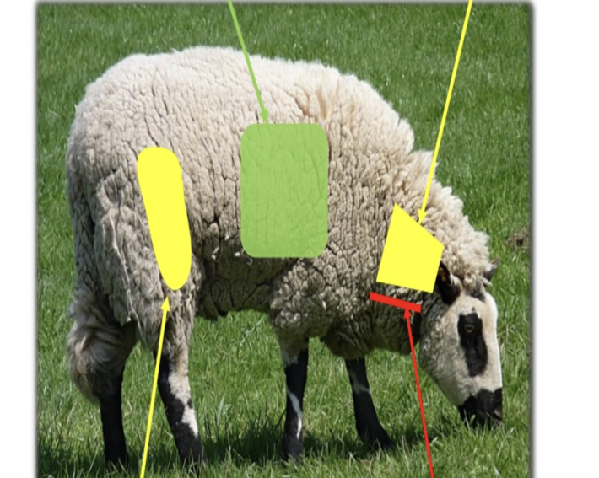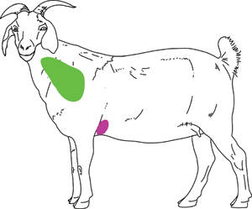
A D
Question | Response (✓/✗)
Do you inject in the neck region of the animal?
Do you inject in the thigh or hindquarter?
Do you inject in the brisket or chest area?
Do you select the site based on meat value preservation?

