Supplementary material: Complete Western Blot image
Dear Editorial Board of Scientific Reports,
Thank you very much for your email and for giving us the opportunity to resubmit our manuscript entitled Mechanistic effects of percutaneous needle fasciotomy on immobilization-induced muscle atrophy in rats: focus on angiogenesis and the HIF-1α/VEGF signaling pathway.
We fully understand and acknowledge the journal’s requirement that full-length, uncropped scans of original Western blot membranes should be provided as supplementary material when cropped blot images are presented in the figures.
In the present study, the Western blot figures included in the manuscript were prepared by cropping the membranes to display the target protein bands together with the corresponding loading controls, in accordance with common presentation practices. However, due to data archiving procedures at the time the experiments were conducted, only the cropped blot images were retained, and the original full-length scans of the membranes are no longer available for submission.
We would like to emphasize that all bands shown in the manuscript were derived from the same membrane for each experiment, and no splicing or selective manipulation was performed. All image adjustments, if any, were applied uniformly across the entire image.
We sincerely apologize for this limitation and any inconvenience it may cause. To ensure transparency, we have already clearly stated this issue in the revised manuscript, including:
- the figure legends (Page 14, line 1. Note: The Western blot images shown in this figure are cropped to focus on the relevant protein bands. These cropped blots represent data obtained from the same membrane, processed under identical experimental conditions. Due to data archiving procedures, full-length scans of the original membranes are no longer available. No splicing or selective manipulation of the data was performed. All image adjustments were applied uniformly across the entire image.);
in accordance with the journal’s policies. We will also strictly adhere to preserving and submitting full-length blot images in all future studies.
The original Western blot data images are provided below. In this experiment, a single membrane was cut into sections for separate antibody incubations. Following the initial development, these membrane sections were reassembled and subjected to a single, unified development step. All relevant images are presented below. Please review it.
We greatly appreciate your understanding and guidance, and we thank you for considering our resubmission.
- HIF-1α Western Blot Data
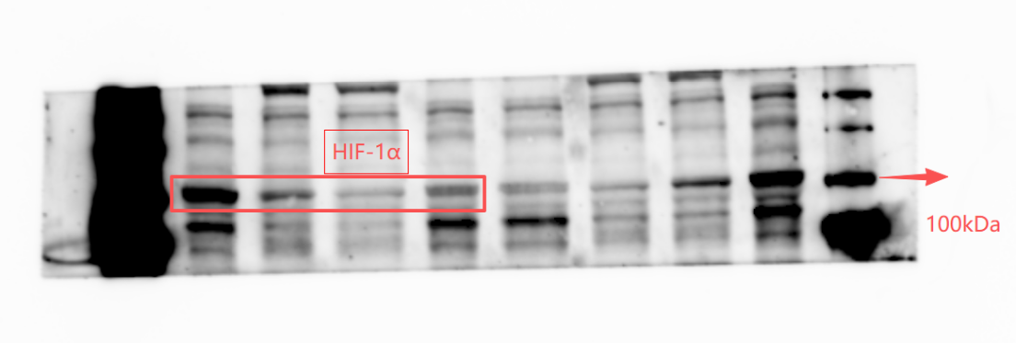
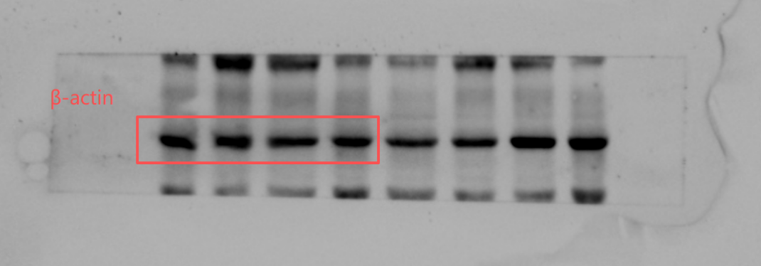
Figure 1A Original data images of HIF-1α and β-actin Western blot
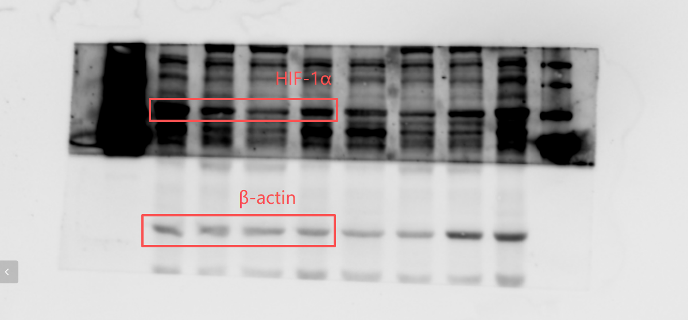
Figure 1B Full membrane image from the HIF-1α Western blot

- Tie-2 Western Blot Data
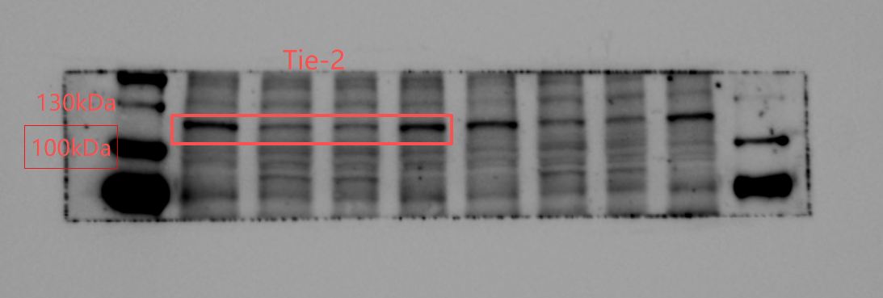
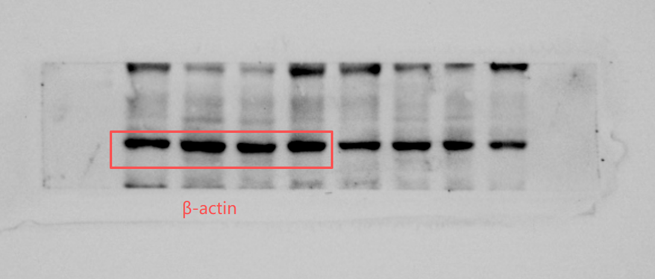
Figure 2A Original data images of Tie-2 and β-actin
Western blot
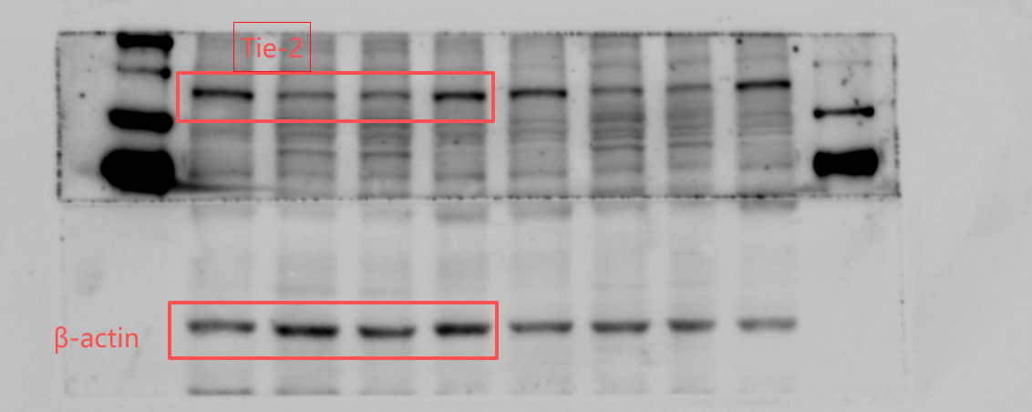
Figure 2B Full membrane image from the Tie-2 Western blot

- Ang-1 Western Blot Data
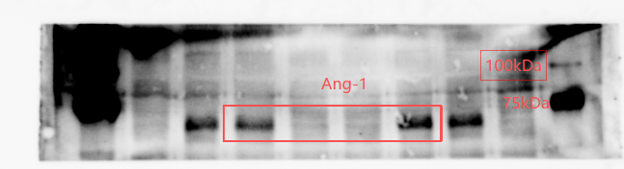
Figure 3 Original data images of Ang-1 Western blot
- Src Western Blot Data

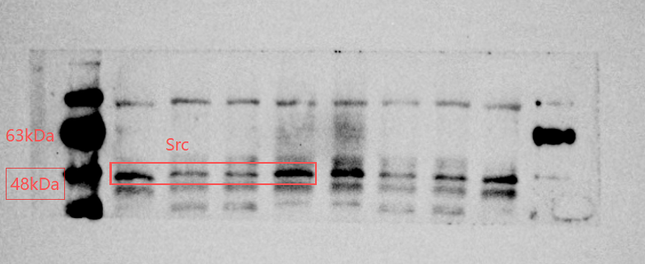
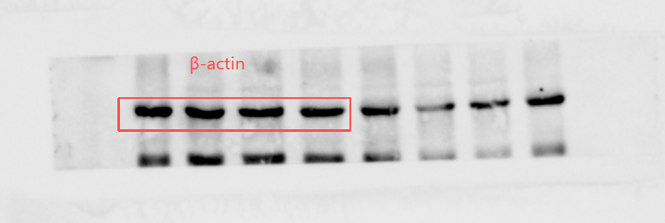
Figure 4 Original data images of Src and β-actin Western blot
- VEGF Western Blot Data

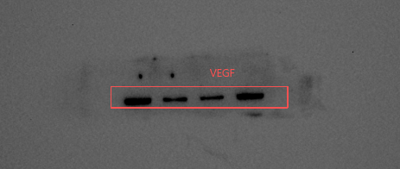
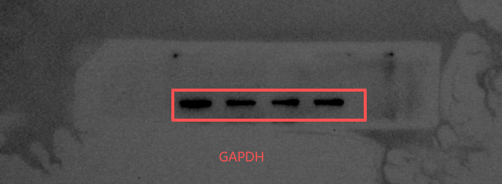
Figure 5 Original data images of VEGF and GAPDH Western blot
- bFGF Western Blot Data
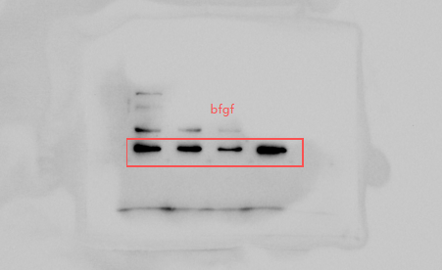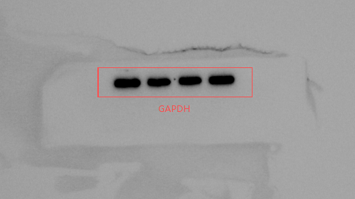
Figure 6 Original data images of bFGF and GAPDH Western blot
(Note: The chemiluminescent substrate was applied specifically to the target protein areas; therefore, the molecular weight marker is not visible in this blot.)

