Volcano plot of the comparison of WT and WT_EMPA groups. The figure shows the fold changes in the quantified metabolites between the groups. FALSE (grey dot): not significantly changed; TRUE (red dot): significantly changed
Volcano plot of the comparison of WT and WT_MPTP groups. The figure shows the fold changes in the quantified metabolites between the groups. FALSE (grey dot): not significantly changed; TRUE (red dot): significantly changed
Volcano plot of the comparison of WT_MPTP and S3KO_MPTP groups. The figure shows the fold changes in the quantified metabolites between the groups. FALSE (grey dot): not significantly changed; TRUE (red dot): significantly changed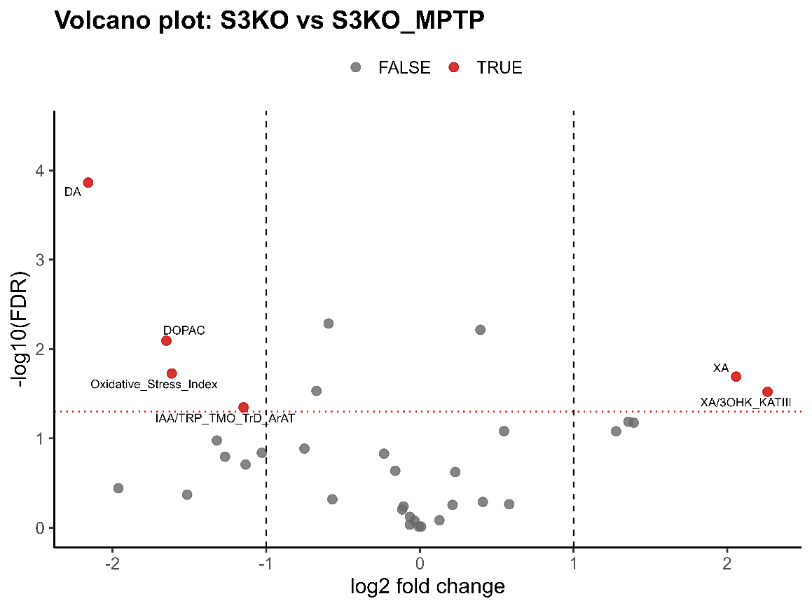
Volcano plot of the comparison of S3KO and S3KO_MPTP groups. The figure shows the fold changes in the quantified metabolites between the groups. FALSE (grey dot): not significantly changed; TRUE (red dot): significantly changed
Volcano plot of the comparison of S3KO and S3KO_EMPA groups. The figure shows the fold changes in the quantified metabolites between the groups. FALSE (grey dot): not significantly changed; TRUE (red dot): significantly changed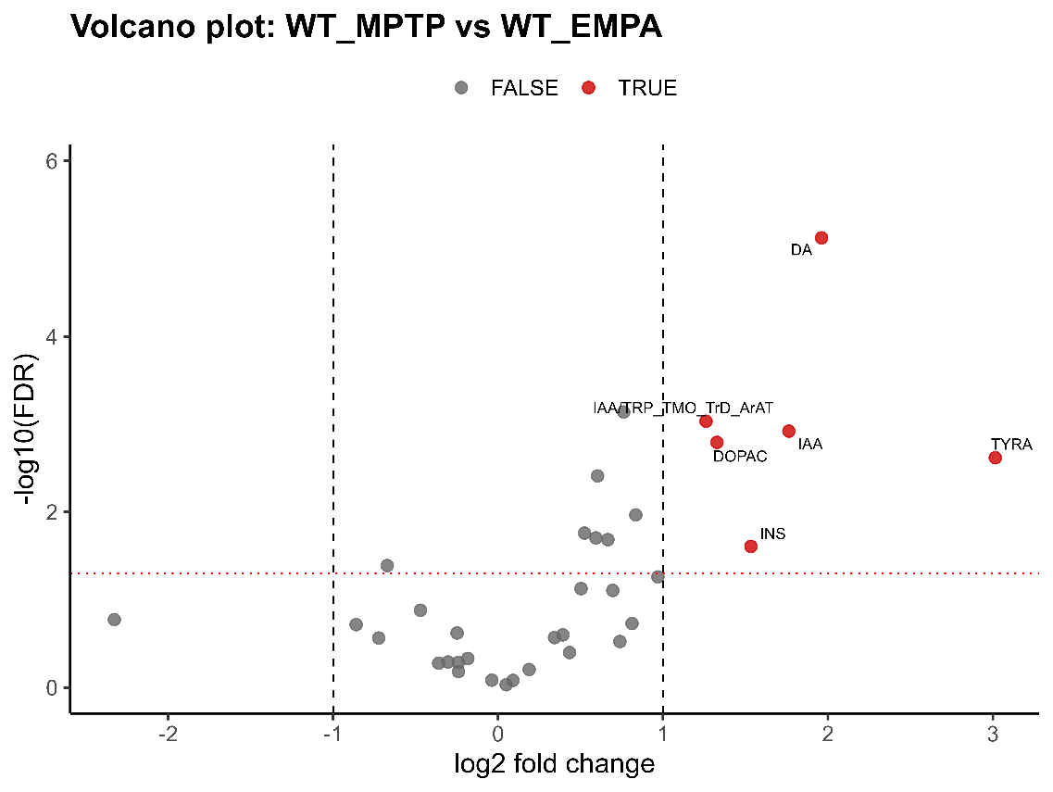
Volcano plot of the comparison of WT_MPTP and WT_EMPA groups. The figure shows the fold changes in the quantified metabolites between the groups. FALSE (grey dot): not significantly changed; TRUE (red dot): significantly changed
Volcano plot of the comparison of S3KO_EMPA and S3KO_MPTP_EMPA groups. The figure shows the fold changes in the quantified metabolites between the groups. FALSE (grey dot): not significantly changed; TRUE (red dot): significantly changed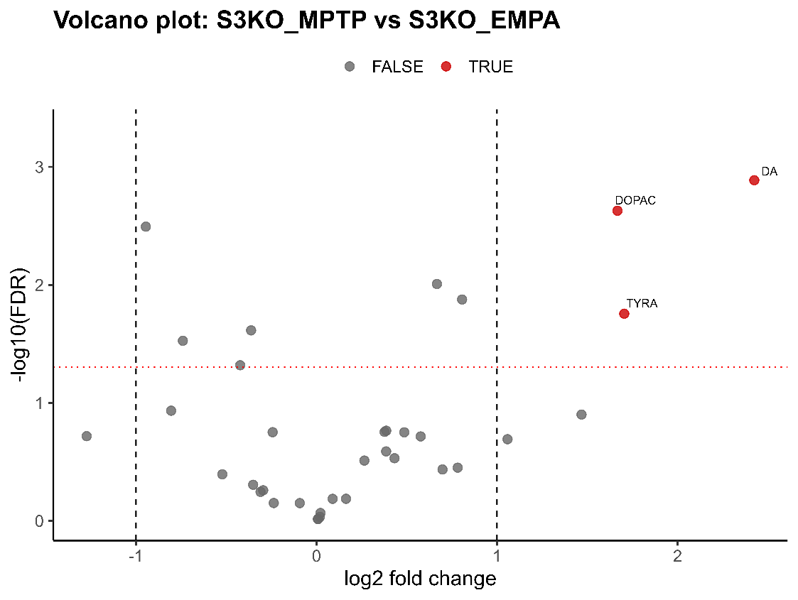
Volcano plot of the comparison of S3KO_MPTP and S3KO_EMPA groups. The figure shows the fold changes in the quantified metabolites between the groups. FALSE (grey dot): not significantly changed; TRUE (red dot): significantly changed

Volcano plot of the comparison of WT and S3KO groups. The figure shows the fold changes in the quantified metabolites between the groups. FALSE (grey dot): not significantly changed; TRUE (red dot): significantly changed

