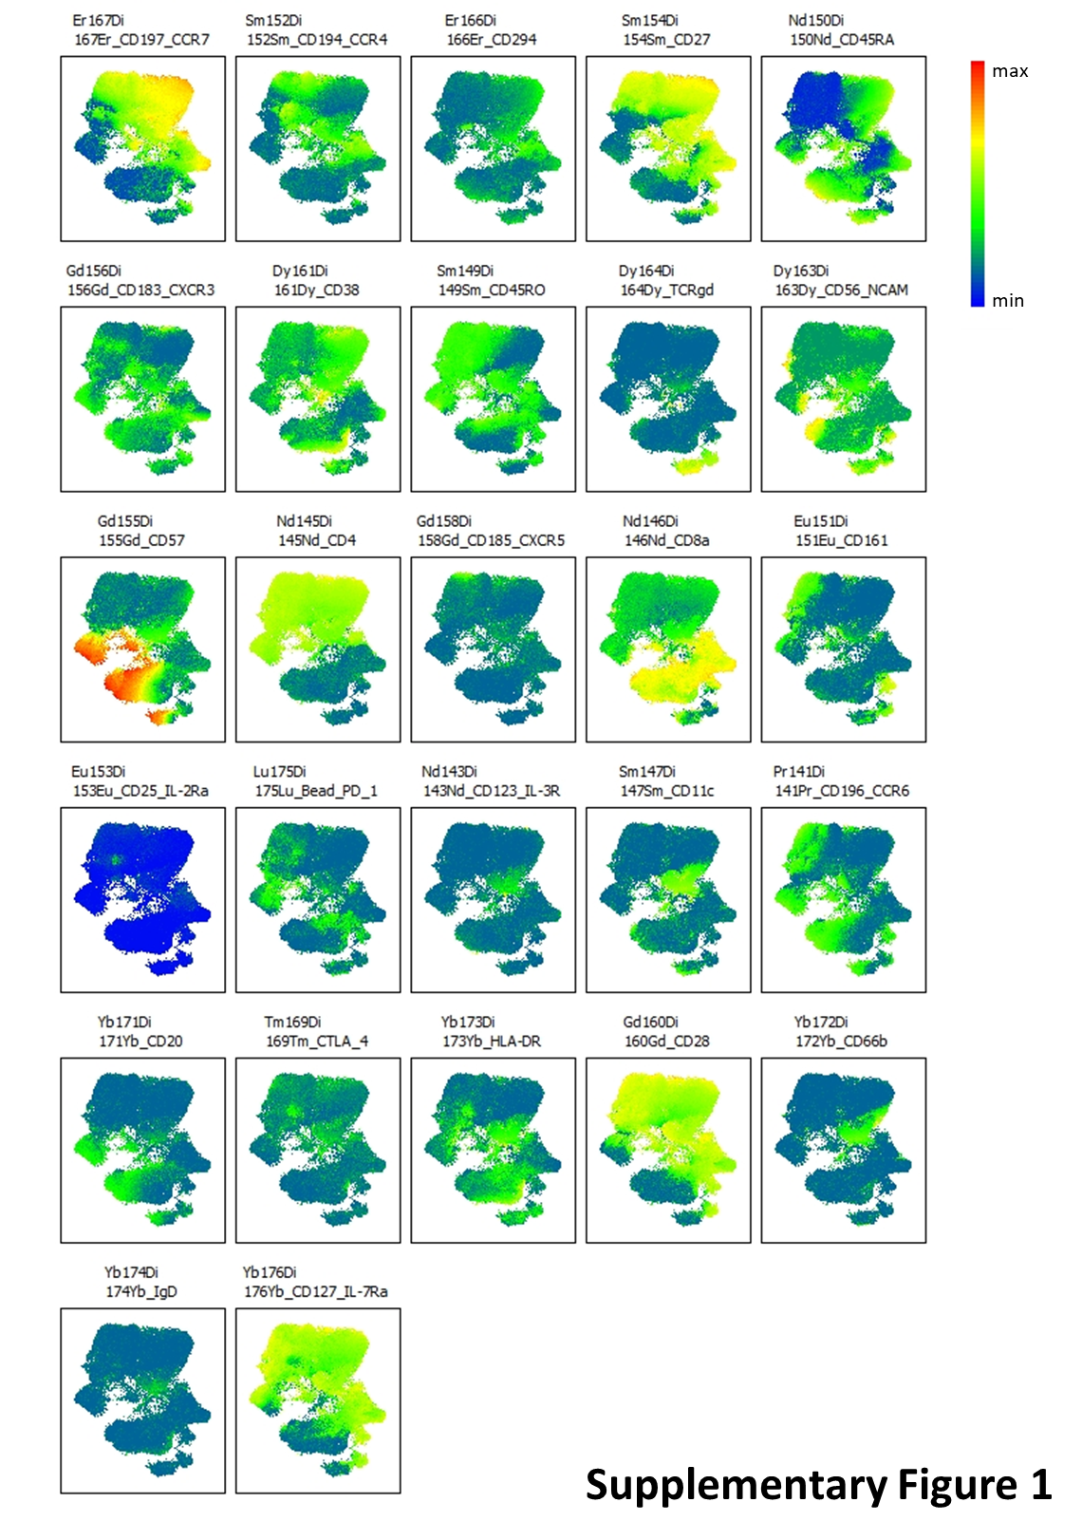
Supplementary Figure 1. UMAP projection of CD3⁺ T cell subsets showing individual marker expression.
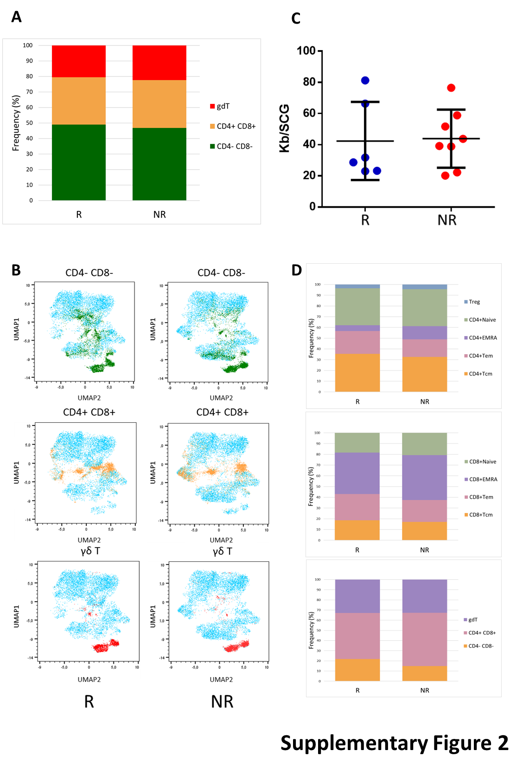
Supplementary Figure 2. A) Proportional bar chart and B) UMAP plots illustrating the differences in the baseline frequency of the non-classical CD4/CD8 T cell subsets—γδ T cells, CD4⁺ CD8⁺, and CD4⁻ CD8⁻ T cells— between R and NR groups. C) Absolute telomere length in R and NR, reported as kilobases (kb) per single-copy gene (SCG). Median and interquartile range (IQR) are indicated. p = 0.9038. D) Proportional bar charts illustrating the differences in the baseline frequencies of CD4⁺, CD8⁺ T and non-classical CD4/CD8 subsets between R and NR groups. Data were obtained from automated analysis using the Astrolabe platform.

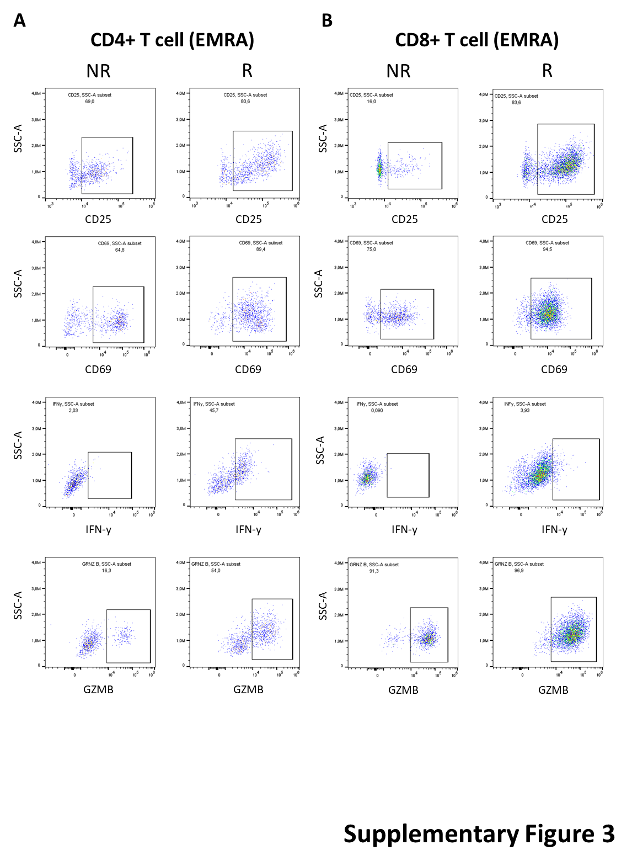
Supplementary Figure 3. Representative flow cytometry plots of CD4⁺ EMRA T cells (A) and CD8⁺ EMRA T cells (B) from R and NR patients, showing expression of CD25, CD69, IFN-γ, and GZMB after PHA stimulation. Gating was performed on viable CD3⁺ cells.

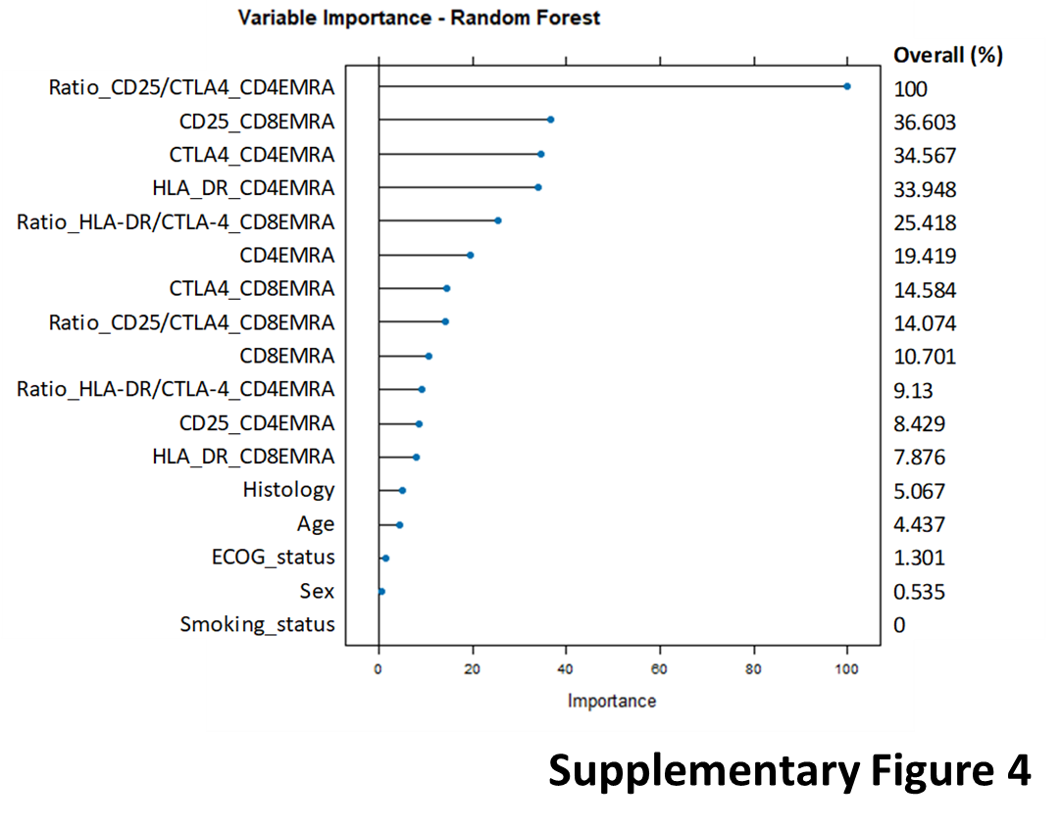

Supplementary Figure 4. Variable importance plot from the Random Forest analysis assessing the relative contribution (%) of clinical vs immunological variables to the predictive model of immunotherapy response in NSCLC. The horizontal axis represents variable importance (in %), while the vertical axis lists the features included in the model.

