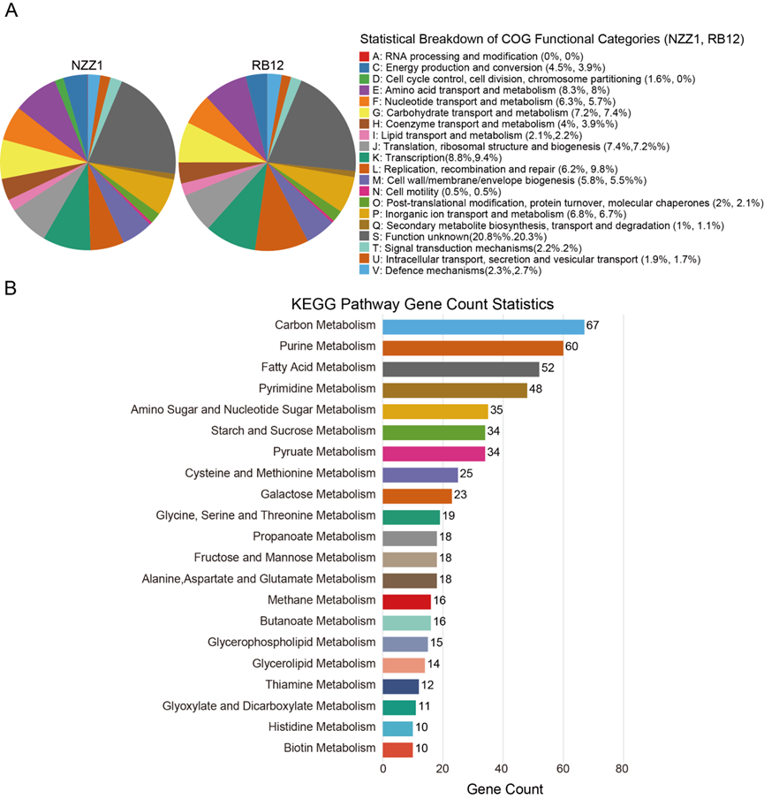

Figure S1: COG (NZZ1 and RB12) and KEGG (NZZ1) annotation results of L. lactis. A Statistical breakdown of COG functional categories (NZZ1 is L. lactis NZZ1, RB12 is L.lactis). B Gene numbers of NZZ1 in the KEGG pathway.

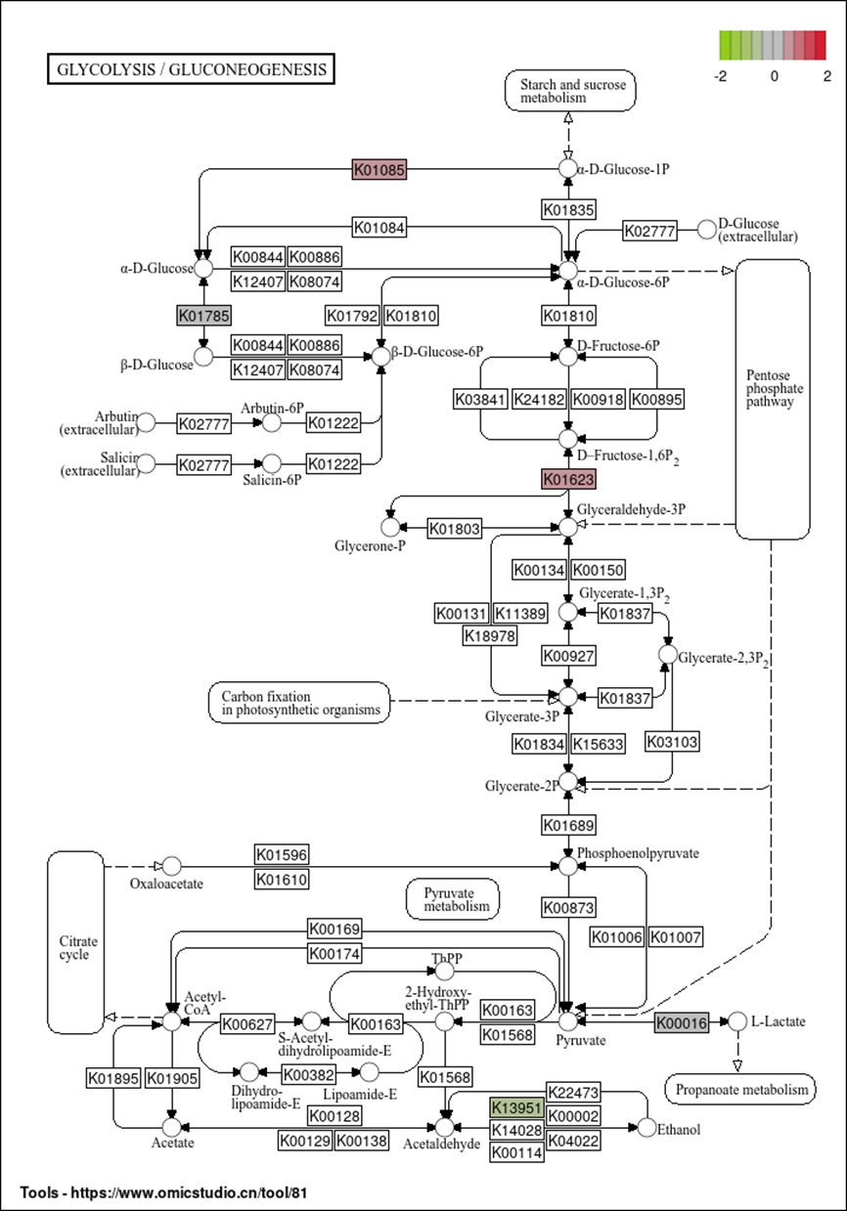
Figure S2: Glycolysis and Gluconeogenesis metabolic pathways. Red represents Strain NZZ1 vs. strain RB12 significantly upregulated and green represents significant downregulation KEGG Orthologys (KOs). Red represents an upward adjustment, green represents a downward adjustment, and the darker the color, the more significant it is.

