Supplementary Information
Single Molecule Swimmer Propelled by Photoredox Brownian Ratchet

Jialin Lai^{1,5+}, Binglin Zeng^{1,2+}, Xiaofeng Li^{1,4+}, Mingliang Li^{1,3}, Qiujiang Liang¹, Wai-Pan Ng¹, Jingyuan Chen^{1,4}, Okuro Kou^{1,3}, Jun Yang^{1,3†}, Lang Rao^{5†} and Jinyao Tang^{1,2,3,4†}
¹Department of Chemistry, The University of Hong Kong, Hong Kong, China.
²HKU-CAS Joint Laboratory on New Materials and Department of Chemistry, Hong Kong, China
³State Key Laboratory of Synthetic Chemistry, The University of Hong Kong, Hong Kong, China
⁴Materials Innovation Institute for Life Sciences and Energy (MILES), HKU-SIRI, Shenzhen, China
⁵Institute of Chemical Biology, Shenzhen Bay Laboratory, Shenzhen, China
⁺These authors contributed equally.
†Correspondence to: juny@hku.hk; lrao@szbl.ac.cn; jinyao@hku.hk

1 Methods 5
1.1 Cell lines and reagents 5
1.2 Lipid bilayer fabrication 5
1.3 Single molecule tracking 6
1.4 The fluorescence recovery after photobleaching (FRAP) of lipid membrane 6
1.5 Photoredox molecular swimmer synthesis 6
1.6 The Ultraviolet-visible spectroscopy analysis 7
1.7 The quantum yield (QY) of NR with or without TEMPO 8
1.8 The liquid chromatography-mass spectrometry analysis (LC-MS) 8
1.9 Time Correlated Single Photon Counting Lifetime Spectroscopy 8
1.10 In vitro studies 8
1.11 Biocompatibility of molecular swimmer 10
1.12 Force spectrum of microbeads on cell membrane by optical tweezer 10
2 Supplementary Contents 11
2.1 The ultraviolet-visible spectroscopy analysis (UV-vis) of NR with increasing TEMPO concentrations and light intensities 11
2.2 The liquid chromatography-mass spectrometry (LC-MS) analysis of NR with TEMPO 12
2.3 Probability density function (PDF) of the displacement of NR molecules 13
2.4 The rotational diffusion coefficient (D_{r}) 14
2.5 The mean square displacement (MSD) of pure NR 15
2.6 Fluorescence lifetimes of NR and Dil with different TEMPO concentrations 16
2.7 Dependence of diffusion coefficient on light intensity and TEMPO concentration 17
2.8 Local temperature rises from light absorption by NR molecules 18
2.9 The MSD of Dil molecules 19
2.10 The fluorescence recovery after photobleaching (FRAP) of Dil molecules 20
2.11 The quantum yields (QY) analysis of NR and NR+TEMPO 21
2.12 Convection analysis of lipid membrane system 23
2.13 The variable speed of NR molecules 24
2.14 Molecular swimmers exhibit Lévy dynamics in short-time observations 24
2.15 The MSD of molecular swimmers 27
2.16 Lévy flights of molecular swimmers 28
2.17 The D of molecular swimmers with increasing molecular densities 30
2.18 Effective TEMPO concentration calculation by matching the D of NRT with NR 30
2.19 Apparent TEMPO concentration calculation for NRT swimmers 31
2.20 Conformational analysis of molecular swimmers 32
2.21 Electron density difference (EDD) maps of molecular swimmers 34
2.22 The dipole moment of NR and NR+TEMPO 35
2.23 Molecular dynamics simulation for molecular swimmer in aqueous solution 36
2.24 Step size of the NR molecule driven by photons 38
2.25 Diffusion model of cell membrane permeability 39
2.26 Cell necroptosis of molecular swimmers 41
2.27 Biocompatibility of molecular swimmers 41
2.28 The co-location of lipid droplet and NRT9 42
2.29 Lévy flights of LDs-NRT9 42
2.30 Molecular characterization 44

3. Supplementary Videos
Video S1. Trajectories of NR with 0, 2.5, 5 mM TEMPO under the light intensity of 585 mW mm⁻².
Video S2. Trajectories of NR under the light intensities of 130, 390 and 585 mW mm⁻² at 5 mM TEMPO concentration.
Video S3. Velocity magnitude field of active turbulence.
Video S4. Trajectories of NRT0, NRT3 and NRT9 swimmers under the light intensity of 585 mW mm⁻².
Video S5. The MD simulation of NRT3 with zero charge (red), with fixed charge (green), and charge/discharge cycles (blue).
Video S6. DAPI intensities within HeLa cells treated with NRT9 and NR under light illumination.
Video S7. Motions of LDs-NRT9 and LDs-NR under the light stimulation.

1 Methods

1.1 Cell lines and reagents
HeLa cells were obtained from the American Type Culture Collection (ATCC). All cells were cultured and maintained under the guidelines provided by ATCC. The reagents employed in this study were obtained from Sigma-Aldrich unless otherwise stated.

1.2 Lipid bilayer fabrication
The microfluid channel device is prepared to fabricate the lipid bilayers¹. The master mold of the microfluidic device is prepared with standard photolithography with SU-8 2050 (Kayaku Advanced Materials) on a silicon wafer using SMART PRINT UV Maskless lithography system (Microlight3D). The microfluidic channels are 100 µm in width. The polydimethylsiloxane (PDMS) microfluidic device was fabricated by replicating the master mold by pouring the PDMS mixture onto the prepared wafer and baking at 65 ºC for 10 hours. Subsequently, PDMS was peeled off and exposed with a thin and cleaned glass slide in reactive oxygen plasma. The PDMS device is bonded with glass to form a complete device. This device is designed to fabricate lipid bilayers and facilitate the easy exchange of the external solution.
The lipid solution was prepared using L-α-Phosphatidylcholine in chloroform to achieve a lipid stock concentration of 15 mg mL⁻¹, which was dried to form the lipid film. Subsequently, the appropriate amount of isopropanol and fluorescent dye to solubilize the dry lipid film. To fabricate the bilayer, isopropanol was introduced through an inlet port at a flow rate of 1000 µL h⁻¹ for 10 min. Subsequently, the prepared lipid solution with fluorescent dye was injected to ensure complete exchange without dilution effects, maintained at a flow rate of 10 µL h⁻¹ for 30 min. The deionized water was flowed into the microfluidic chamber at a flow rate of 500 µL h⁻¹ for 15 min to complete the lipid bilayer fabrication procedure.

1.3 Single molecule tracking
The single molecule tracking was conducted using an objective-based total internal reflection fluorescence microscope (TIRF) equipped with a TIRF 100× oil immersion objective. The time sequences of images were captured using the ORCA-Fusion BT camera (C15440). Image sequences were recorded at a frame rate of 130 fps under light intensities of 455, 520, 585, and 650 mW mm⁻². For light intensities below 455 mW mm⁻², image sequences were recorded at a frame rate of 80 fps. The trajectories of molecules were extracted by using TrackMate from Image J².

1.4 The fluorescence recovery after photobleaching (FRAP) of lipid membrane
The artificial lipid membrane loaded with Dil and immersed into TEMPO solution. For imaging, we used Leica DMi8 confocal laser scanning microscope adjusting the ROIs (radius = 5 µm) for blenching. Bleaching was performed using the 488 nm, 405 nm, 561 nm, and 630 nm laser at full intensities. Recordings were taken at 1 Hz, starting with a 20-picture pre-bleach sequence, followed by a bleach event and a 40 s post-bleach sequence.

1.5 Photoredox molecular swimmer synthesis
All reagents and chemicals were used without further purification unless otherwise noted. All reactions were performed under an inert argon atmosphere in dry solvents using standard Schlenk techniques. ¹H and ¹³C spectra were recorded on Bruker–400 MHz NMR ARX400. Chemical shifts of ¹H and ¹³C NMR signals were quoted to tetramethylsilane (δ = 0.00 ppm) and CDCl₃ (δ = 77.00 ppm) as internal standards, respectively. Mass spectra were recorded on a Bruker APEX IV mass spectrometer. The synthetic route used to obtain Compound 5 (n = 0, 3, and 9) is outlined in Scheme S1. Compounds 1-3 were synthesized according to the literature³.
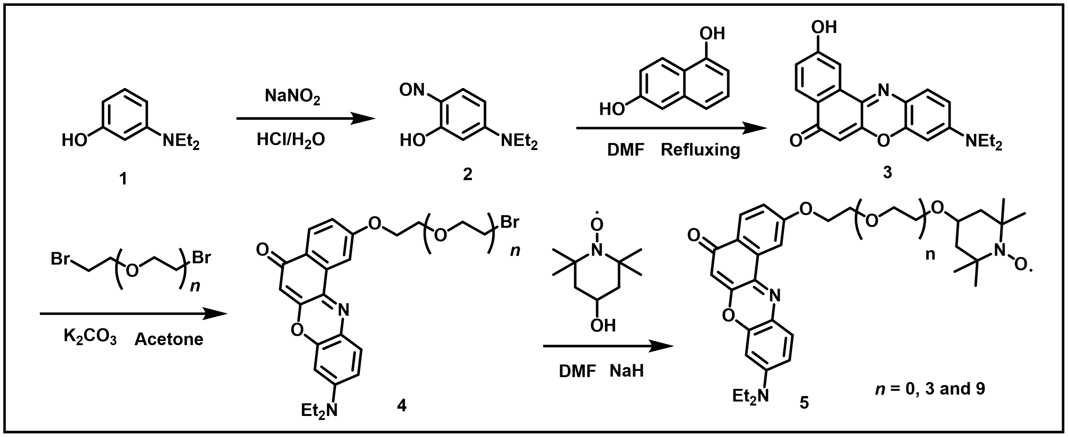
Scheme S1. Synthesis route of compound 5 (n = 0, 3 and 9)
Compound 4. Compound 3 (1 mmol), PEG chain derivatives (3 mM), and K₂CO₃ (5 mM) were dissolved in acetone (50 mL). The mixture was stirred at 60 ºC overnight. The solution was cooled to room temperature and poured into water. The crude product was extracted with ethyl acetate, washed with water, dried over anhydrous Na₂SO_{4,} and concentrated under reduced pressure. The desired product was isolated by silica gel column chromatography.
Compound 5. Compound 4 (1 mM), 4-hydroxy-TEMPO (5 mM) and NaH (8 mM) were dissolved in Dimethylformamide (DMF). Subsequently, the solution was cooled to room temperature and subjected to reduced pressure to remove DMF. To further purify the crude product, it was dissolved in ethyl acetate and subsequently absorbed onto silica gel. Finally, the desired product was isolated through silica gel column chromatography.

1.6 The Ultraviolet-visible spectroscopy analysis
The Ultraviolet-visible spectroscopy (UV-Vis) absorption spectra of Nile red (NR) and TEMPO were recorded using a SpectraMax iD5 microplate reader (Molecular Devices). TEMPO was dissolved in DMSO (0-18 mM), with NR added to each sample at 0.05 mM. Samples were divided into two groups: one irradiated with a green laser (1 W cm⁻², 5 min) and the other kept in the dark. Absorbance was scanned from 350 to 900 nm. Emission spectra were scanned from 580 nm to 800 nm using a 550 nm excitation wavelength.

1.7 The quantum yield (QY) of NR with or without TEMPO
To determine the quantum yield (QY) of NR with and without TEMPO, identical NR stock solutions were prepared in DMSO. A sample containing only NR (0.1 mM) and a sample containing 0.1 mM NR and 5 mM TEMPO (NR+TEMPO) were prepared in DMSO. The integrating sphere-coupled spectrofluorometer (Edinburgh FLS1000) was stabilized, with the excitation set to 550 nm and the emission configured to scan from 630 nm to 650 nm. A baseline correction was performed by recording the excitation spectrum and emission spectrum of pure DMSO solvent. The excitation and emission spectrum for the NR-only sample and the NR+TEMPO sample were also recorded. After subtracting the solvent blank spectra, the integrated areas of the corrected emission spectra and excitation spectra were calculated for NR and NR+TEMPO sample.

1.8 The liquid chromatography-mass spectrometry analysis (LC-MS)
For the NR+TEMPO system, the two components were mixed at a 1:2 molar ratio in methanol and irradiated with a laser (1 W cm⁻², 5 min). Mass spectra were collected on a UHR-TOF LC-MS system (Bruker Impact II). Chromatographic data was acquired and processed using Bruker Compass DataAnalysis software.

1.9 Time Correlated Single Photon Counting Lifetime Spectroscopy
Time Correlated Single Photon Counting (TCSPC) Lifetime Spectroscopy (Edinburgh FLS1000) was used to collect the fluorescence lifetime of NR and Dil with increasing TEMPO concentrations. The analysis of the fluorescence intensity and fluorescence lifetime and the calculation of the autocorrelation functions were performed by the Fluoracle® software package.

1.10 In vitro studies
Cellular behavior was extensively studied utilizing HeLa cell lines with the Leica DMi8 Confocal Laser Scanning Microscope. The cells were cultured in 5% CO₂ and 37 ºC and maintained in Dulbecco's modified Eagle's medium (DMEM) supplemented with 10% fetal bovine serum (FBS), 100 U mL⁻¹ penicillin, and 100 µg mL⁻¹ streptomycin (all from Invitrogen).
To investigate the colocalization of lipid droplets and NRT9, HeLa cells were seeded into confocal dishes (ibidi, LOT052923A001). The cells were then incubated with Bodipy 493/503 and either NR or NRT9 in phosphate-buffered saline (PBS, Invitrogen) for 10 min at 37°C (protected from light). After incubation, the cells were gently washed three times with PBS to remove unbound dye. Subsequently, high-resolution confocal microscopy images were acquired using appropriate excitation/emission settings for each dye.
To investigate lipid droplets (LDs) dynamics, HeLa cells were collected and incubated with 5 μM NR or NRT9 for 10 minutes. Subsequently, the cells were washed three times with PBS and seeded into a confocal dish at a density of 1 × 10⁵ cells mL ⁻¹. After the cells adhered to the dish, they were washed three times again with PBS and supplemented with fresh cell culture medium. The confocal dish was maintained at a constant temperature of 37 ºC in a 5% CO₂ environment to ensure cell viability and exposed to the laser at a wavelength of 552 nm. A movie was recorded at a frame rate of 0.2 fps, and the data analysis was performed using TrackMate from Image J.
To study cell permeabilization, HeLa cells were prepared according to the previously mentioned procedure, using 5 μM of NR, NRT9, or TEMPO. The cell culture medium containing 1 μM DAPI (4',6-diamidino-2-phenylindole, Thermo Fisher) was added to the cells. Subsequently, the cells were immediately exposed to a 552 nm light beam for a duration of 10 minutes. Additionally, a 405 nm light was employed to detect DAPI intensity. To ensure the viability of the cells, the confocal dish was maintained at a constant temperature of 37 ºC within a controlled environment containing 5% CO₂. The movie was recorded at a frame rate of 1 fps, and the data analysis was conducted using Image J.
To investigate cell viability, cells were stained with Hoechst 33342 and subjected to the treatment of 5 μM molecular swimmer. Subsequently, a specific amount of Paclitaxel (PTX) and 1 µM SYTOX Green were added to the medium. Following treatment, the cells were exposed to a 552 nm light beam to activate the molecular swimmers. During confocal imaging, a 488 nm laser was used to detect dead cells via SYTOX Green fluorescence, while a 405 nm laser was used to visualize all cell nuclei via Hoechst 33342, thereby identifying live cells. Throughout the experiment, cells were maintained at 37 °C with 5% CO₂. Time imaging was performed at 0.25 fpm, and data were analyzed using ImageJ.

1.11 Biocompatibility of molecular swimmer
The HeLa cells were treated with a series of concentrations of NRT9 using the procedure described above. After 24 hours, the adhesive cells were washed three times and a CCK-8 solution was prepared by diluting it with the fresh culture medium at a ratio of 1:10. The prepared solution was added to the cells, and the absorbance of the cells was measured using a microplate reader (SpectraMax iD5, Molecular Devices) at a wavelength of 450 nm. Cell viability was calculated according to the CCK-8 protocol.

1.12 Force spectrum of microbeads on cell membrane by optical tweezer
A commercially available dual-trap optical tweezers system incorporating structured illumination (KAYJA-OPTICS) was utilized to analyze the force spectrum of a microbead on HeLa cell membrane. The system features a 60×/1.4 NA oil-immersion objective, through which a near-infrared laser beam (1064 nm, 1000 mW, Cobolt) is focused to generate the optical trap. Force measurements were conducted using a position-sensitive quadrant photodetector (QPD) integrated into the system. For the experiments, a 1 μm silica bead served as a passive probe to capture the fluctuation spectrum caused by molecular swimmers. The cell was illuminated uniformly using structured light source, with power settings of 0 and 3 W cm⁻². Trap stiffness was determined through standard power spectral analysis in the absence of excitation light. The force spectrum was derived using Welch's method with a Hamming window, sampled at a frequency of 50 kHz. The force spectrum P(f) was fitted by Lorentz function:
 | $P\left(f\right)=\frac{1}{2π^{2}}\frac{D_{probe}}{f_{c,x}^{2}+f^{2}}$, | (S1)
where D_{probe} and f_{c,x} are the diffusion coefficient and cut-off frequency of the probe, and f is the frequency in Hz.
Considering that the force acting on the microbead was counterbalanced by the fluid drag force, we can derive the effective temperature of the bead using the Stokes- Einstein equation
 | $T_{eff}=\frac{k_{B}D_{probe}}{6πη_{eff}R}$, | (S2)
where $k_{B}$ = 1.38 × 10⁻²³ J K⁻¹ is the Boltzmann constant, $η_{eff}$ is the effective dynamic viscosity of the surrounding phase of the sphere, and R is the radius of the bead. By substituting the $T_{eff}$ = 298 K into Equation S2, we determined that the $η_{eff}$ ≈ 0.01 Pa s. For the microbead with the radius of 0.5 μm treated with NRT swimmers under illumination with the light intensity of 3 W cm⁻², we obtain $D_{probe}$ ≈ 1.3×10⁻¹³ m² s⁻¹, corresponding an effective temperature of 740 K.

2 Supplementary Contents

2.1 The ultraviolet-visible spectroscopy analysis (UV-vis) of NR with increasing TEMPO concentrations and light intensities
The spectra of different NR concentrations with or without TEMPO and light illumination were also measured. The total photon energy input (E) was calculated:
$$E=I∙t,$$ | (S3)
where I represents the light intensity (1 W cm⁻²) and t is the irradiation duration (300 s). This yielded a total energy of ~300 J cm⁻². In contrast, molecular motion characterization via TIRF microscopy employed illumination at a significantly higher intensity (50-60 W cm⁻²) but with ultra-short exposure (t = 0.14 s; Figure 1c, e). The corresponding energy input for TIRF measurements is ~8 J cm⁻², demonstrating among 30-fold lower cumulative photon energy load compared to UV-vis analysis conditions.
To verify whether any products were formed, we analyzed the corresponding spectra. As shown in Figure S1, the spectra exhibit a consistent absorption maximum at approximately 550 nm, both in the presence (+L) and absence (-L) of light. No characteristic absorption peaks indicative of by-products was observed within the 350-900 nm spectral range, suggesting that no detectable by-products were formed under the specified experimental conditions.
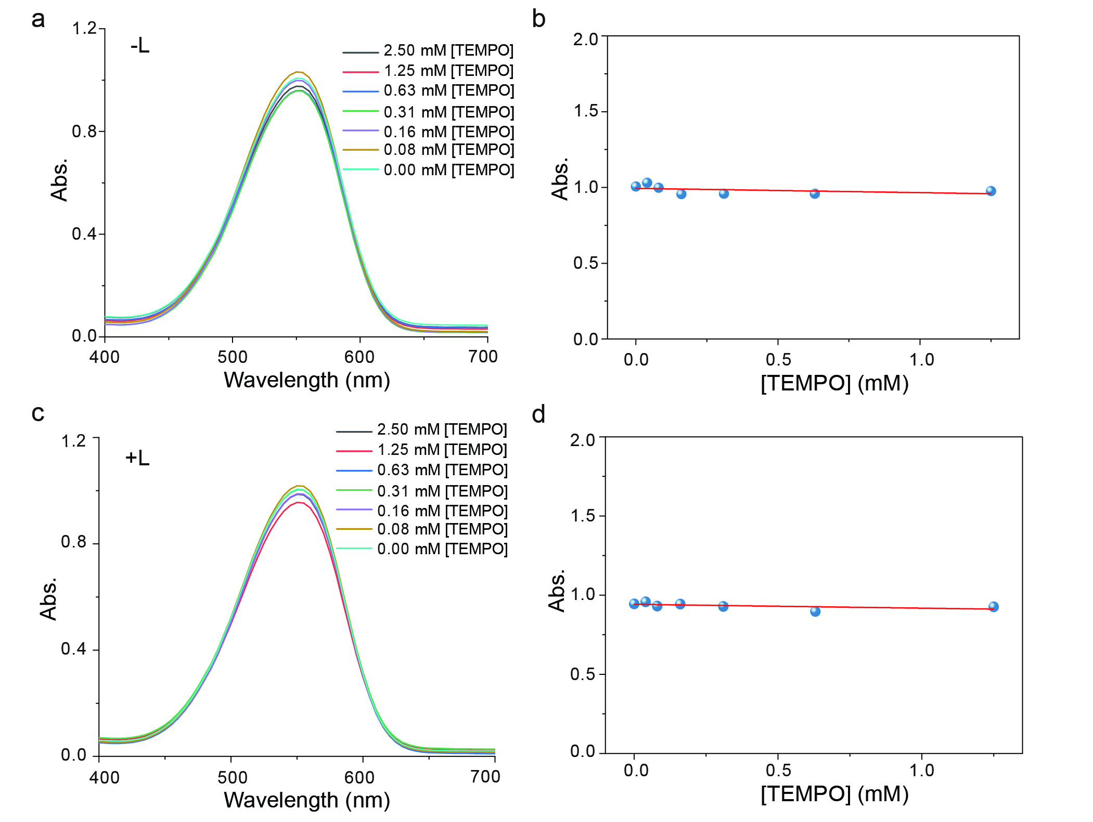
Figure S1. The absorption spectra of NR at various TEMPO concentrations. a, Spectra of NR with different TEMPO concentrations without green laser irradiation (-L). b, Plot of absorbance vs. TEMPO concentrations without light. c, Spectra of NR with different TEMPO concentrations under light irradiation (+L) at 1 W cm⁻² for 5 min. d, Plot of absorbance vs. TEMPO concentrations with light.

2.2 The liquid chromatography-mass spectrometry (LC-MS) analysis of NR with TEMPO
The LC-MS technique was utilized to further verify the absence of by-product formation during the photoredox reaction between NR and TEMPO. As illustrated in Figure S2, the Total Ion Chromatograms (TIC) and Extracted Ion Chromatograms (EIC) of the NR+TEMPO mixture before and after green laser irradiation (1 W cm⁻², 5 min) exhibit identical characteristic peaks. These spectra confirm that no significant light-induced by-products were formed.
Figure S2. Total ion chromatogram (TIC) and extracted ion chromatogram (EIC) of NR+TEMPO with (+L) or without light illumination (-L) (TEMPO: C₉H₁₈NO, m/z 157.15; NR: C₂₀H₁₈N₂O₂, m/z 319.14).

2.3 Probability density function (PDF) of the displacement of NR molecules
Figure S3 displays the probability density function (PDF) of the displacement of NR molecules at various light intensities and TEMPO concentrations, demonstrating a pronounced increase in the probability of NR undergoing long-distance jumps with increasing light intensities and TEMPO concentration.
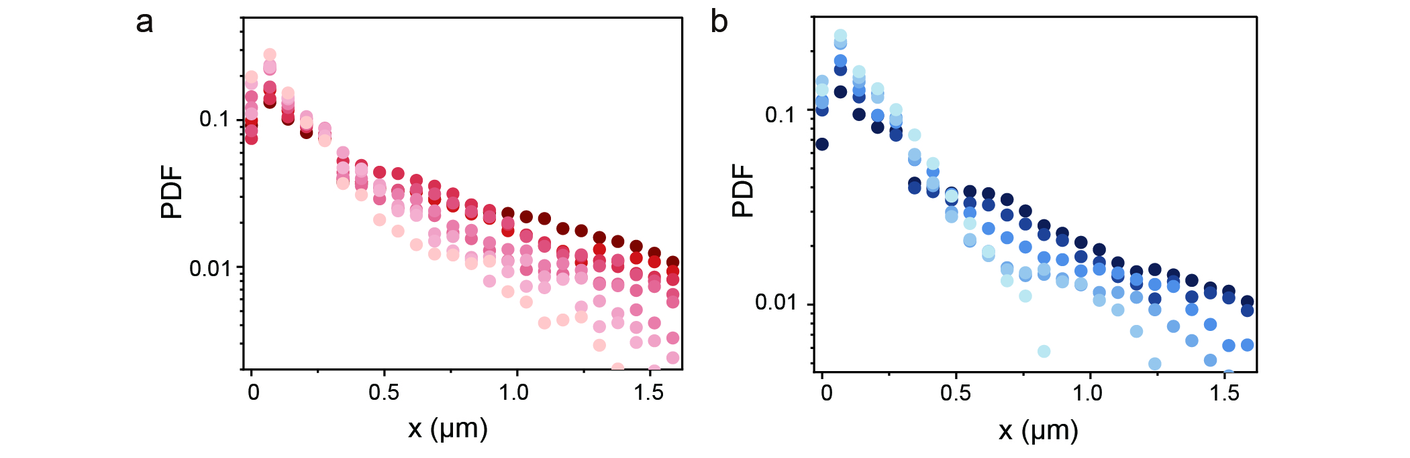
Figure S3. Step length analysis of NR under various light intensities. a, PDF of the NR migration step length (Δt = 24 ms) under various light intensities from 130 to 650 mW mm⁻² at 5 mM TEMPO, with intervals of 65 mW mm⁻², where data points with darker colors represent higher light intensity. b, PDF of the NR migration step length (Δt = 24 ms) under various TEMPO concentrations from 0 to 10 mM at the light intensity of 585 mW mm⁻², where data points with darker colors represent higher TEMPO concentrations.

2.4 The rotational diffusion coefficient (D_{r})
We present the derivation of the rotational diffusion timescale for molecules within the lipid bilayer. The rotational diffusion time scale $τ_{r}$ of NR molecules in lipid bilayer is given by Saffman-Delbrück formula⁴:
 | $$τ_{r}=\frac{1}{D_{r}}=\frac{4πhη_{m}R^{2}}{k_{B}T},$$ | (S4)
where k_{B} =1.380649 × 10⁻²³ m² kg s⁻² K⁻¹ is Boltzmann constant, T = 293 K is room temperature, h ≈ 5 nm is the thickness of the membrane⁵, R ≈ 2 nm is the hydrodynamic radius (not the actual molecular size) of fluorescent lipid probes⁶.
Note that the viscosity of the lipid membrane was affected by numerous factors: membrane phase state (e.g., gel phase L_{β}, liquid crystalline phase L_{α})⁷, temperature⁸, interactions with solid substrate⁹, and the structural and compositional heterogeneity (e.g., coexistence of liquid-ordered L_{o} and liquid-disordered L_{d} domains) at microscale collectively create a dynamic and non-uniform microenvironment¹⁰.
The coexistence of distinct domains in the lipid membrane or other factors results in a broad viscosity range, approximately 10⁻⁸ to 10⁻⁶ Pa s m, which is significantly higher than that in aqueous environment¹¹. More importantly, the artificial supported lipid bilayer used in our experiments was deposited on a solid substrate. This configuration may enhance the membrane’s apparent viscosity and promote the formation of L_{o} domains¹², thereby prolonging the molecular $τ_{r}$ within the membrane. By substituting this viscosity range into Equation S4, we estimate$τ_{r}$to be between 0.1 and 10 ms.
Given that the viscosity discussed above represents a macroscopic average, local viscosity values may exhibit substantial deviations. The TIRF measurements are biased toward high-viscosity regions because only molecules with sufficiently slow motion are tracked reliably (Figure 1b in the manuscript)^{13,14}. Consequently, the dynamics we capture directly correspond to the molecular dynamics in high-viscosity regions, and the measured timescales (7 ms) align with the estimated $τ_{r}$ range (0.1-10 ms).

2.5 The mean square displacement (MSD) of pure NR
The MSD is calculated as follows:
 | $$MSD\left(∆t\right)=\frac{1}{N}\sum_{i=1}^{N}{{\left|r\left(i∆t\right)-r\left(\left(i-1\right)∆t\right)\right|}^{2}},$$ | (S5)
where N is the number of molecules to be averaged, $∆t$ is the lag time, $r\left(i∆t\right)$ is the position of molecules at time $i∆t$. The plot of MSD versus $∆t$ in two dimensions can be fit according to
 | $$MSD\left(∆t\right)=4D{∆t}^{α},$$ | (S6)
where D is the diffusion coefficient and α is the exponent¹⁵. The exponent α distinguishes between different diffusion regimes: α = 1 corresponds to normal diffusion (Brownian motion), which is dominated by thermal fluctuations; α < 1 indicates subdiffusion, typically arising from molecular confinement in spatial heterogeneity; and α > 1 signifies superdiffusion, which is indicative of active propulsion.
Analysis of the MSD and D of pure NR under increasing light intensities revealed that D remained constant (Figure S4), demonstrating that the heat generated by light illumination did not significantly alter NR’s diffusion. In lipid bilayers, molecules generally exhibit subdiffusion due to heterogeneities in membrane viscosity. However, under photoredox conditions, molecular swimmers display superdiffusion (Figure 1c, e).
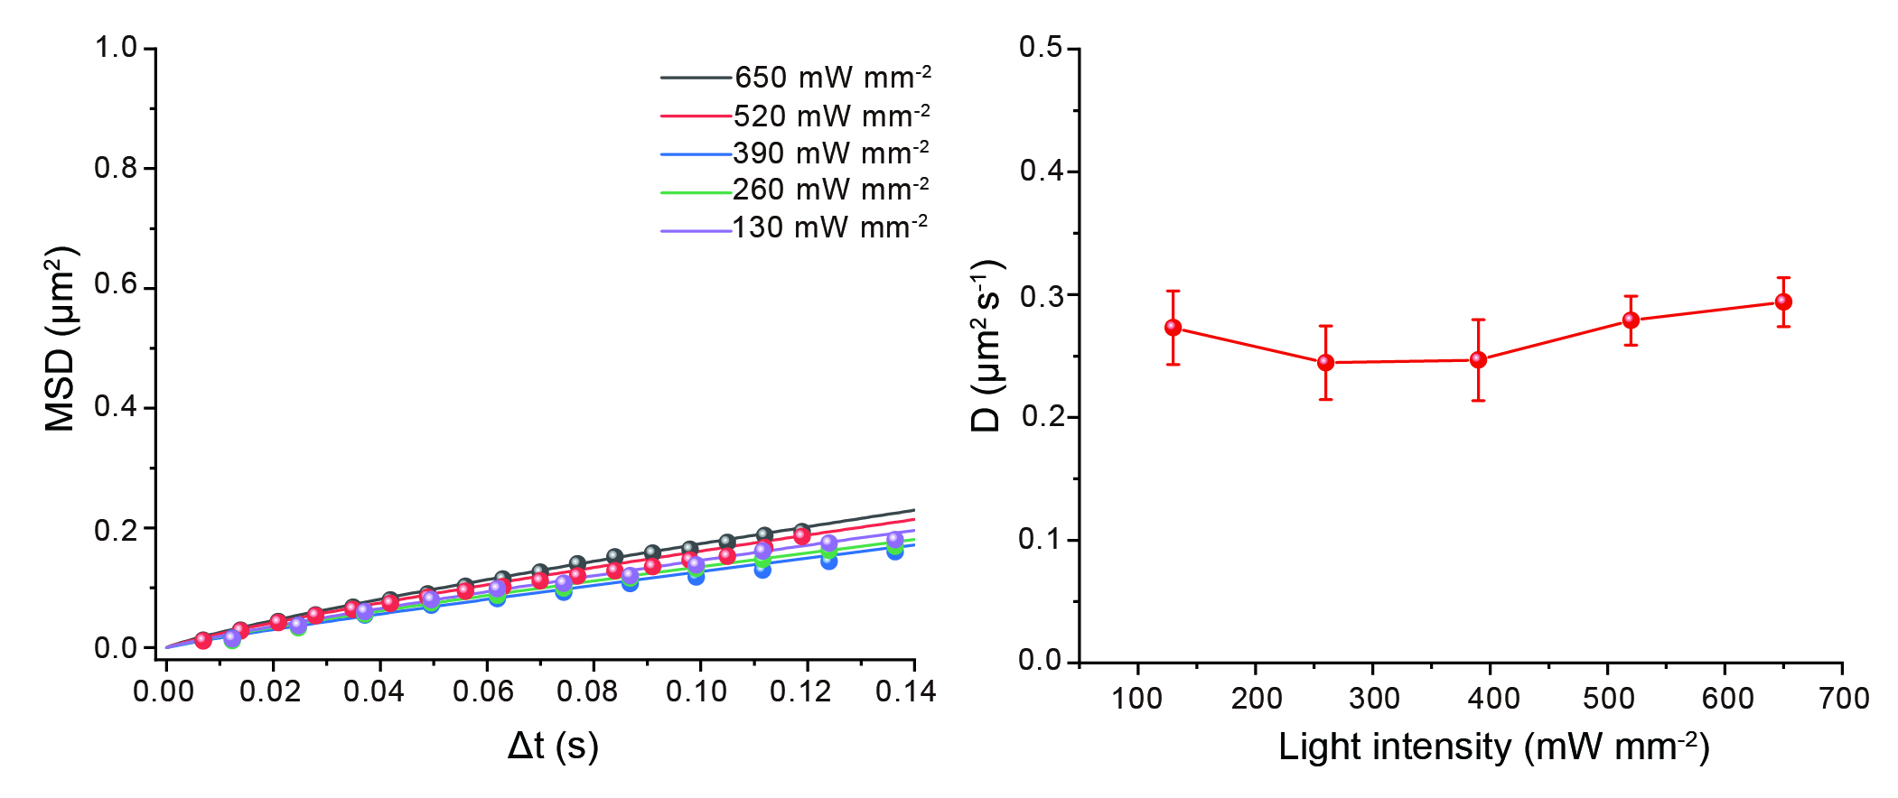
Figure S4. The MSD and D of pure NR with increasing light intensity. All MSD plots yielded α ~ 0.9 < 1.

2.6 Fluorescence lifetimes of NR and Dil with different TEMPO concentrations
The fluorescence lifetimes of NR and Dil were determined using the Time-Correlated Single Photon Counting method (TCSPC) at various TEMPO concentrations. As depicted in Figures S3a, the fluorescence decay of NR molecules accelerates with increasing TEMPO concentration, whereas the fluorescence decay of Dil remains relatively constant across different TEMPO concentrations (Figure S5b). Subsequently, we fitted the decay curves of NR and Dil molecules using single exponential decays equation
 | $I\left(t\right)=B∙e^{\left({-t}/τ\right)},$ | (S7)
where B is the component amplitude, t is the time and τ is the fluorescence lifetime, the average lifetime τ of NR and Dil molecules can be obtained, respectively. Furthermore, by integrating the photon counts depicted in Figure S5a and b over time, we derived the average fluorescence intensity (I) for NR and Dil molecules at different TEMPO concentrations. Figure S5c illustrates the Stern-Volmer plot, depicting the dependence of I₀/I and τ₀/τ values for NR and Dil molecules on TEMPO concentrations, where I₀ and τ₀ represent measurements in the absence of TEMPO. For NR molecules, both I₀/I and τ₀/τ exhibit a strong dependency on TEMPO concentrations, indicating a concentration-dependent quenching effect (Figure S5a and 5c). In contrast, Dil molecules show no significant variation in I₀/I and τ₀/τ with changing TEMPO concentrations, suggesting the absence of fluorophore quenching (Figure S5b and 5c). These findings provide compelling evidence for a photoredox process between NR and TEMPO while ruling out any such reaction between Dil and TEMPO.
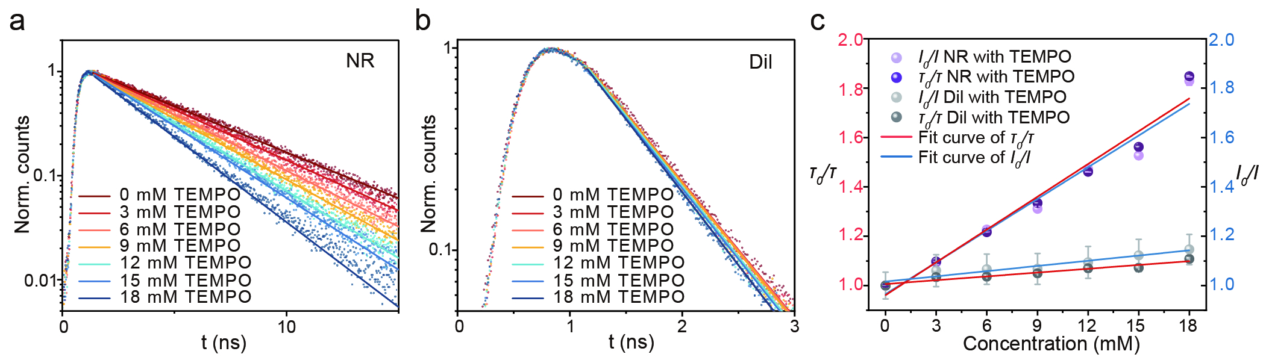
Figure S5. Fluorescence lifetimes of NR and Dil. a,b, Fluorescence lifetimes of NR (a) and Dil (b) at different TEMPO concentrations. c, Stern-Volmer plot based on the average fluorescence intensity and the average fluorescence lifetimes fits.

2.7 Dependence of diffusion coefficient on light intensity and TEMPO concentration
The relationship between the diffusion enhancement of the NR molecule and both light intensity and TEMPO concentration, we initially analyzed the photoredox reaction process occurring between the NR and TEMPO, which can be elucidated as follows:
- Excitation: $NR+hv\underset{→}{I_{a}}{NR}^{*}$
 | $r_{act}=I_{a}\left[NR\right]\left[hv\right]$. | (S8)
- Fluorescence: ${NR}^{*}\underset{→}{k_{f}}NR+hv$
 | $r_{f}=k_{f}\left[{NR}^{*}\right]$. | (S9)
- Charge transfer: ${NR}^{*}+TEMPO\underset{→}{k_{CT}}{NR}^{-}+ {TEMPO}^{+}$
 | $$r_{CT}=k_{CT}\left[{NR}^{*}\right]\left[TEMPO\right].$$ | (S10)
- Regeneration: ${NR}^{-}+ {TEMPO}^{+}\underset{→}{k_{r}}NR+TEMPO$
Here, r_{act}, r_{f} and r_{CT} are the excitation rate, fluorescence rate, internal quenching rate and charge transfer rate; k_{act}, k_{f}, k_{CT} and k_{r} are the corresponding rate constant; [NR], [hv], [NR*] and [TEMPO] are the concentration of NR, photon, NR* and TEMPO, respectively. It is assumed that each external quenching reaction propels a NR molecule over a fixed distance, establishing a direct proportionality between the active velocity of NR and the rate of external quenching reactions, denoted by u_{swim} ~ r_{CT}.
Note that d[NR*]/dt =
 | $\frac{d\left[{NR}^{*}\right]}{dt}=r_{act}- r_{f}-r_{CT}$. | (S11)
The equilibrium state of the entire redox reaction is characterized by d[NR*]/dt = 0. Subsequently, Equation S11 can be derived by substituting Equations S8, S9, S10 and u_{swim} ~ r_{CT}, leading to
 | $$u_{swim} \sim \frac{k_{act}k_{CT}I_{a}\left[TEMPO\right]}{k_{f}+k_{CT}\left[TEMPO\right]}.$$ | (S12)

2.8 Local temperature rises from light absorption by NR molecules
As for the destination of the laser energy, although the light intensity employed in this study reaches up to 650 mW mm⁻², only a small fraction of photons is absorbed by the NR molecules due to their nanometer-scale absorption cross-section. In contrast, the majority of the photons are reflected from the upper surface of the glass substrate as a result of total internal reflection. The total energy absorbed by NR molecules on lipid bilayer can be theoretically calculated by
 | $-∆I=n_{s}σI$, | (S13)
where n_{S} represents the number of NR molecules per unit area, and σ denotes the absorption cross-section of an NR molecule. It is important to note that σ is closely associated with the molar extinction coefficient (ε) of NR, as given by σ = 2303ε/N_{A} = 1.45 × 10⁻²⁰ m² molecule⁻¹, where ε = 38000 cm⁻¹ M⁻¹ is the molar extinction coefficient of NR and N_{A} = 6.02214076×10²³ mol⁻¹ represents the Avogadro constant¹⁶. By considering a typical value for n_{S} at 0.5 molecules μm⁻² and a light intensity of 650 mW mm⁻², Equation S13 allows us to determine ΔI as equal to 4.7×10⁻³ W m⁻², which indicates the amount of light energy absorbed by NR molecules on the lipid bilayer.
Here, it can be assumed that the entire light energy is converted into heat, which then diffuses into the surrounding liquid and substrate, resulting in a quasi-static state for the temperature field. The temperature rise can be determined in accordance with Fick’s law¹⁷, given that
$Q=\frac{κ_{w}}{κ_{w}+κ_{sub}}ΔIS=κ_{w}S\frac{ΔT}{λ_{T}}$, | (S14)
where Q is the heat flux, κ_{w} and κ_{sub} are the thermal conductivity of water and glass substrate, S is the laser spot area, ΔT is the temperature rising and λ_{T} is the thermal boundary layer thickness¹⁸. Considering that S = 9×10⁻⁹ m², ΔI = 4.7×10⁻³ W m⁻², κ_{w} = 0.6 W m⁻¹ K⁻¹, κ_{sub} = 1 W m⁻¹ K⁻¹, and λ_{T} ≈ 5×10⁻⁴ m (around 10 times of the laser spot diameter), we can get that ΔT is in the order of 1 μK.

2.9 The MSD of Dil molecules
By analyzing the MSD and D values of Dil, we observed a consistent diffusion rate for Dil molecules across varying light intensities and TEMPO concentrations.
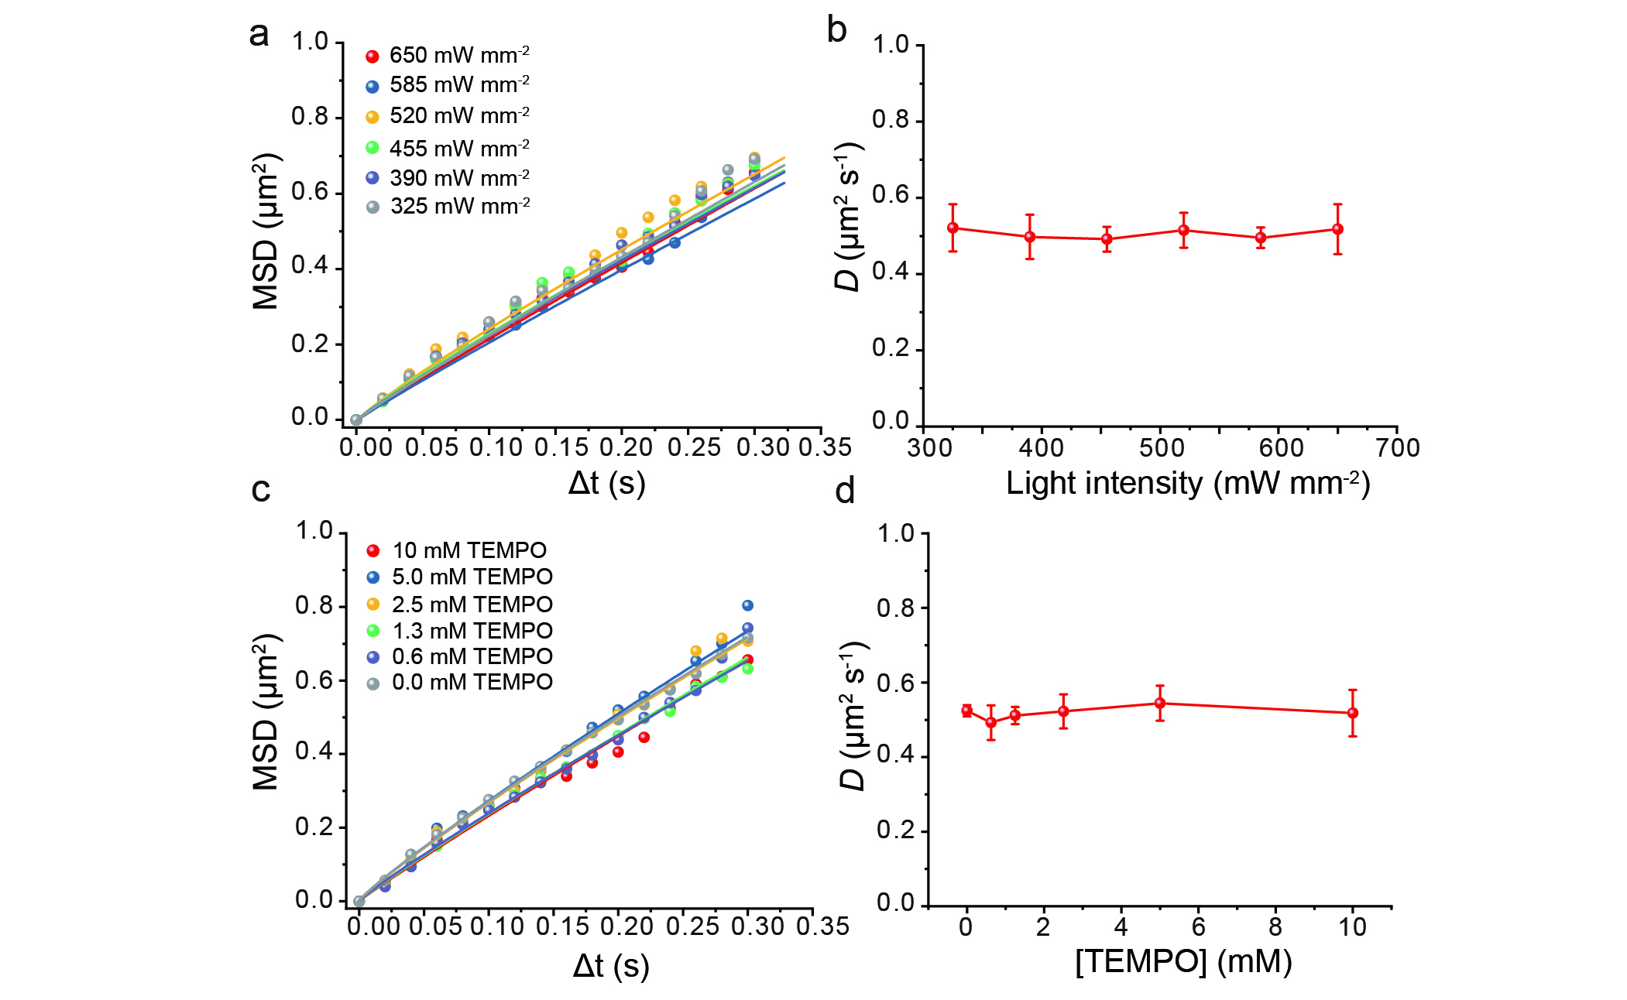
Figure S6. Dil molecular diffusion. a, Plot of MSD (α ~ 0.9) and b, D for Dil diffusion under different light intensities at 5 mM TEMPO. c, Plot of MSD (α ~ 0.9) and d, D for Dil diffusion at varying TEMPO concentrations under the light intensity of 585 mW mm⁻².

2.10 The fluorescence recovery after photobleaching (FRAP) of Dil molecules
First, we normalized intensities to pre-bleach average ($I_{pre}$) and post-bleach minimum ($I_{min}$):
$$I_{norm}\left(t\right)=\frac{I_{corr}\left(t\right)-I_{min}}{I_{pre}-I_{min}}$$ | (S15)
The normalized recovery data were fitted to a 2D diffusion model:
$$I_{norm}\left(t\right)=A(1-e^{-kt}),$$ | (S16)
where t is time elapsed after photobleaching (s), A is mobile fraction (plateau recovery), and k is recovery rate constant (s⁻¹). In this system, k were measured without or with 10 mM TEMPO are 0.07404 ± 0.001 s⁻¹ and 0.0852 ± 0.001 s⁻¹ respectively. As a result, the diffusion coefficient (D) was calculated as:
$$D=\frac{w^{2}k}{4},$$ | (S17)
where w is radius of the bleached region (5 μm). According to the Stokes-Einstein relation, D is related to viscosity. Given that D remained stable at ~0.5 μm² s⁻¹ regardless of TEMPO addition, the membrane viscosity cannot have changed significantly.
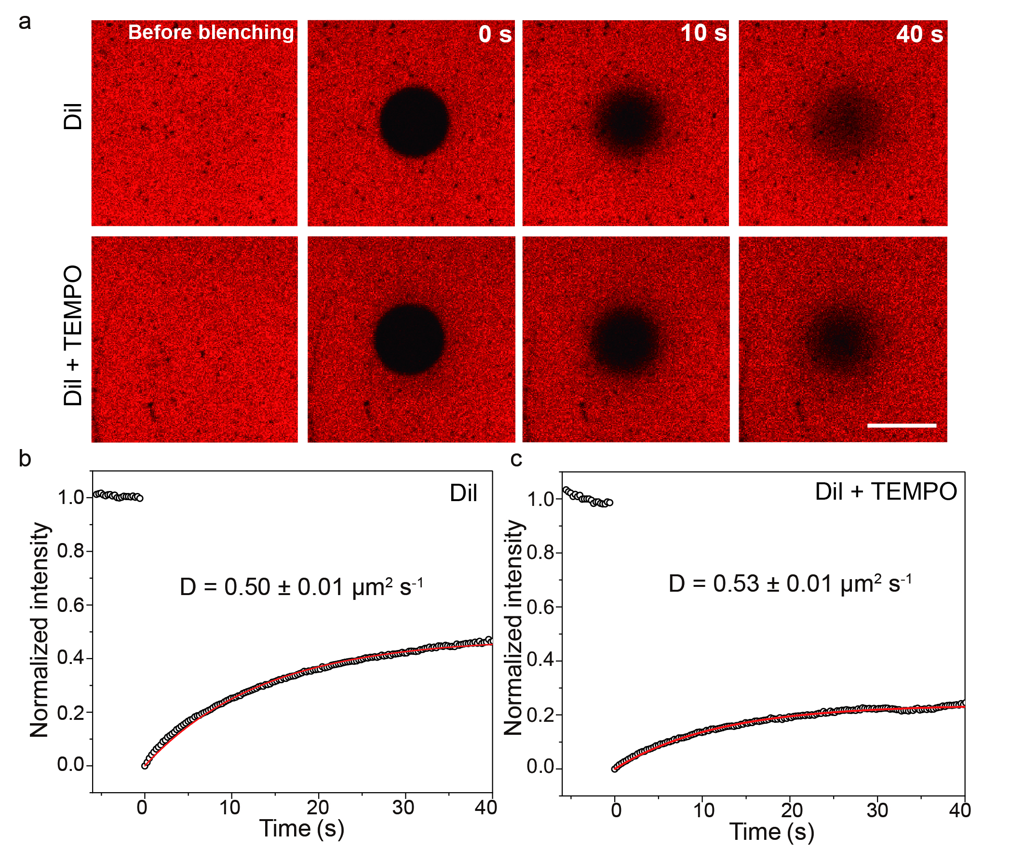
Figure S7. FRAP data of Dil-labeled lipid membrane in water or 10 mM TEMPO solution. a, Images from the FRAP series showing recovery of the bleached spot. Scale bar 10 µm. b, The normalized data and fitted curve are plotted. The D of Dil within water and lipid membrane is ~0.50 μm² s⁻¹. c, The normalized data and fitted curve are plotted. The D of Dil within 10 mM TEMPO and lipid membrane is ~0.53 μm² s⁻¹.

2.11 The quantum yields (QY) analysis of NR and NR+TEMPO
To evaluate the contribution of heat generation to the propulsion mechanism in the NR+TEMPO photoredox system, we employed the fluorescence QY as a key parameter. The QY is defined as the ratio of photons emitted by NR to photons absorbed by NR.
Assuming that all non-radiatively dissipated energy is converted to thermal energy, the heat flux (J) generated can be estimated as:
$$J=I\left(\left(1-QY\%\right)+QY\%×\left(hc×\left(\frac{1}{λ_{abs}}-\frac{1}{λ_{Em}}\right)\right)\right)×\left(\frac{∆I}{I}\right)$$ | (S18)
where h is Planck constant, c is the speed of light, $λ_{abs}$ and $λ_{Em}$ are the wavelengths of absorbed light and emitted light, respectively. $\frac{∆I}{I}$ is the ratio of total absorbed energy to light intensity (details see in Equation S13).
Using an integrating sphere-coupled spectrofluorometer (Edinburgh FLS1000), we measured QY values of 75.9% for pure NR and 66.1% for NR with 5 mM TEMPO (NR+TEMPO). Using these QY values along with the Stokes shift (representative excitation: 550 nm, emission: 630 nm), we calculated the ratio of heat generation to the total energy of absorbed light for the NR and NR+TEMPO systems, yielding H_{NR} and H_{NR+TEMPO} values of 33.9% and 42.3%, respectively. Based on these ratios, we constructed a plot depicting the relationship between light intensity and J (Figure S8). Subsequently, we compare molecular diffusion under conditions yielding comparable heat generation intensities. NR alone under 585 mW mm⁻² light (heat flux ≈ 1.4×10⁻⁴ mW mm⁻²) exhibited low diffusion D ≈ 0.3 µm² s⁻¹. In contrast, NR with TEMPO under significantly lower light intensity (200 mW mm⁻²; heat flux ≈ 0.6×10⁻⁴ mW mm⁻²) achieved substantially higher diffusion (D ≈ 1.5 μm² s⁻¹) (Figure S8). Despite experiencing a higher heat intensity (1.4×10⁻⁴ mW mm⁻² vs. 0.6×10⁻⁴ mW mm⁻²), NR alone diffused more slowly than NR+TEMPO. These results between heat intensity and diffusion rate strongly support the conclusion that enhanced diffusion primarily arises from the photoredox reaction between NR and TEMPO, not thermal effects.
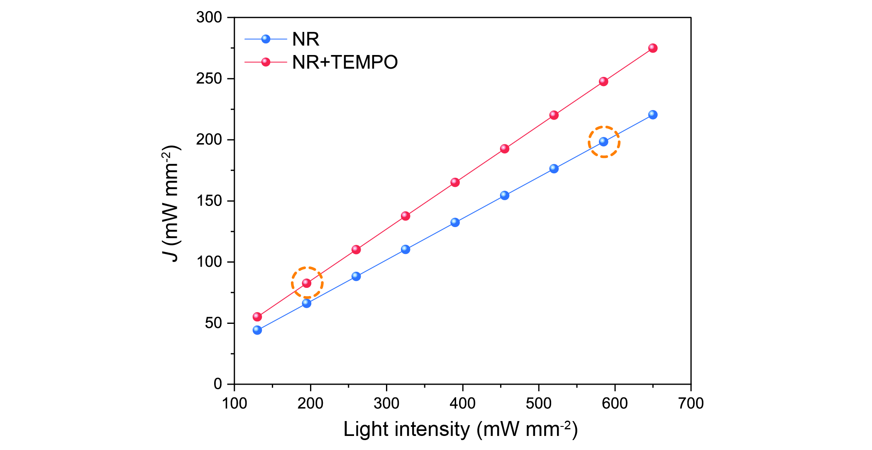
Figure S8. Heat flux (J) of the NR and NR+TEMPO systems under varying light intensities. The orange dashed circles highlight the specific conditions compared in the diffusion analysis: pure NR at 585 mW mm⁻² (heat flux ~1.4×10⁻⁴ mW mm⁻²) and NR+TEMPO at 200 mW mm⁻² (heat flux ~0.6×10⁻⁴ mW mm⁻²). The significantly higher diffusion of NR+TEMPO under a lower heat flux indicates that the enhanced diffusion is not primarily driven by thermal effects.

2.12 Convection analysis of lipid membrane system
The Reynolds number can be estimated for such active turbulence through
 | $Re=\frac{ρvl}{μ}$, | (S19)
where ρ ≈ 1000 kg m⁻³ is the density of lipid, v ≈ 4×10⁻⁶ m s⁻¹ is the average velocity of the active turbulence, l = 5.4×10⁻⁵ m is diameter of the laser spot representing the characteristic length of the turbulence, and μ = 0.05 Pa s is the dynamic viscosity of the membrane. We obtain Re ~10⁻⁶.
The Grashof number, which represents the ratio of buoyancy (gravity) to the viscous force
 | $Gr=\frac{gΔρh^{3}}{ρν_{w}^{2}}$, | (S20)
where g = 9.8 m s⁻² is the gravitational acceleration, $Δρ$ and $ρ$ are the density change and density of solution (mainly water), h = 100 μm is the channel height, ν_{w} = 10⁻⁶ m² s⁻¹ is the kinematic viscosity of water. Here we assume a relative change of density $\frac{Δρ}{ρ}$ as 0.1%, corresponding to a temperature change of 5 K, which is significantly higher than the experiment’s condition. We obtain Gr ≪ 0.01, indicating that the buoyance is negligible compared to the dominant viscous forces.

2.13 The variable speed of NR molecules
We analyzed the relationship between the segment length ΔL and Δt of NR molecules. As shown in Figure S9, the variability in NR velocity confirms that NR exhibits characteristics of a Lévy flight pattern rather than a Lévy walk in its movement dynamics.
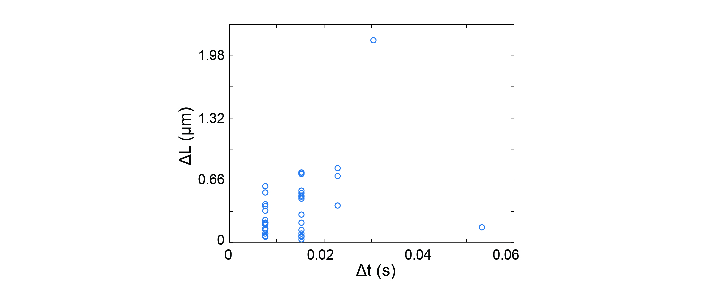Figure S9. The relationship between segment length and Δt. Relationship between segment length and duration time of NR with 5 mM TEMPO under a light intensity of 585 mW mm⁻².

2.14 Molecular swimmers exhibit Lévy dynamics in short-time observations
2D Langevin equation was used to simulate the dynamics of passive molecules undergoing Brownian motion and active molecules with self-propulsion, respectively. For all molecules, the translational diffusion coefficient (D_{t}) was set to 10 μm² s⁻¹ and the rotational diffusion coefficient (D_{r}) was set to 0.1 rad² s⁻¹. For the propelled and passive molecules, the self-propelled velocity was set to 1 μm s⁻¹ and 0, respectively. The simulation time step was 1 ms, and total simulation duration was 0.5 s. Due to the experimental time limit of 7 ms, we simulated molecular trajectories at both 1 ms and 7 ms (Figure S10a, b). In both cases, the MSD exhibited superdiffusive behavior, with α > 1 (Figure S10c). Typical trajectories of the molecular swimmers at 1 ms and 7 ms, identified by turning points defined as rotation angles greater than 40 °, revealed that the 7 ms observation displayed longer step jumps compared to the 1 ms case (Figure S10d, e). Based on Lévy dynamic theory, the motion of molecular swimmers at both time scales can be characterized as Lévy dynamics with a power-law exponent µ in the range 1 < µ < 3 (Figure S10f).
For passive molecules with only Brownian motion. The MSD analysis confirmed normal diffusion (α = 1; Figure S10g-i). However, when the Lévy dynamics of these Brownian molecules were evaluated based on turning points and flight segments, the resulting power-law exponent was µ = 3 at both 1 ms and 7 ms (Figure S10j-l), a finding that is inconsistent with Lévy theory, which anticipates µ < 3.
The results are conclusive: at both sampling rates, particles with self-propulsion consistently exhibited Lévy flight characteristics, while those undergoing only Brownian motion did not, showing identical Brownian MSD scaling regardless of the sampling interval. This confirms that the observed Lévy behavior is a genuine feature of active propulsion, robust to the temporal resolution of our measurements.
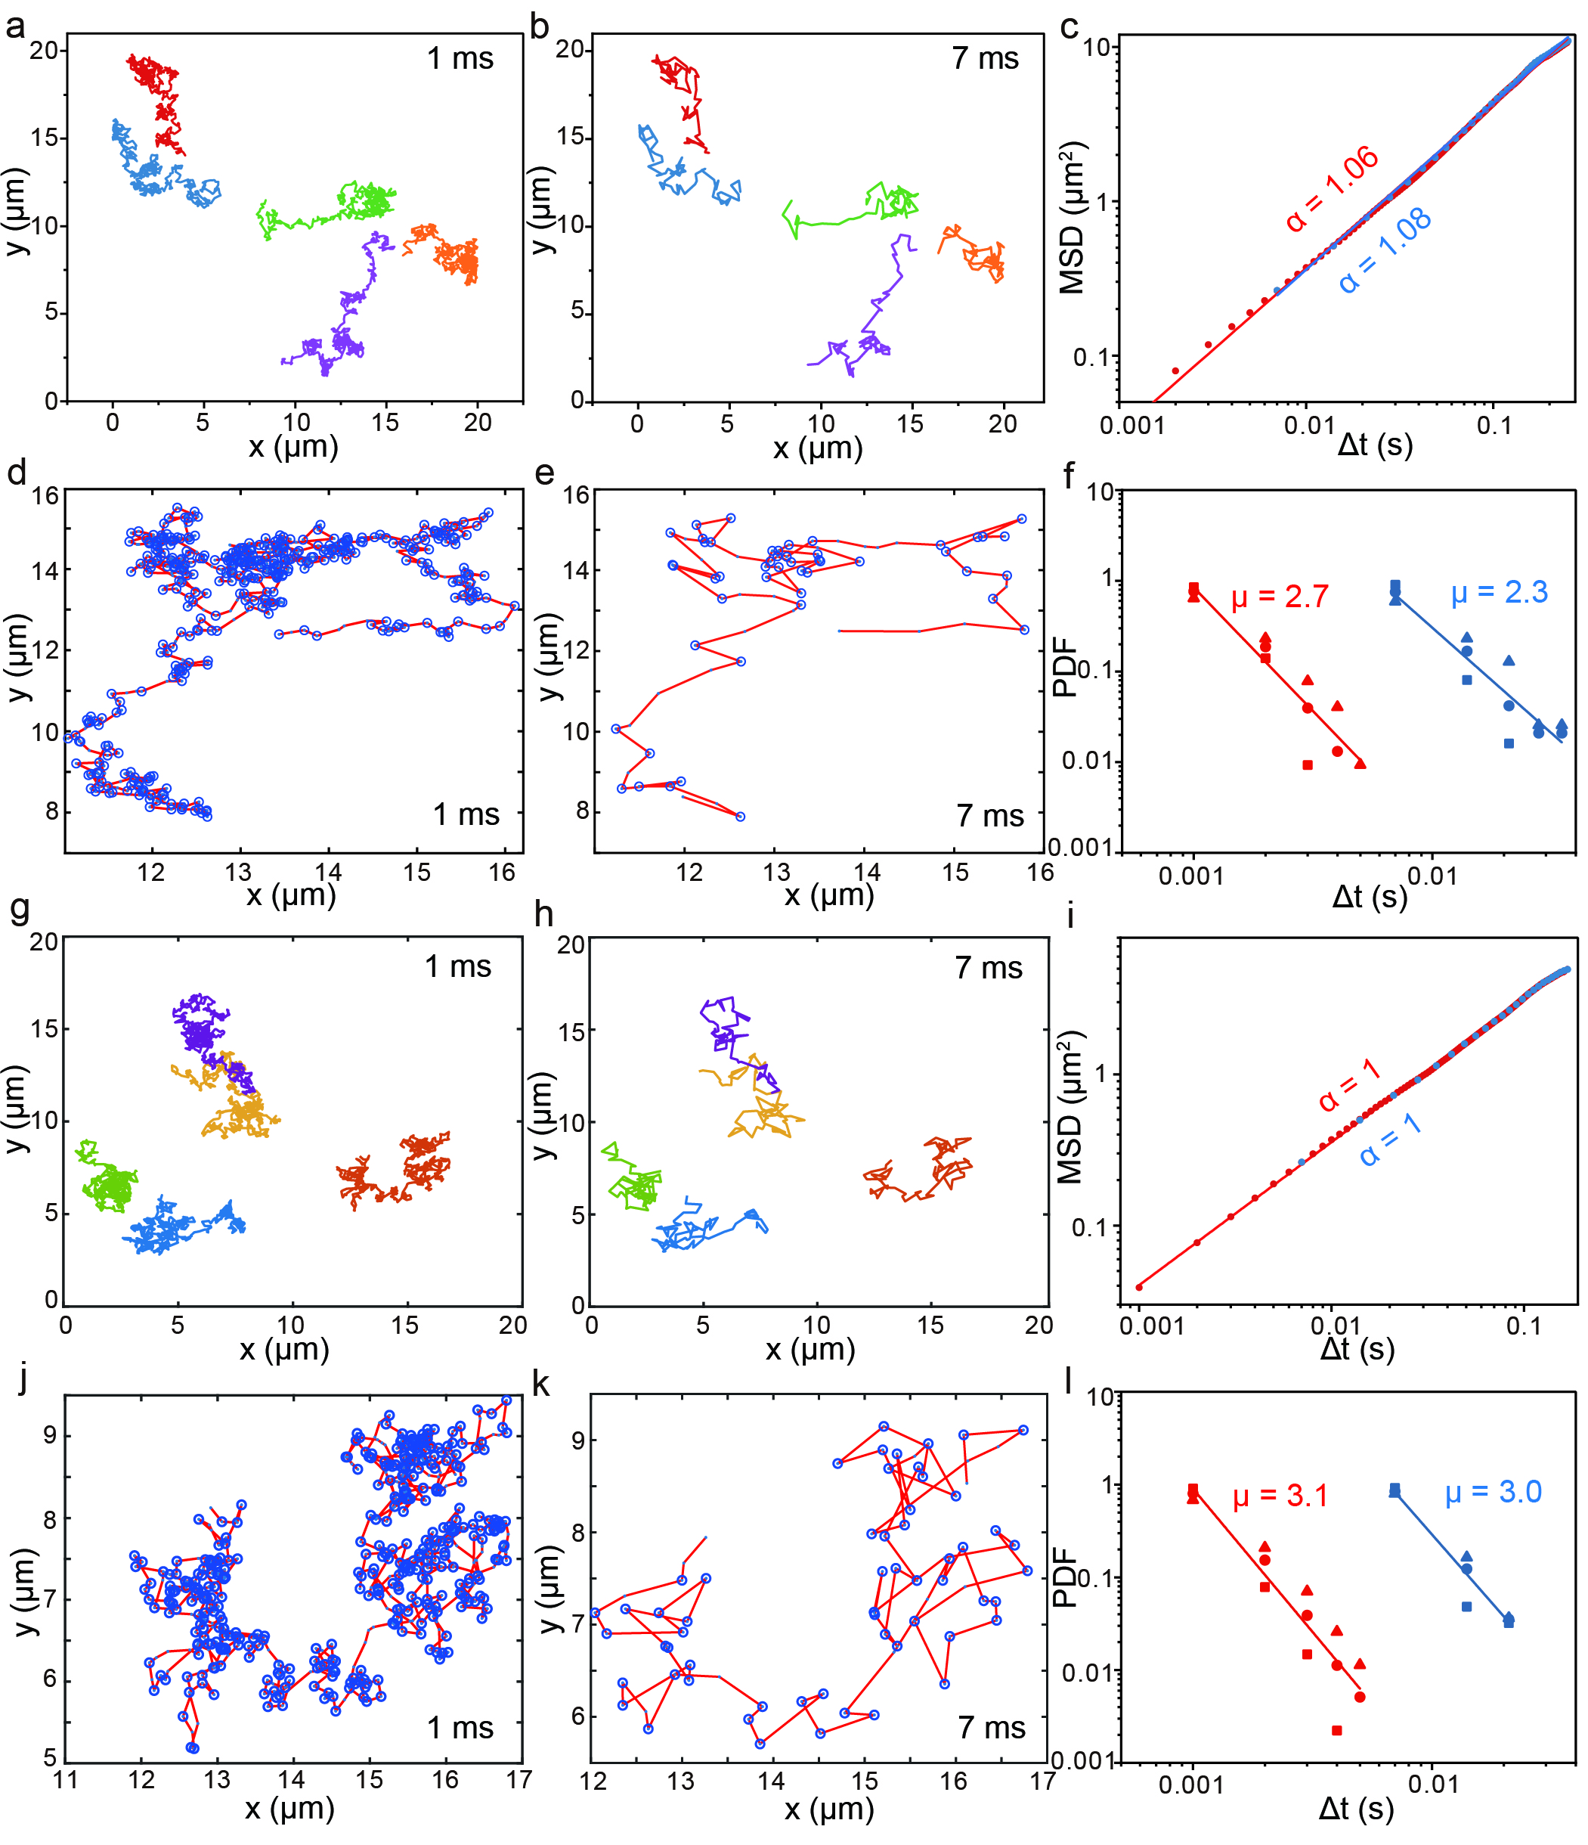
Figure S10. Molecular swimmer perform Lévy dynamics in short-time observations. a,b, Typical trajectories of molecular swimmer at 1 ms and 7 ms. c, The MSD at both scales (1 ms in red and 7 ms in blue), exhibiting superdiffusion (α > 1). d,e, Representative trajectories at each time scale with turning points (defined as rotation angles exceeding 40 °) marked by blue circles. f, PDF of waiting times Δt between turns (20 °, 40 °, and 60 °), following a power-law decay. The extracted exponent μ is 2.7 (1 ms, red) and 2.3 (7 ms, blue). Data points corresponding to 20 °, 40 °, and 60 ° turns are represented by squares, circles, and triangles, respectively. g,h, Typical trajectories of Brownian motion molecule at 1 ms and 7 ms. i, The MSD at both scales (1 ms in red and 7 ms in blue), exhibiting Brownian motion (α = 1). j,k, Representative trajectories at each time scale with turning points (defined as rotation angles exceeding 40 °) marked by blue circles. l, PDF of waiting times Δt between turns (20 °, 40 °, and 60 °), following a power-law decay. The extracted exponent μ is 3.1 (1 ms, red) and 3.0 (7 ms, blue). Data points corresponding to 20 °, 40 °, and 60 ° turns are represented by squares, circles, and triangles, respectively.

2.15 The MSD of molecular swimmers
The MSD of the molecular swimmers were computed following the same methodology as depicted in Figure S4. Subsequently, the D were determined by fitting curves. The results indicate that NRT functions as a light-dependent molecular swimmer and shows no significant alteration in diffusion rate at low densities.
Figure S11. NRT0, NRT3 and NRT9 diffusion. a, MSD of NRT0 was measured at different light intensities at the molecular density of 0.4 molecules µm⁻², and b, MSD of NRT0 was plotted at varying molecular densities under the light intensity of 585 mW mm⁻². c, MSD of NRT3 was analysed at different light intensities at the molecular density of 0.4 molecules µm⁻², and d, MSD of NRT3 was plotted against varying molecular densities under the light intensity of 585 mW mm⁻². e, MSD of NRT9 was measured at different light intensities at the molecular density of 0.4 molecules µm⁻², and f, MSD of NRT9 with varying molecular densities under the light intensity of 585 mW mm⁻².

2.16 Lévy flights of molecular swimmers
In Figures S12a, e, and i, the MSD of NRT0, NRT3, and NRT9 was depicted over time. All assessments indicated superdiffusive behavior, with α exponents of 1.17, 1.12, and 1.05 at the higher light intensity of 585 mW mm⁻². In contrast, α values of 0.77, 0.87, and 0.79 were observed at the lower intensity of 130 mW mm⁻², consistent with subdiffusion. To delve deeper into the molecular dynamics, we analyzed trajectories with turning points (60 °), as delineated in Figures S12b, f, and j. The inter-turn distances were regarded as ‘flight segments’. Figures S12c, g, and k presented the correlation between the segment lengths (ΔL) and durations (Δt), showcasing the variable velocities within these segments. This observation further confirms that the trajectories of the molecular swimmer follow a Lévy flight pattern rather than a Lévy walk. Figures S12d, h, and l exhibited the tail of the PDF under the higher light intensity of segment length, showing decay patterns akin to $ΔL \sim {Δt}^{-µ}$ with µ=1.5, 1.5, and 1.6. These findings are consistent with the theory of Lévy flight.
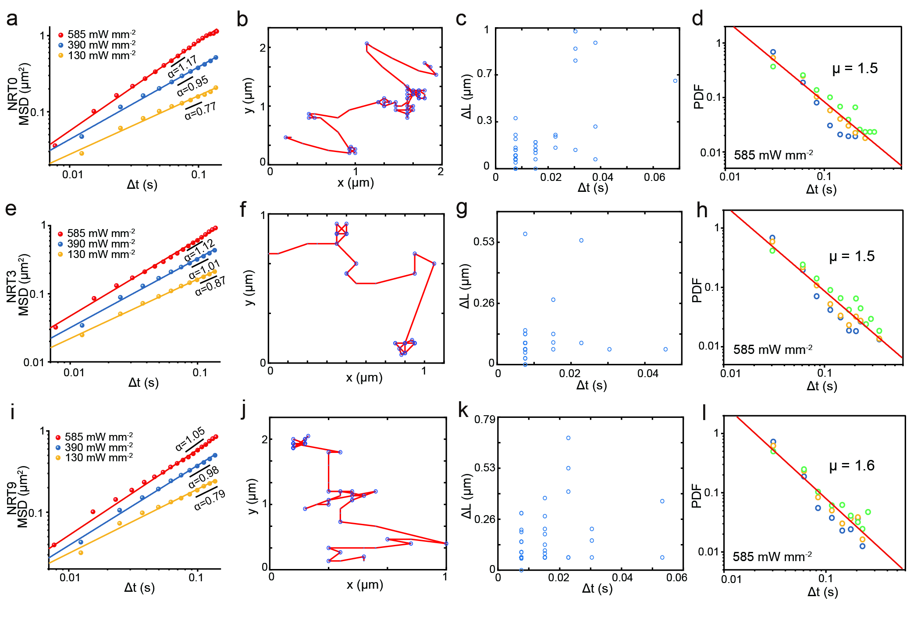
Figure S12. Lévy flights pattern of NRT0, NRT3 and NRT9. a, A log-log histogram of MSD as a function of Δt for NRT0. The values of α was 1.17, 0.95, and 0.77 at light intensities of 585 mW mm⁻², 390 mW mm⁻², and 130 mW mm⁻², respectively. b, A typical Lévy flights pattern of NRT0 with turning points (60 °) marked in blue at 585 mW mm⁻². c, The length of NRT0 flight segments as a function of its duration Δt. d, PDF of NRT0 waiting times between turns at 30 ° (blue), 60 ° (yellow), and 90 ° (green) under 585 mW mm⁻², with a power-law exponent μ = 1.5. e, A log-log histogram of MSD for NRT3 with slopes of 1.12, 1.01, and 0.87, respectively. f, A typical Lévy flights pattern of NRT3 with turning points marked in blue (60 °) at 585 mW mm⁻². g, The length of NRT3 flight segments as a function of its duration Δt. h, PDF of NRT3 waiting times between turns (30 °, 60 ° and 90 °) under 585 mW mm⁻², with a power-law exponent μ = 1.5. i, A log-log histogram of MSD verse Δt for NRT9 with the slope of 1.05, 0.98, and 0.79, respectively. j, A typical Lévy flights pattern of NRT9 with turning points (60 °) marked in blue at 585 mW mm⁻². k, The length of NRT9 flight segments as a function of its duration Δt. l, PDF of waiting times (Δt) for NRT9 at various turning angles (30°, 60°, 90°) under 585 mW mm⁻², with μ = 1.6. The results are obtained by averaging 10 sets of data.

2.17 The D of molecular swimmers with increasing molecular densities
Theoretically, molecular density can impact diffusion due to a higher probability of collisions at elevated concentrations. However, as seen in Figure S13, NRT0, NRT3 and NRT9 exhibit no significant concentration dependence within the tested range (0.4-1.2 molecules μm⁻²), as this range falls below the threshold where intermolecular collisions become statistically relevant. At these relatively low densities, the molecular swimmers predominantly function as isolated entities. To confirm this, we performed additional experiments at a higher concentration (>1.2 molecules μm⁻²), which, as demonstrated in Figure S13, results in a measurable increase in the diffusion coefficient.
Figure S13. The diffusion coefficient D of NRT0, NRT3 and NRT9 within 0.4-1.6 molecules µm⁻².

2.18 Effective TEMPO concentration calculation by matching the D of NRT with NR
The D of NRT0, NRT3, and NRT9 is equivalent to the D of NR at TEMPO concentrations of 1.607 mM, 0.826 mM, and 0.514 mM, respectively, which provides further evidence of NRT with greater self-propulsion compared to NR, under super-low fuel concentration.
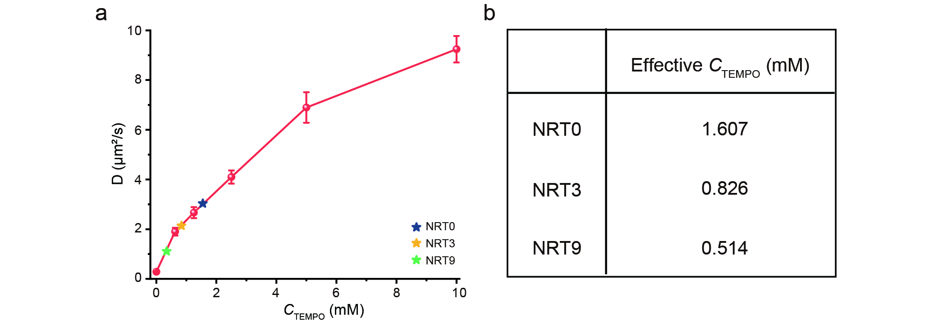
Figure S14. Estimation of effective TEMPO concentration by matching the D between NR and NRT. a, TEMPO concentration corresponding to NRT diffusion coefficient at the same light intensity as NR. The blue, yellow, and green stars represent NRT0, NRT3, and NRT9, respectively, with their corresponding TEMPO concentration requirements for NR. b, The table shows the specific corresponding TEMPO concentration.

2.19 Apparent TEMPO concentration calculation for NRT swimmers
The apparent concentration of TEMPO is estimated using the inverse of the volume of a sphere, with the NR molecule as its center and the distance L_{nt} between the NR molecule and TEMPO molecule as its radius. For NRT0, NRT3, and NRT9 swimmers with varying chain lengths, L_{nt} values of 13.5 Å, 21.2 Å, and 41.1 Å were obtained, respectively. By calculating the volumes of these spheres using V = 4/3πL_{nt}³, we determined V values to be 10306 Å³, 39911 Å³, and 290810 Å³ correspondingly. The apparent concentration can then be calculated as [TEMPO] = 1/(V N_{A}), resulting in apparent [TEMPO] of 161 mM for NRT0 swimmer, 41.6 mM for NRT3 swimmer, and 5.6 mM for NRT9 swimmer.
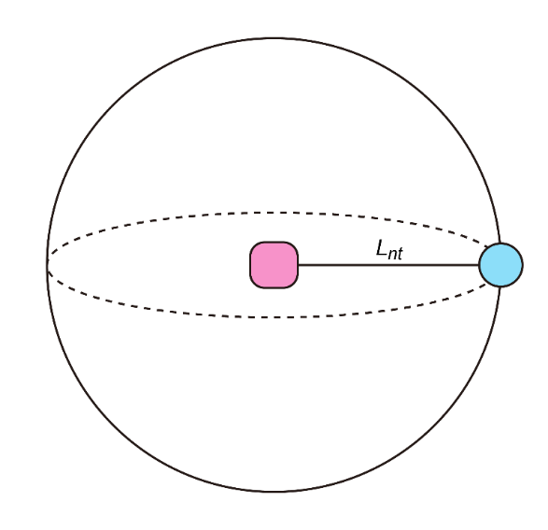
Figure S15. Sketch of the apparent TEMPO concentration estimation for a NRT swimmer.

2.20 Conformational analysis of molecular swimmers
Conformational search was conducted using Crest 3.0.2 for NRT0, NRT3, NRT9 and NR+TEMPO without the bridging linker (no linker) under unrestricted GFN-FF theory with GBSA implicit solvation for water. The lowest energy conformations were identified, and we used Orca 6.0.1 for further geometry optimization under unrestricted density functional theory (UDFT) for the doublet ground state and unrestricted time-dependent DFT (TDDFT) level of theory for the first doublet excited state, respectively. The density functional and the basis set were UB3LYP and def2svp, with the Grimme’s D3BJ empirical dispersion applied throughout the study. The CPCM continuum solvation was employed in DFT and TDDFT calculations to account for the water solvation, which are important for studying charge transfer states. The Hirshfeld atomic charge analysis was conducted to assign the charges to NR, TEMPO and the bridging linker to better understand the nature of the doublet ground states (D₀) and excited states (D₁) (details in Supplementary Information 2.21). Vesta was used for visualization of the frontier molecular orbitals and Avogadro was used for analyzing the conformation and interatomic distance between the NR and TEMPO moieties.
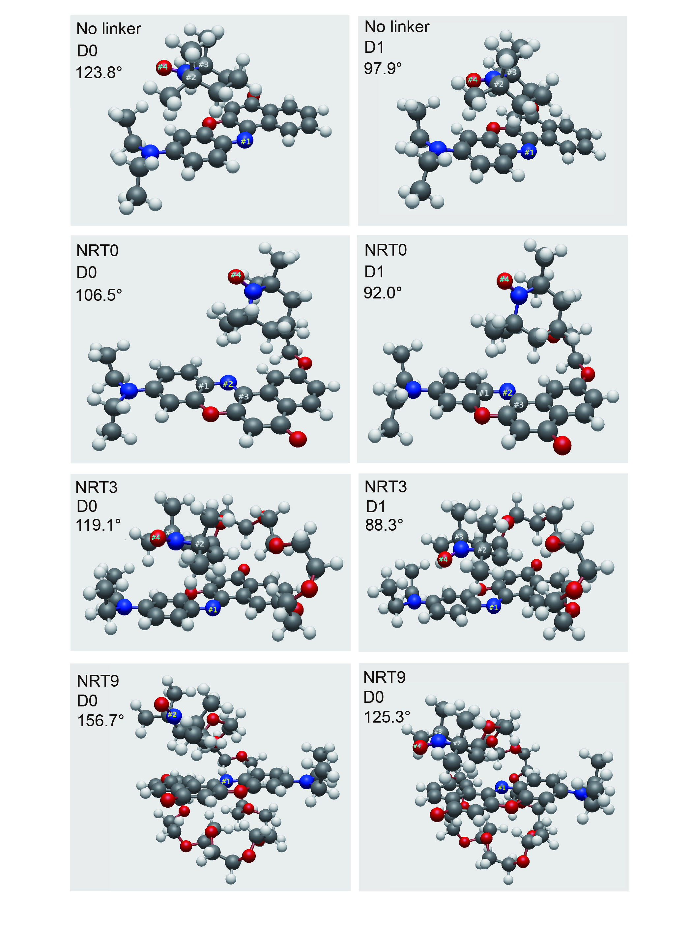
Figure S16. The dipolar exciplex formation of molecular swimmers. Dipolar exciplex formation of molecular swimmers. In the D₀ state, the dihedral angles for no linker, NRT0, NRT3 and NRT9 are 123.8°, 106.5°, 119.1° and 156.7°, respectively. In the D₁ state, these angles become 97.9°, 92.0°, 88.3° and 125.3°, respectively. The radial oxygen atom is oriented toward the NR moiety in the D₁ state, contrasting to its orientation away from NR in the D₀ state. NR and TEMPO are shown to form an exciplex due to the enhanced Coulomb attraction via charge transfer upon photoexcitation. Color of atom, H: white, C: gray, N: blue, O: red.

2.21 Electron density difference (EDD) maps of molecular swimmers
To investigate the charge transfer between the NR and TEMPO fragments, we carried out UDFT and TDDFT calculations for the D₀ and D₁ states, respectively. Hirshfeld atomic charge analysis revealed a pronounced electron density difference (D₁-D₀) between the fragments across structures with varying linker lengths. The D₀ is not a charge-transfer state and exhibits only weak electrostatic interaction, either slightly repulsive or attractive, between NR and TEMPO. In contrast, both the vertical and relaxed D₁ states are characterized as charge-transfer states, accompanied by a notably 1000-2000 enhanced electrostatic attraction. The electron density difference maps illustrate the electron depletion at TEMPO and accumulation at NR, further verified the electron transfer occurs from the TEMPO fragment to the NR fragment upon excitation to the D₁ state (Table S1 and Figure S17). Furthermore, the linker region retains minimal total charge and remains essentially unchanged upon excitation.
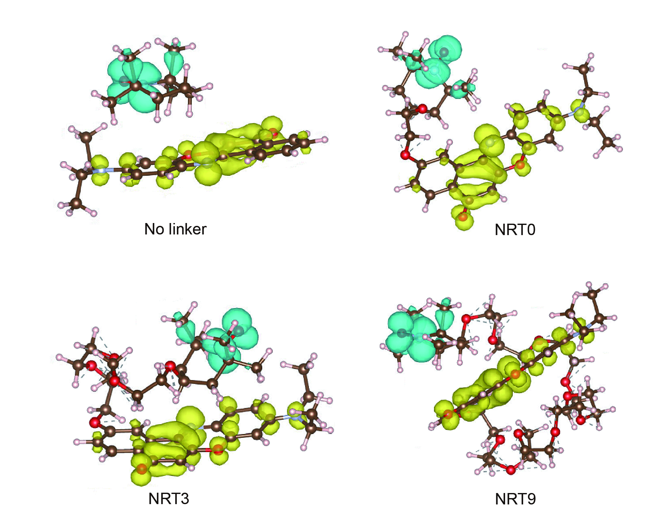
Figure S17. Electron density difference (D₁-D₀) at the ground state structure with no linker, NRT0, NRT3 and NRT9. Regions of higher electron density are indicated in yellow (negative potential), while blue denotes lower electron density (positive potential).
Table S1. Hirshfeld charge analysis of NRT
State/Charge | Nile Red | TEMPO | Linker
No linker C1 D₀ | 0.0568 | -0.0581 | N/A
No linker C1 Vertical D₁ | -0.9177 | 0.9164 | N/A
No linker C1 Relaxed D₁ | -0.9109 | 0.9108 | N/A
NRT0 C1 D₀ | 0.0209 | 0.0287 | -0.0501
NRT0 C1 Vertical D₁ | -0.9644 | 1.0110 | -0.0561
NRT0 C1 Relaxed D₁ | -0.9205 | 0.9785 | -0.0571
NRT3 C1 D₀ | 0.1259 | -0.0217 | -0.1048
NRT3 C1 Vertical D₁ | -0.8461 | 0.9316 | -0.1141
NRT3 C1 Relaxed D₁ | -0.8157 | 0.9157 | -0.1061
NRT9 C1 D₀ | 0.1443 | -0.0480 | -0.1553
NRT9 C1 Vertical D₁ | -0.8218 | 0.9389 | -0.1602
NRT9 C1 Relaxed D₁ | -0.7559 | 0.8812 | -0.1254

2.22 The dipole moment of NR and NR+TEMPO
NR (1 mM in DMSO) and TEMPO (100 mM in ethanol) were prepared. Ethanol (EtOH) and DMSO were blended volumetrically to generate solvent mixtures. NR was diluted to 0.05 mM in all solvent mixtures, with parallel samples containing 5 mM TEMPO. The Stokes shift (Δν, cm⁻¹) was calculated as:
$$Δv=\frac{{10}^{7}}{λ_{abs}-λ_{em}}.$$ | (S21)
Solvent orientation polarizability Δf was computed for each blend using dielectric constants (ε) and refractive indices (n):
$$Δf=\frac{ε-1}{2ε+1}-\frac{n^{2}-1}{2n^{2}+1}.$$ | (S22)
Linear regression of Δv versus Δf yielded the slope for NR with or without TEMPO. The change in dipole moment (Δμ) between ground and excited states was derived as:
$$Δv=\frac{2}{hc}\left(\frac{ε-1}{2ε+1}-\frac{n^{2}-1}{2n^{2}+1}\right)\frac{{\left(u_{E}-u_{G}\right)}^{2}}{a^{3}},$$ | (S23)
where h = 6.626×10⁻²⁷ is Planck constant, c = 2.9979×10¹⁰ cm s⁻¹ is the speed of light, and α = 0.5 nm is the radius of the cavity in which the fluorophore resides. The slope from the Lippert-Mataga plot is 26162 (NR+TEMPO) and 17756 (NR) cm⁻¹. The Lippert-Mataga plot of these two systems are shown in Figure S18. Change in dipole moment for NR+TEMPO is greater than pure NR. NR with TEMPO further increases the charge separation in the excited state¹⁹.
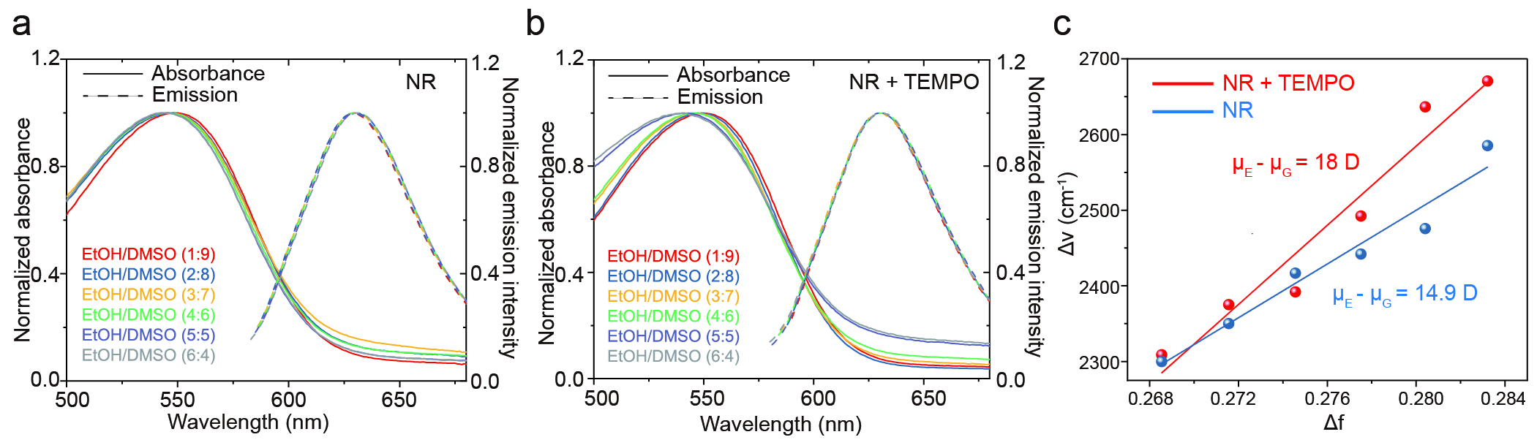Figure S18. Lippert plots for NR and NR with 5 mM TEMPO in ethanol-DMSO mixtures. a, Absorption and fluorescence emission spectra of NR in different solution mixture (volume by volume, v:v). b, Absorption and fluorescence emission spectra of NR with TEMPO in different solution mixture (v:v). c, Lippert-Mataga plot of the observed stokes shift (in wavenumbers) as a function of the solvent orientation polarizability Δf.

2.23 Molecular dynamics simulation for molecular swimmer in aqueous solution
The structures of the studied systems NR and TEMPO with a linker were optimized with DFT at the UB3LYP/6-31G(d, p) level of theory. In the MD simulations, the system was represented by two particles that are connected with a harmonic bond on the centers of the mass of the molecules. The particles interact with the explicit surrounding water molecules and diffuse in the water solvent, while intra-molecular forces drive the internal relaxation of the molecules. The non-bonded water-water and water-particle interactions are simulated with Lennard-Jones potential for Van der Waals interactions and periodic Coulomb potential for electrostatic interactions.
$E_{\text{nonb}}=E_{\text{vdw}}+E_{\text{cou}}$ (S24)
$E_{\text{vdw}}=\sum_{ij}{4ϵ_{ij}\left[{\left(\frac{σ_{ij}}{r_{ij}}\right)}^{12}-{\left(\frac{σ_{ij}}{r_{ij}}\right)}^{6}\right]}$ (S25)
$$E_{\text{cou}}=\frac{1}{2}k_{\text{e}}\sum_{ij}{\sum_{\text{n}}{\frac{Q_{i}Q_{j}\text{erfc}\left(αr_{ij,\text{n}}\right)}{r_{ij,\text{n}}}}}+\frac{k_{\text{e}}}{2πV}\sum_{k≠0}{\frac{\text{exp}\left(-{\left(\frac{πk}{α}\right)}^{2}\right)}{k^{2}}\sum_{ij}{Q_{i}}}Q_{j}\text{exp}\left(2π\text{i}k\left(x_{i}-x_{j}\right)\right)-k_{\text{e}}\frac{α}{\sqrt{π}}\sum_{j}{Q_{j}^{2}.}$$
(S26)
The TDDFT calculations revealed a significant amount of charge transfer from TEMPO to NR in the excited states, whereas the charge transfer is negligible in the ground states. Three charge distributions in the particles have been proposed to mimic the experimental scenario: a) when the lights are off, and the two particles stay in the ground states, the particles remain neutral ($Q_{\text{N}}=Q_{\text{T}}=0$). When the lights are turned on to excite the particles, b) the de-excitation is not permitted and the charge transfer amount is fixed during the simulations ($Q_{\text{N}}={-Q}_{\text{T}}=Q_{\text{ex}}$), and c) both the de-excitation and periodic excitation are simultaneously enabled to yield a time-dependent charge transfer as follows:
$Q_{\text{N}}=-Q_{\text{T}}=Q\left(t+nT_{\text{ex}}\right)=\left\{\begin{aligned}\frac{1}{2}Q_{\text{ex}}\left(\text{COS}\left(πt/T_{\text{dex}}\right)+1\right), &t≤T_{\text{dex}} \\ 0, &t>T_{\text{dex}}\end{aligned}\right.$, (S27)
where $Q_{\text{ex}}$ represents the excitation charge transfer obtained from TD-DFT calculations. $T_{\text{ex}}$ and $T_{\text{dex}}$ refer to the excitation period and de-excitation lifetime, respectively. The model parameters have been tuned to match the experimental diffusion slopes under no photoexcitation.
The isothermal-isobaric (NPT) ensemble MD simulation with Langevin thermostat and Monte Carlo Barostat was carried out for a 1-nanosecond (ns) to maintain the temperature of 298.15 Kelvin and the pressure of 1 Bar. After the equilibration run, 10003-ns canonical ensemble (NVT) MD simulations were carried out for each charge distribution setting. To ensure a smooth time-dependent charge variation, the time step was set to be 1 femtosecond. The time evolution of atoms is driven by an acceleration that superimposes both the particle acceleration vector of the center of mass and the internal acceleration vector of molecular forces.
Figure S19. The MD simulation of NRT3. The PDF of NRT3 with zero charge (red), fixed charge (green), and charge/discharge cycles (blue) was calculated and plotted at a time interval of 0.5 ns. Notably, the molecule with charge/discharge cycle displayed an enhanced diffusion phenomenon through its interaction with H₂O molecules.

2.24 Step size of the NR molecule driven by photons
By calculating the ratio of light intensity to the energy of a single photon, we can determine the total number of photons emitted within the laser spot per second, denoted as N_{photon} = ΔIS/E_{photon}, where S = 9×10⁻⁹ m² is the laser spot area and E_{photon} = 3.7 ×10⁻¹⁹ J represents the energy carried by an individual photon. Consequently, the total number of photons (N_{photon}) was divided by the total number of NR molecules within the laser spot on the bilayer, yielding the absorption rate of photons per NR molecule per second
 | $\frac{dN_{photon}}{dN}=\frac{N_{photon}}{Sn_{s}}$ = $\frac{ΔI}{E_{photon}n_{s}}$. | (S28)
When the light intensity ΔI is 4.7×10⁻³ W m⁻², the NR molecular exhibited a velocity of approximately 18.0 μm s⁻¹ and 5.7 μm s⁻¹ with TEMPO and without TEMPO, respectively. With the values of I and S, we obtained dN_{photon}/dN = 2.6×10⁴ photon number molecule⁻¹. This indicates each NR molecule absorbs ~ 26,000 photons per second under the experimental conditions. Here, we estimated the active velocity by the square root of the difference of two squares of the velocity of NR with TEMPO and without TEMPO, getting u_{swim} ≈ 17 μm s⁻¹. The step size of NR for each photon is given by u_{swim}dN/dN_{photon} ≈ 0.6 nm.

2.25 Diffusion model of cell membrane permeability
A sample theoretical model was built to quantitively describe the diffusion process of DAPI into cell nucleus. As shown in Figure S20a, DAPI molecules are required to traverse the cell membrane to access cytoplasm, and subsequently, they need to get across the nuclear membrane to reach the nucleus. In this model, c₀, $c_{c}$ and $c_{n}$ represent the concentrations of DAPI external to the cell membrane, within the cytoplasm, and within the cell nucleus. According to the Fick's second law¹⁷, the mass flux of DAPI within the cytoplasm is equated to the mass transport from the extracellular environment across the cell membrane into the cytoplasm, minus the mass transport from the cytoplasm to the nucleus, given by
 | ${\dot{m}}_{c}={\dot{c}}_{c}V_{c}=KS_{m}\left[c_{0}-c_{c}\left(t\right)\right]-D_{n}S_{n}\left[\frac{c_{c}\left(t\right)-c_{n}\left(t\right)}{λ}\right]$, | (S29)
where ${\dot{m}}_{c}$ and ${\dot{c}}_{c}$ are the mass flux, concentration flux of DAPI in the cytoplasm, $V_{c}$ is the volume of the cytoplasm, K and S_{m} are the permeability and the surface area of the cell membrane, D_{n} is the diffusion coefficient of DAPI in the nucleus membrane, S_{n} is the surface area of the nuclear pore on the nucleus membrane and $λ$ is radius of the nucleus. In addition, the mass flux of DAPI in the nucleus is equal to the mass change from the cytoplasm to the nucleus, given by
 | $${\dot{m}}_{n}={\dot{c}}_{n}V_{n}=D_{n}S_{n}\left[\frac{c_{c}\left(t\right)-c_{n}\left(t\right)}{λ}\right].$$ | (S30)
Given the initial conditions $c_{c}\left(0\right)=0$ and $c_{n}\left(0\right)=0$, c₀ was treated as a constant. Subsequently, the value of K was determined by numerically resolving Equations S29 and S30, and fitting the DAPI fluorescent intensity exhibited in Figure 4g in the manuscript. The corresponding fitting parameters are provided in Table S2.
Figure S20. Diffusion model of DAPI permeability. a, The scheme of diffusion model of DAPI. b, Permeability coefficient (K) as a function of light intensity, exhibiting a slope of 0.5.
Table S2. Fitting parameters in the Diffusion model of DAPI into cell nucleus
I (mW mm⁻²) | 0 | 1 | 2 | 4
K (m s⁻¹) | 5.1e-10 | 8.5e-10 | 1.37e-09 | 1.78e-09
I (mW mm⁻²) | 8 | 12 | 16 | 20
K (m s⁻¹) | 2.29e-09 | 2.57e-09 | 3.04e-09 | 3.52e-09
S_{m} (m²) | 1e-9
S_{n} (m²) | 1e-12
V_{c} (m³) | 4e-15
D_{n} (m² s⁻¹) | 2.5e-12
V_{n} (m³) | 4e-15
λ (m) | 1e-6

2.26 Cell necroptosis of molecular swimmers
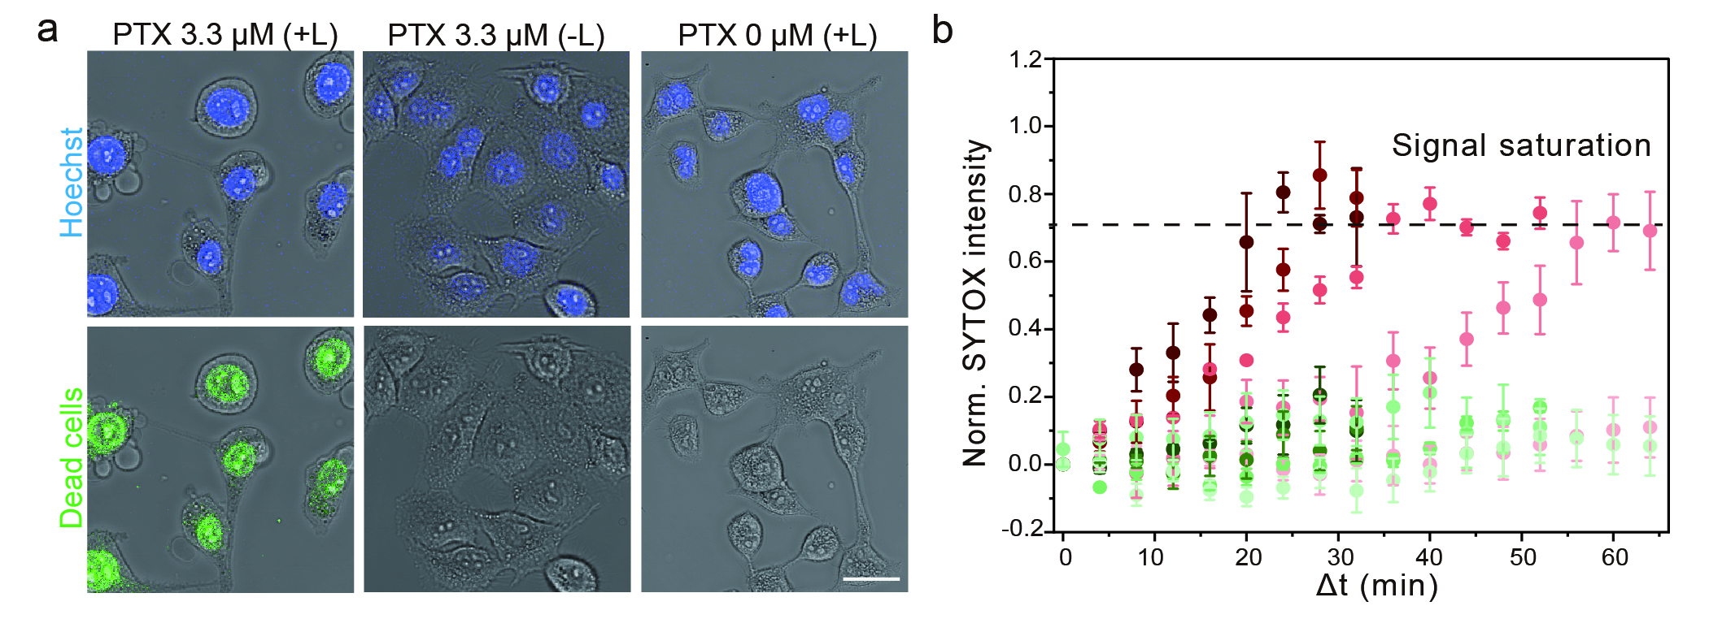
Figure S21. Cell necroptosis of molecular swimmer. a, HeLa cells images of Hoechst and SYTOX signals under three conditions: PTX with light, PTX without light, and light without PTX. Scale bar 30 µm. b, Comparison of the intracellular SYTOX signal evolution with various paclitaxel (PTX) dosages with (red) and without light (green) shows the enhanced efficacy due to molecular swimmer enhanced membrane permeability. The color gradient from light to dark represents an increasing PTX concentration from 0 to 6.6 μM.

2.27 Biocompatibility of molecular swimmers

Figure S22. The assessment of NRT9 biocompatibility in HeLa cells. The figure depicts the results of the CCK-8 experiment, showing the 24h-post cell viability of HeLa cells after incubation at a specific threshold concentration of NRT9.

2.28 The co-location of lipid droplet and NRT9
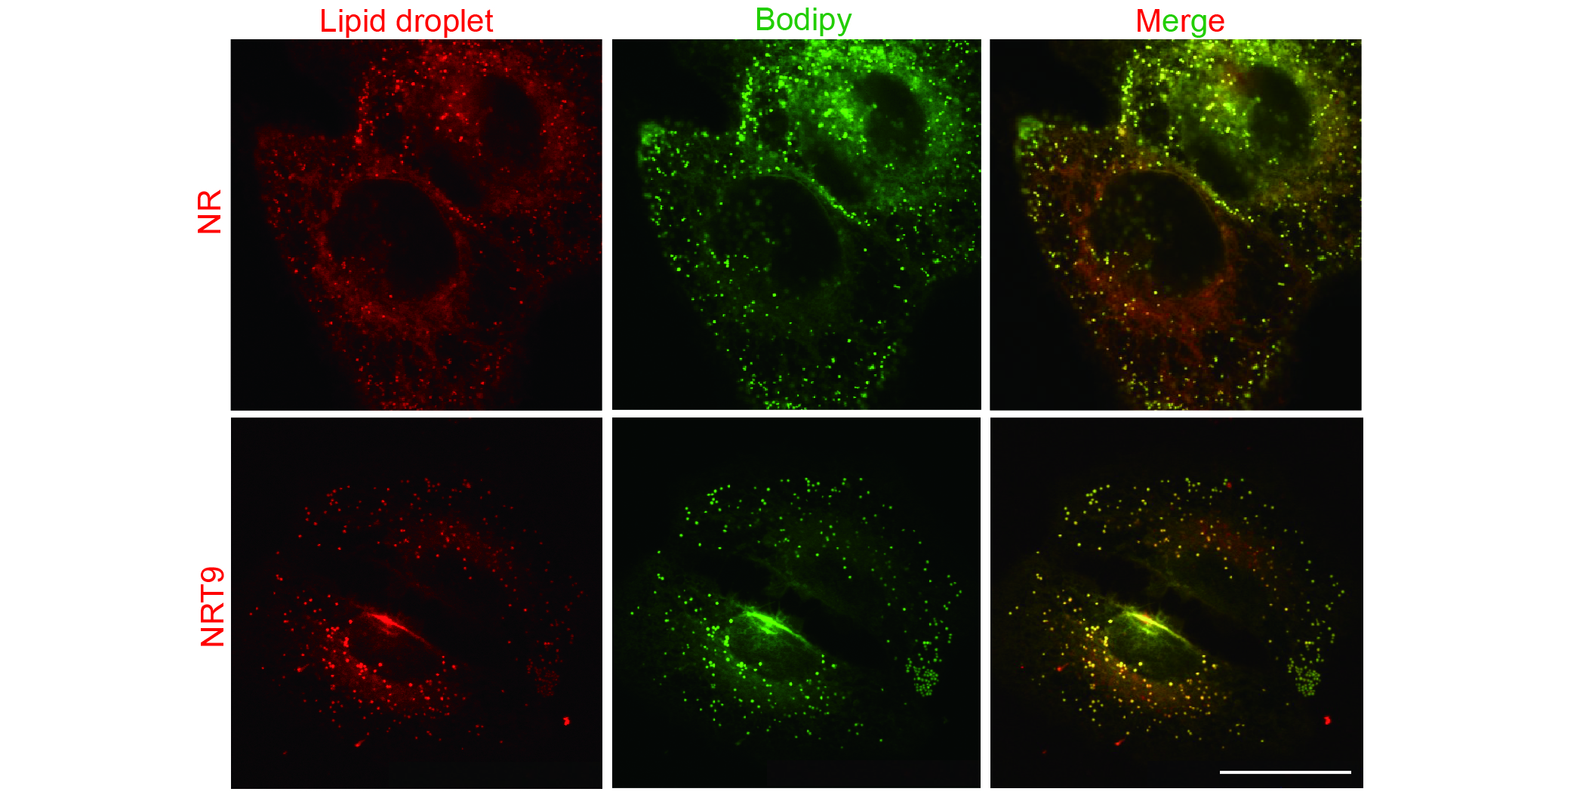
Figure S23. The stained organelles are identified as lipid droplets based on colocalization of Bodipy 493/503 signals with NR or NRT9. Scale bar 25 μm.

2.29 Lévy flights of LDs-NRT9
Applying the same approach as depicted in Figure S12, we examine the trajectories of LDs-NRT9 and LDs-NR, respectively. The MSD of LDs-NRT9 and LDs-NR were shown in Figure S24a, indicating that LDs-NRT9 displayed a more pronounced superdiffusive characteristic, with α = 1.25. Subsequently, trajectories of LDs-NRT9 were isolated with 60 ° turning points (Figure S24b). The variable speeds observed suggest Lévy flights over Lévy walks (Figure S24c). The PDF of LDs-NRT9 was computed with µ = 1.0, solidifying the Lévy flight pattern exhibited by LDs-NRT9 (Figure S24d).
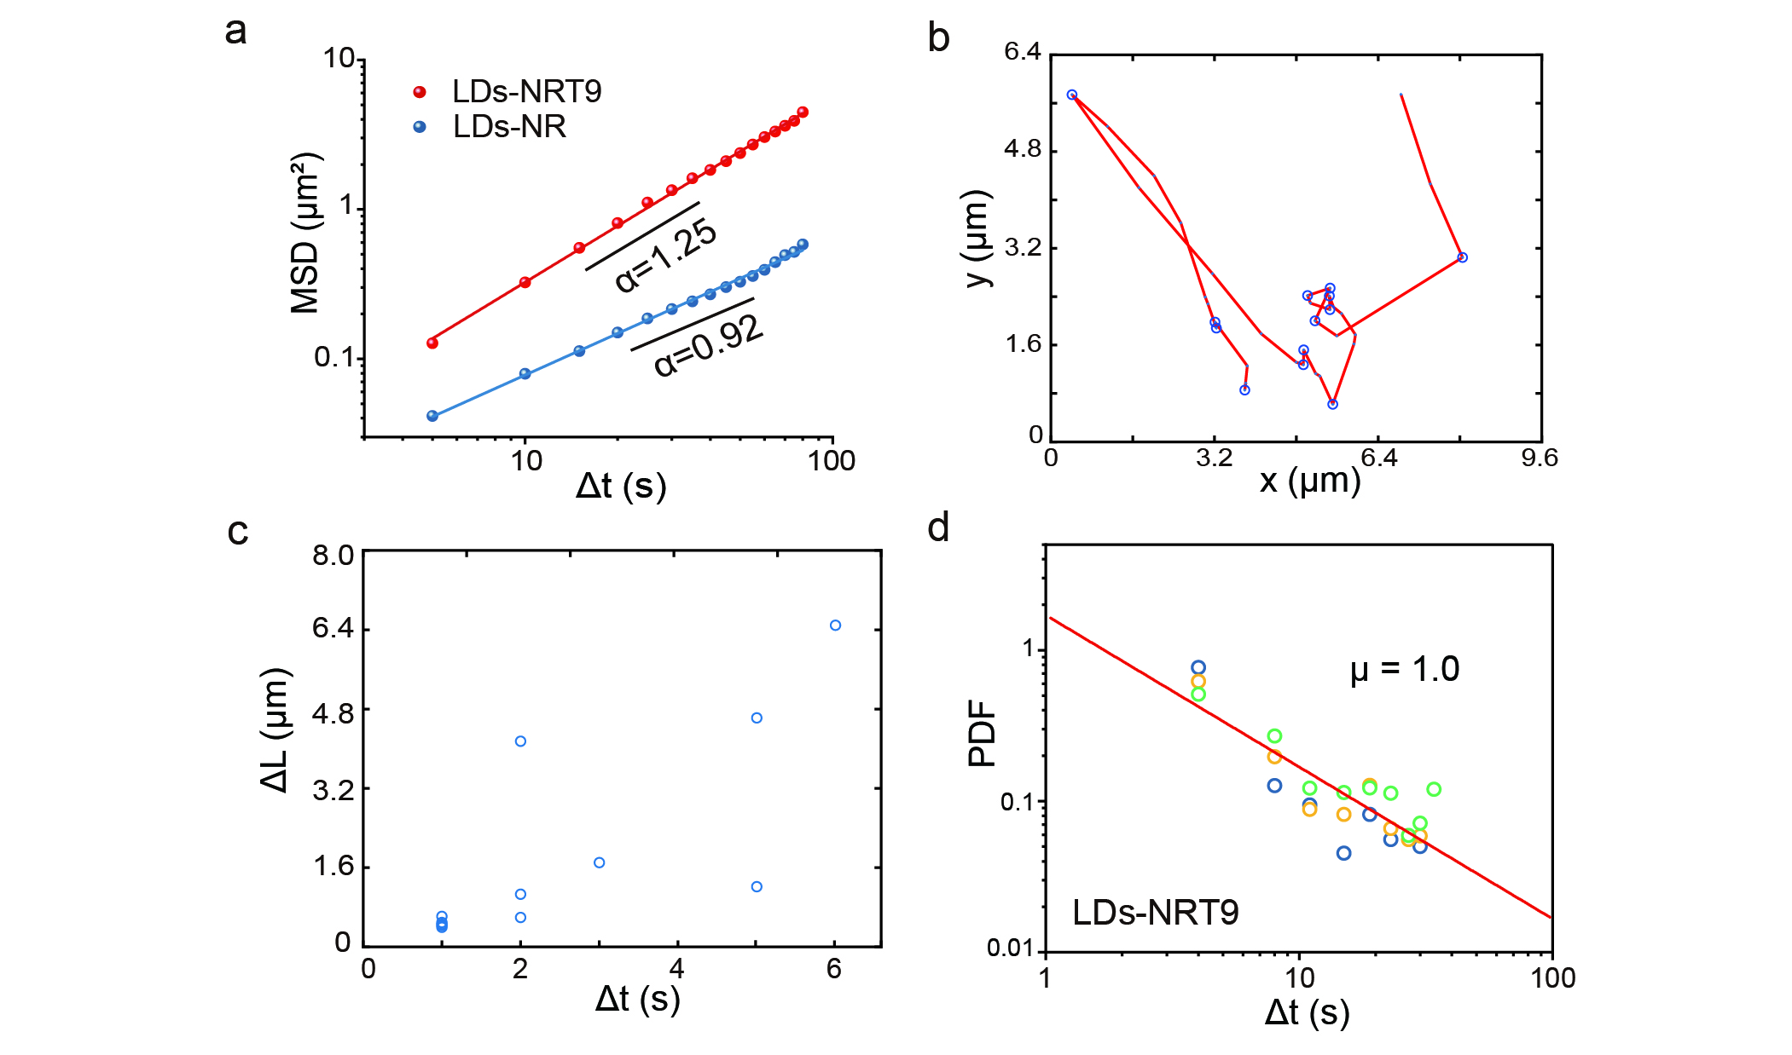
Figure S24. LDs-NRT9 exhibited Lévy flight behavior. a, Log-log histogram of MSD of LDs-NR and LDs-NRT9 with α of 0.92 and 1.25. b, A representative image of LDs-NRT9 trajectory with turning points (60 °) marked in blue under a light intensity of 8 mW mm⁻². c, The relationship between flight segment (ΔL) and duration time (Δt) of LDs-NRT9. The plot clearly demonstrates the variability in the speed of LDs-NRT9. d, Distribution of waiting times between turns for LDs-NRT9 at 30 ° (blue), 60 ° (yellow), and 90 ° (green), showing a power-law decay characterized by an exponent of μ = 1.0. Results represent the average of 10 data sets.

2.30 Molecular characterization
Compound 4 (n = 0)
¹H NMR (CDCl₃, 400 MHz, ppm): δ 8.23 (d, 1H, J = 8.7 Hz), 8.06 (s, 1H), 7.60 (d, 1H, J = 9.0 Hz), 7.20 (d, 1H, J = 6.9 Hz), 6.67 (d, 1H, J = 6.4 Hz), 6.47 (s, 1H), 6.31 (s, 1H), 4.52 (t, 2H, J = 6.1 Hz), 3.75 (t, 2H, J = 6.1 Hz), 3.48 (dd, 4H, J = 6.9, 14.0 Hz), 1.28 (t, 6H, J = 5.4 Hz). ¹³C NMR (CDCl₃, 100 MHz, ppm): 183.16, 171.22, 160.70, 152.14, 150.85, 146.90, 139.66, 134.10, 131.11, 127.94, 126.16, 124.73, 118.35, 109.63, 106.66, 105.28, 68.08, 45.11, 28.96, 12
.64. ESI-HRMS: calcd. for [M+H]⁺: 441.0736. Found: 441.0799.
Compound 4 (n = 3)
¹H NMR (CDCl₃, 400 MHz, ppm): δ 8.14 (d, 1H, J = 8.7 Hz), 8.00 (s, 1H), 7.53 (d, 1H, J = 9.0 Hz), 7.14 (d, 1H, J = 6.9 Hz), 6.58 (d, 1H, J = 6.4 Hz), 6.38 (s, 1H), 6.23 (s, 1H), 4.31 (t, 2H, J = 6.1 Hz), 4.20 (t, 2H, J = 6.0 Hz), 3.91 (t, 2H, J = 6.1 Hz), 3.64 (m, 10H) 3.45 (dd, 4H, J = 6.9, 14.0 Hz), 1.22 (t, 6H, J = 5.4 Hz). ¹³C NMR (CDCl₃, 100 MHz, ppm): 183.22, 171.07, 161.38, 152.05, 150.77, 146.78, 139.55, 134.10, 131.07, 127.64, 125.65, 124.69, 118.40, 109.63, 106.52, 105.32, 71.16, 70.86, 70.67, 70.60, 70.56, 70.53, 70.48, 45.06, 31.75, 12.61. ESI-HRMS: calcd. for [M+H]⁺: 573.1522. Found: 573.1586.
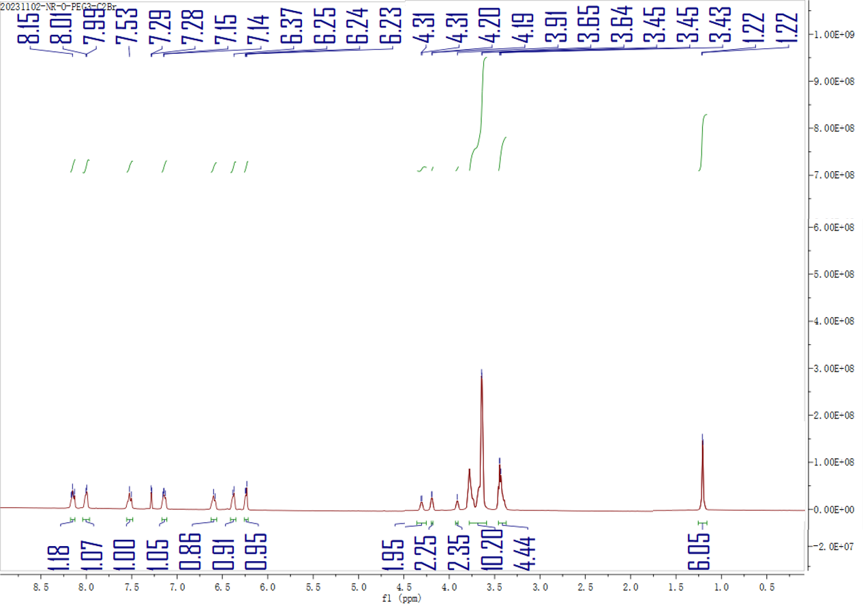
Compound 4 (n = 9)
¹H NMR (DMSO-d₆, 400 MHz, ppm): δ 8.05 (d, 1H, J = 8.7 Hz), 7.93 (d, 1H, J = 2.4 Hz), 7.46 (d, 1H, J = 9.0 Hz), 7.18 (d, 1H, J = 6.9 Hz), 6.72 (d, 1H, J = 6.4 Hz), 6.46 (d, 1H, J = 2.4 Hz), 6.05 (s, 1H), 4.30 (t, 2H, J = 6.1 Hz), 4.18 (t, 2H, J = 6.0 Hz), 3.92 (t, 2H, J = 6.1 Hz), 3.64 (m, 34H) 3.55 (dd, 4H, J = 6.9, 13.7 Hz), 1.25 (t, 6H, J = 5.3 Hz). ¹³C NMR (Actone-d₆, 100 MHz, ppm): 181.64, 170.11, 161.45, 151.79, 150.95, 146.63, 139.17, 133.95, 130.93, 127.27, 125.55, 124.23, 117.75, 109.67, 106.58, 104.47, 70.97, 70.64, 70.49, 70.47, 70.43, 70.39, 70.35, 70.33, 70.24, 70.22, 69.37, 68.79, 44.73, 31.13, 12.13. ESI-HRMS: calcd. for [M+H]⁺: 837.3095. Found: 837.3131.

Compound 5 (n = 0)
¹H NMR (CDCl₃, 400 MHz, ppm): δ 7.70 (d, 1H, J = 8.6 Hz), 7.59 (s, 1H), 6.78 (d, 1H, J = 8.7 Hz), 6.30 (dd, 1H, J = 3.6 Hz, 13.7), 6.22 (d, 1H, J = 7.2 Hz), 5.95 (s, 1H), 4.31 (t, 2H, J = 6.0 Hz), 3.77 (m, 3H), 3.37 (m, 4H), 1.62 (m, 2H), 1.42 (m, 2H) 1.10 (m, 18H). ¹³C NMR (CDCl₃, 100 MHz, ppm): 183.23, 159.48, 152.42, 151.09, 147.37, 139.48, 134.25, 131.44, 128.23, 127.34, 124.97, 119.50, 109.96, 105.45, 97.28, 96.46, 71.30, 68.08, 67.07, 61.67, 45.38, 43.67, 31.22, 12.85. ESI-HRMS: calcd. for [M+H]⁺: 533.2811. Found: 533.2841.

Compound 5 (n = 3)
¹H NMR (CDCl₃, 400 MHz, ppm): δ 7.69 (d, 1H, J = 8.5 Hz), 7.57 (s, 1H), 7.72 (d, 1H, J = 8.6 Hz), 6.78 (d, 1H, J = 6.9 Hz), 6.29 (d, 1H, J = 7.2 Hz), 6.21 (s, 1H), 5.94 (s, 1H), 4.30 (t, 2H, J = 5.9 Hz), 3.76 (m, 2H), 3.63 (m, 1H) 3.51 (s, 12H), 3.35 (m, 4H), 1.60 (m, 2H), 1.42 (m, 2H), 1.27 (m, 18H). ¹³C NMR (CDCl₃, 100 MHz, ppm): 180.69, 164.50, 158.42, 147.15, 145.36, 138.09, 143.25, 130.72, 128.72, 125.09, 119.90, 119.29, 113.73, 109.99, 106.80, 96.93, 71.38, 70.47, 70.18, 69.96, 67.87, 67.74, 61.69, 46.43, 44.76, 26.97, 13.00. ESI-HRMS: calcd. for [M+H]⁺: 665.3598. Found: 665.3567.

Compound 5 (n = 9)
¹H NMR (CDCl₃, 400 MHz, ppm): δ 7.71 (d, 1H, J = 8.5 Hz), 7.59 (s, 1H), 7.23 (d, 1H, J = 8.7 Hz), 6.79 (d, 1H, J = 7.0 Hz), 6.31 (d, 1H, J = 7.2 Hz), 6.22 (s, 1H), 5.95 (s, 1H), 4.31 (t, 2H, J = 5.7 Hz), 3.77 (t, 2H, J = 6.0 Hz), 3.52 (m, 37H), 3.36 (m, 4H), 1.65 (m, 2H), 1.40 (m, 2H), 1.28 (m, 18H). ¹³C NMR (CDCl₃, 100 MHz, ppm): 181.51, 165.31, 159.24, 147.96, 146.17, 138.90, 135.07, 131.53, 129.53, 125.90, 120.72, 120.11, 114.54, 110.80, 107.61, 97.74, 71.28, 70.99, 70.77, 68.68, 68.55, 62.50, 47.24, 45.57, 27.77, 13.81. ESI-HRMS: calcd. for [M+H]⁺: 929.5171. Found: 929.5195.

References
1 Ferhan, A. R. et al. Solvent-assisted preparation of supported lipid bilayers. Nat. Protoc. 14, 2091-2118 (2019).
2 Tinevez, J. Y. et al. TrackMate: An open and extensible platform for single-particle tracking. Methods 115, 80-90 (2017).
3 Hanser, F. et al. Nile Red-Based GPCR Ligands as Ultrasensitive Probes of the Local Lipid Microenvironment of the Receptor. ACS Chem. Biol. 16, 651-660 (2021).
4 Javanainen, M., Ollila, O. H. S. & Martinez-Seara, H. Rotational Diffusion of Membrane Proteins in Crowded Membranes. J. Phys. Chem. B 124, 2994-3001 (2020).
5 Regan, D. et al. Lipid Bilayer Thickness Measured by Quantitative DIC Reveals Phase Transitions and Effects of Substrate Hydrophilicity. Langmuir 35, 13805-13814 (2019).
6 Chandran, S. V. et al. Hydrodynamics of molecular rotors in lipid membranes. Phys. Rev. Fluids 10, L041101 (2025).
7 Kaiser, H. J. et al. Order of lipid phases in model and plasma membranes. Proc. Natl. Acad. Sci. U. S. A. 106, 16645-16650 (2009).
8 Gunderson, R. S. & Honerkamp-Smith, A. R. Liquid-liquid phase transition temperatures increase when lipid bilayers are supported on glass. Biochim. Biophys. Acta-Biomembr. 1860, 1965-1971 (2018).
9 Matsuzaki, T. et al. Simultaneous visualization of membrane fluidity and morphology defines adhesion signatures of cancer cells. Proc. Natl. Acad. Sci. U. S. A. 121, e2412914121 (2024).
10 Renne, M. F. & Ernst, R. Membrane homeostasis beyond fluidity: control of membrane compressibility. Trends Biochem.Sci. 48, 963-977 (2023).
11 Sakuma, Y., Kawakatsu, T., Taniguchi, T. & Imai, M. Viscosity Landscape of Phase-Separated Lipid Membrane Estimated from Fluid Velocity Field. Biophys. J. 118, 1576-1587 (2020).
12 Seu, K. J. et al. Effect of surface treatment on diffusion and domain formation in supported lipid bilayers. Biophys. J. 92, 2445-2450 (2007).
13 Zhang, Z. et al. Single-Molecule Tracking of Reagent Diffusion during Chemical Reactions. J. Am. Chem. Soc. 145, 10512-10521 (2023).
14 Xiang, L. et al. Single-molecule displacement mapping unveils nanoscale heterogeneities in intracellular diffusivity. Nat. Methods 17, 524-530 (2020).
15 Golestanian, R. Enhanced Diffusion of Enzymes that Catalyze Exothermic Reactions. Phys. Rev. Lett. 115, 108102 (2015).
16 "Quest Database™ Extinction Coefficient [Nile Red]." AAT Bioquest, Inc., 31 Aug. 2024, https://www.aatbio.com/resources/extinction-coefficient/nile_red.
17 Fick, A. On liquid diffusion. J. Membrane Sci. 100, 33-38 (1995).
18 Schlichting, H. & Gersten, K. Boundary-layer theory. Springer (2016).
19 Lakowicz, J. R. Principles of fluorescence spectroscopy. Springer US (2006).

