Supplementary Figure 1
Typical images of MRI risk factors
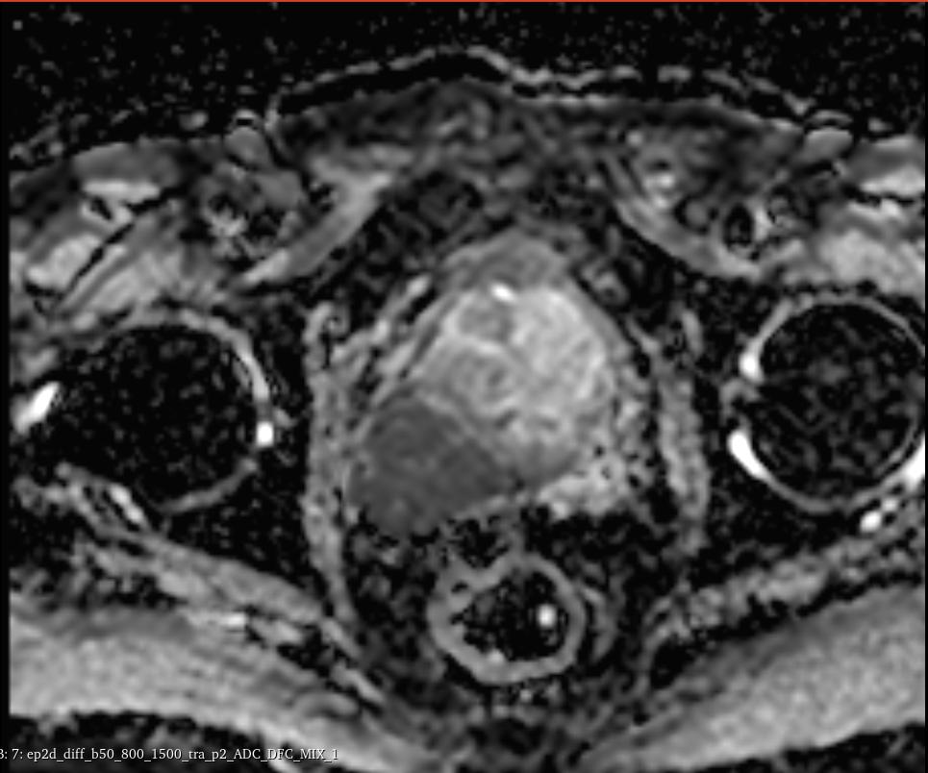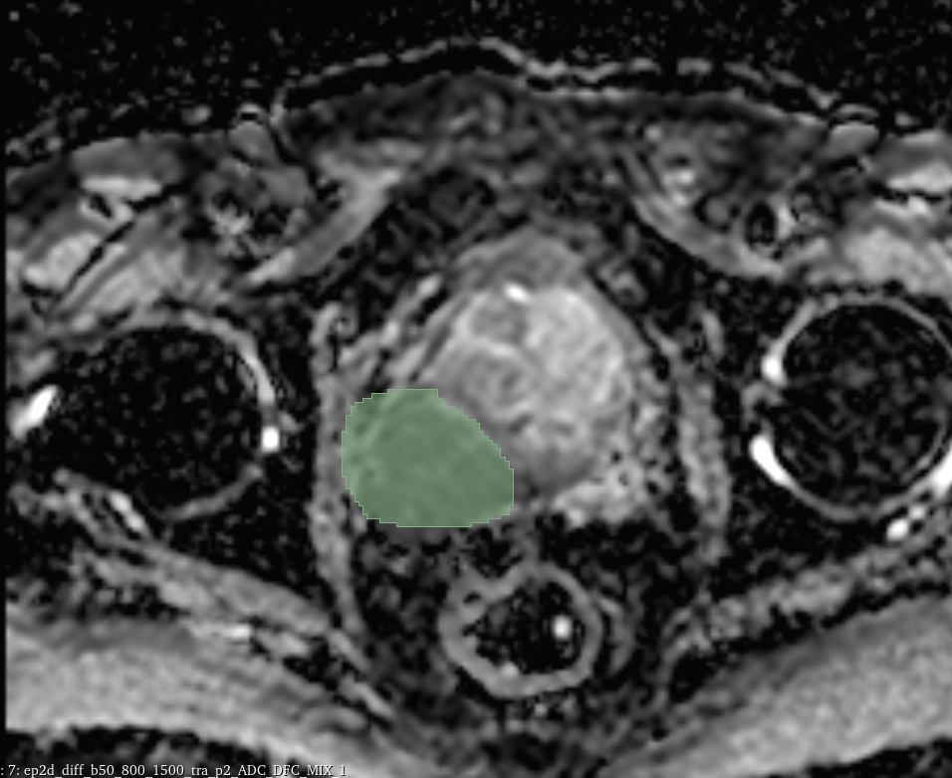
Supplementary Figure 1,SVI: seminal vesicle invasion
Supplementary Table 1. Detailed sequence parameters for prostate mpMRI
Parameters | T2WI | T1W1 | DWI
TR/TE (ms) | 3500/101 | 700/11 | 3500/90
Layer thickness (mm) | 3 | 3 | 3.5
Layer spacing (mm) | 0.3 | 0.3 | 0.3
Field of view (mm × mm) | 200×200 | 200×200 | 250×250
Matrix size | 256×256 | 192×116 | 192×192
Other | - | - | b values =50 -800-1500 s/mm2
T2WI, T2 weighted images; T1W1, T1 weighted images; DWI, diffusion-weighted imaging; mpMRI, multiparametric magnetic resonance imaging; TR, Repetition time; TE, Time echo

Supplementary Table 2. radiomics feature with ICC<0.75
Sequences | Features
ADC
  Feature
  original_shape_Maximum2DDiameterSlice
  original_shape_Maximum3DDiameter
  original_firstorder_Minimum
  original_gldm_LargeDependenceLowGrayLevelEmphasis
  original_gldm_LowGrayLevelEmphasis
  original_glrlm_LongRunLowGrayLevelEmphasis
  wavelet-LLH_gldm_LargeDependenceLowGrayLevelEmphasis
  wavelet-LLH_gldm_LowGrayLevelEmphasis
  wavelet-LLH_gldm_SmallDependenceLowGrayLevelEmphasis
  wavelet-LLH_glrlm_LongRunLowGrayLevelEmphasis
  wavelet-LLH_glrlm_LowGrayLevelRunEmphasis
  wavelet-LLH_glrlm_ShortRunLowGrayLevelEmphasis
  wavelet-LLH_glszm_LargeAreaLowGrayLevelEmphasis
  wavelet-LLH_glszm_LowGrayLevelZoneEmphasis
  wavelet-LLH_ngtdm_Busyness
  wavelet-LHL_gldm_LowGrayLevelEmphasis
  wavelet-LHL_gldm_SmallDependenceLowGrayLevelEmphasis
  wavelet-LHL_glrlm_LowGrayLevelRunEmphasis
  wavelet-LHL_glrlm_ShortRunLowGrayLevelEmphasis
  wavelet-LHL_glszm_LowGrayLevelZoneEmphasis
  wavelet-LHL_glszm_SmallAreaLowGrayLevelEmphasis
  wavelet-LHH_firstorder_Kurtosis
  wavelet-LHH_firstorder_Skewness
  wavelet-LHH_glszm_GrayLevelNonUniformityNormalized
  wavelet-HLH_firstorder_Skewness
  wavelet-HLH_glszm_SmallAreaLowGrayLevelEmphasis
  wavelet-HHL_firstorder_Mean
  wavelet-HHL_gldm_SmallDependenceLowGrayLevelEmphasis
  wavelet-HHL_glszm_SmallAreaLowGrayLevelEmphasis
  wavelet-HHH_firstorder_Kurtosis
  wavelet-HHH_firstorder_Mean
  wavelet-HHH_firstorder_Skewness
  wavelet-HHH_glcm_MCC
  wavelet-HHH_glszm_SmallAreaLowGrayLevelEmphasis
  wavelet-LLL_firstorder_Minimum
  wavelet-LLL_glcm_MaximumProbability
  wavelet-LLL_gldm_DependenceVariance
  wavelet-LLL_gldm_LargeDependenceLowGrayLevelEmphasis
  wavelet-LLL_gldm_LowGrayLevelEmphasis
  wavelet-LLL_glrlm_LongRunLowGrayLevelEmphasis
  wavelet-LLL_glrlm_LowGrayLevelRunEmphasis
  wavelet-LLL_glrlm_RunVariance
  wavelet-LLL_glrlm_ShortRunLowGrayLevelEmphasis
  wavelet-LLL_glszm_LargeAreaLowGrayLevelEmphasis

Supplementary Table 3. The Radiomics Quality Score (RQS)
Supplementary Table 3. The Radiomics Quality Score (RQS)
Criteria |  | Points | Methods | Score
1 | Image protocol quality - well-documented image protocols (for example, contrast, slice thickness, energy, etc.) and/or usage of public image protocols allow reproducibility/replicability | + 1 (if protocols are well-documented) | Imaging protocol is documented. | 1
1 |  | + 1 (if public protocol is used) | Imaging protocol is documented. | 1
2 | Multiple segmentations - possible actions are: segmentation by different physicians/algorithms/software, perturbing segmentations by (random) noise, segmentation at different breathing cycles. Analyse feature robustness to segmentation variabilities | + 1 | Image segmentation was firstly performed by by a MRI radiologists (Reader 1), and a total of 50 patients were randomly selected, their MRI images were dependently delineated again one month later by reader 1 and another senior radiologist to assess the inter- and intra-observer reproducibility | 1
3 | Phantom study on all scanners - detect inter-scanner differences and vendor-dependent features. Analyse feature robustness to these sources of variability | + 1 | 0 | 0
4 | Imaging at multiple time points - collect images of individuals at additional time points. Analyse feature robustness to temporal variabilities (for example, organ movement, organ expansion/ shrinkage) | + 1 | 0 | 0
5 | Feature reduction or adjustment for multiple testing - decreases the risk of overfitting. Overfitting is inevitable if the number of features exceeds the number of samples. Consider feature robustness when selecting features | - 3 (if neither measure is implemented) | The Mann‒Whitney U test, Spearman’s correlation analysis and Boruta feature selection was gradually performed for selecting robust radiomics features with intraclass correlation coefficient (ICC) ≥ 0.75. | 3
5 |  | + 3 (if either measure is implemented) |  | 3
6 | Multivariable analysis with non radiomics features (for example, EGFR mutation) - is expected to provide a more holistic model. Permits correlating/inferencing between radiomics and non radiomics features | + 1 | The radiomics signature generated by the best classifier was defined as a new feature set and further used to construct a combined model with the joint of independent clinical-MRI features. | 1
7 | Detect and discuss biological correlates - demonstration of phenotypic differences (possibly associated with underlying gene–protein expression patterns) deepens understanding of radiomics and biology | + 1 | Detect and discuss biological correlates | 1
8 | Cut-off analyses - determine risk groups by either the median, a previously published cut-off or report a continuous risk variable. Reduces the risk of reporting overly optimistic results | + 1 | The receiver operating characteristic (ROC) curves were plotted and the best cut-off point was obtained by maximizing the Youden index in the training dataset and applied in three validation datasets to reduce the risk of overfitting and reporting overly optimistic results. | 1
9 | Discrimination statistics - report discrimination statistics (for example, C-statistic, ROC curve, AUC) and their statistical significance  (for example, p-values, confidence intervals). One can also apply resampling method (for example, bootstrapping, cross-validation) | + 1 (if a discrimination statistic and its statistical significance are reported) | The area under the ROC curve (AUC) was calculated, the sensitivity, specificity and predictive accuracy were measured. The 95% confidence interval (CI) of the AUC was determined by the bootstrap resampling method with 1000 replicates. | 2
9 |  | + 1 (if a resampling method technique is also applied) |  | 2
10 | Calibration statistics - report calibration statistics (for example, Calibration-in-the-large/slope, calibration plots) and their statistical significance (for example, P-values, confidence intervals). One  can also apply resampling method (for example, bootstrapping, cross-validation) | + 1 (if a calibration statistic and its statistical significance are reported) | a calibration statistic and its statistical significance are reported and a resampling method technique is also applied | 2
10 |  | + 1 (if a resampling method technique is also applied) |  | 2
11 | Prospective study registered in a trial database - provides the highest level of evidence supporting the clinical validity and usefulness of the radiomics biomarker | + 7 (for prospective validation of a radiomics signature in an appropriate trial) | 0 | 0
12 | Validation - the validation is performed without retraining and without adaptation of the cut-off value, provides crucial information with regard to credible clinical performance | - 5 (if validation is missing) | Our study, validation is based on a dataset from the same institute. | 2
12 |  | + 2 (if validation is based on a dataset from the same institute) |  | 2
12 |  | + 3 (if validation is based on a dataset from another institute) |  | 2
12 |  | + 4 (if validation is based on two datasets from two distinct institutes) |  | 2
12 |  | + 4 (if the study validates a previously published signature) |  | 2
12 |  | + 5 (if validation is based on three or more datasets from distinct institutes) |  | 2
13 | Comparison to ‘gold standard’ - assess the extent to which the model agrees with/is superior to the current ‘gold standard’ method (for example, TNM-staging for survival prediction). This comparison shows the added value of radiomics | + 2 | 0 | 0
14 | Potential clinical utility - report on the current and potential application of the model in a clinical setting (for example, decision curve analysis). | + 2 | Decision curve analysis (DCA) was performed to estimate the clinical usefulness of the models at different threshold probabilities. | 2
15 | Cost-effectiveness analysis - report on the cost-effectiveness of the clinical application (for example, QALYs generated) | + 1 | 0 | 0
16 | Open science and data - make code and data publicly available. Open science facilitates knowledge transfer and reproducibility of the study | + 1 (if scans are open source) | The scans are open source. the region of interest segmentation is performed on the open source (ITK-SNAP). The radiomics features are defined and publically available via pyradiomics. The code will be made available upon acceptance of the paper. | 4
16 |  | + 1 (if region of interest segmentations are open source) |  | 4
16 |  | + 1 (if code is open source) |  | 4
16 |  | + 1 (if radiomics features are calculated on a set of representative ROIs and the calculated features and representative ROIs are open source) |  | 4
Total score of this study |  |  |  | 20/36

