Figure 1. FMR1 regulates gene expression in KGN cells
(A) RT-qPCR results comparing control and FMR1-overexpressing samples. Error bars represent mean ± SEM. ***P < 0.001.
(B) Western blot analysis confirming successful FMR1 overexpression.
(C) Principal component analysis (PCA) based on FPKM values of all detected genes in FMR1-overexpressing cells. The ellipse for each group represents the confidence ellipse.
(D) Volcano plot displaying all differentially expressed genes (DEGs) between overexpression (OE) and control (Ctrl) samples.
(E) Hierarchical clustering heatmap showing expression levels of all DEGs.

Figure 2. Validation of FMR1-regulated DEGs
(A) Scatter plot exhibiting the most enriched GO biological process results of upregulated (left panel) and downregulated (right panel) DEGs.
(B) Bar plot showing expression patterns and statistical differences for selected upregulated genes. Error bars represent mean ± SEM. ***P < 0.001.
(C) Bar plot showing expression patterns and statistical differences for selected downregulated genes. Error bars represent mean ± SEM. ***P < 0.001.

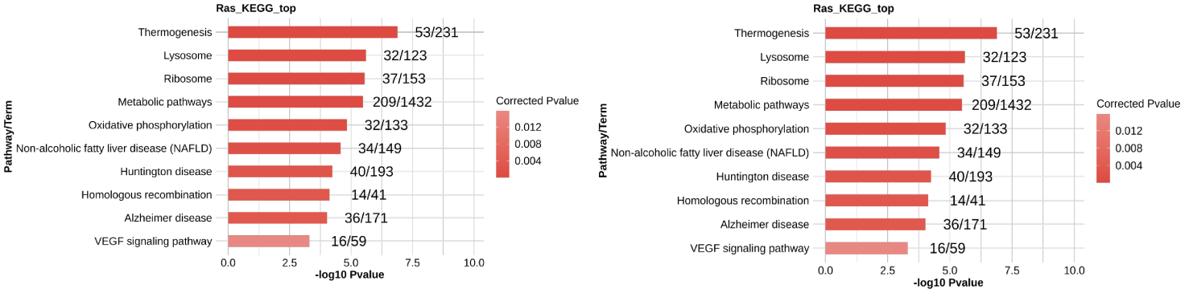

Supplementary Figure S1. KEGG pathway enrichment of FMR1-regulated DEGs
Bar plot exhibiting the top 10 most enriched KEGG pathways for upregulated (left panel) and downregulated (right panel) DEGs.

Figure 3. FMR1 regulates alternative splicing
(A) Bar plot showing the statistical distribution of FMR1-regulated alternative splicing events (RASEs) by event type.
(B) Venn diagram showing 208 overlapping genes between 2,300 RASGs (regulated alternative splicing genes) and 3,008 DEGs (differentially expressed genes), indicating dual-layer regulation by FMR1.
(C) Scatter plot exhibiting the most enriched GO biological process results of the 208 overlapping genes between RASGs and DEGs, highlighting enrichment in innate immune response, response to virus, and immune system processes.
(D) FMR1 regulates alternative splicing of CSF1. Left panel: IGV-sashimi plot showing regulated alternative splicing events and binding sites across mRNA. Reads distribution of RASE is plotted in the upper panel and transcripts are shown below. Right panel: Schematic diagrams depicting ASE structures with RT-qPCR validation shown at bottom. Error bars represent mean ± SEM. ***P < 0.001, **P < 0.01, *P < 0.05.
(E) FMR1 regulates alternative splicing of IRF7. Layout and annotations as in panel D.

Supplementary Figure S2. FMR1 regulates LAMC2 and IFI27 splicing
(A) FMR1 regulates alternative splicing of LAMC2. Left panel: IGV-sashimi plot showing regulated alternative splicing events and binding sites across mRNA. Reads distribution of RASE is plotted in the upper panel and transcripts are shown below. Right panel: Schematic diagrams depicting ASE structures with RT-qPCR validation shown at bottom. Error bars represent mean ± SEM. ***P < 0.001, **P < 0.01, *P < 0.05.
(B) FMR1 regulates alternative splicing of IFI27. Layout and annotations as in panel A.

