CXCR3⁺ LEF1^{low} NK cells cause immunopathological hepatic damage in MASH
Jiaqiang Bo ^{2, 3, #,} *, Jie Yang ^{3, 4, #}, Chen Li², Jia Zheng³, Jianzhong Song^{1,}*
1. Department of Pharmacy, Tumor Hospital Affiliated to Xinjiang Medical University, Urumqi, 8 830011, China
2. School of Life Science and Technology, Southeast University, Nanjing 211198, China.
3. School of Life Science and Technology, China Pharmaceutical University, Nanjing 211198, China.
4. State Key Laboratory of Natural Medicines and School of Life Science and Technology, China Pharmaceutical University, Nanjing 211198, China.
5. Department of Endocrinology, Nanjing Drum Tower Hospital, School of Life Science and Technology, China Pharmaceutical University, Nanjing 211198, China.
* Corresponding authors.
# Contributed equally to this work.
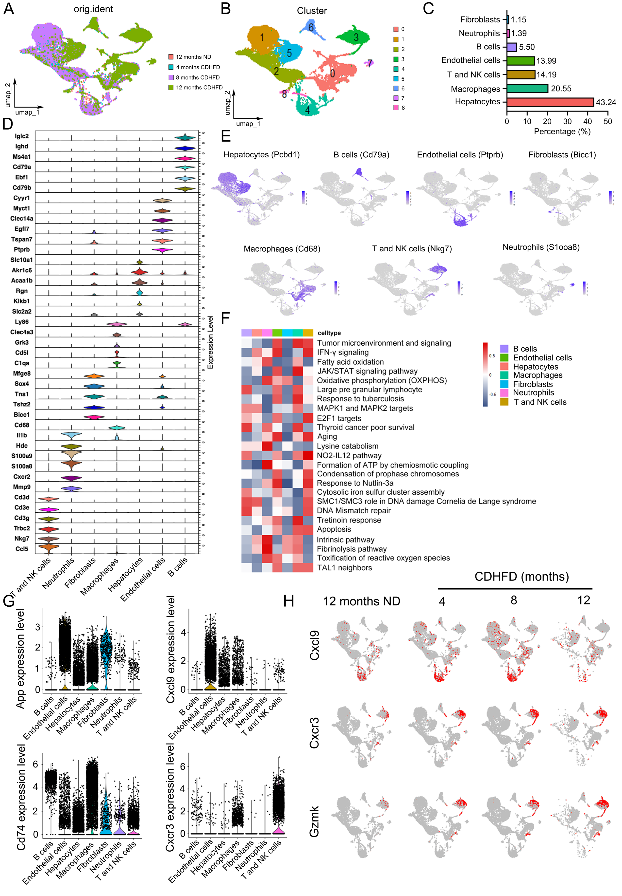
Figure S1. Single-cell RNA sequencing analysis reveals cell type composition, heterogeneity, and molecular features in the liver from MASH mouse.
A. Significant differences were observed in the liver cell population composition between the CDHFD group and the ND group mice. B. Umap plot showing unsupervised clustering of cells. All cells were classified into nine clusters based on their highly expressed, cluster-specific genes. C. Bar plot quantifying the percentage of major cell populations identified: Hepatocytes (43.24%), Macrophages (20.55%), T and NK cells (14.19%), Endothelial cells (13.99%), Neutrophils (11.39%), Fibroblasts (11.15%), and B cells (5.50%). D. The stacked violin plot shows the marker genes (top 6) that are highly expressed in each cellular subpopulation. E. Umap plots visualizing the spatial distribution of cells, annotated by major cell type using canonical marker genes. F. GSEA enrichment analysis of each cellular population. G. The violin plot shows the expression levels of App, Cd74, Cxcl9, and Cxcr3 in different cellular populations. H. The umap plot shows changes in the expression levels of Cxcl9, Cxcr3, and Gzmk in cellular populations across different samples. UMAP, uniform manifold approximation and projection; CDHFD, choline-deficient high-fat diet; ND, normal diet.
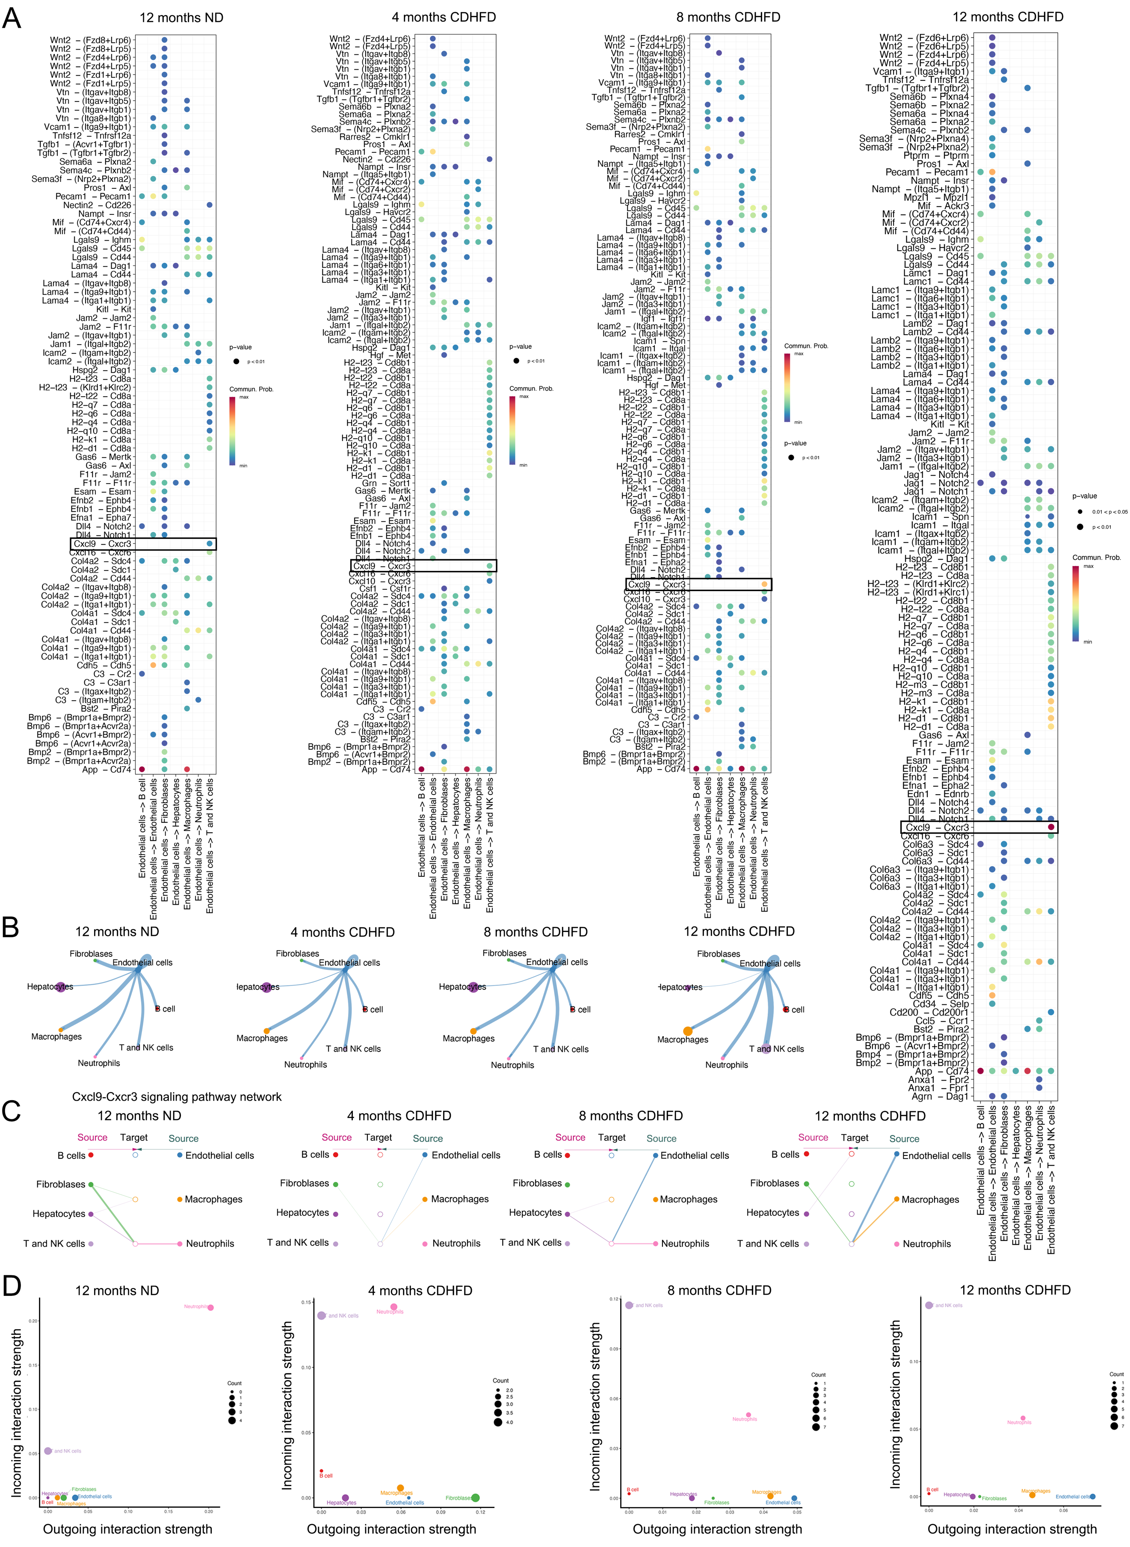
Figure S2. Analysis of cell-cell communication between endothelial and other cellular populations in MASH.
A. Ligand-receptor pairs mediating cell-cell communication between endothelial and other cellular populations. B. Communication strength analysis of endothelial and other cellular populations. C. outgoing interaction strength and incoming interaction strength across cellular subpopulations during MASH progression.
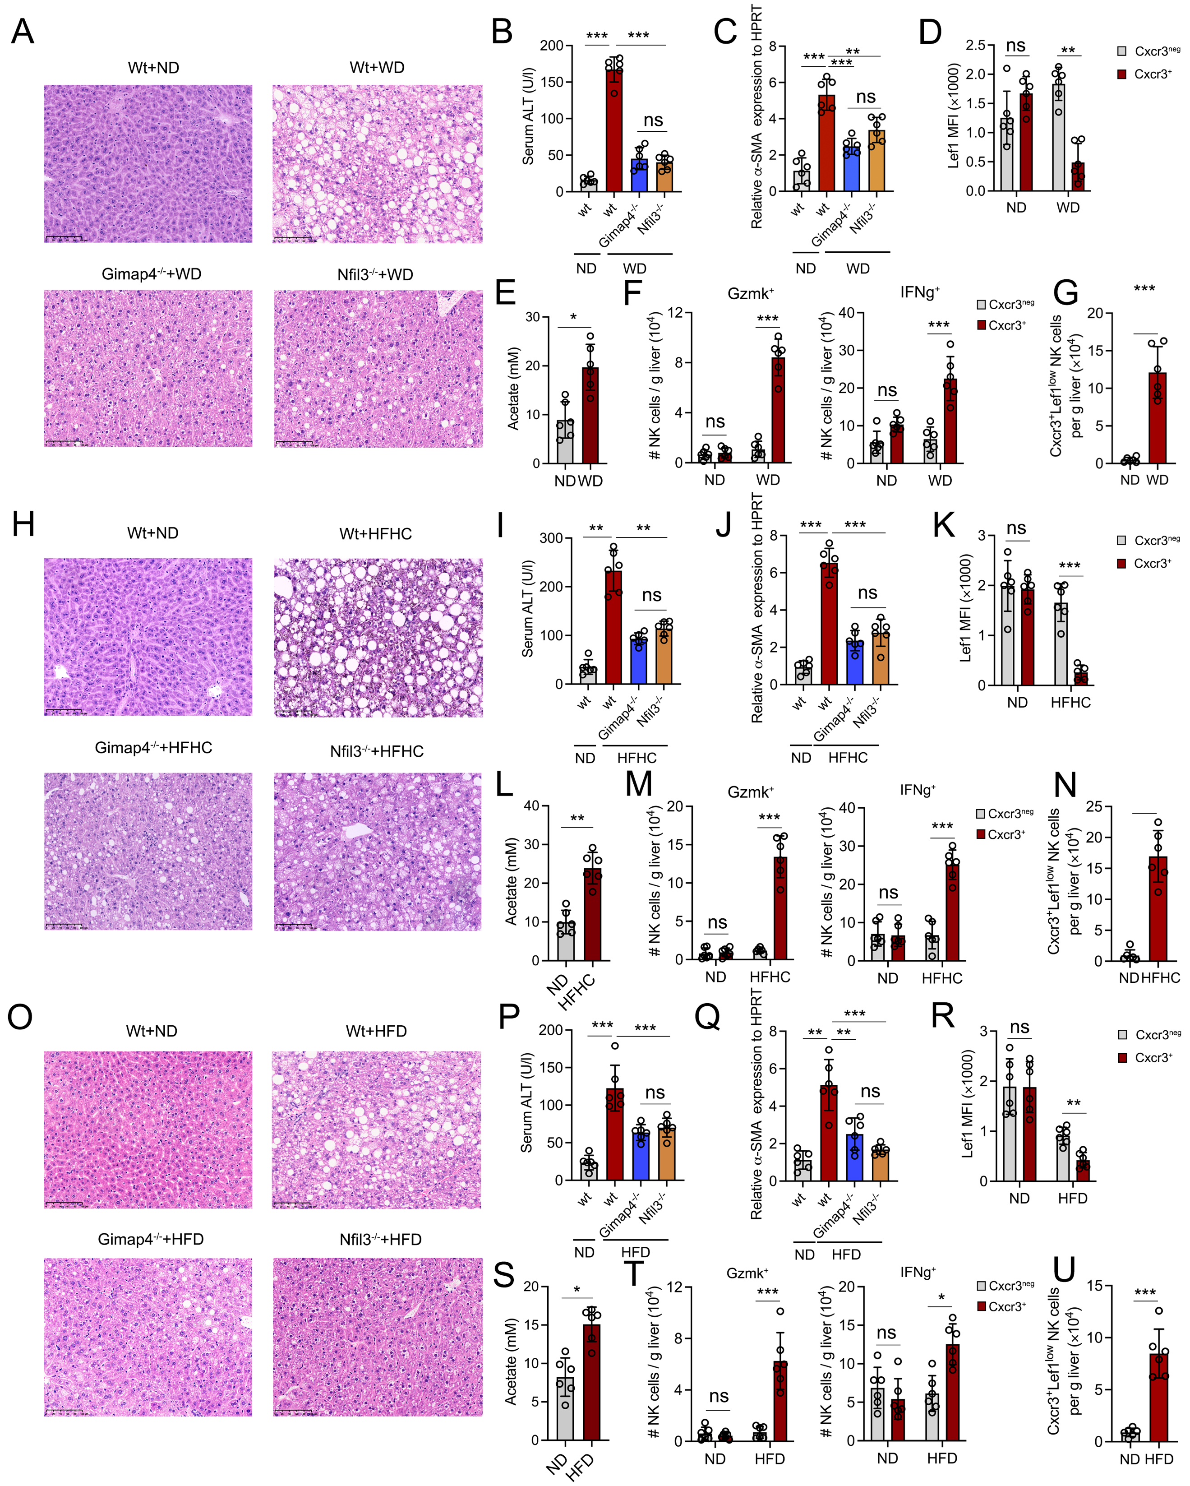
Figure S3. Cxcr3⁺ Lef1^{low} NK cells exhibit consistent functional mechanisms across WD diet-induced, HFHC diet-induced, and HFD diet-induced MASH models.
A. Representative images of mice liver sections stained with H&E in the mice from the ND and WD groups. Scale bar, 100 μm. B. Serum ALT levels in healthy mice and MASH mice induced by WD diet. C. α-SMA expression levels in the liver tissue of healthy mice and WD diet-induced MASH mice. D. Lef1 expression quantified by flow cytometry in liver tissue of WD-induced MASH mouse liver. E. Acetate levels in liver tissue from healthy mice and MASH mice induced by WD diet, n=6. F. The number of GZMK-positive and IFN-γ-positive NK cells in mouse liver tissue of the ND and WD groups. G. Number of Cxcr3⁺Lef1^{low}NK cells in the liver tissue of healthy mice and WD diet-induced MASH mice, n=6. H. Representative images of mice liver sections stained with H&E in the mice from the ND and HFHC groups. Scale bar, 50 mm. I. Serum ALT levels in healthy mice and MASH mice induced by HFHC diet. J. α-SMA expression levels in the liver tissue of healthy mice and MASH mice induced by HFHC diet. K. Lef1 expression quantified by flow cytometry in liver tissue of HFHC-induced MASH mouse. L. Acetate levels in liver tissue from healthy mice and MASH mice induced by HFHC diet，n=6. M. The number of GZMK-positive and IFNγ-positive NK cells in the liver tissue of healthy mice and MASH mice induced by the HFHC diet. N. Number of Cxcr3⁺Lef1^{low} NK cells in liver tissue of healthy mice and MASH mice induced by HFHC diet, n=6. O. Representative images of mice liver sections stained with H&E in the mice from the ND and HFD groups. Scale bar, 50 mm. P. Serum ALT levels in healthy mice and MASH mice induced by HFD. Q. α-SMA expression levels in the liver tissue of healthy mice and MASH mice induced by HFD. R. Lef1 expression quantified by flow cytometry in liver tissue of HFHC-induced MASH mouse. L. Acetate levels in liver tissue from healthy mice and MASH mice induced by HFD, n=6. S. Acetate levels in liver tissue from healthy mice and MASH mice induced by HFD，n=6. T. The number of GZMK-positive and IFNγ-positive NK cells in the liver tissue of healthy mice and MASH mice induced by the HFD. U. Number of Cxcr3⁺Lef1^{low} NK cells in liver tissue of healthy mice and MASH mice induced by HFD, n=6. *P < 0.05, **P < 0.01, ***P < 0.001. One-way ANOVA with Tukey’s multiple comparison test (B, C, I, J, P, Q). two-way ANOVA with Tukey’s multiple comparison test (D, F, K, M, R, T). unpaired two-tailed t-test (E, G, L, N, S, U). All data are presented as mean ± SEM.
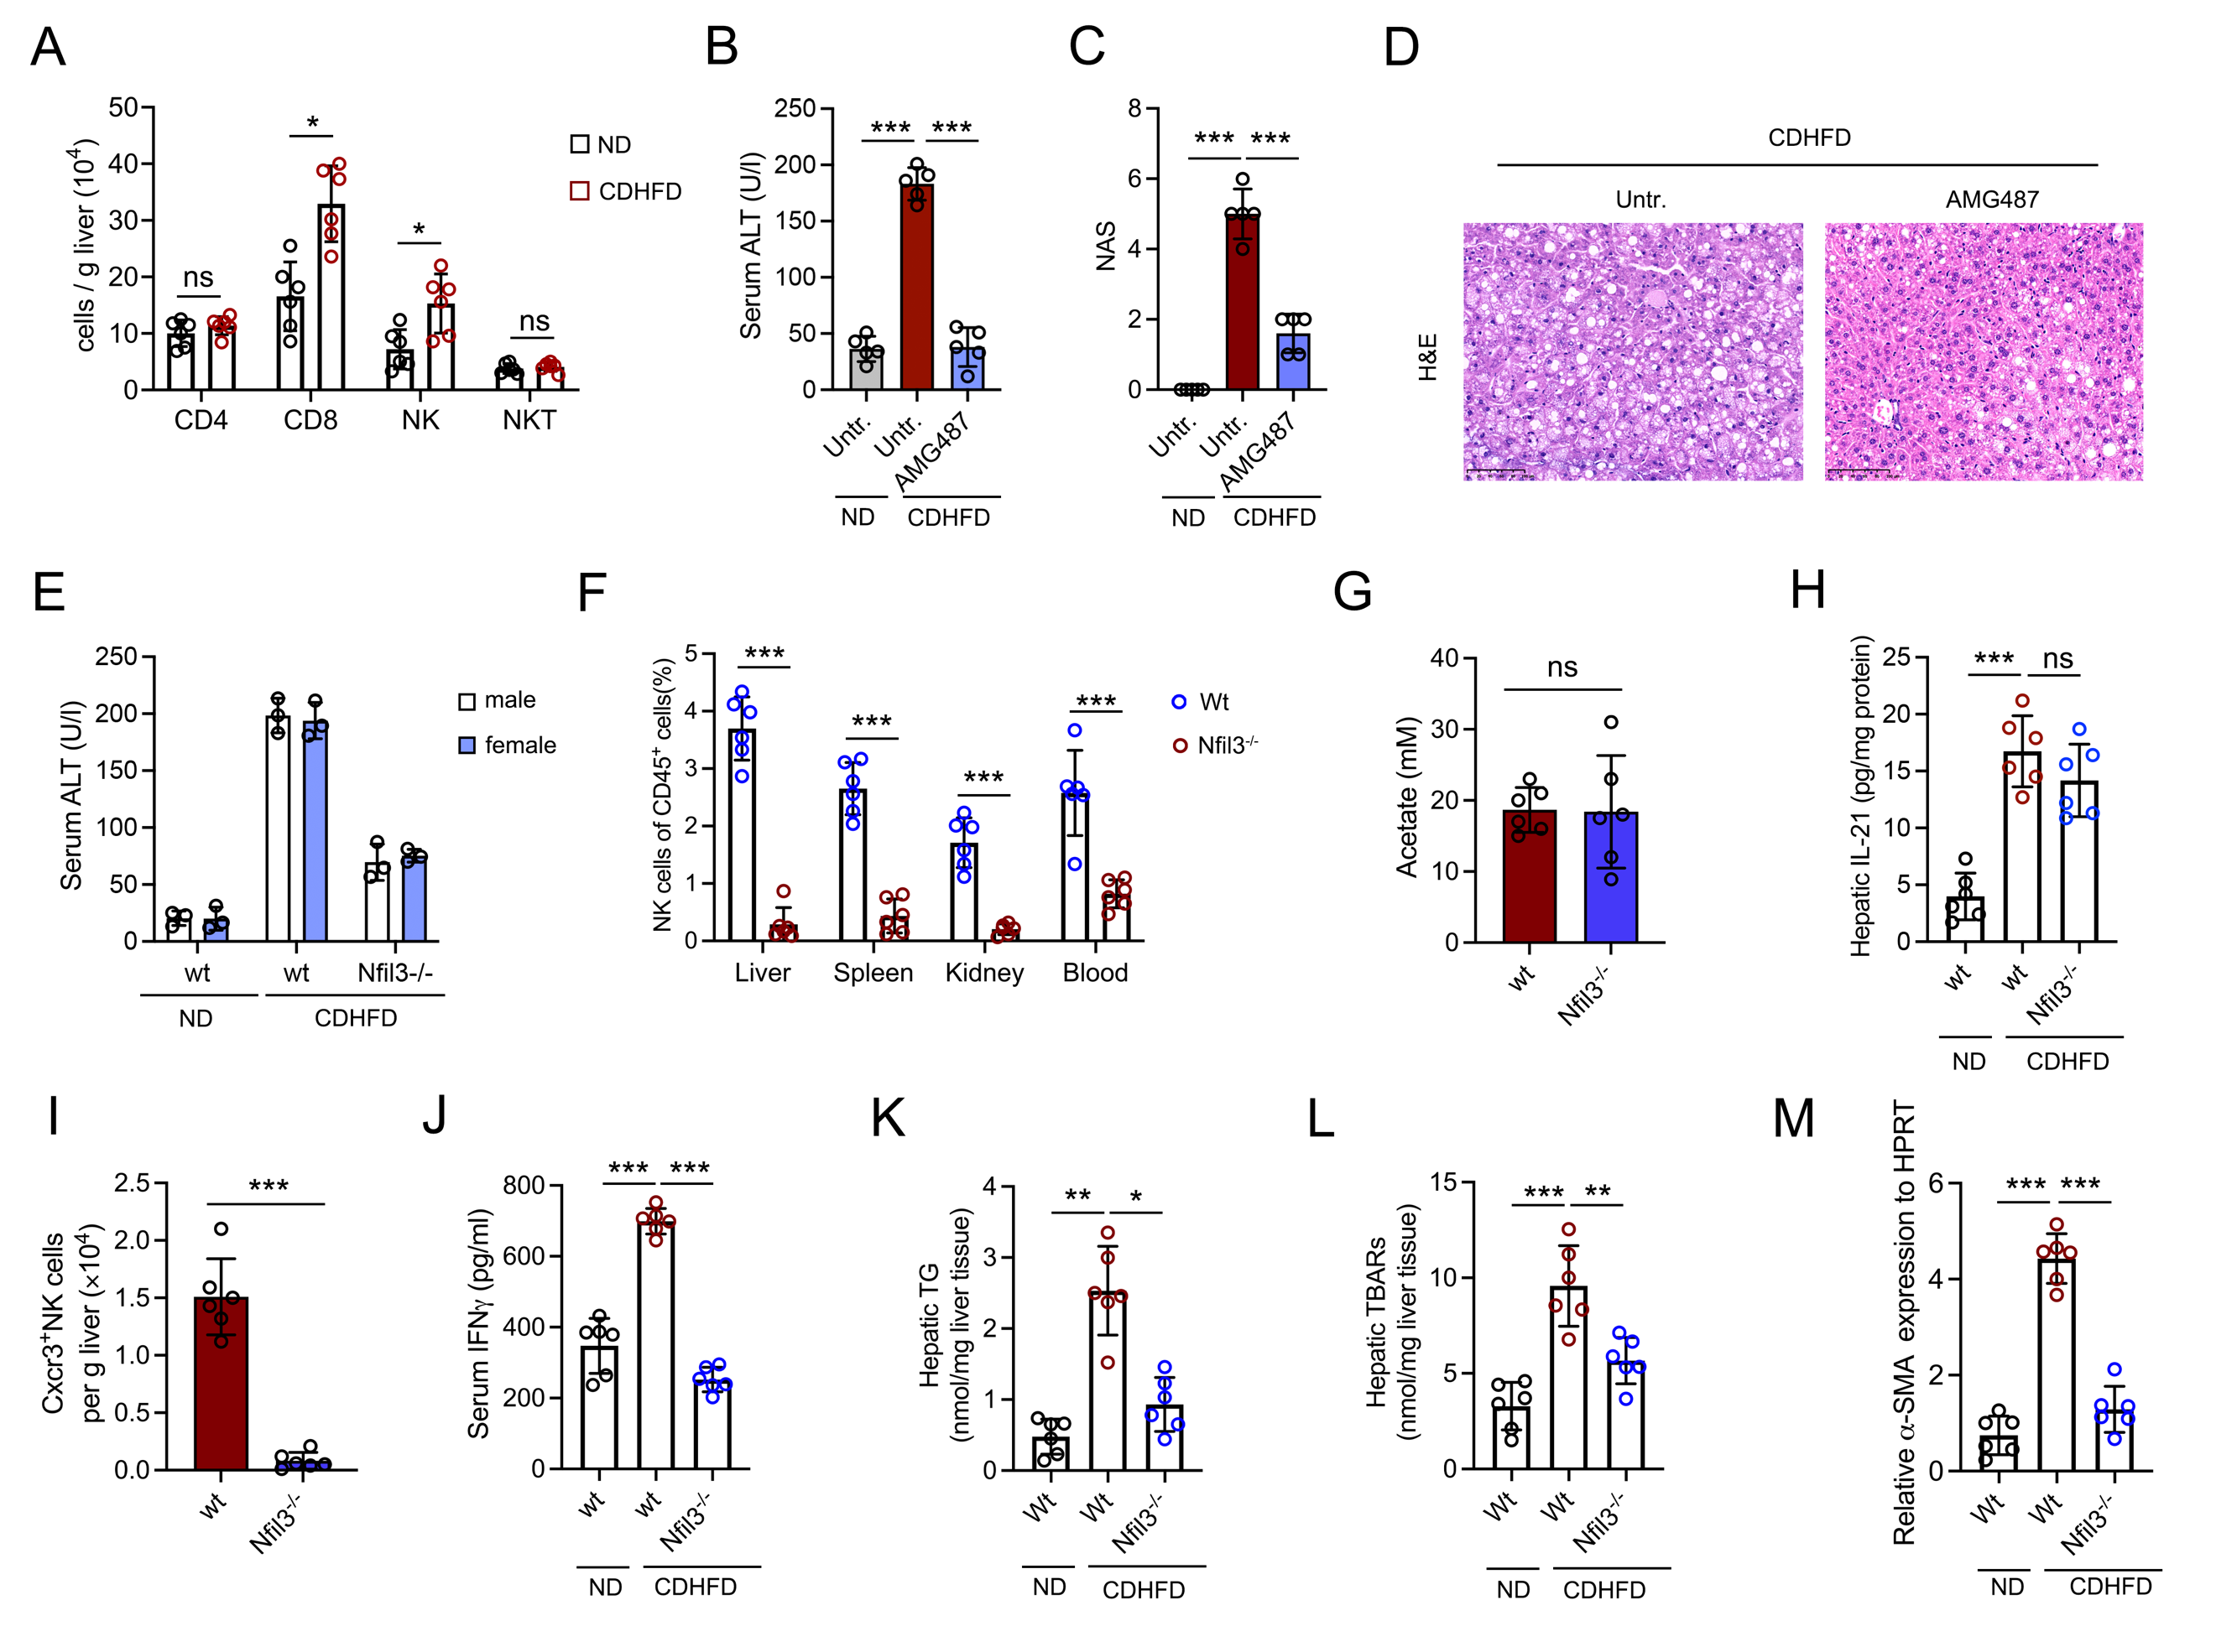Figure S4. Nfil3 knockout protects against CDHFD-induced MASH progression.
A. Numbers of hepatic lymphocytes. B-D. sALT (B), NAS (C) and H&E histopathological staining（D）after AMG487 application (5 mg/kg per mouse/day, at 8 weeks) in mice fed a CDHFD, n = 6. E. Serum alanine aminotransferases (sALT) in Nfil3^{-/-} mice (n = 6, male=3, female=3) compared to wild-type (wt) littermates (n = 6) after 8 months of feeding a CDHFD. F. NK cells of CD45⁺ cells (%) in liver, spleen, kidney and blood after 8 months of feeding a CDHFD. G. Acetate levels in the liver tissue of Nfil3^{-/-} mice after 8 months of feeding a CDHFD. H. IL-21 levels in liver tissue of Nfil3^{-/-} mice after 8 months of feeding a CDHFD. I. Number of Cxcr3⁺ NK cells in the liver tissue of Nfil3^{-/-} mice. J. Serum IFN-γ levels. K-M. Liver TG levels, TBARs levels, and SMA expression levels in Nfil3^{-/-} mice liver tissue compared to wild-type (wt) littermates after 8 months of feeding a CD-HFD, n = 6. *P < 0.05, **P < 0.01, ***P < 0.001. One-way ANOVA with Tukey’s multiple comparison test (B-C, E, H, J-M). Two-way ANOVA with Sidak’s (A, F). unpaired two-tailed t-test (G, I). All data are presented as mean ± SEM.
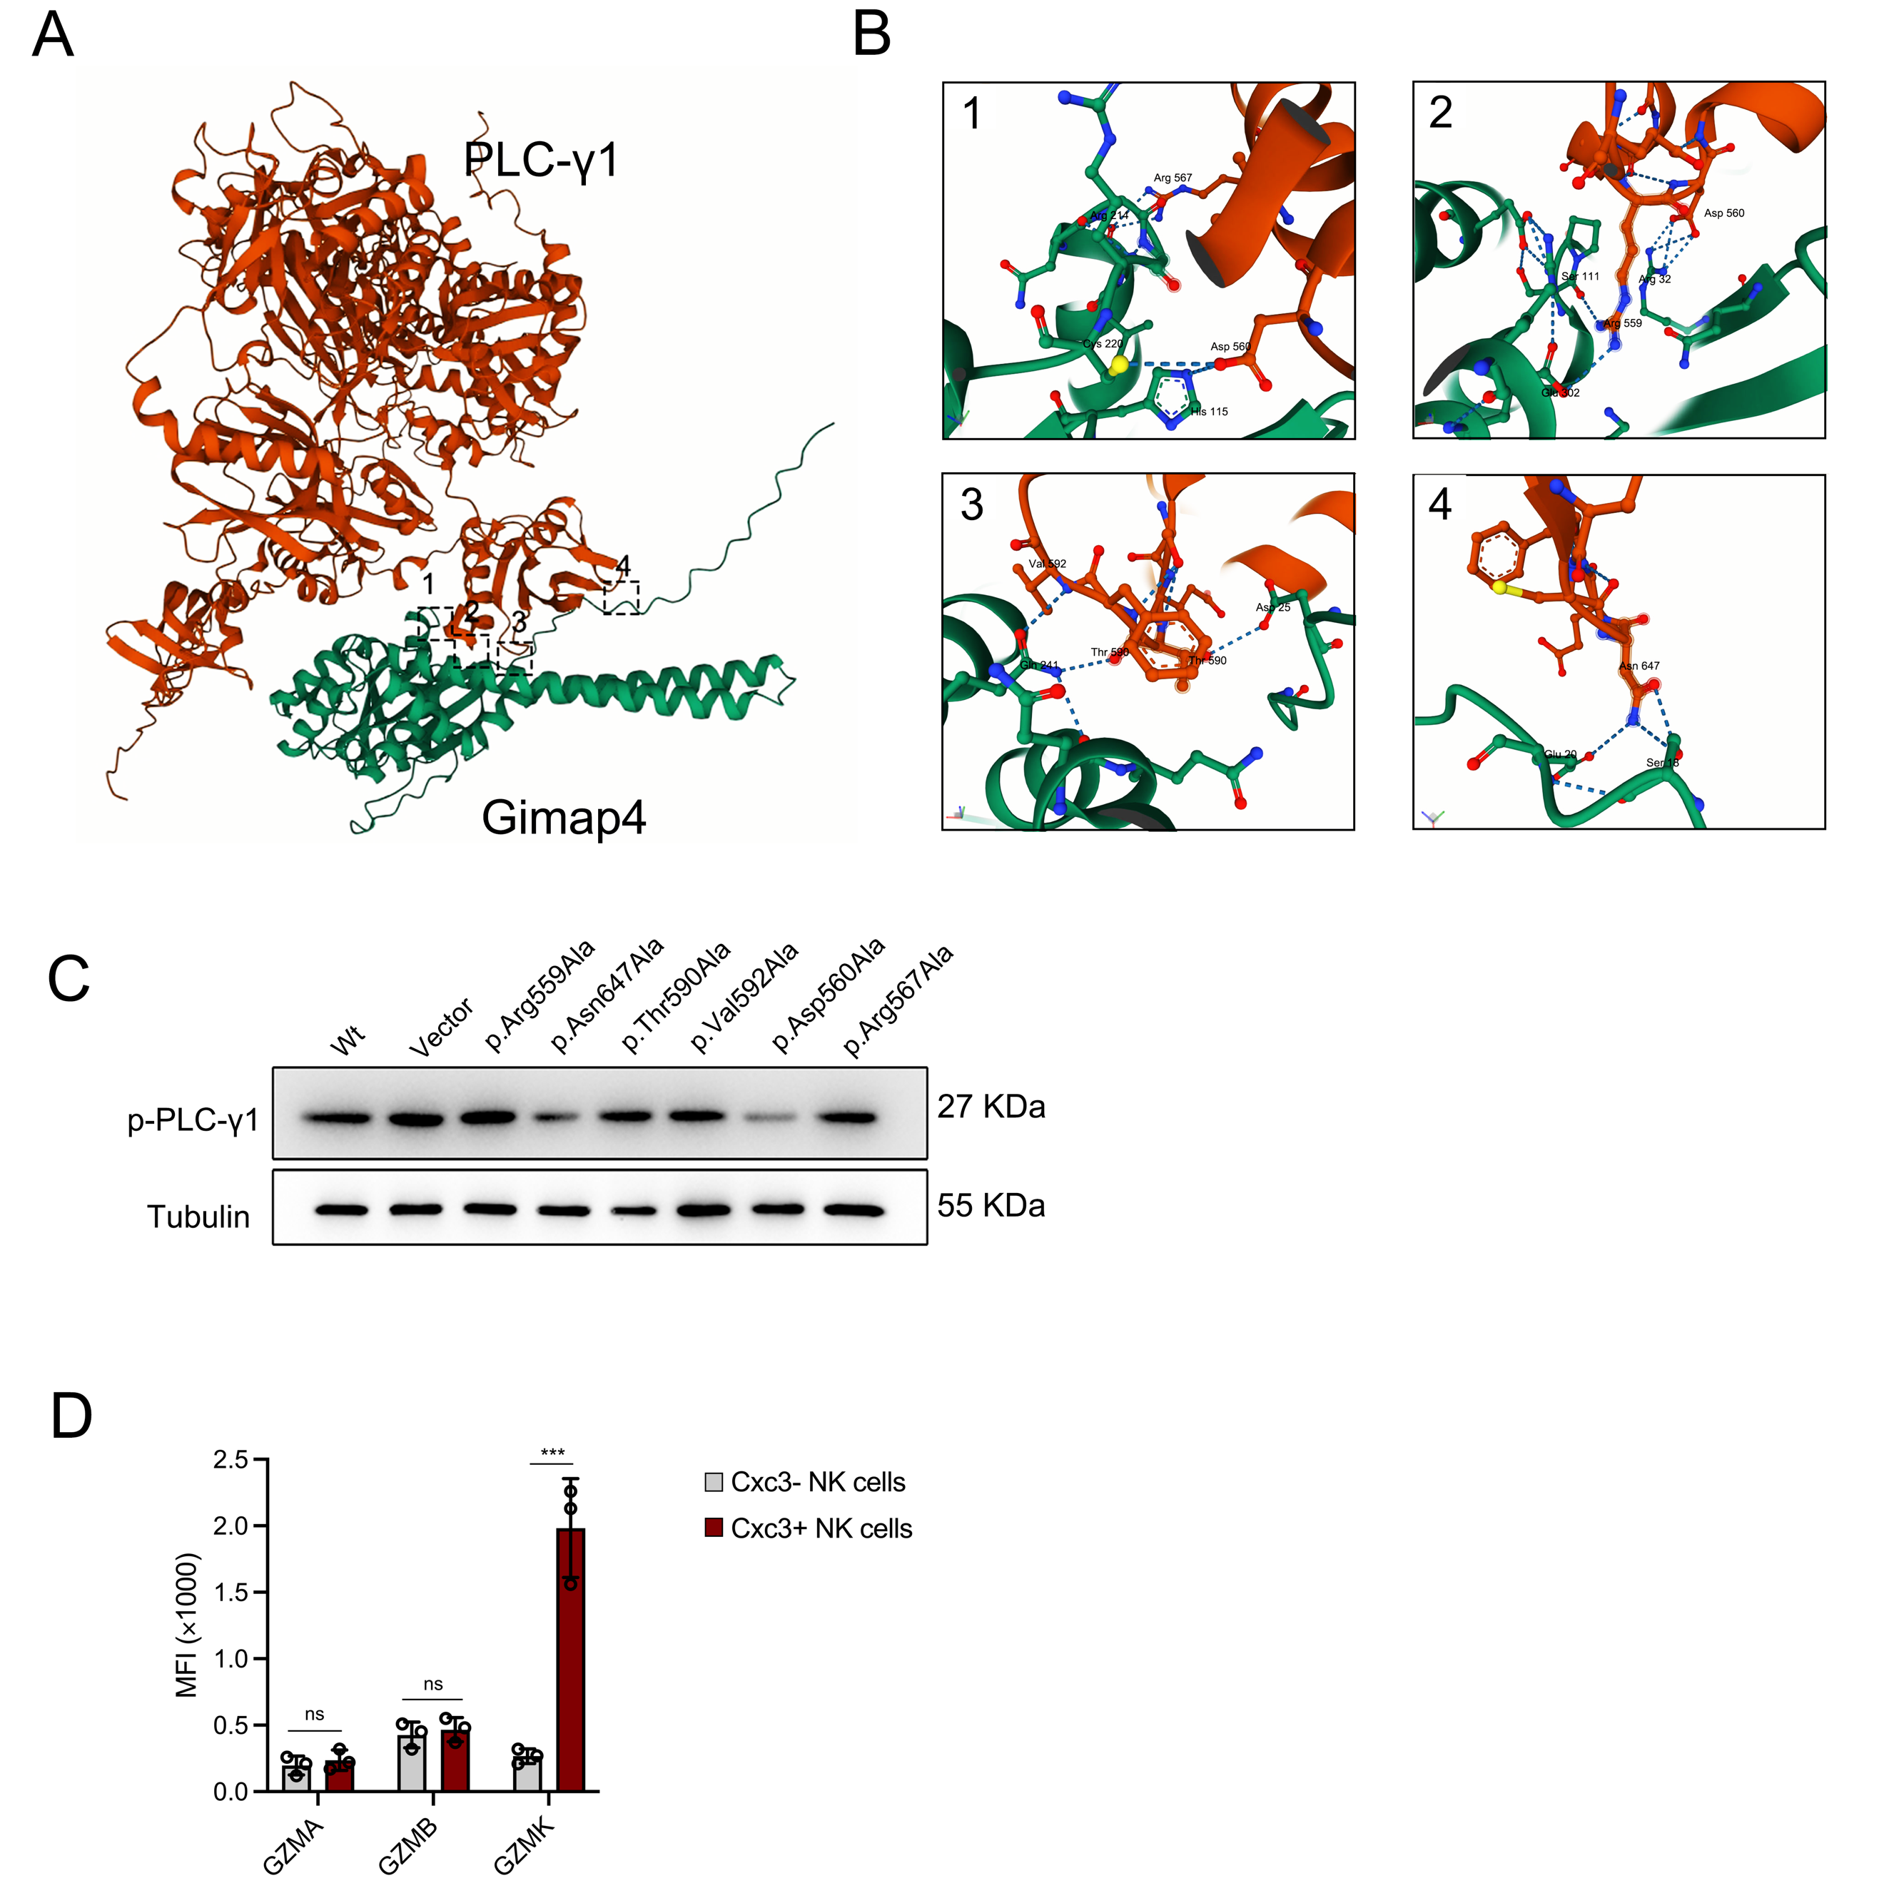
Figure S5: Gimap4 directly interacts with PLC-γ1.
A-B. AlphaFold 3 predicts the binding sites between Gimap4 and PLC-γ1. C. Point mutation of Gimap4 validates the key sites mediating PLC-γ1 phosphorylation by Gimap4. D. Levels of GZMA, GZMB, and GZMK in Cxcr3+ NK cells and Cxcr3- NK cells from MASH mice, n=3.*P < 0.05, **P < 0.01, ***P < 0.001. unpaired two-tailed t-test (D). All data are presented as mean ± SEM.
Figure S6. Reclustering of T/ NK cell subsets.
A. Phenograph-based analysis of liver tissue T/NK cell populations. umap, uniform manifold approximation and projection. B. After re-clustering, the percentage of each cell group. C. Stacked violin plot of marker gene expression (Top 3) for each cell cluster. D. Expression of Cxcr3, Rgs1, and Gzmk across cell populations. E. Umap plot of cell clusters and expression levels of Lef1 in the ND and CDHFD groups. F. Correlation analysis of the expression levels of Gzmk and Lef1 in single cells with the expression level of Cxcr3. G. Transwell assay analysis of the induction of Cxcr3⁺ NK cell migration by Cxcl9, Cxcl10, and Cxcl11. H-I. Cxcr3⁺ CD8⁺ T cells and Cxcr3⁺ CD4⁺ T cells auto-destructiveness activity on primary hepatocytes after treatment with Lef1 degrading agent and stimulation with acetate. J. Umap diagram showing the cell population expressing Cxcr6 and expression levels in the CDHFD group. K. Cxcr6⁺ NK cells exhibit auto-destructive activity against primary hepatocytes after treatment with Lef1 inhibitors and stimulation with acetate. ns, no significance. one-way ANOVA with Tukey’s multiple comparison test (H-I, K). All data are presented as mean ± SEM.

Figure S7. Human CXCR3⁺ IL21R⁺NK cells employ a similar auto-destructive mechanism.
A. Auto-destructive activity against primary human hepatocytes by allogeneic or autologous NK cells following IL-21 and acetate incubation (E:T ratio=3:1). B. Signature gene expression in IL-21-stimulated hepatic CXCR3⁺IL21R⁺ NK cells from MASH patients. C. PCA of transcriptional signatures in Cxcr3⁺Lef1^{low} NK cells versus human CXCR3⁺IL21R⁺ NK cells. D. Transcriptomic concordance between mouse (CXCR3⁺ vs. CXCR3⁻ NK cells in MASH) and human (hepatic CXCR3⁺IL21R⁺ NK cells in MASH) was assessed by Spearman’s correlation, showing the linear regression (solid line) and 95% confidence interval (grey area). E. Cytotoxicity of IL21R⁺ NK cells from healthy donors against primary human hepatocytes. F. Effects of variable IL-21 concentrations on IL21R⁺ NK cell cytotoxicity, n=3. G. Effect of different effector-to-target ratios on the cytotoxic activity of IL21R⁺ NK cells, n=3. H. Auto-destructiveness of IL-21-treated CXCR3⁺ NK cells against human hepatocytes were assessed under the following with or without acetate and in the presence of 10 μg/ml anti-NKG2D antibodies or 20 mM EDTA, n=3. I-J. CXCL9 stimulates NK cell FASL and TRAIL expression, n=6. K. Caspase3/7 and Caspase8 activation in human primary hepatocytes after treating with anti-FasL (10 μg/ml), n = 3. Data are presented as mean ± SEM. *P < 0.05, **P < 0.01, ***P < 0.001. Statistical analyses were performed using one-way ANOVA with Tukey’s test (E-F, H, K), two-way ANOVA with Tukey’s test (A-B, G), or unpaired two-tailed t-test (I-J).

STAR * METHODS
KEY RESOURCES TABLE
REAGENT or RESOURCE | SOURCE | IDENTIFIER
Antibodies for flow cytometric analysis
FITC anti-human/mouse Cd45 | Abcam | Cat# ab27287
BV421 anti-mouse Cxcr3 | BioLegend | Cat# 149023
PE anti-Cxcr3 | BioLegend | Cat# 100206
APC Anti-mouse Cd49b | BioLegend | Cat# 108910
FITC Anti-CD3ε | BioLegend | Cat# 100306
PE Anti-mouse Gzmk | Thermo Fisher | Cat# 50-5897-82
PerCP-Cy5.5 Anti-mouse IFNg | BD Biosciences | Cat# 560699
PerCP-Cy5.5 Anti-mouse Tnf-α | BioLegend | Cat# 506324
Alexa Fluor® 647 Anti-mouse Ki67 | BioLegend | Cat# 652410
PerCP-Cy5.5 Anti-mouse Bcl2 | BD Biosciences | Cat# 562499
Anti-mouse Lef1 | Abcam | Cat# ab137872
BV510 Anti-mouse Il21R | BioLegend | Cat# 135017
Alexa Fluor® 488 Anti-mouse ICAM1 | Abcam | Cat# ab2210
PE Anti-LFA1 | Abcam | Cat# ab33477
Anti-human FASL | BioLegend | Cat# 110406
Anti-human TRAIL | BioLegend | Cat# 308806
Blocking Antibody and Neutralizing Antibody
Anti-CD122 (TM-β1) | BioXcell | Cat# BE0311
Anti-LFA1 (M17/4) | BioXcell | Cat# BE0024
Anti-MHC 1 H-2Kᵇ (AF6-88.5.5.3) | BioXcell | Cat# BE0121
Anti-Nkg2d (CX5) | BioXcell | Cat# BE0308
Anti-Nkp30 (29B1.4) | BioXcell | Cat# BE0279
Human Anti-NKG2D (149810) | BioXcell | Cat# BE0314
Human Anti-FASL (NOK-1) | BioXcell | Cat# BE0307
Anti-TβRII (TR1) | BioXcell | Cat# BE0057
Anti-Tnfr1 (XT3.11) | BioXcell | Cat# BE0061
Anti-Tgf-β1 (1D11) | BioXcell | Cat# BE0057
Anti-Ifnγ1 (XMG1.2) | BioXcell | Cat# BE0055
IgG1 | BioXcell | Cat# BE0088
Antibodies for Western Blot analysis
anti-c-Myc (9E10)-HRP antibody | Sigma-Aldrich | Cat# M4439
anti-Flag® M2-HRP antibody | Sigma-Aldrich | Cat# A8592
Anti-p-PLCγ1 (Tyr783) | Cell Signaling Technology | Cat# 14008
Anti-PLCγ1 | Cell Signaling Technology | Cat# 10607
Anti-Gimap4 | Thermo Fisher Scientific | Cat# MA5-25993
Anti-JAK2 | Abcam | Cat# ab108596
Anti-p-JAK2 (Tyr1007/1008) | APExBIO | Cat# MA4436
Anti-STAT1 | Proteintech | Cat# 10144-2-AP
Anti-p-STAT1 (Tyr701) | Proteintech | Cat# 66418-1-Ig
Anti-JAK1 | Proteintech | Cat# 66636-1-Ig
Anti-IRF4 | Proteintech | Cat# 11335-1-AP
Anti-β-ACTIN | Proteintech | Cat# 60008-1-Ig

REAGENT or RESOURCE | SOURCE | IDENTIFIER
Bacterial and virus strains
pNK-GFP | GeneChem | N/A
pNK-Lef1-GFP | This paper | N/A
pLKO.1-TRC | Addgene | Addgene #10878
pMDLg/pRRE | Addgene | Addgene #12251
pRSV-Rev | Addgene | Addgene #12253
pMD2.G | Addgene | Addgene #12259
pcDNA3.1-Gimap4-Flag | This paper | N/A
pcDNA3.1-PLCγ1-Myc | This paper | N/A
Chemicals, peptides, and recombinant proteins
Percoll | Cytiva | Cat# 17089101
TRIzol RNA isolation reagent | Invitrogen | Cat# 15596018
Antibody Dilution Buffer | Beyotime | Cat# P0023A
RIPA buffer | ThermoFisher | Cat# 89900
eFluor™ 514 Calcium Sensor Dye | ThermoFisher | Cat# 65-0859-39
Lipofectamine 3000 | Invitrogen | Cat# L3000015
DAPI | Beyotime | Cat# P0131
H&E staining kit | Beyotime | Cat# C0105M
Masson staining kit | Solarbio | Cat# G1340
Triglyceride assay kit | Nanjing Jiancheng | Cat# A110-1-1
Acetate assay kit | Merck | Cat# MAK086
Alanine Aminotransferase (ALT) Activity Kit | ThermoFisher | Cat# MAK052
Mouse IL-21 Quantikine ELISA Kit | R&D Systems | Cat# DY594
Mouse CXCL9 Quantikine ELISA Kit | R&D Systems | Cat# MM900
Human IL-21 ELISA Kit | Thermo Fisher Scientific | Cat# BMS221
NK Cell Isolation Kit | Miltenyi Biotec | Cat# 130-115-818
Fumaric acid | Merck | Cat# F8506
Citrate | Merck | Cat# C7254
Acetate | Merck | Cat# S2889
Propionate | Merck | Cat# P880
Pyruvate | Merck | Cat# P2256
Palmitic acid | Merck | Cat# P0500
Butyrate | Merck | Cat# B5887
Oleic acid | Merck | Cat# O1008
Lactate | Merck | Cat# L4263
Cyclosporine A | Merck | Cat# 30024
EGTA | Merck | Cat# E4378
Wortmannin | Merck | Cat# W1628
UO126 | Merck | Cat# U0106
Edelfosine | Merck | Cat# E0165
CXCL9 | R&D Systems | Cat# 492-MG-010
CXCL10 | R&D Systems | Cat# 466-MI-010
CXCL11 | Sino Biological | Cat# 50743-M08H
LPS | Sigma-Aldrich | Cat# L4516
Poly(I:C) | InvivoGen | Cat# tlrl-pic
CpG | InvivoGen | Cat# tlrl-1826-1
Adenosine | Merck | Cat# A9251
ATP | Sigma-Aldrich | Cat# FLAAS-1KT
NAD⁺ | Sigma-Aldrich | Cat# N7004
MICA-FC | R&D Systems | Cat# 1308-MC-050
IL-2 | R&D Systems | Cat# 402-ML-020
IL-15 | ThermoFisher | Cat# PMC2155
IL-21 | ThermoFisher | Cat# PMC0214
TGF-β1 | PeproTech | Cat# 100-21
IL-17 | ThermoFisher | Cat# PMC0175
IL-1β | ThermoFisher | Cat# 14-7012-80
IL-7 | ThermoFisher | Cat# PMC0075
IFN-γ | ThermoFisher | Cat# PMC4033
TNF-α | ThermoFisher | Cat# PMC3014
Experimental models: Organisms/strains
WT C57BL/6J | GemPharmatech | Cat# C001171
Gimap4-knockout C57BL/6J mice | Cyagen Biosciences | N/A
Irf4-knockout C57BL/6J mice | Cyagen Biosciences | N/A
Research diet
ND diet | Research Diets | Cat# D12450J
CDHFD diet | Research Diets | Cat# D05010402
HFHC diet | Research Diets | Cat# D09100301
WD diet | Research Diets | Cat# D12079B
HFD diet | Research Diets | Cat# D12492
Software and algorithms
ImageJ | NIH | https://imagej.nih.gov/ij/
Prism 10 | GraphPad | https://www.graphpad.com/
FlowJo | FlowJo | N/A
R version 5.0.5 | R software | https://www.r-project.org/

