Supplementary Information

Pt/CeO₂ with residual chloride as reusable soft Lewis acid catalysts: application to highly efficient isomerization of allylic esters

Qi-An Huang,¹ Asahi Haruta,¹ Yuhya Kumamoto,¹ Haruno Murayama,*¹ Eiji Yamamoto,¹ Tetsuo Honma,² Mitsutaka Okumura,³ Hiroki Nobutou,³ Makoto Tokunaga*¹

¹Department of Chemistry, Graduate School of Science, Kyushu University, 744 Motooka, Nishi-ku, Fukuoka 819-0395, Japan
²Japan Synchrotron Radiation Research Institute (JASRI), SPring-8, Sayo, Hyogo 679-8198, Japan
³Department of Chemistry, Osaka University, Toyonaka, Osaka 560-0043, Japan

*Corresponding author: haruno9@chem.kyushu-univ.jp, mtok@chem.kyushu-univ.jp

Table of Contents
1. Optimization of reaction S2
1-1. Catalyst screening S2
1-2. Effect of Pt loading S2
1-3. Details for evaluation of catalytic activity S3
1-4. Time course of catalytic isomerization S4
1-5. Effect of supports on catalytic isomerization S4
2. Characterization of the catalysts S5
2-1. HADDF-STEM images S5
2-2. XPS analysis S6
2-3. XAFS analysis S7
2-4. H₂-TPR profiles S10
3. Catalytic isomerization of allylic esters S12
3-1. Substrate scope S12
3-2. Isomerization with homogeneous catalysts S14
3-3. Proposed catalytic cycle S15
4. Computational Details S16
5. Details for substrates discussion S20
5-1. Characterization of the products S20
5-2. ¹H and ¹³C NMR charts of compounds S22

- Optimization of the reaction conditions
1-1 Catalysts screening
Supplementary Table 1. Supporting effect of metal oxide-supported Pt catalysts in the catalytic isomerization of 3,4-DABE.

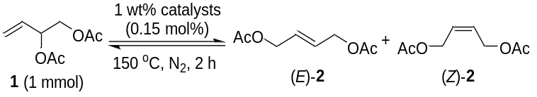
Entry | Catalyst | Conv. (%)ª | Yield (%)ª |  |  | TON
Entry | Catalyst | Conv. (%)ª | (E)-2 | (Z)-2 |  | TON
1^{b} | Pd/ZrO₂ | 0 | 0 |  | 0 | 0
2^{c} | Pd/CeO₂ | 18 | 0 |  | 0 | 0
3 | Ir/CeO₂ | 0 | 0 |  | 0 | 0
4 | Au/ZrO₂ | 14 | 10 |  | 1 | 67
5 | Pt/CeO₂ | 63 | 51 |  | 1 | 347
6 | Pt/ZrO₂ | 57 | 49 |  | 2 | 327
7 | Pt/TiO₂ | 63 | 47 |  | 1 | 320
8 | Pt/Al₂O₃ | 49 | 40 |  | 0 | 267
9 | Pt/MgO | 39 | 27 |  | 0 | 180
10^{d} | Pt/CeO₂ | 55 | 52 |  | 1 | 5300
11^{d,e} | Pt/CeO₂ | 56 | 51 |  | 1 | 5200
12^{d,e,f} | Pt/CeO₂ | 60 | 53 |  | 1 | 5400
13^{g} | Mont-K10 | 18 | 12 |  | 1 | /
14^{g} | ZSM-5 | 27 | 7 |  | 1 | /
ªDetermined by gas chromatography (GC) analysis using tridecane as an internal standard. ^{b}Using 10 wt% Pd/ZrO₂ (2 mol%), THF as the solvent, reacting for 14 h. ^{c}Using 5 wt% Pd/CeO₂ (2 mol%), DMSO as the solvent, reacting for 18 h. ^{d}Reacting in 0.01 mol%. ^{e}Reacting under an air atmosphere. ^{f}Reacting at the feedstock scale of 10 mmol. ^{c}Using 30 mg catalysts under an air atmosphere, reacting for 5 h.

1-1 Effect of the Pt loading
Supplementary Table 2. Effect of the Pt loading on the catalytic isomerization of allylic esters.
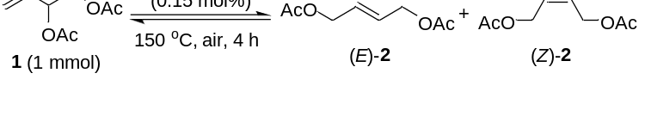

Entry | Catalyst | Conv. (%)ª | Yield (%)ª
Entry | Catalyst | Conv. (%)ª | (E)-2 | (Z)-2
1 | 1 wt% Pt/CeO₂ | 51 | 49 | 1
2 | 3 wt% Pt/CeO₂ | 57 | 50 | 1
3 | 5 wt% Pt/CeO₂ | 48 | 43 | 1
4 | 10 wt% Pt/CeO₂ | 27 | 18 | 0
ª Determined by GC analysis using tridecane as an internal standard.

1-3. Details for evaluation of the catalytic activity
Supplementary Table 3. Effect of the Pt loading on the catalytic isomerization of allylic esters.

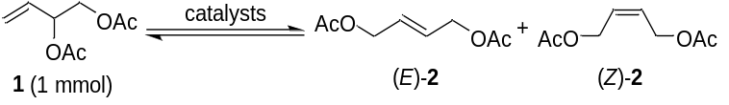
Entry | Catalyst | TON | Mechanism | Ref.
1 | Co(II) ligand | 9ª | π-allyl | 1
2 | Pd(0) ligand | 13 | π-allyl | 2
3 | Pd(II) ligand | 13 | soft Lewis acid | 3
4 | Au(I) ligand | 33ª | soft Lewis acid | 4
5^{b} | Au/ZrO₂ | 67^{d} | soft Lewis acid | this study
6^{c} | Pt/CeO₂ | 5400^{d} | soft Lewis acid | this study
ªMaximum TON of discussed allylic esters substrates. ^{b}Using 1 wt% Au/ZrO₂ (0.15 mol%), reacting for 2 h. ^{c}Using 1 wt% Pt/CeO₂ (0.01 mol%) , reacting for 2 h under an air atmosphere. ^{d}Calculated by gas chromatography (GC) analysis using tridecane as an internal standard.

(1) Mukhopadhyay, M.; Reddy, M. M.; Maikap, G. C.; Iqbal, J. Cobalt(II)-Catalyzed Conversion of Allylic Alcohols/Acetates to Allylic Amides in the Presence of Nitriles. J. Org. Chem.60, 2670–2676 (1995).
(2) Bouquillon, S.; Muzart, J. Palladium(0)-Catalyzed Isomerization of (Z)-1,4-Diacetoxy-2-Butene - Dependence of η1- or η3-Allylpalladium as a Key Intermediate on the Solvent Polarity. Eur. J. Org. Chem. 17, 3301–3305 (2001).
(3) Zawisza, A. M.; Bouquillon, S.; Muzart, J. Palladium(II)-Catalyzed Isomerization of (Z)-1,4-Diacetoxy-2-Butene: Solvent Effects. Eur. J. Org. Chem. 2, 3901-3904 (2007).
(4) Marion, N.; Gealageas, R.; Nolan, S. P. [(NHC)Au1]-Catalyzed Rearrangement of Allylic Acetates. Org. 9, 2653–2656 (2007).
1-2 Time course of catalytic isomerization

Supplementary Figure 1. Reaction time course of the catalytic isomerization of allylic esters within 2 hours.
The time course of the catalytic isomerization of 3,4-DABE over the optimal Pt/CeO₂ catalysts was conducted with a Pt loading of 0.05 mol% at 150 °C within 2 h. After reacting for 30 minutes, few changes in the conversion and yields could be seen during the following process.

1-3 Effect of supports on catalytic isomerization
Pt/CeO₂ Pt/ZrO₂ Pt/TiO₂ Pt/Al₂O₃ Pt/MgO
Supplementary Figure 2. Reusability of Pt catalysts supported by different metal oxides for the catalytic isomerization of allylic esters.
The reusability of the catalysts was evaluated with the Pt catalysts supported by different metal oxide supports. After the Pt/CeO₂ catalysts were used 3 times, no obvious deactivation occurred in the conversions or yields. Nevertheless, a marked decrease in conversions and yields was observed when using the other catalysts.
The reaction solution of the Pt/CeO₂ catalysts was analyzed with MP-AES, and the leaching of the Pt species was detected as around 2 %, which was within the normal range of supported catalysts.

- Characterization of the catalysts
2-1. HADDF-STEM images

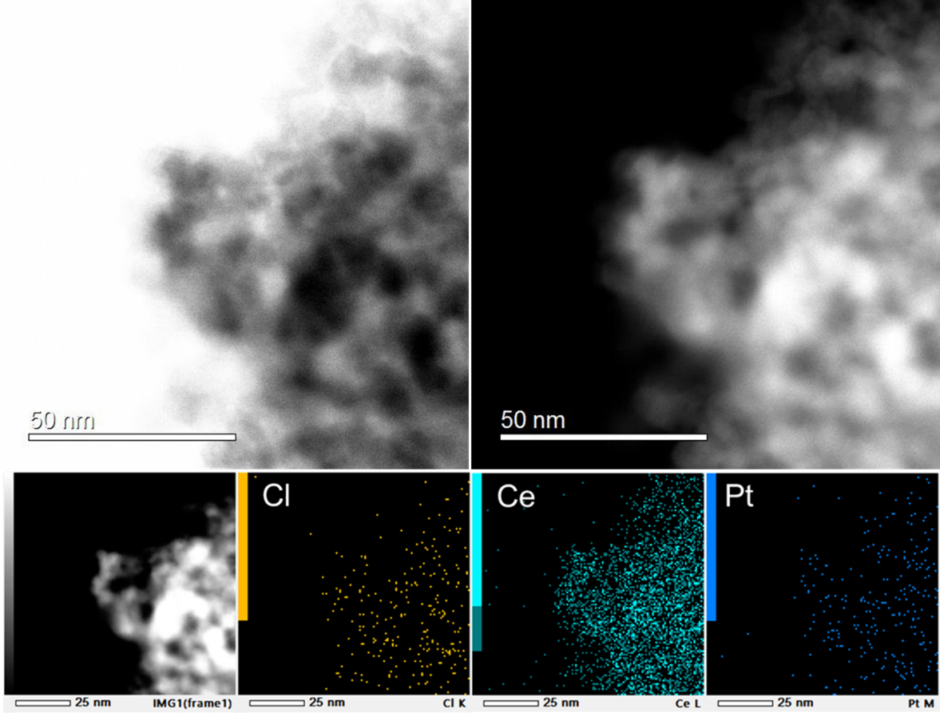

Supplementary Figure 3. HADDF-STEM images coupled with EDS mapping of 1 wt% Pt/CeO₂ prepared from H₂PtCl₆·6H₂O.

2-2. XPS analysis

Supplementary Table 4. Summary of the XPS measurement results for Pt/CeO₂ prepared from various precursors or as-prepared catalysts after HCl treatment.
Sample | Pt 4f XPS (at%) |  |  | Pt/Ce ratio  (at%) | Cl/Pt ratio
Sample | Pt²⁺ (72.7 eV) | Pt⁴⁺ (74.1 eV) | Pt^{4+ (Cl)} (74.8 eV) | Pt/Ce ratio  (at%) | (at%)
Pt/CeO₂_Cl | 85.61% | 6.99% | 7.39% | 0.84 | 6.66
Pt/CeO₂_A | 94.36% | 5.64% | ̶ | 0.75 | ̶
Pt/CeO₂_N | 87.64% | 12.36% | ̶ | 0.87 | ̶
Pt/CeO₂_A_HCl | 75.86% | 1.46% | 22.68% | 0.54 | 15.23
Pt/CeO₂_N_HCl | 74.03% | 14.40% | 11.57% | 0.72 | 10.13

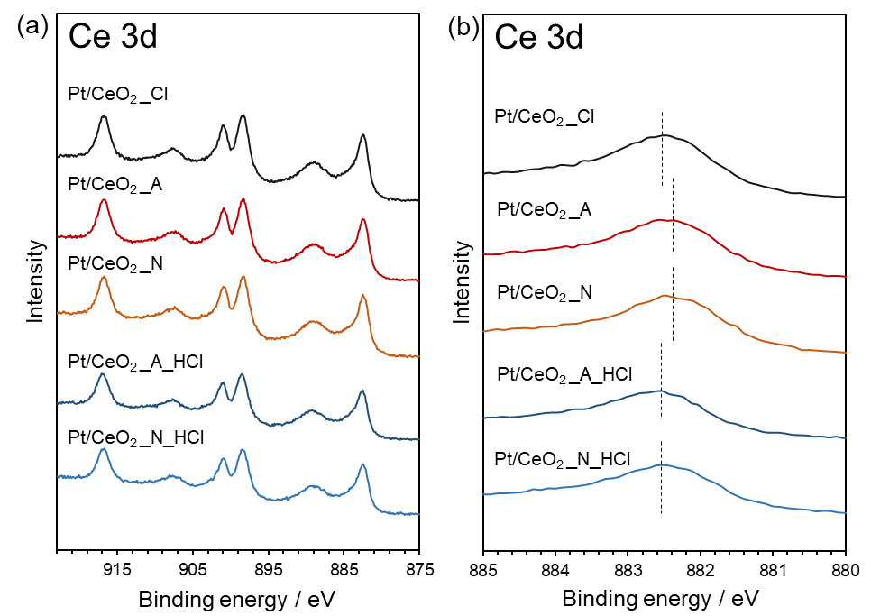
Supplementary Figure 4. Ce 3d XPS spectra of (a) 1 wt% Pt/CeO₂ prepared from various precursors or as-prepared catalysts after HCl treatment and (b) amplification of the peaks.

The Ce 3d peaks of the catalysts prepared from H₂PtCl₆ and HCl-treated catalysts prepared from Pt(acac)₂ or Pt(NH₃)₄(NO₃)₂ shifted by 0.2 eV to higher binding energy compared with that of the catalysts containing no chlorine. The peak shift can be considered as the positive charge effect from chlorine, revealing the strong interaction between CeO₂ and Pt.

2-3. XAFS analysis
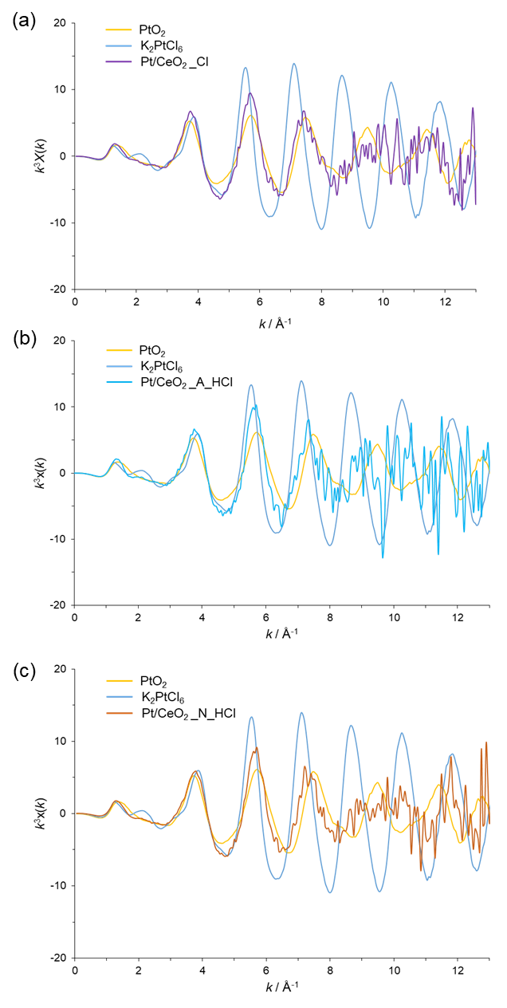

Supplementary Figure 5. The k³-weighted Pt L_{III}-edge EXAFS oscillations of Pt/CeO₂_Cl, Pt/CeO₂_A_HCl, and Pt/CeO₂_N_HCl.

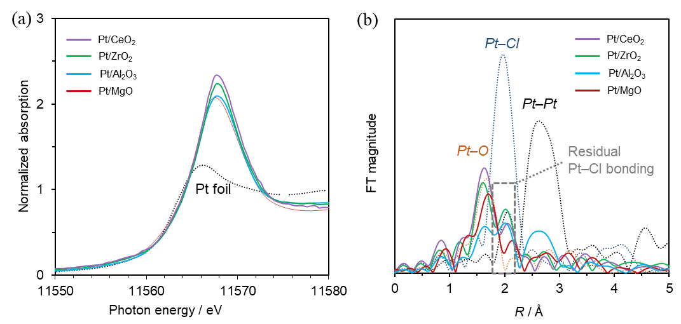
Supplementary Figure 6. (a) Pt L_{III}-edge XANES spectra and (b) Fourier transform magnitude EXAFS spectra of Pt catalysts supported by different metal oxides (k = 3−13 Å⁻¹).

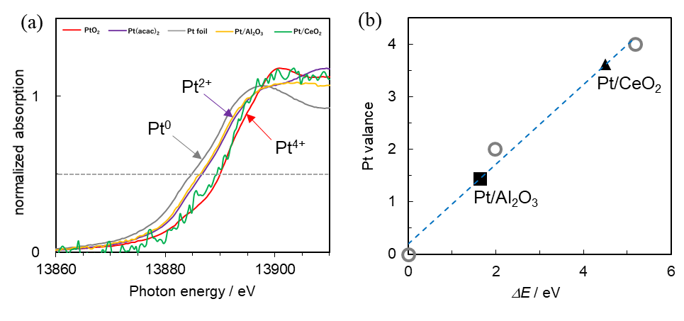
Supplementary Figure 7. (a) Pt L_{I}-edge XANES spectra and (b) edge energy plots of Pt/CeO₂ and Pt/Al₂O₃ prepared from H₂PtCl₆·6H₂O.

Supplementary Figure 7 shows the Pt L_{I}-edge XANES spectra of Pt⁰ foil, Pt²⁺(acac)₂, Pt⁴⁺O_{2,} and the as-prepared catalysts. The energy differences from the edge energy of the Pt foil are shown as ΔE. The ΔEs are found to vary linearly with the oxidation state of Pt. From the relationship, the oxidation states of Pt in Pt/CeO₂_Cl were nearly 4+ and higher compared with those of Pt/Al₂O₃_Cl.

Supplementary Table 5. EXAFS fit parameters of Pt/CeO₂.ª

Catalyst | Scattering path | CN^{b} | R (Å)^{c} | Δσ² (Å²)^{d} | ΔE₀ (eV) ^{e} | R-factor^{f}
Pt/CeO₂ from  Pt(acac)₂ | Pt−O | 3.75 ± 0.48 | 2.01 ± 0.009 | 0.003 ± 0.001 | 16.1 ± 1.58 | 0.018
Pt/CeO₂ from Pt(NO₃)₂(NH₃)₄ | Pt−O | 3.14 ± 0.29 | 1.99 ± 0.006 | 0.003 ± 0.001 | 14.7 ± 1.16 | 0.009
Pt/CeO₂ from  H₂PtCl₆ | Pt−O  Pt−Cl | 3.62 ± 0.49  1.49 ± 0.78 | 1.99 ± 0.011  2.32 ± 0.012 | 0.004 ± 0.001  0.006 ± 0.005 | 11.3 ± 2.26  20.1 ± 0.21 | 0.013
Pt/CeO₂ from  Pt(acac)₂_HCl | Pt−O  Pt−Cl | 4.24 ± 1.03  1.76 ± 1.03 | 2.01 ± 0.038  2.32 ± 0.026 | 0.008 ± 0.002  0.001 ± 0.003 | 12.3 ± 3.91  18.0 ± 6.07 | 0.021
Pt/CeO₂ from Pt(NO₃)₂(NH₃)₄_HCl | Pt−O  Pt−Cl | 2.17 ± 0.28  1.79 ± 0.27 | 1.97 ± 0.013  2.29 ± 0.019 | 0.001 ± 0.001  0.001 ± 0.001 | 12.2 ± 3.52  11.1 ± 4.82 | 0.018
Pt/ZrO₂ | Pt−O  Pt−Cl | 2.30 ± 0.31  1.49 ± 0.23 | 2.00 ± 0.012  2.32 ± 0.018 | 0.001 ± 0.001  0.001 ± 0.001 | 10.7 ± 3.43  12.7 ± 4.91 | 0.028
Pt/MgO | Pt−O  Pt−Cl | 2.83 ± 0.74  1.08 ± 0.46 | 2.00 ± 0.025  2.29 ± 0.036 | 0.005 ± 0.003  0.005 ± 0.003 | 13.4 ± 3.17  13.4 ± 3.17 | 0.031
Pt/Al₂O₃ | Pt−O  Pt−Cl  Pt−Pt | 1.72 ± 0.70  1.62 ± 0.26  3.80 ± 0.71 | 1.99 ± 0.016  2.32 ± 0.023  2.75 ± 0.007 | 0.006 ± 0.003  0.006 ± 0.001  0.006 ± 0.001 | 8.20 ± 2.06  18.2 ± 4.73  8.20 ± 2.06 | 0.015
ª k³: k-range = 3–13 Å⁻¹, Intrinsic loss factor, S₀² = 1.21 (Pt–O) , 0.83 (Pt–Cl), and 0.84 (Pt–Pt).
^{b} Coordination number.
^{c} Bond length.
^{d} Debye-Waller factor.
^{e} Energy differences in the absorption threshold.
^{f} Goodness-of-fit index.

2-4. H₂-TPR profiles

Temperature programmed reduction with hydrogen (H₂-TPR) was carried out in a BELCATII system (MicrotracBEL Corp.) equipped with a thermal conductivity detector (TCD) to quantify the consumed H₂. The samples (100 mg) mounted in a quartz vessel were pretreated in an Ar atmosphere at 200 °C for 30 min to remove the physisorbed water and then cooled to room temperature. TPR profiles were collected by heating the samples from room temperature to 800 °C at a heating rate of 5 °C/min under a 50 mL/min flow of 5% H₂/Ar.

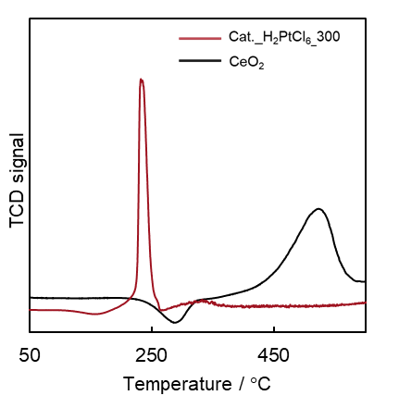
Supplementary Figure 8. Temperature programmed reduction (TPR) profiles of 1 wt% Pt/CeO₂ (prepared from an H₂PtCl₆·6H₂O precursor, red line) and CeO₂ (black line).

CeO₂ usually gave a peak at 550 ℃, which belonged to the reduction of the surface of CeO₂.⁵ Also, Pt/CeO₂_Cl only showed an intense reduction peak at 220 ℃ below 600 ℃, which might be related to the Pt(OH)_{x}Cl_{y} species directly connected to the surface of CeO₂ (Supplementary Figure 8).⁶ Also, the disappearance of the reduction peak of CeO₂ in the curve of the prepared catalysts revealed a strong metal-support interaction (SMSI) between Pt and CeO_{2.} Pt/CeO₂_A showed a peak at 80 ℃, and Pt/CeO₂_N showed a peak at 190 ℃ (Supplementary Figure 9a). The difference in the reduction peaks of the prepared Cl-free catalysts might be related to the surface PtO_{x} of different sizes and Pt/O ratios as well as the strong interaction between Pt and CeO₂.⁷⁻⁹ Pt/CeO₂_Cl was calcined at 300 ℃ and 500 ℃ in the preparation process to obtain Pt(OH)_{x}Cl_{y} and PtO_{x}Cl_{y} as reference peaks.⁶ After HCl treatment, the peak of Pt/CeO₂_A_HCl was mainly observed at approximately 220 ℃ (Supplementary Figure 9b). The peak of Pt/CeO₂_N_HCl shifted to 250 ℃. Therefore, Pt species after HCl treatment were mainly considered Pt(OH)_{x}Cl_{y} and PtO_{x}Cl_{y} with the reference peaks obtained. This result was consistent with the result of the EXAFS spectra. The shift in the temperature may be related to the difference in the ratio of x/y of the species; the main reduction temperature increased along with a decrease in the x/y ratio, which meant that the sample contained a greater amount of Pt–Cl coordination. Hence, the weak reduction peaks occurred at the high temperature in Pt/CeO₂_A_HCl, probably related to the large Pt–Cl coordination numbers or smaller clusters containing stronger Pt–O–Ce bonding.

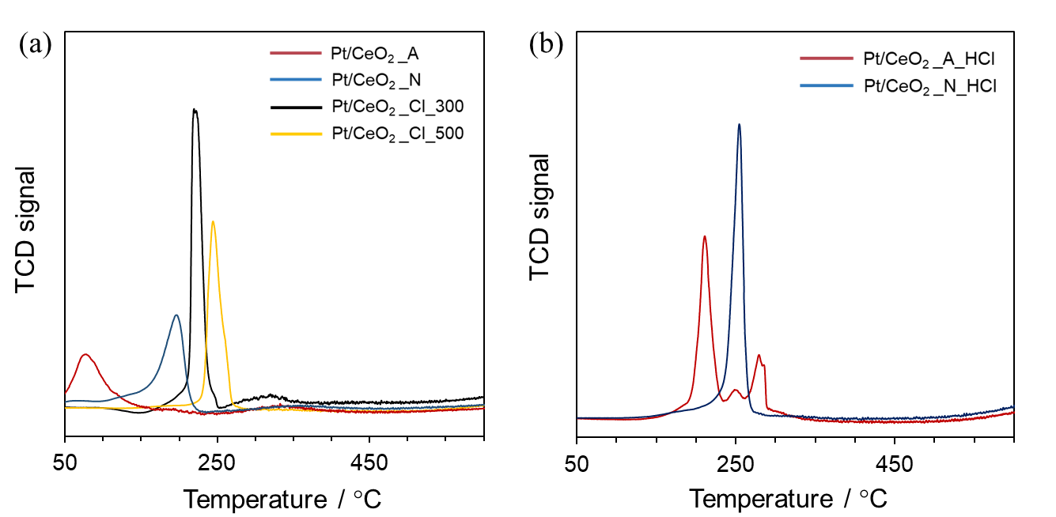
Supplementary Figure 9. Temperature programmed reduction (TPR) profiles of 1 wt% Pt/CeO₂ prepared (a) from different precursors at different calcination temperatures or (b) with HCl posttreatment.

(a) Different precursors: 1 wt% Pt/CeO₂ catalysts prepared from three kinds of precursors were detected by TPR measurement. The catalyst prepared from Pt(acac)₂ showed a peak at 80 ℃ (red). The catalysts prepared from Pt(NH₃)₄(NO₃)₂ gave a peak at 190 ℃ (blue). The catalyst prepared from H₂PtCl₆·6H₂O was calcined at 300 ℃ (black) and 500 ℃ (yellow).

(b) HCl posttreatment: After the HCl treatment, the peak of the Pt catalyst prepared from Pt(acac)₂ turned into three peaks at 215 ℃, 250 ℃, and 275 ℃ (red). The peak of the Pt catalyst prepared from Pt(NH₃)₄(NO₃)₂ shifted to 250 ℃ (blue).

(5) Lee, J.; Ryou, Y.; Chan, X.; Kim, T. J.; Kim, D. H. How Pt Interacts with CeO₂ under the Reducing and Oxidizing Environments at Elevated Temperature: The Origin of Improved Thermal Stability of Pt/CeO₂ Compared to CeO₂. J. Phys. Chem. C 120, 25870-25879 (2016).
(6) Lieske, H.; Lietz, G.; Spindler, H.; Völter, J. Reactions of Platinum in Oxygen- and Hydrogen-Treated Pt γ-Al₂O₃ catalysts. I. Temperature-Programmed Reduction, Adsorption, and Redispersion of Platinum. J. Catal. 81, 8-16 (1983).
(7) Gao, Y.; Wang, W.; Chang, S.; Huang, W. Morphology Effect of CeO₂ Support in the Preparation, Metal-Support Interaction, and Catalytic Performance of Pt/CeO₂ Catalysts. ChemCatChem 5, 3610-3620 (2013).
(8) Acerbi, N.; Tsang, S. C.; Golunski, S.; Collier, P. A Practical Demonstration of Electronic Promotion in the Reduction of Ceria Coated PGM Catalysts. Chem. Commun. 13, 1578-1580 (2008).
(9) Acerbi, N.; Tsang, S. C. E.; Jones, G.; Golunski, S.; Collier, P. Rationalization of Interactions in Precious Metal/Ceria Catalysts Using the d-Band Center Model. Angew. Chem. Int. Ed. 52, 7737-7741 (2013).

- Catalytic isomerization of allylic esters
3-1 Discussion on substrate scope
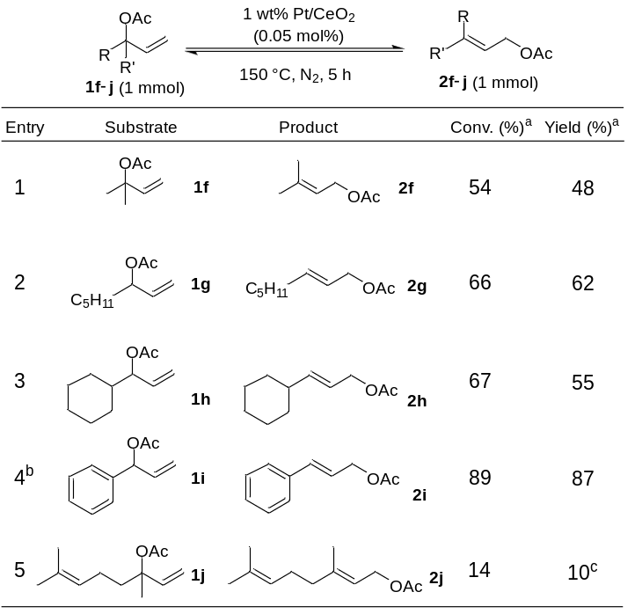
Supplementary Figure 10. Pt/CeO₂-catalyzed isomerization of allylic acetates. ªDetermined by GC analysis using tridecane as an internal standard. ^{b} 0.25 mol% Pt/CeO₂ added. ^{c} 71:29 ratio of E/Z isomers.

When allylic acetates derived from tertiary alcohol were tested, a yield of 48% was achieved (entry 1). The substrates with pentyl or cyclo-hexyl groups showed similar yields to the model reaction discussed above (entries 2 and 3). Particularly, the substrate with the phenyl group provided a higher transformation rate than the others, which might be because of the stable conjugated structure in the product (entry 4). Low transformation and low Z-isomer amounts were detected when using linalyl acetate derived from tertiary alcohols, which might be due to the strong steric effect on the surface (entry 5).

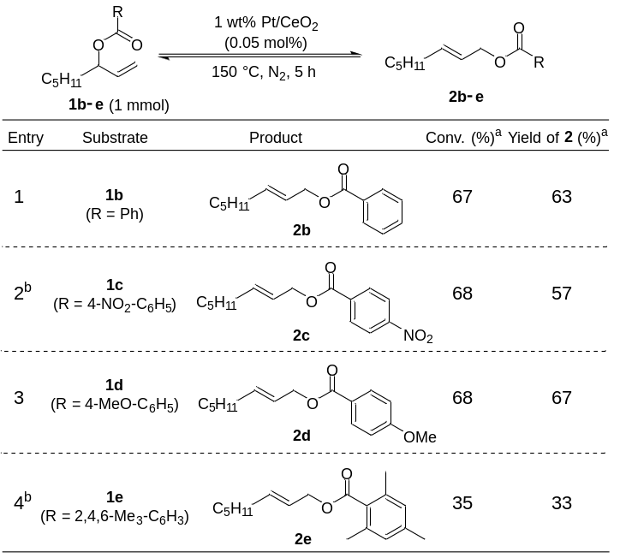
Supplementary Figure 11. Pt/CeO₂-catalyzed isomerization of allylic benzoates. ªDetermined by NMR analysis using mesitylene as an internal standard. ^{b} The experiment was conducted under an air atmosphere.

Regardless of the presence of the electron-donating methoxy or electron-withdrawing nitryl group on the phenyl, the detected yields were almost 57−67% (entries 1−3), revealing the weak electron effect in this reaction system. Furthermore, allylic benzoate with a 2,4,6-trimethylphenyl group was used to confirm the steric effect of the substrates (entry 4). A 33% yield revealed that the steric effect plays a more important role than the electron effect in this reaction.

3-2 Isormerization with homogeneous catalysts.
Supplementary Table 6. Catalytic isomerization of oct-1-en-3-yl benzoate with homogeneous catalysts.

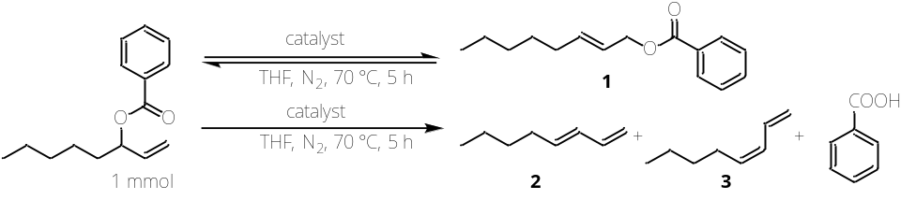

entry | catalyst | solvent | Yield (%)^{b} |  |  | TON^{c}
entry | catalyst | solvent | 1 | 2 | 3 | TON^{c}
1 | Pd(PPh₃)₄ (10 mol%) | THF | 0 | 63 | 31 | 0
2 | PdCl₂(MeCN)₂ (10 mol%) | THF | 64 | 0 | 0 | 6
3 | Pt(PPh₃)₄ (10 mol%) | THF | 0 | 70 | 29 | 0
4 | PtCl₂(PhCN)₂ (10 mol%) | THF | 59 | 0 | 0 | 6
5 | Pt(acac)₂ (10 mol%) | THF | 0 | 0 | 0 | 0
6 | H₂PtCl₆$∙$6H₂O (10 mol%) | THF | 42 | 0 | 0 | 4
7ª | Pt/CeO₂ (0.01 mol%) | neat | 50 | 0 | 0 | 5000
ª Reaction condition: 150 °C, 4 h.
^{b} Determined by NMR analysis using mesitylene as an internal standard
^{c} Turnover numbers of catalytic isomerization of allylic esters.

Homogeneous Pt and Pd catalysts were also used to investigate the reaction mechanism and effect of Pt−Cl bonding by oct-1-en-3-yl benzoate. It was reported that Pd(PPh₃)₄ can catalyze the isomerization of allylic esters through a π-allyl intermediate. However, only dienes were detected in this reaction, which might be due to the relatively low nucleophilicity of the carbonyl oxygen atom in the benzoyl ester group. Hence, the isomerization of substrates such as oct-1-en-3-yl benzoate could only proceed by the soft Lewis acid mechanism. Apart from Pt(PPh₃)₄ and Pt(acac)_{2,} PtCl₂(PhCN)₂ and H₂PtCl₆$∙$6H₂O both showed activity in the isomerization reaction with a low TON. An elimination reaction was observed when using Pt(PPh₃)₄, and no products were detected when using Pt(acac)₂. This result proved that catalysts containing Pt−Cl bonds can act as soft Lewis acids and promote the isomerization of allylic esters.

3-3 Proposed catalytic cycle

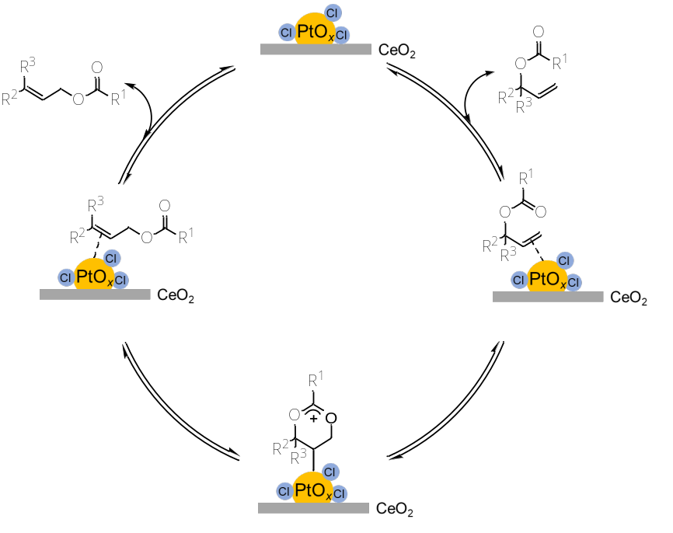
Supplementary Figure 12. Proposed catalytic cycle of the isomerization of allylic esters.

- Details of the calculations and structural models

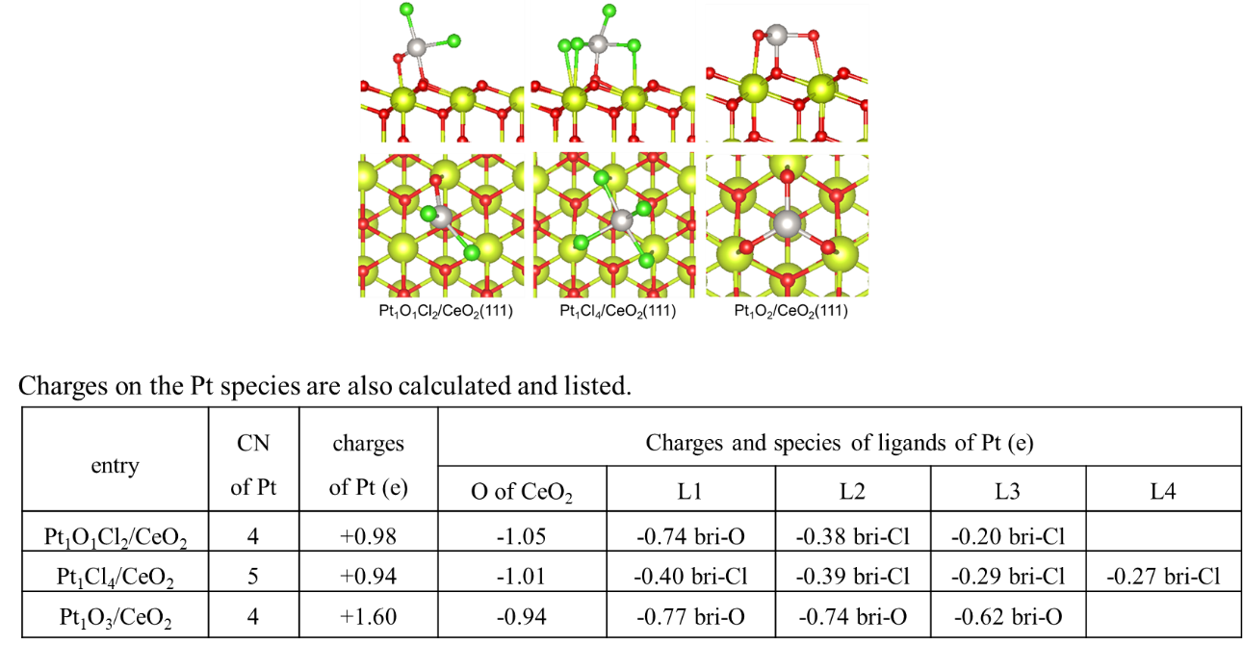
Supplementary Figure 14. Optimized structural models of the CeO₂-supported Pt catalysts and the calculated charges on the Pt species.

Structural models in which chlorine atoms were bonded with platinum on the CeO₂ surface were hypothesized and calculated for the whole 3,4-DABE isomerization reaction. Optimized structural models for each state are shown in Supplementary Figure 15.

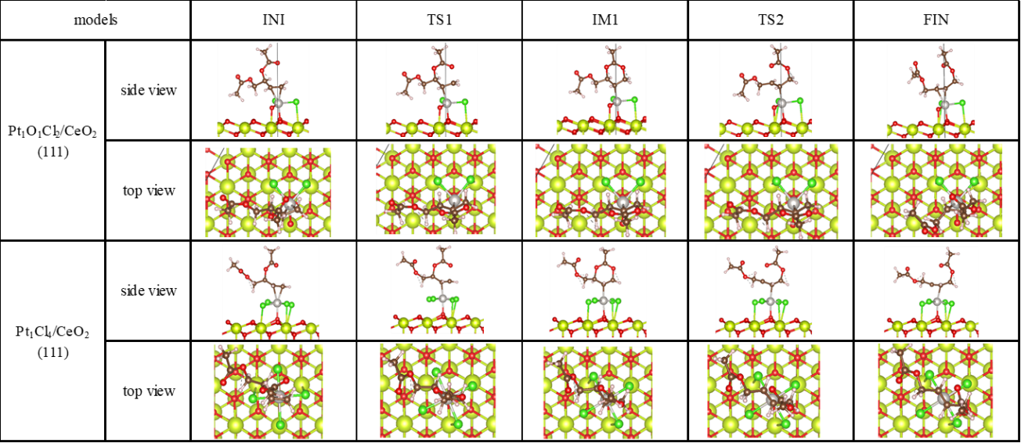
Supplementary Figure 15. Optimized structural models for the reaction path of the isomerization of 3,4-DABE over CeO₂ supported Pt catalysts containing Pt–Cl bonds.

Isomerization of 3,4-DABE on the surface of PtO₂/CeO₂ was also hypothesized and calculated. A structural model of Pt₁O₃/CeO₂ was created and the binding between the surface of the catalyst and 3,4-DABE was thought to be generated via a di–σ (Pt–O) bond instead of a π–bond. Optimized structural models for each state are shown in Supplementary Figure 16.

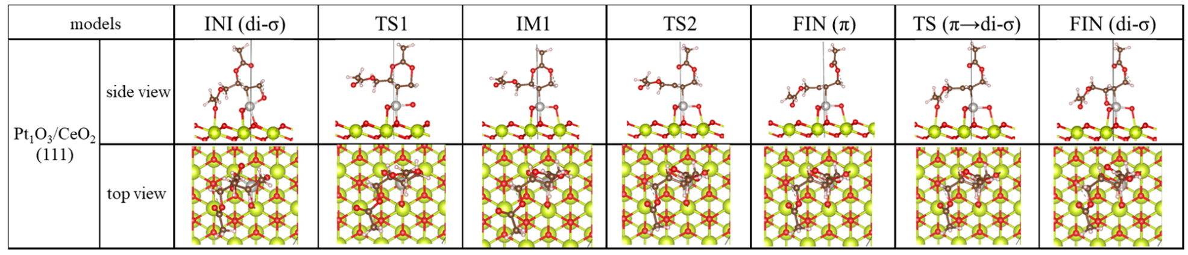
Supplementary Figure 16. Optimized structural models for the reaction path of the isomerization of 3,4-DABE over Pt₁O₃/CeO₂ catalysts.

The calculation result for the isomerization of 3,4-DABE on the bulk surface (011) of PtO₂ catalyst was shown in Supplementary Figure 17. The adsorption of 3,4-DABE should also occur via di–σ (Pt–O) bonding instead of the π–bond. Because of the high desorption energy (1.66 eV), bulk PtO₂ is also inactive for the isomerization of 3,4-DABE.

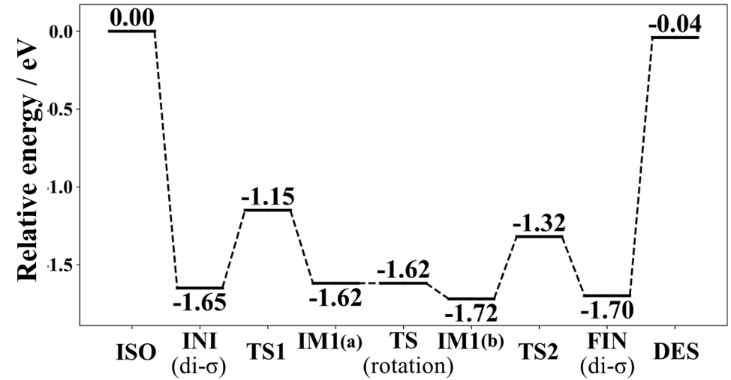
Supplementary Figure 17. Diagram of the energy calculation of the transition states on the model catalyst PtO₂ (011).

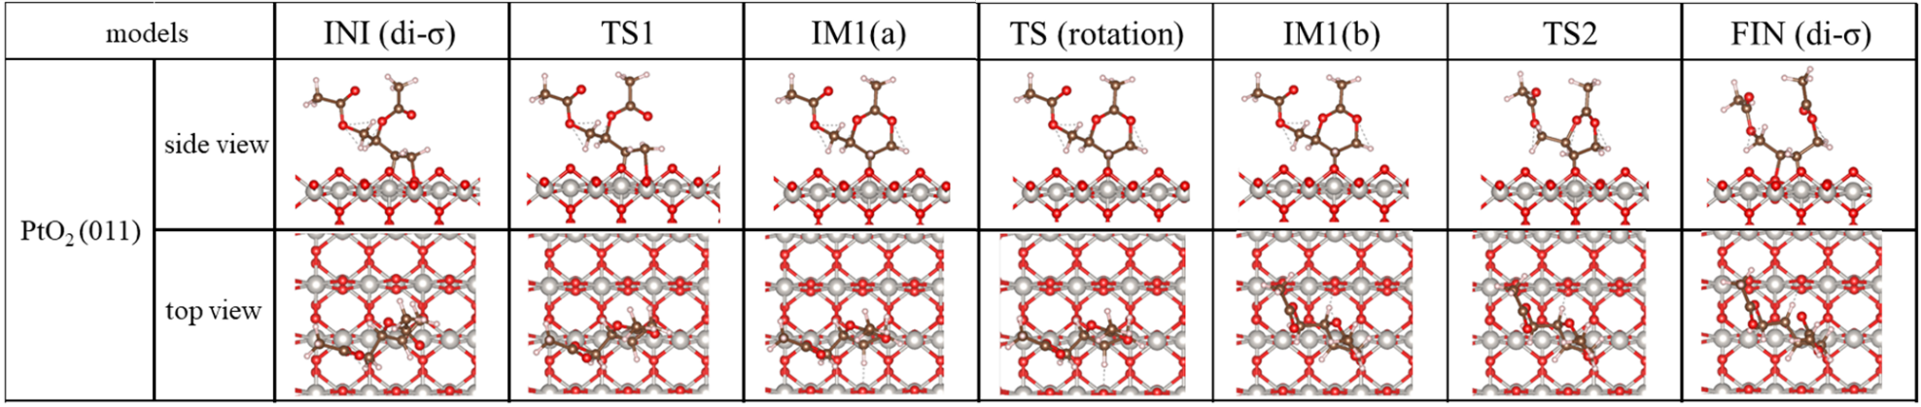
Supplementary Figure 18. Optimized structural models for the reaction path of the isomerization of 3,4-DABE over PtO₂ (011) catalysts.

Both the bulk PtO₂ and the supported PtO₂ catalysts were proved to adsorb C=C via di-σ (Pt–O) bonding at INI and FIN. Since the di–σ (Pt–O) bonding is stable, the desorption of the substrate does not proceed. In order to investigate the basic adsorption site of C=C structure, the adsorption states of ethylene on bulk PtO₂ were compared in Supplementary Figure 19.

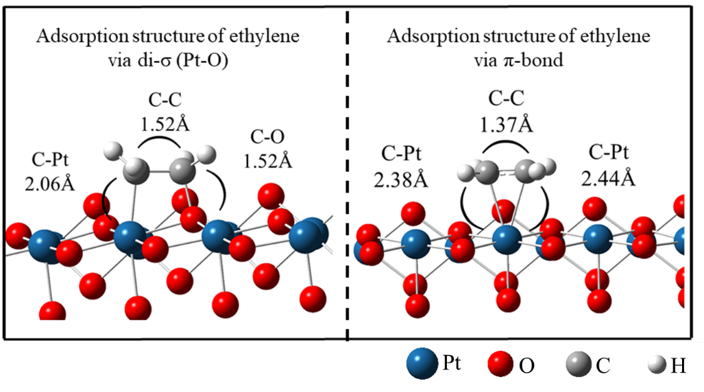
Supplementary Figure 19. Comparison of the adsorption states of ethylene on bulk PtO₂.

The adsorption energies of ethylene on optimized structures of discussed Pt catalysts were compared based on di–σ (Pt–O) bonding and di–σ (Pt–Cl) bonding (Supplementary Table 7). The results show that on the model of the listed catalysts, di–σ (Pt–O) bonding is more stable than the π-bond and tends to be difficult to process the desorption. Also, for the calculation over Pt₁O₁Cl₂/CeO₂ and Pt₁Cl₄/CeO₂, di–σ (Pt–Cl) bonding is less stable than the π-bond.

Supplementary Table 7. Adsorption energy for ethylene on discussed structures.

Catalyst | E_{ad} (eV) | di−σ (Pt−O) |  | di−σ (Pt−Cl)
Catalyst | E_{ad} (eV) | E_{ad} (eV) | ΔE_{ad} (eV) | E_{ad} (eV) | ΔE_{ad} (eV)
Pt₁O₃/CeO₂ | -1.05 | -1.86 | -0.81 | - | -
Pt₁O₁Cl₂/CeO₂ | -1.02 | -1.29 | -0.27 | -0.54 | 0.48
Pt₁Cl₄/CeO₂ | -1.19 | - | - | -1.02 | 0.17
PtO₂ (011) | -0.81 | -1.67 | -0.86 | - | -

- Substrates Discussion
5-1. Characterization of the Products

3-methylbut-2-en-1-yl acetate
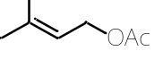
¹H NMR (600 MHz, CDCl₃) δ 5.33–5.30 (1 H, m), 4.54 (2 H, d, J = 7.6 Hz), 2.03 (3 H, s), 1.74 (3 H, s), 1.68 (3 H, s).
¹³C NMR (151MHz, CDCl₃) δ 171.4, 139.3, 118.6, 61.5, 25.9, 21.1, 18.1.

(E)-Oct-2-en-1-yl acetate
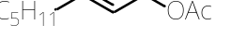
¹H NMR (400 MHz, CD₃OD) δ 5.80–5.73 (1 H, m), 5.56–5.51 (1 H, m), 4.46 (2 H, d, J = 6.9 Hz), 2.05–1.99 (5 H, m), 1.40–1.24 (6 H, m), 0.90–0.86 (3 H, m).
¹³C NMR (151MHz, CD₃OD) δ 171.3, 136.0, 123.9, 64.9, 31.9, 31.2, 28.5, 22.2, 19.5, 13.1.

(E)-3-cyclohexylallyl acetate
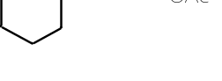
¹H NMR (600 MHz, CDCl₃) δ 5.76–5.68 (1H, m), 5.52–5.47 (1 H, m), 4.49 (2 H, d, J = 6.2 Hz), 2.05 (3 H, m), 1.98–1.94 (1 H, m), 1.72–1.62 (5 H, m) 1.28–0.94 (5 H, m).
¹³C NMR (151MHz, CDCl₃) δ 171.1, 142.3, 121.3, 65.7, 40.4, 32.6, 26.2, 26.0, 21.2.

Cinnamyl acetate
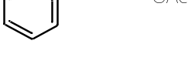
¹H NMR (400MHz, CD₂Cl₂) δ 7.37–7.19 (5 H, m), 6.60 (1 H, d, J = 15.6 Hz), 6.25 (1 H, dt, J = 15.7, 6.3 Hz), 4.66 (2 H, dd, J = 6.4, 1.4 Hz), 2.03 (3 H, s).
¹³C NMR (151MHz, CD₂Cl₂) δ 170.6, 136.3, 133.6, 128.6, 128.0, 126.5, 123.6, 64.9, 20.8.

(a) Geranyl acetate, (b) Neryl acetate
(a) (b)
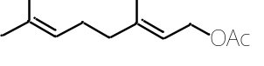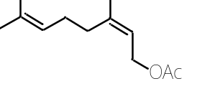
¹H NMR (600 MHz, CD₃OD) δ 5.33–5.28 (1H, m), 5.15–5.06 (1 H, m), 4.56–4.51 (2 H, m), 2.11–1.94 (7 H, m), 1.89–1.64 (6 H, m), 1.59–1.57 (3 H, m).
¹³C NMR (151MHz, CD₃OD) (a) δ 170.5, 141.8, 131.3, 123.6, 118.5, 60.9, 39.2, 26.0, 24.5, 19.5, 16.3, 15.1. (b) δ 170.5, 141.8, 131.3, 123.6, 119.2, 60.7, 31.7, 26.3, 24.5, 22.8, 19.5, 16.3.

(E)-Oct-2-en-1-yl benzoate
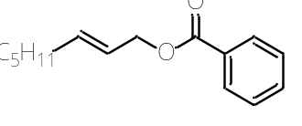
¹H NMR (400 MHz, CDCl₃) δ 8.04–8.01 (2H, m), 7.54–7.50 (1 H, m), 7.43–7.38 (2 H, m), 5.90–5.79 (1 H, m), 5.68–5.61 (1 H, m), 4.73 (2 H, d, J = 6.4 Hz), 2.04 (2 H, q, J = 7.2 Hz), 1.41–1.23 (6 H, m), 0.87–0.83 (3 H, m).
¹³C NMR (151 MHz, CDCl₃) δ 166.6, 136.9, 132.9, 130.5, 129.7, 128.4, 123.8, 65.9, 32.4, 31.5, 28.7, 22.6, 14.1.

(E)-Oct-2-en-1-yl p-nitrobenzoate
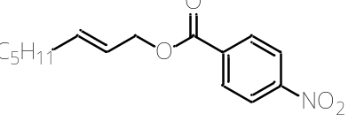
¹H NMR (600 MHz, CDCl₃) δ 8.29–8.27 (2H, m), 8.22–8.20 (2 H, m), 5.91–5.85 (1 H, m), 5.69–5.64 (1 H, m), 4.80 (2 H, d, J = 5.5 Hz), 2.08 (2 H, q, J = 7.1 Hz), 1.43–1.25 (6 H, m), 0.89–0.87 (3 H, m).
¹³C NMR (151 MHz, CDCl₃) δ 164.6, 150.6, 138.0, 135.9, 130.8, 123.6, 123.1, 66.8, 32.4, 31.5, 28.6, 22.6, 14.1.

(E)-Oct-2-en-1-yl p-methoxybenzoate
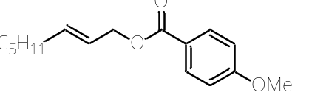
¹H NMR (400 MHz, CDCl₃) δ 7.99–7.96 (2H, m), 6.90–6.86 (2 H, m), 5.89–5.77 (1 H, m), 5.67–5.60 (1 H, m), 4.69 (2 H, d, J = 6.4 Hz), 3.82 (3H, m), 2.03 (2 H, q, J = 7.0 Hz), 1.40–1.23 (6 H, m), 0.87–0.82 (3 H, m).
¹³C NMR (151 MHz, CDCl₃) δ 166.3, 163.4, 136.6, 131.7, 124.0, 122.9, 113.6, 65.6, 55.5, 32.4, 31.5, 28.7, 22.6, 14.1.

(E)-Oct-2-en-1-yl 2,4,6-trimethylbenzoate
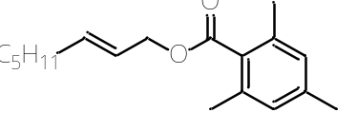
¹H NMR (600 MHz, CDCl₃) δ 6.83 (2H, m), 5.88–5.82 (1 H, m), 5.68–5.63 (1 H, m), 4.73 (2 H, d, J = 6.9 Hz), 2.27–2.26 (9 H, m), 2.05 (2 H, q, J = 7.1 Hz), 1.43–1.23 (6 H, m), 0.89–0.86 (3 H, m).
¹³C NMR (151 MHz, CDCl₃) δ 170.1, 139.3, 137.4, 135.1, 131.1, 128.4, 123.6, 65.8, 32.3, 31.4, 28.6, 22.6, 21.2, 19.7, 14.1.

5-2. ¹H and ¹³C NMR charts of compounds
(some charts contained both substrates and products because of the difficulty in separation)
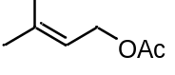
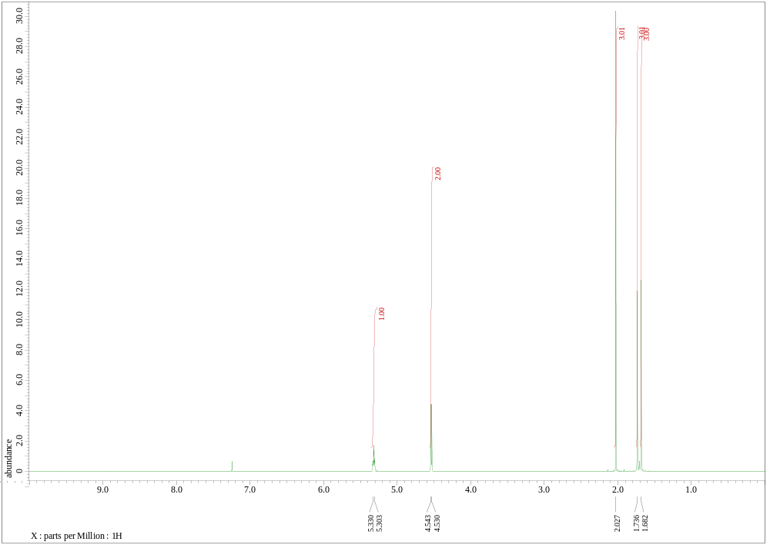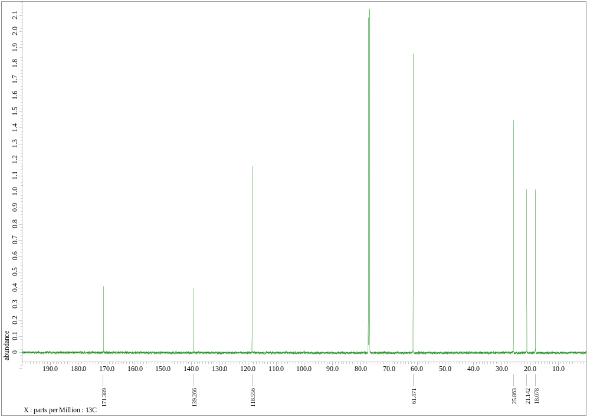

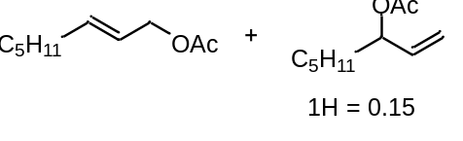
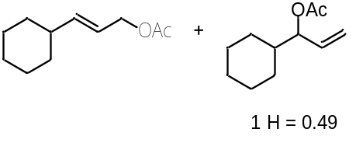
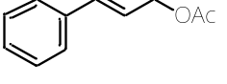
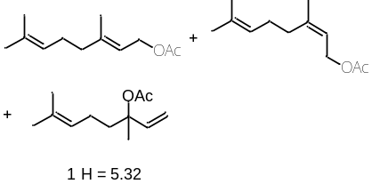
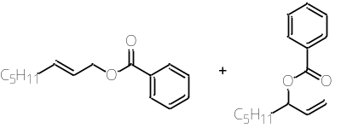
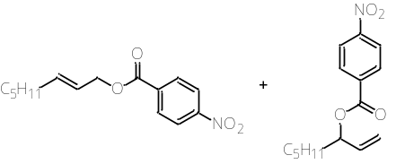
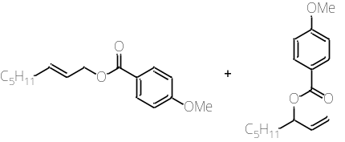
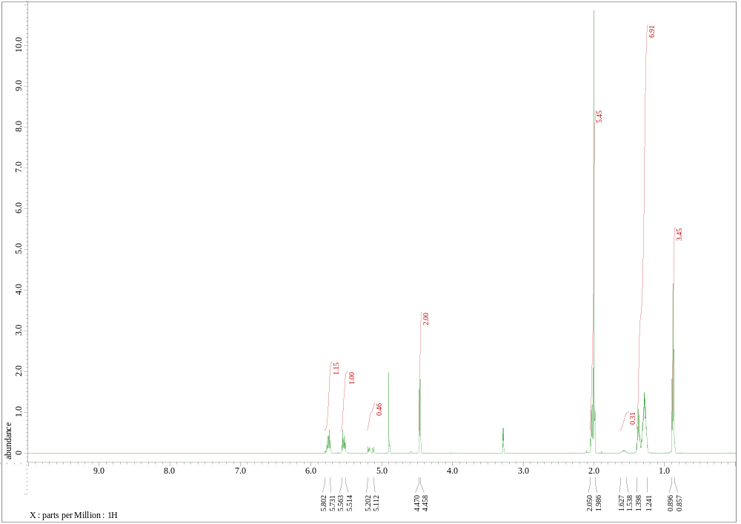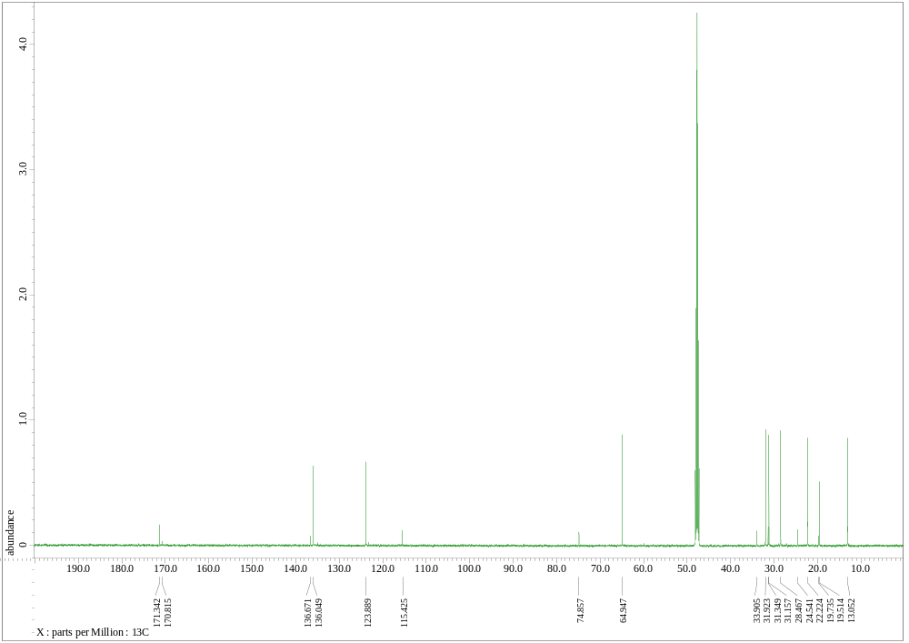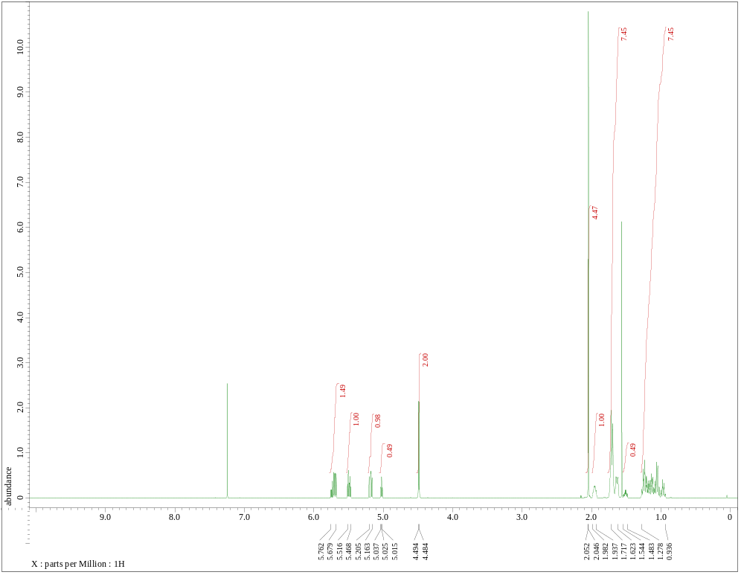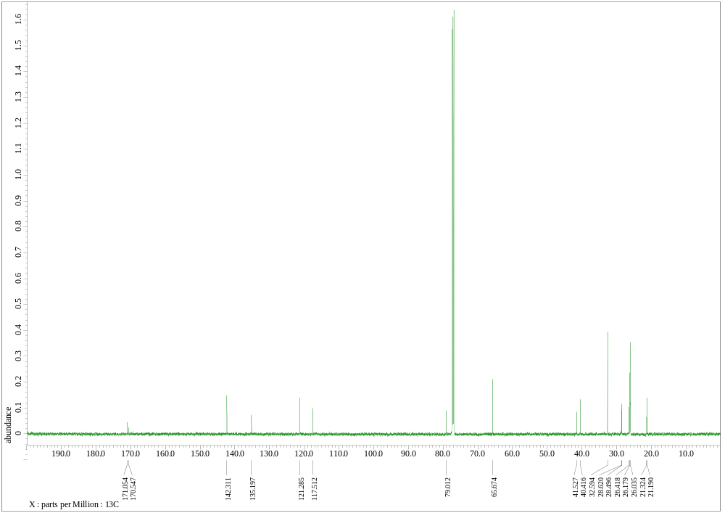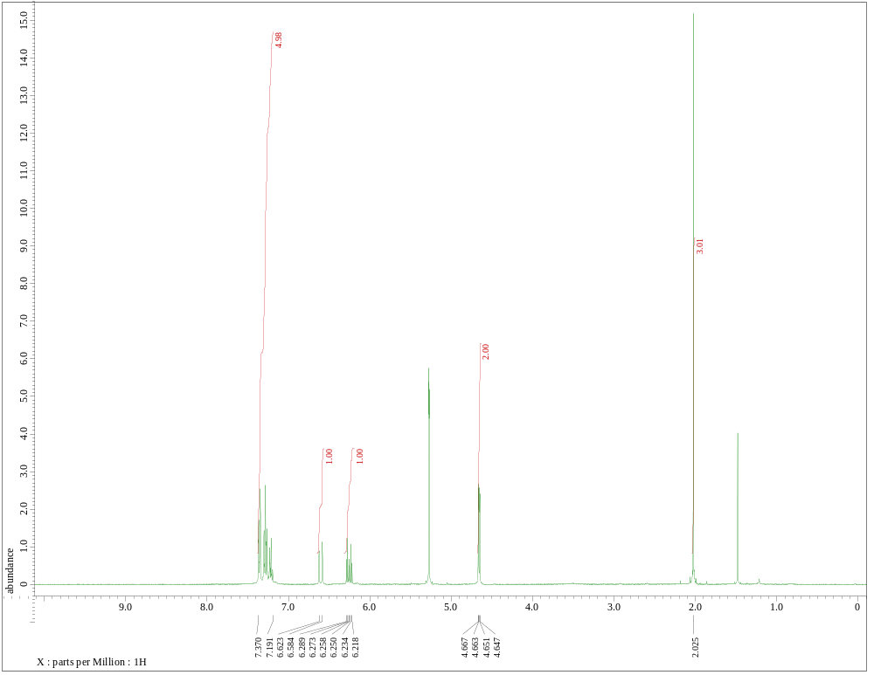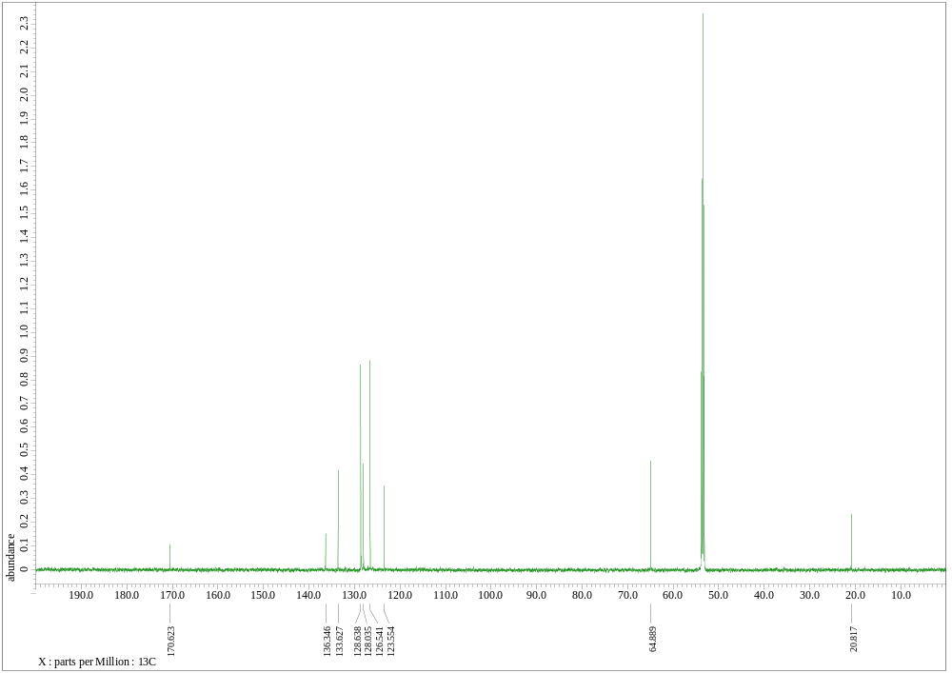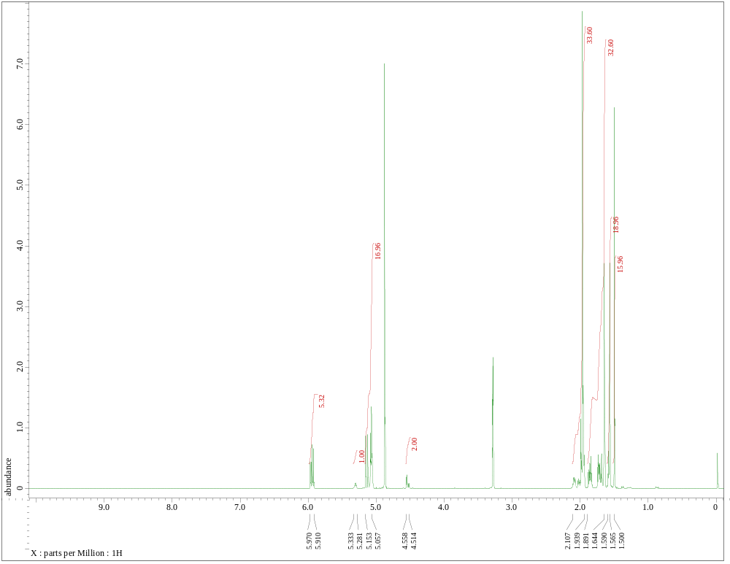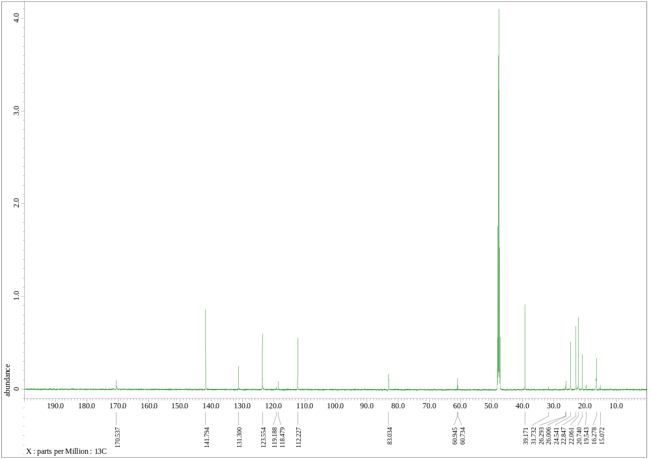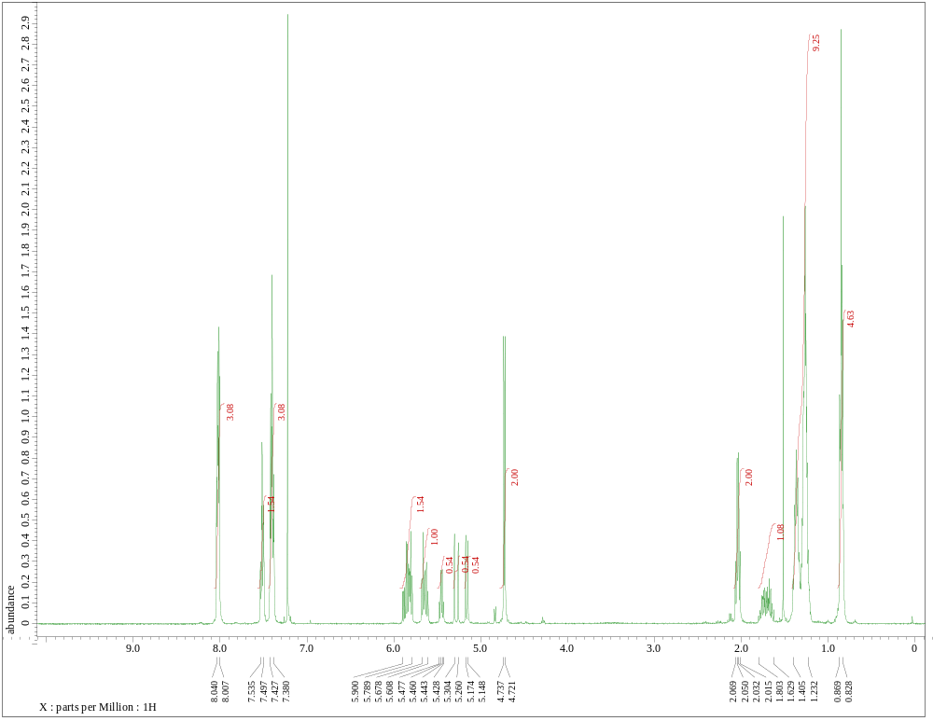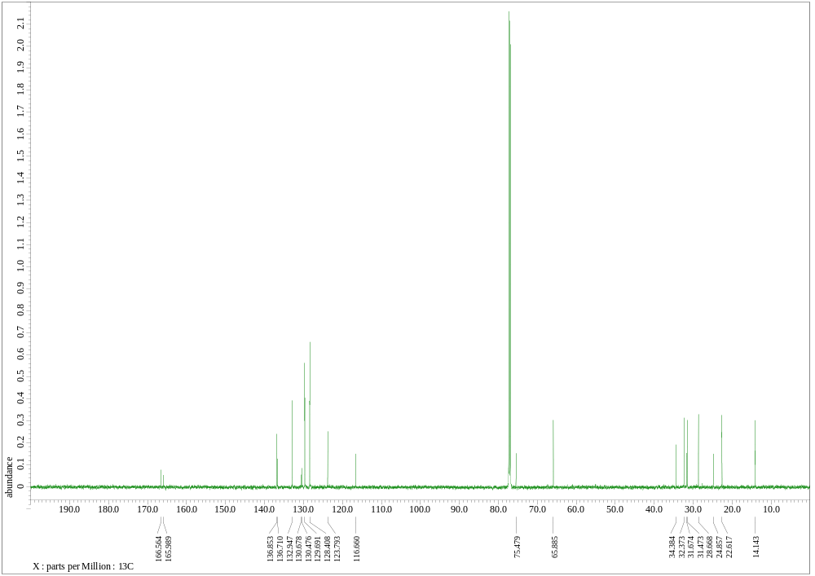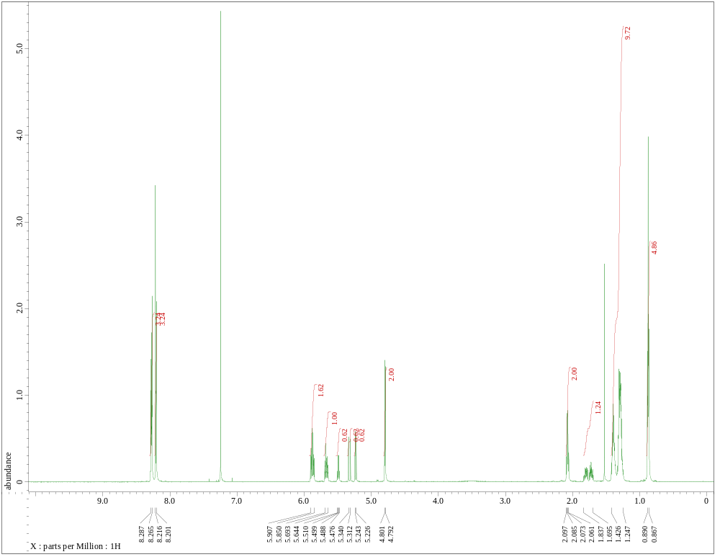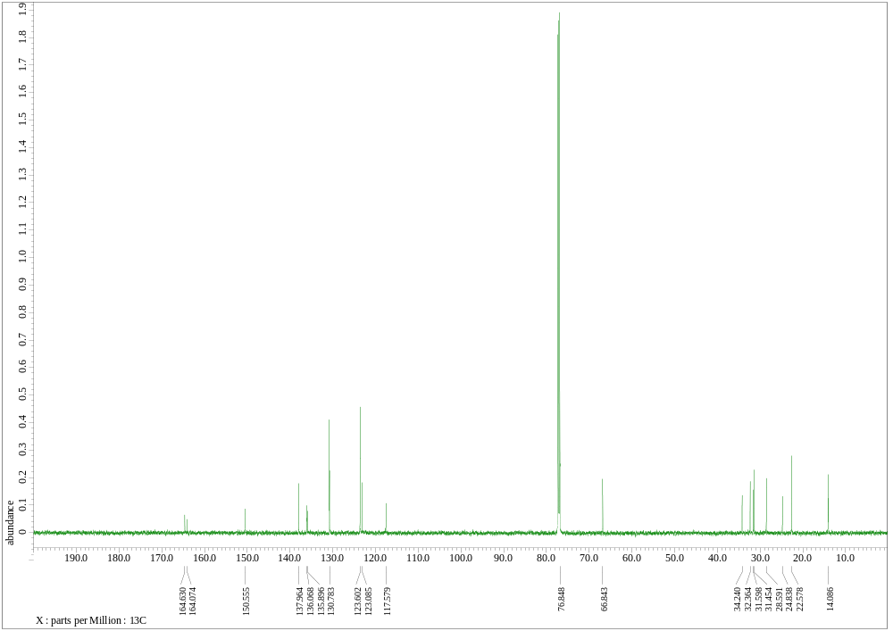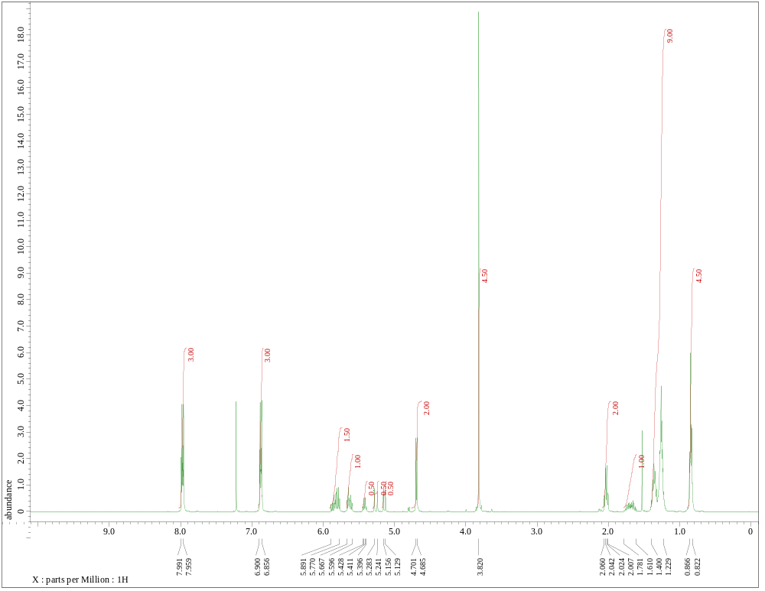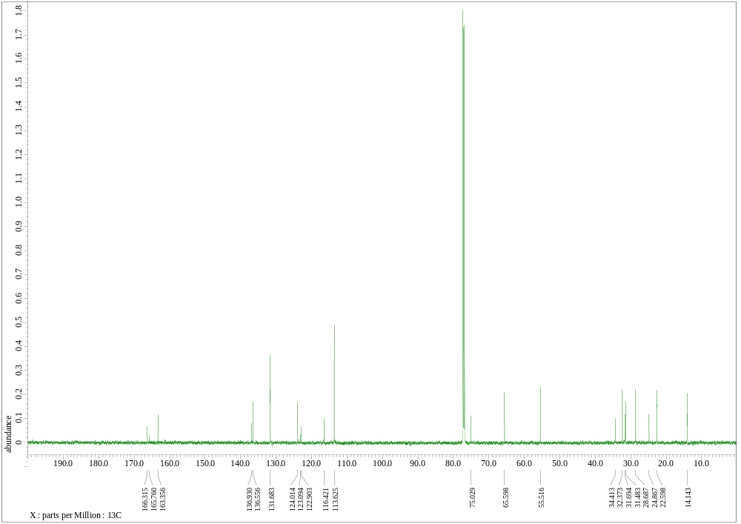

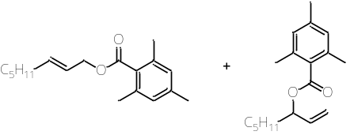
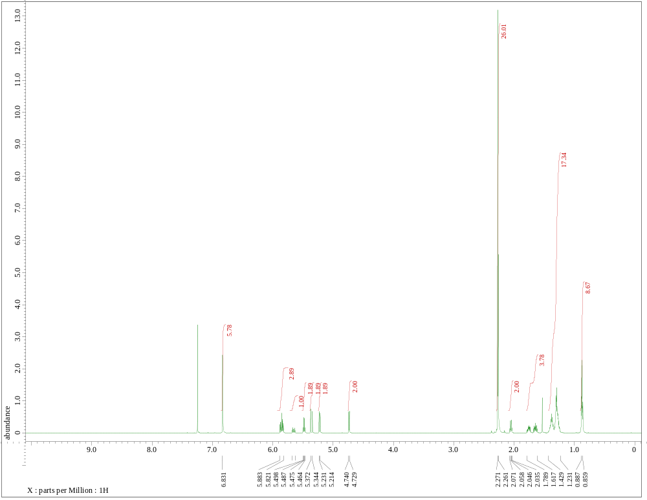
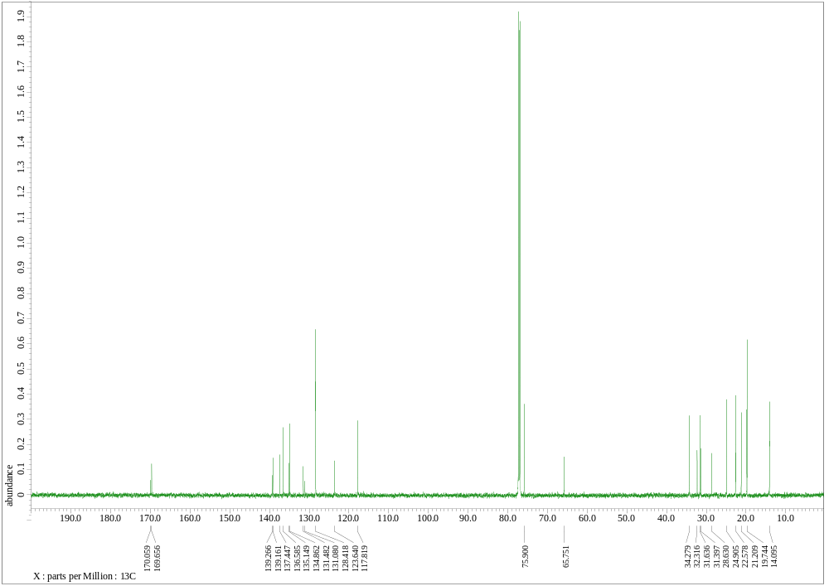

¹H NMR charts of byproducts dienes of isomerization of oct-1-en-3-yl benzoate with homogeneous catalyst.
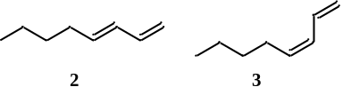
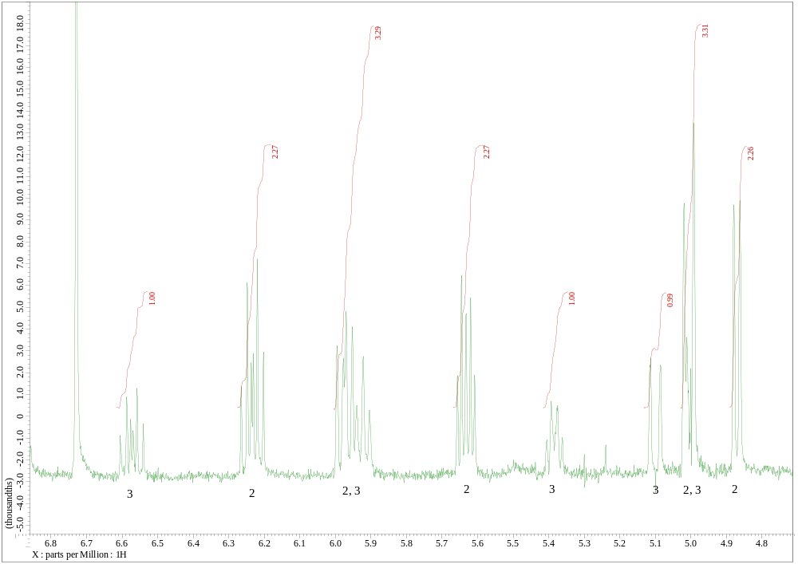
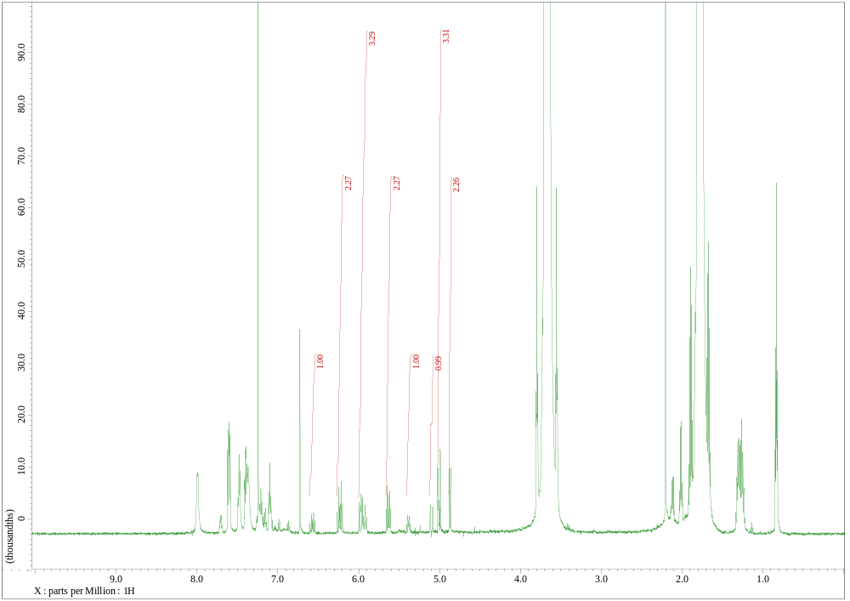

Engman, L.; Bystrom, S. E. Tellurolate-Induced 1,4-Elimination of 1,4-Dibromo 2-Enes. Syntheses of 1,3-Dienes. J. Org. Chem. 1985, 50, 3170–3174.

