The availability, consumption and inequality in access to calories during two years of war
and food import restrictions in the Gaza Strip
Supplementary information
Table of Contents
1. Estimated monthly population 2
2. Population food requirements 2
3. Sensitivity analysis 5
4. Existing stocks in October 2023 11
5. Calculating food and caloric availability via local production 12
6. Caloric conversion factors 15
7. Metric tonnes of available food, October 2023 to September 2025 16
8. Estimates of caloric availability 19
9. Estimates of caloric consumption 22
10. Stockpile dynamics 25
11. Stochastic simulation of caloric distribution 25
References 29

- Estimated monthly population
Table S1: Population dynamics
Month | Population |  | Month | Population
23-Oct | 2,289,696 |  | 24-Oct | 2,106,857
23-Nov | 2,273,872 |  | 24-Nov | 2,092,296
23-Dec | 2,258,157 |  | 24-Dec | 2,077,835
24-Jan | 2,242,550 |  | 25-Jan | 2,063,016
24-Feb | 2,227,051 |  | 25-Feb | 2,048,302
24-Mar | 2,211,660 |  | 25-Mar | 2,033,693
24-Apr | 2,196,375 |  | 25-Apr | 2,019,188
24-May | 2,181,195 |  | 25-May | 2,004,787
24-Jun | 2,166,120 |  | 25-Jun | 1,990,488
24-Jul | 2,151,150 |  | 25-Jul | 1,976,292
24-Aug | 2,136,283 |  | 25-Aug | 1,960,813
24-Sep | 2,121,519 |  | 25-Sep | 1,945,455
Source: Authors’ own elaboration
- Population food requirements
Table S2: Daily caloric requirements, by age group
Age group (years) | Sex | Rounded benchmark (kcal/day)
Children (1-10)
1–3 years |  | ~1 000
4–6 years |  | ~1 400
7–10 years |  | ~1 600
Adolescents (11-19)
11-13 years | Female | ~2 000
11-13 years | Male | ~2 300
14-18 years | Female | ~2 200-2 300
14-18 years | Male | ~2 600-2 700
19 years | Female | ~2 300-2 400
19 years | Male | ~2 700-2 800
Adults (20-64)
20–30 years | Female | ~2 200
20–30 years | Male | ~2 500
31–50 years | Female | ~2 000
31–50 years | Male | ~2 400
51–64 years | Female | ~1 900
51–64 years | Male | ~2 300
Elderly (65+)
65+ years | Female | ~1 600–1 800
65+ years | Male | ~1 900–2 200
Source: (1)

Table S3: Caloric requirements, by age group
 | Children 1-10 years
ITEMS | Cal/100 grams | MRCI grams | MRCI kcal | Pop. Req. (MT) | 87% grams | 87% kcal | Pop. Req. (MT) | 67% grams | 67% kcal | Pop. Req. (MT)
Wheat flour | 360 | 228 | 819 | 141 | 195 | 702 | 121 | 155 | 558 | 96
Lentils | 116 | 115 | 133 | 71 | 103 | 119 | 64 | 95 | 110 | 61
Yoghurt | 59 | 195 | 115 | 121 | 175 | 103 | 109 | 164 | 97 | 105
Apples | 52 | 250 | 130 | 155 | 222 | 115 | 137 | 190 | 99 | 122
Sunflower oil | 844 | 13 | 110 | 8 | 11 | 95 | 7 | 9 | 74 | 6
Dates | 282 | 70 | 197 | 44 | 61 | 172 | 38 | 47 | 132 | 30
Total |  | 871 | 1,505 | 540 | 767 | 1,307 | 476 | 659 | 1,069 | 419

 | Adolescent 11-19 years
ITEMS | Cal/100 grams | MRCI grams | MRCI kcal | Pop. Req. (MT) | 87% grams | 87% kcal | Pop. Req. (MT) | 67% grams | 67% kcal | Pop. Req. (MT)
Wheat flour | 360 | 360 | 1,296 | 169 | 330 | 1,188 | 155 | 230 | 828 | 108
Lentils | 116 | 240 | 278 | 113 | 180 | 209 | 84 | 125 | 145 | 59
Labneh | 100 | 210 | 210 | 98 | 200 | 200 | 94 | 170 | 170 | 80
Dates | 52 | 150 | 78 | 70 | 130 | 68 | 61 | 100 | 52 | 47
Olive oil | 900 | 30 | 270 | 14 | 20 | 180 | 9 | 20 | 181 | 9
Hummus | 200 | 140 | 280 | 66 | 130 | 260 | 61 | 100 | 200 | 47
Total |  | 1,130 | 2,412 | 530 | 990 | 2,104 | 464 | 745 | 1,576 | 349

 | Adults 20-64
ITEMS | Cal/100 grams | MRCI grams | MRCI kcal | Pop. Req. (MT) | 87% grams | 87% kcal | Pop. Req. (MT) | 67% grams | 67% kcal | Pop. Req. (MT)
Wheat flour | 360 | 320 | 1,152 | 305 | 270 | 972 | 257 | 200 | 720 | 190
Chickpeas | 350 | 110 | 385 | 105 | 100 | 350 | 95 | 70 | 245 | 67
Labneh | 100 | 140 | 140 | 133 | 130 | 130 | 124 | 100 | 100 | 95
Dates | 52 | 180 | 94 | 171 | 140 | 73 | 133 | 121 | 63 | 115
Nuts | 900 | 35 | 315 | 33 | 30 | 270 | 29 | 23 | 211 | 22
Olive oil | 900 | 15 | 135 | 14 | 15 | 135 | 14 | 10 | 90 | 10
Hummus | 200 | 120 | 240 | 114 | 105 | 210 | 100 | 90 | 180 | 86
Total |  | 920 | 2,461 | 876 | 790 | 2,140 | 752 | 614 | 1,609 | 585

 | Elderly 65+ years
ITEMS | Cal/100 grams | MRCI grams | MRCI kcal | Pop. Req. (MT) | 87% grams | 87% kcal | Pop. Req. (MT) | 67% grams | 67% kcals | Pop. Req. (MT)
Wheat flour | 360 | 200 | 720 | 12 | 160 | 576 | 10 | 130 | 468 | 8
Chickpeas | 350 | 120 | 420 | 7 | 110 | 385 | 7 | 80 | 280 | 5
Labneh | 100 | 190 | 190 | 11 | 160 | 160 | 10 | 130 | 130 | 8
Dates | 52 | 100 | 52 | 6 | 100 | 52 | 6 | 70 | 36 | 4
Nuts | 900 | 40 | 360 | 2 | 35 | 315 | 2 | 30 | 270 | 2
Olive oil | 900 | 20 | 180 | 1 | 20 | 180 | 1 | 15 | 135 | 1
Hummus | 200 | 50 | 100 | 3 | 50 | 100 | 3 | 30 | 60 | 2
Total |  | 720 | 2,022 | 42 | 635 | 1,768 | 39 | 485 | 1,379 | 30
Source: Authors’ own elaboration

Table S4: Scaling the population of the Gaza Strip
Age category | Latest estimate prior to October 2023, (PCBS projection) | Estimated population by age-group (December 2024)
0-4 | 332,798 | 314,334
5-9 | 325,003 | 306,972
10-14 | 270,904 | 255,874
15-19 | 225,670 | 213,150
20-24 | 230,455 | 217,669
25-29 | 199,171 | 188,121
30-34 | 144,708 | 136,680
35-39 | 115,050 | 108,667
40-44 | 95,976 | 90,651
45-49 | 72,832 | 68,791
50-54 | 67,966 | 64,195
55-59 | 47,686 | 45,041
60-64 | 34,596 | 32,677
65+ | 61,299 | 57,898
Source: Authors’ own elaboration

Table S5: Metric tonnes (MT) of food per day to meet Minimum Recommended Caloric Intake (MRCI)
Age Group | Avg. Kcal/day | Population | Metric tonnes equivalent
100% of MRCI
Children (1–10) | 1,505 | 621,306 | 540
Adolescents (11-19) | 2,412 | 469,024 | 530
Adults (20–64) | 2,461 | 952,492 | 876
Elderly (65+) | 2,022 | 57,898 | 42
TOTAL | ~2,100* | 2,100,719 | 1,988
87% of MRCI
Children (1–10) | 1,307 | 621,306 | 476
Adolescents (11-19) | 2,104 | 469,024 | 464
Adults (20–64) | 2,140 | 952,492 | 752
Elderly (65+) | 1,768 | 57,898 | 39
TOTAL | ~1,831* | 2,100,719 | 1,732
67% of MRCI
Children (1–10) | 1,069 | 621,306 | 419
Adolescents (11-19) | 1,576 | 469,024 | 349
Adults (20–64) | 1,609 | 952,492 | 585
Elderly (65+) | 1,379 | 57,898 | 30
TOTAL | ~1,407* | 2,100,719 | 1,383
Source: Authors’ own elaboration and (2)
*Average

We then applied a proportional scaling which allowed us to estimate monthly food needs that keep per-capita requirements consistent while accounting for the changing population.
Table S6: Population MT monthly requirements
 | MT requirement  100% MRCI | MT requirement  87% MRCI | MT requirements  67% MRCI
Oct-23 | 2,167 | 1,887 | 1,507
Nov-23 | 2,152 | 1,874 | 1,497
Dec-23 | 2,137 | 1,861 | 1,487
Jan-24 | 2,122 | 1,848 | 1,476
Feb-24 | 2,108 | 1,836 | 1,466
Mar-24 | 2,093 | 1,823 | 1,456
Apr-24 | 2,079 | 1,810 | 1,446
May-24 | 2,064 | 1,798 | 1,436
Jun-24 | 2,050 | 1,785 | 1,426
Jul-24 | 2,036 | 1,773 | 1,416
Aug-24 | 2,022 | 1,761 | 1,406
Sep-24 | 2,008 | 1,749 | 1,397
Oct-24 | 1,994 | 1,737 | 1,387
Nov-24 | 1,980 | 1,725 | 1,378
Dec-24 | 1,967 | 1,713 | 1,368
Jan-25 | 1,953 | 1,701 | 1,358
Feb-25 | 1,939 | 1,688 | 1,349
Mar-25 | 1,925 | 1,676 | 1,339
Apr-25 | 1,911 | 1,664 | 1,329
May-25 | 1,897 | 1,653 | 1,320
Jun-25 | 1,884 | 1,641 | 1,310
Jul-25 | 1,870 | 1,629 | 1,301
Aug-25 | 1,856 | 1,616 | 1,291
Sep-25 | 1,841 | 1,604 | 1,281
Average | 2,002 | 1,744 | 1,393
Source: Authors’ own elaboration

- Sensitivity analysis
Three sensitivity analyses were carried out: 1) on our assumptions underlying the UN-Pallets and UN-20MT data series; 2) on possible upward bias in 2025 COGAT data arising from differences in data collection points along the supply chain and weighting of food shipments; and 3) on assumptions regarding food loss.
3.1 Assumptions underlying the UN-Pallets and UN-20MT data series
First, we compared monthly MT (Figure S1) and monthly average caloric availability (kcal/person/day) (Figure S2) for COGAT, UN-Pallet and UN-20MT conversion, and the estimates made by Fliss-Isakov and coauthors (3), for the period January 1 to July 31, 2024. Fliss-Isakov estimates are based on data with finer detail on food composition provided by COGAT, using USDA caloric conversion, and assuming 15% food loss. In both figures, all sources have the same time trends, with COGAT showing the highest numbers and the UN-Pallet measure the lowest. Fliss-Isakov and the UN 20MT method are similar, with UN 20MT showing higher amounts in January through April, and Fliss-Isakov higher amounts in May through July. Remarkably, the total amount of MTs of food over the period for these two estimates is nearly identical (Table S7), while the average caloric availability is similar (3,004 kcal/person/day for Fliss-Isakov versus 2,911, in Table S8).
Figure S1: Metric tonnes of food, by source, January 1 to July 31, 2024.
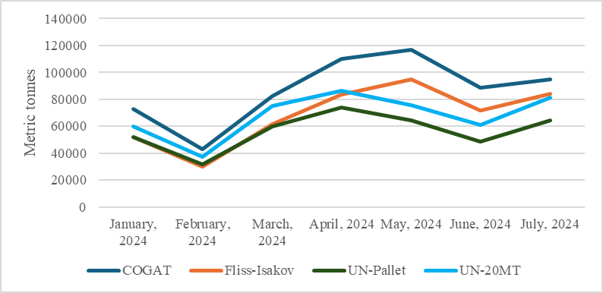
Source: Authors’ own elaboration, (3)

Figure S2: Average caloric availability, by source, January 1 to July 31, 2024.
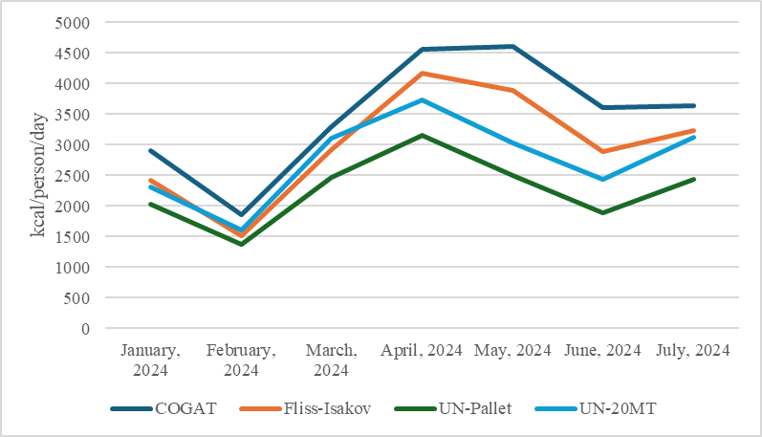
Source: Authors’ own elaboration, (3)
Table S7: Metric tonnes, by source, January 1 to July 31, 2024
 | COGAT | Fliss-Isakov | UN-Pallet | UN-20MT
January, 2024 | 72,624 | 52,293 | 52,046 | 59,804
February, 2024 | 43,202 | 30,290 | 31,785 | 37,292
March, 2024 | 82,394 | 61,330 | 59,831 | 75,135
April, 2024 | 109,912 | 83,587 | 74,099 | 86,681
May, 2024 | 116,855 | 94,884 | 64,667 | 75,708
June, 2024 | 88,460 | 71,903 | 48,727 | 61,090
July, 2024 | 94,997 | 83,942 | 64,249 | 81,492
Total | 608,443 | 478,229 | 395,404 | 477,202
Source: Authors’ own elaboration, (3)

Table S8: Average caloric availability, by source, January 1 to July 31, 2024.
 | COGAT | Fliss-Isakov | UN-Pallet | UN-20MT
January, 2024 | 2,911 | 2,424 | 2,029 | 2,315
February, 2024 | 1,862 | 1,508 | 1,372 | 1,612
March, 2024 | 3,298 | 2,919 | 2,472 | 3,103
April, 2024 | 4,555 | 4,167 | 3,163 | 3,738
May, 2024 | 4,604 | 3,886 | 2,497 | 3,031
June, 2024 | 3,615 | 2,893 | 1,895 | 2,436
July, 2024 | 3,638 | 3,232 | 2,437 | 3,129
Average | 3,498 | 3,004 | 2,266 | 2,766
Source: Authors’ own elaboration, (3)
3.2 Potential upwards bias in 2025 COGAT data
To assess the implications of a potential upward bias in 2025 COGAT data, we calculated the difference between the COGAT-scanned UN shipments and collected shipments in the UN2720 data for the period May 19 to September 30 and expressed this gap as a percentage of the COGAT UN scanned. Over the period, the percentage difference gradually reduced; overall, shipments collected at the Gaza Strip border were 7% less than the shipments scanned outside. The comparison of COGAT scanned data with UN2720 offloaded and collected data can be seen in Figure S3 and Table S9, and the COGAT numbers adjusted for the 7% difference in Table S10. We also compared the weight in metric tonnes as reported by COGAT and the UN2720 to look for any systematic differences. This comparison can be found in Table S11.
Figure S3: UN food aid scanned (COGAT), offloaded and collected (UN2720), cumulative total, May 19 to September 30, 2025.
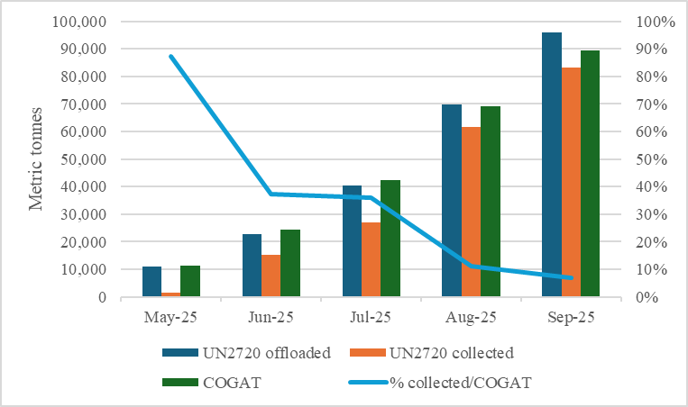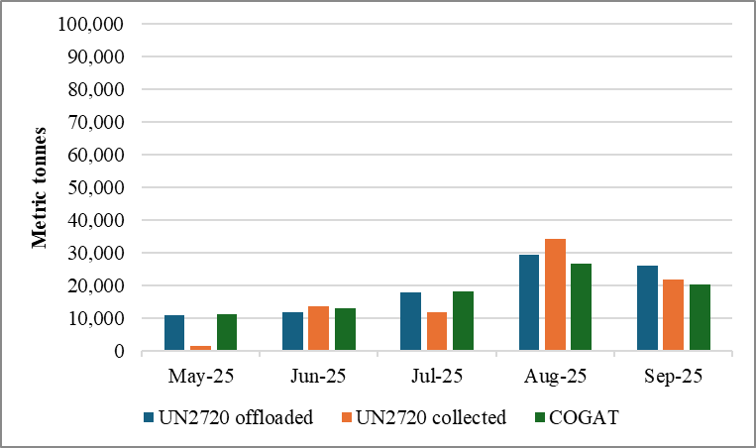Source: Authors’ own elaboration. UN2720 data accessed 9 December 2025; COGAT accessed 6 December 2025

Table S9: UN food aid (MT) offloaded and collected (UN2720) and scanned (COGAT), monthly and cumulative total, May 19 to September 30, 2025.
 | Cumulative |  |  |  | Monthly
Month | UN2720 Offloaded MT | UN2720 Collected MT | COGAT Scanned MT | % Collected/ COGAT | UN272 Offloaded MT | UN2720CollectedMT | COGAT Scanned MT
May-25 | 10,877 | 1,449 | 11,306 | 87% | 10,877 | 1,449 | 11,306
Jun-25 | 22,666 | 15,194 | 24,241 | 37% | 11,789 | 13,745 | 12,935
Jul-25 | 40,539 | 27,134 | 42,436 | 36% | 17,873 | 11,940 | 18,195
Aug-25 | 69,846 | 61,513 | 69,162 | 11% | 29,307 | 34,379 | 26,726
Sep-25 | 95,934 | 83,202 | 89,494 | 7% | 26,088 | 21,689 | 20,332
Source: Authors’ own elaboration. UN2720 data accessed 9 December 2025; COGAT accessed 6 December 2025.

Table S10: UN food aid (MT) and caloric availability (COGAT), by month, 15% food loss, with 7% correction for possible bias, January to September 30, 2025. Caloric availability includes local production.
 | MT |  | Kcal/pp/day
Month | COGAT | COGAT adjusted | COGAT | COGAT adjusted
Jan-25 | 14,3091 | 13,3741 | 4,898 | 4,573
Feb-25 | 18,6760 | 17,4453 | 7,166 | 6,689
Mar-25 | 2,816 | 2,816 | 33 | 33
Apr-25 | 2,645 | 2,645 | 32 | 32
May-25 | 19,584 | 18,453 | 636 | 596
Jun-25 | 34,736 | 32,581 | 1,229 | 1,149
Jul-25 | 48,021 | 44,979 | 1,680 | 1,570
Aug-25 | 106,888 | 99,900 | 3,862 | 3,605
Sep-25 | 82,800 | 77,417 | 3,091 | 2,886
Average | 69,705 | 65,221 | 2,514 | 2,348
Source: Authors’ own elaboration. Metric tonnes accessed 6 December 2025.

Table S11: UN monthly food aid (MT) offloaded (UN2720) and scanned (COGAT), in MT, number of trucks and MT/truck, May 19 to September 30, 2025.
Month | UN2720 Offloaded MT | COGAT Scanned MT | UN2720 Offloaded Trucks | COGAT Scanned Trucks | UN2720 Offloaded MT/truck | COGAT Scanned MT/truck
May-25 | 10,877 | 11,306 | 549 | 526 | 19.8 | 21.5
Jun-25 | 11,789 | 12,935 | 563 | 614 | 20.9 | 21.1
Jul-25 | 17,873 | 18,195 | 959 | 940 | 18.6 | 19.4
Aug-25 | 29,307 | 26,726 | 1,564 | 1,334 | 18.7 | 20.0
Sep-25 | 26,088 | 20,332 | 1,148 | 962 | 22.7 | 21.1
Total | 95,934 | 89,494 | 4,783 | 4,376 | 20.1 | 20.5
Source: Authors’ own elaboration. UN2720 data accessed 9 December 2025; COGAT accessed 6 December 2025

3.3 Sensitivity regarding food loss assumptions
Finally, we compared the sensitivity of the results in caloric availability, caloric consumption and inequality to our choice to emphasize the 15% food loss results. The results for average per capita daily caloric availability are not very surprising, as seen in Figure S4.

Figure S4: Caloric availability (COGAT), kcal/pp/day, October 2023 to September 2025, by 0%, 5% and 15% food loss.
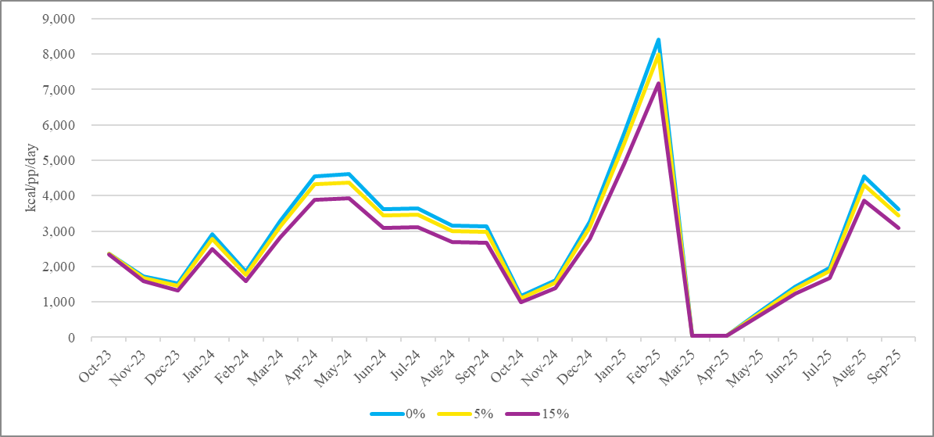
Source: Authors’ own elaboration.

The implications of the choice of 15% over 5% are more evident with caloric consumption. In Figure S5, referring to the COGAT data series, relevant differences are evident in February 2024 (from 2,051 to 1,987 to 1,719 kcal/pp/day with increasing losses), while in Figure S6, referring to the UN-20MT data series, a relevant difference emerges in November 2024 (from 2,098 to 1,584). For June and July 2024, even with 5% food loss food deprivation is critical, at 1,231 and 1,341 kcal/pp/day, respectively. Similarly, in both data series, even with 5% food loss December 2023 average daily consumption of calories is very low (1,378 kcal/pp/day in the COGAT series and 1,459 in the UN-MT series).
Figure S5: Caloric consumption (COGAT), kcal/pp/day, October 2023 to September 2025, by 0%, 5% and 15% food loss.
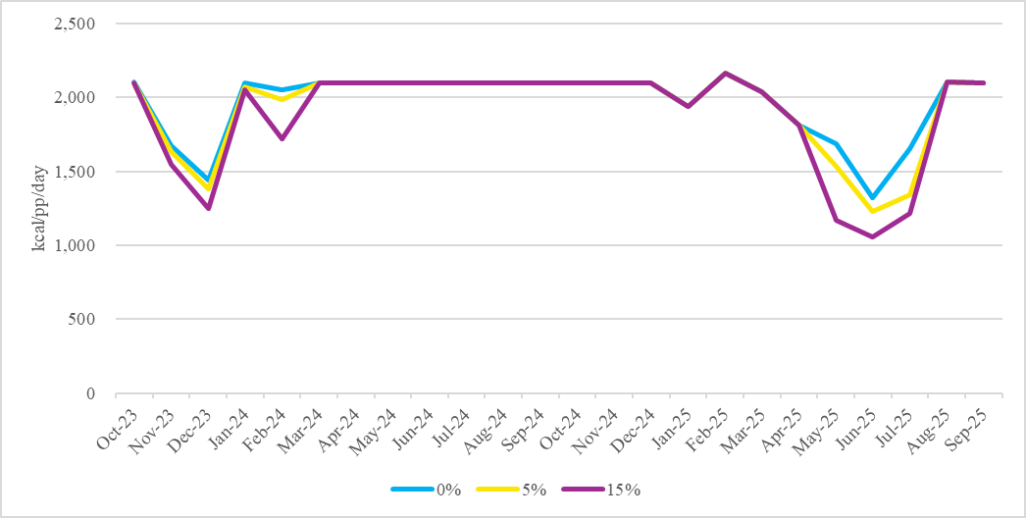
Source: Authors’ own elaboration.

Figure S6: Caloric consumption (UN-MT), kcal/pp/day, October 2023 to September 2025, by 0%, 5% and 15% food loss.
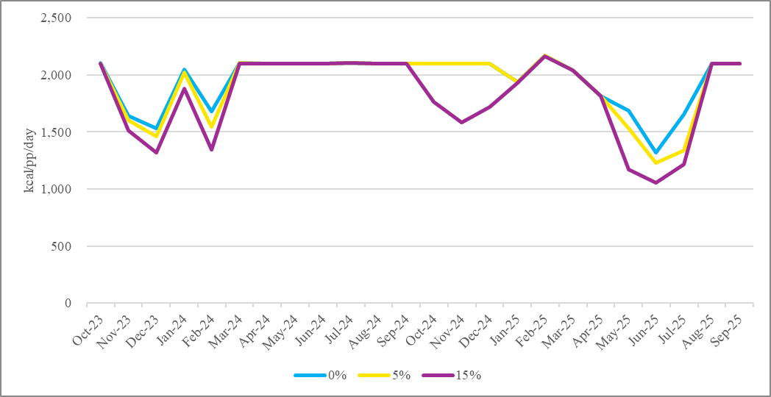
Source: Authors’ own elaboration.

In terms of inequality of access with the unimodal distribution, the choice of 15% versus 5% regarding food loss is relevant for the same months (the differences between 5% and 0% are negligible). Looking at the unimodal distribution, moving from 15% to 5% food loss reduces the share of the population consuming less than 1,000 kcal/pp/day in December 2023 and from May to July 2025. For example, in June 2025 the percentage drops from 39% (15%) to 5% (5%) (Figures S7 and S8). Similarly, the share of the population consuming less than 1,407 kcal/pp/day drops from to 96% (15%) to 63% (5%). In July 2025 the share of the population consuming less than 1,407 kcal/pp/day drops from 82% to 10% (0%). The share of the population consuming less than 1,407 kcal/pp/day in December 2023 drops from 78% (15%) in the COGAT series to 24 (5%).
On the other hand, with the bimodal distribution, few differences were evident moving from 15% to 5%. The only difference of note was the share of the population consuming less than 1,000 kcal/pp/day in July 2025 reduced from 51% (15%) to 24% (5%). More relevant differences were evident with the 0% assumption. The share of the population living below 1,000 kcal/pp/day dropped to 0%, and below 1,407 kcal/pp/day to 3% and 9% in May 19-30 and July 2025, respectively (Figure S9).
Figure S7: Percentage of the population below specified levels of kcal/pp/day, Monte Carlo Simulation of average daily caloric consumption with normal distribution, (October 2023 to September 30), COGAT and UN-20MT series, 5% food loss.
COGAT UN-20MT
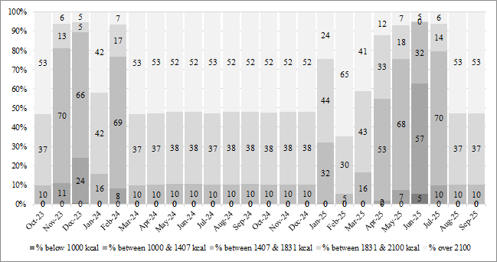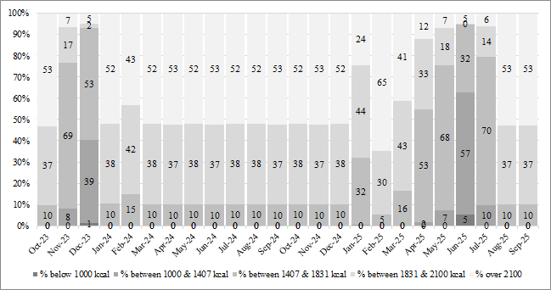
Source: Authors’ own elaboration.

Figure S8: Percentage of the population below specified levels of kcal/pp/day, Monte Carlo Simulation of average daily caloric consumption with normal distribution, (October 2023 to September 30), COGAT and UN-20MT series, 15% food loss.
COGAT UN-20MT
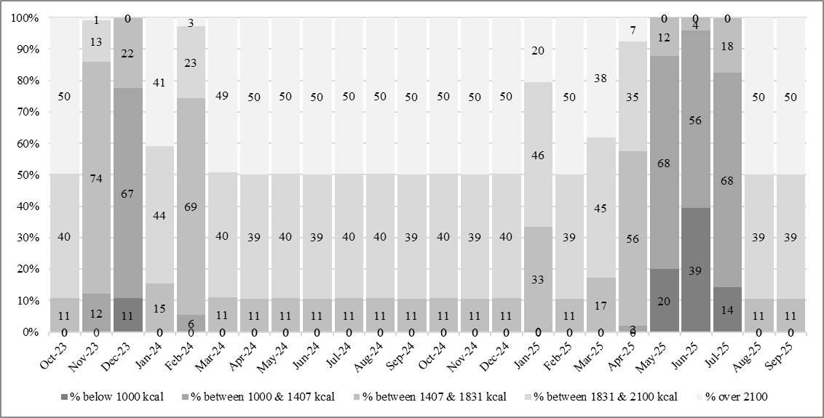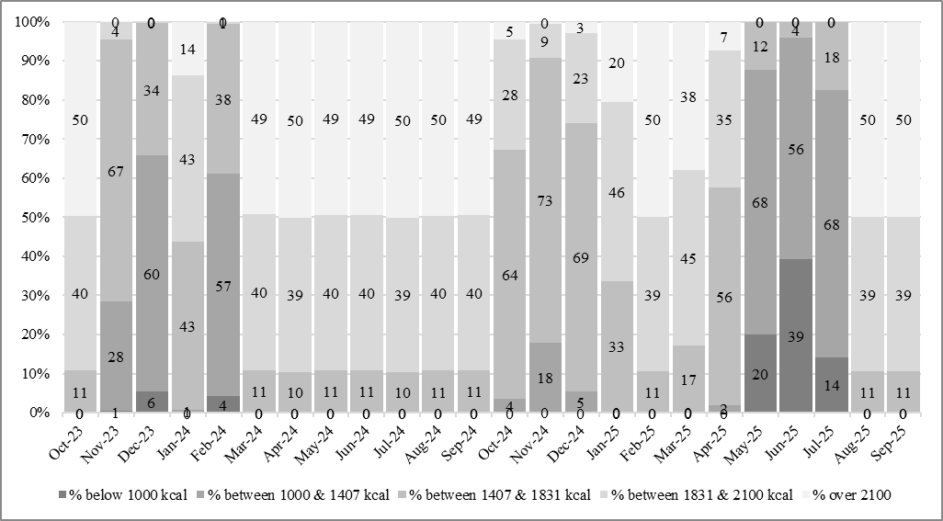
Source: Authors’ own elaboration.
Figure S9: Percentage of the population below specified levels of kcal/pp/day, Monte Carlo Simulation of average daily caloric consumption with bimodal distribution (May 2025 to September 30), COGAT data series, 15%, 5% and 0% food loss.
15% 5% 0%
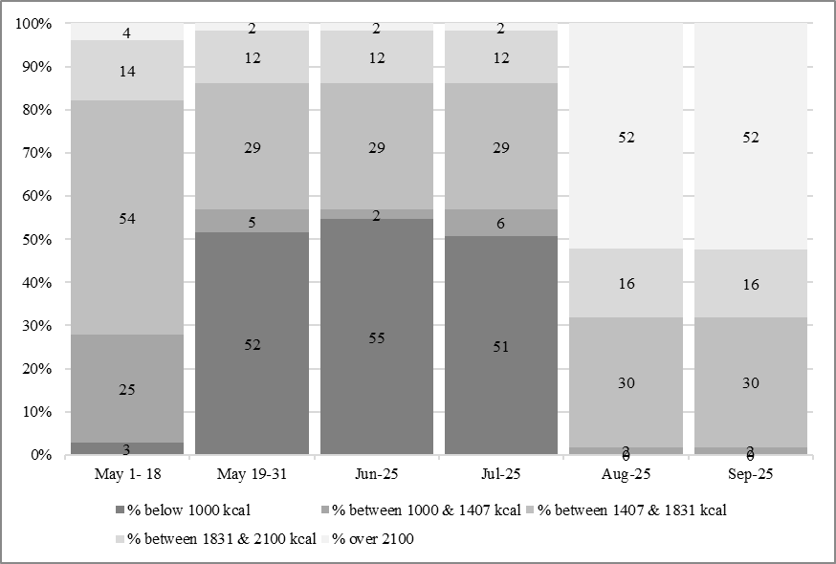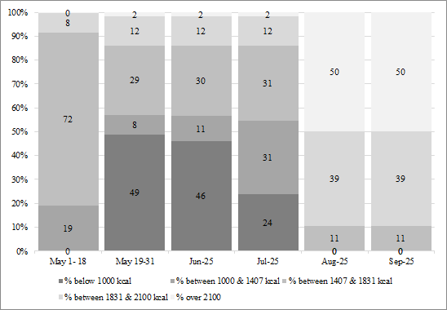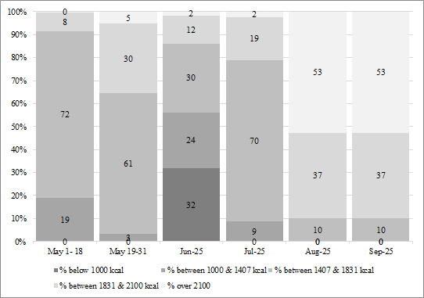
Source: Authors’ own elaboration.

- Existing stocks in October 2023

Table S12: Calories from imports and internal production, September 2022 to September 2023
Month | Calories from imports | Calories Internal Production | Total calories
Sep-22 | 2,309 | 259 | 2,570
Oct-22 | 2,253 | 259 | 2,517
Nov-22 | 2,289 | 259 | 2,554
Dec-22 | 2,507 | 259 | 2,770
Jan-23 | 2,785 | 245 | 3,029
Feb-23 | 2,325 | 245 | 2,574
Mar-23 | 2,547 | 245 | 2,789
Apr-23 | 2,197 | 245 | 2,446
May-23 | 2,200 | 245 | 2,451
Jun-23 | 1,926 | 245 | 2,169
Jul-23 | 2,367 | 245 | 2,606
Aug-23 | 2,411 | 245 | 2,649
Sep-23 | 2,179 | 245 | 2,417
Average |  |  | 2,580
Source: Authors’ own elaboration. Metric tonnes accessed 6 December 2025.
The decay model was parameterised such that availability declines only marginally during the first two weeks—falling from 2,558 kcal/pp/day on 7 October to 2,251 kcal/pp/day on 21 October, reflecting that some household stocks and market circulation were still temporarily accessible. After 21 October, the logistic curve produces a rapid decline in accessible stock as consumption continued and household and warehouse stores were destroyed in the bombing. Under this specification, the inflection point occurs on 4 November, after which the stockpile decays steeply and approaches near-zero by early December.
The decay model takes the form:
$$S_{t}=\frac{2 580}{1+e^{0.1424(t-28)}}$$
- $S_{t}$ represents the accessible pre-war stockpile in kcal per person per day-on-day t.
- t is the number of days since 7 October 2023 (e.g., t = 0 on 7 October; t = 54 on 30 November).
- 2 558 is the initial accessible stock on 7 October, derived from the average pre-war availability calculated using the February 2022–September 2023 dataset.
- 0.1424 is the decay rate parameter, which determines how quickly the stockpile declines after the onset of the conflict.
- 28 is the inflection point (half-depletion date), corresponding to approximately 4 November, when the rate of decline accelerates most sharply.
The decay-rate parameter was numerically calibrated so that the logistic-decay curve satisfied two empirical constraints derived from the pre-war dataset and the observed early-crisis conditions:
- Constraint 1 - Pre-war starting level (7 October): Using the pre-war dataset (Feb 2022–30 Sept 2023), we estimated an initial availability of 2,580 kcal/day.
- Constraint 2: Different sources (including WFP market monitoring and Food Security Sector Updates) show that during the first two weeks of the conflict some commercial stocks still circulated, households had still some reserves, and markets had not yet collapsed. To reflect this, we fixed the caloric availability on 21 October at 2,200 calories.
- Constraint 3: Steep collapse started mid-November (as documented).
- Constraint 4: Near exhaustion by 30 November.
The trend from October to December 2023 can be seen in the stockpile dynamics in Figures S17-S19.
- Calculating food and caloric availability via local production
Following Heesemann et al. (forthcoming) (4) we quantified total agricultural losses as follows:
(i) Crop losses due to destruction of crop land were estimated by combining geospatial assessments of conflict-related destruction with detailed agricultural and production data. Geospatial information, provided by the Geospatial Unit of the Land and Water Division (NLS) at FAO, identifies the share of cropland and greenhouse structures destroyed through high-resolution satellite imagery and damage classification by locality. These data were merged with plot-level information from the 2021 Agricultural Census, which reports cultivated areas by crop, irrigation system, and protection type. Losses were quantified by applying official crop yield data from the Ministry of Agriculture to the destroyed cultivated area. A key underlying assumption of this analysis is that agricultural output is lost in direct proportion to the share of land destroyed. This approach does not account for potential spillover effects. Damage to greenhouses is provided separately as detailed below.
(ii) Losses from irrigation disruption were estimated by assessing the impact of reduced water availability on crop productivity. For field crops and trees, we compared national average yields under irrigated and rainfed conditions, attributing the difference to irrigation. This yield gap was applied to production that was not already lost due to direct destruction, thereby capturing the additional effect of irrigation failure. With reference to differences in yields for trees, particularly for rainfed and irrigated olives and other tree crops, we supplement them with disaggregated data from the 2010–2011 Agricultural Survey, as the Ministry’s data provide only generalized yield data. For greenhouse crops, losses were modelled according to the water source. Households relying on agricultural wells were assumed to experience partial productivity reductions proportional to the share of wells harmed, as calculated by NLS. Those dependent on public water networks were assumed to face complete loss due to network destruction, while greenhouses relying on streams or natural water sources were considered unaffected, besides the military damage. For greenhouse crops, losses were modelled according to the water source. Households relying on agricultural wells were assumed to experience partial productivity reductions proportional to the share of wells harmed. Those dependent on public water networks were assumed to face complete loss due to network destruction, while greenhouses relying on streams or natural water sources were considered unaffected, besides the military damage. For greenhouse crops, losses were modelled according to the water source. Households relying on agricultural wells were assumed to experience partial productivity reductions proportional to the share of wells harmed. Those dependent on public water networks were assumed to face complete loss due to network destruction, while greenhouses relying on streams or natural water sources were considered unaffected, besides the military damage.
(iii) Livestock losses were assessed by quantifying production losses resulting from conflict-related animal mortality. Data on herd size and structure by species, sex, and age group were obtained from the 2021 Agricultural Census and combined with average output levels for milk, meat and eggs from the Ministry of Agriculture, disaggregated at the governorate level. Mortality rates at the Gaza Strip level have been estimated from herder surveys and distribution records collected during the conflict and then applied to production data to calculate the lost output in terms of meat, milk and eggs. As this approach focuses exclusively on the direct use value of livestock products (5), limiting the analyses to meat, milk and eggs, we acknowledge a underestimation of total livestock-related losses.
Crop and livestock-products lost were aggregated across all crops cultivated and livestock raised and across all agricultural holdings (excluding corporations) in the Gaza strip to obtain total production losses for the Gaza Strip at three and twelve months after the onset of the conflict.

The equations estimated and the derivation of the elasticity is as follows. Given that undamaged resources are expressed as a proportion between 0 and 1, the estimated regression coefficient represents a semi-elasticity that correspond to an approximation of the elasticity of the dependent variable with respect to the independent variable in this specific context. Formally the model is specified as:

$${Kcal}_{j,t}=α+β{und_resources}_{j,t}+ε_{j,t}$$

Where ${Kcal}_{j,t}$is the locally produced kcal left from human consumption at time t (month), for sector j (crop or livestock), $α$ is a constant, ${und_resources}_{j,t}$ is the share of undamaged resources at time t, for sector j, such that ${und_resources}_{j,t} Î[0,1]$ and $ε_{j,t}$ is the error term. As we are interested in how the percentage change in locally produced kcal left changes when undamaged resources changes, and considering the strictly positive distribution of kcal left, we implement a logarithm transformation of the kcal left. In this way, we obtain:
$$ln⁡({Kcal}_{j,t})=α+β{und_resources}_{j,t}+ε_{j,t}$$

Assuming differentiability of the dependent variable with respect to independent variable and taking the partial derivative with respect to undamaged resources:

$d$ [$\ln\left({Kcal}_{j,t}\right)]=βd [{und_resources}_{j,t}]$

By the chain rule d [$\ln\left({Kcal}_{j,t}\right)=\frac{{d(Kcal}_{j,t})}{{Kcal}_{j,t}}$

Therefore:

$$\frac{{d(Kcal}_{j,t})}{{Kcal}_{j,t}}= β d [{und_resources}_{j,t}]$$

The semi-elasticity of ${Kcal}_{j,t}$ with respect to ${und_resources}_{j,t}$ is thus by definition: $\frac{{d(Kcal}_{j,t})/{(Kcal}_{j,t})}{d [{und_resources}_{j,t}]}$ =$β$

If ${und_resources}_{j,t+1}$= ${und_resources}_{j,t}+D und_resources$, for sufficiently small $D und_resources$, a first-order Taylor approximation yields:

$\frac{DKcal}{Kcal}$≈ $β$ $D und_resources$

which by definition represents the elasticity of ${Kcal}_{j,t}$ with respect to ${und_resources}_{j,t} .$

Expressed in percentage:

$\%Dy$≈100* $β$ $D und_resources$

For $D und_resources$ =0.01, namely 1 percentage point, the elasticity is:

$\frac{DKcal}{Kcal}$≈ $β*$ $0.01$ ;

which expressed in percentage would lead to

$\%Dy$≈100 $*0.01*β$ ≈ $β$

Hence, under appropriate assumptions and interpretation, the estimated semi-elasticity $β$ closely approximates the elasticity of locally produced kilocalories with respect to undamaged agricultural resources.

Table S13: Estimated availability of locally produced foods (kcal/person/day), September 2023 to September 2025
Month | Undamaged crop land | kcal left from crop per person per day | Survival of livestock | kcal left from livestock per person per day | Total kcal left (crop+livestock) per person per day
Sep-23 | 1.00 | 169.28 | 1.00 | 75.71 | 244.99
Oct-23 | 0.96 | 159.40 | 0.90 | 61.32 | 220.72
Nov-23 | 0.92* | 151.13 | 0.79 | 50.00 | 201.14
Dec-23 | 0.72* | 80.00 | 0.69 | 40.78 | 120.78
Jan-24 | 0.64 | 71.73 | 0.64 | 37.54 | 109.27
Feb-24 | 0.57* | 64.32 | 0.60 | 34.55 | 98.88
Mar-24 | 0.52 | 60.36 | 0.55 | 31.81 | 92.16
Apr-24 | 0.48 | 56.64 | 0.50 | 29.28 | 85.91
May-24 | 0.43* | 53.15 | 0.46 | 26.95 | 80.09
Jun-24 | 0.40 | 51.37 | 0.41 | 24.81 | 76.17
Jul-24 | 0.38 | 49.65 | 0.36 | 22.83 | 72.48
Aug-24 | 0.35 | 47.99 | 0.32 | 21.02 | 69.00
Sep-24 | 0.32* | 38.08 | 0.27 | 19.35 | 57.43
Oct-24 | 0.30 | 37.04 | 0.22 | 17.81 | 54.85
Nov-24 | 0.27 | 36.02 | 0.18 | 16.39 | 52.42
Dec-24 | 0.25* | 35.04 | 0.13 | 15.09 | 50.13
Jan-25 | 0.23 | 34.26 | 0.08 | 13.89 | 48.15
Feb-25 | 0.21 | 33.50 | 0.04 | 12.79 | 46.29
Mar-25 | 0.19* | 32.75 | 0.00 | 0.00 | 32.75
Apr-25 | 0.17 | 32.03 | 0.00 | 0.00 | 32.03
May-25 | 0.16 | 31.79 | 0.00 | 0.00 | 31.79
Jun-25 | 0.15 | 31.55 | 0.00 | 0.00 | 31.55
Jul-25 | 0.14* | 31.31 | 0.00 | 0.00 | 31.31
Aug-25 | 0.13 | 31.10 | 0.00 | 0.00 | 31.10
Sep-25 | 0.12 | 30.88 | 0.00 | 0.00 | 30.88
Source: Authors’ own elaboration. *Data on the undamaged land from satellite assessments conducted by FAO (6–13).
In order to obtain metric tonnes of potential livestock and crop production from this estimation, we use our estimates on caloric availability and the energy density of common animal-based foods found in the Gaza Strip, as seen in Table S14.
Table S14: Estimated metric tonnes of locally produced foods, October 2023 to September 2025
Month | Livestock MT/day | Crop MT/day | Total Agriculture MT/month
Oct-23 | 88 | 498 | 6,446
Nov-23 | 72 | 469 | 16,204
Dec-23 | 58 | 246 | 9,432
Jan-24 | 53 | 219 | 8,441
Feb-24 | 48 | 195 | 7,068
Mar-24 | 44 | 182 | 7,014
Apr-24 | 40 | 170 | 6,302
May-24 | 37 | 158 | 6,046
Jun-24 | 34 | 152 | 5,566
Jul-24 | 31 | 146 | 5,472
Aug-24 | 28 | 140 | 5,209
Sep-24 | 26 | 110 | 4,079
Oct-24 | 24 | 106 | 4,030
Nov-24 | 22 | 103 | 3,731
Dec-24 | 20 | 99 | 3,689
Jan-25 | 18 | 96 | 3,547
Feb-25 | 16 | 94 | 3,081
Mar-25 | 0 | 91 | 2,816
Apr-25 | 0 | 88 | 2,645
May-25 | 0 | 87 | 2,694
Jun-25 | 0 | 86 | 2,569
Jul-25 | 0 | 84 | 2,616
Aug-25 | 0 | 83 | 2,577
Sep-25 | 0 | 82 | 2,458
Total Oct 23 to Dec 24 | 624 | 2993 | 98,731
Total Jan 25 to Sep 25 | 35 | 791 | 25,003
Overall total | 659 | 3784 | 123,733
Source: Authors’ own elaboration

- Caloric conversion factors

Table S15. Donor-specific caloric conversion factors.
Donor / Route | kcal kg⁻¹
UN agencies | 3,020
INGOs | 2,283
Mixed / bilateral donors | 2,283
Private sector | 2,344
Airdrops | 3,300
Source: Authors’ own elaboration

Table S16. Kilocalories assigned to Gaza Humanitarian Foundation food box.
Item | Quantity | Unit | kcal/100 g | Total kcal | Source
Wheat flour | 2 | kg | 364 | 7,280 | NutVal
Red lentils | 1 | kg | 343 | 3,430 | NutVal
Vegetable oil | 0.98 | L | 884 | 8,663 | NutVal
Fava beans | 1 | kg | 110 | 1,100 | USDA
Chickpeas (dry) | 1 | kg | 364 | 3,640 | NutVal
Salt | 1 | kg | 0 | 0 | NutVal
Pasta | 1 | kg | 371 | 3,710 | NutVal
Halva bar | 1 | kg | 560 | 5,600 | NutVal
Green beans | 1.5 | kg | 31 | 465 | USDA
Total weight: 10.48 kg
Total caloric content: 33,888 kcal
Average caloric density: 3,234 kcal/kg
Source: Authors’ own elaboration based on (14), (15) and (16)

Table S17: Donor-specific caloric conversion factors used from 19 May 2025 to 30 September 2025.
Donor / Route | kcal kg⁻¹
UN agencies | 3,020
INGOs | 2,283
GHF | 3,234
Mixed / bilateral donors | 2,283
Private sector | 2,344
Airdrops | 3,300
Source: authors’ own calculations

- Metric tonnes of available food, October 2023 to September 2025

Although UN and COGAT data generally show similar trends over time, the amounts they report often differ substantially(17), with COGAT usually reporting higher numbers of trucks and metric tonnes. First, the two systems do not apply consistent categorization, especially for consignments delivered by UN partners. Second, they measure different stages of the supply chain: COGAT records imports that have been scanned at crossing points outside, and in some cases far from, the Gaza Strip (such as Nitzana), whereas UN data refers to shipments which reach inside Gaza. The UN2720 mechanism goes further by tracking each stage: aid offloaded on the Israeli side, aid collected by trucks inside Gaza, and aid distributed within Gaza. The gap between offloaded and collected shipments can be substantial, though it has varied over time. Between May 19 and September 30, the aggregate amount collected was 13% less than the amount offloaded.(18) By comparison, COGAT reported 7% less food aid from the UN than the offloaded reported in the UN2720, and 7% greater than the collected, with monthly differences diminishing over this period (See Figures S3 and Table S9).(19).
A third difference has to do with the reported weights of each pallet or truck. Checchi et al (2024) cast doubt on the precision of COGAT’s reporting of weight through 2024 as they found evidence of data heaping. By 2025 differences had diminished. Comparing UN2720 Mechanism and COGAT data on UN shipments since May 19 through September 30, we find that COGAT reports on average 20.5 MT per truck compared to 20.1 MT by the UN2720 Mechanism (based on the offloaded), a difference of less than 2% (See Table S11).(18) (19)
Since the UN platform reported most quantities in pallets, we use two approaches to convert to MT. First, pallets were converted at 0.75 MT each, in line with the January 2024 Standard Operating Procedures (SOP) for Importation, which established 750 kg as the maximum pallet weight (3). This approach is similar to that used by Checchi et al. (2024) (4). Shipments already reported in MT or tonnes were retained as provided, while specific conversion rules were applied for cartons of eggs (e.g., converting 9.216 MT) and other items with known weight equivalents. As a point of comparison, data from UN2720 platform allow calculation of the weight of pallets for most trucks offloaded; from 19 May 2025 to 30 September 2025, the average weight of the pallet was 0.97 MT, which could reflect updated SOPs. Second, all shipments were converted assuming a 20-MT truck, consistent with guidance received via personal communication in December 2023 from the Palestine Logistics Cluster regarding typical truck capacity. As a point of comparison, UN2720 records show that trucks transporting food between May 19 and September 30 carried an average of 20.1 MT.(18)
Figure S10. Metric tonnes of COGAT and UN-reported food shipments into the Gaza Strip (October, 2023 to December, 2024) and COGAT (January to September, 2025), combined with metric tonnes of local agricultural production, by month, 15% food loss
Note: The red line at 61,000 MT is the approximate monthly amount necessary to provide 2,100 kcal/pp/day.
Source: Authors’ own elaboration using COGAT(19) and UNRWA(20).

Table S18: Metric tonnes of COGAT and UN-reported food shipments into the Gaza Strip (October 2023 to December 2024) and COGAT (January to September 2025), by month – 0%, 5% and 15% food loss
 | 0% |  |  | 5% |  |  | 15%
Month | UN-Pallets | UN-20MT | COGAT | UN-Pallets | UN-20MT | COGAT | UN-Pallets | UN-20MT | COGAT
Oct-23 | 1761 | 2,220 | 1,650 | 1,673 | 2,109 | 1568 | 1497 | 1887 | 1403
Nov-23 | 27,680 | 33,342 | 24,827 | 26,296 | 31,674 | 23585 | 23528 | 28340 | 21103
Dec-23 | 35,984 | 43,046 | 38,531 | 34,185 | 40,893 | 36604 | 30586 | 36589 | 32751
Jan-24 | 52,046 | 59,804 | 72,624 | 49,444 | 56,813 | 68992 | 44239 | 50833 | 61730
Feb-24 | 31,785 | 37,292 | 43,202 | 30,196 | 35,427 | 41041 | 27017 | 31698 | 36721
Mar-24 | 59,831 | 75,135 | 82,395 | 56,840 | 71,378 | 78275 | 50857 | 63865 | 70035
Apr-24 | 74,099 | 86,681 | 109,912 | 70,394 | 82,346 | 104416 | 62984 | 73678 | 93425
May-24 | 64,667 | 75,708 | 116,855 | 61,434 | 71,923 | 111012 | 54967 | 64352 | 99326
Jun-24 | 48,727 | 61,090 | 88,460 | 46,290 | 58,036 | 84037 | 41418 | 51927 | 75191
Jul-24 | 64,249 | 81,492 | 94,997 | 61,037 | 77,417 | 90247 | 54612 | 69268 | 80747
Aug-24 | 47,384 | 54,960 | 80,343 | 45,015 | 52,212 | 76326 | 40276 | 46716 | 68292
Sep-24 | 48,963 | 53,884 | 76,514 | 46,515 | 51,189 | 72688 | 41619 | 45801 | 65036
Oct-24 | 15,941 | 20,864 | 25,434 | 15,144 | 19,821 | 24162 | 13550 | 17734 | 21619
Nov-24 | 24,357 | 32,444 | 35,374 | 23,139 | 30,822 | 33605 | 20703 | 27577 | 30068
Dec-24 | 34,217 | 45,640 | 77,953 | 32,506 | 43,358 | 74055 | 29085 | 38794 | 66260
Jan-25 | 164,148 | 164,148 | 164,148 | 155,941 | 155,941 | 155941 | 139526 | 139526 | 139526
Feb-25 | 216,075 | 216,075 | 216,075 | 205,271 | 205,271 | 205271 | 183664 | 183664 | 183664
Mar-25 | 0 | 0 | 0 | 0 | 0 | 0 | 0 | 0 | 0
Apr-25 | 0 | 0 | 0 | 0 | 0 | 0 | 0 | 0 | 0
May-25 | 19,871 | 19,871 | 19,871 | 18,877 | 18,877 | 18877 | 16890 | 16890 | 16890
Jun-25 | 37,843 | 37,843 | 37,843 | 35,951 | 35,951 | 35951 | 32167 | 32167 | 32167
Jul-25 | 53,418 | 53,418 | 53,418 | 50,747 | 50,747 | 50747 | 45405 | 45405 | 45405
Aug-25 | 122,719 | 122,719 | 122,719 | 116,583 | 116,583 | 116583 | 104311 | 104311 | 104311
Sep-25 | 94,520 | 94,520 | 94,520 | 89,794 | 89,794 | 89794 | 80342 | 80342 | 80342
Total Oct 23 to Dec 24 | 631,691 | 763,599 | 969,066 | 600,106 | 725,419 | 920613 | 536937 | 649059 | 823706
Total Jan 25 to Sep 25 | 708,594 | 708,594 | 708,594 | 673,165 | 673,165 | 673165 | 602305 | 602305 | 602305
Overall total | 1,340,285 | 1,472,193 | 1,677,660 | 1,273,271 | 1,398,583 | 1593777 | 1139242 | 1251364 | 1426011
Source: Authors’ own elaboration

Table S19: Metric tonnes of COGAT and UN-reported food shipments into the Gaza Strip (October 2023 to December 2024) and COGAT (January to September 2025), combined with metric tonnes of local agricultural production, by month – 0%, 5% and 15% food loss
 |  | 0% |  |  | 5% |  |  | 15%
Month | UN-Pallets | UN-20MT | COGAT | UN-Pallets | UN-20MT | COGAT | UN-Pallets | UN-20MT | COGAT
Oct-23 | 8207 | 8666 | 8096 | 8119 | 8555 | 8013 | 7943 | 8333 | 7848
Nov-23 | 43884 | 49546 | 41031 | 42500 | 47879 | 39789 | 39732 | 44544 | 37307
Dec-23 | 45416 | 52477 | 47962 | 43617 | 50325 | 46036 | 40018 | 46020 | 42183
Jan-24 | 60488 | 68245 | 81065 | 57886 | 65255 | 77434 | 52681 | 59274 | 70171
Feb-24 | 38853 | 44360 | 50270 | 37264 | 42495 | 48110 | 34086 | 38766 | 43790
Mar-24 | 66846 | 82149 | 89409 | 63854 | 78393 | 85289 | 57871 | 70879 | 77050
Apr-24 | 80401 | 92983 | 116214 | 76696 | 88649 | 110718 | 69287 | 79981 | 99727
May-24 | 70713 | 81754 | 122901 | 67480 | 77969 | 117058 | 61013 | 70398 | 105373
Jun-24 | 54292 | 66656 | 94025 | 51856 | 63601 | 89602 | 46983 | 57492 | 80756
Jul-24 | 69721 | 86964 | 100469 | 66509 | 82889 | 95719 | 60084 | 74740 | 86219
Aug-24 | 52593 | 60169 | 85552 | 50223 | 57421 | 81535 | 45485 | 51925 | 73500
Sep-24 | 53042 | 57963 | 80593 | 50594 | 55269 | 76767 | 45698 | 49880 | 69116
Oct-24 | 19971 | 24894 | 29464 | 19174 | 23851 | 28192 | 17580 | 21765 | 25649
Nov-24 | 28087 | 36175 | 39105 | 26869 | 34552 | 37336 | 24434 | 31308 | 33799
Dec-24 | 37906 | 49329 | 81642 | 36195 | 47047 | 77744 | 32774 | 42483 | 69949
Jan-25 | 167695 | 167695 | 167695 | 159487 | 159487 | 159487 | 143072 | 143072 | 143072
Feb-25 | 219156 | 219156 | 219156 | 208353 | 208353 | 208353 | 186745 | 186745 | 186745
Mar-25 | 2816 | 2816 | 2816 | 2816 | 2816 | 2816 | 2816 | 2816 | 2816
Apr-25 | 2645 | 2645 | 2645 | 2645 | 2645 | 2645 | 2645 | 2645 | 2645
May-25 | 22565 | 22565 | 22565 | 21571 | 21571 | 21571 | 19584 | 19584 | 19584
Jun-25 | 40412 | 40412 | 40412 | 38520 | 38520 | 38520 | 34736 | 34736 | 34736
Jul-25 | 56034 | 56034 | 56034 | 53363 | 53363 | 53363 | 48021 | 48021 | 48021
Aug-25 | 125297 | 125297 | 125297 | 119161 | 119161 | 119161 | 106889 | 106889 | 106889
Sep-25 | 96978 | 96978 | 96978 | 92252 | 92252 | 92252 | 82800 | 82800 | 82800
Total Oct 23 to Dec 24 | 730421 | 862329 | 1067797 | 698837 | 824149 | 1019343 | 635668 | 747789 | 922437
Total Jan 25 to Sep 25 | 733597 | 733597 | 733597 | 698167 | 698167 | 698167 | 627308 | 627308 | 627308
Overall total | 1464018 | 1595926 | 1801394 | 1397004 | 1522317 | 1717511 | 1262976 | 1375097 | 1549745
Source: Authors’ own elaboration

- Estimates of caloric availability

Table S20: Internal stock depletion adjustment
Month | ρ | Number of calories lost (% x 2 100) per person, per day | Number of calories lost (% x 2 100) per person, per month
Jan-25 | 0.2% | 5.2 | 163
Feb-25 | 0.4% | 9.4 | 265
Mar-25 | 0.6% | 13.6 | 423
Apr-25 | 0.8% | 17.8 | 535
May-25 | 1.5% | 30.4 | 944
Jun-25 | 2.3% | 47.2 | 1,418
Jul-25 | 3.3% | 68.2 | 2,116
Aug-25 | 0.1% | 2.1 | 65
Source: Authors’ own elaboration

Figure S11: Average caloric availability (kcal/person/day) with 95% confidence intervals, by month – no food loss
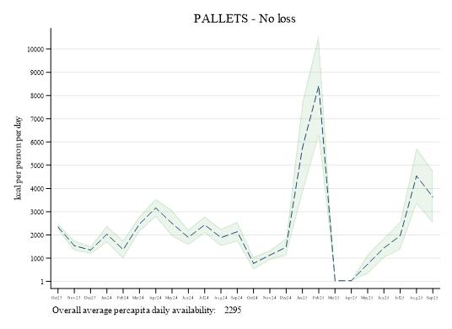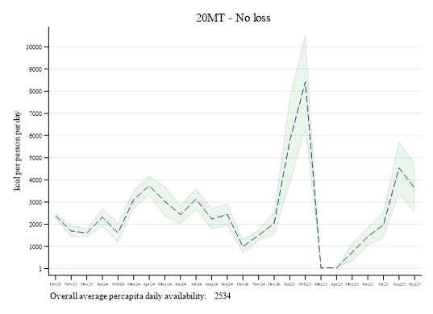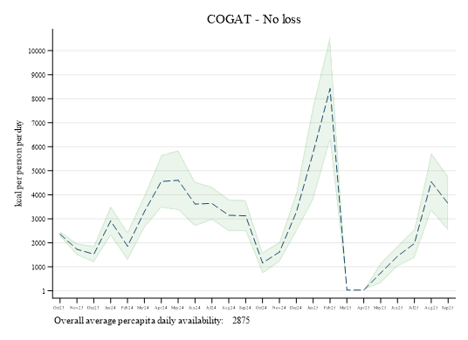 Source: Authors’ own elaboration
Table S21: Average caloric availability (kcal/person/day) with 95% confidence intervals, by month – no food loss
Month | UN-Pallet | UN-20MT | COGAT
Oct-23 | 2,345 (2,222–2,468) | 2,381 (2,250–2,511) | 2,363 (2,256–2,470)
Nov-23 | 1,538 (1,323–1,753) | 1,697 (1,434–1,960) | 1,731 (1,489–1,973)
Dec-23 | 1,349 (1,190–1,509) | 1,604 (1,414–1,794) | 1,526 (1,186–1,866)
Jan-24 | 2,029 (1,671–2,388) | 2,315 (1,901–2,729) | 2,911 (2,303–3,519)
Feb-24 | 1,372 (982–1,762) | 1,612 (1,163–2,061) | 1,861 (1,273–2,448)
Mar-24 | 2,472 (2,143–2,802) | 3,103 (2,694–3,512) | 3,298 (2,628–3,968)
Apr-24 | 3,163 (2,778–3,548) | 3,738 (3,298–4,178) | 4,555 (3,465–5,646)
May-24 | 2,497 (1,933–3,061) | 3,031 (2,334–3,727) | 4,604 (3,358–5,851)
Jun-24 | 1,895 (1,564–2,226) | 2,436 (2,004–2,867) | 3,615 (2,694–4,537)
Jul-24 | 2,437 (2,081–2,792) | 3,129 (2,650–3,608) | 3,638 (2,952–4,325)
Aug-24 | 1,886 (1,513–2,260) | 2,234 (1,748–2,720) | 3,148 (2,484–3,812)
Sep-24 | 2,139 (1,718–2,559) | 2,440 (1,936–2,945) | 3,125 (2,482–3,769)
Oct-24 | 776 (506–1,047) | 993 (657–1,329) | 1,161 (724–1,599)
Nov-24 | 1,131 (931–1,331) | 1,498 (1,240–1,756) | 1,615 (1,201–2,029)
Dec-24 | 1,479 (1,113–1,846) | 2,035 (1,513–2,557) | 3,274 (2,465–4,082)
Jan-25 | 5,754 (3,786–7,722) | 5,754 (3,786–7,722) | 5,754 (3,786–7,722)
Feb-25 | 8,422 (6,254–10,589) | 8,422 (6,254–10,589) | 8,422 (6,254–10,589)
Mar-25 | 33 | 33, | 33
Apr-25 | 32 | 32, | 32
May-25 | 743 (323–1,162) | 743 (323–1,162) | 743 (323–1,162)
Jun-25 | 1,440 (1,014–1,867) | 1,440 (1,014–1,867) | 1,440 (1,014–1,867)
Jul-25 | 1,971 (1,367–2,575) | 1,971 (1,367–2,575) | 1,971 (1,367–2,575)
Aug-25 | 4,538 (3,333–5,743) | 4,538 (3,333–5,743) | 4,538 (3,333–5,743)
Sep-25 | 3,631 (2,505–4,757) | 3,631 (2,505–4,757) | 3,631 (2,505–4,757)
Average Oct 23 to Dec 24 | 1,901 (1578–2,223) | 2,283 (1,882–2,684), | 2,828 (2,197–3,460)
Average Jan 25 to Sep 25 | 2,952 (2,655–4,917) | 2,952 (2,655–4,917) | 2,952 (2,655–4,917)
Overall Average | 2,295 (1,921–3,080) | 2,534 (2,128–3,394) | 2,875 (2,343–3,923)
Source: Authors’ own elaboration

Figure S12: Average caloric availability (kcal/person/day) with 95% confidence intervals, by month – 5% food loss
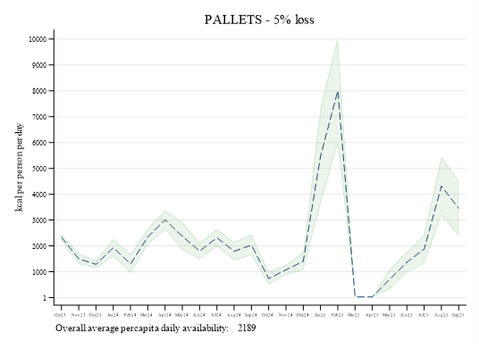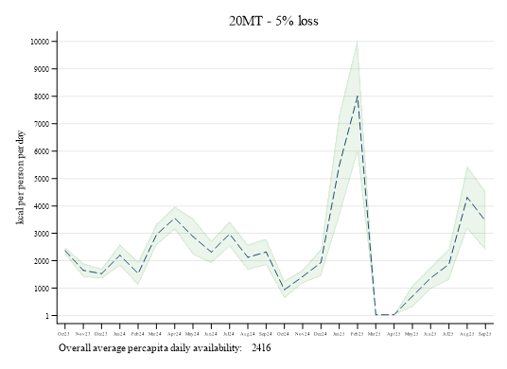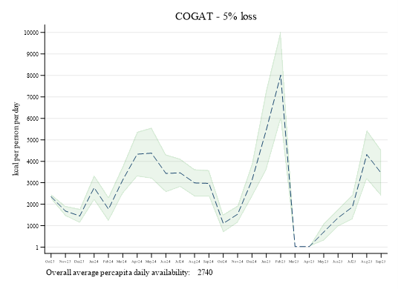Source: Authors’ own elaboration
Table S22: Average caloric availability (kcal/person/day) with 95% confidence intervals, by month – 5% food loss
Month | UN-Pallet | UN-20MT | COGAT
Oct-23 | 2,337 (2,216–2,458) | 2,372 (2,244–2,499) | 2,355 (2,249–2,461)
Nov-23 | 1,502 (1,295–1,709) | 1,652 (1,402–1,903) | 1,685 (1,453–1,916)
Dec-23 | 1,288 (1,137–1,440) | 1,530 (1,349–1,710) | 1,456 (1,133–1,778)
Jan-24 | 1,933 (1,593–2,274) | 2,205 (1,811–2,598) | 2,770 (2,193–3,348)
Feb-24 | 1,309 (938–1,679) | 1,537 (1,110–1,963) | 1,772 (1,214–2,331)
Mar-24 | 2,353 (2,040–2,666) | 2,953 (2,564–3,341) | 3,138 (2,502–3,775)
Apr-24 | 3,009 (2,644–3,375) | 3,555 (3,137–3,973) | 4,332 (3,296–5,368)
May-24 | 2,376 (1,840–2,912) | 2,883 (2,222–3,544) | 4,378 (3,194–5,562)
Jun-24 | 1,804 (1,490–2,118) | 2,318 (1,907–2,728) | 3,439 (2,563–4,314)
Jul-24 | 2,318 (1,981–2,656) | 2,976 (2,522–3,431) | 3,460 (2,808–4,112)
Aug-24 | 1,795 (1,441–2,150) | 2,126 (1,664–2,587) | 2,994 (2,363–3,624)
Sep-24 | 2,034 (1,635–2,434) | 2,321 (1,842–2,800) | 2,972 (2,361–3,583)
Oct-24 | 740 (483–997) | 946 (627–1,265) | 1,106 (691–1,522)
Nov-24 | 1,077 (887–1,267) | 1,426 (1,181–1,671) | 1,537 (1,144–1,930)
Dec-24 | 1,408 (1,060–1,756) | 1,936 (1,440–2,431) | 3,113 (2,345–3,881)
Jan-25 | 5,469 (3,599–7,339) | 5,469 (3,599–7,339) | 5,469 (3,599–7,339)
Feb-25 | 8,003 (5,944–10,062) | 8,003 (5,944–10,062) | 8,003 (5,944–10,062)
Mar-25 | 33 | 33 | 33
Apr-25 | 32 | 32 | 32
May-25 | 707 (309–1,105) | 707 (309–1,105) | 707 (309–1,105)
Jun-25 | 1,370 (965–1,775) | 1,370 (965–1,775) | 1,370 (965–1,775)
Jul-25 | 1,874 (1,300–2,448) | 1,874 (1,300–2,448) | 1,874 (1,300–2,448)
Aug-25 | 4,313 (3,168–5,458) | 4,313 (3,168–5,458) | 4,313 (3,168–5,458)
Sep-25 | 3,451 (2,381–4,521) | 3,451 (2,381–4,521) | 3,451 (2,381–4,521)
Average Oct 23 to Dec 24 | 1,819 (1,512–2,126) | 2,182 (1,801–2,563), | 2,700 (2,100–3,300)
Average Jan 25 to Sep 25 | 2,806 (2,524–4,672) | 2,806 (2,524–4,672) | 2,806 (2,524–4,672)
Overall average | 2,189 (1,834–2,936) | 2,416 (2,031–3,234) | 2,740 (2,235–3,737)
Source: Authors’ own elaboration
Figure S13: Average caloric availability (kcal/person/day) with 95% confidence intervals, by month – 15% food loss
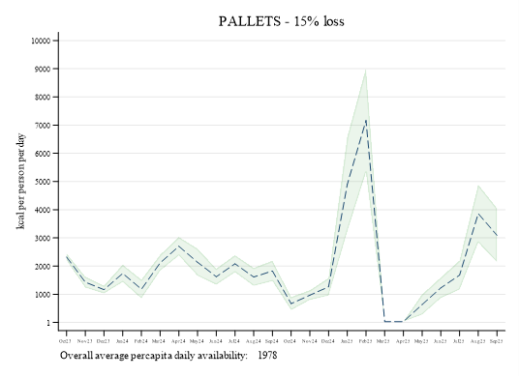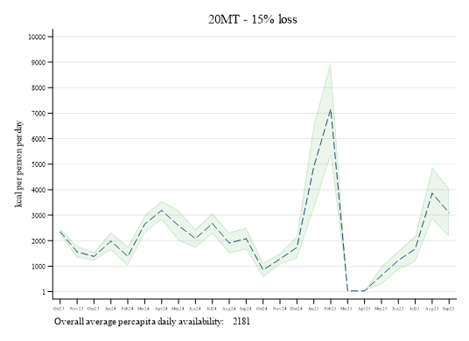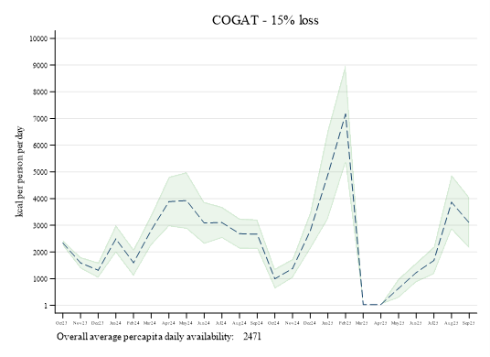 Source: Authors’ own elaboration

Table S23: Average daily caloric availability (kcal/person/day) with 95% confidence intervals, by month – 15% food loss
Month | UN-Pallet | UN-20MT | COGAT
Oct-23 | 2,323 (2,205–2,441) | 2,353 (2,231–2,476) | 2,338 (2,234–2,442)
Nov-23 | 1,428 (1,236–1,621) | 1,563 (1,335–1,791) | 1,592 (1,380–1,804)
Dec-23 | 1,165 (1,030–1,301) | 1,381 (1,220–1,543) | 1,315 (1,026–1,604)
Jan-24 | 1,741 (1,437–2,046) | 1,984 (1,632–2,336) | 2,490 (1,974–3,007)
Feb-24 | 1,181 (850–1,513) | 1,385 (1,004–1,767) | 1,596 (1,097–2,096)
Mar-24 | 2,115 (1,835–2,395) | 2,652 (2,304–2,999) | 2,817 (2,248–3,387)
Apr-24 | 2,701 (2,375–3,028) | 3,190 (2,816–3,564) | 3,885 (2,958–4,812)
May-24 | 2,135 (1,655–2,614) | 2,588 (1,996–3,180) | 3,926 (2,866–4,985)
Jun-24 | 1,622 (1,341–1,903) | 2,082 (1,715–2,449) | 3,085 (2,301–3,868)
Jul-24 | 2,082 (1,780–2,384) | 2,671 (2,264–3,078) | 3,103 (2,520–3,687)
Aug-24 | 1,614 (1,296–1,931) | 1,909 (1,496–2,322) | 2,686 (2,122–3,250)
Sep-24 | 1,826 (1,469–2,184) | 2,083 (1,654–2,512) | 2,665 (2,118–3,212)
Oct-24 | 668 (438–898) | 852 (567–1,138) | 995 (624–1,367)
Nov-24 | 969 (799–1,139) | 1,281 (1,062–1,500) | 1,381 (1,029–1,732)
Dec-24 | 1,265 (953–1,577) | 1,737 (1,294–2,181) | 2,790 (2,103–3,477)
Jan-25 | 4,898 (3,225–6,571) | 4,898 (3,225–6,571) | 4,898 (3,225–6,571)
Feb-25 | 7,166 (5,323–9,008) | 7,166 (5,323–9,008) | 7,166 (5,323–9,008)
Mar-25 | 33 | 33 | 33
Apr-25 | 32 | 32 | 32
May-25 | 636 (279–992) | 636 (279–992) | 636 (279–992)
Jun-25 | 1,229 (867–1,591) | 1,229 (867–1,591) | 1,229 (867–1,591)
Jul-25 | 1,680 (1,167–2,193) | 1,680 (1,167–2,193) | 1,680 (1,167–2,193)
Aug-25 | 3,862 (2,837–4,887) | 3,862 (2,837–4,887) | 3,862 (2,837–4,887)
Sep-25 | 3,091 (2,134–4,048) | 3,091 (2,134–4,048) | 3,091 (2,134–4,048)
Average Oct 23 to Dec 24 | 1,656 (1,380–1,932) | 1,981 (1,639–2,322), | 2,444 (1,907–2,982)
Average Jan 25 to Sep 25 | 2,514 (2,262–4,184) | 2,514 (2,262–4,184) | 2,514 (2,262–4,184)
Overall average | 1,978 (1,661–2,648) | 2,181 (1,837–2,915) | 2,471 (2,020–3,365)
Source: Authors’ own elaboration

- Estimates of caloric consumption
Figure S14: Average caloric consumption (kcal/person/day) with 2.5 and 97.5 percentiles , by month – no food loss
Source: Authors’ own elaboration. Metric tonnes accessed 6 December 2025.

Table S24: Average caloric consumption (kcal/person/day) with 2.5 and 97.5 percentiles, by month – no food loss
Month | UN-Pallets | UN-20MT | COGAT
Oct-23 | 2,102 (1,838–2,392) | 2,103 (1,838–2,392) | 2,103 (1,838–2,392)
Nov-23 | 1,493 (1,297–1,702) | 1,640 (1,425–1,850) | 1,675 (1,476–1,889)
Dec-23 | 1,285 (1,142–1,434) | 1,534 (1,361–1,708) | 1,438 (1,237–1,668)
Jan-24 | 1,899 (1,648–2,137) | 2,045 (1,828–2,233) | 2,097 (1,937–2,260)
Feb-24 | 1,359 (1,098–1,678) | 1,677 (1,383–2,003) | 2,051 (1,829–2,250)
Mar-24 | 2,074 (1,909–2,235) | 2,103 (1,937–2,258) | 2,098 (1,939–2,260)
Apr-24 | 2,100 (1,941–2,265) | 2,101 (1,955–2,264) | 2,100 (1,941–2,265)
May-24 | 2,098 (1,939–2,260) | 2,097 (1,940–2,265) | 2,098 (1,939–2,260)
Jun-24 | 2,100 (1,941–2,265) | 2,097 (1,945–2,262) | 2,100 (1,941–2,265)
Jul-24 | 2,098 (1,939–2,260) | 2,101 (1,947–2,259) | 2,098 (1,939–2,260)
Aug-24 | 2,098 (1,939–2,260) | 2,098 (1,953–2,265) | 2,098 (1,939–2,260)
Sep-24 | 2,100 (1,941–2,265) | 2,097 (1,949–2,261) | 2,100 (1,941–2,265)
Oct-24 | 1,502 (1,277–1,821) | 2,099 (1,950–2,275) | 2,098 (1,939–2,260)
Nov-24 | 1,264 (1,128–1,422) | 2,098 (1,940–2,256) | 2,100 (1,941–2,265)
Dec-24 | 1,427 (1,246–1,606) | 2,098 (1,944–2,263) | 2,098 (1,939–2,260)
Jan-25 | 1,867 (1,733–1,935) | 1,935 (1,935–1,935) | 1,935 (1,935–1,935)
Feb-25 | 2,166 (1,970–2,200) | 2,166 (1,970–2,200) | 2,166 (1,970–2,200)
Mar-25 | 2,039 (1,995–2,086) | 2,039 (1,995–2,086) | 2,039 (1,995–2,086)
Apr-25 | 1,812 (1,764–1,866) | 1,812 (1,764–1,866) | 1,812 (1,764–1,866)
May-25 | 1,685 (1,505–1,800) | 1,685 (1,505–1,800) | 1,685 (1,505–1,800)
Jun-25 | 1,318 (1,102–1,559) | 1,318 (1,102–1,559) | 1,318 (1,102–1,559)
Jul-25 | 1,653 (1,174–2,035) | 1,653 (1,174–2,035) | 1,653 (1,174–2,035)
Aug-25 | 2,101 (1,928–2,303) | 2,101 (1,928–2,303) | 2,101 (1,928–2,303)
Sep-25 | 2,101 (1,922–2,296) | 2,101 (1,922–2,296) | 2,101 (1,922–2,296)
Average Oct 23 to Dec 24 | 1,800 (1,794–1,806) | 1,999 (1,993–2,005) | 2,024 (2,018–2,029)
Average Jan 25 to Sep 25 | 1,860 (1,855–1,866) | 1,868 (1,863–1,873) | 1,868 (1,863–1,873)
Overall average | 1,823 (1,817–1,828) | 1,950 (1,944–1,955) | 1,965 (1,960–1,971)
Source: Authors’ own elaboration. Metric tonnes accessed 6 December 2025.

Figure S15: Average caloric consumption (kcal/person/day) with 2.5 and 97.5 percentiles, by month – 5% food loss
Source: Authors’ own elaboration. Metric tonnes accessed 6 December 2025.
Table S25: Average caloric consumption (kcal/person/day) with 2.5 and 97.5 percentiles, by month – 5% food loss
Month | UN-Pallets | UN-20MT | COGAT
Oct-23 | 2,097 (1,831–2,384) | 2,098 (1,836–2,388) | 2,098 (1,833–2,389)
Nov-23 | 1,453 (1,263–1,660) | 1,601 (1,384–1,820) | 1,634 (1,432–1,849)
Dec-23 | 1,225 (1,084–1,366) | 1,459 (1,297–1,630) | 1,378 (1,189–1,594)
Jan-24 | 1,836 (1,592–2,102) | 2,019 (1,765–2,238) | 2,072 (1,877–2,245)
Feb-24 | 1,266 (1,024–1,555) | 1,543 (1,263–1,843) | 1,987 (1,715–2,229)
Mar-24 | 2,077 (1,917–2,236) | 2,102 (1,937–2,258) | 2,098 (1,939–2,260)
Apr-24 | 2,100 (1,941–2,265) | 2,101 (1,955–2,264) | 2,100 (1,941–2,265)
May-24 | 2,098 (1,939–2,256) | 2,097 (1,940–2,265) | 2,098 (1,939–2,260)
Jun-24 | 2,099 (1,939–2,265) | 2,097 (1,945–2,262) | 2,100 (1,941–2,265)
Jul-24 | 2,098 (1,939–2,260) | 2,101 (1,947–2,259) | 2,098 (1,939–2,260)
Aug-24 | 2,085 (1,922–2,252) | 2,098 (1,953–2,265) | 2,098 (1,939–2,260)
Sep-24 | 2,098 (1,941–2,263) | 2,097 (1,949–2,261) | 2,100 (1,941–2,265)
Oct-24 | 915 (751–1,146) | 2,099 (1,950–2,275) | 2,098 (1,939–2,260)
Nov-24 | 1,039 (912–1,182) | 2,098 (1,940–2,256) | 2,100 (1,941–2,265)
Dec-24 | 1,339 (1,169–1,517) | 2,098 (1,944–2,263) | 2,098 (1,939–2,260)
Jan-25 | 1,862 (1,721–1,935) | 1,935 (1,935–1,935) | 1,935 (1,935–1,935)
Feb-25 | 2,166 (1,970–2,200) | 2,166 (1,970–2,200) | 2,166 (1,970–2,200)
Mar-25 | 2,039 (1,995–2,086) | 2,039 (1,995–2,086) | 2,039 (1,995–2,086)
Apr-25 | 1,812 (1,764–1,866) | 1,812 (1,764–1,866) | 1,812 (1,764–1,866)
May-25 | 1,532 (1,353–1,800) | 1,532 (1,353–1,800) | 1,532 (1,353–1,800)
Jun-25 | 1,231 (1,023–1,470) | 1,231 (1,023–1,470) | 1,231 (1,023–1,470)
Jul-25 | 1,341 (875–1,725) | 1,341 (875–1,725) | 1,341 (875–1,725)
Aug-25 | 2,101 (1,928–2,303) | 2,101 (1,928–2,303) | 2,101 (1,928–2,303)
Sep-25 | 2,101 (1,922–2,296) | 2,101 (1,922–2,296) | 2,101 (1,922–2,296)
Average Oct 23 to Dec 24 | 1,722 (1,716–1,727) | 1,981 (1,975–1,987) | 2,010 (2,005–2,016)
Average Jan 25 to Sep 25 | 1,798 (1,793–1,804) | 1,806 (1,801–1,812) | 1,806 (1,801–1,812)
Average | 1,750 (1,745–1,756) | 1,915 (1,910–1,921) | 1,934 (1,928–1,939)
Source: Authors’ own elaboration. Metric tonnes accessed 6 December 2025.

Figure S16: Average caloric consumption (kcal/person/day) with 2.5 and 97.5 percentiles, by month – 15% food loss
Source: Source: Authors’ own elaboration. Metric tonnes accessed 6 December 2025.

Table S26: Average daily caloric consumption (kcal/person/day), by month – 15% food loss
Month | UN-Pallets | UN-20MT | COGAT
Oct-23 | 2,096 (1,831–2,382) | 2,098 (1,832–2,386) | 2,096 (1,833–2,388),
Nov-23 | 1,381 (1,199–1,573) | 1,514 (1,313–1,722) | 1,544 (1,353–1,754),
Dec-23 | 1,109 (982–1,234) | 1,319 (1,169–1,469) | 1,248 (1,075–1,446)
Jan-24 | 1,661 (1,436–1,902) | 1,882 (1,612–2,141) | 2,054 (1,830–2,237),
Feb-24 | 1,132 (916–1,394) | 1,344 (1,093–1,626) | 1,719 (1,454–2,018),
Mar-24 | 1,966 (1,785–2,156) | 2,096 (1,933–2,255) | 2,096 (1,937–2,255),
Apr-24 | 2,099 (1,941–2,265) | 2,101 (1,955–2,264) | 2,100 (1,941–2,265),
May-24 | 2,072 (1,829–2,245) | 2,097 (1,940–2,265) | 2,098 (1,939–2,260),
Jun-24 | 1,778 (1,596–1,977) | 2,097 (1,945–2,262) | 2,100 (1,941–2,265),
Jul-24 | 2,014 (1,787–2,215) | 2,101 (1,947–2,259) | 2,098 (1,939–2,260),
Aug-24 | 1,584 (1,397–1,784) | 2,098 (1,953–2,265) | 2,098 (1,939–2,260),
Sep-24 | 1,743 (1,566–1,945) | 2,097 (1,949–2,261) | 2,100 (1,941–2,265),
Oct-24 | 648 (520–823) | 1,761 (1,510–2,104) | 2,098 (1,939–2,260),
Nov-24 | 920 (809–1,041) | 1,584 (1,420–1,774) | 2,100 (1,941–2,265),
Dec-24 | 1,203 (1,051–1,362) | 1,721 (1,520–1,930) | 2,098 (1,939–2,260),
Jan-25 | 1,851 (1,694–1,935) | 1,933 (1,902–1,935) | 1,935 (1,935–1,935),
Feb-25 | 2,165 (1,970–2,200) | 2,165 (1,970–2,200) | 2,165 (1,970–2,200),
Mar-25 | 2,039 (1,995–2,086) | 2,039 (1,995–2,086) | 2,039 (1,995–2,086),
Apr-25 | 1,812 (1,764–1,866) | 1,812 (1,764–1,866) | 1,812 (1,764–1,866),
May-25 | 1,168 (679–1,793) | 1,168 (679–1,793) | 1,168 (679–1,793),
Jun-25 | 1,054 (859–1,271) | 1,054 (859–1,271) | 1,054 (859–1,271),
Jul-25 | 1,214 (793–1,600) | 1,214 (793–1,600) | 1,214 (793–1,600),
Aug-25 | 2,101 (1,928–2,303) | 2,101 (1,928–2,303) | 2,101 (1,928–2,303),
Sep-25 | 2,101 (1,922–2,296) | 2,101 (1,922–2,296) | 2,101 (1,922–2,296),
Average Oct 23 to Dec 24 | 1,560 (1,555–1,566) | 1,861 (1,854–1,867) | 1,976 (1,971–1,982)
Average Jan 25 to Sep 25 | 1,723 (1,716–1,730) | 1,732 (1,725–1,739) | 1,732 (1,725–1,739)
Average | 1,621 (1,615–1,628) | 1,812 (1,806–1,819) | 1,885 (1,879–1,891),
Source: Authors’ own elaboration. Metric tonnes accessed 6 December 2025.

- Stockpile dynamics
Figure S17. Daily cumulative stockpile of calories, October 2023 to September 2025 – no food loss
UN-Pallet UN-MT20 COGAT
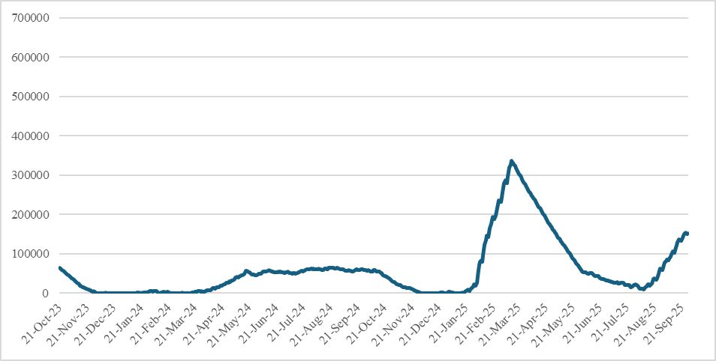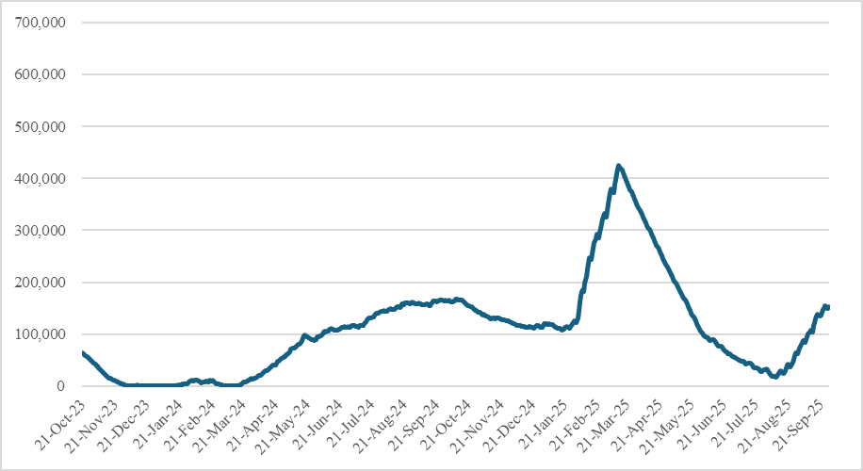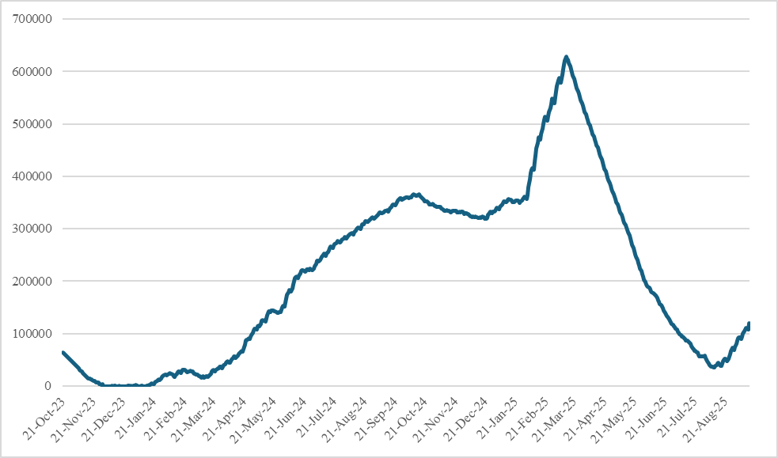
Source: Authors’ own elaboration

Figure S18. Daily cumulative stockpile of calories, October 2023 to September 2025 – 5% food loss
UN-Pallet UN-MT20 COGAT
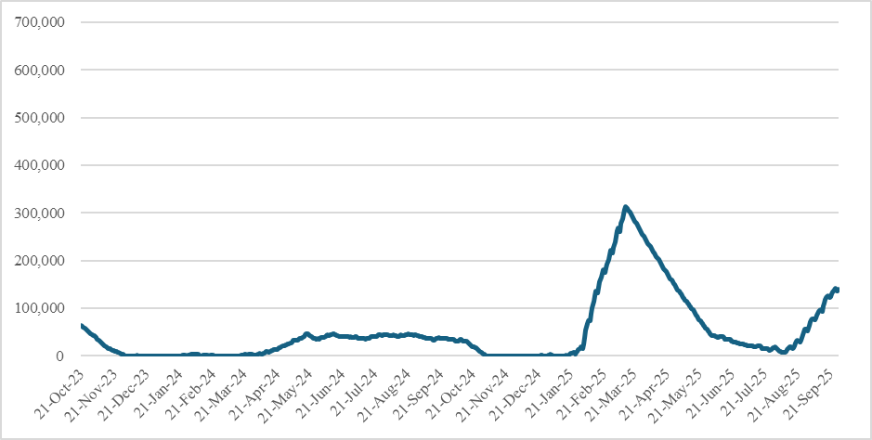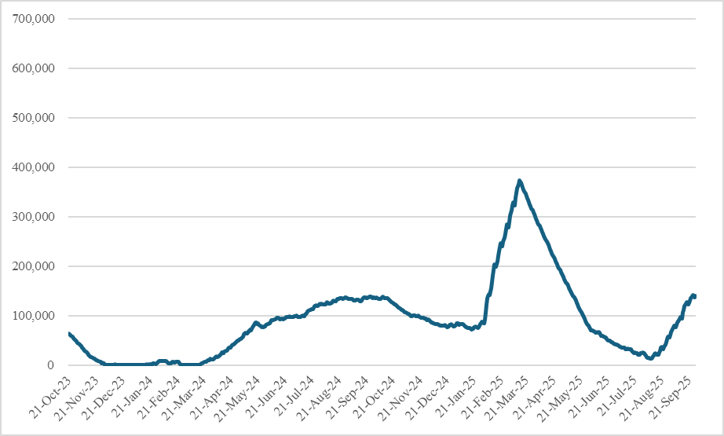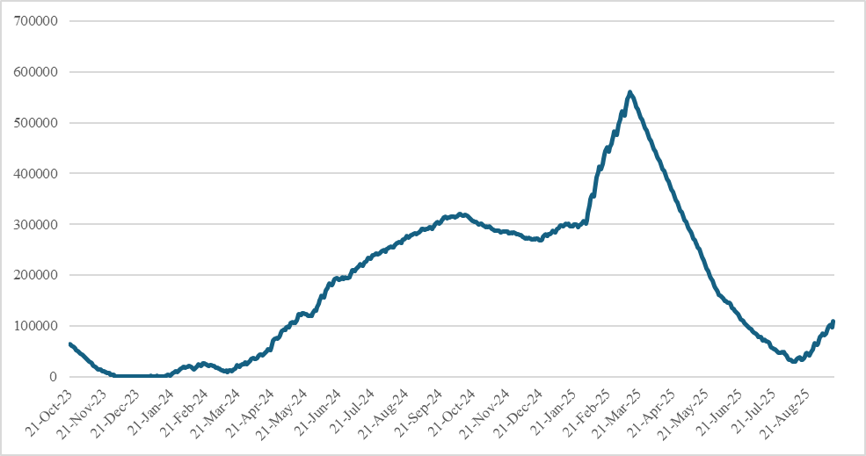
Source: Authors’ own elaboration

Figure S19. Daily cumulative stockpile of calories, October 2023 to September 2025 – 15% food loss
UN-Pallet UN-MT20 COGAT
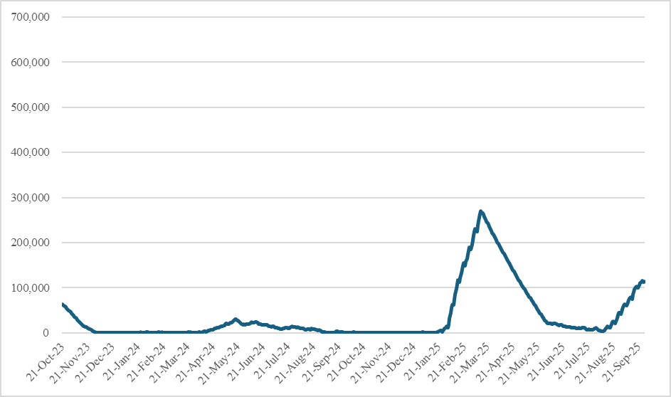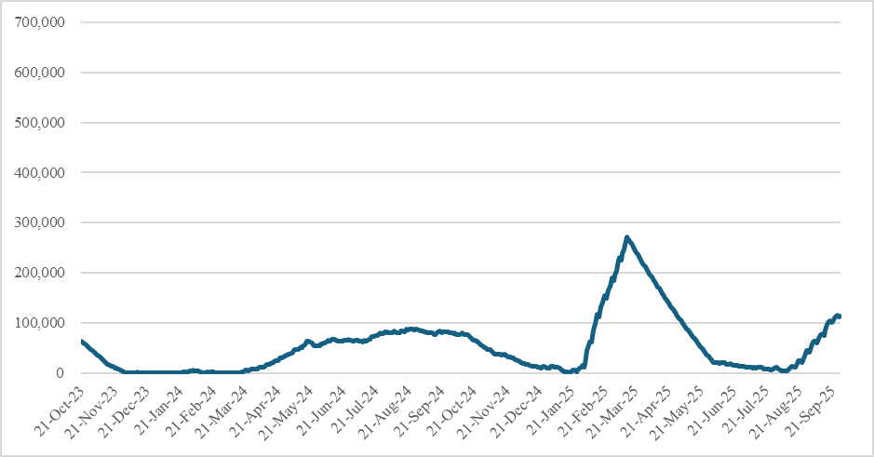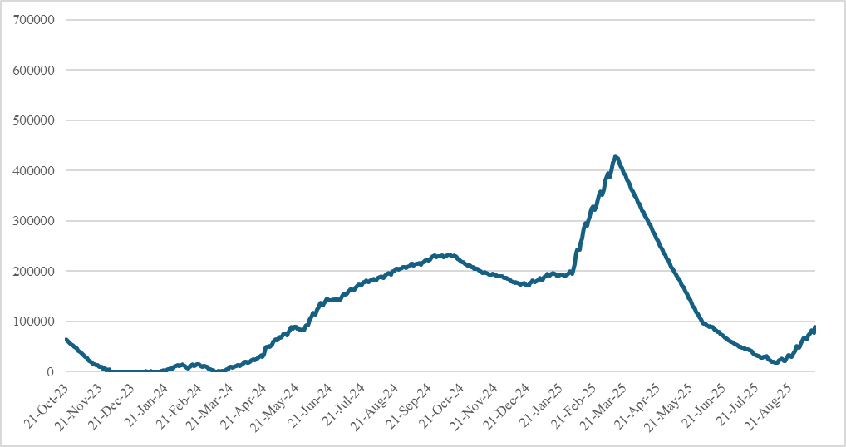
Source: Authors’ own elaboration

- Stochastic simulation of caloric distribution
The purpose of the simulation is to estimate the population distribution of daily caloric intake with inequality in access and to derive (i) mean per-capita intake and (ii) population shares under key thresholds.
Model 1
For the period October 2023 to 18 May 2025, we assume that all individuals belong to a single population group with a common distribution.
Input
- N: total population for each month
- R: number of Monte Carlo replications (here R =300)
- K: average daily total available kcal in each month
- Truncation bounds: L = 0, U = 3 500 kcal/person/day
- Binning step: h = 50 kcal
- Thresholds: T₁=1 407 kcal, T₂=2 100 kcal
Generative Model
For each individual $j∈\left\{1, …,N\right\}$, the latent caloric intake is drawn as follows:
 | $$X_{j}\sim N\left(μ,σ^{2}\right)$$ | (1)

We also apply truncation to obtain the intake:
 | $$Y_{j}=min\left\{max\left\{X_{j}, L\right\},U\right\}$$ | (2)

Procedure (per run r = 1, …, R)
- Sample intakes ${\left\{Y_{j}^{\left(r\right)}\right\}}_{j=1}^{N}$from the mixture defined above.
- Bin to 50-kcal cells: we map each $Y_{j}^{\left(r\right)}$ to a bin $b∈\left\{0, 50, 100,…\right\}$ via
 | $b_{j}^{\left(r\right)}=h∙\left\lfloor \frac{Y_{j}^{\left(r\right)}}{h}\right\rfloor$ with midpoint $m_{b}=b+\frac{h}{2}$ | (3)

- Collapse to a histogram: we compute for each bin b, frequency${ f}_{b}^{\left(r\right)}$ and percentage
 | $$P_{b}^{\left(r\right)}=100 ×\frac{f_{b}^{\left(r\right)}}{N}$$ | (4)

- Specific weighted mean is run:
 | $${\overline{y}}^{\left(r\right)}=\frac{\sum_{b}{m_{b}p_{b}^{\left(r\right)}}}{\sum_{b}{p_{b}^{\left(r\right)}}}$$ | (5)
Aggregation Across Runs
- Average intake distribution: for each bin b,
 | $${\overline{p}}_{b}=\frac{1}{R^{*}}\sum_{r=1}^{R^{*}}{P_{b}^{\left(r\right)}}$$ | (6)
where $R^{*}$ is the number of retained replications.
- Overall mean per-capita intake:
 | $$\overline{y}=\frac{\sum_{b}{m_{b}{\overline{p}}_{b}}}{\sum_{b}{{\overline{p}}_{b}}}$$ | (7)

Extension: Two-population Model (period 2)
For the period 18 May to 30 September 2025, the population is partitioned into two sub-groups:
- GHF – served population (g=1)
- Non-GHF population (g=2)
Within each group, we replicate Eq. (1) – Eq. (7).
- Stability check: compute cumulative averages $\frac{1}{r}\sum_{k=1}^{r}{{\overline{y}}^{\left(k\right)}}$over r = 1, …, R* to verify convergence.
Consistency with single population model:
We calibrated the two-population specification so that population-weighted average intake in Period 2 equals population-weighted average intake under a single-population model using the same total calories consumed as in Table S26.
Allowance for intakes above 2,100 kcal/pp/day
To allow for a small share of individuals to consume more than 2,100 kcal/pp/day, we model individual caloric intake as a two-component mixture distribution.
Let $π∈\left(0,1\right)$ denote the share of the population with access to relatively higher caloric intake.
For each individual $j$:
 | $$X_{j}\sim \left\{\begin{aligned}N\left(μ_{L},σ_{L}^{2}\right), \text{ with probability }\left(1-π\right) \\ N\left(μ_{H},σ_{LH}^{2},\right) \text{with probability }π \end{aligned} \right.$$ | (1a)
where:
- $μ_{L}$<2,100 kcal/person/day is the majority of the population facing constrained intake
- $μ_{H}$>2,100 kcal/person/day captures a smaller group with higher access to food.
- $π$ is calibrated to be small (around 5%)
The unconditional mean intake is constrained to match observed monthly availability $K$ (meaning that $π$ could be very small and fluctuate between 0% and 5%):
 | $$\left(1-π\right)μ_{L}+πμ_{H}=K$$ | (1b)

Threshold shares and group totals
Using the aggregated histogram $\left\{{\overline{p}}_{b}\right\}$, we define:
$$S_{<T_{1}}=\sum_{b:m_{b}<T_{1}}{{\overline{p}}_{b}}$$
$$S_{\left(T_{1},T_{2}\right)}=\sum_{b:{T_{1}<m}_{b}<T_{2}}{{\overline{p}}_{b}}$$
and
$$S_{≥T_{2}}=\sum_{b:m_{b}≥T_{2}}{{\overline{p}}_{b}}$$
Convert to headcounts:
$$H_{<T_{1}}=\frac{S_{<T_{1}}}{100}$$
$$H_{\left(T_{1},T_{2}\right)}=\frac{S_{\left(T_{1},T_{2}\right)}}{100}$$
$$H_{≥T_{2}}=\frac{S_{≥T_{2}}}{100}$$
Simulation stability is assessed through convergence of repeated Monte Carlo runs to the average per capita caloric intake for the period.

References
1. FAO, UNU, WHO. Human energy requirements: report of a joint FAO/WHO/UNU expert consultation Rome, 17 - 24 October 2001. Rome: Food and Agricultural Organization of the United Nations; 2001.
2. UNHCR, UNICEF, WFP, WHO. Food and nutrition needs in emergencies [Internet]. Geneva; 2002. Available from: https://www.who.int/publications/i/item/food-and-nutrition-needs-in-emergencies
3. Fliss-Isakov N, Nitzan D, Magnazi MB, Mendlovic J, Preis SA, Twig G, et al. Food supplied to Gaza during seven months of the Hamas-Israel war. Israel Journal of Health Policy Research. 2025 Feb 12;14(1):8.
4. Heesemann E, Giaquinto AM, Staffieri I, Sitko NJ, Davis B. The impacts of the 2023/2025 Gaza Conflict: short- and medium-term harm to agriculture, income, and nutrition. FAO Inclusive Agrifood Systems Working Papers. Forthcoming;
5. Schrobback P, Dennis G, Li Y, Mayberry D, Shaw A, Knight-Jones T, et al. Approximating the global economic (market) value of farmed animals. Global Food Security. 2023 Dec;39:100722.
6. FAO. Damage to cropland due to the conflict in the Gaza Strip as of 1 December 2023 [Internet]. Rome, Italy: FAO; 2024 [cited 2025 Dec 15]. Available from: https://openknowledge.fao.org/handle/20.500.14283/cc9279en
7. FAO. Damage to cropland due to the conflict in the Gaza Strip as of 31st December 2023 [Internet]. Rome, Italy: FAO; 2024 [cited 2025 Dec 15]. Available from: https://openknowledge.fao.org/handle/20.500.14283/cc9399en
8. FAO. Damage to cropland due to the conflict in the Gaza Strip as of 15 February 2024 [Internet]. Rome, Italy: FAO; 2024 [cited 2025 Dec 15]. Available from: https://openknowledge.fao.org/handle/20.500.14283/cc9795en
9. FAO. Damage to cropland due to the conflict in the Gaza Strip as of 20 May 2024 [Internet]. Rome, Italy: FAO; 2024 [cited 2025 Dec 15]. Available from: https://openknowledge.fao.org/handle/20.500.14283/cd1141en
10. FAO, UNITAR. Damage to cropland due to the conflict in the Gaza Strip as of 1 September 2024 [Internet]. Rome, Italy: FAO; 2024 [cited 2025 Dec 15]. Available from: https://openknowledge.fao.org/handle/20.500.14283/cd2595en
11. FAO U and U. Damage to cropland due to the conflict in the Gaza Strip as of 31st of December 2024 [Internet]. Rome, Italy: FAO; 2025 [cited 2025 Dec 15]. Available from: https://openknowledge.fao.org/handle/20.500.14283/cd4036en
12. FAO. Land availability for cultivation in the Gaza Strip as of April 2025 [Internet]. 2025. Available from: https://openknowledge.fao.org/server/api/core/bitstreams/c4be554e-170f-413e-ae57-f77030be8d09/content
13. FAO. Land available for cultivation in the Gaza Strip as of 28 July 2025. [Internet]. 2025. Available from: https://openknowledge.fao.org/server/api/core/bitstreams/c93215e8-2ac0-4e36-a82b-25ee66fa80b7/content
14. BBC. ​​What is inside the GHF food box being distributed in Gaza [Internet]. 2025 [cited 2025 Dec 3]. Available from: https://www.bbc.com/news/articles/cd787er1qz4o
15. The Jerusalem Post. Yahoo News. 2025 [cited 2025 Dec 3]. What food is being distributed in Gaza? GHF releases full list. Available from: https://www.yahoo.com/news/food-being-distributed-gaza-ghf-021241309.html
16. News18. News18. [cited 2025 Dec 3]. ​​What is inside the GHF food aid box being distributed in Gaza? Available from: https://www.news18.com/videos/breaking-news/what-is-inside-ghf-food-aid-box-in-gaza-9465302.html
17. Checchi F, Ververs MT, Jamaluddine Z. Wartime food availability in the Gaza Strip, October 2023 to August 2024: a retrospective analysis. 2024.
18. UNOPS. UN2720 Monitoring & Tracking Dashboard [Internet]. [cited 2025 Dec 6]. Available from: https://app.un2720.org/mt
19. COGAT. Israel Humanitarian efforts - Swords of Iron [Internet]. [cited 2025 Dec 4]. Available from: https://Gaza-aid-data.gov.il/mainhome/
20. UNRWA. Gaza Supplies and Dispatch tracking. [Internet]. 2025 [cited 2025 Jan 30]. Available from: https://app.powerbi.com/view?r=eyJrIjoiZTVkYmEwNmMtZWYxNy00ODhlLWI2ZjctNjIzMzQ5OGQxNzY5IiwidCI6IjI2MmY2YTQxLTIwZTktNDE0MC04ZDNlLWZkZjVlZWNiNDE1NyIsImMiOjl9&pageName=ReportSection3306863add46319dc574.

