Supplementary Information

Table S1. Sample sizes for linear-mixed effects comparisons
Data Type | Women using HRT | Women nHRT | Age-matched men | Total
Sleep composition & CV recovery (nights, cohort differences) | 470 | 469 | 469 | 1408
Sleep composition & CV recovery (nights, between ATR conditions) | 406 | 409 | 415 | 1230
Skin temperatures (T_{SK}, nights) | 180 | 189 | 183 | 552
Core temperature (T_{C}, nights) | 136 | 168 | 104 | 408
Body temperature (T_{B}, nights) | 92 | 105 | 76 | 273
Circadian rhythm of T_{C} (24-hour periods) | 86 | 125 | 68 | 279
Circadian rhythm of heart rate (24-hour periods) | 229 | 262 | 178 | 669
Note: Sample size for each data type, including sleep, cardiovascular (CV) recovery, and skin, core, and body temperature. Both nightly estimates and those used for circadian analysis are displayed (nights vs. 24-hour periods) and shown by cohorts. HRT = hormone replacement therapy, nHRT = not using HRT.

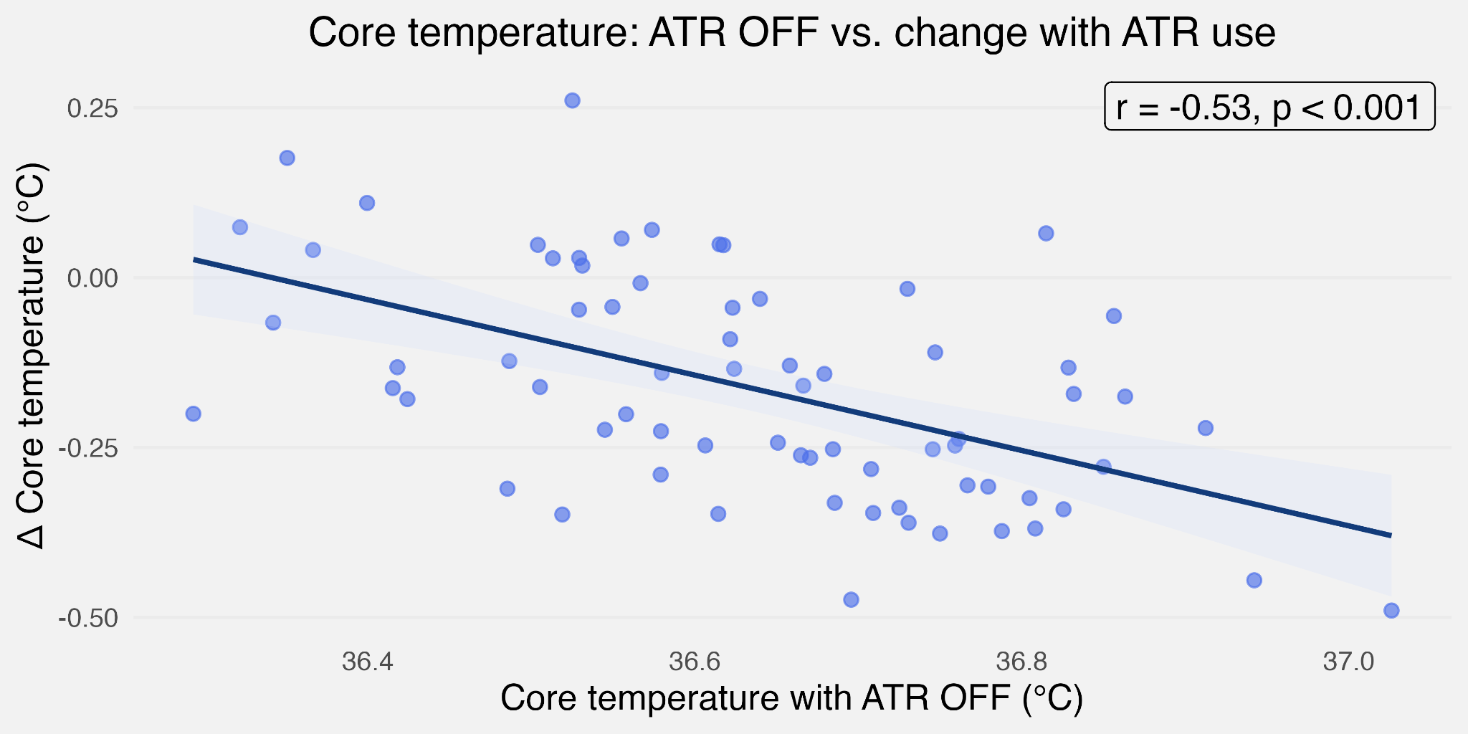

Figure S1: Core temperature (T_{C}) with active temperature regulation (ATR) OFF is negatively associated with T_{C} cooling response to ATR ON.
Each blue datapoint represents participant-means (n=70). Higher T_{C} during ATR OFF correlates with greater T_{C} reduction during ATR ON (r = -0.53, p < 0.001). The shaded area shows SE.

Table S2. Participant characteristics
Cohort | Age (years) | Height ‡ ⧻ (cm) | Weight ‡ ⧻  (kg) | BMI (kg/m²) | PdG ‡ ✝ (µg/mL) | LH ‡ ✝ ⧻ (mIU/mL) | FSH ‡ ✝ ⧻ (mIU/mL) | E3G ‡ ✝ (ng/mL)
All participants (n=90) | 56.4 ± 6.1 | 170.2 ± 8.0 | 73.0 ± 13.3 | 25.1 ± 3.9 | 9.6 ± 12.3 | 9.4 ± 10.1 | 44.6 ± 44.8 | 82.2 ± 82.3
Women using HRT (n=30) | 55.4 ± 4.9 | 166.5 ± 6.2 | 68.6 ± 13.7 | 24.7 ± 4.7 | 25.5 ± 8.0 | 9.1 ± 5.9 | 45.1 ± 30.1 | 126.1 ± 125.3
Women nHRT (n=30) | 57.2 ± 6.5 | 166.4 ± 5.8 | 68.6 ± 11.2 | 24.8 ± 4.1 | 1.3 ± 0.7 | 15.6 ± 13.9 | 78.9 ± 50.9 | 55.1 ± 34.7
Age-matched men (n=30) | 56.7 ± 6.7 | 177.8 ± 5.9 | 81.8 ± 10.3 | 25.8 ± 2.6 | 1.7 ± 0.9 | 3.3 ± 1.4 | 8.7 ± 6.3 | 64.7 ± 24.6
Note: Data are presented as mean ± SD. Abbreviations: HRT = hormone replacement therapy, PdG = pregnanediol glucuronide, LH = luteinizing hormone, FSH = follicle-stimulating hormone, E3G = estrone-3-glucuronide. ‡ = significant difference (p<0.05) between women using HRT vs. age-matched men, ✝ = significant difference (p<0.05) between women using HRT vs. women not using HRT (nHRT), ⧻ = significant difference (p<0.05) between age-matched men vs. women nHRT. Statistical analysis was conducted on age, height, and weight estimates in addition to participant-level means of hormones (measured during both active temperature regulation conditions) using one-way ANOVA and Tukey-adjusted pairwise comparisons.

Table S3. Nightly selected temperature settings by sleep phase and cohort
Cohort | Bedtime phase | Initial phase | Final phase
Women using HRT (n=30) | 25.3 ± 3.9°C | 25.1 ± 3.0°C | 26.2 ± 2.7°C
Women nHRT (n=30) | 22.7 ± 4.6°C | 23.3 ± 3.5°C | 24.7 ± 3.9°C
Age-matched men (n=30) | 24.7 ± 4.3°C | 24.5 ± 3.0°C | 25.7 ± 2.7°C
Note: All values in °C, presented as mean ± SD. The Bedtime phase is the timeframe from bed entry to 15 minutes after detected sleep onset. The Initial phase is the first 4 hours of sleep and the Final phase is from the end of the Initial phase to detected wake. No statistical differences in selected bed temperatures were observed between cohorts within each sleep phase. HRT = hormone replacement therapy. nHRT = not using HRT.

Data Filtration
Sleep and Cardiovascular Metric Filtration
Following sleep metric calculations, outlier removal was applied. Across nightly and Initial/Final phase estimates, estimates were excluded if sleep duration was <4 or >14 hours. Individual nights were also excluded if either of the following were true (1) WASO exceeded +2.5 standard deviations from the participant’s study mean or (2) any sleep stage percentage (deep, light, or REM) fell outside ± 2.5 standard deviations from the participant’s study mean. These exclusion criteria removed abnormal nights relative to each participant, retaining 1,408 nights out of 1,463 nights among 90 participants. These numbers reflected the 14 experimental nights, the 2 nights before the study started (when participants were setting up some equipment), and any repeat nights (e.g. forgetting to acquire skin temperature data). Of the 1,408 retained nights, 1,230 nights were during the experimental phase (ATR ON or OFF).
Skin Temperatures Filtration
Skin temperature data were excluded if sleep duration was <4 or >14 hours or if T_{SK} fell below 30°C, indicating sensor detachment. As the normal range for skin temperature during sleep is 33-36°C⁵², a 30°C threshold allowed for slight individual deviations. Additional nights were excluded for poor data quality (k=4) or trimmed due to rapid shifts in T_{SK}, indicating a loosely attached sensor (k=1), both determined through visual inspection. One participant was omitted due to lost sensors. After removal, 552 nights from 89 participants were included in the analysis. This number also reflects repeated nights (e.g. where participants forgot to wear smart rings).

Core Temperature Filtration
T_{C} pills were activated at the research lab and shipped to participants, therefore, all T_{C} values during shipping and prior to the pill being swallowed (4 hours before bedtime on Night 3 during each ATR condition) were removed. Data were retained only after temperature readings demonstrated stable physiological values (≥36°C for >15 consecutive minutes) to ensure the pill had reached the small intestines. On average, the T_{C} pill remained in the participants’ systems for 65 ± 44 hours, providing 2-3 nights of data per individual during both ATR ON and OFF. Temperature fluctuations due to external factors were removed, including artifacts from hot/cold water intake. Data points were removed if the rate of change between consecutive readings (1 min sampling rate) was >|0.4|°C, allowing for exercise-related T_{C} changes while removing hot/cold beverage artifacts^{59,60}. Additionally, data 5 minutes before and 10 minutes after unexpected temperature changes were removed to allow T_{C} to return to pre-spike values. These windows were expanded in three participants due to slower T_{C} dynamics (determined through visual inspection); a total of 17 nights were manually excluded due to T_{C} dynamics differing from the participant's normal rhythm on other nights. Nights with <4 total hours of T_{C} data during sleep (<240 data points after filtration) were removed, resulting in 408 nights from 87 participants for analysis.

Circadian Rhythm Filtration
In addition to filtration described above, T_{C} periods with >4 hours of missing data across each 24-hour period were excluded, except for 9 manually included periods, where missing data distribution still allowed for cosinor fitting. This resulted in 279 24-hour periods from 78 participants (27 women using HRT, 28 women nHRT, and 23 age-matched men).

HR 24-hour periods were excluded if sleep duration was <4 hours or >14 hours, if any gap between consecutive data points was >4 hours, or if data density was too low for cosinor fitting (manual exclusion). After exclusions, 669 24-hour periods from 54 participants were included. When combined with T_{C}, 148 24-hour periods from 46 participants were included in the Circadian analysis.

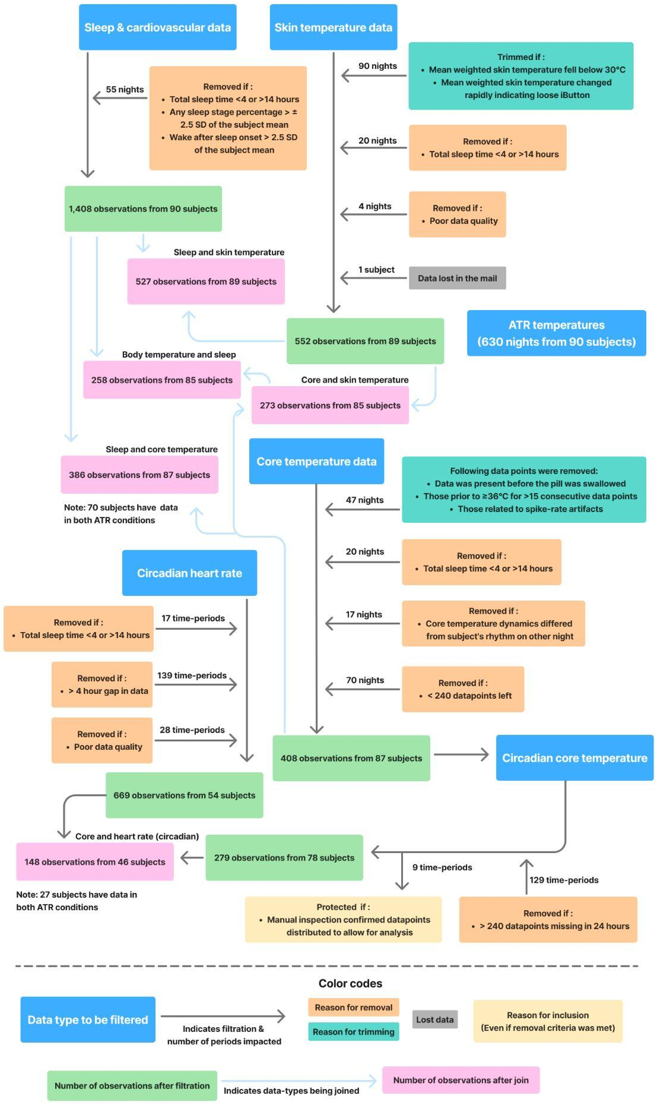

Figure S2. Data preprocessing, filtration, and dataset combination for analysis.
Blue boxes indicate primary data sources; teal boxes indicate nights or time periods trimmed based on data-quality thresholds; and orange boxes indicate exclusion criteria applied to remove select observations. Yellow boxes denote periods that were manually inspected and retained despite meeting exclusion criteria. Gray arrows show the sequential filtration pipeline, with labels indicating the number of nights, participants, or time periods that were excluded, trimmed, or manually retained at each step, according to the box they point to or away from. Gray arrows will ultimately lead to green boxes, which summarize the remaining sample size for each data type. Light blue arrows denote steps where datasets were joined. Finally, pink boxes indicate the resulting sample sizes for the merged datasets and respective analysis.

