Supporting Information

Recognition of Non-standard Base Pairs by Triplex-Forming Oligonucleotides Containing an Expanded Genetic Alphabet

Michael Brazzill,¹ Ruolin Ma,¹ Kieron Munn,¹ Léna Prestifilippo,^{1,2} Andrew R. Pickford,³ Hyo-Joong Kim,^{4,5} Cen Chen,^{4,5} Shuichi Hoshika,^{4,5*} Steven A. Benner,^{4,5} and David A. Rusling^{1*}

¹School of Medicine, Pharmacy and Biomedical Sciences, University of Portsmouth, Portsmouth, PO1 2DT, UK
²Polytech Angers, 16 Boulevard Daviers, 49100 Angers, France
³Centre for Enzyme Innovation, School of the Environment and Life Sciences, University of Portsmouth, Portsmouth, PO1 2DT, UK
⁴Foundation for Applied Molecular Evolution, Alachua, FL 32615, USA
⁵Firebird Biomolecular Sciences LLC, Alachua, FL 32615, USA

*Corresponding authors: david.rusling@port.ac.uk and shoshika@ffames.org

Table S1: Nucleobase abbreviations used in this study. Chemical structures of the modified nucleobases are presented in Figure 2 and Figure S2.
Abbreviation | Number | Chemical name
Z | 1 | 6-amino-5-nitropyridin-2-one
S^{c} | 2 | 1-methylcytosine
K^{n} | 3 | 2,6-diamino-3-nitropyridine
V | 4 | 6-amino-3-nitropyridin-2-one
8amA | 5 | 8-aminoadenine
8amG | 6 | 8-aminoguanine
8oxA | 7 | 8-hydroxyadenine
8oxG | 8 | 8-hydroxyguanine
ΨC | 9 | Pseudoisocytosine
5meC | 10 | 5-methylcytosine
ΨU | 11 | Pseudouracil
5hoC | 12 | 5-hydroxycytosine
5hoU | 13 | 5-hydroxyuracil
2amA | 14 | 2-aminoadenine
B | 15 | Isoguanine
P | 16 | 5-aza-7-deazaguanine
B^{c} | 17 | 7-deazaisoguanine
NI | 18 | 5-nitroindole
I | 19 | Inosine

Table S2: Sequences and naming nomenclature of oligonucleotides used in Figure 3, 5, S6, S7, S11, S12 and S13; numbers in bold indicate nucleobase modifications; underlined bases were those under study.
Name | Oligonucleotide sequences | Modification
Con TFO-T | 5ʹ-TTCTTTCTTCTCT
TFO-T | 5ʹ-TT1TTT1TT1T1T | 1 = Z
TFO-C | 5ʹ-TT1TCT1TT1T1T | 1 = Z
TFO-Z | 5ʹ-TT1T1T1TT1T1T | 1 = Z
TFO-S^{c} | 5ʹ-TT1T2T1TT1T1T | 1 = Z, 2 = S^{c}
TFO-K^{n} | 5ʹ-TT1T3T1TT1T1T | 1 = Z, 3 = K^{n}
TFO-V | 5ʹ-TT1T4T1TT1T1T | 1 = Z, 4 = V
Duplex  A-T | 5ʹ-AAGAAAGAAGAGA  3ʹ-TTCTTTCTTCTCT
Duplex  G-C | 5ʹ-AAGAGAGAAGAGA  3ʹ-TTCTCTCTTCTCT
Duplex  T-A | 5ʹ-AAGATAGAAGAGA  3ʹ-TTCTATCTTCTCT
Duplex  C-G | 5ʹ-AAGACAGAAGAGA  3ʹ-TTCTGTCTTCTCT
Duplex  U-A | 5ʹ-AAGAUAGAAGAGA  3ʹ-TTCTATCTTCTCT
Duplex 8amA-T | 5ʹ-AAGA5AGAAGAGA  3ʹ-TTCTTTCTTCTCT | 5 = 8amA
Duplex 8amG-C | 5ʹ-AAGA6AGAAGAGA  3ʹ-TTCTCTCTTCTCT | 6 = 8amG
Duplex 8oxA-T | 5ʹ-AAGA7AGAAGAGA  3ʹ-TTCTTTCTTCTCT | 7 = 8oxA
Duplex 8oxG-C | 5ʹ-AAGA8AGAAGAGA  3ʹ-TTCTCTCTTCTCT | 8 = 8oxG
Duplex  ΨC-G | 5ʹ-AAGA9AGAAGAGA  3ʹ-TTCTGTCTTCTCT | 9 = ΨC
Duplex 5meC-G | 5ʹ-AAGA10AGAAGAGA  3ʹ-TTCTGTCTTCTCT | 10 = 5meC
Duplex  ΨU-A | 5ʹ-AAGA11AGAAGAGA  3ʹ-TTCTATCTTCTCT | 11 = ΨU
Duplex  5ohC-G | 5ʹ-AAGA12AGAAGAGA  3ʹ-TTCTGTCTTCTCT | 12 = 5ohC
Duplex  5ohU-A | 5ʹ-AAGA13AGAAGAGA  3ʹ-TTCTATCTTCTCT | 13 = 5ohU
Duplex  2amA-T | 5ʹ-AAGA14AGAAGAGA  3ʹ-TTCTTTCTTCTCT | 14 = 2amA
Duplex  B-S^{c} | 5ʹ-AAGA15AGAAGAGA  3ʹ-TTCT2TCTTCTCT | 15 = B, 2 = S^{c}
Duplex  P-Z | 5ʹ-AAGA16AGAAGAGA  3ʹ-TTCT1TCTTCTCT | 16 = P, 1 = Z
Duplex  B*-S^{c} | 5ʹ-AAGA17AGAAGAGA  3ʹ-TTCT2TCTTCTCT | 17 = B^{C}, 2 = S^{c}
Duplex  Z-P | 5ʹ-AAGA1AGAAGAGA  3ʹ-TTCT16TCTTCTCT | 1 = Z, 16 = P
Duplex  NI-T | 5ʹ-AAGA18AGAAGAGA  3ʹ-TTCTTTCTTCTCT | 18 = NI
Duplex  NI-C | 5ʹ-AAGA18AGAAGAGA  3ʹ-TTCTCTCTTCTCT | 18 = NI
Table S3: Sequences and nomenclature of the oligonucleotides used in Figure S4; numbers in bold indicate nucleobase modifications; underlined bases were those under study.
Name | Oligonucleotide sequences | Modifications
TFO-Va | 5’-TT1TTT1TT141T | 1 = Z, 4 = V
TFO-2V | 5’-TT1TTT1T4141T | 1 = Z, 4 = V
TFO-3V | 5’-TT1TTT144141T | 1 = Z, 4 = V
Duplex  G-C 1 | 5ʹ-AAGAAAGAAGGGA  3ʹ-TTCTTTCTTCCCT
Duplex  G-C 2 | 5ʹ-AAGAAAGAGGGGA  3ʹ-TTCTTTCTCCCCT
Duplex  G-C 3 | 5ʹ-AAGAAAGGGGGGA  3ʹ-TTCTTTCCCCCCT

Table S4: Sequences and nomenclature of the oligonucleotides used in Figure 4, 6, S8, S9, and S10; numbers in bold indicate nucleobase modifications; underlined bases were those under study.
Name | Oligonucleotide sequences | Modifications
Con TFO-T | 5ʹ-TTCTTTCTTCTCT
TFO-T | 5ʹ-TT1TTT1TT1T1T | 1 = Z
TFO-4S^{c} | 5ʹ-T21T2T1T2121T | 1 = Z, 2 = S^{c}
TFO-4K^{n} | 5ʹ-T31T3T1T3131T | 1 = Z, 3 = K^{n}
TFO-2C | 5ʹ-TT1TCT1TT1C1T | 1 = Z
TFO-2K | 5ʹ-TT1T3T1TT131T | 1 = Z, 3 = K^{n}
Duplex  A-T | 5ʹ-AAGAAAGAAGAGA  3ʹ-TTCTTTCTTCTCT
Duplex  8amA-T | 5ʹ-A5GAA5GA5G5GA  3ʹ-TTCTTTCTTCTCT | 5 = 8amA
Duplex  8amG-C | 5ʹ-AA6AAA6AA6A6A  3ʹ-TTCTTTCTTCTCT | 6 = 8amG
Duplex  8oxA-T | 5ʹ-A7GAA7GA7G7GA  3ʹ-TTCTTTCTTCTCT | 7 = 8oxA
Duplex  8oxG-C | 5ʹ-A8GAA8GA8G8GA  3ʹ-TCCTTCCTCCCCT | 8 = 8oxG
Duplex  ΨU-A / ΨC-G | 5ʹ-A11GA9AGA11G9GA  3ʹ-TACTGTCTACGCT | 9 = ΨC, 11 = ΨU
Duplex  2amA-T | 5ʹ-A14GAA14GA14G14GA  3ʹ-TTCTTTCTTCTCT | 14 = 2amA
Duplex  B-S^{c} / P-Z | 5ʹ-A15GA16AGA15G16GA  3ʹ-T2CT1TCT2C1CT | 1 = Z, 16 = P  2 = S^{c}, 15 = B,

Table S5: Sequences and nomenclature of the primers used in Figure 5, S12, and S13; numbers in bold indicate nucleobase modifications; underlined bases were those under study.
Name | Oligonucleotide sequences | Modifications
Mutagenic Forward | 5ʹ-GAGCAGCCTAAGA8AGAAGAGAGGGACATCA | 8 = 8oxG
Non-mutagenic Forward | 5ʹ-GAGCAGCCTAAGAAAGAAGAGAGGGACATCA
Reverse 1 (SDM) | 5ʹ-TGATGTCCCTCTCTTCTTTCTTAGGCTGCTC
Reverse 2 (PCR) | 5ʹ-GCGCGTTGGCCGATTCATT

Table S6: Sequences and nomenclature of the template and primers used in Figure 6; numbers in bold indicate nucleobase modifications; underlined bases were those under study.
Name | Oligonucleotide sequences | Modifications
T1 | 5’-TC1C2TCT1TC2TGGCCGATCCAGCGCAGTTG | 1 = Z, 2 = S^{c}
P1 | 5ʹ-CAACTGCGCTGGATCGGCC
A-T con | 5ʹ-CAACTGCGCTGGATCGGCCAAGAAAGAAGAGA  3’-GTTGACGCGACCTAGCCGGTTCTTTCTTCTCT
T2 | 5ʹ-AGAGAAGAAAGAACACGTGCACCATTGGTGCACG19G | 19 = inosine

Figure S1 – Triplex recognition of natural and non-natural base pairs using an expanded genetic alphabet. (a) Structures of standard and non-standard “pyrimidine” nucleobases (T, 5meC, 5ohU, 5ohC, and Z) presenting a bulky substituent in the major groove. (b) Structure of the universal base analogue 5-nitroindole with reduced Hoogsteen bonding capacity in the major groove. Hydrogen bond donor (D, red) and acceptor (A, blue) arrangements are indicated. Both sets of nucleobases were expected to hinder TFO binding in the major groove and reduce triplex stability.

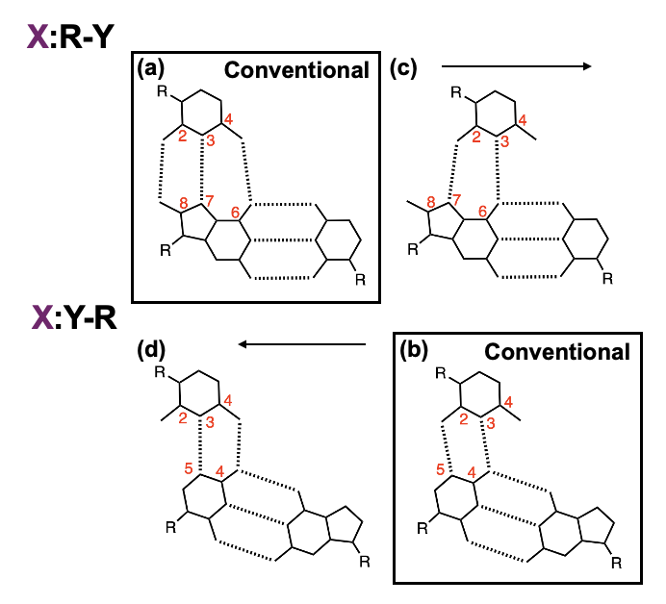
Figure S2 – Possible conventional and non-conventional triplet interactions for X:R-Y and X:Y-R parallel triplets. (a) Recognition of purines typically involves hydrogen bond formation between the 3- and 4-positions of the third strand base and the 7- and 6-positions of the purine within the W-C pair. Recognition of 8-modified purines may allow additional interactions between the 2-position of the third strand base and a group positioned at the 8-position. (b) By contrast, recognition of pyrimidines generally involves bonding between the 2- and 3-positions of the third strand base and the 5- and 4-positions of the pyrimidine. In both cases, unconventional C-H…O/N contacts may contribute additional stability. Other non-conventional pairing geometries are possible that involve a shift in the position of the TFO base further into (c) or out of (d) the major groove. However, the formation of these triplets are likely to be destabilising, as they are not isostructural with the T:A-T and Z:G-C triplets formed by the oligonucleotide.
Figure S3 – Triplex selectivity of unmodified TFO-T (con TFO-T) at pH 5.0. (a) Triplex motif used to assess nucleobase (X) selectivity for each base pair (R-Y) in turn. (b) EMSA analysis of unmodified TFO-T at low pH with each duplex. Oligonucleotides were annealed in pH 5.0 sodium cacodylate buffer containing magnesium at a final concentration of 1 μM duplex and 2 μM TFO and then separated on a 20% non-denaturing polyacrylamide gel in standard tris-acetate running buffer. As expected, triplex formation was only evident for the triplex generated with a central T:A-T triplet.

Figure S4 – Screening of the V nucleobase in different sequence contexts. (a) Putative structures of the V:A-T and V:G-C triplets under study. (b) Triplex motif used to assess the selectivity of the nucleobase V for each base pair (R-Y) in turn within a different sequence context. Oligonucleotides were annealed in pH 7.0 sodium cacodylate buffer containing magnesium at a final duplex and TFO concentration of 1 μM and 2 μM, respectively. Samples were then separated on a 20% non-denaturing polyacrylamide gel in standard tris-acetate running buffer. Again, triplex formation is evident for the complex containing an unconventional V:G-C triplet (black asterisk). (c) Triplex motif used to assess the stability of triplexes containing multiple V:G-C triplets by EMSA analysis. Oligonucleotides were annealed in pH 7.0 sodium cacodylate buffer containing magnesium at a final duplex and TFO concentration of 1 μM and 2 μM, respectively. Samples were then separated on a 20% non-denaturing polyacrylamide gel in tris-acetate running buffer containing magnesium. As expected, triplex stability decreases as the number of V:G-C triplets increase, on account of the V:G-C triplet not being isostructural with T:A-T and Z:G-C triplets.
Figure S5 – Additional screening of modified TFOs. (a) Triplex motif used to assess nucleobase (X) selectivity for each base pair (R-Y) in turn. (b) EMSA analysis of modified TFOs positioning each nucleobase opposite each of the W-C pyrimidine inversions. Oligonucleotides were annealed in pH 7.0 sodium cacodylate buffer containing magnesium at a final duplex and TFO concentration of 1 μM and 10 μM, respectively. Samples were then separated on a 20% non-denaturing polyacrylamide gel in standard tris-acetate running buffer containing magnesium. Triplex formation with pyrimidine nucleobases is evident under these stabilising conditions, with the most stable triplets generated with C and K^{n} opposite U-A (black asterisk). (d) EMSA analysis of the major triplets formed in Figure 3 but run side-by-side on a single PAGE gel. Oligonucleotides were annealed in pH 7.0 sodium cacodylate buffer containing magnesium at a final duplex and TFO concentration of 1 μM and 2 μM, respectively. Samples were then separated on a 20% non-denaturing polyacrylamide gel in standard tris-acetate running buffer containing magnesium. Shifted species ran with the same mobility suggesting formation of the same triplex architectures.

Figure S6 – Triplex selectivity of an expanded genetic alphabet (pH analysis). (a) Triplex motif used to assess nucleobase (X) selectivity for each base pair (R-Y) in turn at different pH. (b) Electrophoretic mobility shift assay for each sample. Oligonucleotides were annealed in pH 5.0 or pH 9.0 sodium cacodylate buffer containing magnesium at a final duplex and TFO concentration of 1 μM and 2 μM, respectively. Complexes were separated on a 20% non-denaturing polyacrylamide gel in tris-acetate running buffer at the equivalent pH and subjected to post-staining with GelRed. Triplex formation is evidenced by reduced mobility of a sample relative to the duplex only control. The selectivity of the three nucleobases remains unaltered at each pH, except for TFO-K^{n} which shows a minor interaction with 8amG-C at pH 5.0 indicating minor protonation at N3 (red asterisk).

Figure S7 – Triplex selectivity of an expanded genetic alphabet (melting analysis). Fluorescence melting profiles for the duplex (a) and triplex (b) sequences shown in Figure 3. Oligonucleotides were annealed in pH 7.0 sodium cacodylate buffer containing magnesium at a final duplex and TFO concentration of 1 uM and 2 μM, respectively. Samples were then melted at 0.2 °C min⁻¹ in the presence of SYBR Green I (Ex 488 nm/Em 522 nm). Triplex melting temperatures (T_{m}) indicate the mid-point of the melting transition and in each case were shifted to higher temperatures compared to the equivalent duplex only samples. Thermal stability was dependent on the nature of the triplet formed.
Figure S8 – Modular recognition of different base pair combinations (EMSA analysis). Triplex motifs under study are shown and varied in the type and number of modified base triplets (T1-10). Oligonucleotides were annealed in pH 7.0 sodium cacodylate buffer containing magnesium, at a final duplex concentration of 1 μM and TFO concentration of 30, 10, 3, 1, 0.3 and 0.1 μM (lanes 2-7, respectively). Complexes were separated on a 20% non-denaturing polyacrylamide gel in standard tris-acetate running buffer in the presence or absence of magnesium as highlighted. Gels were then subjected to post-staining with GelRed. Triplex formation is evidenced by reduced mobility of a sample relative to the duplex only control sample and was evident for all triplex sequences under study (black asterisk). Sequences T4, T6, T8, T9, T10 required magnesium in the running buffer for stability.

Figure S9 – Modular recognition of different base pair combinations (CD analysis). Triplex motifs under study are shown and varied in the type and number of modified base triplets (T1-10). Oligonucleotides were annealed in pH 7.0 sodium cacodylate buffer containing magnesium. Final concentration of the duplex and TFO were 5 and 10 μM, respectively. Spectra were collected between 320–200 nm, at 100 nm/min, 1 s response time, 1 nm bandwidth in Hellma synthetic quartz cuvettes with a 1 mm pathlength. Each spectrum was accumulated five times and averaged to smooth. Triplex formation is evidenced by an increased negative peak at 210 nm compared to the duplex only sample⁷ (black data points) and was observed for all triplex sequences under study (purple data points and purple arrows).

Figure S10 – Modular recognition of different base pair combinations (UV melting). Triplex motifs under study are shown and varied in the type and number of modified base triplets (T1-10). Oligonucleotides were annealed in pH 7.0 sodium cacodylate buffer containing magnesium. Final concentration of the duplex and TFO were 5 and 10 μM, respectively. Complexes were heated at 0.2 °C min⁻¹ and spectra measured in a Shimadzu UV-3600 UV-Vis-NIR Spectrophotometer. Melting temperatures (T_{m}) indicate the mid-point of the melting transition and in for six of the triplexes were shifted to higher temperatures compared to the equivalent duplex only samples. Thermal stability was dependent on the nature of the triplet formed. Triplex samples obtained with the Y5-derivatives and AEGIS base pairs produced melting profiles like that obtained for the underlying duplex, indicating triplex and duplex melting in a single transition.

Figure S11 – Modular recognition of different base pair combinations (Additional ITC). Oligonucleotides were dissolved in pH 7.0 sodium cacodylate buffer containing magnesium at a final duplex and TFO concentration of 5 μM and 60 μM, respectively. (a) The unmodified triplex motif under study is shown (T0). Weak triplex formation is evident with an affinity in the micromolar range (Table 1). (b) The T:2amA-T triplex motif under study is shown (T7). Additional injections reveal a biphasic isotherm.

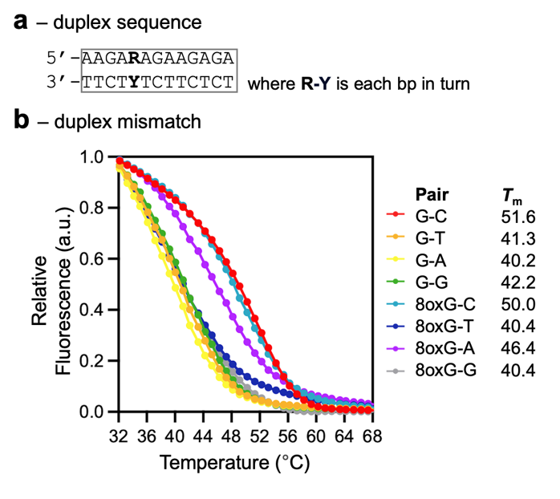
Figure S12 – G-Y and 8oxG-Y duplex melting analysis. (a) Duplex motif used to assess the stability of mismatched G-Y and 8oxG-Y base pairs, where Y is each base in turn. (b) Fluorescence melting profiles for the samples. Oligonucleotides were annealed in pH 7.0 sodium cacodylate buffer with magnesium at a final concentration of 1 μM and melted at 0.2 °C min⁻¹ in the presence of SYBR Green I (Ex 488 nm/Em 522 nm). Melting temperatures (T_{m}) were determined for each sample, with G-C and 8oxG–C bases exhibiting, as expected, the highest thermal stability. The next most stable was 8oxG-A, then a much lower thermal stability for the remainder of the mismatch combinations.

Figure S13 – Selectivity of K^{n} for targeting A-T in enzymatically assembled constructs. (a) Triplex motif used to assess the interaction of K^{n} with an A-T base pair. (b) A-T was introduced into pUC18 by site-directed mutagenesis (SDM, blue asterisk), the parental DNA digested by DpnI, and probed with 5′-³²P-labelled TFO-K^{n} at reducing plasmid concentrations. Complexes were resolved on a 12% native polyacrylamide gel in tris–acetate buffer and the TFO-bound sample visualised by phosphorimaging (black asterisk). As observed previously, no binding of K^{n} to A-T was evident under these experimental conditions. (c) A-T was introduced into a 251-bp fragment by PCR and targeted with 5′-³²P-labelled TFO-K^{n} after successive PCR cycles. Complexes were resolved on an 8% native polyacrylamide gel in tris–acetate buffer and the TFO-bound sample visualised by phosphorimaging (black asterisk). Only minor binding was observed after 32 PCR cycles (lane 6).

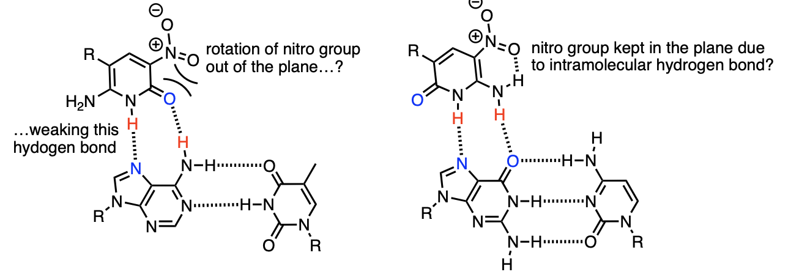
Figure S14 – Differential effects of the nitro group in V:A-T (left) and Z:G-C (right) triplets. Steric interactions with the adjacent 4-carbonyl may force the nitro group of V out of plane, decreasing the acidity and positioning of the ring N-H group, weakening hydrogen-bond donation. By contrast, intramolecular hydrogen bonding between the adjacent 4-amino and nitro group of Z likely enforces planarity and enhance hydrogen-bonding interactions.

REFERENCES
(1) Darby, R. A. J.; Sollogoub, M.; McKeen, C.; Brown, L.; Risitano, A.; Brown, N.; Barton, C.; Brown, T.; Fox, K. R. High Throughput Measurement of Duplex, Triplex and Quadruplex Melting Curves Using Molecular Beacons and a LightCycler. Nucleic Acids Research 2002, 30, e39. https://doi.org/10.1093/nar/30.9.e39.
(2) Xia, Y.; Chu, W.; Qi, Q.; Xun, L. New Insights into the QuikChangeTM Process Guide the Use of Phusion DNA Polymerase for Site-Directed Mutagenesis. Nucleic Acids Res. 2015, 43 (2), e12–e12. https://doi.org/10.1093/nar/gku1189.
(3) Yang, Z.; Sismour, A. M.; Sheng, P.; Puskar, N. L.; Benner, S. A. Enzymatic Incorporation of a Third Nucleobase Pair. Nucleic Acids Research 2007, 35, 4238–4249. https://doi.org/10.1093/nar/gkm395.
(4) Singh, I.; Laos, R.; Hoshika, S.; Benner, S. A.; Georgiadis, M. M. Snapshots of an Evolved DNA Polymerase Pre- and Post-Incorporation of an Unnatural Nucleotide. Nucleic Acids Res. 2018, 46 (15), gky552-. https://doi.org/10.1093/nar/gky552.
(5) Moody, E. R.; Obexer, R.; Nickl, F.; Spiess, R.; Lovelock, S. L. An Enzyme Cascade Enables Production of Therapeutic Oligonucleotides in a Single Operation. Science 2023, 380 (6650), 1150–1154. https://doi.org/10.1126/science.add5892.
(6) Rusling, D. A. Triplex-Forming Properties and Enzymatic Incorporation of a Base-Modified Nucleotide Capable of Duplex DNA Recognition at Neutral pH. Nucleic Acids Res. 2021, 49 (13), 7256–7266. https://doi.org/10.1093/nar/gkab572.
(7) Gray, D. M.; Hung, S. H.; Johnson, K. H. Absorption and Circular Dichroism Spectroscopy of Nucleic Acid Duplexes and Triplexes. Methods Enzym. 1995, 246, 19–34. https://doi.org/10.1016/0076-6879(95)46005-5.

