Supplementary Materials
Participating Hospitals
We retrospectively collected brain MRI data from 16 Chinese hospitals, include: Xiangya Hospital of Central South University (HunanXiangya), Hubei Provincial Hospital of Traditional Chinese Medicine (HubeiTCM), Yueyang Central Hospital (YueyangZhongxin), Hunan University of Medicine General Hospital (HunanUnivMedicine), The First People's Hospital of Yunnan Province (YunnanRenmin1st), Hunan Provincial People's Hospital (HunanRenmin), The Fourth Hospital of Changsha (Changsha4th), Xiangya Changde Hospital (XiangyaChangde), The 331st Hospital of Zhuzhou (Zhuzhou331), Huaihua Hospital of Traditional Chinese Medicine (HuaihuaTCM), The Fourth People's Hospital of Chenzhou (ChenzhouRenmin4th), Yichang Central People's Hospital (YichangZhongxin), Chaling People's Hospital of Zhuzhou (ZhuzhouChalingRenmin), Linxiang People's Hospital of Yueyang (YueyangLinxiangRenmin), The Third People's Hospital of Chenzhou (ChenzhouRenmin3rd), Pingjiang Hospital of Traditional Chinese Medicine in Yueyang (YueyangPingjiangTCM).

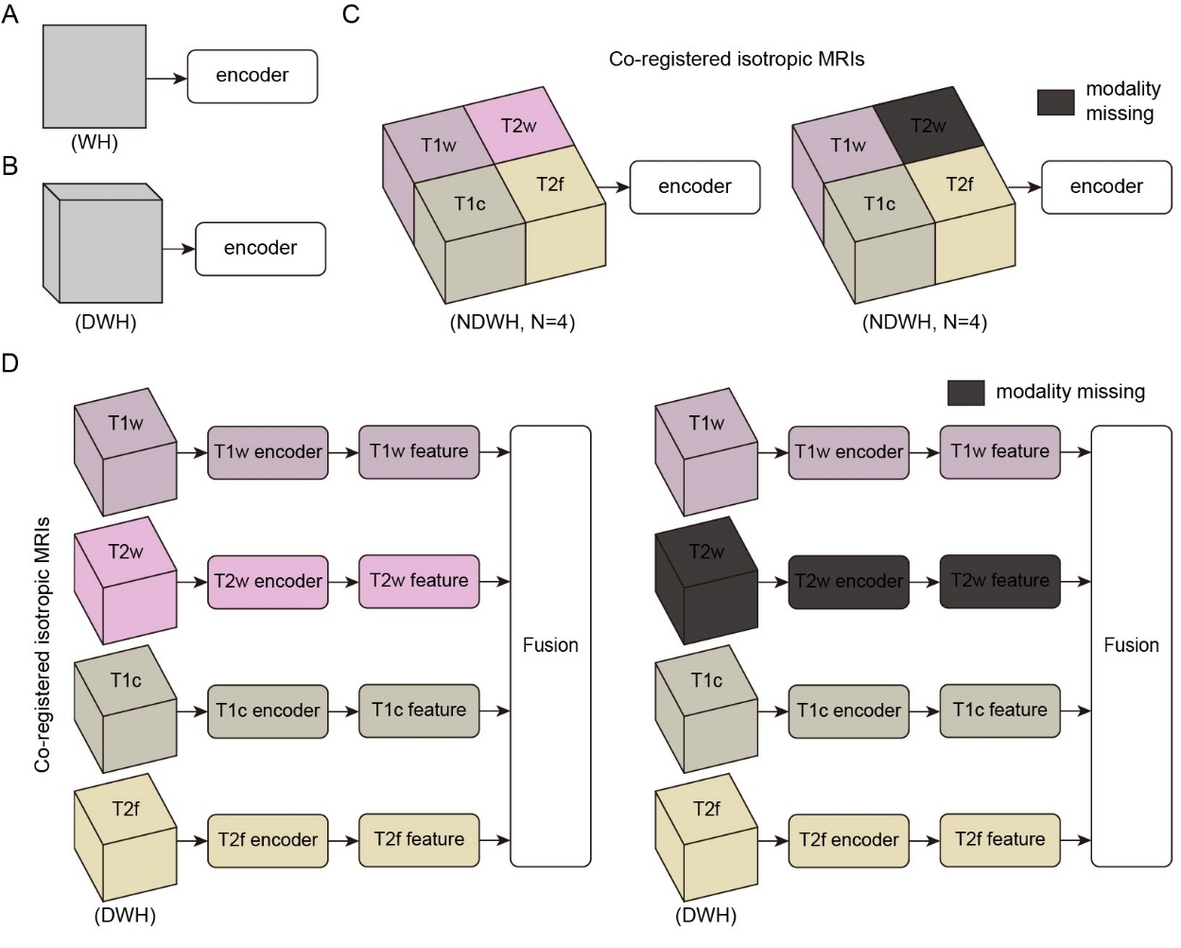
Fig. S1 Input design paradigms for existing brain MRI analysis models.
A. Single 2D image input. The model accepts an individual 2D slice as input^{31,37}.
B. Single 3D volume input. The model processes an entire 3D MRI volume as a single input^{32,37}.
C. 4D concatenated input of T1w, T2w, T1c, and T2f MRIs. Four distinct MRI sequences are concatenated into a 4D data block following a predefined order^{40,41}. Left panel: All four modalities are available as input. Right panel: Input with missing modalities.
D. Modality-specific encoder design. Four modality-specific encoders extract features from their corresponding predefined MRI sequences (T1w, T2w, T1c, and T2f), followed by subsequent feature fusion^{42–44}. Left panel: All four modalities are available as input. Right panel: Input with missing modalities.
C-D. These methods require all input MRIs to be isotropic and co-registered.

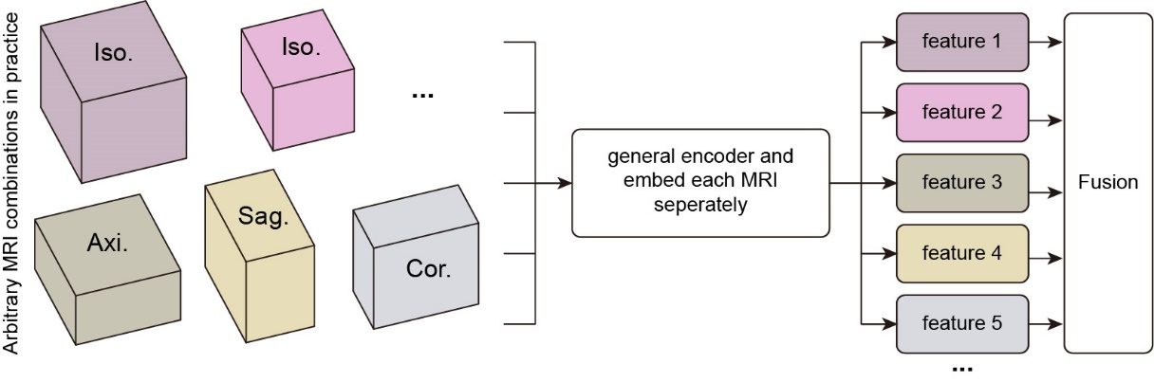
Fig. S2 Input design paradigm of OmiMRI. OmiMRI processes arbitrary MRI combinations without format restrictions or heavy preprocessing. Iso. represents isotropic MRIs. Axi., Sag., and Cor. represent anisotropic MRIs obtained from axial, sagittal, and coronal views, respectively.

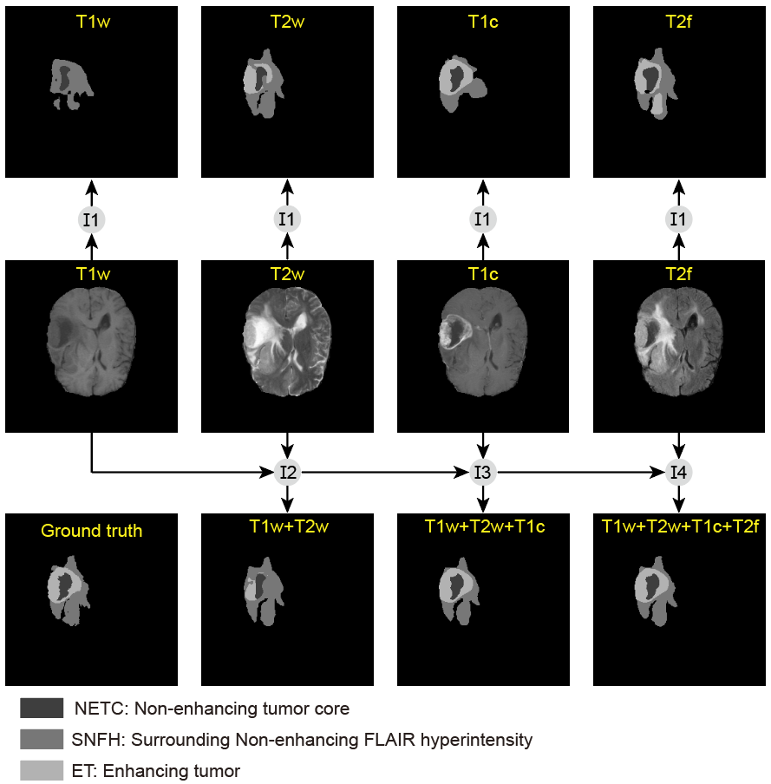
Fig. S3 Performance of OmiMRI in tumor segmentation with progressively increased MRI sequences.
OmiMRI_I1 denotes inference performed by OmiMRI using any single sequence from T1w, T2w, T1c, or T2f. OmiMRI_I2 through OmiMRI_I4 represent the same model utilizing two to four MRIs for inference, constructed by sequentially adding T2w, T1c, and T2f sequences to the T1w baseline.

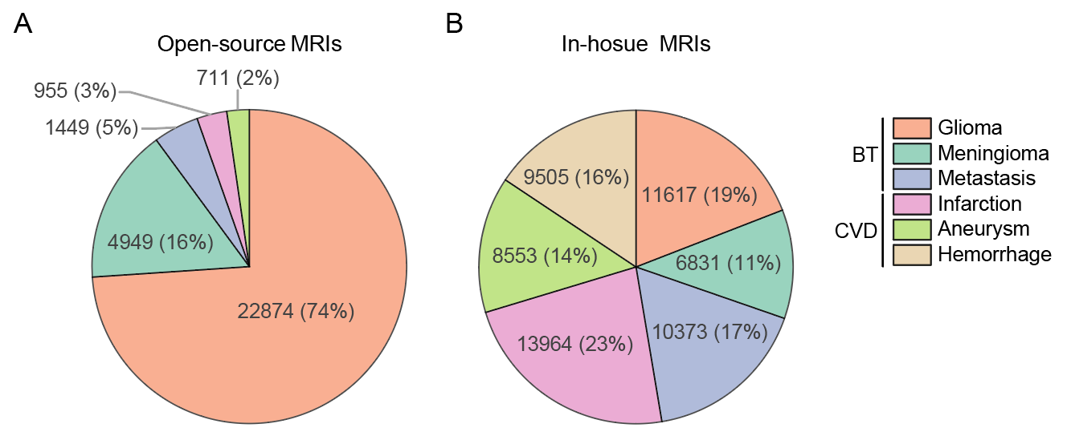
Fig. S4 Count of MRIs across brain tumors (BT) and cerebrovascular diseases (CVD).
A. Proportion of six diseases in open-source MRIs.
B. Proportion of six diseases in in-house MRIs.

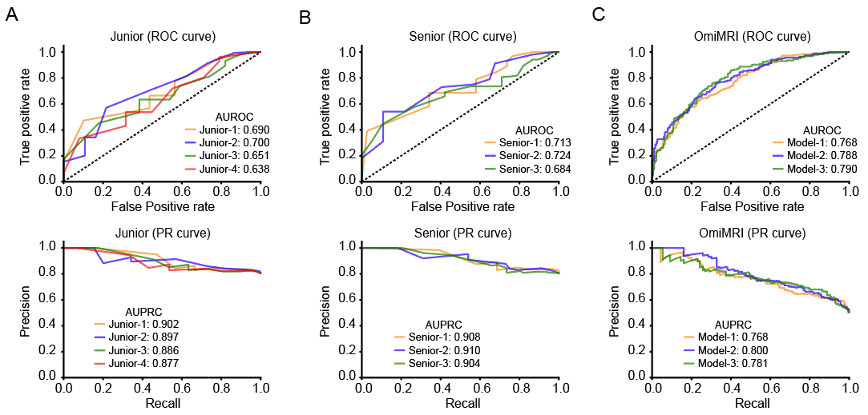
Fig. S5 Receiver operating characteristic (ROC) curve and Precision-Recall (PR) curve for the test dataset with one MRI.
A. Junior neuroradiologist group. Upper panel: ROC curve. Down panel: PR curve.
B. Senior neuroradiologist group. Upper panel: ROC curve. Down panel: PR curve.
C. OmiMRI model group. Upper panel: ROC curve. Down panel: PR curve.

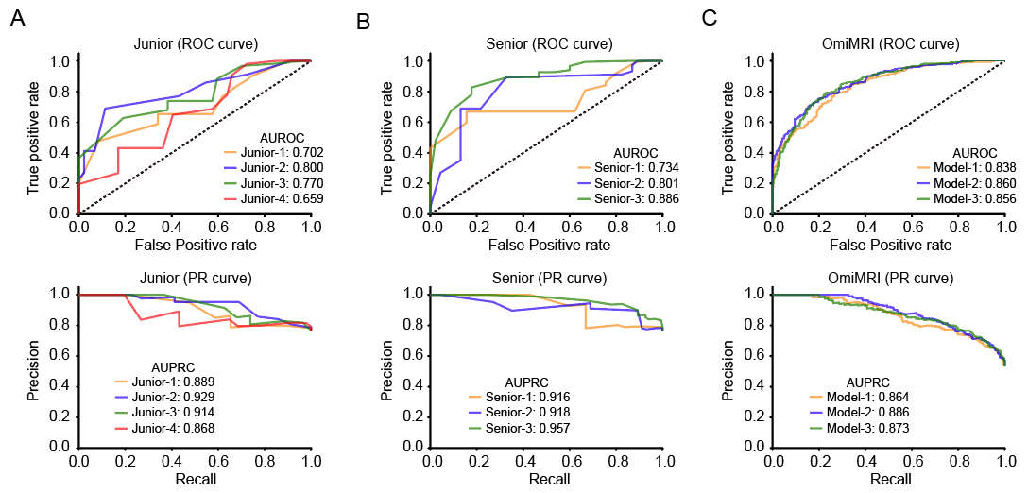
Fig. S6 Receiver operating characteristic (ROC) curve and Precision-Recall (PR) curve for the test dataset using combined input with two MRIs.
A. Junior neuroradiologist group. Upper panel: ROC curve. Down panel: PR curve.
B. Senior neuroradiologist group. Upper panel: ROC curve. Down panel: PR curve.
C. OmiMRI model group. Upper panel: ROC curve. Down panel: PR curve.

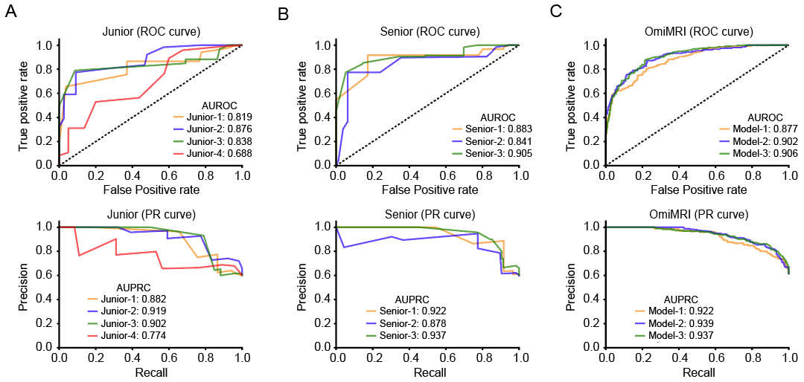
Fig. S7 Receiver operating characteristic (ROC) curve and Precision-Recall (PR) curve for the test dataset using combined input with three MRIs.
A. Junior neuroradiologist group. Upper panel: ROC curve. Down panel: PR curve.
B. Senior neuroradiologist group. Upper panel: ROC curve. Down panel: PR curve.
C. OmiMRI model group. Upper panel: ROC curve. Down panel: PR curve.

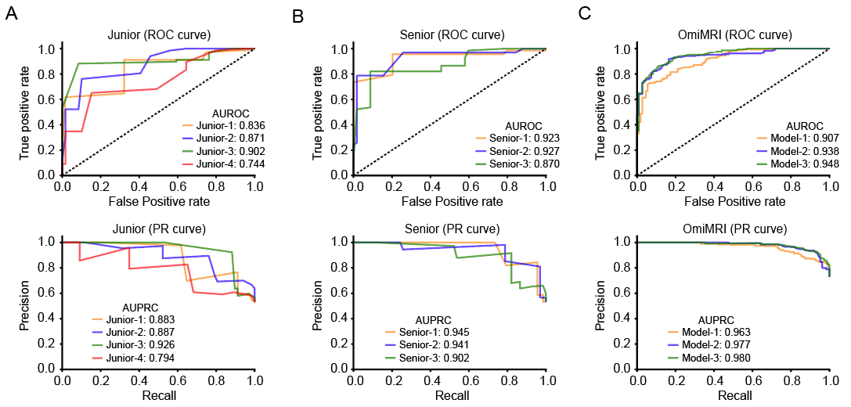
Fig. S8 Receiver operating characteristic (ROC) curve and Precision-Recall (PR) curve for the test dataset using combined input with four MRIs.
A. Junior neuroradiologist group. Upper panel: ROC curve. Down panel: PR curve.
B. Senior neuroradiologist group. Upper panel: ROC curve. Down panel: PR curve.
C. OmiMRI model group. Upper panel: ROC curve. Down panel: PR curve.

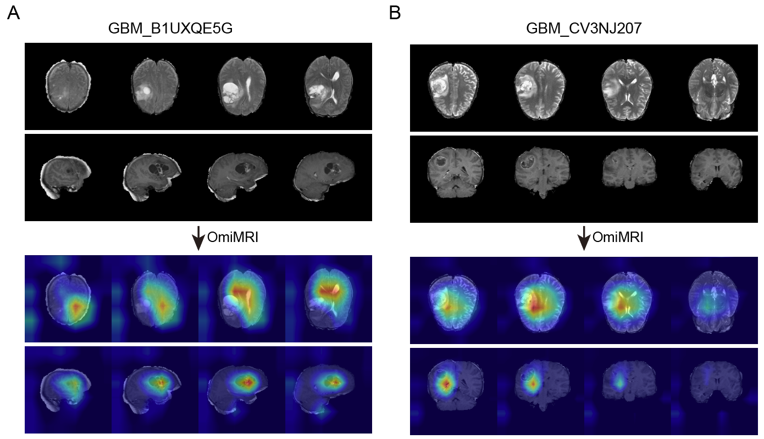
Fig. S9 Saliency visualizations of OmiMRI for a combined input with two MRIs.
A. Combined MRIs acquired from axial and sagittal scanning planes. Upper panel: original brain MRIs. Lower panel: corresponding saliency heatmaps.
B. Combined MRIs acquired from axial and coronal scanning planes.

Table S1. Summary of the parameters of for each module.
Model name (backbone) | Parameters (MB)
Model name (backbone) | Encoder | Omi-Neck/Head | Fixed-Neck/Head
CT-FM (ResNet) | 296.63 | 2.19 | 1.02
BrainSegFounder (SwinT) | 7.79 | 1.94 | 0.77
BrainIAC (ViT) | 344.13 | 2.69 | 1.52
BrainLaMIM (ViT) | 1844.84 | 5.19 | 4.02
Conv2D+1Dd (ResNet34) | 242.48 | 2.17 | 4.01
Conv3D-TPN (ResNet50) | 128.01 | 5.67 | 9.01

