Supporting Information

S.1 Additional methods
S.1.1 Particle morphology and distribution analysis
Particle analysis of micrographs of 3D-printed and solvent cast samples, before and after fracture, was conducted using ImageJ. Nine micrographs from three samples of each composition were taken, from the middle and closer to each edge of the films. Images were converted into 16-bit format and then processed using a bandpass filter and binary thresholding. ImageJ’s in-built particle analysis feature was used to calculate the average size and measurements of all particles between 1-100 μm. The following particle shape parameters were calculated (definitions included):
- Average size = $\frac{Total particle area}{Particle count}$
- Circularity = $4π. (\frac{area}{perimeter^{2}})$
- Aspect Ratio = $\frac{major axis}{minor axis}$ of fitted ellipse (least square fitting of distance from points to ellipse)
- Roundness = $\frac{4}{π}(\frac{area}{major axis^{2}} )$
- Solidity = $\frac{area}{convex area}$
- Feret Diameter - The longest distance between any two points along the selection boundary, also known as maximum caliper.
- Feret Angle (0-180 degrees) is the angle between the Feret's diameter and a line parallel to the x-axis of the image.
To measure the homogeneity of particle distribution, each micrograph was divided into 9 sub-images in a 3x3 matrix. The number of particles in each sub-image was measured, and the Coefficient of Variation (CV) calculated as follows:

Coefficient of variation = $\frac{√(\sum_{i=1}^{s}{(n_{i}-{μ)}^{2})/s}}{μ}$, where:
- $n_{i}=$ no. of particles in each sub-image,
- $μ=$ $\frac{N}{s}$ (expected no. of particles)
- $N=$ total no. of particles
- $s=$ no. of sub-images

The CV represents the deviation of particle distribution from a perfectly uniform, homogeneous distribution (CV=0%).

S.1.2 Nanoindentation
Nanoindentation using an Anton-Paar® NHT-2 tester was used to measure the elastic modulus of Chlorella cells. Chlorella powder was first compressed into cylindrical pellets of 5 mm diameter and thickness. Indentation was performed using a diamond Berkovich indenter of 1.5 µm diameter, with an indent depth of about 3 times that. A force of 10 mN was applied at a loading rate of 20 mN/min and held for 10 seconds, before being released at an identical unloading rate. Instrumented hardness (HIT), Instrumented elastic modulus (EIT) and Reduced modulus (E_{r}) were measured.

S.1.3 Rheometry
Shear rheometry was performed using the Malvern Kinexus® PRO+ Rheometer, with a parallel plate geometry (25 mm circular plates). The upper plate was rotated at a constant shear rate of 150 s⁻¹ at room temperature (25ºC). The variaation in shear viscosity with composition was studied (calculated by measuring shear stress response with the applied constant shear rate) ^{[1]}.

S.2 Results

S.2.1 3D printing process and structures
The Hyrel Engine HR® 3D Bioprinter (Figure S1 (a)) was used to print single layer tensile sample films and layered 3D structures. The synthesized PVA/Chl. inks were filled in 30 mL syringe and loaded onto the printer. The ink was extruded onto a glass printbed held at 25°C, as is visible in Figure S1-b during the printing of the tensile films.
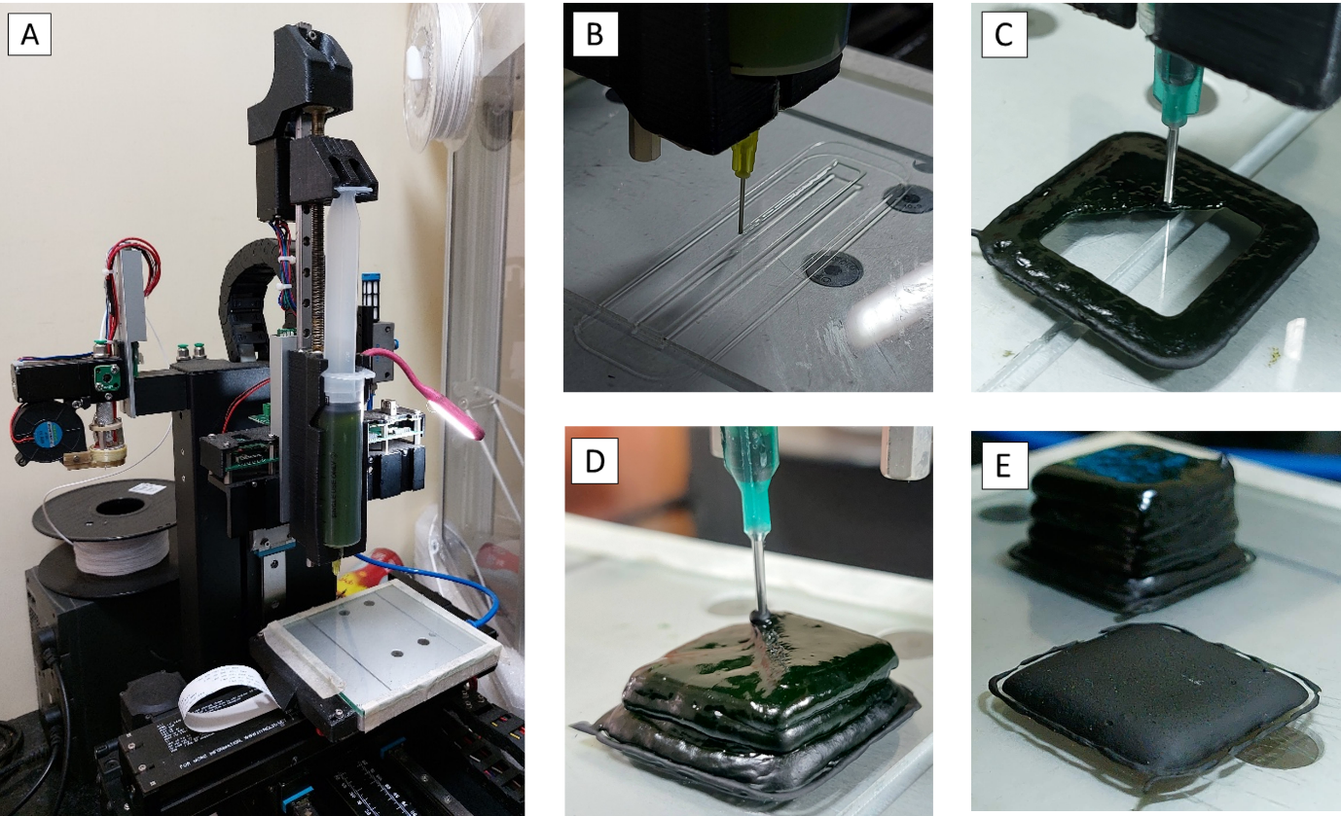
Figure S1: (a) Direct ink write 3D printing setup with loaded PVA/Chl. ink syringe (5 wt%). (b) Single layer film for tensile testing being printed using a 1 mm nozzle. (c) double-layer square puck (20 mm x 20 mm) being printed using a 45° infill and a 2 mm nozzle. (c) twenty-layer square puck being printed using a 45° infill and a 2 mm nozzle. (d) side by side comparison of the 2 and 20-layer structures.

S.2.2 Tensile testing of biopolymer films
A Hounsfield® (H10KS) Universal Testing Machine (UTM) was used to perform uniaxial tensile testing of the fabricated samples at 10mm/min using a 500N load cell, until failure. The schematic in Figure S2 represents the characterization approach taken to evaluate the mechanical performance of the films.
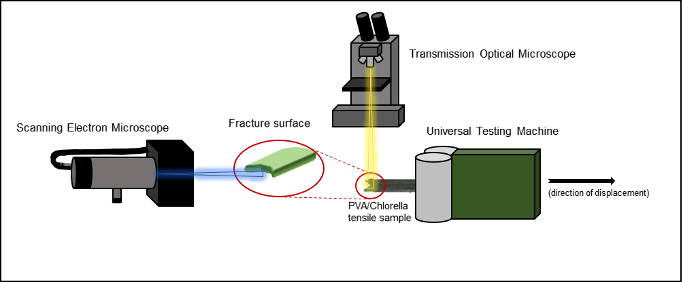
Figure S2: Schematic describing the mechanical and structural characterization process for printed and cast biopolymer films. Transmission optical microcopy was performed before and after tensile testing, to observe the change in particle distribution and orientation due to the loading and of the fracture surface. Au-sputtered fracture surfaces were then imaged using SEM to observe microstructural effects of the deformation
In addition to the 0 wt% and 5 wt% Chl. samples, stress strain curves for the 0.5 wt% and 1 wt% samples are present in Figs. S3 and S4. The yield stress and fracture strain data as measured from these curves are also included. It can be observed that 3D printed samples display significantly improved fracture strain (Figure S3-d) than cast samples. Longitudinally printed samples also have a higher yield stress than transverse samples (Figure S4-c).
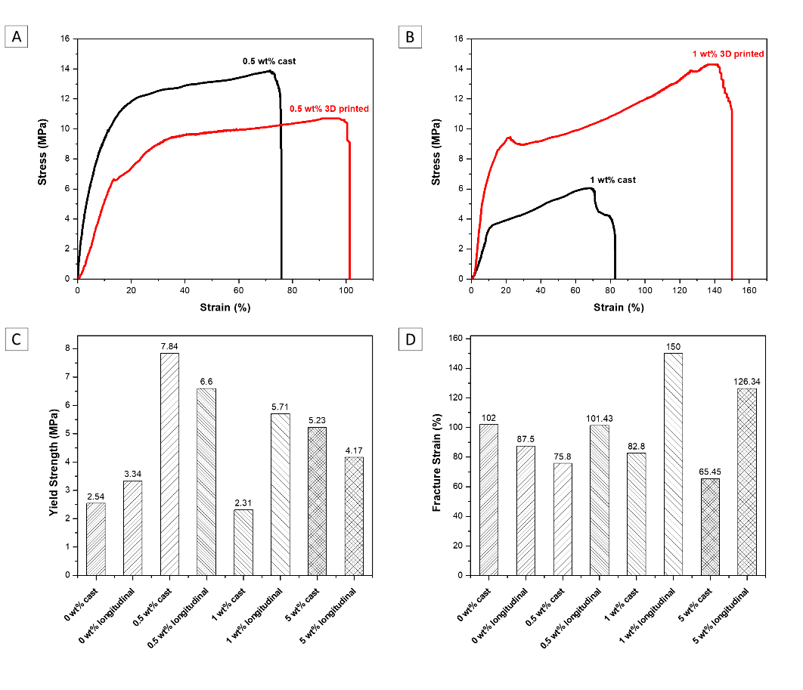
Figure S3: Stress vs. Strain plots obtained by tensile tests on PVA-Chlorella composite films analysing the effect of fabrication method: Solvent Casting vs. Direct-Ink Writing (longitudinal direction). Sample composition (a) 0.5 wt% chl, (b) 1 wt% chl; Comparison of mechanical properties of solvent cast and 3D printed samples of varying composition: (c) Yield strength, (d) Fracture strain.

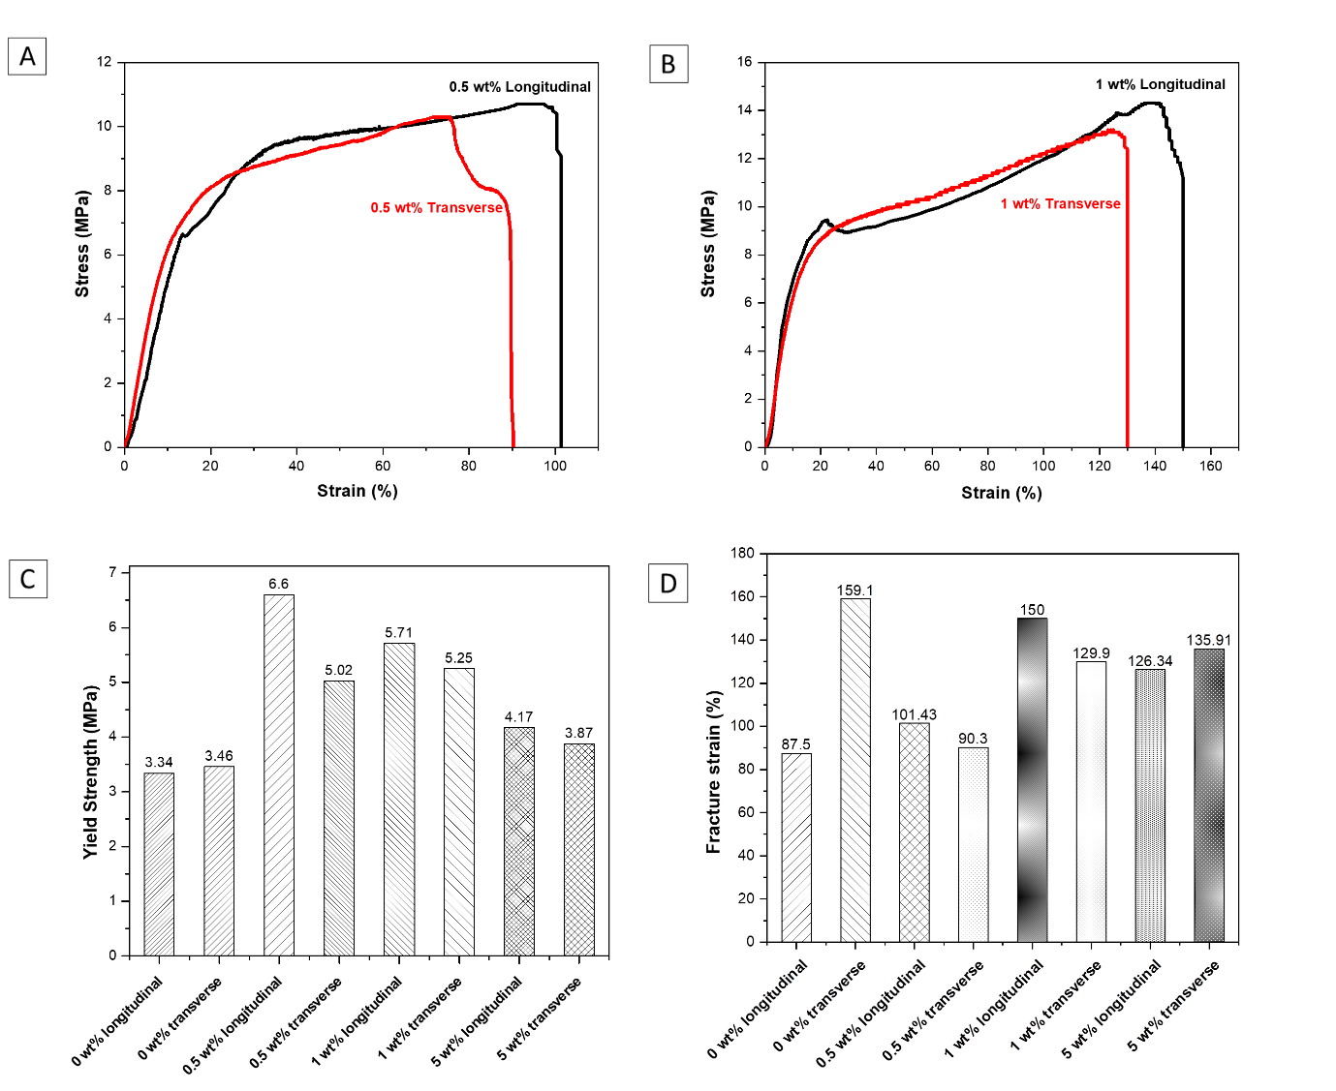
Figure S4: Stress vs. Strain plots obtained by tensile tests on PVA-Chlorella composite films analysing the effect of printing direction in Direct-Ink Writing (Transverse direction vs. Longitudinal direction with respect to sample orientation). Sample composition (a) 0.5 wt% chl, (b) 1 wt% chl; Comparison of mechanical properties of 3D printed samples of varying composition, printed in transverse and longitudinal orientations: (c) Yield strength, (d) Fracture strain.

S.2.3 Particle analysis
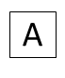
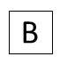
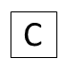

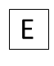
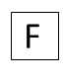
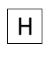
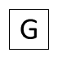
Figure S5: Micrograph thresholding and particle analysis for (a-b) 0.5 wt% chl. 3DP-longitudinal sample before fracture; (c-d) 0.5 wt% chl. 3DP-longitudinal sample after fracture; (e-f) 0.5 wt% chl. solvent cast sample before fracture; (g-h) 0.5 wt% chl. solvent cast sample after fracture.
Ultimately, the Feret diameter and Aspect ratio were chosen to represent particle size and morphology respectively. This is since the maximum distance between two ends of a particle is a characteristic length that best represents the particles response to tensile loading (due to the preferred orientation of the major axis in the direction of extrusion).
Figure S6: Illustration of calculation of Feret diameter and minimum Feret diameter for a chlorella particle in a thresholded image.
Sample | Particle count | Avg. feret diameter (um) | Avg. Aspect Ratio | Mean Coefficient of Variation (%)
0.5 wt% chl. 3DP-L (longitudinal) | 1432 | 5.865 | 1.958 | 16.95
0.5 wt% chl. 3DP-L - fractured | 454 | 9.988 | 2.252 | 52.35
0.5 wt% chl. SC (cast) | 666 | 7.497 | 1.625 | 19.35
0.5 wt% chl. SC - fractured | 300 | 9.547 | 1.686 | 40.02

Table S1: Morphology and distribution of chlorella particles in PVA biocomposite

S.2.4 Nanoindentation
Nanoindentation of the chlorella powder could obtain the hardness and modulus of these cells, to ascertain their effectiveness as a reinforcing particle in the composite. Three quantities were calculated: Instrumented Hardness (HIT), Instrumented Elastic Modulus (EIT) and Reduced Modulus (E_{r}). These quantities were calculated by the indentation tester from the penetration depth and force vs. time curves, and the indentation force vs depth curve (Figure S7) ^{[2]}. The average of the desired value, obtained after four tests on the sample, is given in Table S2.
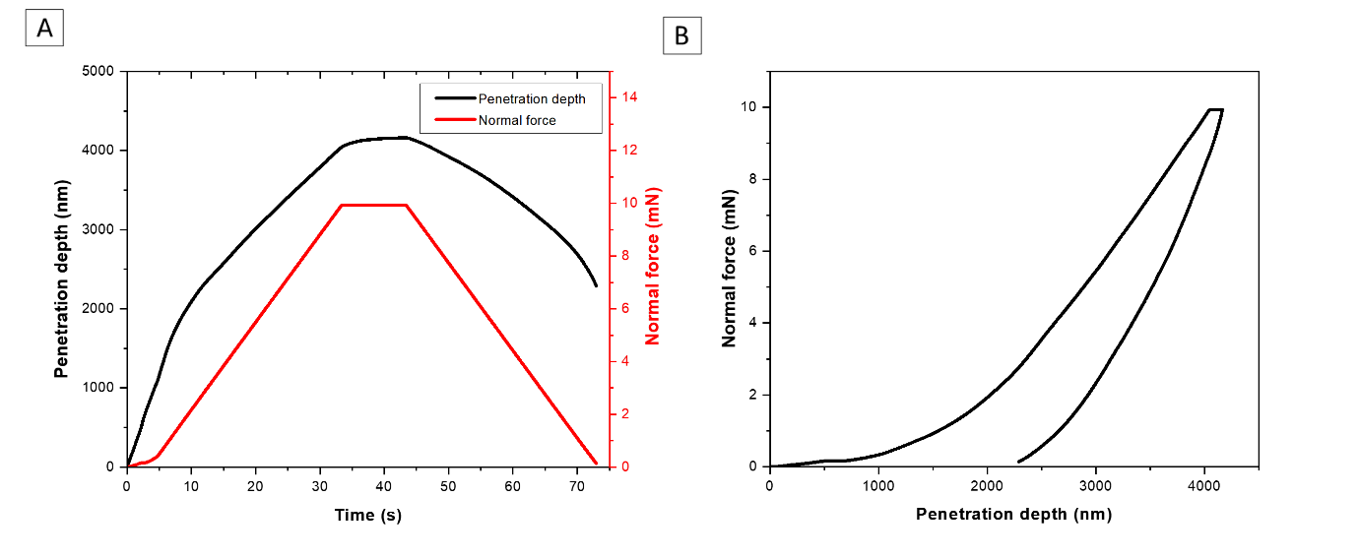
Figure S7: Instrumented indentation properties of Chlorella cells
HIT (MPa) | EIT (GPa) | E_{r} (GPa)
33.763 | 0.426 | 0.468

Table S2: Instrumented indentation properties of Chlorella cells

S.2.5 Rheometry
Composition (wt% chl.) | Shear Viscosity (Pa-s)
0% | 1.774
0.5% | 6.532
1% | 6.881
5% | 9.782
Table 1.2 shows that the shear viscosity of the ink increases from the pure PVA solution (1.77 Pa-s) as increasing amounts of Chlorella are added to the ink (9.78 Pa-s) . This could be due to the polarity of the cell walls causing attractive forces (agglomeration) that increase the viscosity of the solution on shearing. This non-linear increase in shear viscosity with particle concentration must be considered during DIW by increasing pressure. Figure S8-a also indicates that the PVA/Chl. inks appear to show shear-thicknening behavior, as apparent viscosity rises on increased shear rate.

Table S3: Shear viscosity of inks of varying Chl. wt% used for DIW.
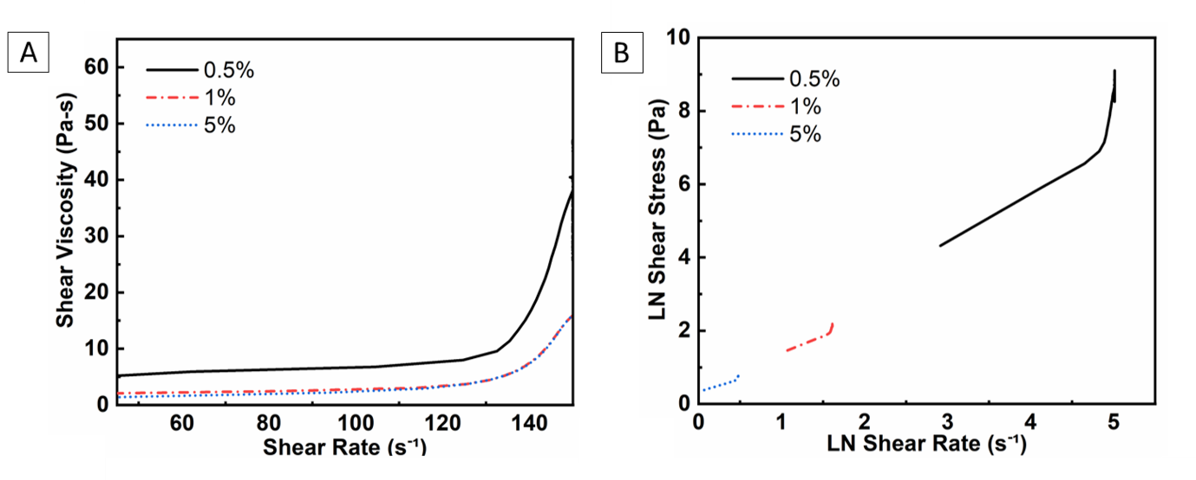
Figure S8: (a) Shear viscosity vs. shear rate (flow rate sweep) of inks of differing Chl. wt% used for DIW, (b) Measured shear stress on varying shear rate on inks of differing Chl. wt% (log-log axes)

S.2.5 Shrinkage and porosity
Composition (wt% Chl) | Type | Shrinkage | Porosity
0.0% | Cast | 91.14% | 27.91%
0.0% | 3D Printed | 50.23% | 50.58%
0.5% | Cast | 90.00% | 23.83%
0.5% | 3D Printed | 61.14% | 41.46%
1.0% | Cast | 89.95% | 49.62%
1.0% | 3D Printed | 16.94% | 23.93%
5.0% | Cast | 90.50% | 46.01%
5.0% | 3D Printed | 22.51% | 18.56%
The solvent cast and 3d printed samples of each formulation were measured using a vernier calipers after solidification and compared to the initial dimensions (GCode for the 3d printed sample). The percentage shrinkage was calculated by measuring the difference in volume. This shrinkage is caused by the evaporation of the solvent (water) from the water-based ink. The mass of each sample was also measured after solidification in order to calculate the actual density. The difference between the calculated density of the formulation and the actual density was used to calculate the percentage porosity. The results are collected in Table S4.

Table S4: Calculated shrinkage and porosity of tensile Chlorella-PVA samples

On shrinkage, the thickness reduced from 0.2 mm to about 0.02 mm (a larger layer thickness was taken due to the large amount of shrinkage expected). The sample gauge length and width were unaffected. A significantly larger shrinkage is observed in all the solvent cast samples of about 90%, resulting in little to no dimensional control. A smaller shrinkage of 17- 50% was observed for the printed samples – while lesser, this change in dimensions represents the drawback of DIW inks that solidify based on solvent evaporation.

Porosity of cast samples is seen to increase with Chl. wt%, likely due to agglomeration of particles. This coupled with the large volume change on solvent evaporation likely causes the incorporation of bubbles and voids, which act as stress concentrators in tension as seen in Figure 4(a-b).

However, porosity of the printed samples is seen to decrease with Chl. wt%. Since a similar reduction in shrinkage is also observed, it could be hypothesized that the high wt% printed samples incorporate less bubbles and voids due to a homogenous distribution, while the increased Chlorella concentration leads to polar inter-particle interactions that stabilise the microstructure during solidification. On solidification, the gauge length of printed samples reduced from 70 mm to 65-69 mm, while the thickness reduced from 0.1 mm to 0.05-0.08 mm. The sample width was unaffected.

References
[1] S. O. Cinar, Z. K. Chong, M. A. Kucuker, N. Wieczorek, U. Cengiz, K. Kuchta, Int J Environ Res Public Health 2020, 17, DOI 10.3390/ijerph17113842.
[2] V. Shah, Handbook of Plastics Testing and Failure Analysis: Third Edition, 2006.

