SUPPLEMENTARY FILES
Table A: SEARCH STRATEGY
JOURNAL | STRATEGY | Number of Articles | Date
PUBMED | (((((((((Pregnant Women[MeSH Terms]) OR ("Pregnant Women"[Title/Abstract] OR "Pregnant Woman"[Title/Abstract] OR "Women, Pregnant"[Title/Abstract])) OR ((Postpartum Period[MeSH Terms]) OR ("Postpartum Period"[Title/Abstract] OR Postpartum[Title/Abstract] OR "Postpartum Women"[Title/Abstract] OR Puerperium[Title/Abstract] OR "Period, Postpartum"[Title/Abstract] OR "Women, Postpartum"[Title/Abstract]))) OR ("Post partum care"[Title/Abstract] OR "post partum period"[Title/Abstract] OR "postpartum care"[Title/Abstract] OR puerperal[Title/Abstract] OR "puerperal care"[Title/Abstract])) OR (Postpartum[Title/Abstract])) OR ((Infant, Premature[MeSH Terms]) OR ("Infant, Premature"[Title/Abstract] OR "Infant, Preterm"[Title/Abstract] OR "Infants, Premature"[Title/Abstract] OR "Infants, Preterm"[Title/Abstract] OR "Neonatal Prematurity"[Title/Abstract] OR "Premature Infant"[Title/Abstract] OR "Premature Infants"[Title/Abstract] OR "Prematurity, Neonatal"[Title/Abstract] OR "Preterm Infant"[Title/Abstract] OR "Preterm Infants"[Title/Abstract]))) OR (Prematurity[Title/Abstract] OR "extremely premature infant"[Title/Abstract] OR "infant, extremely premature"[Title/Abstract] OR "neonate, premature"[Title/Abstract] OR "pre-mature infant"[Title/Abstract] OR "pre-term baby"[Title/Abstract] OR "pre-term child"[Title/Abstract] OR "pre-term infant"[Title/Abstract] OR "pre-term neonate"[Title/Abstract] OR "pre-term newborn"[Title/Abstract] OR premature[Title/Abstract] OR "premature baby"[Title/Abstract] OR "premature birth"[Title/Abstract] OR "premature child"[Title/Abstract] OR "premature childbirth"[Title/Abstract] OR "premature infant"[Title/Abstract] OR "premature infant disease"[Title/Abstract] OR "premature infant diseases"[Title/Abstract] OR "premature neonate"[Title/Abstract] OR "premature newborn"[Title/Abstract] OR "premature syndrome"[Title/Abstract] OR prematuritas[Title/Abstract] OR "preterm baby"[Title/Abstract] OR "preterm child"[Title/Abstract] OR "preterm infant"[Title/Abstract] OR "preterm neonate"[Title/Abstract] OR "preterm newborn"[Title/Abstract])) OR ("maternal near miss"[Title/Abstract])) OR ((Maternal Health[MeSH Terms]) OR ("Maternal Health"[Title/Abstract] OR "Health, Maternal"[Title/Abstract]))) AND ((((((Machine Learning[MeSH Terms]) OR ("Machine Learning"[Title/Abstract] OR "Learning, Machine"[Title/Abstract] OR "Transfer Learning"[Title/Abstract] OR "Learning, Transfer"[Title/Abstract])) OR ("learning machine"[Title/Abstract] OR "learning machines"[Title/Abstract])) OR ((Artificial Intelligence[MeSH Terms]) OR ("Artificial Intelligence"[Title/Abstract] OR "AI (Artificial Intelligence) "[Title/Abstract] OR "Acquisition, Knowledge (Computer) "[Title/Abstract] OR "Computational Intelligence"[Title/Abstract] OR "Computer Reasoning"[Title/Abstract] OR "Computer Vision System"[Title/Abstract] OR "Computer Vision Systems"[Title/Abstract] OR "Intelligence, Artificial"[Title/Abstract] OR "Intelligence, Computational"[Title/Abstract] OR "Intelligence, Machine"[Title/Abstract] OR "Knowledge Acquisition (Computer) "[Title/Abstract] OR "Knowledge Representation (Computer) "[Title/Abstract] OR "Knowledge Representations (Computer) "[Title/Abstract] OR "Machine Intelligence"[Title/Abstract] OR "Reasoning, Computer"[Title/Abstract] OR "Representation, Knowledge (Computer) "[Title/Abstract] OR "System, Computer Vision"[Title/Abstract] OR "Systems, Computer Vision"[Title/Abstract] OR "Vision System, Computer"[Title/Abstract] OR "Vision Systems, Computer"[Title/Abstract]))) OR ((Decision Support Systems, Clinical[MeSH Terms]) OR ("Decision Support Systems, Clinical"[Title/Abstract] OR "Clinical Decision Support Systems"[Title/Abstract] OR "Clinical Decision Support System"[Title/Abstract] OR "Clinical Decision Support"[Title/Abstract] OR "Clinical Decision Supports"[Title/Abstract] OR "Decision Supports, Clinical"[Title/Abstract] OR "Support, Clinical Decision"[Title/Abstract] OR "Supports, Clinical Decision"[Title/Abstract] OR "Decision Support, Clinical"[Title/Abstract]))) OR ("CDS system (clinical decision support system) "[Title/Abstract] OR "clinical decision support (CDS) system"[Title/Abstract] OR "clinician decision support system"[Title/Abstract])) | 1.568 | 22/08/2023
SCOPUS | ( ( INDEXTERMS ( pregnancy OR pregnancies OR gestation ) OR INDEXTERMS ( "Pregnant Women" OR "Pregnant Woman" OR "Women, Pregnant" ) OR INDEXTERMS ( "Postpartum Period" OR postpartum OR "Postpartum Women" OR puerperium OR "Period, Postpartum" OR "Women, Postpartum" ) OR INDEXTERMS ( "Post partum care" OR "post partum period" OR "postpartum care" OR puerperal OR "puerperal care" ) OR INDEXTERMS ( postpartum ) OR INDEXTERMS ( "Infant, Premature" OR "Infant, Preterm" OR "Infants, Premature" OR "Infants, Preterm" OR "Neonatal Prematurity" OR "Premature Infant" OR "Premature Infants" OR "Prematurity, Neonatal" OR "Preterm Infant" OR "Preterm Infants" ) OR INDEXTERMS ( prematurity OR "extremely premature infant" OR "infant, extremely premature" OR "neonate, premature" OR "pre-mature infant" OR "pre-term baby" OR "pre-term child" OR "pre-term infant" OR "pre-term neonate" OR "pre-term newborn" OR premature OR "premature baby" OR "premature birth" OR "premature child" OR "premature childbirth" OR "premature infant" OR "premature infant disease" OR "premature infant diseases" OR "premature neonate" OR "premature newborn" OR "premature syndrome" OR prematuritas OR "preterm baby" OR "preterm child" OR "preterm infant" OR "preterm neonate" OR "preterm newborn" ) OR INDEXTERMS ( "maternal near miss" ) OR INDEXTERMS ( "Maternal Health" OR "Health, Maternal" ) ) ) AND ( ( INDEXTERMS ( "Machine Learning" OR "Learning, Machine" OR "Transfer Learning" OR "Learning, Transfer" ) OR INDEXTERMS ( "learning machine" OR "learning machines" ) OR INDEXTERMS ( "Artificial Intelligence" OR "AI (Artificial Intelligence) " OR "Acquisition, Knowledge (Computer) " OR "Computational Intelligence" OR "Computer Reasoning" OR "Computer Vision System" OR "Computer Vision Systems" OR "Intelligence, Artificial" OR "Intelligence, Computational" OR "Intelligence, Machine" OR "Knowledge Acquisition (Computer) " OR "Knowledge Representation (Computer) " OR "Knowledge Representations (Computer) " OR "Machine Intelligence" OR "Reasoning, Computer" OR "Representation, Knowledge (Computer) " OR "System, Computer Vision" OR "Systems, Computer Vision" OR "Vision System, Computer" OR "Vision Systems, Computer" ) OR INDEXTERMS ( "Decision Support Systems, Clinical" OR "Clinical Decision Support Systems" OR "Clinical Decision Support System" OR "Clinical Decision Support" OR "Clinical Decision Supports" OR "Decision Supports, Clinical" OR "Support, Clinical Decision" OR "Supports, Clinical Decision" OR "Decision Support, Clinical" ) OR INDEXTERMS ( "CDS system (clinical decision support system) " OR "clinical decision support (CDS) system" OR "clinician decision support system" ) ) ) | 2.476 | 10/08/2023
WEB OF SCIENCE | Pregnancy OR Pregnancies OR Gestation (Topic) or "Pregnant Women" OR "Pregnant Woman" OR "Women, Pregnant" (Topic) or "Postpartum Period" OR Postpartum OR "Postpartum Women" OR Puerperium OR "Period, Postpartum" OR "Women, Postpartum" (Topic) or "Post partum care" OR "post partum period" OR "postpartum care" OR puerperal OR "puerperal care" (Topic) or Postpartum (Topic) or "Infant, Premature" OR "Infant, Preterm" OR "Infants, Premature" OR "Infants, Preterm" OR "Neonatal Prematurity" OR "Premature Infant" OR "Premature Infants" OR "Prematurity, Neonatal" OR "Preterm Infant" OR "Preterm Infants" (Topic) or Prematurity OR "extremely premature infant" OR "infant, extremely premature" OR "neonate, premature" OR "pre-mature infant" OR "pre-term baby" OR "pre-term child" OR "pre-term infant" OR "pre-term neonate" OR "pre-term newborn" OR premature OR "premature baby" OR "premature birth" OR "premature child" OR "premature childbirth" OR "premature infant" OR "premature infant disease" OR "premature infant diseases" OR "premature neonate" OR "premature newborn" OR "premature syndrome" OR prematuritas OR "preterm baby" OR "preterm child" OR "preterm infant" OR "preterm neonate" OR "preterm newborn" (Topic) or "maternal near miss" (Topic) or "Maternal Health" OR "Health, Maternal" (Topic) and Preprint Citation Index (Exclude – Database) AND "Machine Learning" OR "Learning, Machine" OR "Transfer Learning" OR "Learning, Transfer" (Topic) or "learning machine" OR "learning machines" (Topic) or "Artificial Intelligence" OR "AI (Artificial Intelligence) " OR "Acquisition, Knowledge (Computer) " OR "Computational Intelligence" OR "Computer Reasoning" OR "Computer Vision System" OR "Computer Vision Systems" OR "Intelligence, Artificial" OR "Intelligence, Computational" OR "Intelligence, Machine" OR "Knowledge Acquisition (Computer) " OR "Knowledge Representation (Computer) " OR "Knowledge Representations (Computer) " OR "Machine Intelligence" OR "Reasoning, Computer" OR "Representation, Knowledge (Computer) " OR "System, Computer Vision" OR "Systems, Computer Vision" OR "Vision System, Computer" OR "Vision Systems, Computer" (Topic) or "Decision Support Systems, Clinical" OR "Clinical Decision Support Systems" OR "Clinical Decision Support System" OR "Clinical Decision Support" OR "Clinical Decision Supports" OR "Decision Supports, Clinical" OR "Support, Clinical Decision" OR "Supports, Clinical Decision" OR "Decision Support, Clinical" (Topic) or "CDS system (clinical decision support system) " OR "clinical decision support (CDS) system" OR "clinician decision support system" (Topic) and Preprint Citation Index (Exclude – Database)  LINK PERMANENTE: https://www.webofscience.com/wos/alldb/summary/9c7f63a6-c3b8-46c8-803f-889f82eb10d6-9d196cbc/relevance/1 | 4.699 | 22/08/2023
EMBASE | ('pregnancy'/syn OR 'pregnant woman'/syn OR 'puerperium'/syn OR postpartum OR 'prematurity'/syn OR 'maternal near miss' OR 'maternal health':ti,ab,kw OR 'health, maternal':ti,ab,kw) AND ('machine learning'/syn OR 'artificial intelligence'/syn OR 'clinical decision support system'/syn) AND ([embase]/lim NOT ([embase]/lim AND [medline]/lim) OR ([medline]/lim NOT ([embase]/lim AND [medline]/lim) NOT ([embase classic]/lim AND [medline]/lim))) | 3.250 | 22/08/2023
COCHRANE LIBRARY | MeSH descriptor: [Pregnancy] explode all trees OR (Pregnancy OR Pregnancies OR Gestation):ti,ab,kw (Word variations have been searched) OR MeSH descriptor: [Pregnant Women] explode all trees OR ("Pregnant Women" OR "Pregnant Woman" OR "Women, Pregnant"):ti,ab,kw (Word variations have been searched) OR MeSH descriptor: [Postpartum Period] explode all trees OR ("Postpartum Period" OR Postpartum OR "Postpartum Women" OR Puerperium OR "Period, Postpartum" OR "Women, Postpartum"):ti,ab,kw OR ("Post partum care" OR "post partum period" OR "postpartum care" OR puerperal OR "puerperal care"):ti,ab,kw OR (Postpartum):ti,ab,kw OR MeSH descriptor: [Infant, Premature] explode all trees OR ("Infant, Premature" OR "Infant, Preterm" OR "Infants, Premature" OR "Infants, Preterm" OR "Neonatal Prematurity" OR "Premature Infant" OR "Premature Infants" OR "Prematurity, Neonatal" OR "Preterm Infant" OR "Preterm Infants"):ti,ab,kw OR (Prematurity OR "extremely premature infant" OR "infant, extremely premature" OR "neonate, premature" OR "pre-mature infant" OR "pre-term baby" OR "pre-term child" OR "pre-term infant" OR "pre-term neonate" OR "pre-term newborn" OR premature OR "premature baby" OR "premature birth" OR "premature child" OR "premature childbirth" OR "premature infant" OR "premature infant disease" OR "premature infant diseases" OR "premature neonate" OR "premature newborn" OR "premature syndrome" OR prematuritas OR "preterm baby" OR "preterm child" OR "preterm infant" OR "preterm neonate" OR "preterm newborn"):ti,ab,kw OR ("maternal near miss"):ti,ab,kw OR MeSH descriptor: [Maternal Health] explode all trees OR ("Maternal Health" OR "Health, Maternal"):ti,ab,kw AND MeSH descriptor: [Machine Learning] explode all trees OR ("Machine Learning" OR "Learning, Machine" OR "Transfer Learning" OR "Learning, Transfer"):ti,ab,kw OR ("learning machine" OR "learning machines"):ti,ab,kw OR MeSH descriptor: [Artificial Intelligence] explode all trees OR ("Artificial Intelligence" OR "AI (Artificial Intelligence) " OR "Acquisition, Knowledge (Computer) " OR "Computational Intelligence" OR "Computer Reasoning" OR "Computer Vision System" OR "Computer Vision Systems" OR "Intelligence, Artificial" OR "Intelligence, Computational" OR "Intelligence, Machine" OR "Knowledge Acquisition (Computer) " OR "Knowledge Representation (Computer) " OR "Knowledge Representations (Computer) " OR "Machine Intelligence" OR "Reasoning, Computer" OR "Representation, Knowledge (Computer) " OR "System, Computer Vision" OR "Systems, Computer Vision" OR "Vision System, Computer" OR "Vision Systems, Computer"):ti,ab,kw OR MeSH descriptor: [Decision Support Systems, Clinical] explode all trees OR ("Decision Support Systems, Clinical" OR "Clinical Decision Support Systems" OR "Clinical Decision Support System" OR "Clinical Decision Support" OR "Clinical Decision Supports" OR "Decision Supports, Clinical" OR "Support, Clinical Decision" OR "Supports, Clinical Decision" OR "Decision Support, Clinical"):ti,ab,kw OR ("CDS system (clinical decision support system) " OR "clinical decision support (CDS) system" OR "clinician decision support system"):ti,ab,kw | 193 | 23/08/2023
Compendex (Engineering Village - Elsevier) | found in Compendex for 1884-2023: (( (((((((((($Pregnancy OR $Pregnancies OR $Gestation) WN KY) OR (({Pregnant Women} OR {Pregnant Woman} OR {Women, Pregnant}) WN KY)) OR (({Postpartum Period} OR $Postpartum OR {Postpartum Women} OR $Puerperium OR {Period, Postpartum} OR {Women, Postpartum}) WN KY)) OR (({Post partum care} OR {post partum period} OR {postpartum care} OR $puerperal OR {puerperal care}) WN KY)) OR (($Postpartum) WN KY)) OR (({Infant, Premature} OR {Infant, Preterm} OR {Infants, Premature} OR {Infants, Preterm} OR {Neonatal Prematurity} OR {Premature Infant} OR {Premature Infants} OR {Prematurity, Neonatal} OR {Preterm Infant} OR {Preterm Infants}) WN KY)) OR (($Prematurity OR {extremely premature infant} OR {infant, extremely premature} OR {neonate, premature} OR {pre-mature infant} OR {pre-term baby} OR {pre-term child} OR {pre-term infant} OR {pre-term neonate} OR {pre-term newborn} OR $premature OR {premature baby} OR {premature birth} OR {premature child} OR {premature childbirth} OR {premature infant} OR {premature infant disease} OR {premature infant diseases} OR {premature neonate} OR {premature newborn} OR {premature syndrome} OR $prematuritas OR {preterm baby} OR {preterm child} OR {preterm infant} OR {preterm neonate} OR {preterm newborn}) WN KY)) OR (({maternal near miss}) WN KY)) OR (({Maternal Health} OR {Health, Maternal}) WN ALL))) AND ( (((((({Machine Learning} OR {Learning, Machine} OR {Transfer Learning} OR {Learning, Transfer}) WN KY) OR (({learning machine} OR {learning machines}) WN KY)) OR (({Artificial Intelligence} OR {AI (Artificial Intelligence) } OR {Acquisition, Knowledge (Computer) } OR {Computational Intelligence} OR {Computer Reasoning} OR {Computer Vision System} OR {Computer Vision Systems} OR {Intelligence, Artificial} OR {Intelligence, Computational} OR {Intelligence, Machine} OR {Knowledge Acquisition (Computer) } OR {Knowledge Representation (Computer) } OR {Knowledge Representations (Computer) } OR {Machine Intelligence} OR {Reasoning, Computer} OR {Representation, Knowledge (Computer) } OR {System, Computer Vision} OR {Systems, Computer Vision} OR {Vision System, Computer} OR {Vision Systems, Computer}) WN KY)) OR (({Decision Support Systems, Clinical} OR {Clinical Decision Support Systems} OR {Clinical Decision Support System} OR {Clinical Decision Support} OR {Clinical Decision Supports} OR {Decision Supports, Clinical} OR {Support, Clinical Decision} OR {Supports, Clinical Decision} OR {Decision Support, Clinical}) WN KY)) OR (({CDS system (clinical decision support system) } OR {clinical decision support (CDS) system} OR {clinician decision support system}) WN KY)))) | 1.863 | 23/08/2023
TOTAL |  | 14.049
TOTAL NUMBER OF DUPLICATE REFERENCES | 1,522 Duplicate records removed in EndNote Web  3,469 Duplicate records removed in Rayyan | 4.991
TOTAL AFTER EXCLUSION OF DUPLICATES |  | 9.058

Table B: Percentage of Articles for each sub-category

Variable | Category | n (%)
Area Code | NPO | 28 (38.89%)
Area Code | OCMM | 20 (27.78%)
Area Code | GDMD | 14 (19.44%)
Area Code | HDCC | 7 (9.72%)
Area Code | PDMH | 3 (4.17%)
Continent | Asia | 21 (29.17%)
Continent | Europe | 20 (27.78%)
Continent | North America | 17 (23.61%)
Continent | Not Specified | 5 (6.94%)
Continent | Intercontinental | 4 (5.56%)
Continent | Africa | 2 (2.78%)
Continent | Australia | 2 (2.78%)
Continent | South America | 1 (1.39%)
Study Design | Observational | 55 (76.39%)
Study Design | Experimental | 11 (15.28%)
Study Design | Qualitative | 5 (6.94%)
Study Design | not specified | 1 (1.39%)
Algorithm Category | ML | 35 (48.61%)
Algorithm Category | BSIA | 12 (16.67%)
Algorithm Category | CDSS | 12 (16.67%)
Algorithm Category | DL & other AIs | 10 (13.89%)
Algorithm Category | NLP & AI.ass | 3 (4.17%)
*Gestational Diabetes and Metabolic Disorders (GDMD), Hypertensive Disorders and Cardiovascular Complications (HDCC), Obstetric Complications and Maternal Morbidity (OCMM) and Postpartum Depression & Mental Health (PDMH).
Machine Learning (ML), Biomedical signal and image analysis (BSIA), Clinical decision support systems (CDSS), Deep learning (DL), Natural Language Processing and Artificial Intelligent Assistants (NLP & AI.ass)

Table C: Characteristics of included studies including RoB
Authors (year) | Title | Applicability / Risk of bias | Clinical area | Specific focus | AI approach / Algorithmic class
Andreasen et al (2023) | Multi-centre deep learning for placenta segmentation in ultrasound | Low concern / Low RoB | Neonatal and perinatal outcomes | Placenta segmentation | Deep learning / Transformer-based models
Artzi et al (2020) | Prediction of gestational diabetes based on nationwide electronic health records | Low concern / Low RoB | Gestational diabetes and metabolic disorders | Gestational diabetes | Clinical decision support systems
Badr et al (2023) | Chest CT predictors of ICU admission in pregnant women with COVID-19 | Low concern / Low RoB | Hypertensive disorders / COVID-19 | ICU admission risk | Biomedical signal & imaging analysis
Clapp et al (2023) | NLP of admission notes to predict postpartum hemorrhage | Low concern / Low RoB | Obstetric complications and maternal morbidity | Postpartum hemorrhage | Natural language processing / AI assistants
Clapp et al (2023) | NLP of admission notes to predict postpartum hemorrhage | Low concern / Low RoB | Obstetric complications | Postpartum hemorrhage | Natural language processing
Douali et al (2015) | Personalized prediction of gestational diabetes using a CDSS | High concern / High RoB | Gestational diabetes and metabolic disorders | Gestational diabetes | Clinical decision support systems
Duval et al (2023) | Hybrid AI model leveraging multicentric clinical data for fetal heart rate prediction | Low concern / Low RoB | Neonatal and perinatal outcomes | Fetal heart rate | Deep learning / Hybrid models
Escobar et al (2021) | Prediction of obstetrical and fetal complications using automated EHR data | Low concern / Low RoB | Obstetric complications and maternal morbidity | Obstetrical and fetal complications | Machine learning models
Escobar et al (2021) | Prediction of obstetrical and fetal complications using automated EHR data | Low concern / Low RoB | Obstetric complications | Obstetrical and fetal complications | Machine learning models
Espinosa Bernal et al (2023) | Multiomic signals and maternal factors contributing to preterm birth | Low concern / Low RoB | Neonatal and perinatal outcomes | Preterm birth | Machine learning models
Flaucher et al (2022) | Smartphone-based colorimetric analysis of urine test strips for prenatal care | Low concern / Low RoB | Obstetric complications | Prenatal monitoring | Deep learning models
Fotiadou et al (2020) | End-to-end trained encoder-decoder convolutional neural network for fetal ECG signal denoising | Low concern / High RoB | Neonatal and perinatal outcomes | Fetal ECG signal denoising | Deep learning / Transformer-based models
Fung et al (2020) | Personalized fetal growth prediction using international cohort data | Low concern / Low RoB | Neonatal and perinatal outcomes | Fetal growth & GA | Machine learning models
Gu et al (2024) | ML approach for prediction of macrosomia | Low concern / Low RoB | Gestational diabetes | Macrosomia | Machine learning models
Guedalia et al (2021) | Transporting ML model for predicting emergency cesarean delivery | Low concern / Low RoB | Obstetric complications | Emergency cesarean prediction | Machine learning models
Hawken et al (2020) | External validation of elastic net models including newborn metabolomics for postnatal GA estimation | Low concern / Low RoB | Neonatal and perinatal outcomes | Gestational age estimation | Machine learning models
Hoffman et al (2021) | ML algorithm for predicting maternal readmission for hypertensive disorders | Low concern / Low RoB | Hypertensive disorders | Postpartum hypertension | Machine learning models
Hu et al (2022) | Model for predicting the outcome of induced labor in full-term pregnancy based on ML algorithm | Low concern / Low RoB | Obstetric complications and maternal morbidity | Induced labor outcome | Machine learning models
Hu et al (2022) | ML-based model for predicting outcome of induced labor | Low concern / Low RoB | Obstetric complications | Labor induction | Machine learning models
Leonard et al (2021) | Disparities in severe maternal morbidity using updated comorbidity scores | Low concern / Low RoB | Obstetric complications | Maternal morbidity disparities | Clinical decision support systems
Li et al (2021) | EHR-based prediction of pre-eclampsia using ML algorithms | Low concern / Low RoB | Hypertensive disorders and cardiovascular complications | Pre-eclampsia prediction | Machine learning models
Li et al (2021) | EHR-based ML prediction of pre-eclampsia | Low concern / Low RoB | Hypertensive disorders | Pre-eclampsia | Machine learning models
Li et al (2022) | Improving preeclampsia risk prediction via pregnancy trajectories from EMR data | Low concern / Low RoB | Hypertensive disorders and cardiovascular complications | Preeclampsia | Machine learning models
Li et al (2022) | Modeling pregnancy trajectories from EMR data to improve preeclampsia prediction | Low concern / Low RoB | Hypertensive disorders | Preeclampsia trajectories | Machine learning models
Li et al (2023) | Prediction of gestational diabetes mellitus at first trimester using ML algorithms | Low concern / Low RoB | Gestational diabetes and metabolic disorders | Early GDM prediction | Machine learning models
Lipschuetz et al (2020) | Prediction of vaginal birth after cesarean delivery using ML | Low concern / Low RoB | Obstetric complications and maternal morbidity | VBAC prediction | Machine learning models
Lipschuetz et al (2020) | ML-based prediction of vaginal birth after cesarean | Low concern / Low RoB | Obstetric complications | VBAC prediction | Machine learning models
Liu et al (2020) | Development and validation of an obstetric comorbidity risk score for clinical use | Low concern / Low RoB | Obstetric complications and maternal morbidity | Obstetric comorbidity | Clinical decision support systems
Liu et al (2021) | Neural network-based MRI analysis for cervical cerclage | Low concern / Low RoB | Obstetric complications | Cervical insufficiency | Deep learning models
Mariana R. et al (2021) | Causal dynamic Bayesian networks for glucose control in GDM | High concern / High RoB | Gestational diabetes and metabolic disorders | GDM management | Clinical decision support systems
Mateen et al (2020) | EHR-based prediction of gestational diabetes risk | Low concern / High RoB | Gestational diabetes | Risk prediction | Machine learning models
Montenegro et al (2022) | Usability evaluation of a pregnancy chatbot | Low concern / High RoB | Obstetric complications | Prenatal care | NLP & AI assistants
Payne et al (2020) | DNA methylation biomarkers predict antenatal and postpartum depression | Low concern / Low RoB | Postpartum depression | Depression biomarkers | Machine learning models
Pinto et al (2023) | Gut microbiota-induced inflammation drives gestational diabetes before diagnosis | Low concern / Low RoB | Gestational diabetes | Inflammation biomarkers | Machine learning models
Pluym et al (2021) | Automated 3D ultrasound for fetal head biometry | Low concern / Low RoB | Neonatal and perinatal outcomes | Fetal biometry | Biomedical signal & imaging analysis
Qiao et al (2021) | Intelligent feature learning system for fetal cardiac imaging | Low concern / Low RoB | Neonatal and perinatal outcomes | Fetal echocardiography | Biomedical signal & imaging analysis
Sandra et al (2022) | User-centered design of NLP for maternal monitoring chatbot system | Unclear / Unclear | Obstetric complications and maternal morbidity | Maternal monitoring | NLP & AI assistants
Sendra-Balcells et al (2023) | Generalisability of fetal ultrasound deep learning models to low-resource imaging settings | Low concern / Low RoB | Neonatal and perinatal outcomes | Fetal ultrasound | Deep learning / Transformer-based models
Sendra-Balcells et al (2023) | Generalisability of fetal ultrasound deep learning models in Africa | Low concern / Low RoB | Neonatal and perinatal outcomes | Fetal ultrasound | Deep learning models
Shah et al (2023) | Prediction of postpartum hemorrhage using ML in a Kenyan population | Low concern / Low RoB | Obstetric complications and maternal morbidity | Postpartum hemorrhage | Machine learning models
Shen et al (2020) | An innovative AI-based app for diagnosis of gestational diabetes mellitus (GDM-AI): development study | Low concern / Low RoB | Gestational diabetes and metabolic disorders | Gestational diabetes mellitus | Machine learning models
Starling et al (2020) | A molecular signal for preeclampsia | Low concern / Low RoB | Hypertensive disorders | Molecular biomarkers | Machine learning models
Sufriyana et al (2020) | AI-assisted prediction of preeclampsia using nationwide health insurance data (BPJS Kesehatan, Indonesia) | Low concern / Low RoB | Hypertensive disorders and cardiovascular complications | Preeclampsia prediction | Machine learning models
Tsur et al (2020) | Development and validation of a machine-learning model for prediction of shoulder dystocia | Low concern / Low RoB | Obstetric complications and maternal morbidity | Shoulder dystocia | Machine learning models
Venkatesh et al (2020) | ML and statistical models to predict postpartum hemorrhage | Low concern / Low RoB | Obstetric complications | Postpartum hemorrhage | Machine learning models
Xu et al (2022) | Fetal movement detection by wearable accelerometer duo based on ML | Low concern / High RoB | Neonatal and perinatal outcomes | Fetal movement counting | Machine learning models
Xu et al (2022) | Fetal movement detection by wearable accelerometers using ML | Low concern / High RoB | Neonatal and perinatal outcomes | Fetal movement | Machine learning models
Yang et al (2022) | ML-based risk stratification for gestational diabetes management | Low concern / Low RoB | Gestational diabetes | Risk stratification | Machine learning models

Abbreviations: AI = artificial intelligence; ML = machine learning; NLP = natural language processing; CDSS = clinical decision support system; DL = deep learning; RoB = risk of bias; cfDNA = cell-free DNA; EMR = electronic medical record.
Table D: Summary Indices of Metrics
Variable | Full Name | n | Mean | Median | SD | Min | Max
CALIBRATION | Calibration slope | 2 | 1.54 | 1.54 | 0.00 | 1.54 | 1.54
MSE_internval | Mean Squared Error (internal validation) | 1 | 0.02 | 0.02 |  | 0.02 | 0.02
R2_internval | Coefficient of Determination (internal validation) | 2 | 0.65 | 0.65 | 0.23 | 0.48 | 0.81
MAE_internval | Mean Absolute Error (internal validation) | 2 | 1.96 | 1.96 | 2.61 | 0.11 | 3.80
ACCURACY_internval | Accuracy (internal validation) | 15 | 0.89 | 0.93 | 0.11 | 0.65 | 0.99
SEN_internval | Sensitivity (internal validation) | 9 | 0.79 | 0.88 | 0.21 | 0.38 | 1.00
SPE_internval | Specificity (internal validation) | 10 | 0.89 | 0.90 | 0.09 | 0.69 | 0.99
PPV_internval | Positive Predictive Value (internal validation) | 5 | 0.46 | 0.47 | 0.31 | 0.15 | 0.88
NPV_internval | Negative Predictive Value (internal validation) | 3 | 0.90 | 0.88 | 0.07 | 0.85 | 0.98
PRECI_internval | Precision (internal validation) | 7 | 0.81 | 0.86 | 0.19 | 0.45 | 0.98
Recall_internval | Recall (internal validation) | 2 | 0.89 | 0.88 | 0.10 | 0.79 | 0.99
F1_internval | F1 Score (internal validation) | 9 | 0.72 | 0.81 | 0.27 | 0.12 | 0.99
AUC_internval | Area Under the Receiver Operating Characteristic Curve (internal validation) | 30 | 0.82 | 0.82 | 0.08 | 0.68 | 0.99
AUPRC_internval | Area Under the Precision–Recall Curve (internal validation) | 1 | 0.73 | 0.73 |  | 0.73 | 0.73
OR_internval | Odds Ratio (internal validation) | 5 | 4.00 | 4.00 | 3.72 | 0.58 | 8.10
RR_internval | Relative Risk (internal validation) | 1 | 0.02 | 0.02 |  | 0.02 | 0.02
CALIBRA_EXT | Calibration slope (external validation) | 2 | 1.28 | 1.28 | 0.27 | 1.09 | 1.47
MSE_externval | Mean Squared Error (external validation) | 2 | 0.04 | 0.04 | 0.02 | 0.02 | 0.05
R2_externval | Coefficient of Determination (external validation) | 1 | 0.51 | 0.51 |  | 0.51 | 0.51
MAE_externval | Mean Absolute Error (external validation) | 1 | 0.11 | 0.11 |  | 0.11 | 0.11
ACCURACY_externval | Accuracy (external validation) | 16 | 0.87 | 0.90 | 0.09 | 0.63 | 0.97
SEN_externval | Sensitivity (external validation) | 9 | 0.59 | 0.55 | 0.29 | 0.22 | 0.98
SPE_externval | Specificity (external validation) | 7 | 0.92 | 0.96 | 0.08 | 0.78 | 1.00
PPV_externval | Positive Predictive Value (external validation) | 5 | 0.74 | 0.95 | 0.38 | 0.08 | 1.00
NPV_externval | Negative Predictive Value (external validation) | 3 | 0.87 | 0.88 | 0.03 | 0.83 | 0.89
PRECI_externval | Precision (external validation) | 6 | 0.82 | 0.84 | 0.09 | 0.66 | 0.91
Recall_externval | Recall (external validation) | 3 | 0.87 | 0.82 | 0.09 | 0.82 | 0.97
F1_externval | F1 Score (external validation) | 7 | 0.71 | 0.65 | 0.20 | 0.44 | 0.96
AUC_externval | Area Under the Receiver Operating Characteristic Curve (external validation) | 28 | 0.80 | 0.81 | 0.08 | 0.60 | 0.96
AUPRC_externval | Area Under the Precision–Recall Curve (external validation) | 1 | 0.40 | 0.40 |  | 0.40 | 0.40

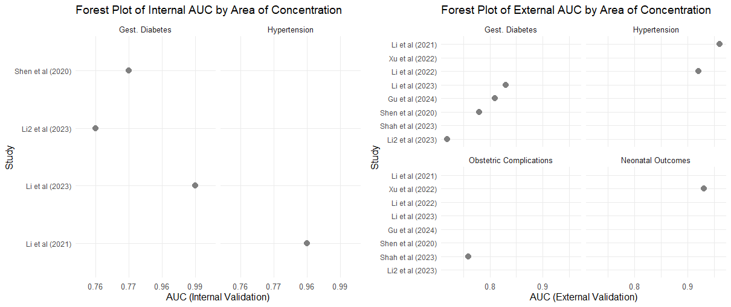

Figure A– Forest plot by area of concentration (internal and external validation), using AUC values
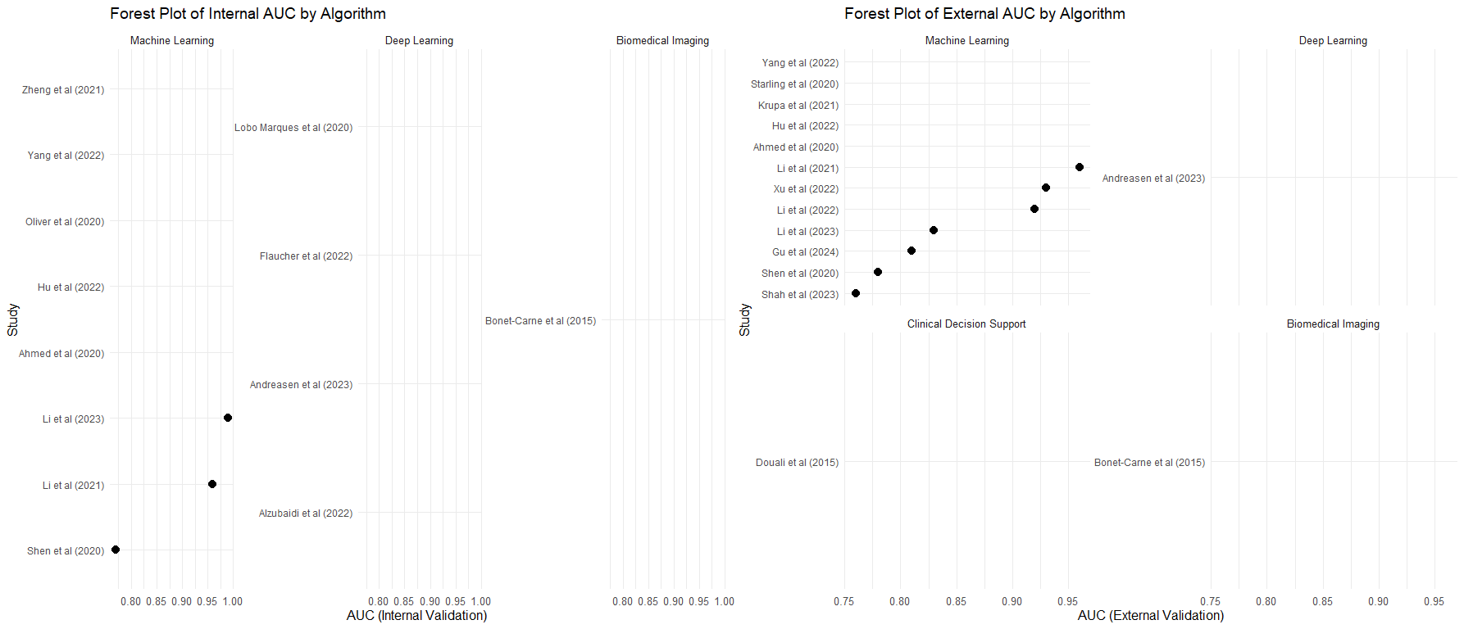
Figure B: Forest plot by Algorithms (internal and external validation) using AUC values

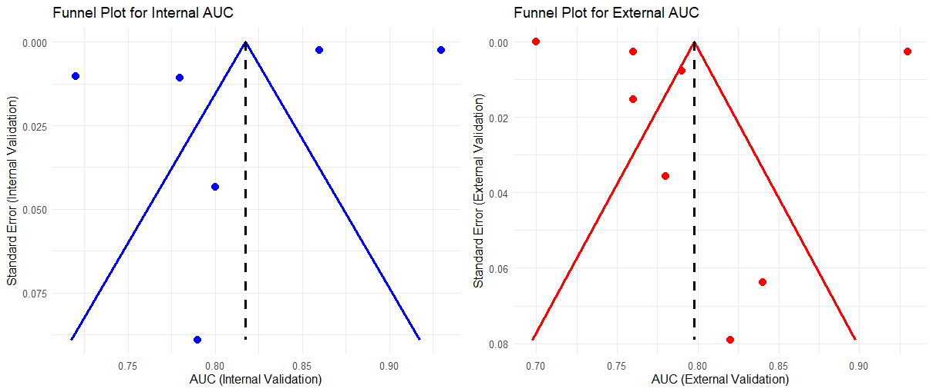
Figure C: Funnel plot using the calculated Standard Error ($\frac{Upper CI-Lower CI}{2z}$) for studies that reported both Internal and External Validation result

