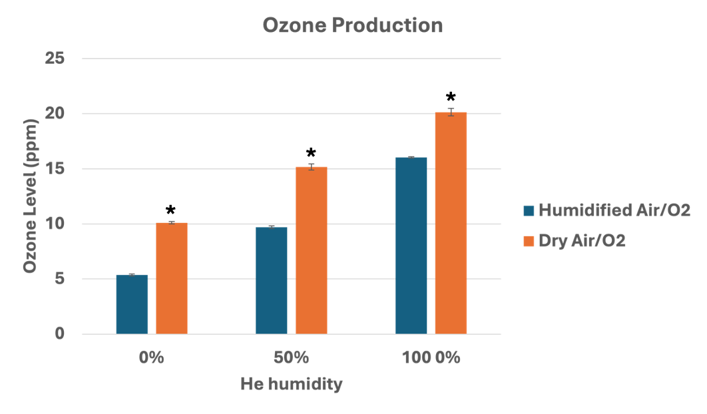
Figure S1: Ozone production rate by the Canady Helios Cold Plasma HERO System with humidified or dry Air/O₂ mixture and He + 0-100% humidity at 70V with 114 khz frequency . The data represent the mean ± SEM from n = 3 biological replicates, each containing triplicate technical measurements. Significance determined using paired two tailed Student t-test at (*p > 0.05).

Figure S2: Body temperature recording during HERO treatment

Figure S3: End tidal CO₂ recording during HERO treatment

Figure S4: O2 saturation recording during HERO treatment

Figure S5: Pulse recording during HERO treatment

