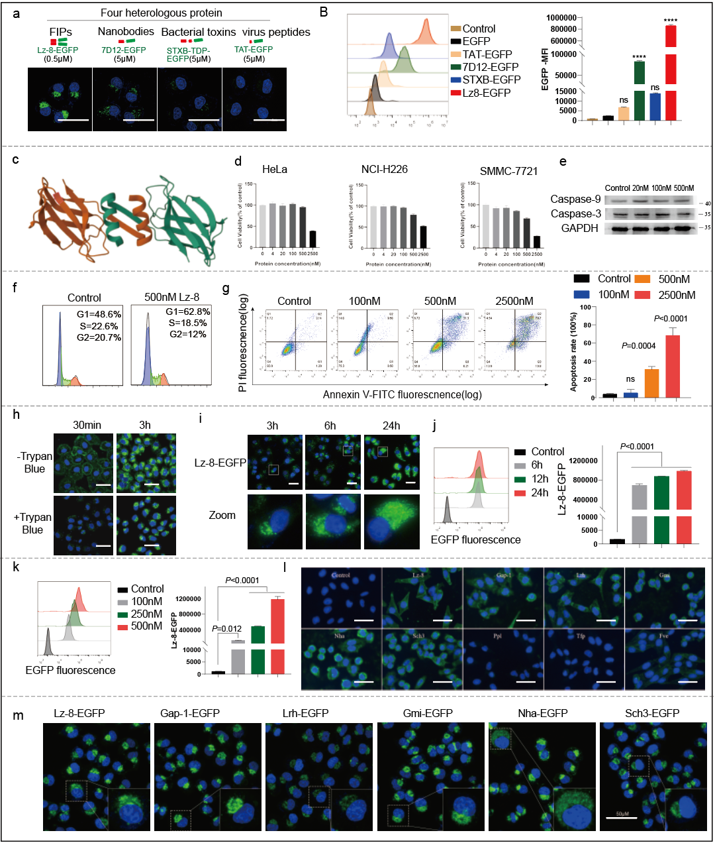
Extended Data Fig. 1 a, b. HeLa cells were treated with 0.5 µM Lz-8-EGFP, 5 µM 7D12-EGFP, 5 µM STxB-TDP-EGFP, or 5 µM TAT-EGFP for 6 h, followed by fixation and confocal imaging to assess EGFP uptake (a). Mean fluorescence intensity (MFI) was quantified using flow cytometry; statistical significance was determined relative to the control group (b). c. Three-dimensional structure of the fungal immunomodulatory protein Lz-8 (RCSB PDB: 3F3H). d. Viability of HeLa, NCI-H226, and SMMC-7721 cells treated with Lz-8 at indicated concentrations (0–2500 nM) for 48 h, as measured by MTT assay. e. Western blot analysis of Caspase-3 and -9 in HeLa cells treated with Lz-8 (0–500 nM) for 24 h. f. Cell cycle distribution of HeLa cells treated with 500 nM Lz-8 for 24 h, analyzed using FlowJo. g. Apoptosis rate in HeLa cells treated with Lz-8 (0–2500 nM) for 24 h, assessed by flow cytometry; statistical significance was calculated versus the control. h. HeLa cells treated with 500 nM Lz-8-EGFP for 0.5 or 3 h, with or without Trypan Blue quenching, fixed and imaged by confocal microscopy. i. Confocal images of HeLa cells treated with 500 nM Lz-8-EGFP for 3, 6, or 24 h; lower panels show enlarged views of boxed regions. j, k. EGFP uptake in HeLa cells treated with 500 nM Lz-8-EGFP for indicated times (0–24 h) (j) or with indicated concentrations (0–500 nM) of Lz-8-EGFP for 24 h (k); MFI was measured by flow cytometry. l. HeLa cells treated with 500 nM Lz-8, GAP-1, Lrh, Gmi, Nha, Sch3, Ppl, Tfp, or Fve for 6 h, fixed, stained with anti-6xHis antibody and FITC-conjugated secondary antibody, and imaged by fluorescence microscopy. m. Confocal microscopy images of HeLa cells treated with 500 nM EGFP-tagged Lz-8, GAP-1, Lrh, Gmi, Nha, or Sch3 for 6 h; insets show enlarged views of boxed regions. Data are presented as mean ± SD.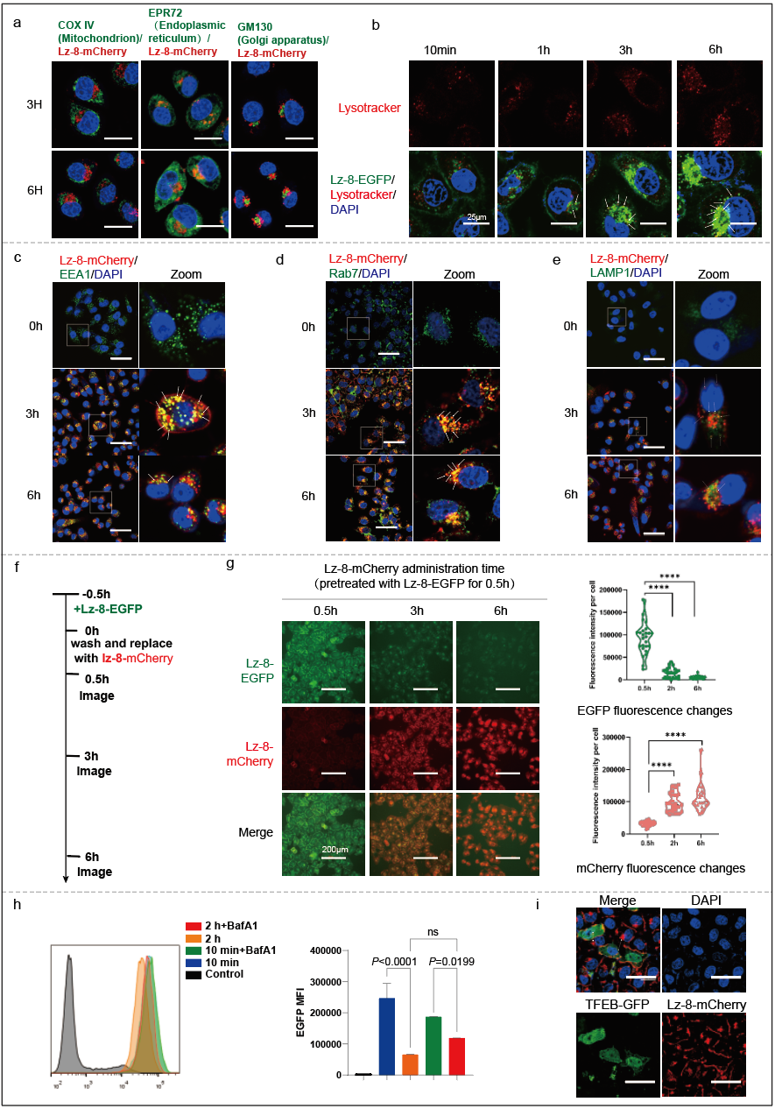
Extended Data Fig. 2 a. HeLa cells treated with 500 nM Lz-8-mCherry for 3 or 6 h were fixed, immunostained with antibodies against COX IV, EPR72, or GM130, followed by incubation with FITC-conjugated secondary antibodies, and imaged by confocal microscopy. b. HeLa cells were treated with 500 nM Lz-8-EGFP for the indicated times (10 min to 6 h), stained with LysoTracker Red, fixed, and visualized using confocal microscopy. c–e. HeLa cells treated with 500 nM Lz-8-mCherry for 0, 3, or 6 h were fixed and co-stained with antibodies against EEA1 (c), RAB7 (d), or LAMP1 (e), followed by Alexa Fluor 488-conjugated secondary antibodies. Confocal images are shown; enlarged views of boxed regions are presented on the right. Arrowheads indicate colocalization between Lz-8-mCherry and the respective markers. f, g. Schematic and quantitative analysis of a two-color pulse-chase experiment in HeLa cells. Cells were pre-treated with 500 nM Lz-8-EGFP for 0.5 h, washed, and then incubated with Lz-8-mCherry. Fluorescence images were acquired at 0.5, 3, and 6 h after treatment. EGFP and mCherry intensities per cell were quantified using ImageJ with background subtraction (n = 20). Scale bar: 200 μm. h. EGFP uptake in HeLa cells treated with 500 nM Lz-8-EGFP for 10 min or 2 h, with or without pre-treatment with 50 nM bafilomycin A1 (BafA1) for 2 h. Mean fluorescence intensity (MFI) was measured by flow cytometry; statistical significance was assessed relative to the corresponding group without BafA1. i. HeLa cells transiently expressing TFEB-GFP were treated with 500 nM Lz-8-mCherry for 6 h, fixed, and imaged by confocal microscopy. Arrowheads indicate differences in Lz-8-mCherry distribution between TFEB-GFP–expressing and non-expressing cells. Statistical significance was determined by one-way ANOVA followed by multiple comparisons (g, h). Data are presented as mean ± SD; *p < 0.05, **p < 0.01, ***p < 0.001, ****p < 0.0001; ns, not significant. All cells in panels a–e and i were counterstained with DAPI. Scale bars: 50 μm.

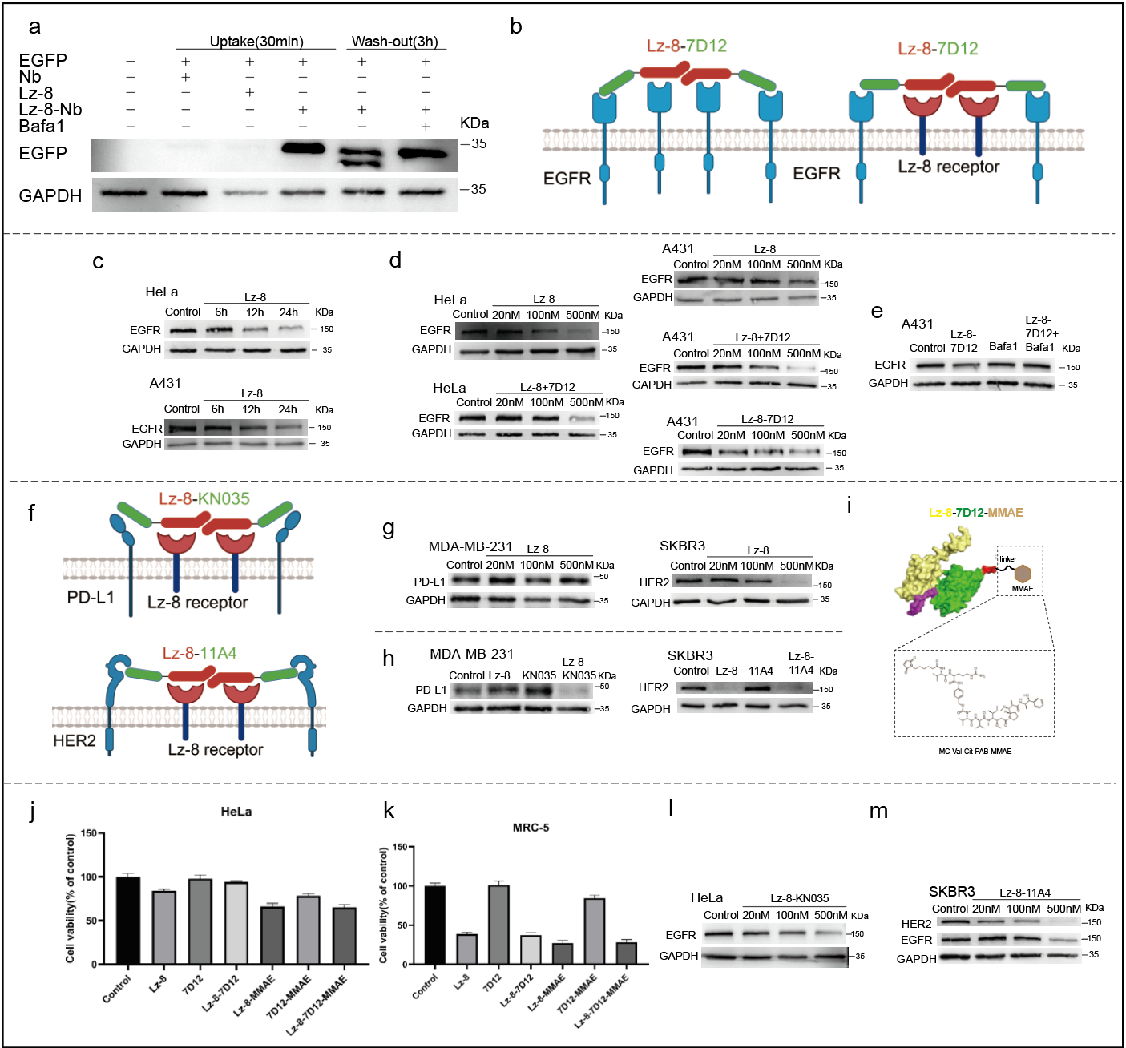
Extended Data Fig. 3 a. Degradation of extracellular EGFP mediated by Nb^{EGFP}, Lz-8-Nb^{EGFP}, with or without 50 nM bafilomycin A1 (BafA1), or Lz-8 alone. b. Schematic representation of Lz-8-7D12 binding to EGFR and the Lz-8 receptor. c. EGFR expression in HeLa and A431 cells treated with 500 nM Lz-8 for 0–24 h. d. Western blot of EGFR in HeLa and A431 cells treated for 24 h with Lz-8, Lz-8 + 7D12, or Lz-8-7D12 at indicated concentrations (0–500 nM). e. EGFR levels in A431 cells treated with 500 nM Lz-8-7D12 for 24 h, with or without 50 nM BafA1. f. Binding schematics of Lz-8-KN035 to PD-L1 and Lz-8-11A4 to HER2, each engaging the Lz-8 receptor. g. PD-L1 expression in MDA-MB-231 cells treated with Lz-8 (0–500 nM) for 24 h, and HER2 levels in SKBR3 cells treated with Lz-8-11A4 (0–500 nM) for 24 h. h. PD-L1 in MDA-MB-231 and HER2 in SKBR3 cells after 24 h treatment with 500 nM of Lz-8, KN035, Lz-8-KN035, 11A4, or Lz-8-11A4. i. Schematic structure of Lz-8-7D12-MMAE. j, k. Viability of HeLa (j) and MRC-5 (k) cells treated for 24 h with 500 nM of the indicated compounds, assessed by MTT assay. l. EGFR expression in HeLa cells treated with Lz-8-KN035 (0–500 nM) for 24 h. m. HER2 and EGFR expression in SKBR3 cells treated with Lz-8-11A4 (0–500 nM) for 24 h. Data are presented as mean ± SD.

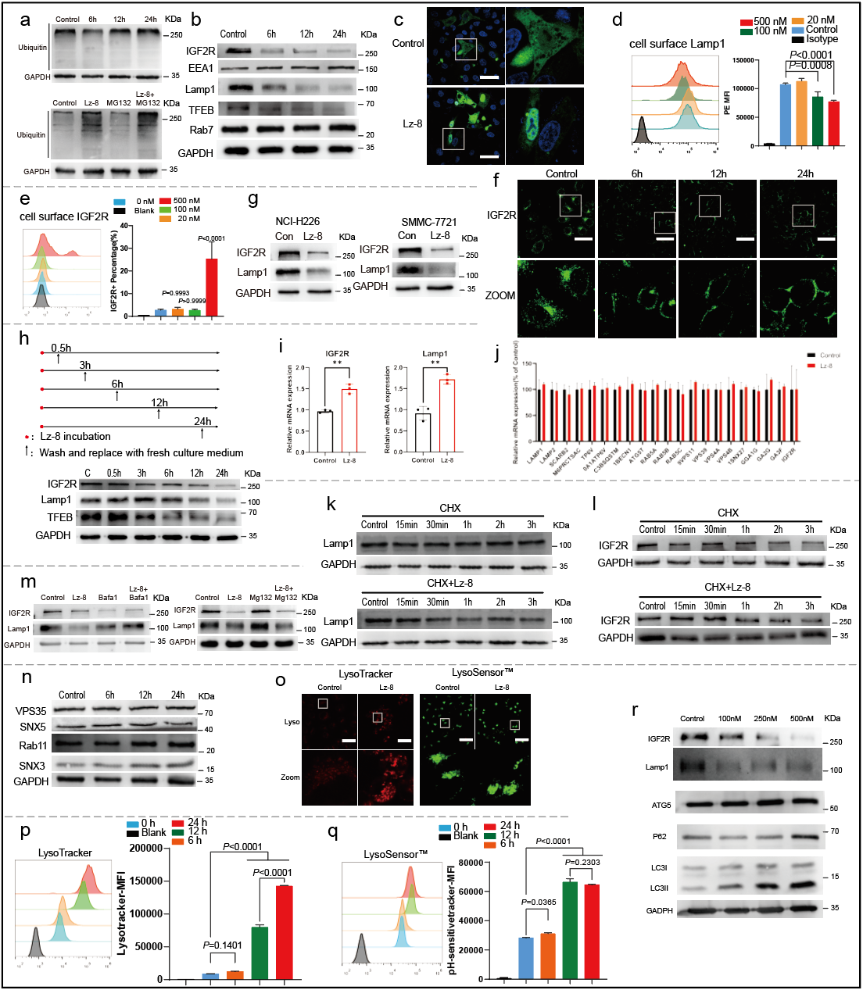
Extended Data Fig. 4 a. Western blot analysis of ubiquitinated proteins in HeLa cells treated with 500 nM Lz-8 for 0–24 h (left), or treated with Lz-8 in the presence or absence of 50 nM bafilomycin A1 (BafA1) or 20 μM MG132 (right). b. Western blot of IGF2R, LAMP1, TFEB, RAB7, and EEA1 in HeLa cells treated with 500 nM Lz-8 for the indicated times (0–24 h). c. Confocal microscopy images of HeLa cells transiently expressing TFEB-EGFP after treatment with 500 nM Lz-8 for 24 h. d. Cell surface LAMP1 levels in live HeLa cells treated with Lz-8 (0–500 nM) for 24 h, stained with PE-conjugated anti-LAMP1 antibody and analyzed by flow cytometry. Statistical significance was determined versus the control group. e. Cell surface IGF2R levels in live HeLa cells treated with Lz-8 (0–500 nM) for 24 h, stained with anti-IGF2R antibody and Alexa Fluor 488-conjugated secondary antibody, and quantified by flow cytometry. Statistical significance is relative to control. f. Immunofluorescence staining of IGF2R in HeLa cells treated with 500 nM Lz-8 for 0–24 h, using anti-IGF2R and Alexa Fluor 488-conjugated secondary antibody. Enlarged views of boxed regions are shown below. g. Western blot of IGF2R and LAMP1 in NCI-H226 and SMMC-7721 cells treated with 500 nM Lz-8 for 24 h. h. Western blot of IGF2R, LAMP1, and TFEB in HeLa cells treated with 500 nM Lz-8 for various durations (0–24 h), including a recovery time course after removal of Lz-8. i. mRNA levels of IGF2R and LAMP1 in HeLa cells treated with 500 nM Lz-8 for 24 h, analyzed by qRT-PCR. j. Histogram of differentially expressed genes (DEGs) from RNA-seq in HeLa cells treated with 500 nM Lz-8 for 24 h (left). qPCR validation of selected lysosomal-related genes, normalized to GAPDH and presented as mean ± SEM (n = 3). k, l. Western blot of LAMP1 (k) and IGF2R (l) in HeLa cells treated with 50 ng/mL cycloheximide (CHX) alone or with 500 nM Lz-8 for the indicated times (0–3 h). m. Western blot of IGF2R and LAMP1 in HeLa cells treated with 500 nM Lz-8 for 24 h with or without BafA1 or MG132. n. Western blot of SNX5, SNX3, VPS35, and Rab11 in HeLa cells treated with 500 nM Lz-8 for 6–24 h. o. Live-cell confocal imaging of HeLa cells treated with 500 nM Lz-8 for 6 h and stained with LysoTracker Red or Lysosensor Green. Enlarged views are shown below. p, q. Flow cytometry analysis of LysoTracker Red (p) or Lysosensor Green (q) fluorescence intensity in HeLa cells treated with 500 nM Lz-8 for 0–24 h. Statistical significance is relative to the 0 h group. r. Western blot of IGF2R, LAMP1, p62, pro- and mature CTSD, ATG5, and LC3-I/II in HeLa cells treated with Lz-8 (0–500 nM) for 24 h. Data are presented as mean ± SD unless stated otherwise. Statistical significance was determined by one-way ANOVA: *p < 0.05, **p < 0.01, ***p < 0.001, ****p < 0.0001; ns, not significant. Scale bars: 50 μm (c, f, o).

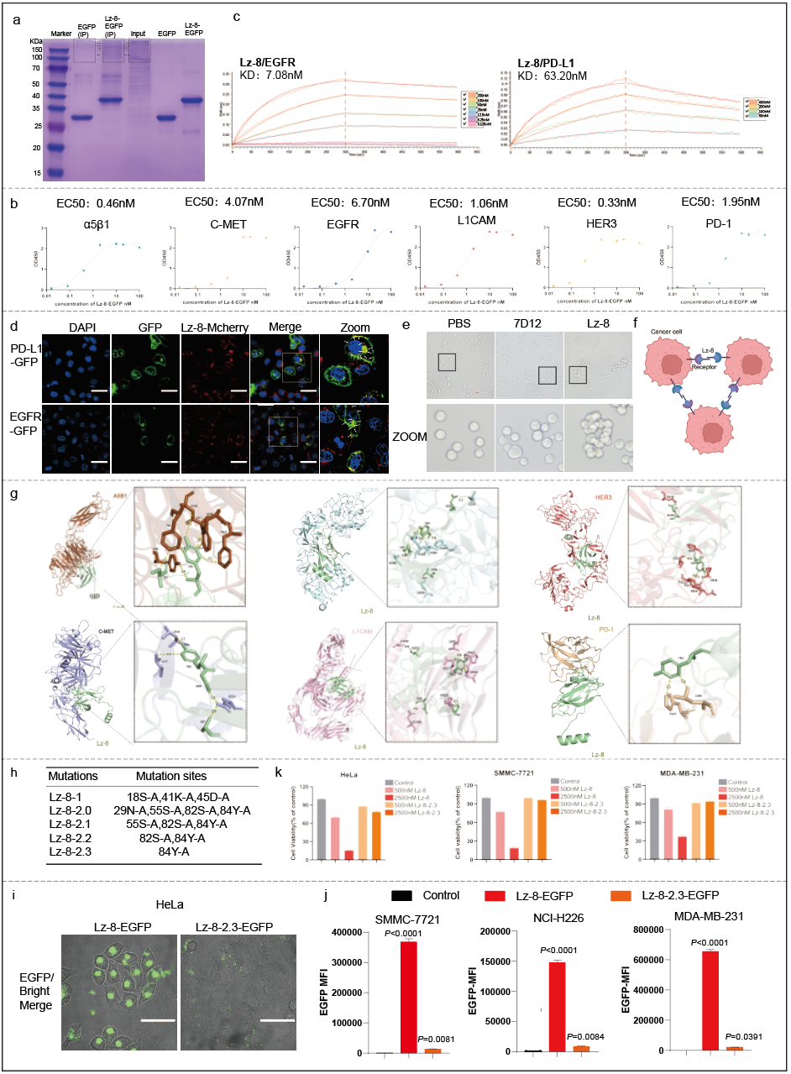
Extended Data Fig. 5 a. HeLa cells were treated with 500 nM Lz-8-EGFP or EGFP for 24 h. Pull-down assays were performed using anti-EGFP antibody conjugated to protein G agarose beads, followed by SDS-PAGE. Protein bands within the red box were excised for LC-MS identification. b. Binding affinity of Lz-8-EGFP to human α5β1, c-MET, L1CAM, HER3, EGFR, and PD-1 measured by ELISA. EC₅₀ values were calculated using GraphPad Prism. c. Binding interactions between Lz-8 and EGFR or PD-L1 assessed using bio-layer interferometry (BLI). d. HeLa cells transiently expressing PD-L1-GFP or EGFR-GFP were treated with 500 nM Lz-8-mCherry for 6 h, fixed, and imaged by confocal microscopy. Enlarged views are shown on the right; arrowheads indicate colocalization of Lz-8-mCherry with PD-L1-GFP or EGFR-GFP. Nuclei were counterstained with DAPI. e. Single-cell suspensions of HeLa cells were incubated with PBS, 500 nM 7D12, or 500 nM Lz-8 at 37 °C for 30 min and visualized using fluorescence microscopy. f. Schematic model of Lz-8–induced cross-linking of HeLa cells. g. Molecular docking models of Lz-8 with α5β1 (PDB: 3VI4), c-MET (2UZX), EGFR (2UZX), L1CAM (predicted by AlphaFold2.3), HER3 (1M6B), and PD-1 (7CGW). Key interacting residues are highlighted on the right. h. Summary table of mutation sites introduced in the Lz-8 protein. i. Confocal microscopy images of HeLa cells treated with 500 nM Lz-8-EGFP or Lz-8-2.3-EGFP for 6 h. j. Internalization of EGFP into CT26, SMMC-7721, NCI-H226, and MDA-MB-231 cells treated with 500 nM Lz-8-EGFP or Lz-8-2.3-EGFP for 6 h, as quantified by mean fluorescence intensity (MFI) using live-cell flow cytometry. Statistical significance was calculated versus the control group using one-way ANOVA. k. Viability of HeLa, SMMC-7721, and MDA-MB-231 cells treated with 0, 500, or 2500 nM Lz-8 or Lz-8-2.3 for 24 h, assessed by MTT assay. Data are presented as mean ± SD.

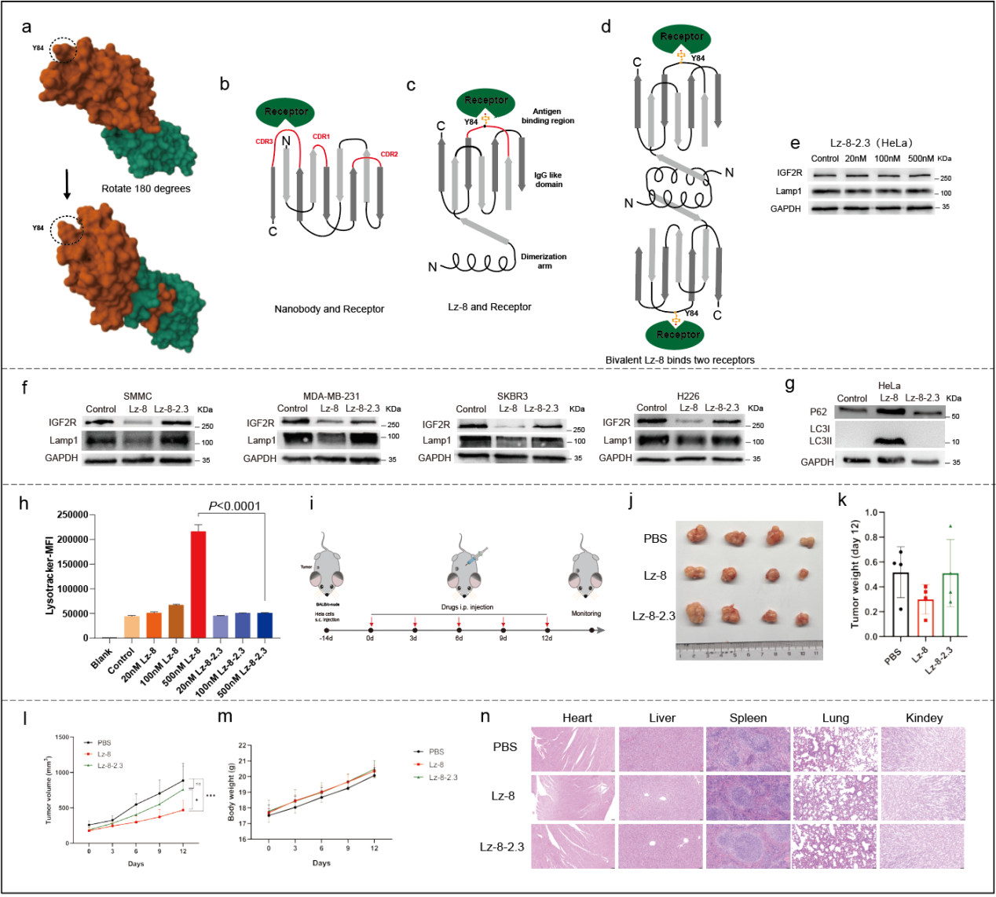
Extended Data Fig. 6 a. Two views of the three-dimensional structure of Lz-8 (PDB: 3F3H), with residue Y84 highlighted by a dotted box. b. Schematic representation of the CDR3 region of a nanobody binding to its target receptor. c, d. Proposed binding models: interaction between Y84 within the CDR3-like region of Lz-8 and its receptor (c), and Lz-8 dimer mediating cross-linking of two receptor molecules (d). e. Western blot analysis of IGF2R and LAMP1 expression in HeLa cells treated for 24 h with increasing concentrations (0–500 nM) of Lz-8. f. Western blot of IGF2R and LAMP1 in SMMC-7721, MDA-MB-231, SKBR3, and NCI-H226 cells treated for 24 h with 500 nM Lz-8 or Lz-8-2.3. g. Western blot of p62 and LC3-I/II in HeLa cells treated for 24 h with 500 nM Lz-8 or Lz-8-2.3. h. LysoTracker Red fluorescence intensity in HeLa cells treated for 6 h with Lz-8 or Lz-8-2.3 (0–500 nM), quantified by live-cell flow cytometry. Statistical significance was determined by one-way ANOVA (n = 3). i. Schematic of the subcutaneous HeLa tumor model in BALB/c-nude mice. Mice were treated intraperitoneally every three days with 1 mg/kg PBS, Lz-8, or Lz-8-2.3. j, k. Body weight (j) and tumor volume (k) of mice during the treatment period. l, m. Representative excised tumor photographs at day 12 (l) and tumor weights (m) (n = 4; data presented as mean ± SD). n. Representative H&E-stained images of major organ tissues from mice. Scale bars: 50 μm.

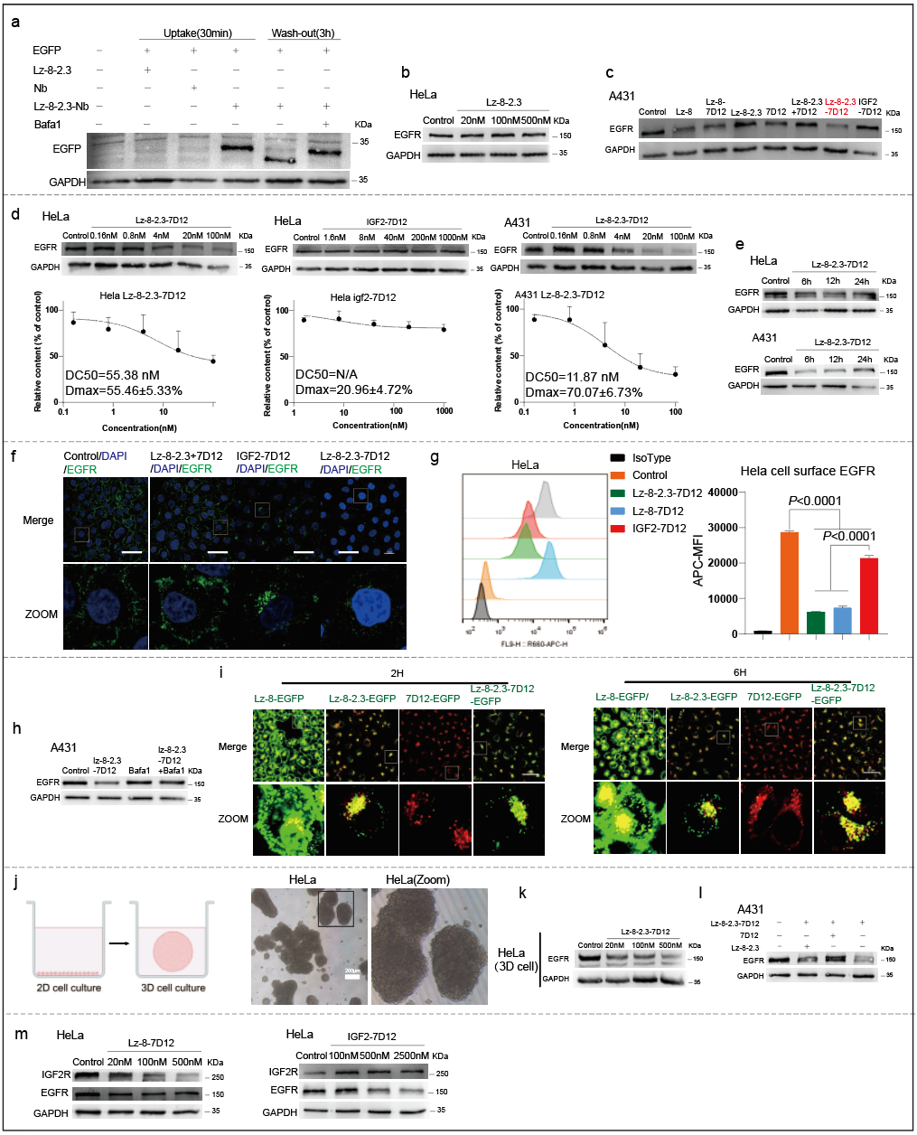
Extended Data Fig. 7 a. Degradation of extracellular EGFP. EGFP was pre-mixed with Lz-8-2.3-Nb^{EGFP}, Nb^{EGFP}, or Lz-8-2.3 for 10 min, then HeLa cells were treated with the mixtures for 30 min. For the Lz-8-2.3-Nb^{EGFP} and Lz-8-2.3-Nb^{EGFP} + BafA1 groups, cells were washed and further incubated for 3 h. b. Western blot analysis of EGFR in HeLa cells treated for 24 h with Lz-8-2.3 at indicated concentrations (0–500 nM). c. EGFR expression in A431 cells treated for 24 h with 500 nM of Lz-8, Lz-8-7D12, Lz-8-2.3, Lz-8-2.3 + 7D12, Lz-8-2.3-7D12, or IGF2-7D12. d. Western blot of EGFR in HeLa and A431 cells treated with Lz-8-2.3-7D12 or IGF2-7D12 (0–100 nM) for 24 h. Degradation efficiency was quantified by grayscale analysis in ImageJ; DC₅₀ and Dmax were determined using GraphPad Prism. e. Time-dependent degradation of EGFR in HeLa and A431 cells treated with 500 nM Lz-8-2.3-7D12 for 0–24 h. f. Confocal microscopy images of HeLa cells treated for 6 h with 500 nM Lz-8-2.3 + 7D12, IGF2-7D12, or Lz-8-2.3-7D12, fixed and immunostained with anti-EGFR antibody and Alexa Fluor 488-conjugated secondary antibody. Enlarged views of boxed regions are shown below. Nuclei were counterstained with DAPI. Scale bar: 50 μm. g. Cell surface EGFR levels in live HeLa cells treated for 24 h with 500 nM Lz-8-7D12, Lz-8-2.3-7D12, or IGF2-7D12, stained with APC-conjugated anti-EGFR antibody and analyzed by flow cytometry. Statistical significance was determined by one-way ANOVA. h. Western blot of EGFR in A431 cells treated with 500 nM Lz-8-2.3-7D12 for 24 h with or without 50 nM bafilomycin A1 (BafA1). i. Confocal images of HeLa cells treated with 500 nM Lz-8-EGFP, Lz-8-2.3-EGFP, 7D12-EGFP, or Lz-8-2.3-7D12-EGFP for 2 or 6 h and stained with LysoTracker Red. Enlarged views are shown below. Scale bar: 50 μm. j. Schematic of 3D cell culture model and bright-field image of a HeLa spheroid. Scale bar: 200 μm. k. Western blot of EGFR in HeLa spheroids treated with Lz-8-2.3-7D12 (0–500 nM). l. Western blot of EGFR in A431 cells pre-treated with 500 nM Lz-8-2.3 or 7D12 for 0.5 h, washed, and then treated with 500 nM Lz-8-2.3-7D12 for 24 h. m. Western blot of IGF2R and EGFR in HeLa cells treated with Lz-8-7D12 (0–500 nM) or IGF2-7D12 (0–2500 nM) for 24 h. Data are presented as mean ±SD. 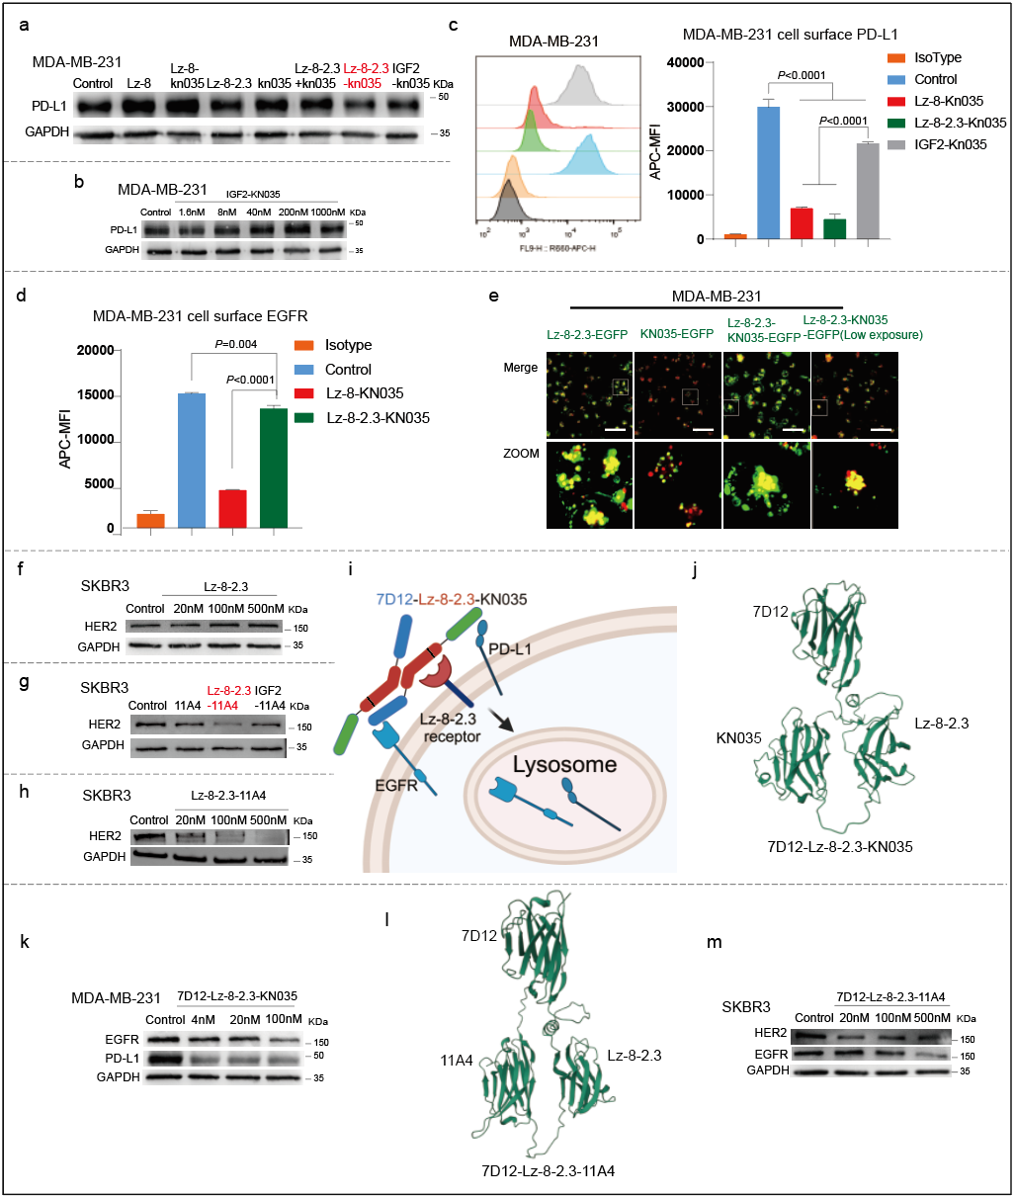
Extended Data Fig. 8 a. Western blot analysis of PD-L1 in MDA-MB-231 cells treated for 24 h with 500 nM of Lz-8, Lz-8-KN035, Lz-8-2.3, KN035, Lz-8-2.3 + KN035, Lz-8-2.3-KN035, or IGF2-KN035. b. PD-L1 expression in HeLa cells treated with IGF2-KN035 (0–1000 nM) for 24 h. c. Cell surface PD-L1 levels in live MDA-MB-231 cells treated for 24 h with 100 nM Lz-8-KN035, Lz-8-2.3-KN035, or IGF2-KN035, stained with APC-conjugated anti-PD-L1 antibody and analyzed by flow cytometry. d. Cell surface EGFR levels in live MDA-MB-231 cells treated for 24 h with 500 nM Lz-8-KN035, Lz-8-2.3-KN035, or IGF2-KN035, stained with APC-conjugated anti-EGFR antibody and analyzed by flow cytometry. e. Confocal microscopy images of MDA-MB-231 cells treated for 6 h with 500 nM Lz-8-2.3-EGFP, KN035-EGFP, or Lz-8-2.3-7D12-EGFP and stained with LysoTracker Red. Enlarged views of boxed regions are shown below. Scale bar: 50 μm. f. Western blot of HER2 in SKBR3 cells treated with Lz-8-2.3 (0–500 nM) for 24 h. g. HER2 expression in SKBR3 cells treated for 24 h with 500 nM 11A4, Lz-8-2.3-11A4, or IGF2-11A4. h. Western blot of HER2 in SKBR3 cells treated with Lz-8-2.3-11A4 (0–500 nM) for 24 h. i. Schematic model of 7D12-Lz-8-2.3-KN035 simultaneously binding PD-L1, EGFR, and the Lz-8 receptor, leading to their lysosomal degradation. j. Homology modeling of the structure of 7D12-Lz-8-2.3-KN035. k. Western blot analysis of PD-L1 and EGFR in MDA-MB-231 cells treated with 7D12-Lz-8-2.3-KN035 (0–500 nM) for 24 h. l. Homology modeling of the structure of 7D12-Lz-8-2.3-11A4. m. Western blot of HER2 and EGFR in SKBR3 cells treated with 7D12-Lz-8-2.3-11A4 (0–500 nM) for 24 h. Statistical significance was determined by one-way ANOVA (c, d; n = 3; data presented as mean ± SD).

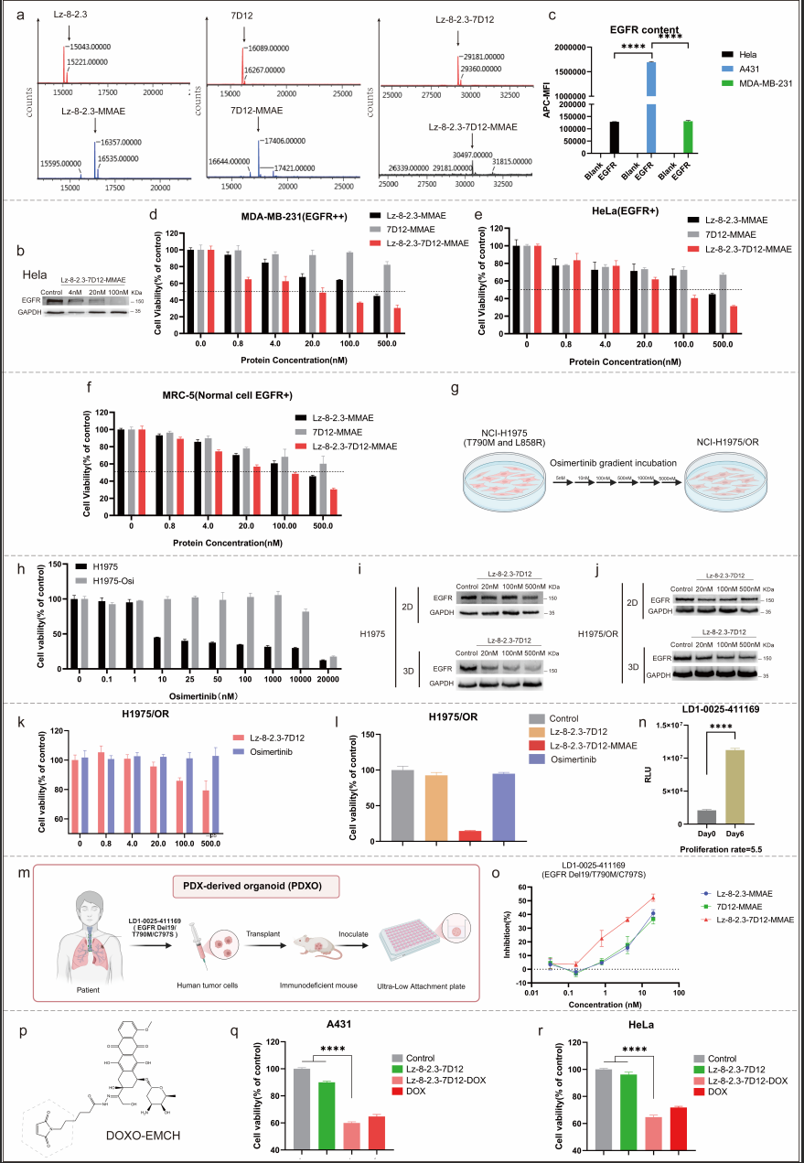
Extended Data Fig. 9 a. LC-MS analysis of Lz-8-2.3-Cys, 7D12-Cys, Lz-8-2.3-7D12-Cys, and their respective MMAE conjugates (complete dataset available in original statistics). b. Western blot analysis of EGFR in HeLa cells treated for 24 h with Lz-8-2.3-7D12-MMAE at indicated concentrations (0–100 nM). c. EGFR expression levels in HeLa, A431, and MDA-MB-231 cells measured by flow cytometry using APC-conjugated anti-EGFR antibody. d–f. Viability of MDA-MB-231 (EGFR⁺⁺, d), HeLa (EGFR⁺, e), and MRC-5 (EGFR⁺ normal cells, f) treated for 48 h with Lz-8-2.3-MMAE, 7D12-MMAE, or Lz-8-2.3-7D12-MMAE at concentrations ranging from 0 to 500 nM, as assessed by MTT assay. The gray dashed line indicates 50% cell viability. g. Schematic of generating osimertinib-resistant NCI-H1975 cells (H1975/OR) through gradient concentration induction. h. Viability of H1975 and H1975-OR cells treated with osimertinib (0–20,000 nM) for 72 h. i, j. Western blot of EGFR in conventional 2D and 3D cultured H1975 (i) and H1975-OR (j) cells treated with Lz-8-2.3-7D12 (20–500 nM) for 24 h. k. Viability of H1975-OR cells treated with Lz-8-2.3-7D12 or osimertinib (0–500 nM) for 7 days.
l. Viability of H1975-OR cells treated for 48 h with 100 nM Lz-8-2.3-7D12, Lz-8-2.3-7D12-MMAE, or osimertinib. m. Schematic of the LD1-0025-411169 PDX-derived organoid (PDXO) model carrying EGFR Del19/T790M/C797S triple mutation. n. Fresh solid tumor samples from patients were digested and inoculated into ultra-low attachment 96-well plates (Day 0). Organoids were cultured until Day 6, and viability was assessed at both time points using CellTiter-Glo® luminescent assay. o. Inhibition rate of LD1-0025-411169 PDXO cells treated for 7 days with Lz-8-2.3-MMAE, 7D12-MMAE, or Lz-8-2.3-7D12-MMAE (0–20 nM). p. Molecular structure of doxorubicin-conjugated EMCH (DOXO-EMCH). q, r. Viability of A431 (q) and HeLa (r) cells treated for 48 h with 500 nM Lz-8-2.3-7D12, Lz-8-2.3-7D12-DOX, or free DOX. Statistical significance was determined by one-way ANOVA (c, o, p; n = 3; data presented as mean ± SD). *p < 0.05, **p < 0.01, ***p < 0.001, ****p < 0.0001; ns, not significant.
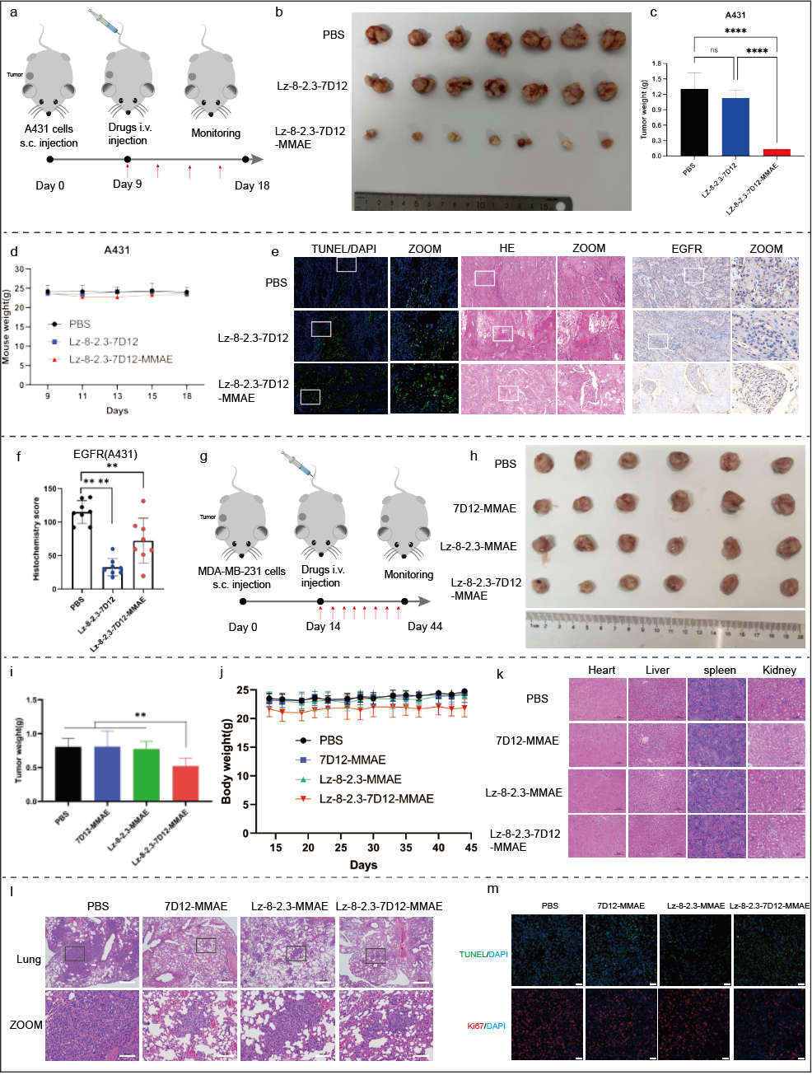 Extended Data Fig. 10 a. Schematic of the subcutaneous A431 tumor model in BALB/c nude mice. Tumor-bearing mice were treated intravenously every two days with 3 mg/kg PBS, Lz-8-2.3-7D12, Lz-8-2.3-7D12-MMAE for a total of eight injections. b, c. Representative excised tumors at day 18 (b) and tumor weight quantification (c) (n = 7; data presented as mean ± SD). d. Body weight changes of mice monitored every 2–3 days during the study. e. Representative images in tumors. From left to right are the apoptosis probe TUNEL staining (blue for DAPI staining), HE immunohistochemistry, and anti EGFR immunohistochemistry. Enlarged views of boxed regions are shown right. Scale bar: 100 μm. f. Anti-EGFR immunohistochemical score of A431 subcutaneous tumor after administration.Randomly selected 8 regions for calculation and scoring. Data presented as mean ± SD. g. Schematic of the subcutaneous MDA-MB-231 tumor model in BALB/c nude mice. Tumor-bearing mice were treated intravenously every three days with 1.5 mg/kg PBS, 7D12-MMAE, Lz-8-2.3-MMAE, Lz-8-2.3-7D12-MMAE, or Cetuximab-MMAE, for a total of eight injections. h, i. Representative excised tumors at day 45 (h) and tumor weight quantification (i) (n = 6; data presented as mean ± SD). j. Body weight changes of mice monitored every 2–3 days during the study. k. Representative H&E-stained images of heart, liver, spleen, and kidney collected on day 44. Scale bar: 500 μm. l. Representative H&E-stained images of lung tissue on day 44; right panel shows an enlarged view of the boxed region. Scale bars: 500 μm (left) and 100 μm (right). m. Representative fluorescent images of TUNEL (green) and Ki67 (red) staining combined with DAPI (blue) in tumor sections. Scale bar: 50 μm. Statistical significance was determined by one-way ANOVA. *p < 0.05, **p < 0.01, ***p < 0.001, ****p < 0.0001; ns, not significant.

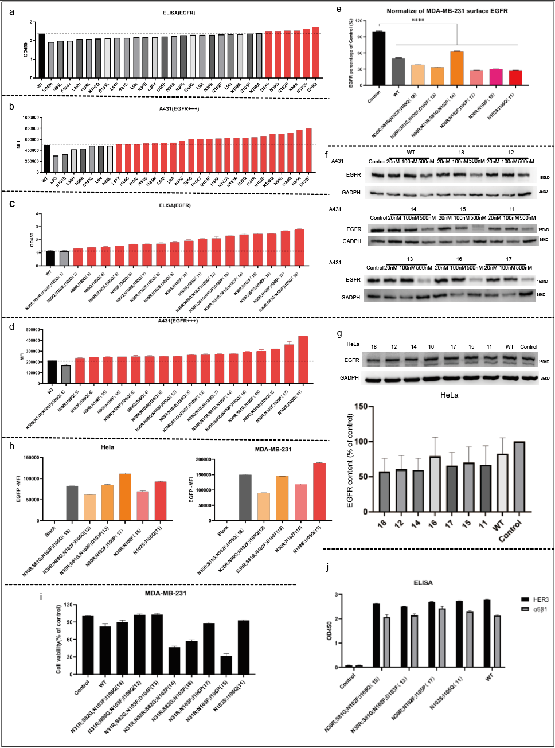
Extended Data Fig. 11 a. ELISA binding analysis of 20 nM Lz-8-EGFP and 29 single-point mutants to EGFR. b. Internalization of EGFP into A431 (EGFR-high) cells treated with 100 nM Lz-8-EGFP or single-point mutant-EGFP conjugates for 1 h, quantified by mean fluorescence intensity (MFI) using flow cytometry. c. ELISA binding of 5 nM Lz-8-EGFP and 18 multi-point mutants to EGFR. d. Uptake of EGFP in A431 cells treated with 100 nM Lz-8-EGFP or multi-point mutant-EGFP for 1 h, measured by flow MFI. e. Cell surface EGFR levels in MDA-MB-231 cells incubated with 100 nM Lz-8 or its single-point mutants for 1 h, stained with APC-anti-EGFR and analyzed by flow cytometry. Statistical significance was determined versus the control group. f. Western blot analysis of EGFR in A431 cells treated for 24 h with Lz-8 or its multi-point mutants at 20, 100, or 500 nM. g. EGFR expression in HeLa cells treated with 50 nM Lz-8 or multi-point mutants for 24 h. Grayscale quantification was performed using ImageJ and analyzed with GraphPad Prism. h. EGFP uptake in HeLa or MDA-MB-231 cells treated with 500 nM Lz-8-EGFP or multi-point mutant-EGFP for 6 h, assessed by MFI via flow cytometry. i. Viability of MDA-MB-231 cells treated with 500 nM Lz-8 or Lz-8-2.3 for 48 h, evaluated by MTT assay. j. ELISA binding of 20 nM Lz-8 or 29 multi-point mutants to HER3 or α5β1. Numbers in (f) and (g) correspond to mutant identifiers shown in (c) and (d).
Statistical significance was determined by one-way ANOVA (e). *p < 0.05, **p < 0.01, ***p < 0.001, ****p < 0.0001; ns, not significant. Data are presented as mean ± SD.
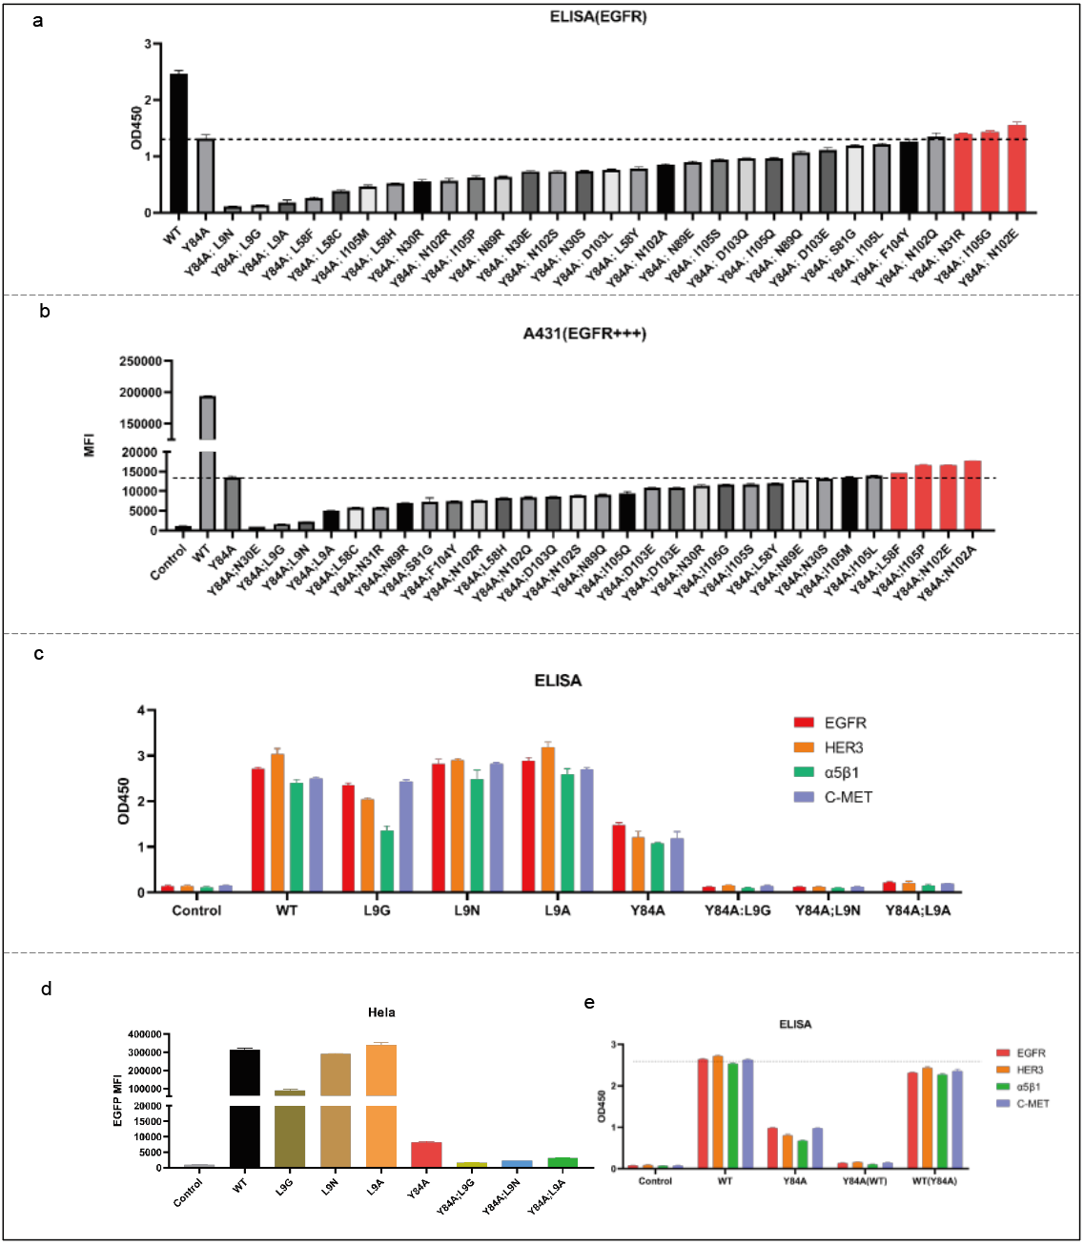Extended Data Fig. 12 a. ELISA analysis of the binding between 5 nM Lz-8, Lz-8-2.3 (Y84A), or 29 multi-point mutants and EGFR. b. Cell surface EGFR levels in A431 (EGFR-high) cells incubated with 100 nM Lz-8, Lz-8-2.3 (Y84A), or 29 multi-point mutants for 1 h, stained with APC-conjugated anti-EGFR antibody and analyzed by flow cytometry. c. Binding affinity of 20 nM Lz-8, Lz-8-2.3 (Y84A), or 7 selected single- or multi-point mutants to EGFR, HER3, α5β1, or c-MET, as measured by ELISA. d. Internalization of EGFP into HeLa cells treated with 500 nM Lz-8-EGFP (wild-type) or 7 mutant EGFP fusion proteins for 1 h, quantified by mean fluorescence intensity (MFI) using flow cytometry. e. Binding of 20 nM Lz-8-EGFP or Lz-8-2.3 (Y84A)-EGFP to EGFR, HER3, α5β1, or c-MET, with or without pre-treatment with 500 nM unlabeled Lz-8 or Lz-8-2.3 (Y84A), as assessed by ELISA. Data are presented as mean ± SD.

