SUPPORTING INFORMATION

Increased water availability accelerates C cycling in a dry forest ecosystem

Luisa I. Minich*, Claudia Guidi, Alois Zürcher, Dylan Geissbühler, Margaux Moreno Duborgel, Katrin Di Bella Meusburger, Negar Haghipour, Jonas Gisler, Marcus Schaub, Lukas Wacker, Philip Gautschi, Frank Hagedorn
* Correspondence author: E-mail: luisa.minich@gmail.com
This file includes Table S1 – Table S5, Figure S1 – S4.

Table S1: Monthly mean values from long-term measurements of soil respiration (mg CO₂-C m⁻² h⁻¹), soil moisture (w-% of moist soil), and soil temperature (°C) for the dry control and irrigation treatment, averaged over the period 2012-2024.
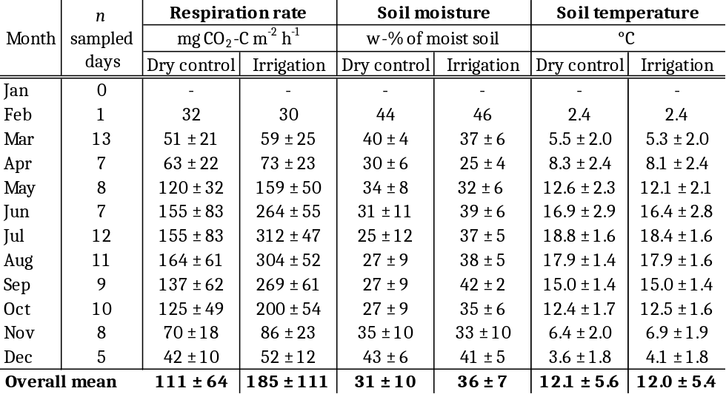
Table S2: Significance levels (p-values) of ANOVA analyses examining the variance in respiration rates, soil moisture, and soil temperature from long-term measurements across treatments, seasons, and irrigation periods.
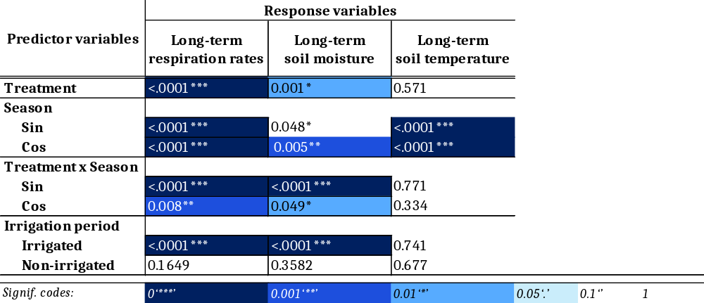
Table S3: Model output of Generalized Least Square models to investigate the effect of soil temperature and moisture on soil respiration under dry control and irrigated conditions.
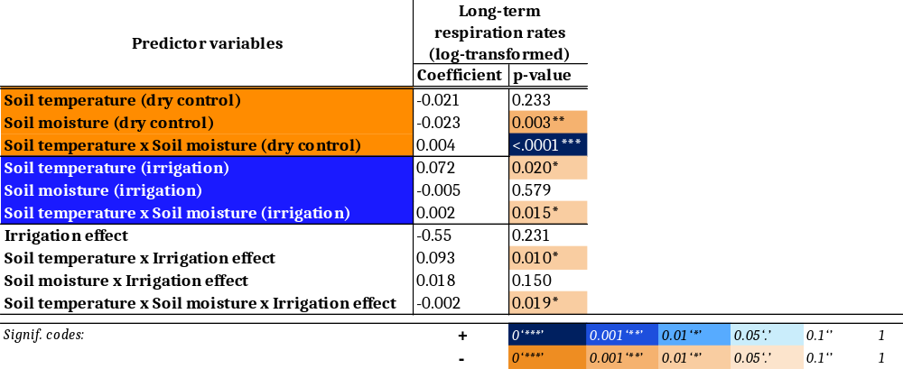
Table S4: Significance levels (p-values) of ANOVA analyses examining the variance in SOC stocks, fine root biomass, C mineralization, Δ¹⁴C values of SOC, respired CO₂, and fine roots across treatments and soil depths.
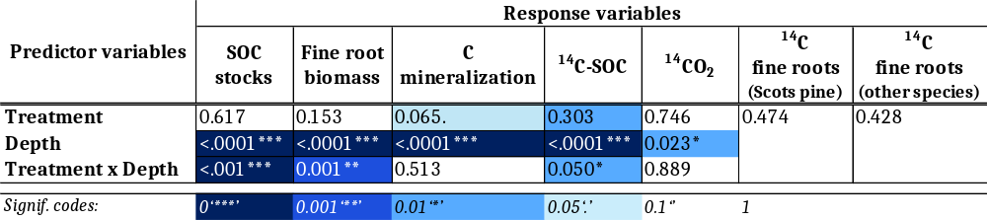

Table S5: Significance levels (p-values) of ANOVA analyses examining the variance in SOC stocks, fine root biomass, C mineralization, Δ¹⁴C values of SOC and respired CO₂ across treatments in each soil depth.
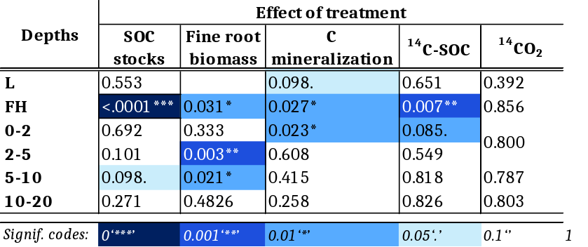

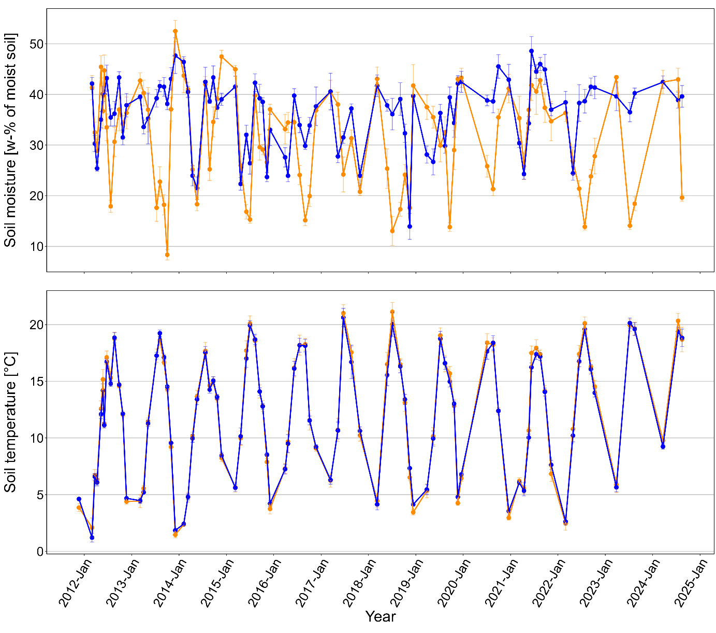
Figure S1: Soil moisture (w-% of moist soil; top) and soil temperature (°C; bottom) during measurements of soil respiration rates in dry dry control and irrigation treatment from winter 2012 to summer 2014.
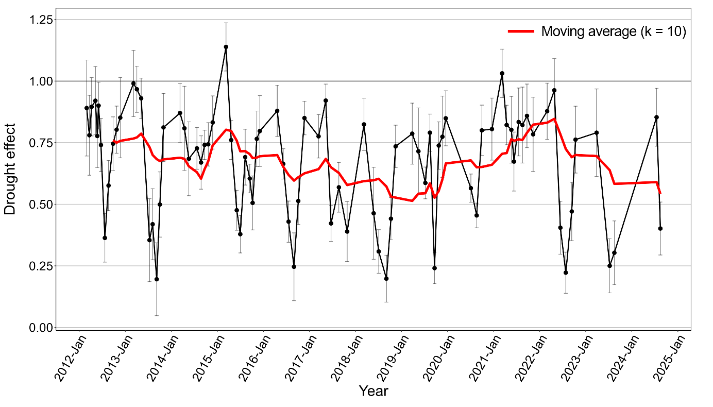
Figure S2: Drought effect on soil respiration (SR_{dry control}/SR_{irrigation}) from winter 2012 to summer 2024. The red line represents a moving average calculated using a 10-point window (k = 10) to highlight temporal trends.

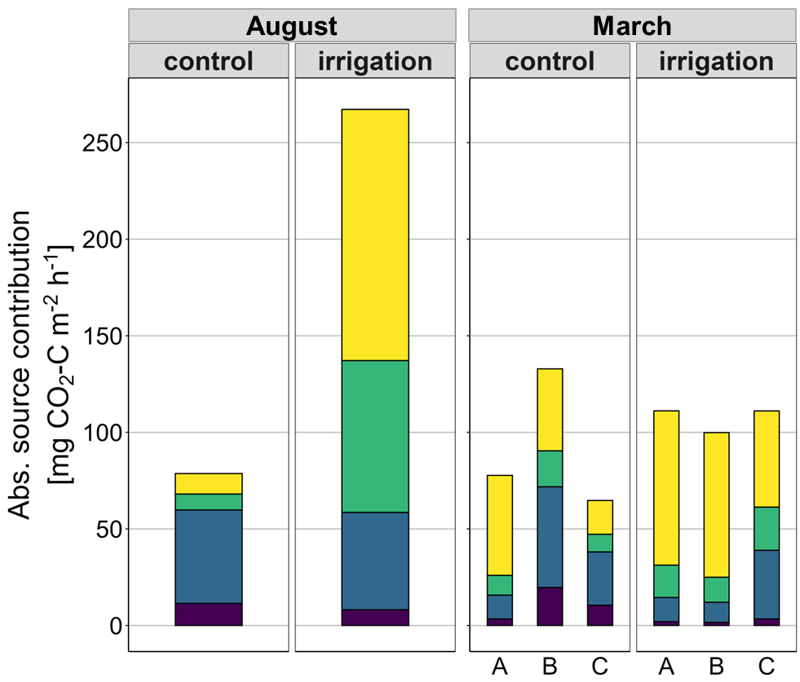
Figure S3: Absolute contributions of autotrophic respiration and heterotrophic respiration from the organic layer (OL), topsoil, and subsoil (mg CO₂-C m⁻² h⁻¹) in both treatments and seasons. Source contributions are shown for replicates in March.
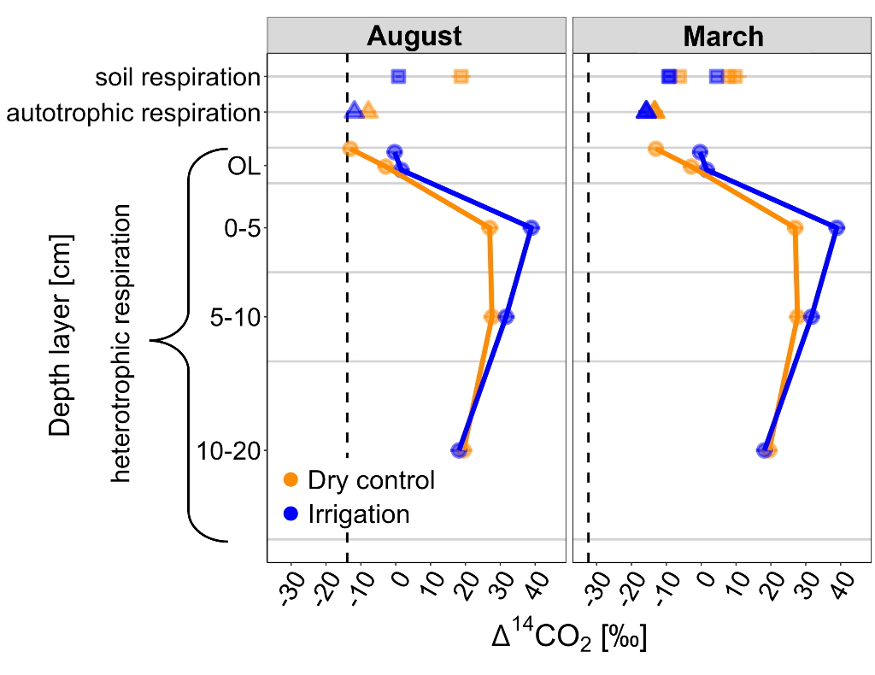
Figure S4: Δ¹⁴CO₂ values (‰) of in situ soil respiration, its autotrophic component and heterotrophic respiration across different soil depth layers used for source partitioning. Heterotrophic Δ¹⁴CO₂ was measured upon incubation of soil sampled in August. Black dashed lines represent atmospheric Δ¹⁴CO₂ levels at the time of sampling.

