Supplementary Information
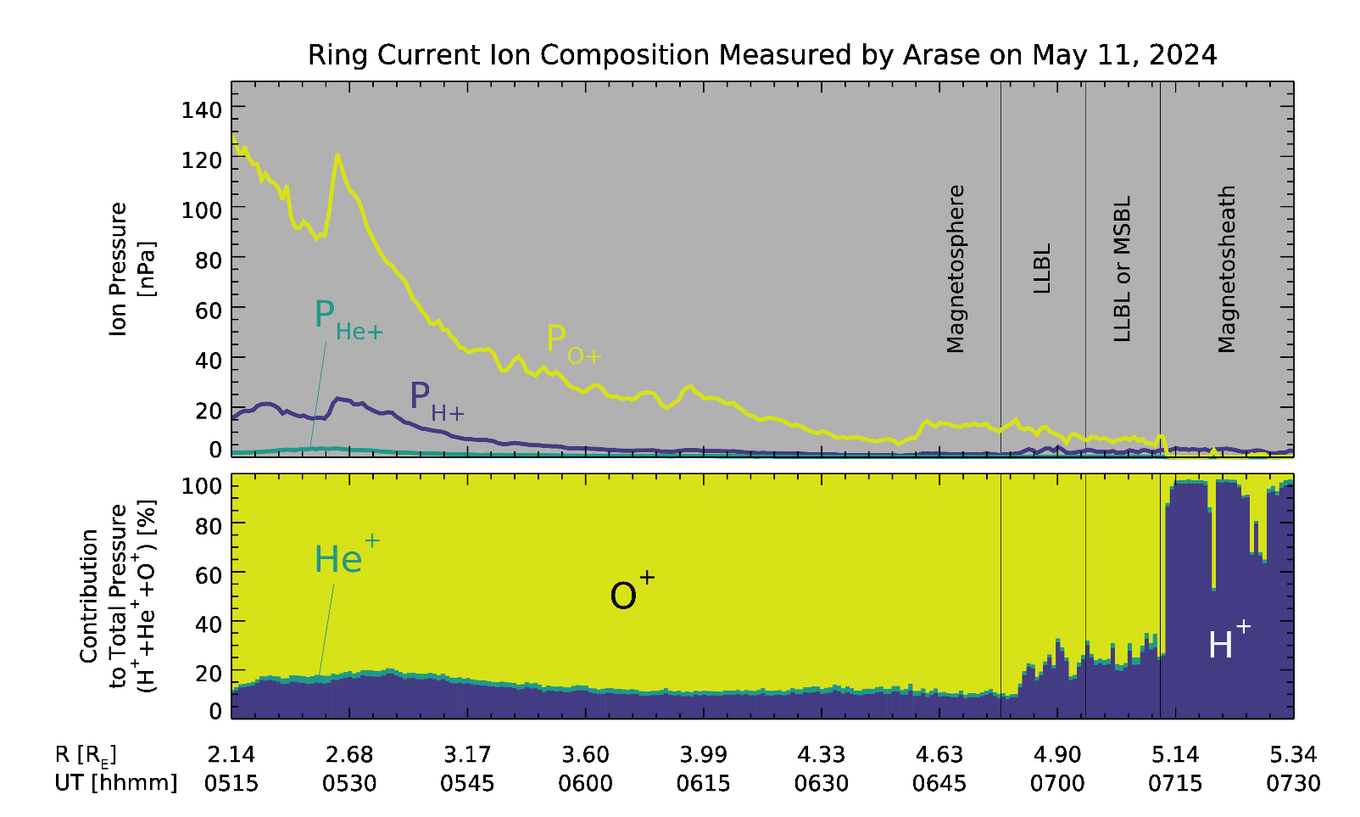

Supplementary Information Fig. 1 | Ion thermal pressures of proton (H⁺), He⁺, and O⁺ and their contributions to total ion thermal pressure, showing O⁺ dominance (>80%) in the magnetosphere. The total ion thermal pressure is the sum of the pressures of the three ion species. LEP-i (0.035–19.2 keV) and MEP-i (22.1–184.2 keV) measurements were used to calculate pressure. Notably, the proton count of LEP-i was saturated in the magnetosheath.

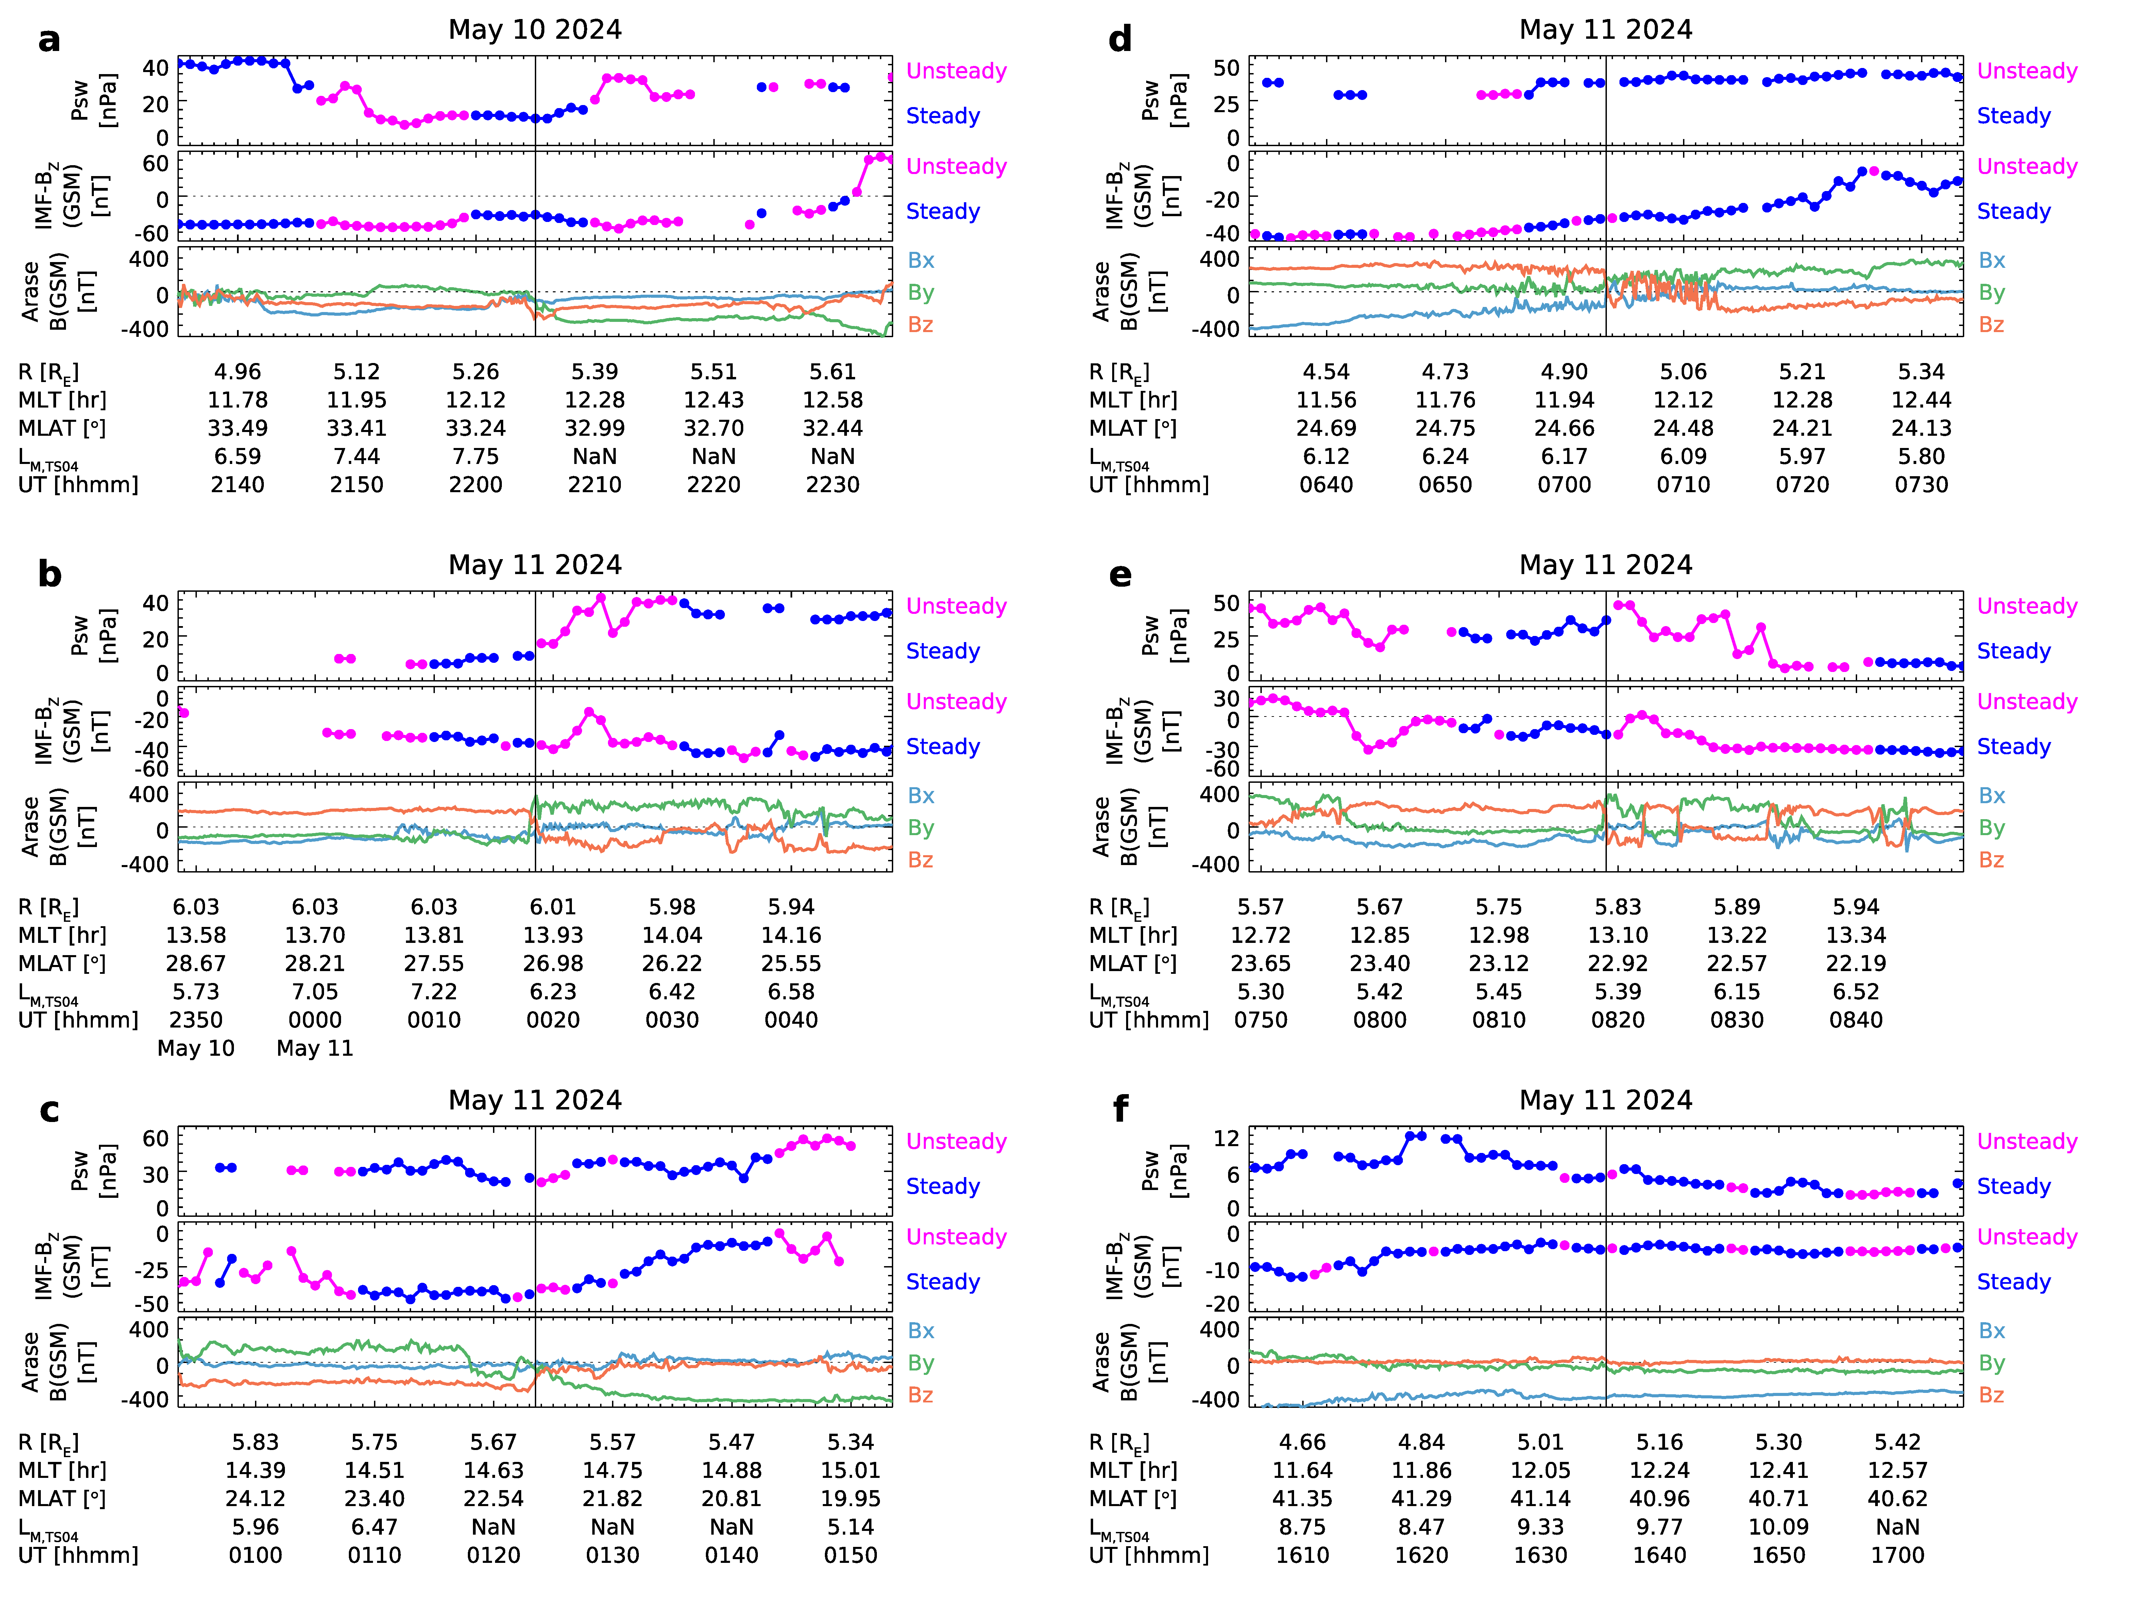

Supplementary Information Fig. 2 | Magnetopause crossing by the Arase satellite under a steady solar wind during the May 2024 super geomagnetic storm. From the top of the panels, the solar wind dynamic pressure, the Z-component of IMF in the GSM coordinates, and the magnetic field vectors at Arase in the GSM coordinates are shown. The vertical lines indicate the timing of magnetopause crossing.

