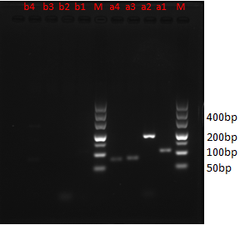
Figure S4: Lane M : 500 bp DNA marker, lanes a1–a4 : human blood DNA (template DNA used to amplify the target genes GAPDH, TH01, TPOX and D7S820), with clear bands. Lanes b1–b4: mouse liver DNA (template used to amplify the target genes GAPDH, TH01, TPOX and D7S820), with no bands.

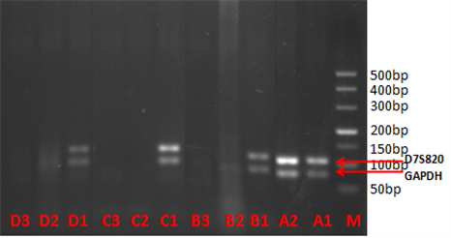
120min | 80min | 40min | 0min | marker

Figure S5: Lane M: 500 bp DNA marker. Lanes A1 and A2: pre-gavage (0 min). Lanes B1–B3, C1–C3, D1–D3: post-gavage times of 40, 80, 120 min, respectively. Lanes B1, C1 and D1: stomach contents, with GAPDH and D7S820 bands. Lanes B2, B3, C2, C3, D2 and D3: small intestine contents, with no DNA bands.

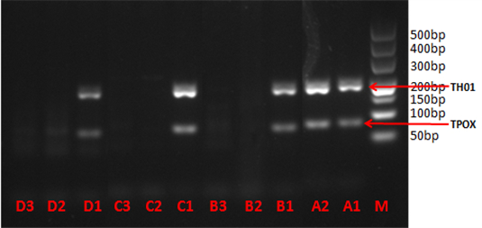
120min | 80min | 40min | 0min | marker

Figure S6: Amplification of the TH01 and TPOX genes. Lane M: DNA marker. Lanes A1 and A2: pre-gavage. Lanes B1–B3, C1–C3, D1–D3: post-gavage times of 40, 80, 120 min, respectively. Lanes B1, C1 and D1: stomach content DNA bands. Lanes B2, B3, C2, C3, D2 and D3: small intestine chyme, with no DNA bands.

