An All-Iron Photo-Assisted Redox-Flow Battery
Junzhe Pei^{1,2}, Yuxi Song³, Miao Li³, Shaojun Nan³, Qinghua Xu^{1,4*}, Qing Wang^{1,3*}

¹National University of Singapore (Suzhou) Research Institute, Suzhou, Jiangsu 215123, China.
²Department of Chemistry, National University of Singapore, Singapore 117576, Singapore
³Department of Materials Science and Engineering, National University of Singapore, Singapore 117576, Singapore
⁴School of Chemistry, Eastern Institute of Technology, Ningbo 315200, China

Corresponding Author
Qinghua Xu - National University of Singapore (Suzhou) Research Institute, Suzhou, Jiangsu 215123, China; School of Chemistry, Eastern Institute of Technology, Ningbo 315200, China
Qing Wang - Department of Materials Science and Engineering, National University of Singapore, Singapore 117576, Singapore; National University of Singapore (Suzhou) Research Institute Suzhou, Jiangsu 215123, China; Email: msewq@nus.edu.sg

Hematite photoanode preparation
The hematite photoanode was fabricated followed two-steps procedures. First a fluorine-doped tin oxide (FTO) conductive glass substrate was cleaned in detergent, ethanol and deionized water for 30 minutes under ultrasound, respectively. Then this FTO was placed in a 50 mL stainless autoclave with conductive side facing upwards. A 10 mL solution consisting of 150 mM ferric chloride hexahydrate (Greagent), 1 M sodium nitrate (Greagent) and different amount of 40 mM Germanium oxide (Adamas) was added into the autoclave. Then the autoclave was sealed and transferred into an over set to 95°C for 3h. After hydrothermal step, the autoclave was transferred to ambient condition and cool to room temperature. Next the sample was transferred to a muffle furnace at 800°C for annealing for 20 minutes and immediately taken out to cool to room temperature.

Synthesis of FeTiPA
FeTiPA(III) was synthesized followed by the procedure published in the previous work [1]. To synthesize 20 mM Fe(TiPA)(III) in 20 mL of 1.0 M KOH solution, 0.100 g of iron sulfate (Adamas) powder was dissolved in 10 ml of deionized water. After completely dissolved, 0.153 g of triisopropanolamine (TiPA) (Adamas) was added to the solution. After 10 minutes, 1.120 g of KOH was dissolved in 10 mL of water and added dropwise to the solution. The Fe(TiPA) complex immediately began to form. The solution was stirred for one day, and the precipitated K₂SO₄ powder was removed by centrifugation.

Photoelectrochemical measurement
All the photoelectrochemical measurements were done using a three-electrode configuration. In cyclic voltammogram (CV) test, graphite rod electrode was used as working electrode, while Ag/AgCl electrode and Pt electrode were used as reference and counter electrode, respectively. The scan rate for CV test is 100 mV/s. In linear sweep voltammogram (LSV) test, hematite photoanode was used as working electrode and reference and counter electrode remain the same as CV test. The data was collected at a scan rate of 10 mV/s under 100 mW/cm² AM1.5G light illumination (Microsolar 300). For Mott-Schottky test, the configuration is the same as LSV test and solution used is 1 M KOH.

Fabrication and cycling performance of RFB and PARFB
The performance of RFB and PARFB was tested using a H-cell. 5 mL of 20 mM FeTiPA(III) in 1 M KOH was used as the catholyte and 10 mL of 50 mM K₄[Fe(CN)₆] in 1 M KOH was used as the anolyte. The graphite electrodes were used as cathode and anode in RFB. Hematite photoanode and graphite electrode were used as anode and cathode in PARFB respectively. SPEEK was used as ion exchange membrane. And the stirring speed for magnets in anolyte and catholyte was 900 RPM. The anolyte and catholyte were bubbled with nitrogen for 30 minutes before testing. And during the charging and discharging period, the device was placed in a glove box filled with nitrogen. For the photo-charging process, the illumination area was 1 cm Í 1 cm. The charging and discharging current were 0.5 mA/cm² and the time was controlled to 20 minutes. Besides, the discharging step stopped when the voltage dropped to 0.80 V.

Calculation
The applied bias photon-to-current conversion efficiency of the hematite photoanode is calculated using the equation below [2]:
$$ABPE={\left[\frac{\left|J_{photo}\right|×(0.5−V)}{P}\right]}_{AM1.5G}$$
Where V is the applied bias on the hematite photoanode and J_{photo} is the photocurrent measured under this voltage. P is the illumination power calculated by 100 mW/cm² AM1.5G light source.
The solar-to-output electricity efficiency (SOEE) of this device is calculated using the equation below [3]:
$$SOEE (\%)=\frac{E_{discharging}}{E_{illumination}}=\frac{\int{I_{out}}V_{out}dt}{\int{S} A dt}$$
Where the I_{out} is the discharging current, V_{out} is the output voltage, S is the total incident solar power, and A is the illumination area.

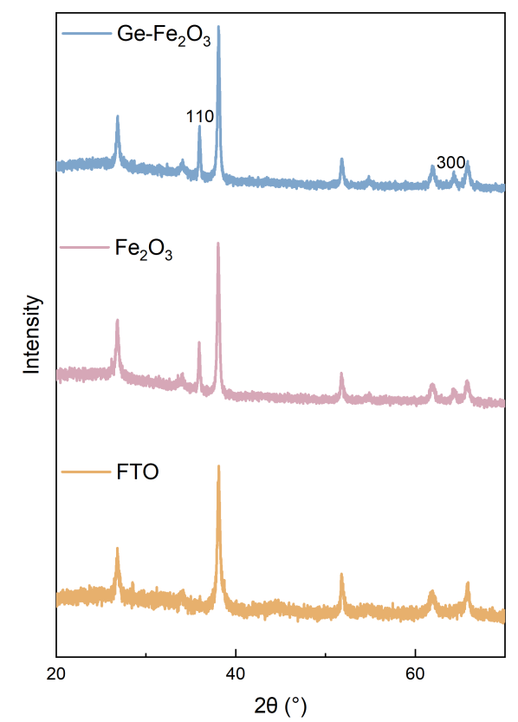
Figure S1. XRD patterns of FTO substrate, Fe₂O₃ and Ge-Fe₂O₃ photoanodes.

Figure S2. XPS spectra of a) Ge 3d_{5/2} and b) Fe 2p_{3/2} and Fe 2p_{1/2}.

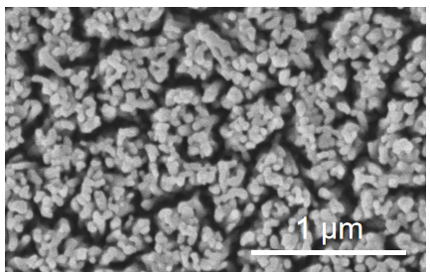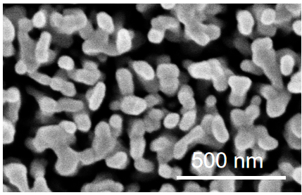
b
a
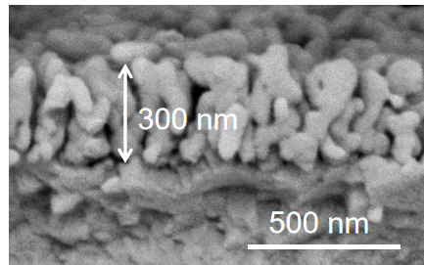
c
Figure S3. (a-b) SEM images of the surface of the hematite photoanode. (c) SEM image of the cross-section of the hematite photoanode. The thickness of hematite layer is approximately 300 nm.
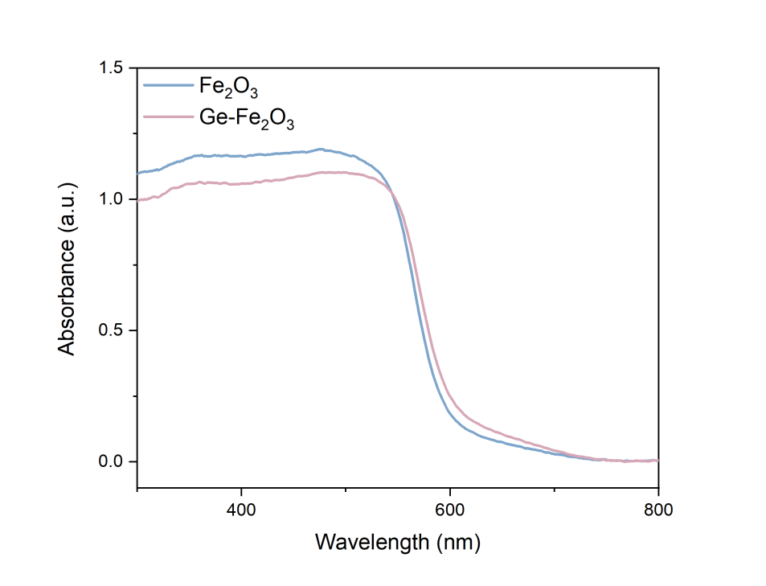
Figure S4. UV-Vis absorbance spectra of Fe₂O₃ and Ge-Fe₂O₃.

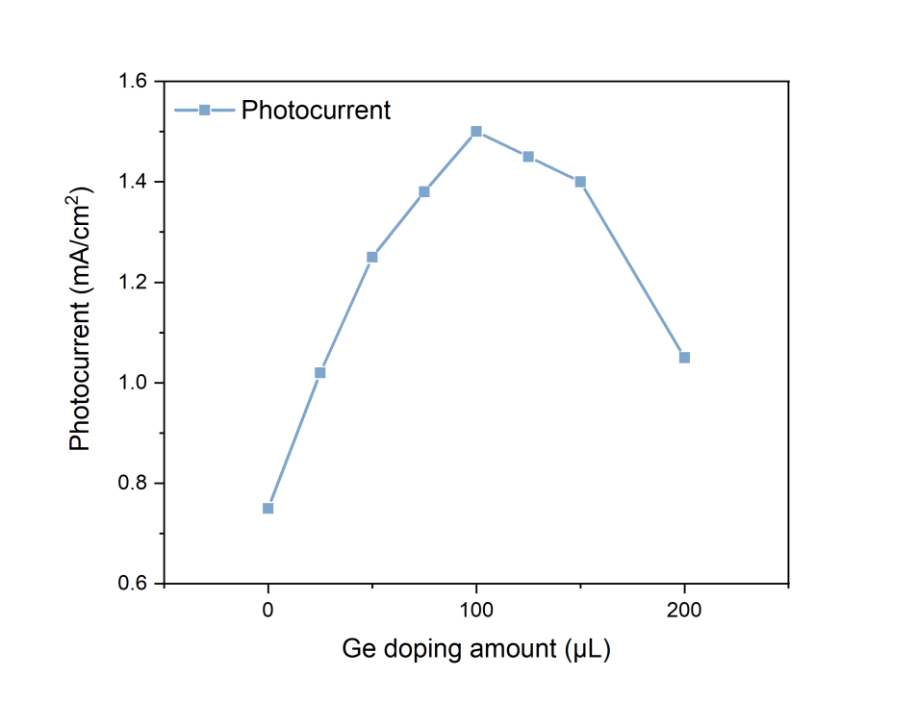
Figure S5. The photocurrent of hematite photoanode with different Ge doping amount at an applied bias of 0.50 V (vs. SHE).

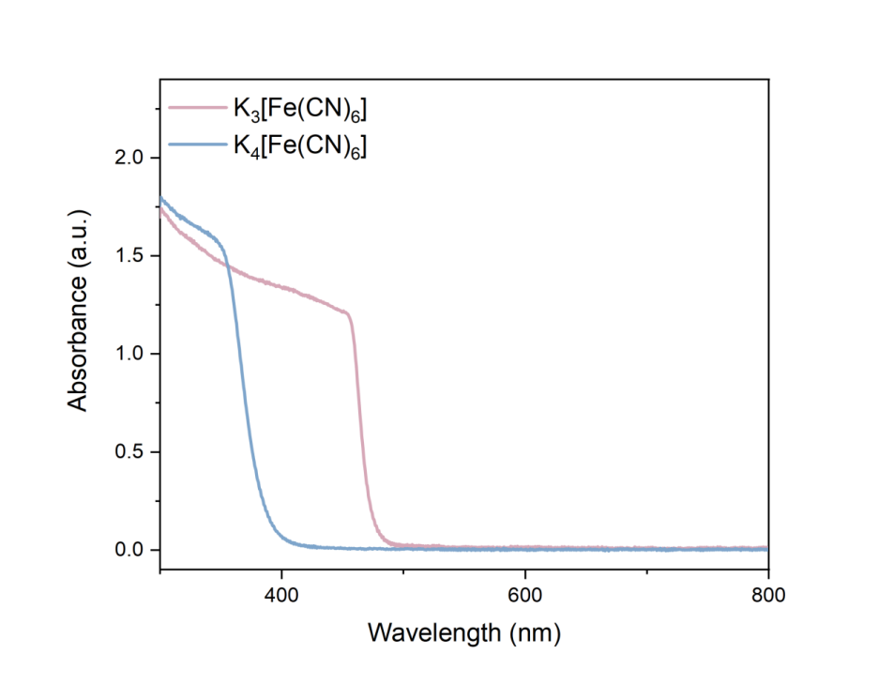
Figure S6. UV-Vis absorbance spectra for 50mM K₄[Fe(CN)₆] and K₃[Fe(CN)₆].

Reference
- Noh, Chanho, Yongjin, Chung, and Yongchai, Kwon. Highly stable aqueous organometallic redox-flow batteries using cobalt triisopropanolamine and iron triisopropanolamine complexes. Chem. Eng. J. 405, 126966 (2021).
- Dotan, Hen, et al. On the solar to hydrogen conversion efficiency of photoelectrodes for water splitting. J. Phys. Chem. Lett. 5, 3330-3334 (2014).
- Li, Wenjie, et al. Integrated photoelectrochemical solar energy conversion and organic redox-flow battery devices. Angew. Chem. Int. Ed. 55, 13104 (2016).

