Supplementary Figures:

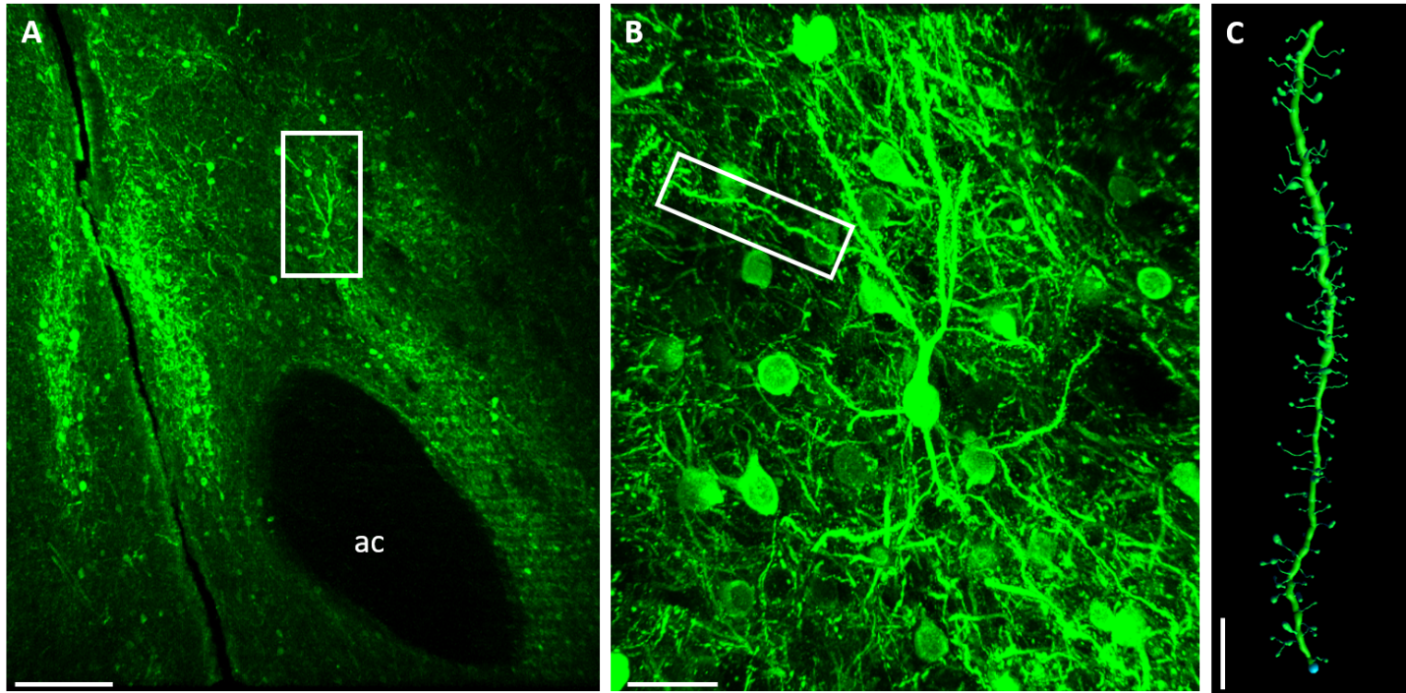
Supplementary Figure 1. Ruby2-smFP-Flag labeled neurons. Rendering and quantification of a confocal image of a virus-labeled, Ruby2-smFP-Flag filled dendrite segment from a D1-Cre MSN rat. A) Confocal image of Ruby2-Flag-fill neurons in the NAcore. Box identifies the dendrite rendered in panel C. Bar= 300μm. B) Magnification of Neuron and dendrite segment chosen for spine analysis Bar= 30μm. C) Respective filling of the chosen dendrite from B using the IMARIS module. Bar= 7μm.

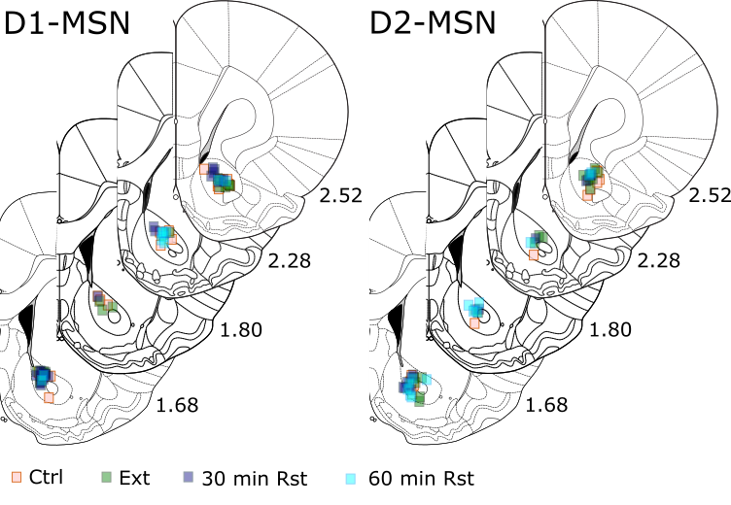
Supplementary Figure 2. Anatomical distribution of confocal images used for c-FOS quantification from D1 transgenic rats (left) and D2 transgenic rats (right). Different treatment groups are color coded (see legend).

Supplementary Table 1 Shapiro-Wilk Normality tests
Experiment | D1 |  |  | D2
Experiment | N | W | p | N | W | p
Figure 1C: avg. Infusions | 34 | 0.9121 | 0.0097 | 26 | 0.8816 | 0.0062
Figure 1 D: Reinstatement | 15 | 0.9188 | 0.1848 | 10 | 0.9164 | 0.3276
Experiment | Vehicle |  |  | Extinction |  |  | RST 30 mins
Experiment | N | W | p | N | W | p | N | W |  | p
Figure 2B: D1-Spine heads | 21 | 0.9711 | 0.7569 | 24 | 0.9466 | 0.2284 | 23 | 0.9316 |  | 0.1182
Figure 2B: D1-Spine Density | 21 | 0.9804 | 0.9314 | 24 | 0.9508 | 0.2822 | 23 | 0.9720 |  | 0.7377
Figure 2E: sEPSC Amplitude | 9 | 0.9197 | 0.3898 | 10 | 0.9596 | 0.7482 | 14 | 0.8889 |  | 0.0781
Figure 2E: sEPSC IEI | 9 | 0.6907 | 0.0002 | 10 | 0.9293 | 0.1890 | 14 | 0.7250 |  | 0.0002
Figure 3B: D2-Spine heads | 22 | 0.9528 | 0.3584 | 23 | 0.9735 | 0.7722 | 15 | 0.9666 |  | 0.8055
Figure 3B: D2-Spine Density | 22 | 0.9673 | 0.6487 | 23 | 0.9434 | 0.2120 | 15 | 0.9338 |  | 0.3109
Figure 3E: sEPSC Amplitude | 13 | 0.9580 | 0.7226 | 15 | 0.9698 | 0.8553 | 11 | 0.9847 |  | 0.9866
Figure 3E: sEPSC IEI | 13 | 0.9558 | 0.6888 | 15 | 0.8906 | 0.0685 | 11 | 0.9616 |  | 0.7914
Figure 4A: D1-WIN | 7 | 0.7894 | 0.0321 | 7 | 0.9717 | 0.9102 | - | - |  | -
Figure 4B: D1-LFS Plasticity | 11 | 0.9408 | 0.5299 | 9 | 0.9560 | 0.7557 | 14 | 0.9559 |  | 0.6551
Figure 4C: D2-WIN | 6 | 0.9279 | 0.5332 | 6 | 0.9763 | 0.9319 | - | - |  | -
Figure 4D: D2-LFS Plasticity | 8 | 0.8998 | 0.2879 | 11 | 0.9563 | 0.7253 | 9 | 0.9449 |  | 0.6339
Experiment | Vehicle |  |  | Extinction |  |  | RST 30 mins |  |  |  |  | RST 60 mins
Experiment | N | W | p | N | W | p | N | W |  | p |  | N |  | W |  |  | P
Figure 5C: Total cFOS | 42 | 0.9405 | 0.0296 | 35 | 0.9600 | 0.2288 | 33 | 0.9508 |  | 0.1408 |  | 27 |  | 0.9448 |  |  | 0.1602
Figure 5D: D1-cFOS overlap | 24 | 0.9367 | 0.1378 | 14 | 0.9474 | 0.5209 | 20 | 0.9779 |  | 0.9039 |  | 13 |  | 0.8969 |  |  | 0.1211
Figure 5E: D2-cFOS overlap | 18 | 0.9018 | 0.0618 | 18 | 0.9457 | 0.3611 | 13 | 0.9631 |  | 0.8010 |  | 14 |  | 0.9741 |  |  | 0.9259

Supplementary Figure 3. A) Average THC+CBD SA and extinction over time shows no difference between males and females (2-way ANOVA F_{(19,988)}=0.876, p=0.616. B) Similar average Infusion rates in male and female rats. C) Similar Discrimination index (= [active lever presses/inactive lever Presses]/[active lever presses+inactive lever presses]; average over the last 3 days of SA) in male and female rats. D) Average Vehicle SA. Animals lost lever discrimination by day 8 of vehicle SA. E) Similar average infusion rates in Vehicle and THC+CBD rats. F) THC+CBD rats showed a higher discrimination index than vehicle Control rats (t₍₇₄₎₌2.119, p=0.038; unpaired t-test). Bar graphs show mean ± SEM. G) Average THC+CBD Infusion rates for all animals used for Spine analysis (1-way ANOVA F_{(3,19)}= .4433, p=0.7261). H) Average THC+CBD infusion rates for all animals used for sEPSC analysis (1-way ANOVA F_{(3,19)}= 2.413, p=0.094). I) Average THC+CBD Infusion rates for all animals used for WIN55,212-2 experiment (unpaired t-test t₍₉₎=1.982, p=0.079. J) Average THC+CBD Infusion rates for all animals used for LFS-pairing plasticity experiment (1-way ANOVA F_{(3,19)}= 2.021, p=0.145).

Supplementary Figure 4. Bar graphs comparing sEPSP amplitude and IEI at baseline and 15-25 minutes after plasticity induction. A) Vehicle controls show no significant change in either parameter, reflecting the lack of long-term plasticity in Figure 3D. B) The LTP in THC+CBD extinguished animals LTD was accompanied by a decrease in sEPSC IEI, indicating a presynaptic locus of LTP. C) Cue-Reinstated animals showed no significant change in either parameter.
Supplementary Figure 5. Synaptic plasticity in response to the LFS-pairing protocol for Long-Evans wild-type littermates and pooled data from D1-MSNs (Figure 4D) and D2-MSNs (Figure 5D). The average time course of LTD for Sprague Dawley rats (Figure 3A from (Neuhofer et al. 2019)) is indicated as line. The time course of synaptic response to plasticity induction protocol revealed no difference between MSNS from Long-Evans wild-type littermates and pooled data from D1-MSN and D2-MSNs from transgenic rats. (interaction F_{(33, 510)}=0.5151, P=0.9902, time F_{(6.489, 194.6)} = 11.26, p<0.001; strains F_{(2,30)} =3.540, p=0.0417; LE wild-type vs. D1+D2-MSN P=0.3334, LE wild-type vs. Sprague Dawley P<0.001, 2-way ANOVA for time course of current response after plasticity induction with Holm-Sidak post-hoc test).

