Bimetallic CoMoS₄ Decorated MOF-Derived CdS: A Synergistic Heterostructure for Enhanced Photocatalytic Hydrogen Evolution
Irem Firtina-Ertis^{a*}
ª Department of Chemical Engineering, Faculty of Engineering, Gebze Technical University, Gebze, Kocaeli, Turkey
Table S1. BET surface area of CdM, CdS, OMS5 and OMS10 samples
Catalyst | S_{BET} (m²/g) | Catalyst | S_{BET} (m²/g)
CdM | 41.56 | OMS5 | 154.98
CdS | 19.73 | OMS10 | 120.55
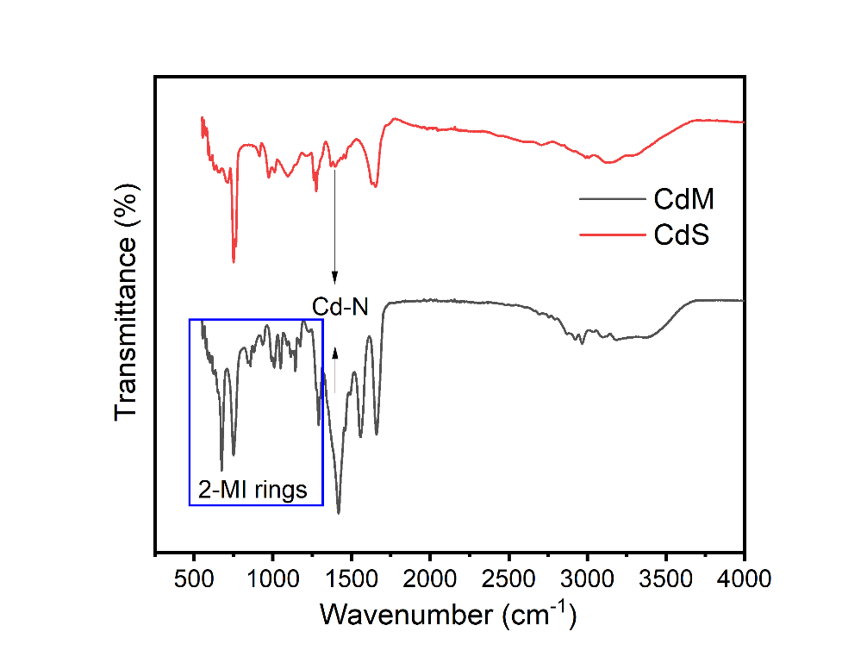
Fig. S1. FT-IR spectra of CdM and CdS samples
Table S2. Band gap values of the samples
Catalyst | Band Gap (eV) | Catalyst | Band Gap (eV)
CdM | 2.76 | OMS2.5 | 2.26
CdS | 2.38 | OMS5 | 2.36
OMS | 1.53 | OMS10 | 2.32
Table S3. Comparison of hydrogen evolution performances of CdS based catalysts
Photocatalysts | Incident Light | Sacrificial agent | H₂ Production Rate (mmol g⁻¹ h⁻¹⁾ | Reference
(MOF derived) CdS/MoS₂ | 300 W Xe | Na₂S, Na₂SO₃ | 3.318 | [1]
(MOF derived)  CdS/MoS₂ | 300 W Xe | Na₂S, Na₂SO₃ | 5.586 | [2]
CoMoS₄/CdS | 300 W Xe | 10% Lactic acid | 0.214 | [3]
Cu₂MoS₄/CdS | 150 W Xe | 20% Lactic acid | 15.56 | [4]
CoMoS₄/CdS | 300 W Xe | Benzyl alcohol | 2.86 | [5]
(MOF derived)  CoMoS₄/CdS (OMS2.5) | 300 W Halogen | 6 % TEOA | 5.8 | This Work
Fig. S2. Recyclability tests of the photocatalytic H₂ production over the catalysts

References
[1] S. Liu, Y. Yang, W. Xiao, S. Xia, C. Jin, W. Wang, S. Li, M. Zhong, S. Wang, C. Chen, Metal-organic frameworks derived porous MoS2/CdS heterostructure for efficient photocatalytic performance towards hydrogen evolution and organic pollutants, International Journal of Hydrogen Energy 48 (2023) 32729–32738. https://doi.org/10.1016/j.ijhydene.2023.05.050.
[2] L. Lin, S. Huang, Y. Zhu, B. Du, Z. Zhang, C. Chen, X. Wang, N. Zhang, Construction of CdS/MoS 2 heterojunction from core-shell MoS 2 @Cd-MOF for efficient photocatalytic hydrogen evolution, Dalton Transactions 48 (2019) 2715–2721. https://doi.org/10.1039/c8dt04745f.
[3] Q. Li, X.Q. Qiao, Y. Jia, D. Hou, D.S. Li, Amorphous CoMoS4 Nanostructure for Photocatalytic H2 Generation, Nitrophenol Reduction, and Methylene Blue Adsorption, ACS Applied Nano Materials 3 (2020) 68–76. https://doi.org/10.1021/acsanm.9b01582.
[4] S. Hong, D.P. Kumar, D.A. Reddy, J. Choi, T.K. Kim, Excellent photocatalytic hydrogen production over CdS nanorods via using noble metal-free copper molybdenum sulfide (Cu 2 MoS 4 ) nanosheets as co-catalysts, Applied Surface Science 396 (2017) 421–429. https://doi.org/10.1016/j.apsusc.2016.10.171.
[5] C. Li, S. Du, C. Lu, K. Ren, Q. Wang, S. Shan, Q. Li, Z. Fang, X. Li, W. Dou, Bimetallic MMoS4 (M = Ni, Co, Cu) cocatalysts architected CdS nanoflowers for synergistically boosting visible-light-driven photocatalytic H2 evolution from water and benzyl alcohol, Journal of Alloys and Compounds 924 (2022) 166645. https://doi.org/10.1016/j.jallcom.2022.166645.

