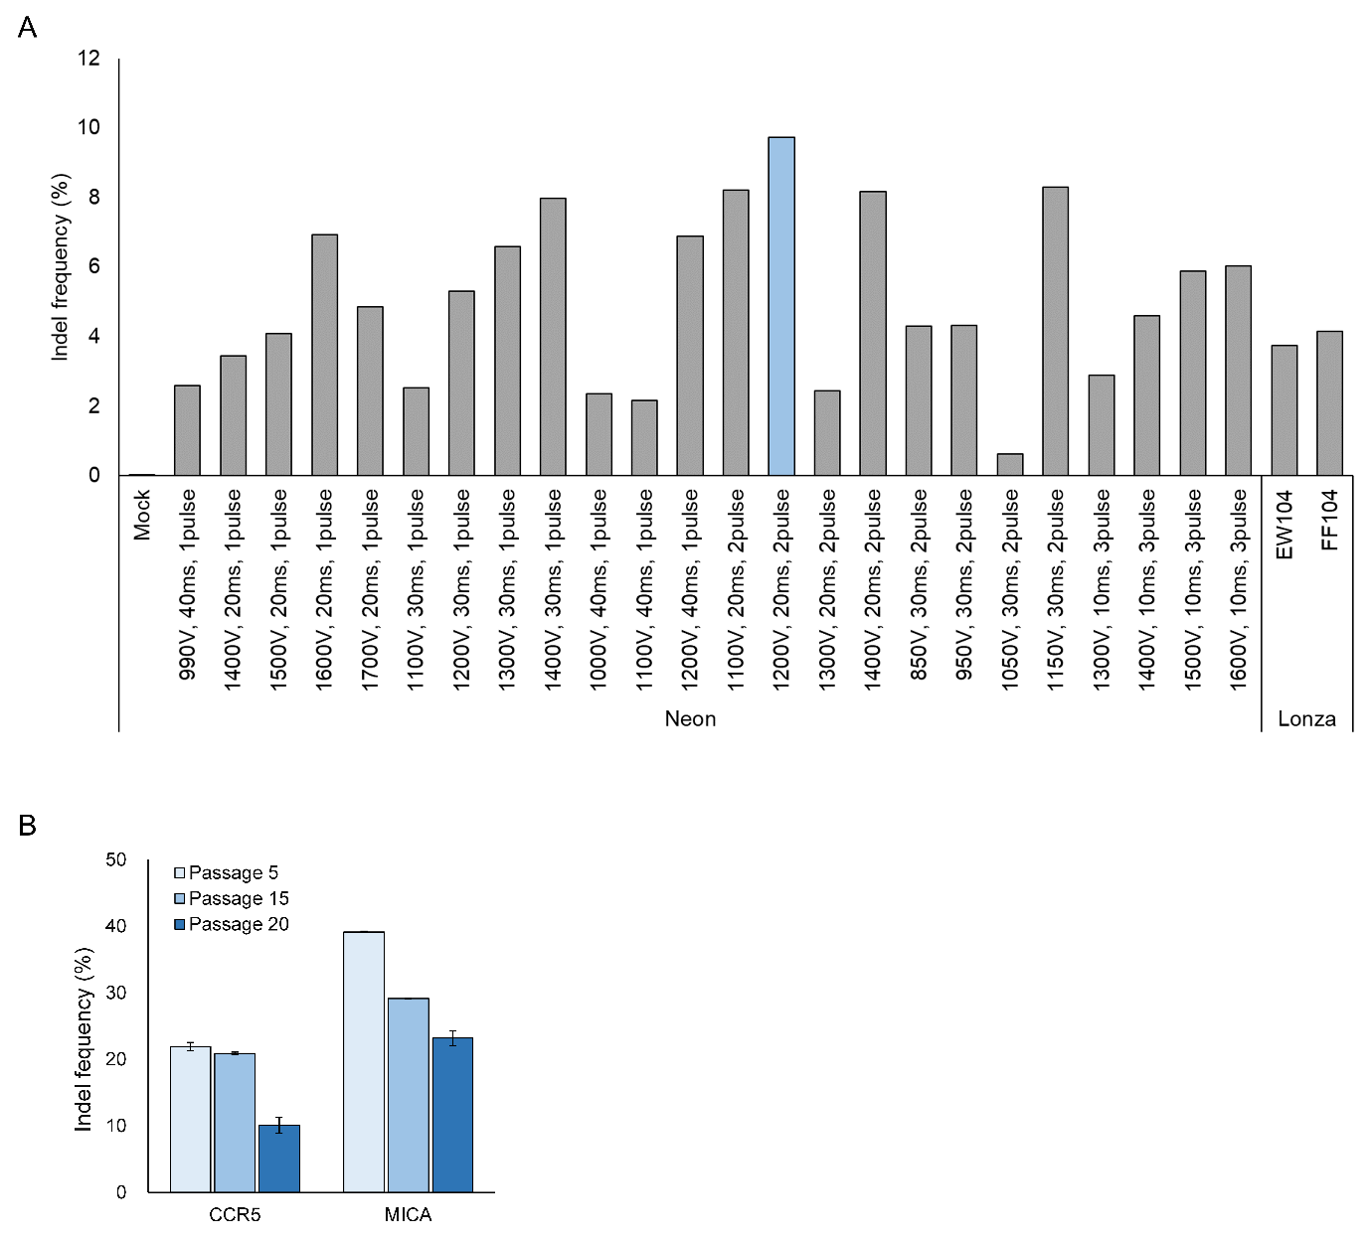

Supplementary Figure 1. Optimizations of RNP-mediated gene knockout in human MSCs. (A) Different sets of protocols applied to electroporate CRISPR RNP complex to MSCs using Neon transfection system and Lonza 4D Nucleofector system. (B) Cells with three different passages were electroporated with CCR5- or MICA-targeting RNPs and mutation frequencies was measured by targeted-deep sequencing (n=2).

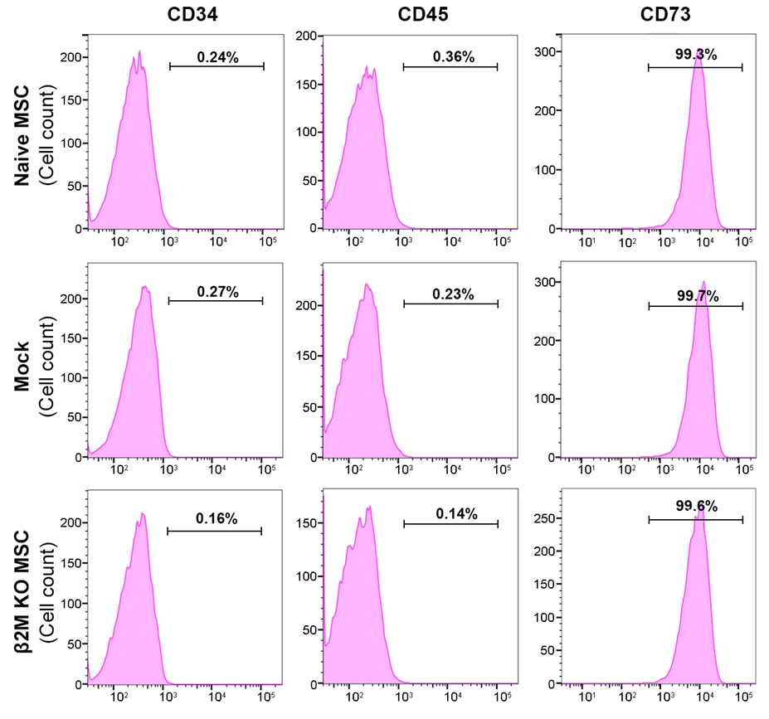
Supplementary Figure 2. Representative MSC markers CD73, CD90 and MSC-negative markers CD34, CD45 in naïve, mock and β2M KO MSCs, analyzed by flow cytometry (passage 19).

Gene | Sequence (5’-3’w/ PAM)
CCR5 | TGACATCAATTATTATACATCGG
B2M-TS 1 | GAGTAGCGCGAGCACAGCTAAGG
B2M-TS 2 | CTCGCGCTACTCTCTCTTTCTGG
B2M-TS 3 | ACTCTCTCTTTCTGGCCTGGAGG
TYRO3 | GGCCACACTAGCGTTGCTGCTGG
MICA | TGTCCTGGGAAATAAGACATGGG
MICB | GCGATATCTGAAATCCGGGGTGG
ULBP2 | TCTTCTCTGAGTCAAAGAGGAGG
RAET1L | ACAGCAGGAACAGAAGCGGGAGG
HEK2 | GAACACAAAGCATAGACTGCGGG
Site4 | GAGCAAAGAGAATAGACTGTAGG
HPRT1 | GAAAGGGTGTTTATTCCTCATGG
CFTR | TGAGATCTTTGACAGTCATTTGG
MTOR | GGCCTATGGTCGAGATTTAATGG

Supplementary Table 1 Lists of target sequences of each gRNA

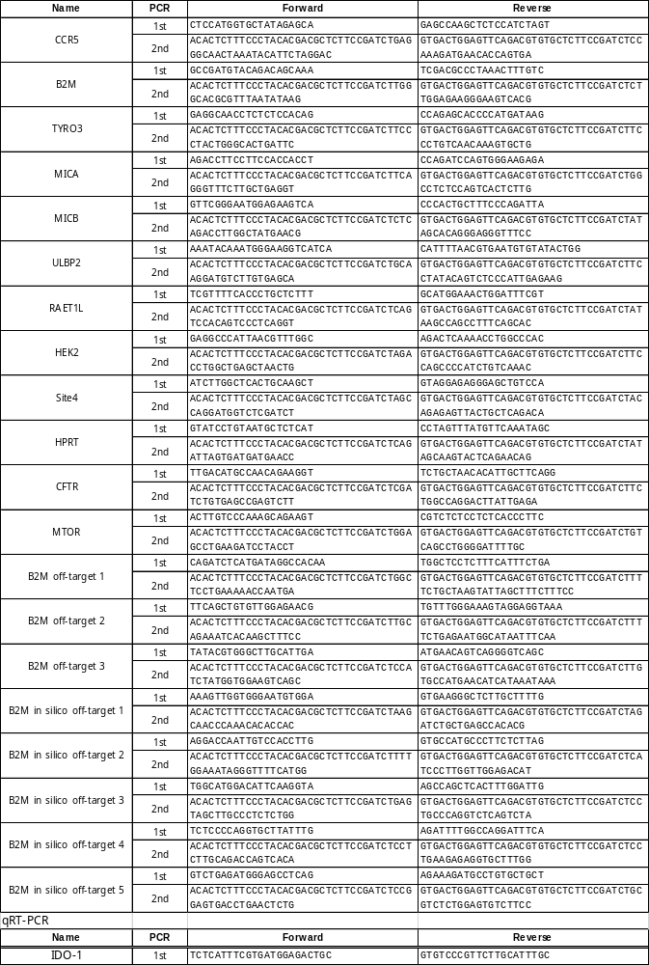
Supplementary Table 2 List of primers used in this study

