Use the "Insert Citation" button to add citations to this document.
Supporting Information
Poly (N-vinylpyrrolidone) Modified Phosphomolybdate-based Nanoparticles Mitigates Plasma Protein Corona Formation for Nanodrug Design
Youyi Yu, Behafarid Ghalandari, Guangxia Shen, Liping Wang, Xiao Liu,Aiting Wang, Sijie Li, Haiyang Xie* and Xianting Ding*
State Key Laboratory of Oncogenes and Related Genes, Institute for Personalized Medicine, School of Biomedical Engineering, Shanghai Jiao Tong University, Shanghai, 200030, China.

Table of Contents
- Experimental details
- Electron microscopy analysis
- Size statistics analysis
- The model proteins adsorption condition
- Fluorescence quenching data

1. Experimental details
Synthesis of cesium dodecylsulfate (CDS).
A saturated water solution of sodium dodecylsulfate (1 g, 3.5 mmole) was treated with 5% HCl (a few drops) to get pH ~ 0. This mixture treated with a saturated water solution of cesium carbonate (0.75 g, 5 mmol) and white waxy solid CDS precipitated upon stirring. The product collected by vacuum filtration and dried at temperature (0.96 g, 2.5 mmol, 72% yield).
Synthesis of CDS-PMo₁₂@PVP₀ NPs
An aqueous solution of H₃PMo₁₂O₄₀.3H₂O (0.01 M, 200 μL) was added dropwise to an aqueous solution of CDS (0.01M, 500 μL) at 25 °C under vigorous magnetic stirring, produced a pale-yellow precipitate CDS-PMo₁₂@PVP₀ NPs immediately.
Synthesis of CDS-PMo₁₂@PVP_{x}(x=0.05~1) NPs
A mixture of 200 µL of a 0.01 M H₃PMo₁₂O₄₀ water solution and 800 µL of different concentration (0.05 g/L, 0.1 g/L, 0.25 g/L, 0.5 g/L, and 1 g/L) of a poly (N-vinylpyrrolidone) (PVP) aqueous, then, the mixture was added to 500 µL 0.01 M water solution of CDS, under vigorous magnetic stirring. The formation process of pale-yellow precipitate slowed down (0.5-24 h). The synthesized nanoparticles named as CDS-PMo₁₂@PVP_{0.05,} CDS-PMo₁₂@PVP_{0.1}, CDS-PMo₁₂@PVP_{0.25}, CDS-PMo₁₂@PVP_{0.5} and CDS-PMo₁₂@PVP₁, respectively.
2. Electron microscopy analysis
Sample preparation for Transmittance electron microscopy analysis:
Nanoparticles deposition for TEM analysis. Freshly synthesized nanoparticles suspended in ddH₂O were diluted with ddH₂O to an appropriate volume and a 3 µL aliquot was deposited on a thin carbon films and dried at room temperature.
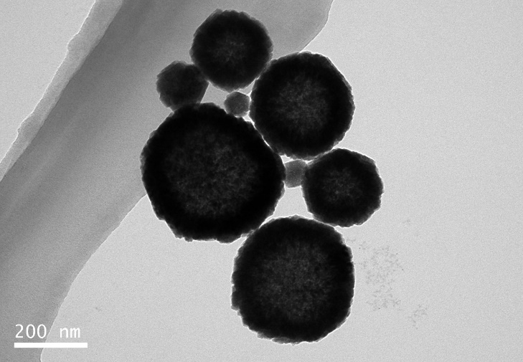

Figure S1 TEM images of the CDS-PMo₁₂@PVP₀ NPs.
- Size statistics analysis
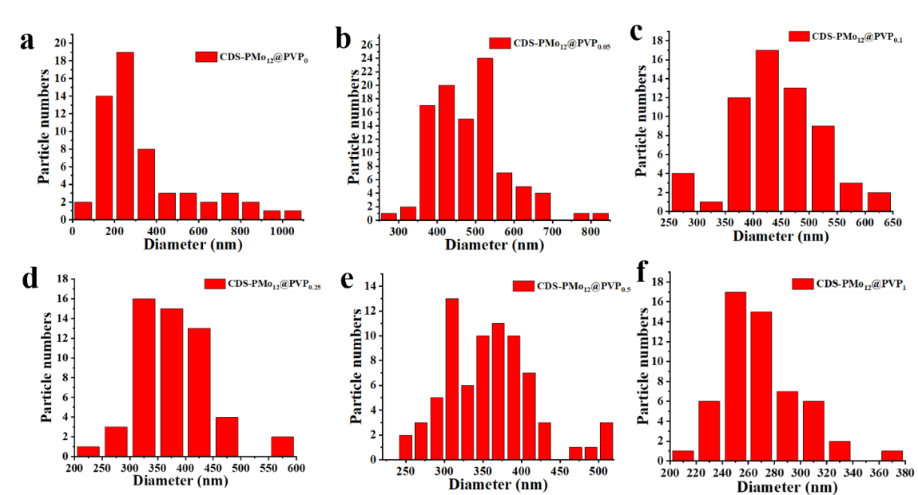
Figure S2 Size distributions of CDS-PMo₁₂@PVP_{x} (x=0~1) NPs. (a) CDS-PMo₁₂@PVP₀, (b) CDS-PMo₁₂@PVP_{0.1}, (c) CDS-PMo₁₂@PVP_{0.25}, (d) CDS-PMo₁₂@PVP_{0.5} and (e) CDS-PMo₁₂@PVP₁.

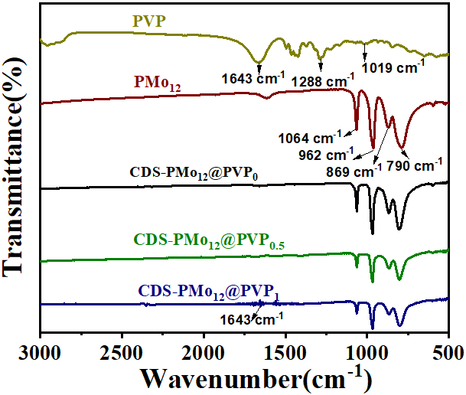
Figure S3 FTIR spectra of the PVP, H₃PMo₁₂O₃₀, CDS-PMo₁₂@PVP_{0,} CDS-PMo₁₂@PVP_{0.5,} and CDS-PMo₁₂@PVP₁ NPs.
The adsorption condition
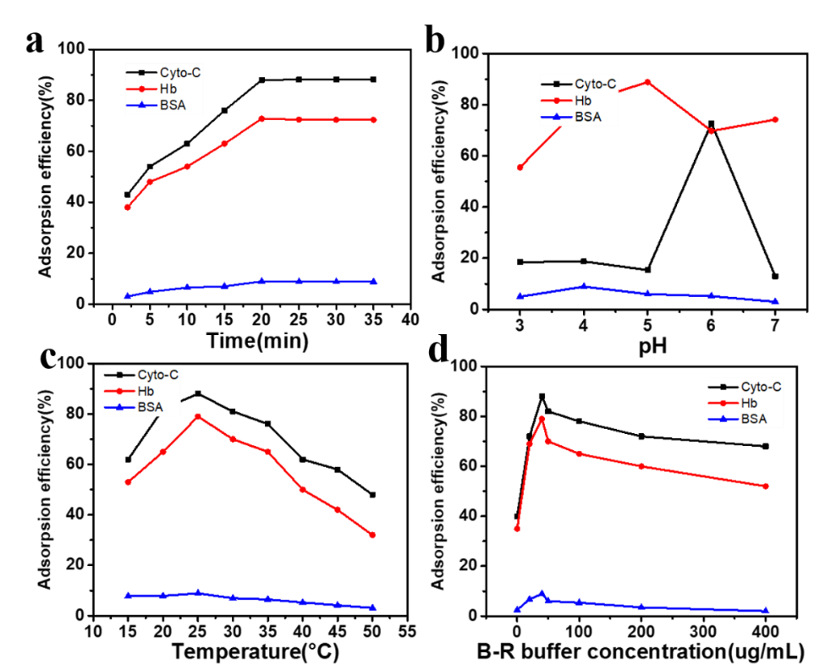
Figure S4 Optimized preparation of absorbent. (a) Adsorption time, (b) pH, (c) temperature and (d) ionic strength of B-R buffer on the adsorption efficiency of BSA, Hb, and Cyt-c. Protein solution: 100 μg/mL, 1.0 mL; CDS-PMo₁₂@PVP₀: 5.0 mg.
An obvious improvement in the adsorption efficiency for protein is observed with the increase of adsorption time up to 20 min (Figure S4(a)). The gain for further increasing the adsorption time is very limited, and thus an adsorption time of 20 min is appropriate. The effect of pH on adsorption efficiency illustrated in Figure S 4(b). The adsorption behaviors of protein species on the CDS-PMo₁₂@PVP₀ NPs were further investigated under ionic strength conditions 0.04-0.4 mol L⁻¹(B-R buffer) at pH 6 (Figure S4(d)). The experimental results indicated that the favorable adsorption of proteins achieved when the B-R concentration was 0.04 mol L⁻¹.

- Fluorescence quenching data
Figure S5 Fluorescence emission spectra of (a-b) Cyt-C (d-e) Hb and (g-h) BSA decrease with the increasing amount of CDS-PMo₁₂@PVP₀ NPs at 298 K and 310 K. the maximum fluorescence intensity of (c) Cyt-C, (f) Hb and (i) BSA decrease in the presence of CDS-PMo₁₂@PVP₀ NPs (0-15µM) at 298 K and 310 K, respectively.

Figure S6 Fluorescence emission spectra of (a-b) Cyt-C (d-e) Hb and (g-h) BSA decrease with the increasing amount of CDS-PMo₁₂@PVP₁ NPs at 298 K and 310 K. the maximum fluorescence intensity of (c) Cyt-C, (f) Hb and (i) BSA decrease in the presence of CDS-PMo₁₂@PVP₁ NPs (0-15µM) at 298 K and 310 K, respectively.
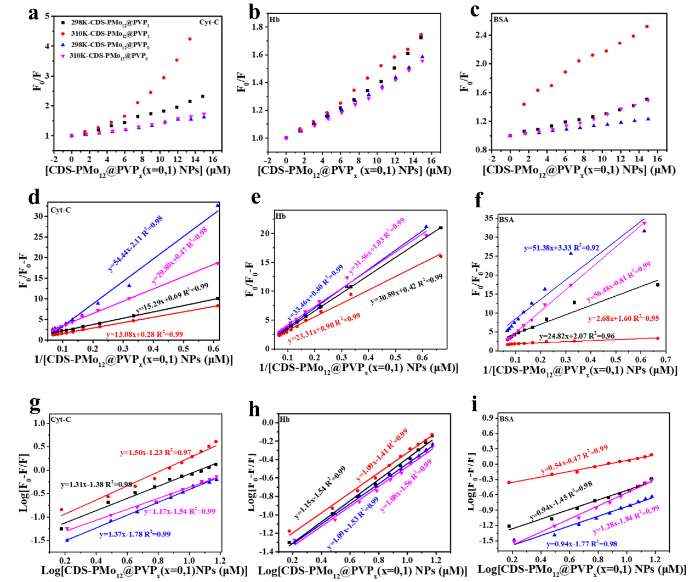
Figure S7 Stern-Volmer plot derived from the fluorescence emission spectrum of the (a) Cyt-C, (b) Hb, and (c) BSA interaction with PMo₁₂ NPs. The Modified Stern-Volmer plot of (d) Cyt-C, (e) Hb, and (f) BSA interaction with PMo₁₂ NPs. The binding logarithmic graph of (g) Cyt-C, (h) Hb, and (i) BSA interaction with PMo₁₂ NPs at 298 K and 310 K, respectively.

Figure S8 The heatmap of 76 differential proteins of CDS-PMo₁₂@PVP₁ comparing to CDS-PMo₁₂@PVP₀, as identified by LC-MS/MS.

Table S1 The top ten up-regulated and down-regulated proteins of 76 differential proteins.
