Supplementary materials

Supplementary Figures

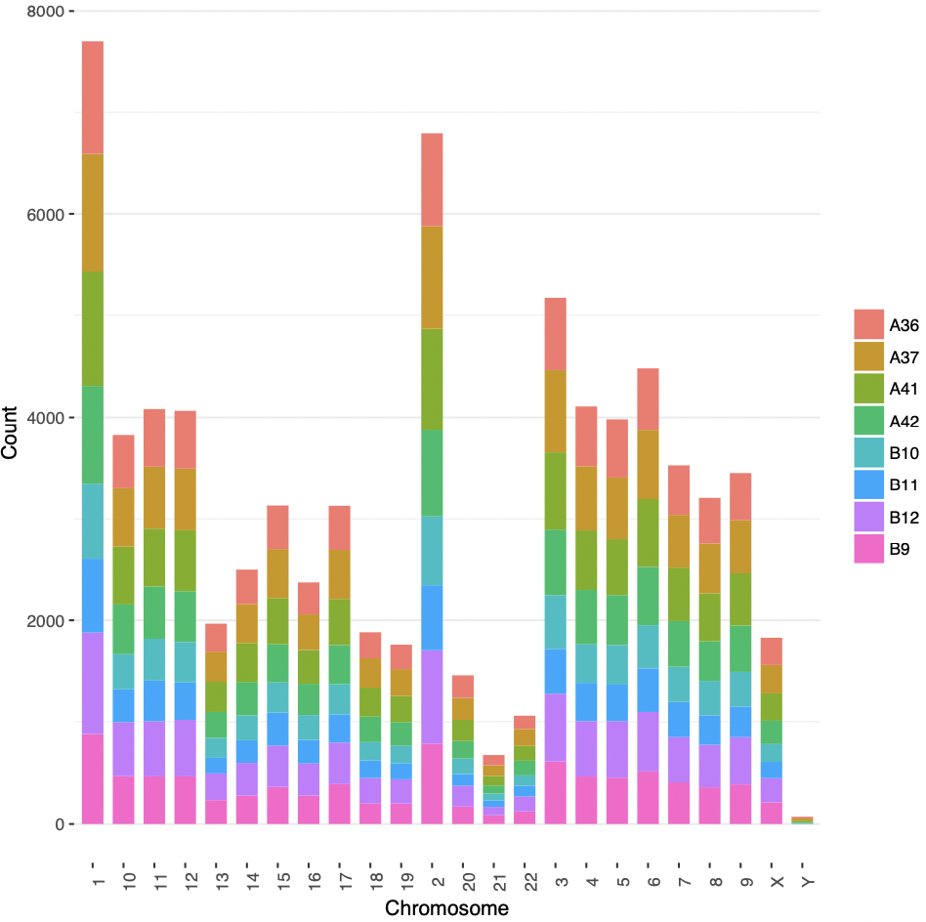
A
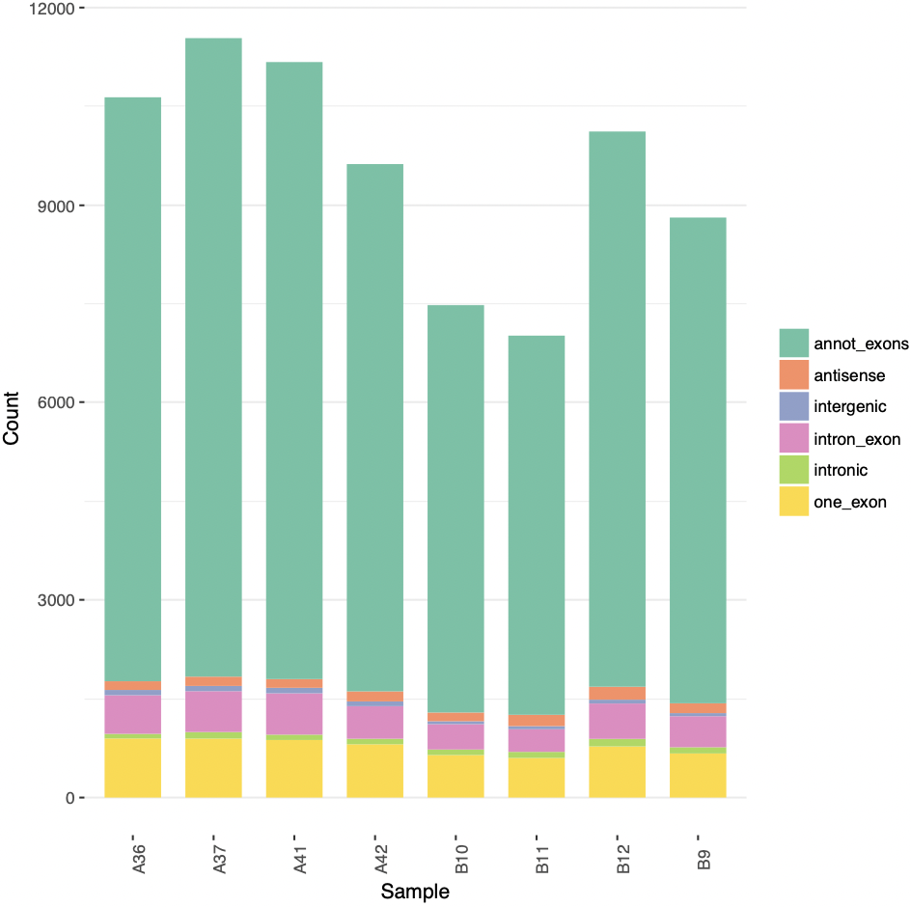
B

Supplementary Figure 1. The characterization of differentially expressed circRNAs. Differentially expressed circRNAs were identified by high-throughput sequencing in the stenotic vascular tissues and normal blood vessel tissues of AVF: A: the distribution feature of circRNAs in 24 chromosomes. B: the classification of circRNAs.

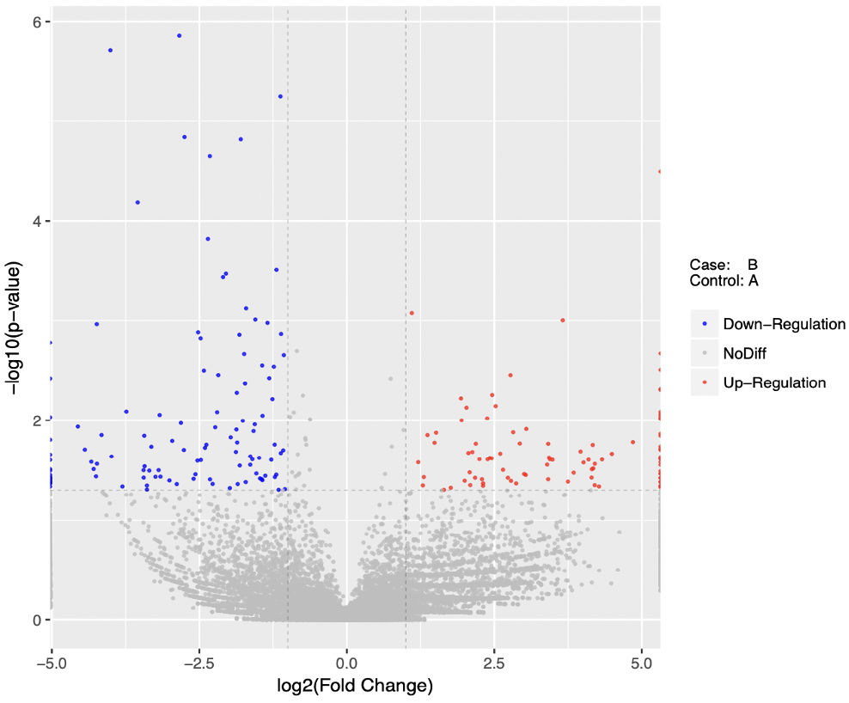
Supplementary Figure 2. The volcanic plot of differentially expressed circRNAs. The vertical line indicates expression difference threshold of 2 times, the horizontal line indicates the threshold of P value = 0.05 in the picture above. The blue dots indicate a significant downregulation gene and the red dots indicate a significant upregulation of the gene, and gray indicates no significant difference in the expression of the gene.

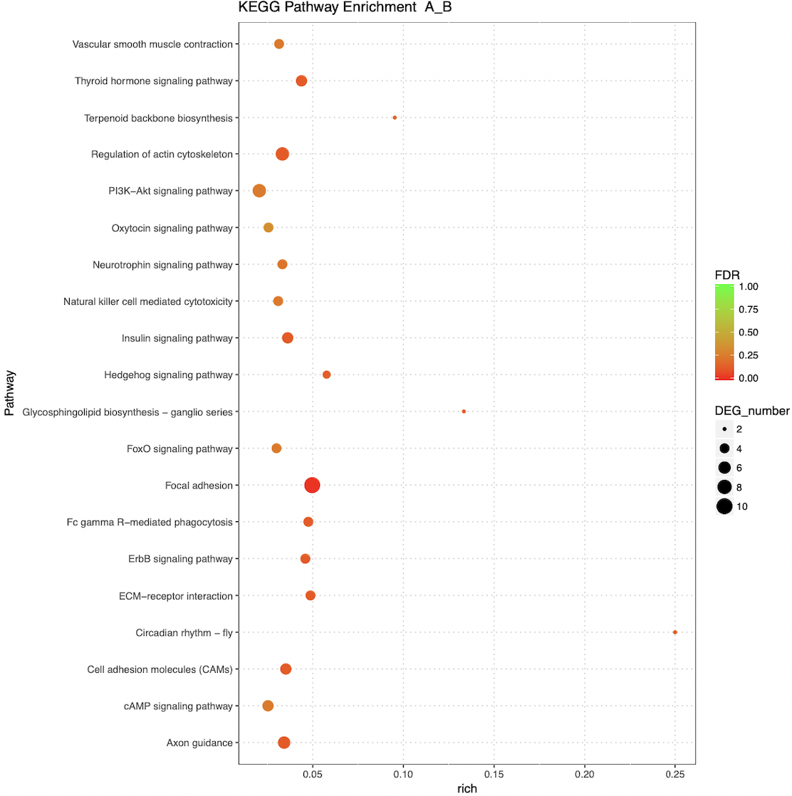

Supplementary Figure 3. KEGG pathway analysis of differentially expressed circRNAs. The y-axis, signaling pathways significantly correlated with circRNAs (Top 20); x-axis, the rich factor. The color of each dot represents P value of the pathway, and the size of each dot represents the number of differentially expressed circRNAs enriching the pathway. KEGG, Kyoto Encyclopedia of Genes and Genomes; circRNA, circular RNA. P value < 0.05 was statistically significant.

Supplementary Tables

Supplementary Table 1. The clinical characteristics of the patients in the two groups
characteristics | The AVF stenosis group (AG) |  |  |  | The control group (CG)
 | Case1 | Case2 | Case3 | Case4 | Case1 | Case2 | Case3 | Case4
Gender | Female | Male | Female | Female | Male | Male | Male | Female
Age(year) | 59 | 49 | 32 | 64 | 78 | 40 | 51 | 67
Hypertension (Yes/No) | No | Yes | Yes | Yes | Yes | No | Yes | No
Diabetes (Yes/No) | No | No | No | No | No | No | No | No
The AVF stenosis (%) | 69.4 | 74.2 | 82.6 | 78.1 | 0 | 0 | 0 | 0
Age of AVF (month) | 48 | 7 | 96 | 4 | 0 | 0 | 0 | 0
Side of the fistula | Left | Left | Left | Left | Left | Left | Left | Left
Site of the fistula | Forearm | Forearm | Forearm | Across antecubital fossa | Forearm | Forearm | Forearm | Forearm
AVF type | Radio-  cephalic | Radio-  cephalic | Radio-  cephalic | Brachio-  cephalic | Radio-  cephalic | Radio-  cephalic | Radio-  cephalic | Radio-  cephalic

Supplementary Table 2. Primers of circRNA sequences
CircRNA ID | Primer type | Primer sequence | Annealing temperature  (℃) | Amplicon length, bp
Hsa_circ_015036 | Forward  Reverse | 5'-CTGATAGCCACTACCTCCTCTTTG-3'  5'-TGGTTGTCCTAGTAACAGCTCAGC-3' | 60 | 132
Hsa_circ_005718 | Forward  Reverse | 5'-AGGAGAGCCTGTGAGTTGGTTG-3'  5'-GCCCTGAAATACCAGTTCCAAT-3' | 60 | 61
Hsa_circ_007293 | Forward  Reverse | 5'-TGGGGTCACCTATTACTTCAAAGT-3'  5'-TACAATGTATTTTCGGCCAGGA-3' | 60 | 145
Hsa_circ_017814 | Forward  Reverse | 5'-GGACCCAAATGTCAAACTACCAA-3'  5'-TGGTTGTCCTAGTAACAGCTCAGC-3' | 60 | 115
Hsa_circ_026394 | Forward  Reverse | 5 -CGTTCTACAGCGATGGCGAG-3'  5'-AAAGTCGTCATCCTTCAGTTCTCC-3' | 60 | 168
Hsa_circ_035577 | Forward  Reverse | 5'-CGACTCCCTAAAATGTATAAAACCA-3'  5'-TGGAGTAATCAGGTAGAGAGAAACA-3' | 60 | 117
Hsa_circ_019184 | Forward  Reverse | 5'-ACGAAGGCAGACTGGACAGGTA -3'  5'-ACCAACATAATCGGGACTACTGAG-3' | 60 | 116
H-Actin | Forward  Reverse | 5'-AGCACAGAGCCTCGCCTTTG-3'  5'-CTTCTGACCCATGCCCACCA-3' | 60 | 208

Supplementary Table 3. The top 10 significantly upregulated or downregulated circRNAs
CircRNA | Chr | P-value | Log2(FC) | Gene name | Regulation
Hsa-circ_069327 | chr5:108341927-108348530- | 0.008598284 | 4.850360737 | FBXL17 | up
Hsa-circ_018523 | chr1:39350785-39359264+ | 0.014067498 | 4.493359944 | MACF1 | up
Hsa-circ_058777 | chr1:193138085-193142066+ | 0.017625795 | 4.327321292 | CDC73 | up
Hsa-circ_055029 | chr1:52978217-52980543+ | 0.031319943 | 4.275395466 | SCP2 | up
Hsa-circ_010179 | chr1:40514515-40517186+ | 0.020759018 | 4.204103446 | EXO5 | up
Hsa-circ_037359 | chr10:30450258-30451744+ | 0.028029177 | 4.202003777 | MAP3K8 | up
Hsa-circ_026207 | chr7:74096622-74097189+ | 0.021538336 | 4.177204153 | LIMK1 | up
Hsa-circ_034701 | chr3:154187685-154194718+ | 0.009998726 | 4.168966805 | ARHGEF26 | up
Hsa-circ_013305 | chr3:33124408-33132700+ | 0.02162644 | 4.154037578 | CRTAP | up
Hsa-circ_040366 | chr2:203208637-203209322+ | 0.024538093 | 4.149120297 | NBEAL1 | up
Hsa-circ_019802 | chr4:147946617-148023413+ | 0.011569646 | -4.558873238 | ARHGAP10 | down
Hsa_circ_026557 | chr4:77005601-77030970+ | 0.019637649 | -4.440527121 | SEPT11 | down
Hsa_circ_005718 | chrX:108595509-108597568+ | 0.026073021 | -4.330980138 | COL4A5 | down
Hsa_circ_057916 | chr1:77044204-77068843+ | 0.030786969 | -4.291822119 | ST6GALNAC5 | down
Hsa_circ_057391 | chr1:112581992-112598086- | 0.036400545 | -4.251115267 | ST7L | down
Hsa_circ_051570 | chr10:96155924-96160402+ | 0.001085798 | -4.238296741 | ZNF518A | down
Hsa_circ_059827 | chr6:109475399-109476930- | 0.027276166 | -4.234998091 | ZBTB24 | down
Hsa_circ_066580 | chr21:32694228-32695282- | 0.014052874 | -4.157293886 | SYNJ1 | down
Hsa_circ_038223 | chr5:158941694-158941979- | 1.95609E-06 | -4.006949964 | EBF1 | down
Hsa_circ_001774 | chr5:109713520-109755456+ | 0.023048625 | -3.988107934 | MAN2A1 | down

