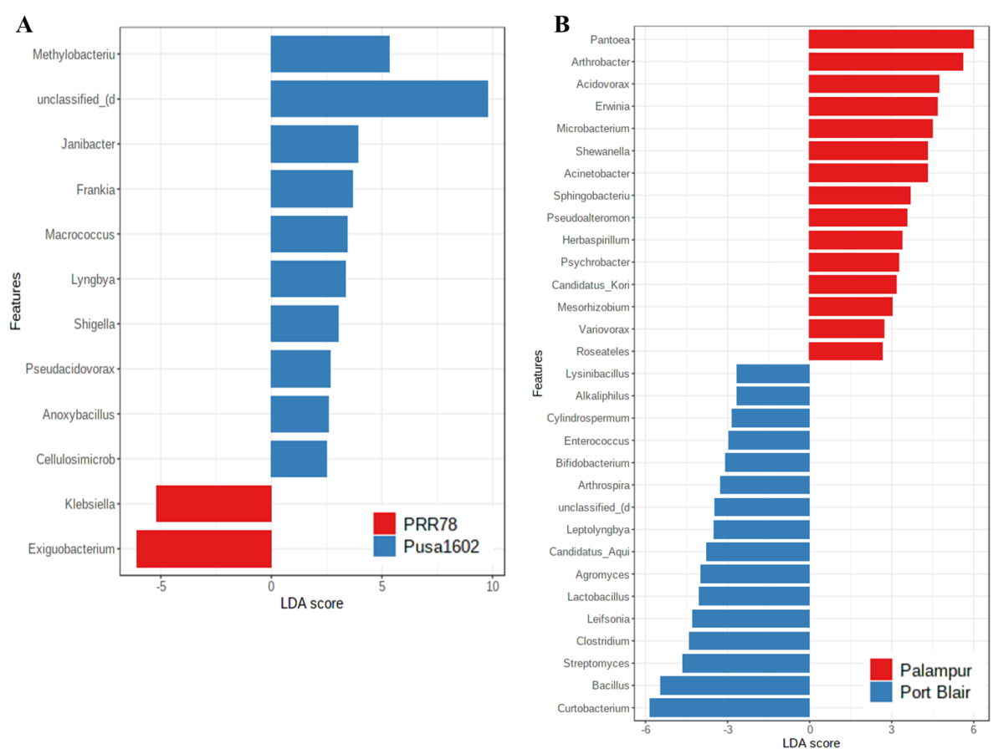
Supplementary Fig. 1. Identification of biomarkers based on the linear discriminant analysis (LDA) and effect size (LEfSe) pipeline; (A) Two genotypes i.e. PRR78 and Pusa1602; (B) Two location i.e. Palampur and Port Blair

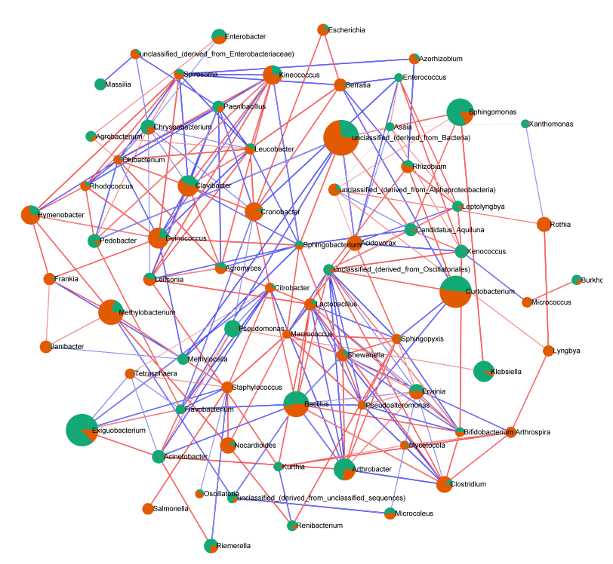(A) 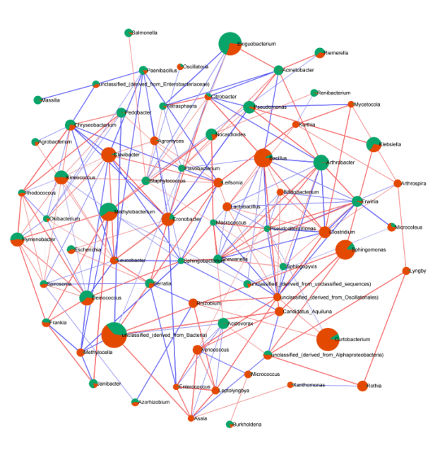(B)
Supplementary Fig. 2. Network analysis of rice phyllospheric microbiome using SparCC correlation coefficients (Normal group). The figure shows networks between abundant sequences at the genus level built from SparCC correlation coefficients. Network plotted with correlation coefficient R²>0.6 or <0.6 and P<0.5. The edges were marked with red line which indicates the positive while blue indicates negative correlation. Genera were filtered with <20 read and then normalized using total scaling sum (TSS) method. The nodes represent genera of bacteria; different nodes size indicate the taxa size; (A) Two genotypes i.e. PRR78 (Green) and Pusa1602 (Orange); (B) Two location i.e. Palampur (Green) and Port Blair (Orange).

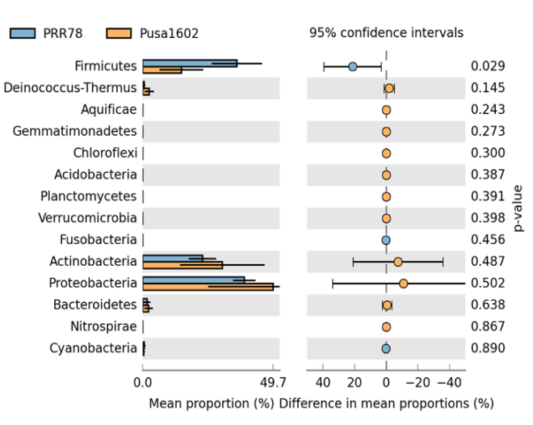 | 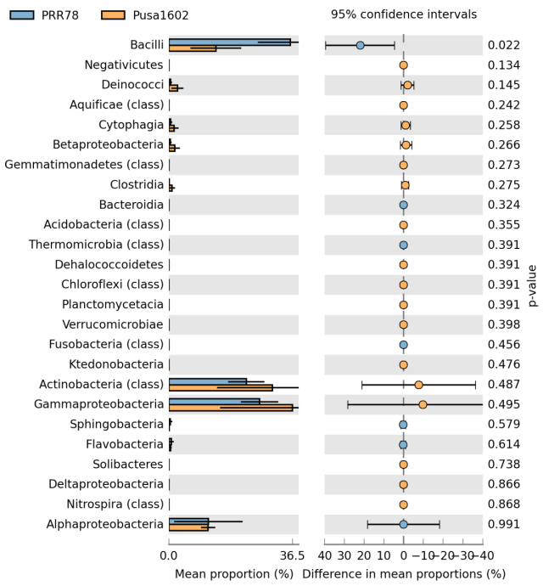
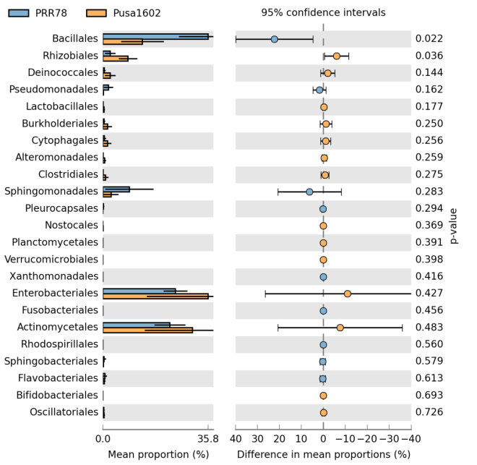 | 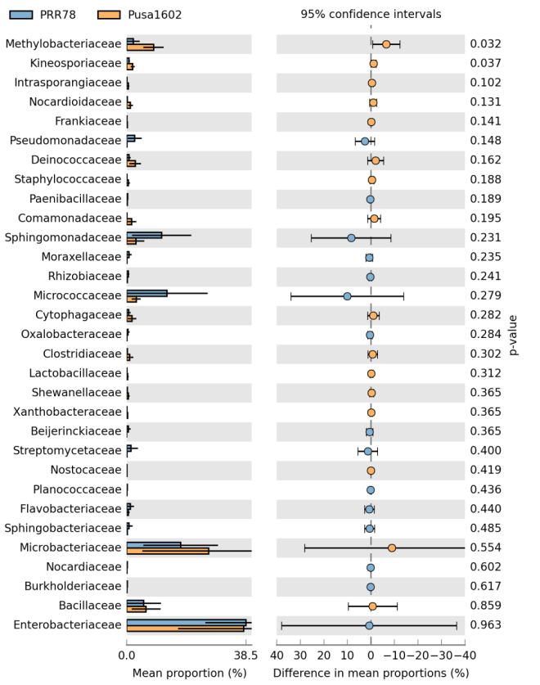

Supplementary Fig. 3. Extended error bar plot at various taxonomic hierarchy of phyllomicrobiome of rice genotypes, PRR78 and Pusa Basmati 1602

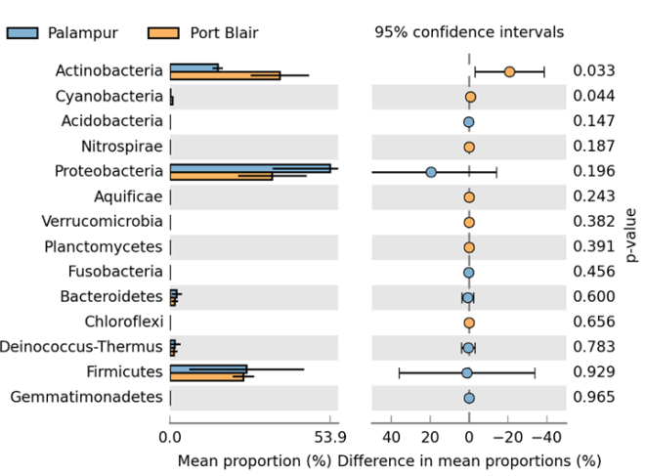 | 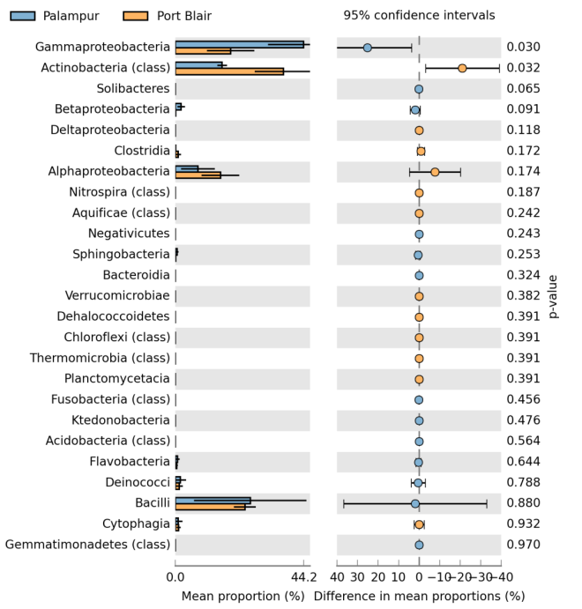
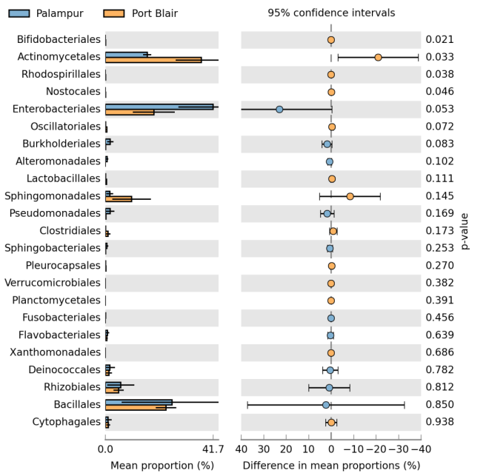 | 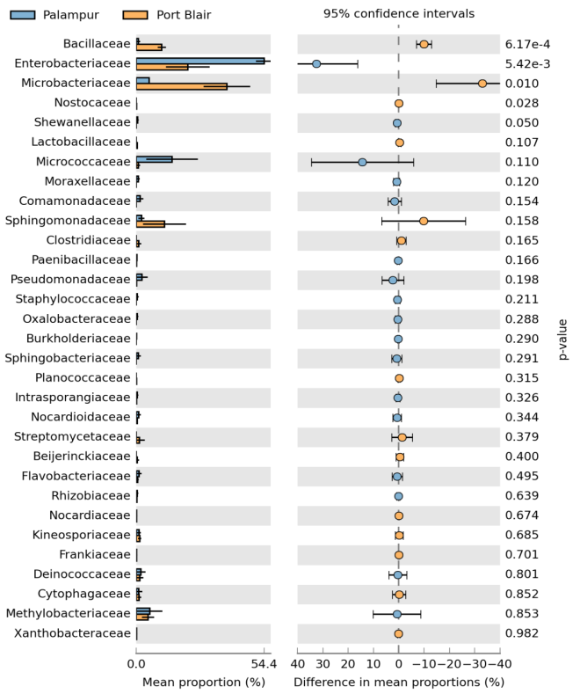

Supplementary Fig. 4. Extended error bar plot at various taxonomic hierarchy level of phyllomicrobiome of rice grown in Palampur, Himachal Pradesh and Port Blair, Andaman Island

Supplementary Fig. 5. Relative abundance of phyllosphere bacterial communities on rice genotypes grown in two agroclimatic zones of India

Supplementary Fig. 6. Relative abundance of phyllosphere bacterial communities at genus level on two rice genotypes representing contrasting agroclimatic zones of India

Marker | 15P1 | 15P2 | 15P3 | 15P4 | 15P5 | 15P6 | 15P7 | 15P8 | 15P9 | 15P10 | 15P11 | 15P12 | 15P13 | 15P14 | 15P15 | 30P1 | 30P2 | 30P3 | 30P4 | 30P5 | 30P6 | 30P7 | 30P8 | 30P9 | 30P10 | 30P11 | 30P12 | 30P13 | 30P14 | 30P15 | 30P16 | 30P17 | 30P18 | 30P19 | 30P20 | 30P21 | 30P22 | 30P23 | Marker

- Palampur
Marker | 15A1 | 115A2 | 15A3 | 15A4 | 15A5 | 15A6 | 15A7 | 15A8 | 15A9 | 15A10 | 15A11 | 15A12 | 15A13 | 15A14 | 15A15 | 15A16 | 15A17 | 15A18 | 30A1 | 30A2 | 30A3 | 30A4 | 30A5 | 30A6 | 30A7 | 30A8 | 30A9 | 30A10 | 30A11 | 30A12 | 30A13 | 30A14 | 30A15 | 30A6 | 30A17 | 30A18 | 30A19 | 30A20 | 30A21 | 30A22 | Marker

- Andaman & Nicobar Island

Supplementary Fig 7. BOX PCR finger printing of cultured bacterial isolates of rice phyllosphere; M: DNA size marker; Lanes: Isolates of bacteria isolated from phyllosphere of rice leaf;

Note: Isolates 15P4, 15P8, 15P9, 15P10, 15P13 and 15P15 shared all amplicons; one of them, 15P9, was considered as representative isolate for further work; Note: Isolates 30P3 and 30P5 shared all amplicons; one of them, 30P3, was considered as representative isolate for further work; Note: Isolates 30P9 and 30P13 shared all amplicons; one of them, 30P9, was considered as representative isolate for further work; Note: Isolates 30P4, 30P8, 30P12 and 30P15 shared all amplicons; one of them, 30P4, was considered as representative isolate for further work

Note: Isolates, 15A7 and 15A16 shared all amplicons; one of them, 15A7, was considered as representative isolate for further work; Note: Isolates 15A10, 15A11, 15A17 and 15A18 shared all amplicons; one of them, 15A10, was considered as representative isolate for further work; Note: Isolates 15A12, 15A13 and 15A14 shared all amplicons; one of them, 15A12, was considered as representative isolate for further work; Note: Isolates 30A5, 30A7 and 30A12 shared all amplicons; one of them, 30A5, was considered as representative isolate for further work; Note: Isolates 30A6 and 30A16 shared all amplicons; one of them, 30A6, was considered as representative isolate for further work

Marker | 15P1 | 15P2 | 15P3 | 15P5 | 15P6 | 15P7 | 15P9 | 15P11 | 15P12 | 15P14 | 30P1 | 30P2 | 30P3 | 30P4 | 30P6 | 30P7 | 30P9 | 30P10 | 30P11 | 30P14 | 30P16 | 30P17 | 30P18 | 30P19 | 30P20 | 30P21 | 30P22 | 30P23 | Marker

B. Palampur
Marker | 15A1 | 115A2 | 15A3 | 15A4 | 15A5 | 15A6 | 15A7 | 15A8 | 15A9 | 15A10 | 15A12 | 15A15 | 30A1 | 30A2 | 30A3 | 30A4 | 30A5 | 30A6 | 30A8 | 30A9 | 30A10 | 30A11 | 30A13 | 30A14 | 30A15 | 30A17 | 30A18 | 30A19 | 30A20 | 30A21 | 30A22 | Marker

C. Andaman & Nicobar Island

Supplementary Fig. 8. Amplification of 16S rRNA gene of bacterial isolates of rice phyllosphere
M: DNA size marker; Lane 1-31: Phyllosphere bacteria isolated from phyllosphere of rice leaf

Colonies of Rice epiphytic Acidovorax |  | Close up view of Acidovorax colonies |  | Species identity  & Isolate name
Nutrient Agar | Nutrient agar +  2, 3, 5 triphenyl tetrazolium chloride | Nutrient Agar | Nutrient agar +  2, 3, 5 triphenyl tetrazolium chloride | Species identity  & Isolate name
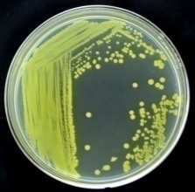 | 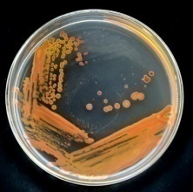 | 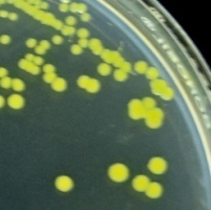 | 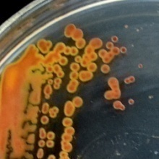 | Acidovorax avenae  (OsEp-Plm-30P1)
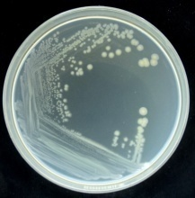 | 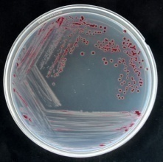 | 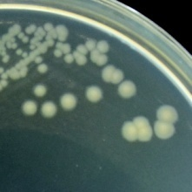 | 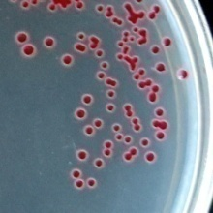 | Acidovorax avenae  (OsEp-Plm-30P23)
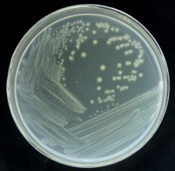 | 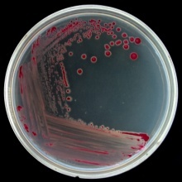 | 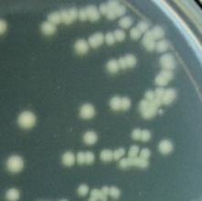 | 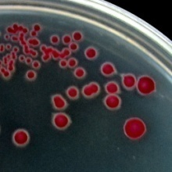 | Acidovorax avenae  (OsEp-Plm-30P6)

Supplementary Fig. 9a. Colonies of cultured Acidovorax species from rice phyllomicrobiome
Colonies of Rice epiphytic Acinetobacter |  | Close up view of Acinetobacter colonies |  | Species identity  & Isolate name
Nutrient Agar | Nutrient agar +  2, 3, 5 triphenyl tetrazolium chloride | Nutrient Agar | Nutrient agar +  2, 3, 5 triphenyl tetrazolium chloride | Species identity  & Isolate name
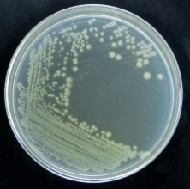 | 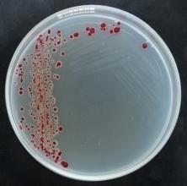 | 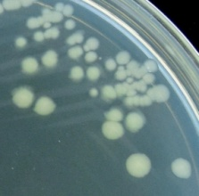 | 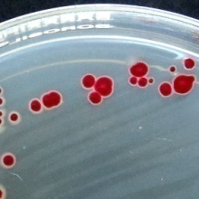 | Acinetobacter baumannii (OsEp-Plm-30P11)
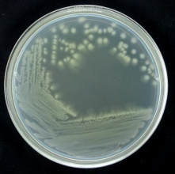 | 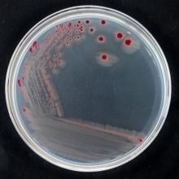 | 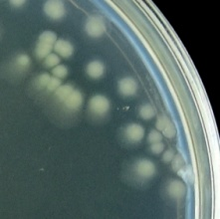 | 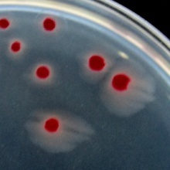 | Acinetobacter baumannii (OsEp-Plm-30P17)
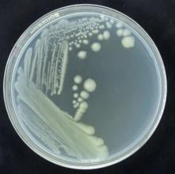 | 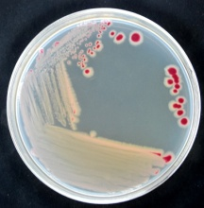 | 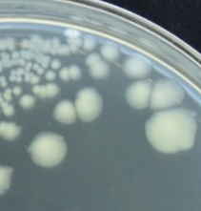 | 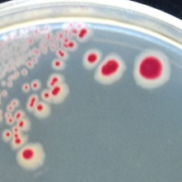 | Acinetobacter junii (OsEp-AN-30A17)
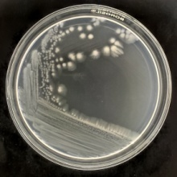 | 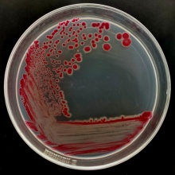 | 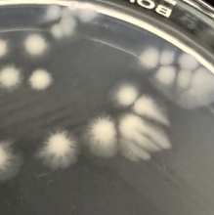 | 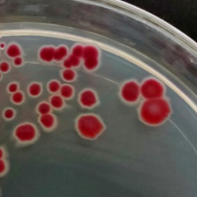 | Acinetobacter soli (OsEp-Plm-30P2)
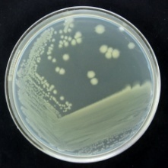 | 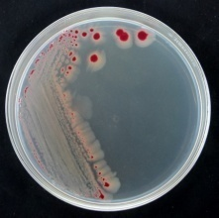 | 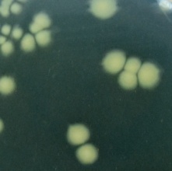 | 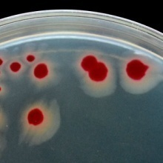 | Acinetobacter soli (OsEp-Plm-30P22)
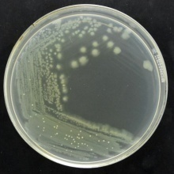 | 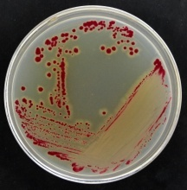 | 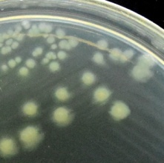 | 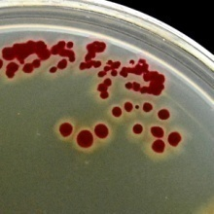 | Acinetobacter soli (OsEp-Plm-30P4)

Supplementary Fig. 9b. Colonies of cultured Acinetobacter species from rice phyllomicrobiome

Colonies of Rice epiphytic Agrobacterium |  | Close up view of Agrobacterium colonies |  | Species identity  & Isolate name
Nutrient Agar | Nutrient agar +  2, 3, 5 triphenyl tetrazolium chloride | Nutrient Agar | Nutrient agar +  2, 3, 5 triphenyl tetrazolium chloride | Species identity  & Isolate name
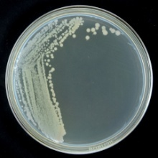 | 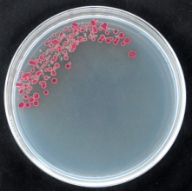 | 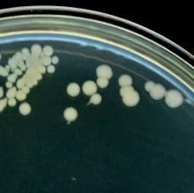 | 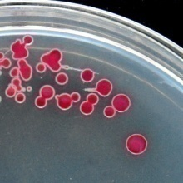 | Agrobacterium larrymoorei (OsEp-Plm-30P19)

Supplementary Fig. 9c. Colonies of cultured Agrobacterium species from rice phyllomicrobiome

Colonies of Rice epiphytic Aureimonas |  | Close up view of Aureimonas colonies |  | Species identity  & Isolate name
Nutrient Agar | Nutrient agar +  2, 3, 5 triphenyl tetrazolium chloride | Nutrient Agar | Nutrient agar +  2, 3, 5 triphenyl tetrazolium chloride | Species identity  & Isolate name
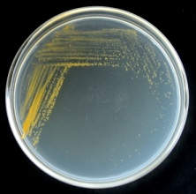 | 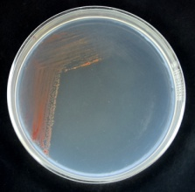 | 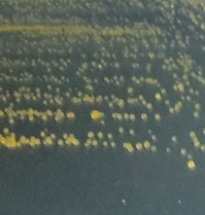 | 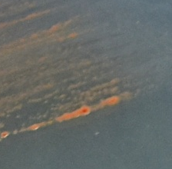 | Aureimonas phyllosphaerae (OsEp-AN-30A11)
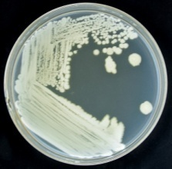 | 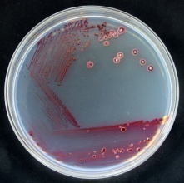 |  | 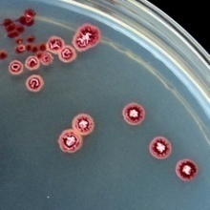 | Aureimonas sp. (OsEp-Plm-30P7)

Supplementary Fig. 9d. Colonies of cultured Aureimonas species from rice phyllomicrobiome

Colonies of Rice epiphytic Curtobacterium |  | Close up view of Curtobacterium colonies |  | Species identity  & Isolate name
Nutrient Agar | Nutrient agar +  2, 3, 5 triphenyl tetrazolium chloride | Nutrient Agar | Nutrient agar +  2, 3, 5 triphenyl tetrazolium chloride | Species identity  & Isolate name
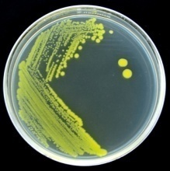 | 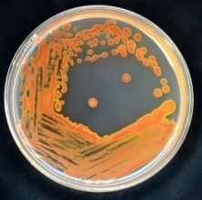 | 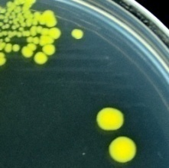 | 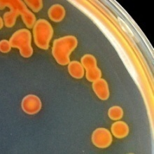 | Curtobacterium albidum (OsEp-Plm-15P1)
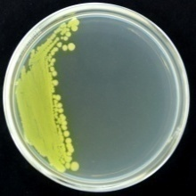 | 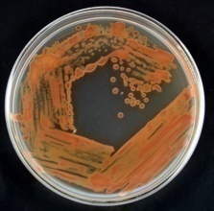 | 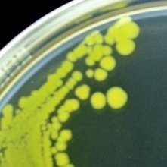 | 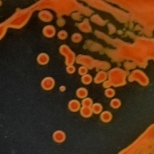 | Curtobacterium albidum (OsEp-Plm-30P20)
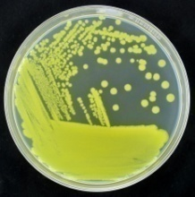 | 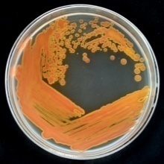 | 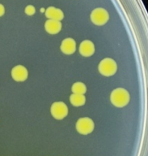 | 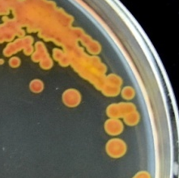 | Curtobacterium citreum (OsEp-AN-30A1)
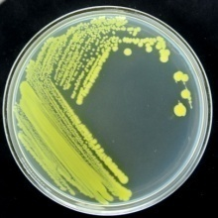 | 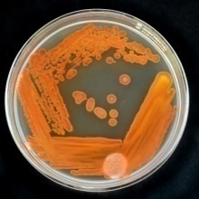 | 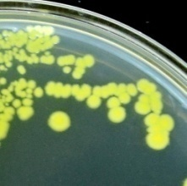 | 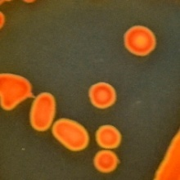 | Curtobacterium luteum (OsEp-Plm-15P7)
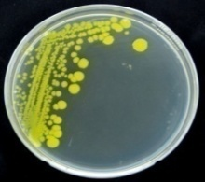 | 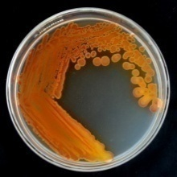 |  | 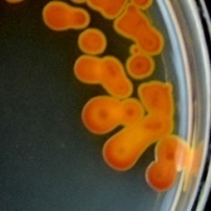 | Curtobacterium luteum (OsEp-Plm-30P9)

Supplementary Fig. 9e. Colonies of cultured Curtobacterium species from rice phyllomicrobiome

Colonies of Rice epiphytic Enterobacter |  | Close up view of Enterobacter colonies |  | Species identity  & Isolate name
Nutrient Agar | Nutrient agar +  2, 3, 5 triphenyl tetrazolium chloride | Nutrient Agar | Nutrient agar +  2, 3, 5 triphenyl tetrazolium chloride | Species identity  & Isolate name
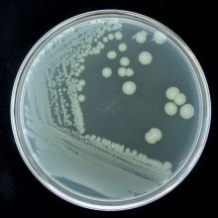 | 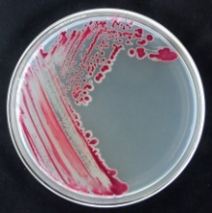 | 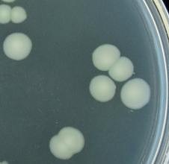 | 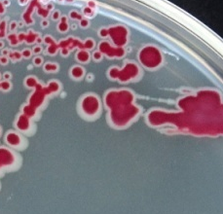 | Enterobacter asburiae (OsEp-AN-30A22)
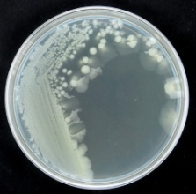 | 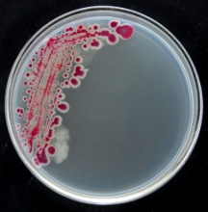 | 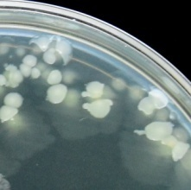 | 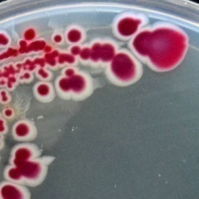 | Enterobacter asburiae (OsEp-Plm-30P16)
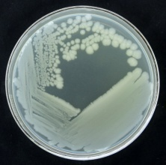 | 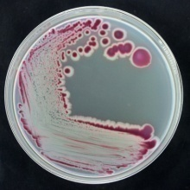 | 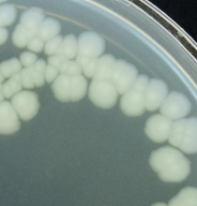 | 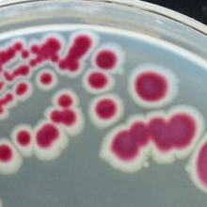 | Enterobacter cloacae (OsEp-AN-15A7)
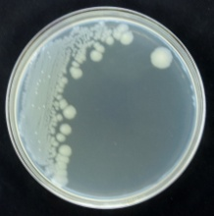 | 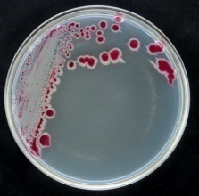 | 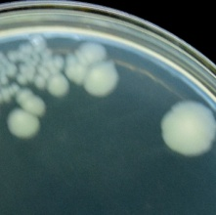 | 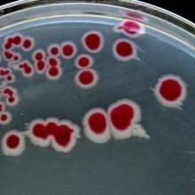 | Enterobacter cloacae (OsEp-Plm-30P18)
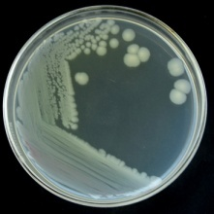 |  | 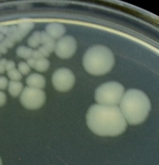 | 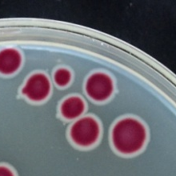 | Enterobacter mori (OsEp-AN-30A20)
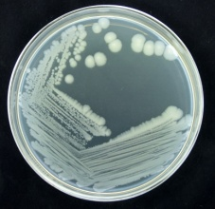 | 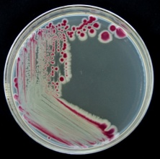 | 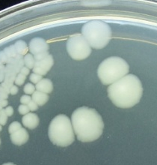 | 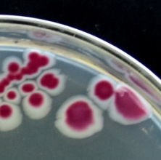 | Enterobacter sichuanensis (OsEp-AN-15A12)

Supplementary Fig. 9f. Colonies of cultured Enterobacter species from rice phyllomicrobiome

Colonies of Rice epiphytic Erwinia |  | Close up view of Erwinia colonies |  | Species identity  & Isolate name
Nutrient Agar | Nutrient agar +  2, 3, 5 triphenyl tetrazolium chloride | Nutrient Agar | Nutrient agar +  2, 3, 5 triphenyl tetrazolium chloride | Species identity  & Isolate name
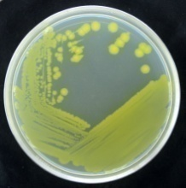 | 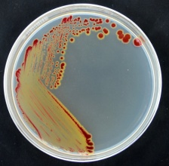 | 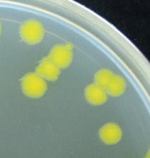 | 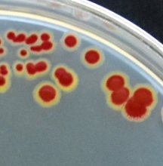 | Erwinia tasmaniensis (OsEp-AN-15A5)

Supplementary Fig. 9g. Colonies of cultured Erwinia species from rice phyllomicrobiome
Colonies of Rice epiphytic Exiguobacterium |  | Close up view of Exiguobacterium colonies |  | Species identity  & Isolate name
Nutrient Agar | Nutrient agar +  2, 3, 5 triphenyl tetrazolium chloride | Nutrient Agar | Nutrient agar +  2, 3, 5 triphenyl tetrazolium chloride | Species identity  & Isolate name
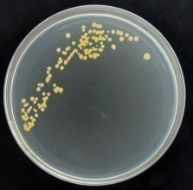 | 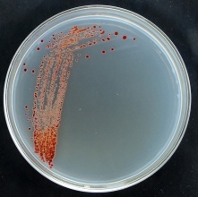 | 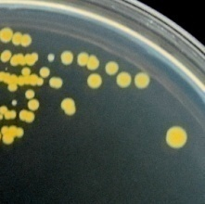 | 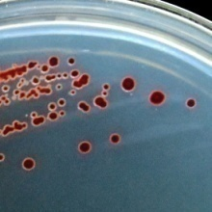 | Exiguobacterium acetylicum (OsEp-Plm-15P3)
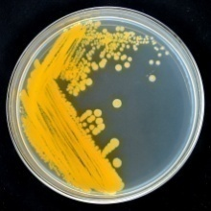 |  | 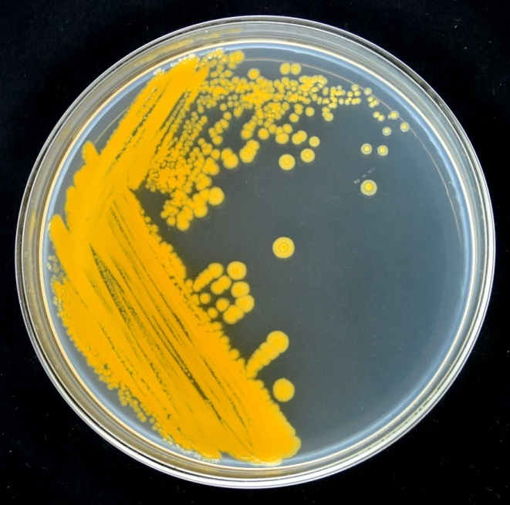 | 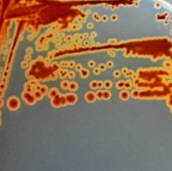 | Exiguobacterium indicum (OsEp-AN-30A4)
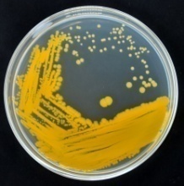 |  | 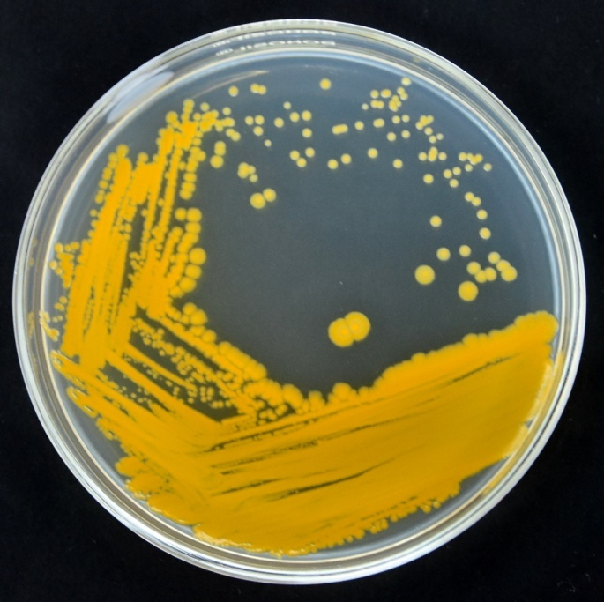 | 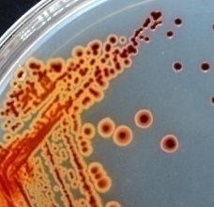 | Exiguobacterium indicum (OsEp-AN-30A6)
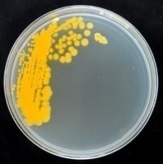 | 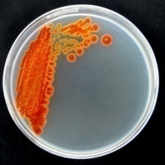 | 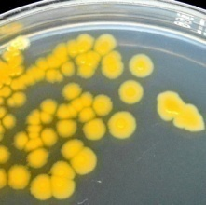 | 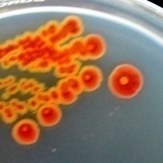 | Exiguobacterium indicum (OsEp-Plm-30P14)

Supplementary Fig. 9h. Colonies of cultured Exiguobacterium species from rice phyllomicrobiome

Colonies of Rice epiphytic Microbacterium |  | Close up view of Microbacterium colonies |  | Species identity  & Isolate name
Nutrient Agar | Nutrient agar +  2, 3, 5 triphenyl tetrazolium chloride | Nutrient Agar | Nutrient agar +  2, 3, 5 triphenyl tetrazolium chloride | Species identity  & Isolate name
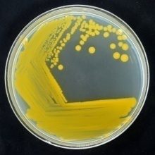 | 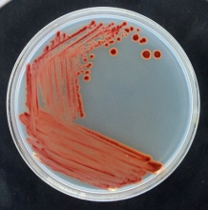 | 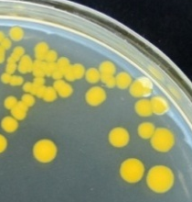 | 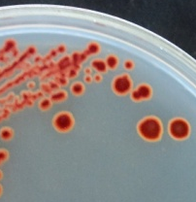 | Microbacterium sp.  (OsEp-AN-15A2)
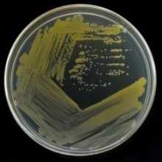 | 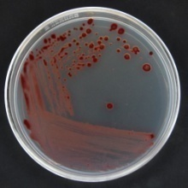 | 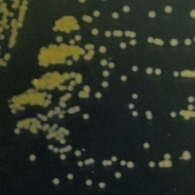 | 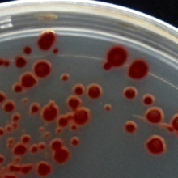 | Microbacterium testaceum (OsEp-AN-30A2)

Supplementary Fig. 9i. Colonies of cultured Microbacterium species from rice phyllomicrobiome

Colonies of Rice epiphytic Micrococcus |  | Close up view of Micrococcus colonies |  | Species identity  & Isolate name
Nutrient Agar | Nutrient agar +  2, 3, 5 triphenyl tetrazolium chloride | Nutrient Agar | Nutrient agar +  2, 3, 5 triphenyl tetrazolium chloride | Species identity  & Isolate name
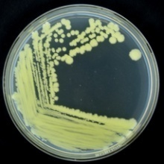 | 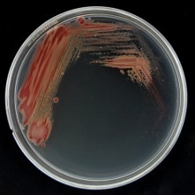 | 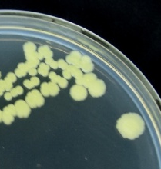 | 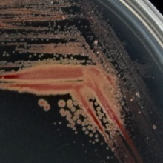 | Micrococcus luteus (OsEp-AN-15A1)

Supplementary Fig. 9j. Colonies of cultured Micrococcus species from rice phyllomicrobiome

Colonies of Rice epiphytic Pantoea |  | Close up view of Pantoea colonies |  | Species identity  & Isolate name
Nutrient Agar | Nutrient agar +  2, 3, 5 triphenyl tetrazolium chloride | Nutrient Agar | Nutrient agar +  2, 3, 5 triphenyl tetrazolium chloride | Species identity  & Isolate name
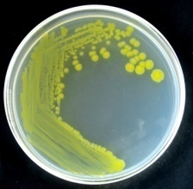 | 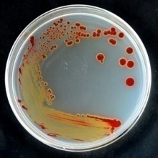 | 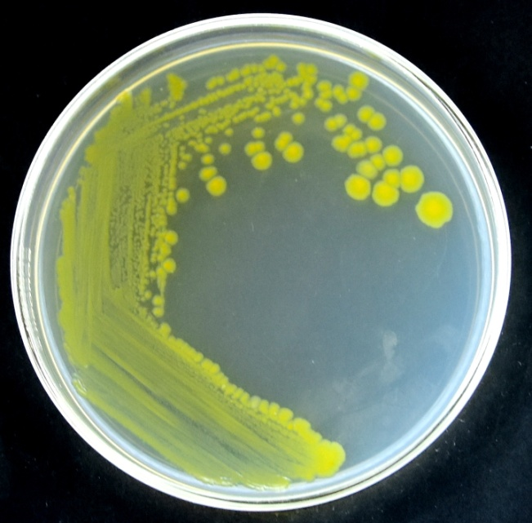 | 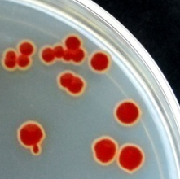 | Pantoea agglomerans (OsEp-AN-15A8)
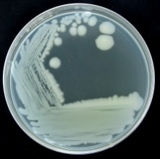 | 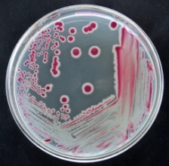 | 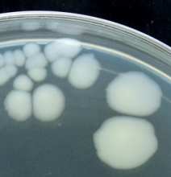 | 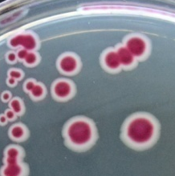 | Pantoea agglomerans (OsEp-AN-30A14)
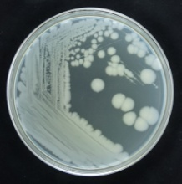 | 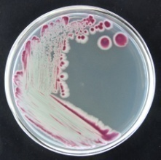 | 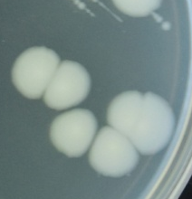 | 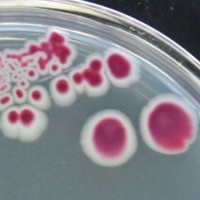 | Pantoea agglomerans (OsEp-AN-30A21)
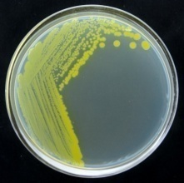 | 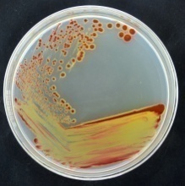 | 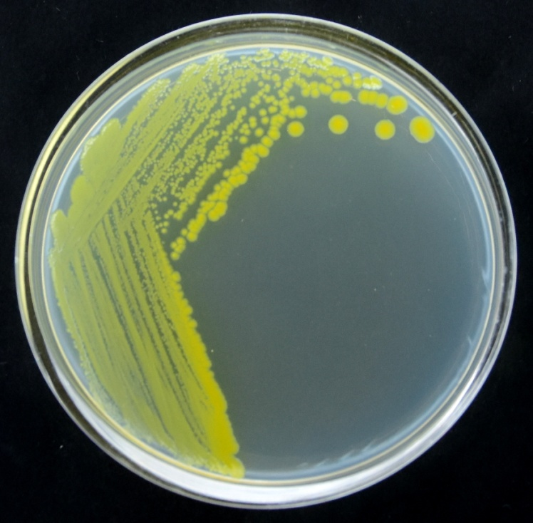 | 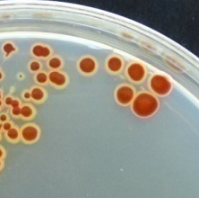 | Pantoea ananatis (OsEp-AN-15A10)
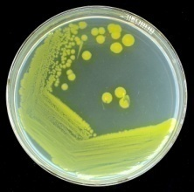 | 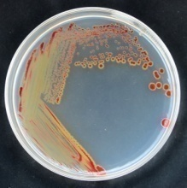 | 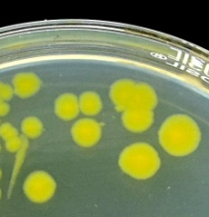 | 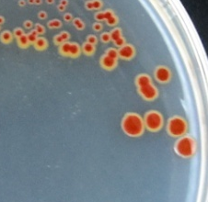 | Pantoea ananatis (OsEp-AN-30A19)
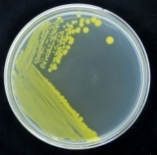 | 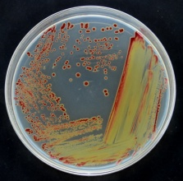 | 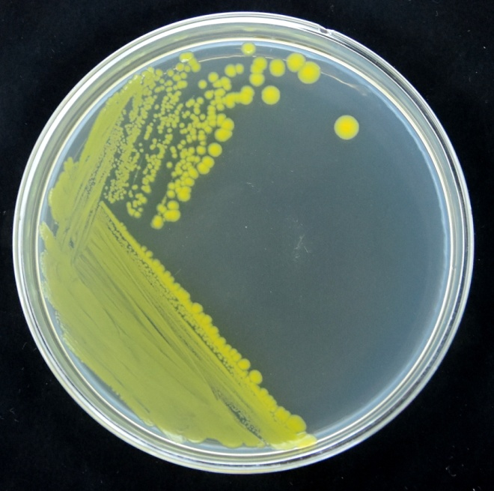 | 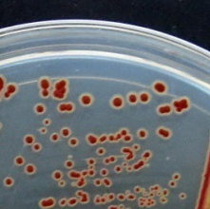 | Pantoea ananatis (OsEp-AN-30A5)
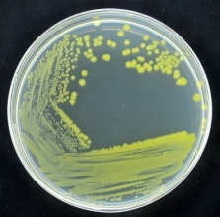 | 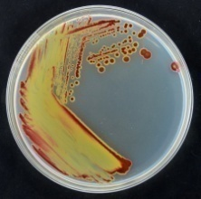 | 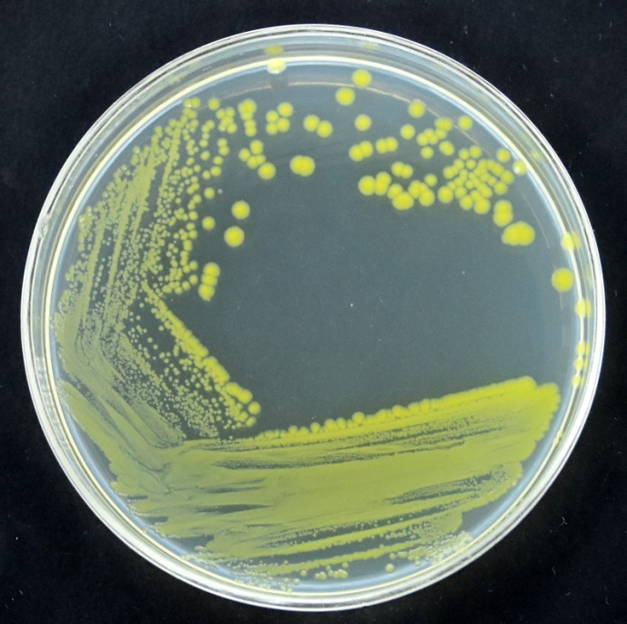 | 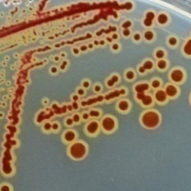 | Pantoea ananatis (OsEp-AN-30A8)
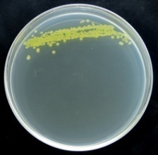 | 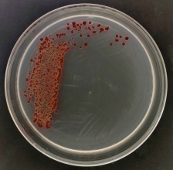 | 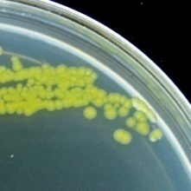 | 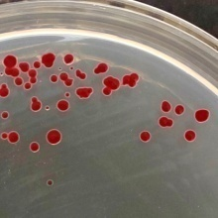 | Pantoea ananatis (OsEp-Plm-15P9)
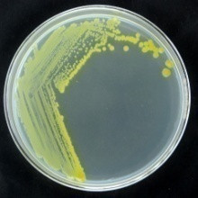 | 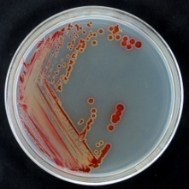 | 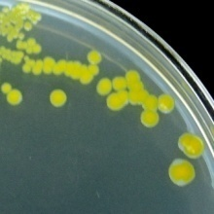 | 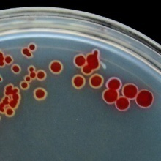 | Pantoea ananatis (OsEp-Plm-30P21)
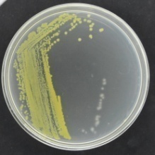 | 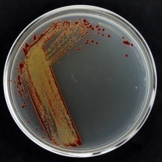 | 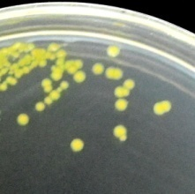 | 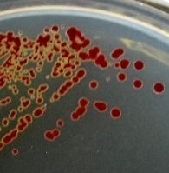 | Pantoea ananatis (OsEp-Plm-30P3)
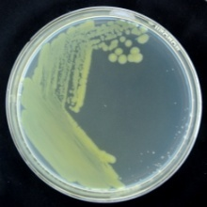 | 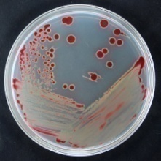 | 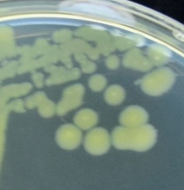 | 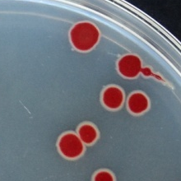 | Pantoea dispersa (OsEp-AN-30A18)
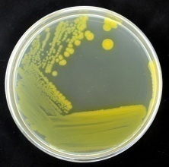 | 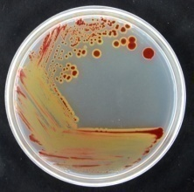 | 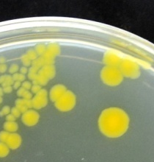 | 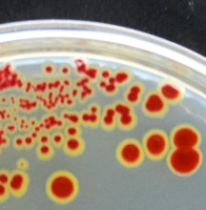 | Pantoea eucrina (OsEp-AN-15A4)
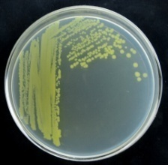 | 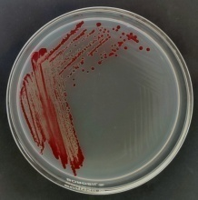 | 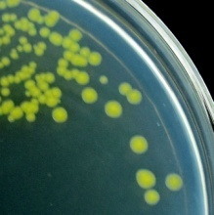 | 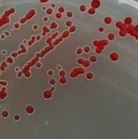 | Pantoea eucrina (OsEp-Plm-15P14)
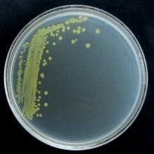 | 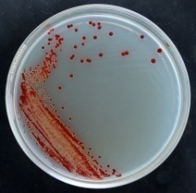 | 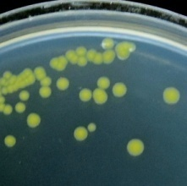 | 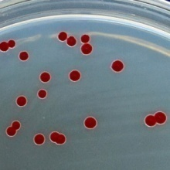 | Pantoea eucrina (OsEp-Plm-30P10)
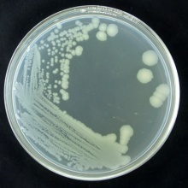 | 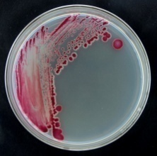 | 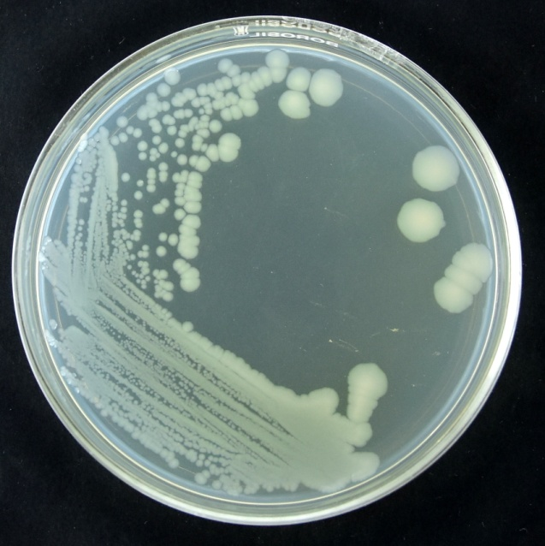 | 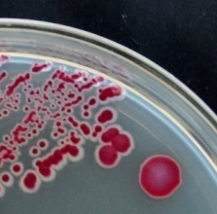 | Pantoea sp. (OsEp-AN-15A15)
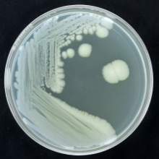 | 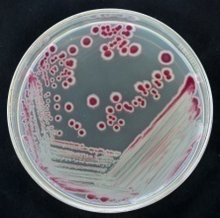 | 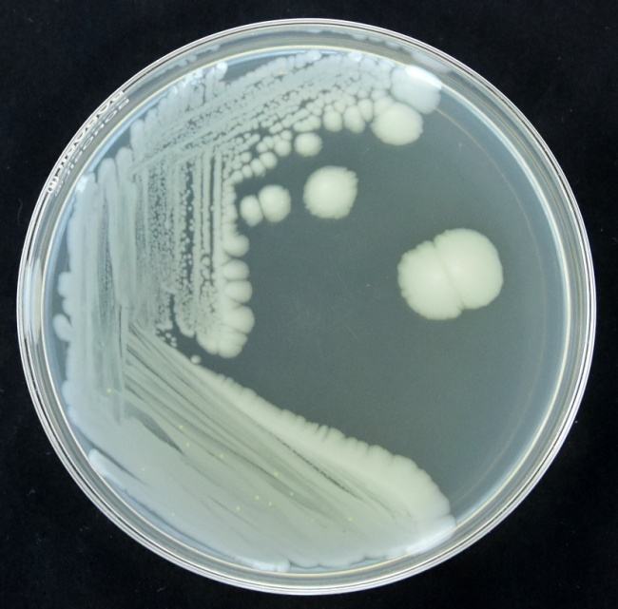 | 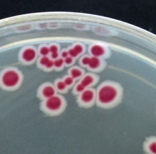 | Pantoea sp. (OsEp-AN-15A9)

Supplementary Fig. 9k. Colonies of cultured Pantoea species from rice phyllomicrobiome

Colonies of Rice epiphytic Pseudomonas |  | Close up view of Pseudomonas colonies |  | Species identity  & Isolate name
Nutrient Agar | Nutrient agar +  2, 3, 5 triphenyl tetrazolium chloride | Nutrient Agar | Nutrient agar +  2, 3, 5 triphenyl tetrazolium chloride | Species identity  & Isolate name
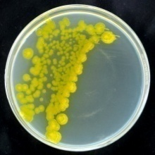 | 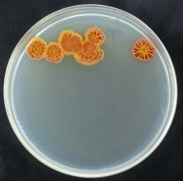 | 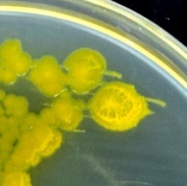 | 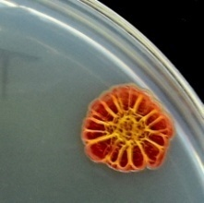 | Pseudomonas oryzihabitans (OsEp-Plm-15P6)
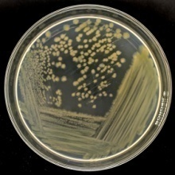 | 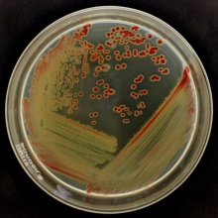 | 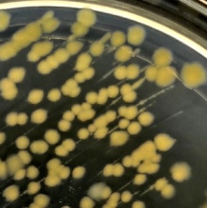 | 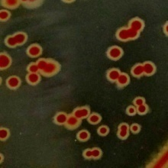 | Pseudomonas parafulva (OsEp-Plm-15P12)
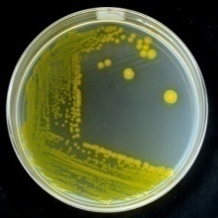 | 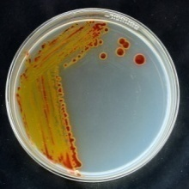 | 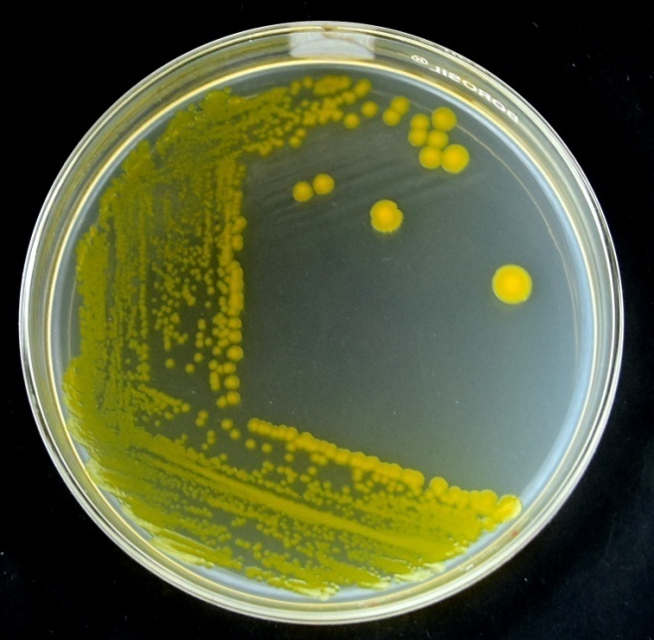 | 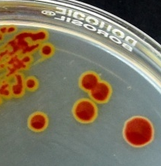 | Pseudomonas psychrotolerans (OsEp-AN-15A6)
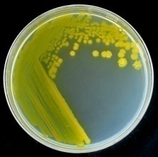 | 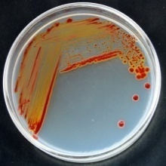 | 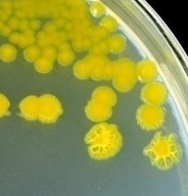 | 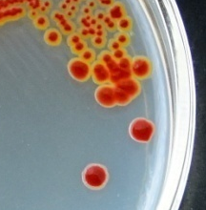 | Pseudomonas psychrotolerans (OsEp-AN-30A13)
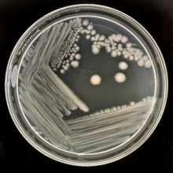 | 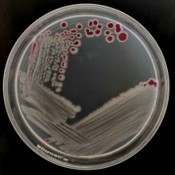 | 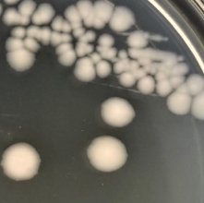 | 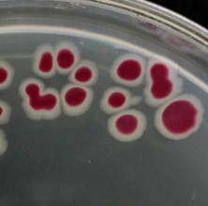 | Pseudomonas putida (OsEp-Plm-15P11)

Supplementary Fig. 9l. Colonies of cultured Pseudomonas species from rice phyllomicrobiome

Colonies of Rice epiphytic Sphingomonas |  | Close up view of Sphingomonas colonies |  | Species identity  & Isolate name
Nutrient Agar | Nutrient agar +  2, 3, 5 triphenyl tetrazolium chloride | Nutrient Agar | Nutrient agar +  2, 3, 5 triphenyl tetrazolium chloride | Species identity  & Isolate name
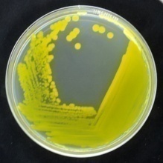 | 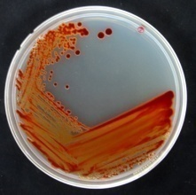 | 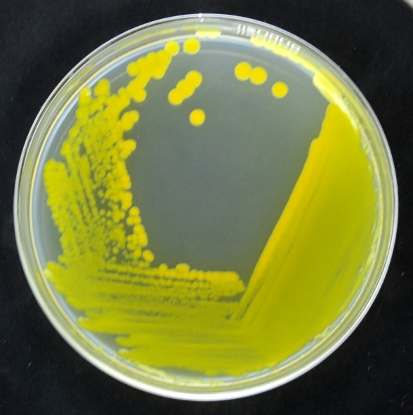 | 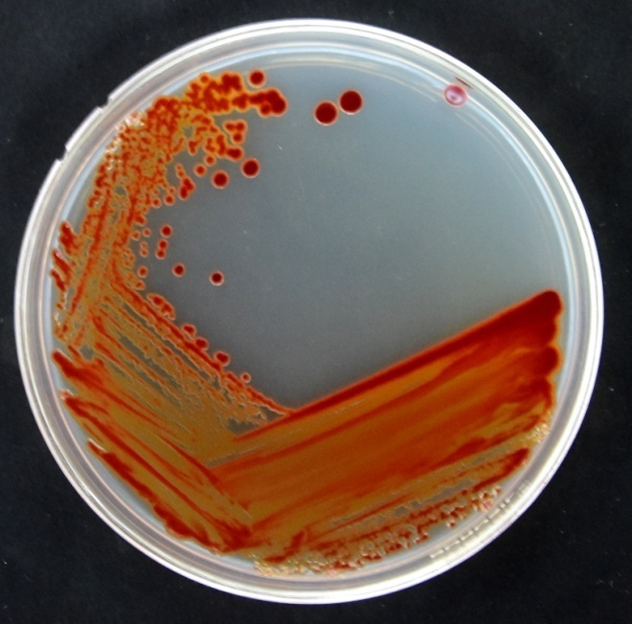 | Sphingomonas paucimobilis (OsEp-AN-15A3)
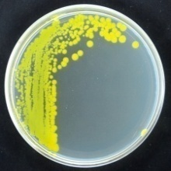 | 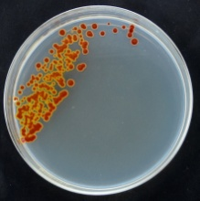 | 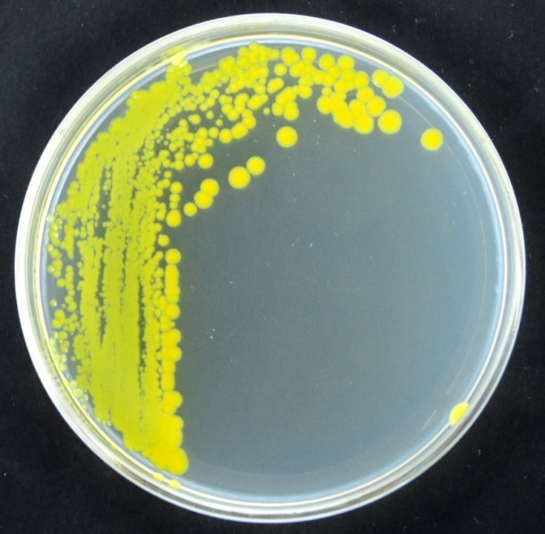 | 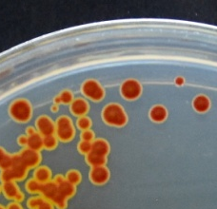 | Sphingomonas paucimobilis (OsEp-AN-30A9)
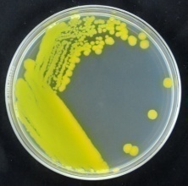 | 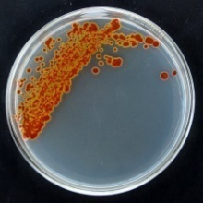 | 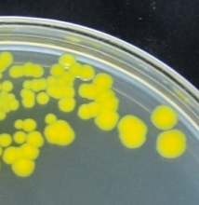 | 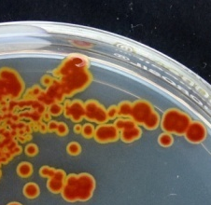 | Sphingomonas pseudosanguinis (OsEp-AN-30A10)
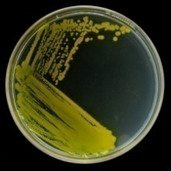 | 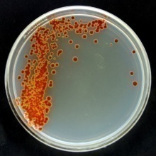 | 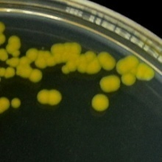 | 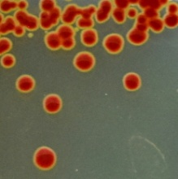 | Sphingomonas pseudosanguinis (OsEp-Plm-15P2)
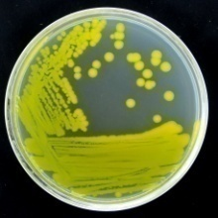 | 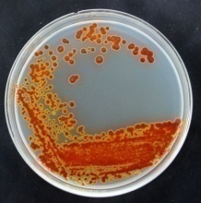 | 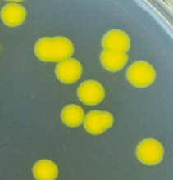 | 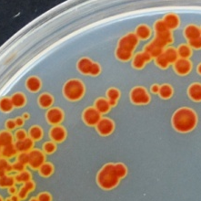 | Sphingomonas sp. (OsEp-AN-30A15)
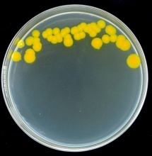 | 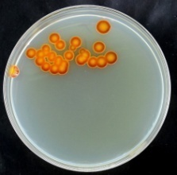 | 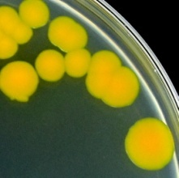 | 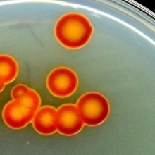 | Sphingomonas sp. (OsEp-Plm-15P5)
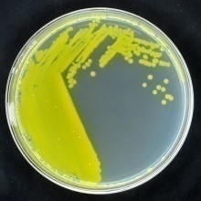 | 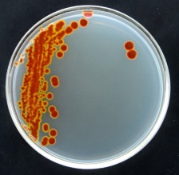 | 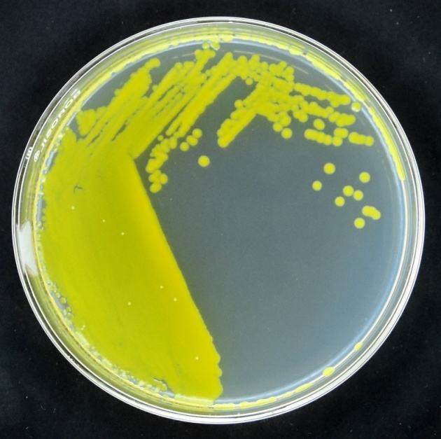 | 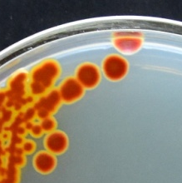 | Sphingomonas yabuuchiae (OsEp-AN-30A3)

Supplementary Fig. 9m. Colonies of cultured Sphingomonas species from rice phyllomicrobiome

Acidovorax | Acidovorax avenae  OsEp-Plm-30P1 | Acidovorax avenae  OsEp-Plm-30P23 | Acidovorax avenae  OsEp-Plm-30P6
Acidovorax | 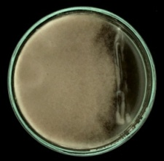 | 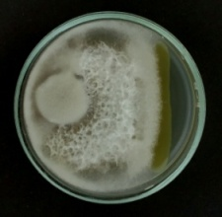 | 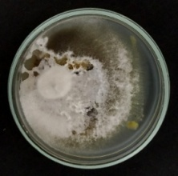
Acinetobacter | Acinetobacter baumannii  OsEp-Plm-30P11 | Acinetobacter baumannii  OsEp-Plm-30P17 | Acinetobacter junii  OsEp-AN-30A17
Acinetobacter | 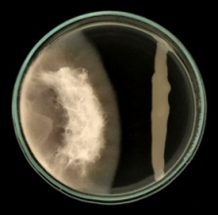 | 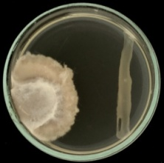 | 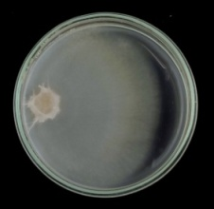
Acinetobacter | Acinetobacter soli  OsEp-Plm-30P2 | Acinetobacter soli  OsEp-Plm-30P22 | Acinetobacter soli  OsEp-Plm-30P4
Acinetobacter | 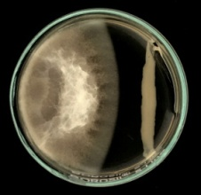 | 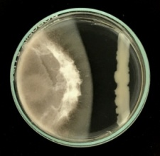 | 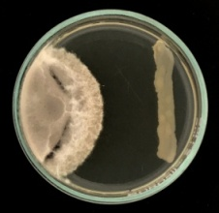
Agrobacterium | Agrobacterium larrymoorei  OsEp-Plm-30P19
Agrobacterium | 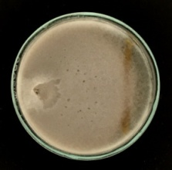
Aureimonas | Aureimonas phyllosphaerae  OsEp-AN-30A11 | Aureimonas sp.  OsEp-Plm-30P7
Aureimonas | 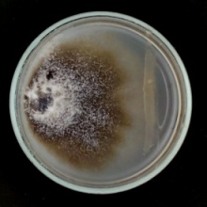 | 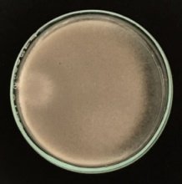
Curtobacterium | Curtobacterium albidum OsEp-Plm-15P1 | Curtobacterium albidum OsEp-Plm-30P20 | Curtobacterium citreum  OsEp-AN-30A1
Curtobacterium | 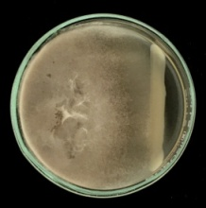 | 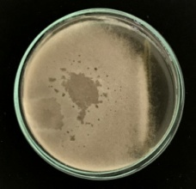 | 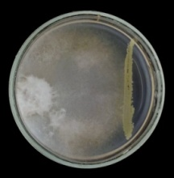
Curtobacterium | Curtobacterium luteum  OsEp-Plm-15P7 | Curtobacterium luteum  OsEp-Plm-30P9
Curtobacterium | 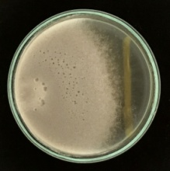 | 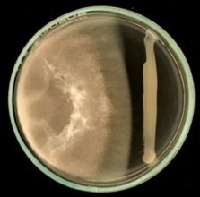
Enterobacter | Enterobacter asburiae  OsEp-AN-30A22 | Enterobacter asburiae  OsEp-Plm-30P16 | Enterobacter cloacae  OsEp-AN-15A7
Enterobacter | 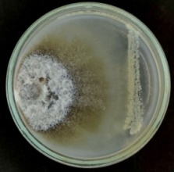 | 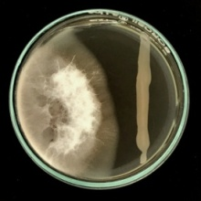 | 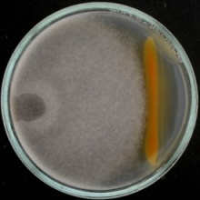
Enterobacter | Enterobacter cloacae  OsEp-Plm-30P18 | Enterobacter mori  OsEp-AN-30A20 | Enterobacter sichuanensis  OsEp-AN-15A12
Enterobacter | 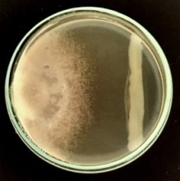 | 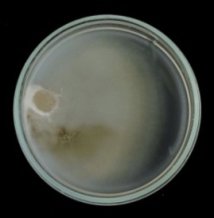 | 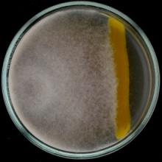
Erwinia | Erwinia tasmaniensis  OsEp-AN-15A5
Erwinia | 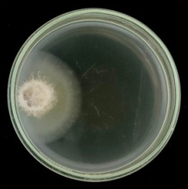
Exiguobacterium | Exiguobacterium acetylicum  OsEp-Plm-15P3 | Exiguobacterium indicum  OsEp-AN-30A4 | Exiguobacterium indicum  OsEp-AN-30A6
Exiguobacterium | 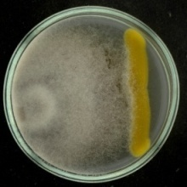 | 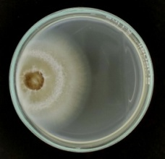 | 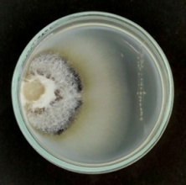
Exiguobacterium | Exiguobacterium indicum  OsEp-Plm-30P14
Exiguobacterium | 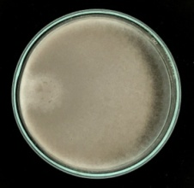
Microbacterium | Microbacterium sp.  OsEp-AN-15A2 | Microbacterium testaceum  OsEp-AN-30A2
Microbacterium | 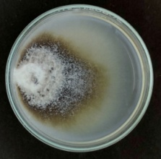 | 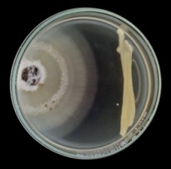
Micrococcus | Micrococcus luteus  OsEp-AN-15A1
Micrococcus | 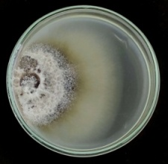
Pantoea | Pantoea agglomerans  OsEp-AN-15A8 | Pantoea agglomerans  OsEp-AN-30A14 | Pantoea agglomerans  OsEp-AN-30A21
Pantoea | 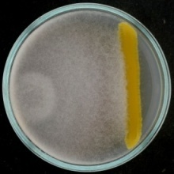 | 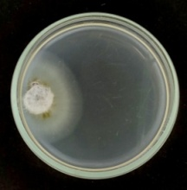 | 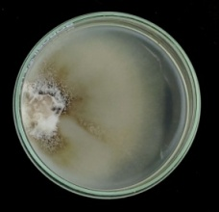
Pantoea | Pantoea ananatis  OsEp-AN-15A10 | Pantoea ananatis  OsEp-AN-30A19 | Pantoea ananatis  OsEp-AN-30A5
Pantoea | 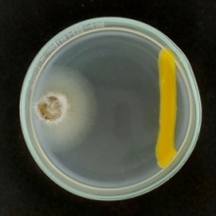 | 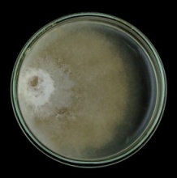 | 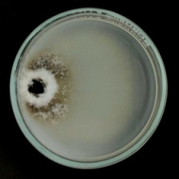
Pantoea | Pantoea ananatis  OsEp-AN-30A8 | Pantoea ananatis  OsEp-Plm-15P9 | Pantoea ananatis  OsEp-Plm-30P21
Pantoea | 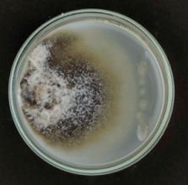 | 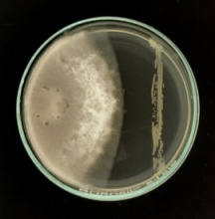 | 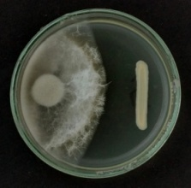
Pantoea | Pantoea ananatis  OsEp-Plm-30P3 | Pantoea dispersa  OsEp-AN-30A18 | Pantoea eucrina  OsEp-AN-15A4
Pantoea | 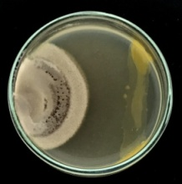 | 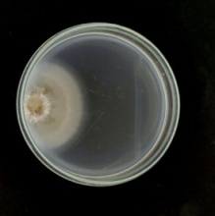 | 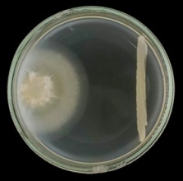
Pantoea | Pantoea eucrina  OsEp-Plm-15P14 | Pantoea eucrina  OsEp-Plm-30P10 | Pantoea sp.  OsEp-AN-15A15
Pantoea | 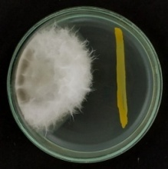 | 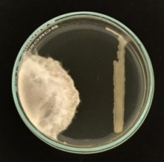 | 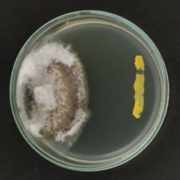
Pantoea | Pantoea sp.  OsEp-AN-15A9
Pantoea | 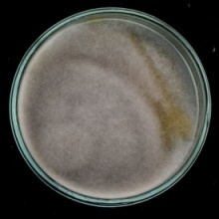
Pseudomonas | Pseudomonas oryzihabitans  OsEp-Plm-15P6 | Pseudomonas parafulva  OsEp-Plm-15P12 | Pseudomonas psychrotolerans  OsEp-AN-15A6
Pseudomonas | 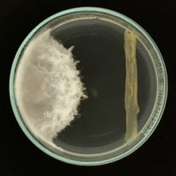 | 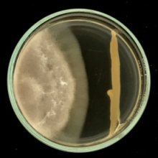 | 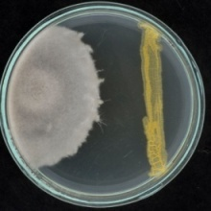
Pseudomonas | Pseudomonas psychrotolerans  OsEp-AN-30A13 | Pseudomonas putida  OsEp-Plm-15P11
Pseudomonas | 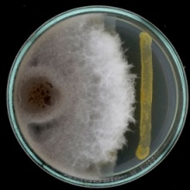 | 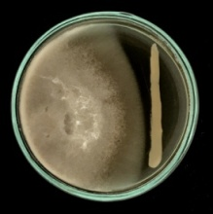
Sphingomonas | Sphingomonas paucimobilis  OsEp-AN-15A3 | Sphingomonas paucimobilis  OsEp-AN-30A9 | Sphingomonas pseudosanguinis  OsEp-AN-30A10
Sphingomonas | 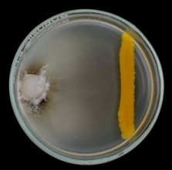 | 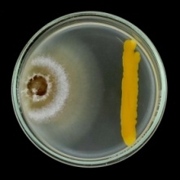 | 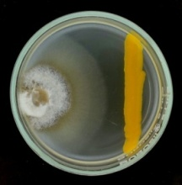
Sphingomonas | Sphingomonas pseudosanguinis  OsEp-Plm-15P2 | Sphingomonas sp.  OsEp-AN-30A15 | Sphingomonas sp.  OsEp-Plm-15P5
Sphingomonas | 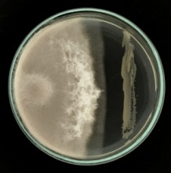 | 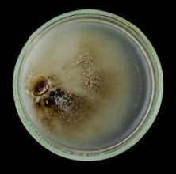 | 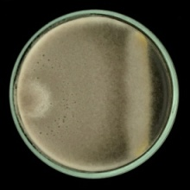
Sphingomonas | Sphingomonas yabuuchiae  OsEp-AN-30A3
 | 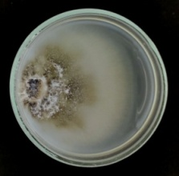
Mock | Mock | Mock
Mock | 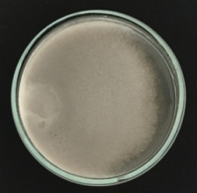 | 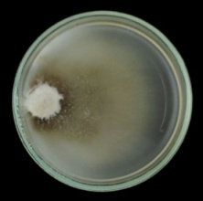

Supplementary Fig. 10. Secreted metabolite mediated in vitro antifungal activity of rice phyllosphere bacterial isolates on Magnaporthe oryzae

Acidovorax | Acidovorax avenae  OsEp-Plm-30P1 | Acidovorax avenae  OsEp-Plm-30P23 | Acidovorax avenae  OsEp-Plm-30P6
Acidovorax | 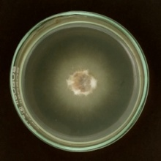 | 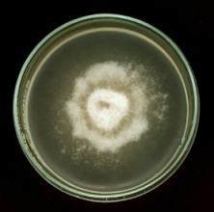 | 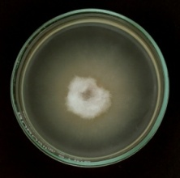
Acinetobacter | Acinetobacter baumannii  OsEp-Plm-30P11 | Acinetobacter baumannii  OsEp-Plm-30P17 | Acinetobacter junii  OsEp-AN-30A17
Acinetobacter | 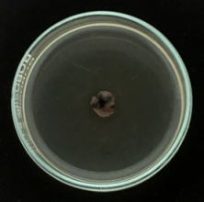 | 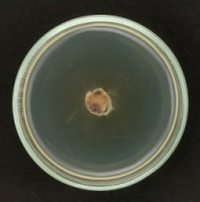 | 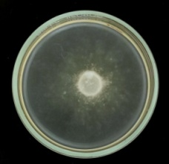
Acinetobacter | Acinetobacter soli  OsEp-Plm-30P2 | Acinetobacter soli  OsEp-Plm-30P22 | Acinetobacter soli  OsEp-Plm-30P4
Acinetobacter | 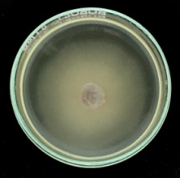 | 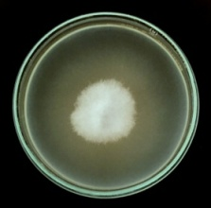 | 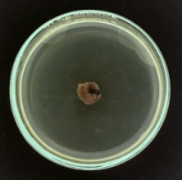
Agrobacterium | Agrobacterium larrymoorei  OsEp-Plm-30P19
Agrobacterium | 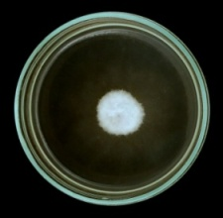
Aureimonas | Aureimonas phyllosphaerae  OsEp-AN-30A11 | Aureimonas sp.  OsEp-Plm-30P7
Aureimonas | 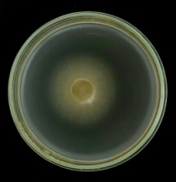 | 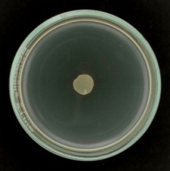
Curtobacterium | Curtobacterium albidum OsEp-Plm-15P1 | Curtobacterium albidum OsEp-Plm-30P20 | Curtobacterium citreum  OsEp-AN-30A1
Curtobacterium | 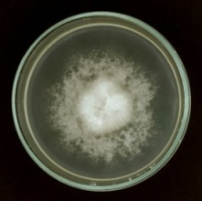 | 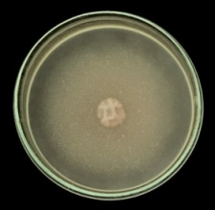 | 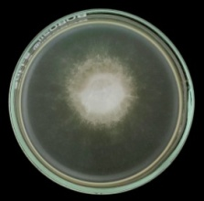
Curtobacterium | Curtobacterium luteum  OsEp-Plm-15P7 | Curtobacterium luteum  OsEp-Plm-30P9
Curtobacterium | 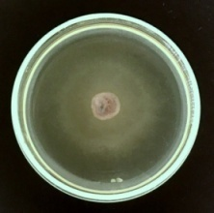 | 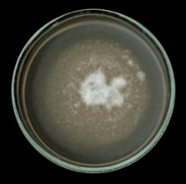
Enterobacter | Enterobacter asburiae  OsEp-AN-30A22 | Enterobacter asburiae  OsEp-Plm-30P16 | Enterobacter cloacae  OsEp-AN-15A7
Enterobacter | 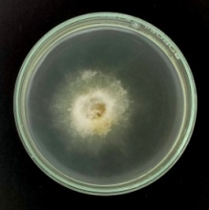 | 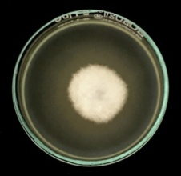 | 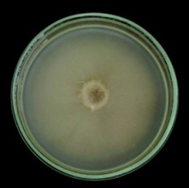
Enterobacter | Enterobacter cloacae  OsEp-Plm-30P18 | Enterobacter mori  OsEp-AN-30A20 | Enterobacter sichuanensis  OsEp-AN-15A12
Enterobacter | 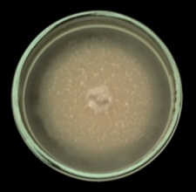 | 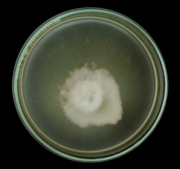 | 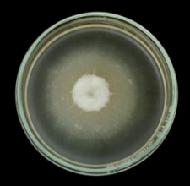
Erwinia | Erwinia tasmaniensis  OsEp-AN-15A5
Erwinia | 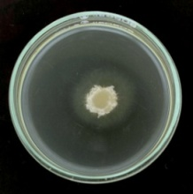
Exiguobacterium | Exiguobacterium acetylicum  OsEp-Plm-15P3 | Exiguobacterium indicum  OsEp-AN-30A4 | Exiguobacterium indicum  OsEp-AN-30A6
Exiguobacterium | 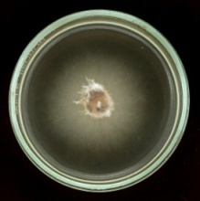 | 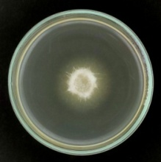 | 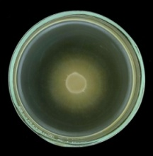
Exiguobacterium | Exiguobacterium indicum  OsEp-Plm-30P14
Exiguobacterium | 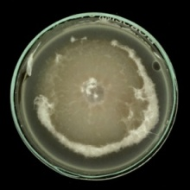
Microbacterium | Microbacterium sp.  OsEp-AN-15A2 | Microbacterium testaceum  OsEp-AN-30A2
Microbacterium | 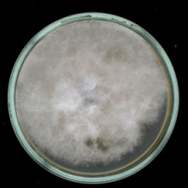 | 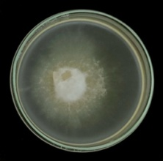
Micrococcus | Micrococcus luteus  OsEp-AN-15A1
Micrococcus | 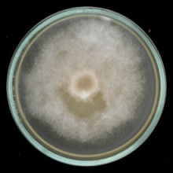
Pantoea | Pantoea agglomerans  OsEp-AN-15A8 | Pantoea agglomerans  OsEp-AN-30A14 | Pantoea agglomerans  OsEp-AN-30A21
Pantoea | 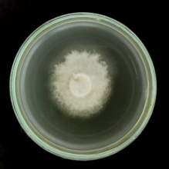 | 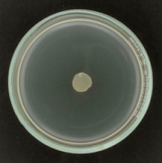 | 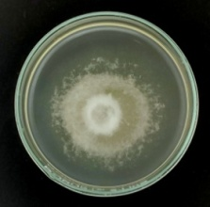
Pantoea | Pantoea ananatis  OsEp-AN-15A10 | Pantoea ananatis  OsEp-AN-30A19 | Pantoea ananatis  OsEp-AN-30A5
Pantoea | 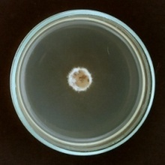 | 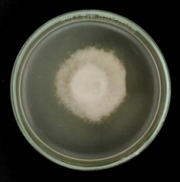 | 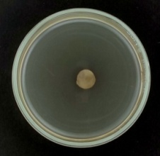
Pantoea | Pantoea ananatis  OsEp-AN-30A8 | Pantoea ananatis  OsEp-Plm-15P9 | Pantoea ananatis  OsEp-Plm-30P21
Pantoea | 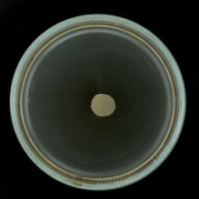 | 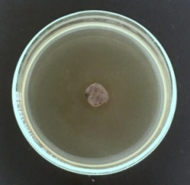 | 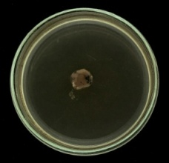
Pantoea | Pantoea ananatis  OsEp-Plm-30P3 | Pantoea dispersa  OsEp-AN-30A18 | Pantoea eucrina  OsEp-AN-15A4
Pantoea | 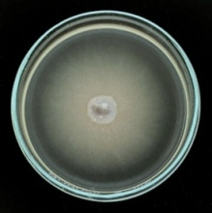 | 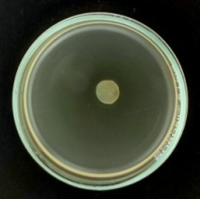 | 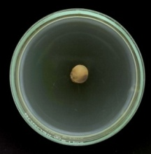
Pantoea | Pantoea eucrina  OsEp-Plm-15P14 | Pantoea eucrina  OsEp-Plm-30P10 | Pantoea sp.  OsEp-AN-15A15
Pantoea | 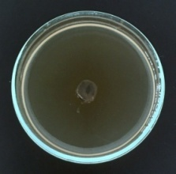 | 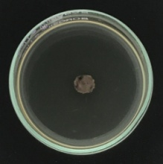 | 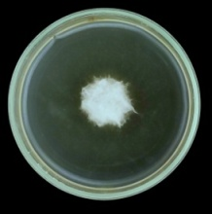
Pantoea | Pantoea sp.  OsEp-AN-15A9
Pantoea | 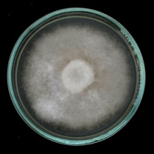
Pseudomonas | Pseudomonas oryzihabitans  OsEp-Plm-15P6 | Pseudomonas parafulva  OsEp-Plm-15P12 | Pseudomonas psychrotolerans  OsEp-AN-15A6
Pseudomonas | 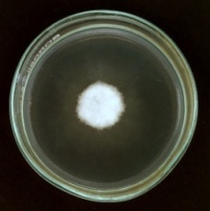 | 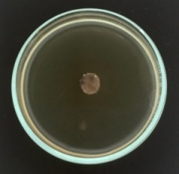 | 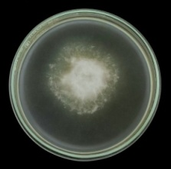
Pseudomonas | Pseudomonas psychrotolerans  OsEp-AN-30A13 | Pseudomonas putida  OsEp-Plm-15P11
Pseudomonas | 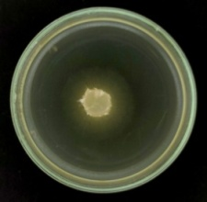 | 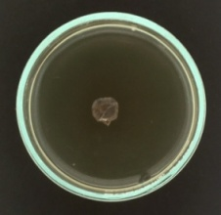
Sphingomonas | Sphingomonas paucimobilis  OsEp-AN-15A3 | Sphingomonas paucimobilis  OsEp-AN-30A9 | Sphingomonas pseudosanguinis  OsEp-AN-30A10
Sphingomonas | 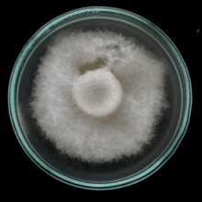 | 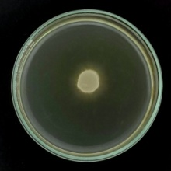 | 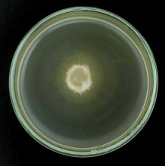
Sphingomonas | Sphingomonas pseudosanguinis  OsEp-Plm-15P2 | Sphingomonas sp.  OsEp-AN-30A15 | Sphingomonas sp.  OsEp-Plm-15P5
Sphingomonas | 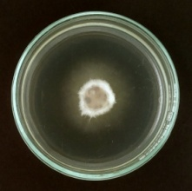 | 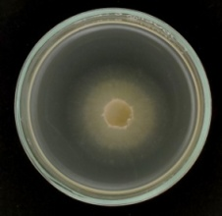 | 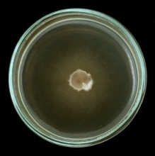
Sphingomonas | Sphingomonas yabuuchiae  OsEp-AN-30A3
 | 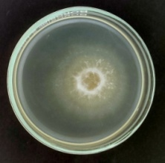
Mock | Mock | Mock
Mock | 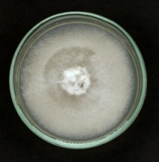 | 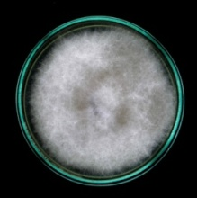

Supplementary Fig. 11. Volatile mediated in vitro antifungal activity of rice phyllosphere bacterial isolates on Magnaporthe oryzae

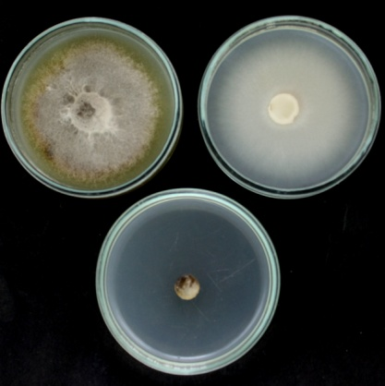 | 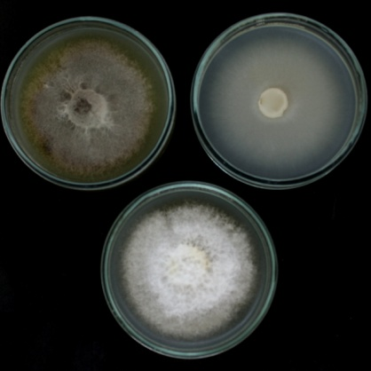 | 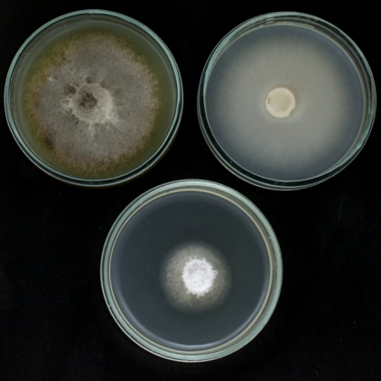
Pantoea ananatis  OsEp-Plm-15P9 | Pseudomonas putida  OsEp-Plm-15P11 | Pseudomonas parafulva  OsEp-Plm-15P12
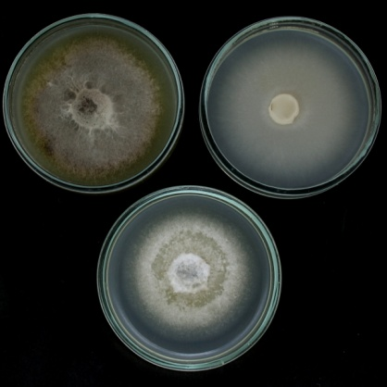 | 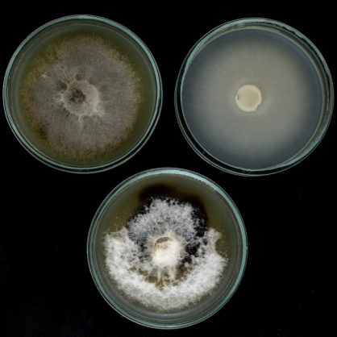 | 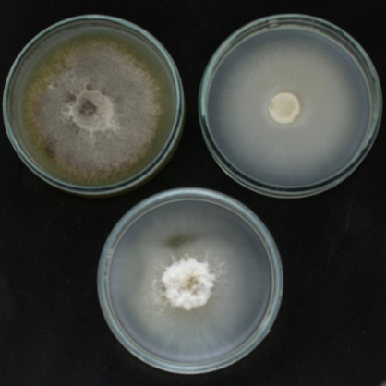
Pantoea eucrina  OsEp-Plm-15P14 | Acinetobacter soli  OsEp-Plm-30P4 | Aureimonas sp.  OsEp-Plm-30P7
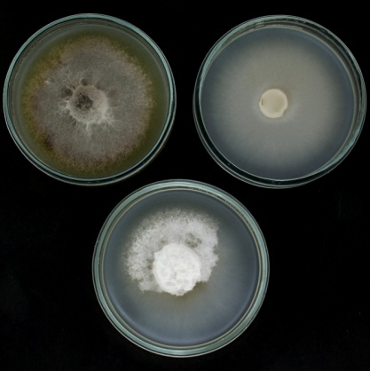 | 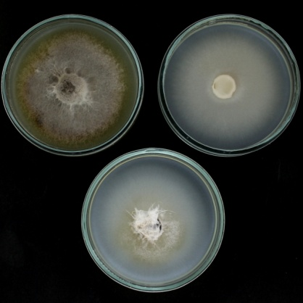 | 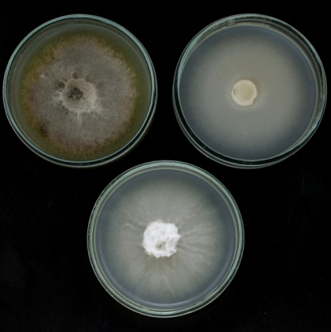
Pantoea eucrina  OsEp-Plm-30P10 | Acinetobacter baumannii  OsEp-Plm-30P11 | Acinetobacter baumannii  OsEp-Plm-30P17
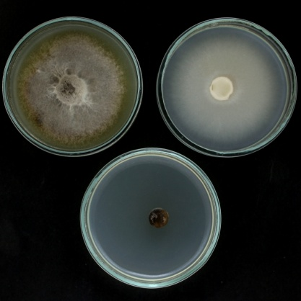 | 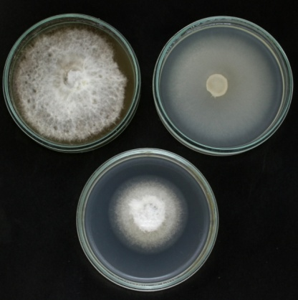 | 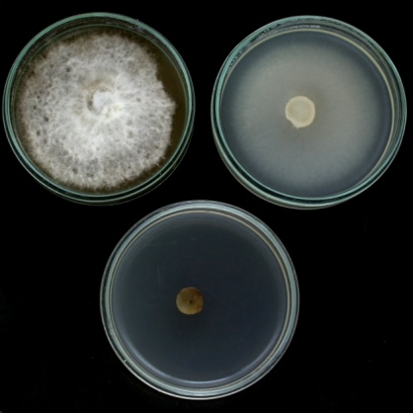
Pantoea ananatis  OsEp-Plm-30P21 | Pantoea eucrina  OsEp-AN-15A4 | Pantoea ananatis  OsEp-AN-30A5
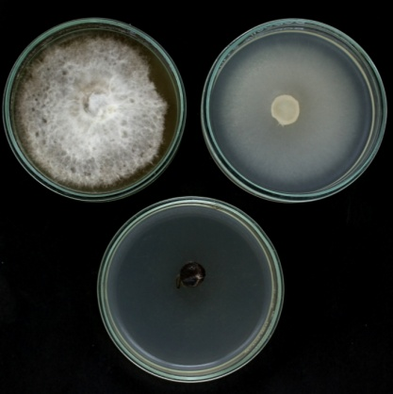 | 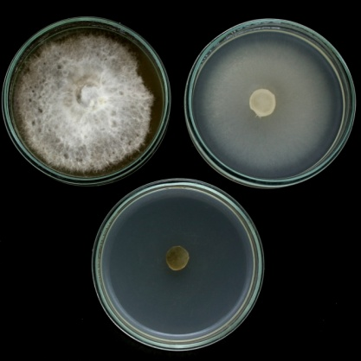 | 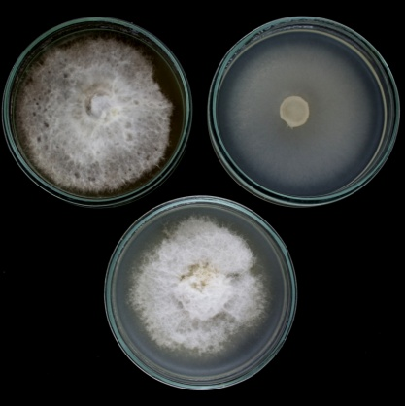
Pantoea ananatis  OsEp-AN-30A8 | Pantoea agglomerans  OsEp-AN-30A14 | Pantoea dispersa  OsEp-AN-30A18

Supplementary Fig. 12. Analysis of nature of BVC mediated growth inhibition of Magnaporthe oryzae; Note: In each image; Top left plate: Mock from the beginning; Right plate: Mock from the day when volatile exposure in removed; Bottom plate: Plate incubated after removal of bacterial volatile exposure

Pantoea ananatis OsEp-Plm-30P3  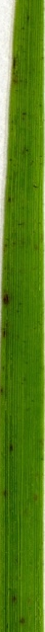 | Pantoea ananatis OsEp-Plm-30P21  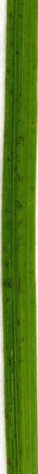 | Aureimonas sp. OsEp-Plm-30P7  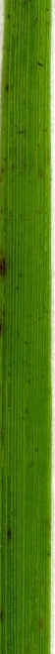 | Pantoea ananatis OsEp-AN-30A8  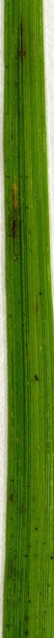 | Pantoea eucrina OsEp-Plm-30P10  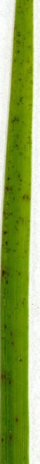 | Pseudomonas putida OsEp-Plm-15P11  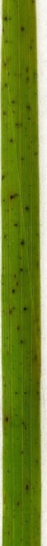 | Pantoea ananatis OsEp-Plm-15P9  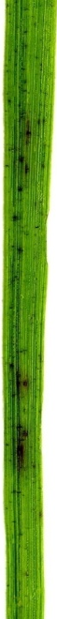 | Acinetobacter baumannii OsEp-Plm-30P11  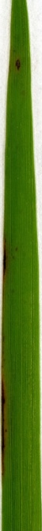 | Pantoea eucrina OsEp-AN-15A4  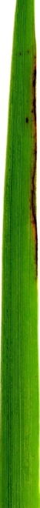 | Pantoea ananatis OsEp-AN-15A10   | Pantoea sp. OsEp-AN-15A15 | 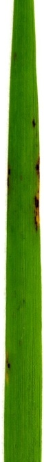
R | R | R | R | R | R | MR | MR | MR | MR | MR

Pantoea eucrina OsEp-Plm-15P14  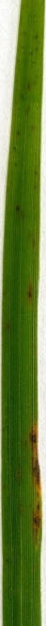 | Acinetobacter baumannii OsEp-Plm-30P17  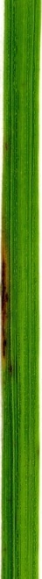 | Pantoea agglomerans OsEp-AN-30A14  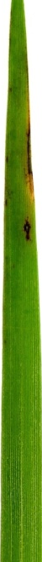 | Pantoea ananatis OsEp-AN-30A5 | Pantoea dispersa OsEp-AN-30A18  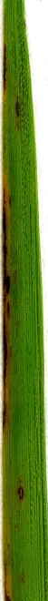 | Pseudomonas parafulvaOsEp-Plm-15P12  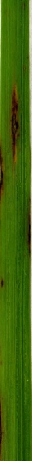 | Exiguobacterium indicumOsEp-AN-30A4  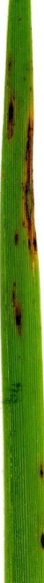 | Acinetobacter soliOsEp-Plm-30P4  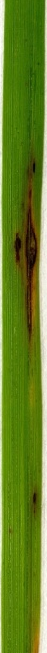 | Erwinia tasmaniensis OsEp-AN-15A5  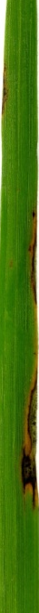 | Control (Mock)  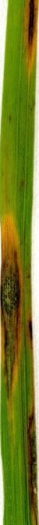 | Tricyclazole control | 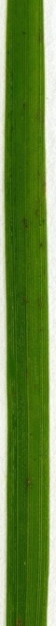
MR | MR | MR | MR | MS | MS | MS | MS | MS | S | R

Supplementary Fig. 13. Effect of phyllobacterization on rice blast disease incited by Magnaporthe oryzae

OsPAD4 | OsEDS1
OsNPR1 | OsPDF2.2
OsCERK1 | OsCEBiP
OsFMO | OsPR1.1

Supplementary Fig. 14. qPCR based transcriptional analysis of defense genes expression in rice seedlings upon phyllobacterization

