Supplementary information

Reinforcement Learning-Augmented ProteinMPNN Improve the Binding Affinity of TNFR1-Targeting Minibinders
Lin Wei^{a,b,c,1}, Zhiyong Wu^{a,c,1}, Yang Hu^{a,c,1}, Yihe Fang^{a,c,1}, Miaomiao Geng^{a,c}, Banbin Xing^{a,c}, Jun Weng^{a,c,d,*}, Song Liuª, Ke Ming^{a,b,c}, Zigong Wei^{a,b,c,*}
ªState Key Laboratory of Biocatalysis and Enzyme Engineering, School of Life Sciences, Hubei University, Wuhan, Hubei 430062, China
^{b}National & Local Joint Engineering Research Center of High-throughput Drug Screening Technology, School of Life Sciences, Hubei University, Wuhan, Hubei 430062, China
^{c}Animal Innovative Drug Research Center, School of Life Sciences, Hubei University, Wuhan, Hubei, PR China
^{d}Key Laboratory of Molecular Biophysics of Ministry of Education, College of Life Science and Technology, Huazhong University of Science and Technology, Wuhan, Hubei 430074, China

*Corresponding authors. Tel: +86-27-88661237. E-mail: weizigong@163.com; weizigong@hubu.edu.cn.
¹These authors contributed equally to this work.

Part I. Figures.
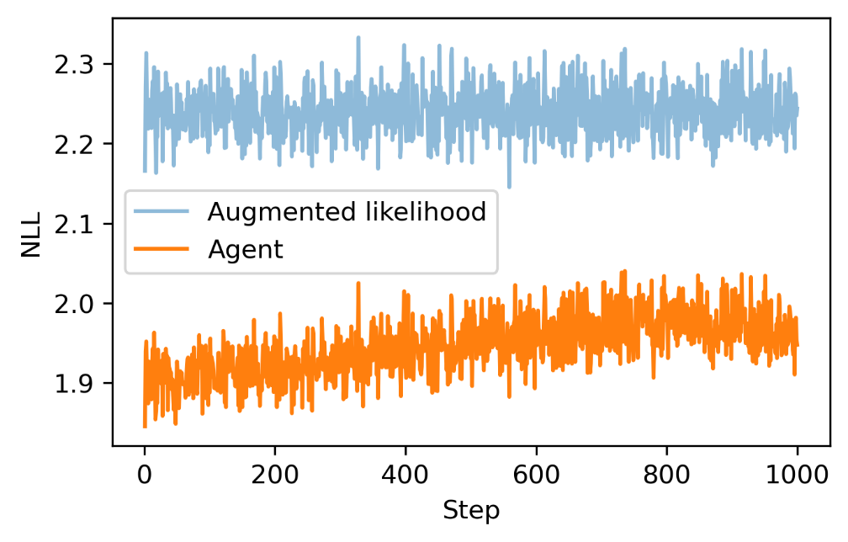
Fig. S1. The NLL curves of the augmented likelihood and “Agent”.

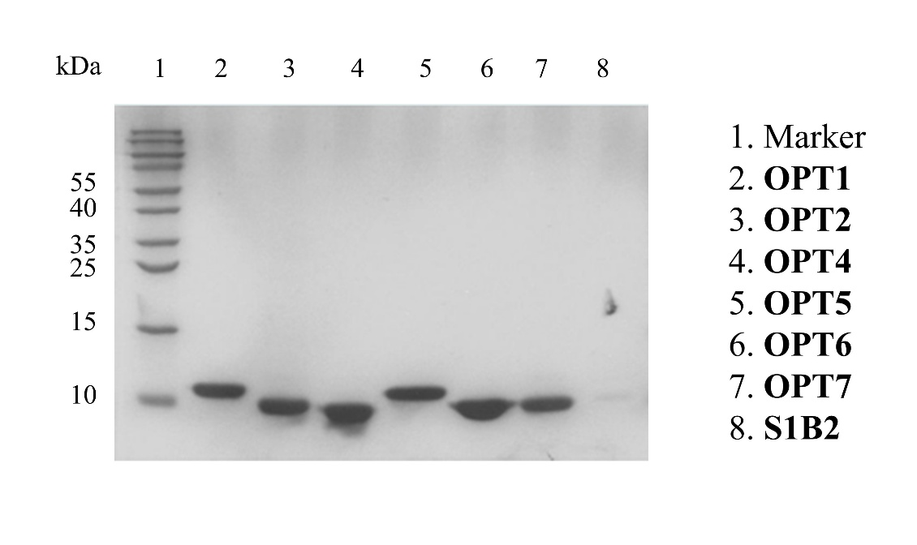
Fig. S2. SDS-PAGE confirming the expression and purification of OPT1, OPT2, OPT4-OPT7, S1B2.

.
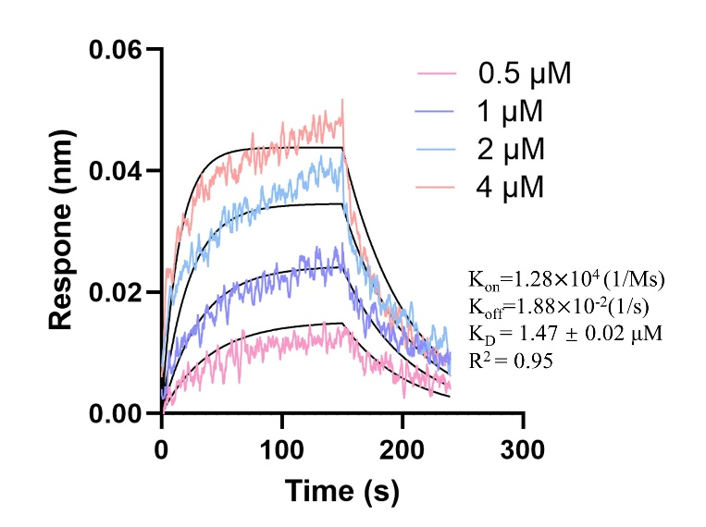
Fig. S3. The binding affinity of S1B2 to human TNFR1 was determined using biolayer interferometry.

Fig. S4. The OPT6 shows low binding affinity, determined by biolayer interferometry.

Part II. Validation of the ability of ProAffinity-GNN to predict the pK_{D} of minibinders.
To validate the applicability of ProAffinity-GNN for predicting the binding affinity of de novo designed minibinders with a triple-helix fold, we performed a correlation analysis using publicly available data, which remain comparable limited for this class of proteins. We extracted 16 sequences and their experimentally measured comparable dissociation constants (K_{D}) from the work of Berger et al. ¹ (Table S1). The structures of these sequences were predicted using AF3, among which 13 exhibited a predicted local distance difference test (pLDDT) > 80, indicating high model confidence. For these 13 high-confidence structures, the corresponding pK_{D} values were predicted with ProAffinity-GNN. Comparison between predicted and experimental pK_{D} yielded a Pearson correlation (R) coefficient of 0.66, demonstrating a moderate correlation (Fig. S5). This result supports the reliability of ProAffinity-GNN for estimating the relative binding affinity of de novo designed, triple-helix minibinders.

Fig. S5. The correlation between pK_{D} predicted by ProAffinity-GNN and the real pK_{D}. The data was collected from Berger’s work.

Table S1. Details for the 16 sequences from the work of Berger et al. ¹
Name | Sequence | Real K_{D} | real pK_{D} | ProAffinity-GNN predicted pKd | pLDDT
23R-10 | MEEEKYVRELVKKYYEKKLSQPEAVEEIRKYARKKGLEAWKLVWAFMELVKRNI | 370pM | 9.43 | 7.94 | 86.77
23R-15 | MEPEKYVREKVKKYYEGKLSQPEAVEEIRKYARKKGLEAWKLIWHFMQLVKRDI | 1nM | 9.00 | 7.88 | 86.47
23R-24 | NLWQIFYVLNTIYKRTGDPTAKKLNKALREALKKHDEKATKELAKKATKYIRS | 45pM | 10.35 | 8.13 | 86.39
23R-91 | PLWQVFYLLNTCIKRTGDPTCKKLAKALRECLKKGDLKACNELADKAVKYINS | <1pM | 12.00 | 8.31 | 86.31
23R-13 | MEEEKYVRELVKKYYEGKLSHQEAVVEIRKYARKKGLEAWKLVWMFMQLVKRNI | 650pM | 9.19 | 7.80 | 86.30
23R-22 | NLWVIFYLLNTIHKRTGDPTAKKLIKALDEAMKKGDEKATKELAKKALKYIRS | 350pM | 9.46 | 7.37 | 86.13
23R-2 | NLWQIFYQLSTILKRTGDPTAKKLLKALAEALKKGDEKALKELAKKATKYIRS | 34nM | 7.47 | 7.18 | 85.96
23R-19 | NLWQIFYILNTIHKRTGDPTAKKLPKALREAMKKGDEKAMKELAKKALKYIRS | 81nM | 7.09 | 7.69 | 85.53
23R-75 | NLWVIFYLLNTCIKRTGDPTCKKLKKALRECLKKGDEKACKELAKKAMKYIRS | 75pM | 10.12 | 9.23 | 85.25
17-2 | EPREEEAEKYIKRANGDYDLAELLAFLDGNAEIASAIVEYKER | 200nM | 6.70 | 7.32 | 83.74
17-35 | EPREEEAENYIKWAGGDYDLAELMAFLDGNAEAAVAIVRAKER | 3.3nM | 8.48 | 7.14 | 83.08
23R-1 | MESEKYLRELVKKYYEGKLSVQEAVEEVRKYARKKGLEAWMLTWMFMELVKRYI | 26nM | 7.59 | 7.67 | 82.74
17-1 | TWHIDVLAPPEVVKTAASQAGAEVHKAPGDWWRITTDDETAVDIVELILFIAGYQFHISSS | 51nM | 7.29 | 7.28 | 80.66
17-3 | TWHIDVKADPSIVKAAASAAGAEVHKLPGDKWRITVDDETAVDIVELILFIWGVEFHISSS | 47nM | 7.33 | 7.78 | 79.47
17-51 | EPREECVENYIKWAGGDYDLAELMAFLDGNAECAVAIVRAKER | 5.7nM | 8.24 | 6.85 | 69.29
17-53 | EPREECVENYIKWAGGDYDLAELMAFLDGNAECAVAIVRAKERLPASPASPASPASPASPASPASPASEPREECVENYIKWAGGDYDLAELMAFLDGNAECAVAIVRAKER | 10pM | 11.00 | 6.92 | 58.87

References
1. Berger, S. et al. Preclinical proof of principle for orally delivered Th17 antagonist miniproteins. Cell 187, 1-13 (2024).

