Supporting Information

CRP detection using gold nanosensors – effect of layer thickness and immobilization chemistry
Stephan Kastner, Pia Pritzke, Andrea Csáki and Wolfgang Fritzsche*
Department Nanobiophotonics, Leibniz Institute of Photonic Technology (IPHT), Jena, Germany
* wolfgang.fritzsche@leibniz-ipht.de

Table S1: Example CRP-Assay pump plan
Step number | Comment | Reagent | Flowrate [µl/min] | time [s]
1 | immobilization buffer | 10 mM NaAc pH 5 | 10 | 200
2 | capture solution | 0.25 mg/ml α-hCRPc | 5 | 400
3 | immobilization buffer | 10 mM NaAc pH 5 | 10 | 200
4 | blocking solution | 10 mg/ml BSA | 10 | 300
5 | immobilization buffer | 10 mM NaAc pH 5 | 10 | 200
6 | running buffer | PBS | 10 | 300
7 | target solution | 31.2 µg/ml hCRP | 5 | 150
8 | running buffer | PBS | 10 | 300
9 | secondary antibody | 0.25 mg/ml α-hCRPd | 5 | 150
10 | running buffer | PBS | 10 | 300
11 | regeneration solution | 10 mM glycine-HCl pH 2.5 | 10 | 150
12 | running buffer | PBS | 10 | 300

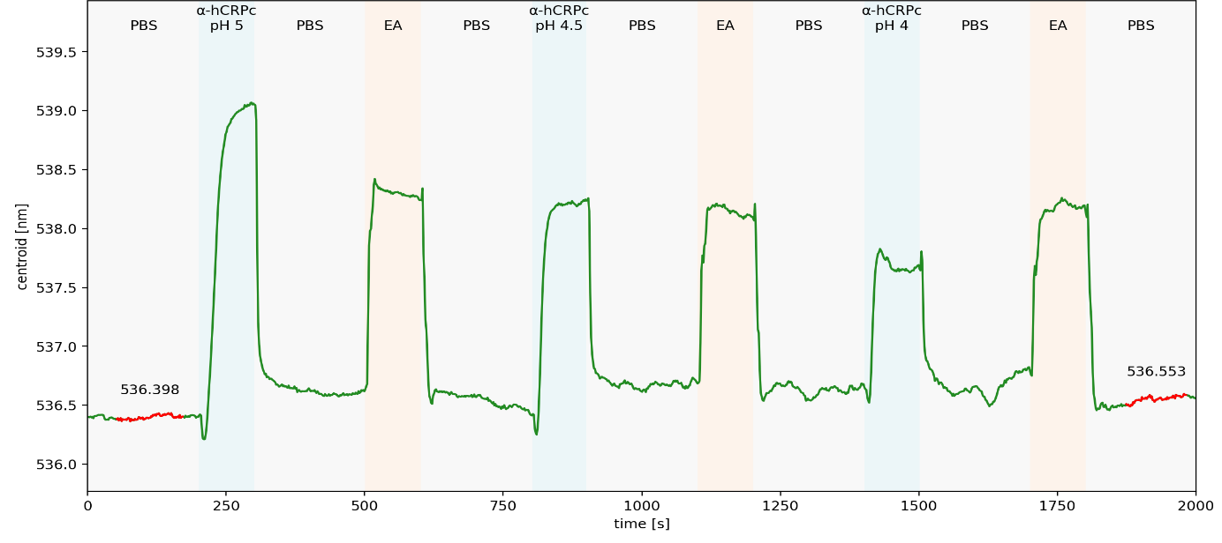
Figure S1
Immobilization scouting (testing various conditions for optimal binding) for EDC/NHS based anti-CRP antibody immobilization on MUA/MUD mixed SAM. Anti-human CRP antibody (α-hCRPc) in 10 mM NaAc buffer with varying pH (pH 4; 4.5 & 5) were compared to find best conditions. PBS = phosphate buffered saline; EA = 1 M ethanolamine hydrochloride pH 8.

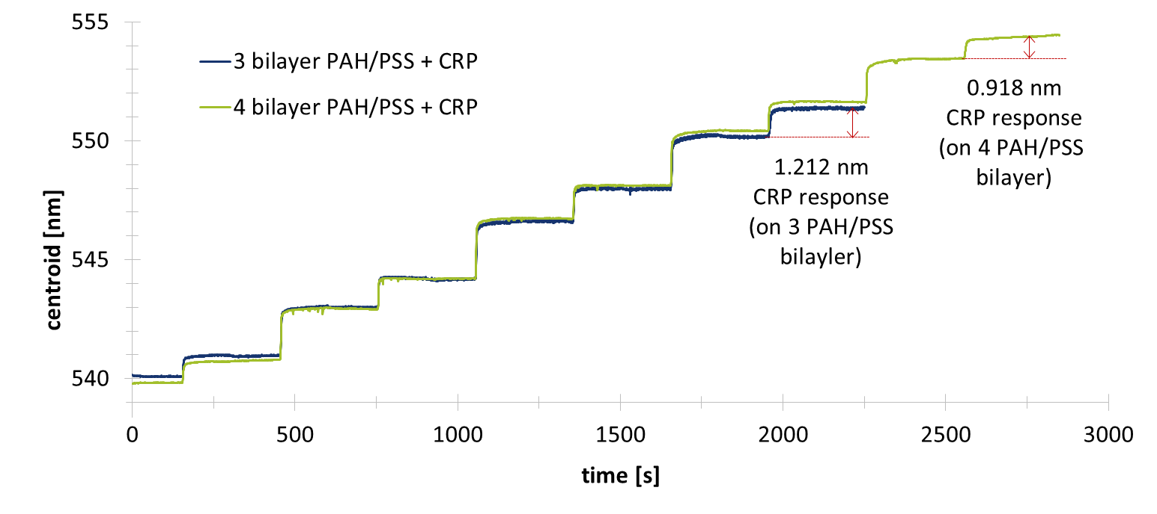
Figure S2
Sensogram of the deposition of 3/4 bilayers PAH/PSS prior to 31 µg/ml CRP. NaCl = 0.5 M sodium chloride; PAH = 2 mg/ml polyallylamine hydrochloride; PSS = 2 mg/ml polystyrene sulfonate; CRP = 31 µg/ml C-reactive protein; all in 0.5 M NaCl.

