Supplementary results

Structural inequities shape biodiversity and climate mitigation outcomes in livestock systems

Ganesh Bhattarai¹, Karen M. Christie-Whitehead², Karel Mokany³, Anna Drake⁴, Christine Chen⁴, Hugh Burley³, Geoff Roberts⁵, Natalie Doran-Browne^{6,7}, Adam Liedloff⁸, Mario Herrero⁹, Ke Liu¹, Robert Waterworth⁵, Rebekah Ash¹, Andrew Smith¹⁰, Michelle Cain¹¹, Lucinda J. Watt¹², Courtney M. Regan^{13,14}, Anthony O'Grady¹⁵, Pete Smith¹⁶, Daniel Mendham¹⁷, Jinfeng Chang¹⁸, Sasha Gennet^{19,20}, Xiaogang Yin²¹, MD Jahangir Kabir ²² and Matthew T. Harrison^{1*}

¹Tasmanian Institute of Agriculture, University of Tasmania, Launceston, TAS 7248, Australia
²Tasmanian Institute of Agriculture, University of Tasmania, Burnie, TAS 7320, Australia
³CSIRO, Canberra, ACT 2601, Australia
⁴Rabobank Australia, Sydney, NSW 2000, Australia
⁵FLINTpro, Canberra, ACT 2601, Australia
⁶Agricultural Research Advisors, New Gisborne, VIC 3438, Australia
⁷Integrity Ag, Melbourne, VIC 3000, Australia
⁸CSIRO Environment, Winnellie, NT 0822, Australia
⁹Cornell University, Ithaca, NY, 14853, USA
¹⁰FarmSystSci Consulting, Norwood, SA 5067, Australia
¹¹Cranfield Environment Centre, Cranfield University, Cranfield, England MK43 OAL, United Kingdom
¹²CSIRO Agriculture & Food, St Lucia, QLD 4067, Australia
¹³CSIRO Agriculture & Food, Urrbrae, SA 5064, Australia
¹⁴CSIRO Towards Net Zero Mission, Canberra, ACT 2601, Australia
¹⁵CSIRO Environment, Sandy Bay, TAS 7005, Australia
¹⁶Institute of Biological and Environmental Sciences, University of Aberdeen, Aberdeen, Scotland AB24 3UU, United Kingdom
¹⁷CSIRO Land and Water, Acton, ACT 2601, Australia
¹⁸College of Environmental and Resource Sciences, Zhejiang University, Hangzhou, 310058, China
¹⁹The Nature Conservancy, Arlington, Virginia 22203, USA
²⁰University of California, Berkeley, California 94720, USA
²¹College of Agronomy and Biotechnology, China Agricultural University, Beijing 100193, China
²²Strategy & Business Development Group, Grains Research and Development Corporation, Toowoomba, QLD, 4350, Australia
*Corresponding author: matthew.harrison@utas.edu.au
Supplementary Information Table S1. Climate, production system, greenhouse gas (GHG) emissions, and profitability characterisation of baseline conditions for six cattle farms (C1–C6) and seven sheep farms (S1–S7) distributed across Australia. Farms are arranged from left to right along a gradient of increasing long-term annual rainfall (highlighted in bold), consistent with analyses presented in the main text (Table 1; Supplementary Methods Fig. S1). Profit values are reported under the low meat price scenario, following the pricing and economic assumptions applied across farms (Supplementary Methods Tables S1–S4). Long-term average rainfall includes irrigation, as determined from SILO climate data spanning 1992–2022. Biodiversity metrics for S5 (WA) are calculated across the total farm area. Negative carbon sequestration values indicate net loss in tree vegetation carbon between 2004 and 2020, consistent with baseline carbon stock simulations. Greenhouse gas emissions are expressed using GWP₁₀₀. State and Territory abbreviations: NSW, New South Wales; NT, Northern Territory; QLD, Queensland; SA, South Australia; TAS, Tasmania; WA, Western Australia; VIC, Victoria. Other abbreviations: AE, adult equivalent (1 AE = 8.4 DSE); AUD, Australian dollars; CFW, clean fleece weight; DSE, dry sheep equivalent; HIS, high-income pricing structure; LIS, low-income pricing structure; LW, live weight; n/a, not applicable. See Methods and Supplementary Methods for further details.
Description | C5 (SA) | C4 (WA) | S5 (WA) | S2 (SA) | S1 (TAS) | C2 (QLD) | S3 (VIC)
Average annual rainfall (mm) | 160 | 245 | 320 | 465 | 480 | 507 | 600
Farm area (ha) | 498,000 | 206,000 | 5,850 | 890 | 7,777 | 5,410 | 690
Grazing area (ha) | 448,200 | 170,380 | 3,484 | 865 | 3,170 | 5,410 | 600
Pasture production (kg DM ha⁻¹ yr⁻¹) | 102 | 424 | 5,291 | 5,480 | 6,915 | 6,380 | 8,242
Stocking rate- total farm area (DSE ha⁻¹) | 0.1 | 0.1 | 1.5 | 4.6 | 3.2 | 1.5 | 14.2
Stocking rate- grazed area (DSE ha⁻¹) | 0.1 | 0.1 | 2.5 | 4.7 | 7.9 | 1.5 | 16.4
Stocking rate- grazed area (AE km⁻²) | 1.3 | 1.5 | 29.1 | 55.8 | 94.2 | 18.3 | 194.9
Annual meat sold (kg) | 575,803 | 212,238 | 173,719 | 130,972 | 285,444 | 161,163 | 190,097
Annual clean fleece wool sold (kg) | n/a | n/a | 10,379 | 6,837 | 78,026 | n/a | 23,063
Annual protein (meat + wool) sold (kg) | 103,645 | 38,203 | 41,648 | 30,412 | 129,406 | 29,009 | 57,280
Protein (meat + wool) sold per ha of grazed area (kg ha⁻¹) | 0.23 | 0.22 | 12.0 | 35.2 | 40.8 | 29.8 | 95.5
Tree carbon stocks on the farm in 2020 (t CO₂eq) | 59 | 1,439,526 | 9,208 | 7,716 | 1,300,655 | 7,775 | 4,795
Effective habitat area in 2020 (ha) | 470,344 | 192,195 | 133 | 37 | 4,812 | 1,517 | 43
Area under high-quality habitat condition in 2020 (ha) | 494,683 | 203,285 | 75 | 27 | 4,568 | 1,608 | 18
Threatened species habitat 2020 (species.ha) | 1,735,110 | 358,484 | 469 | 189 | 55,465 | 234 | 225
Benefit for plant species persistence in 2020 (number of species) | 3.5756 | 0.7605 | 0.0007 | 0.0010 | 0.0479 | 0.0154 | 0.0002
Gross total farm GHG emissions (t CO₂eq yr⁻¹) | 7,825 | 2,891 | 1,593 | 1,315 | 5,935 | 1,794 | 2,159
Carbon sequestration/loss by trees on farm (t CO₂eq yr⁻¹) | -1 | 11,856 | 28 | 19 | -950 | -401 | 71
Net farm GHG emissions (t CO₂eq yr⁻¹) | 7,826 | -8,965 | 1,565 | 1,296 | 6,885 | 2,195 | 2,087
Emissions intensity of meat (excl. sequestration; kg CO₂eq kg LW⁻¹) | 13.6 | 13.6 | 6.9 | 7.8 | 8.3 | 11.1 | 6.8
Emissions intensity of wool (excl. sequestration; kg CO₂eq kg CFW⁻¹) | n/a | n/a | 38.3 | 43.2 | 45.9 | n/a | 37.7
Emissions intensity of meat (incl. sequestration; kg CO₂eq kg LW⁻¹) | 13.6 | -42.2 | 6.8 | 7.7 | 9.6 | 13.6 | 6.6
Emissions intensity of wool (incl. sequestration; kg CO₂eq kg CFW⁻¹) | n/a | n/a | 37.6 | 42.6 | 53.2 | n/a | 36.4
Profit per yr (AUD yr⁻¹; LIS) | 946,299 | 241,789 | 251,623 | 145,361 | 980,908 | 220,459 | 448,991
Profit per ha of total farm area (AUD yr⁻¹) | 1.9 | 1.2 | 64.5 | 163.3 | 126.1 | 40.8 | 650.7
Profit per ha of grazed area (AUD yr⁻¹) | 2.1 | 1.4 | 72.2 | 168.0 | 309.4 | 40.8 | 748.3
Profit per kg of protein (AUD yr⁻¹) | 9.1 | 6.3 | 6.0 | 4.8 | 7.6 | 7.6 | 7.8

Supplementary Information Table S1 cont. Climate, production system, greenhouse gas (GHG) emissions, and profitability characterisation of baseline conditions for six cattle farms (C1–C6) and seven sheep farms (S1–S7) distributed across Australia. Farms are arranged from left to right along a gradient of increasing long-term annual rainfall (highlighted in bold), consistent with analyses presented in the main text (Table 1; Supplementary Methods Fig. S1). Profit values are reported under the low meat price scenario, following the pricing and economic assumptions applied across farms (Supplementary Methods Tables S1–S4). Long-term average rainfall includes irrigation, as determined from SILO climate data spanning 1992–2022. Greenhouse gas emissions are expressed using GWP₁₀₀. Negative carbon sequestration values indicate net loss in tree vegetation carbon between 2004 and 2020, consistent with baseline carbon stock simulations. State and Territory abbreviations: NSW, New South Wales; NT, Northern Territory; QLD, Queensland; SA, South Australia. Other abbreviations: AE, adult equivalent (1 AE = 8.4 DSE); AUD, Australian dollars; CFW, clean fleece weight; DSE, dry sheep equivalent; HIS, high-income pricing structure; LIS, low-income pricing structure; LW, live weight; n/a, not applicable. See Methods and Supplementary Methods for further details.
Description | S7 (SA) | C6 (NT) | S6 (VIC) | C3 (NSW) | S4 (NSW) | C1 (QLD)
Avg. annual rainfall (mm) | 625 | 635 | 720 | 738 | 800 | 870
Farm area (ha) | 2,000 | 231,400 | 495 | 910 | 250 | 650
Grazing area (ha) | 1,880 | 98,470 | 440 | 736 | 160 | 390
Pasture production (kg DM ha⁻¹ yr⁻¹) | 12,296 | 1,586 | 12,374 | 6,715 | 12,465 | 2,903
Stocking rate: total farm area (DSE ha⁻¹) | 27.9 | 0.2 | 21.9 | 5.6 | 3.8 | 1.9
Stocking rate: grazed area (DSE ha⁻¹) | 29.7 | 0.4 | 24.6 | 7.0 | 5.9 | 3.1
Stocking rate: grazed area (AE km⁻²) | 353.1 | 4.6 | 293.1 | 82.8 | 70.5 | 40.0
Annual meat sold (kg) | 1,122,333 | 374,482 | 117,308 | 100,613 | 14,799 | 26,810
Annual clean fleece wool sold (kg) | 85,918 | n/a | 30,488 | n/a | 2,097 | n/a
Annual protein (meat + wool) sold (kg) | 287,938 | 67,407 | 51,604 | 18,110 | 4,761 | 4,826
Protein (meat + wool) sold per ha of grazed area (kg ha⁻¹) | 153.2 | 0.68 | 117.3 | 24.6 | 29.80 | 12.4
Tree carbon stocks on the farm in 2020 (t CO₂eq) | 407 | 1,599,315 | 7,530 | 109,481 | 19,872 | 118,112
Effective habitat area in 2020 (ha) | 10 | 223,373 | 16 | 221 | 93 | 564
Area under high-quality habitat condition in 2020 (ha) | 0 | 231,200 | 7 | 173 | 70 | 539
Threatened species habitat 2020 (species.ha) | 11 | 674,716 | 141 | 2,003 | 1,345 | 8,115
Benefit for plant species persistence in 2020 (number of species) | 0.0008 | 0.7211 | 0.0001 | 0.0004 | 0.0005 | 0.0225
Gross total farm GHG emissions (t CO₂eq yr⁻¹) | 11,226 | 6,885 | 2,601 | 1,232 | 226 | 174
Carbon sequestration/loss by trees on farm (t CO₂eq yr⁻¹) | 4 | -3,345 | -267 | -45 | 56 | 166
Net farm GHG emissions (t CO₂eq yr⁻¹) | 11,222 | 10,230 | 2,867 | 1,277 | 170 | 9
Emissions intensity of meat (excl. sequestration; kg CO₂eq kg LW⁻¹) | 7.0 | 18.4 | 9.1 | 12.2 | 8.6 | 6.5
Emissions intensity of wool (excl. sequestration; kg CO₂eq kg LW⁻¹) | 39.0 | n/a | 50.4 | n/a | 47.6 | n/a
Emissions intensity of meat (incl. sequestration; kg CO₂eq kg LW⁻¹) | 7.0 | 27.3 | 10.0 | 12.7 | 6.4 | 0.3
Emissions intensity of wool (incl. sequestration; kg CO₂eq kg LW⁻¹) | 39.0 | n/a | 55.6 | n/a | 35.7 | n/a
Profit per yr (AUD yr⁻¹) | 1,802,517 | 253,222 | 656,231 | 103,261 | 65,345 | 43,378
Profit per ha of total farm area (AUD yr⁻¹) | 901.3 | 1.1 | 1,325.7 | 113.5 | 261.4 | 66.7
Profit per ha of grazed area (AUD yr⁻¹) | 958.8 | 2.6 | 1,491.4 | 140.3 | 408.4 | 111.2
Profit per kg of protein (AUD yr⁻¹) | 6.3 | 3.8 | 12.7 | 5.7 | 13.7 | 9.0

Supplementary Information Table S2. Simulated changes in baseline vegetation area (ha) and associated carbon stocks (t CO₂) for six cattle farms (C1–C6) and seven sheep farms (S1–S7) distributed across Australia. Simulations were derived from spatially explicit dynamic vegetation modelling implemented in FLINTpro from 2005 to 2021 (Supplementary Methods Figs. S4–S6). Negative changes in forest area indicate net loss of forested land (e.g., due to deforestation, senescence, or land-use conversion). Negative changes in carbon stocks reflect net emissions (positive GHG contribution) from tree vegetation. These data were incorporated into baseline carbon stocks and subsequent farm-level greenhouse gas accounting. Greenhouse gas emissions are expressed using GWP₁₀₀. State and Territory abbreviations: NSW, New South Wales; NT, Northern Territory; QLD, Queensland; SA, South Australia; TAS, Tasmania; WA, Western Australia. See Methods and Supplementary Methods for further details.
Case study farm | Forest area 2005 (ha) | Forest area 2021 (ha) | Change in forest area (ha) | Carbon stocks 2005 (t CO₂) | Carbon stocks 2021 (t CO₂) | Change in carbon stocks (t CO₂) | Annual net change  (t CO₂ yr⁻¹)
C1 (QLD) | 621 | 607 | -14 | 115,459 | 118,105 | 2,646 | 165
C2 (QLD) | 105 | 53 | -52 | 14,180 | 7,765 | -6,415 | -401
C3 (NSW) | 215 | 229 | 14 | 110,197 | 109,481 | -717 | -45
C4 (WA) | 48,268 | 71,188 | 22,920 | 1,249,825 | 1,439,530 | 189,704 | 11,857
C5 (SA) | 5 | 15 | 10 | 77 | 58 | -19 | -1
C6 (NT) | 19,667 | 19,043 | -625 | 1,652,821 | 1,599,316 | -53,504 | -3,344
S1 (TAS) | 4,132 | 4,205 | 73 | 1,315,940 | 1,300,665 | -15,284 | -955
S2 (SA) | 46 | 49 | 3 | 7,419 | 7,718 | 299 | 19
S3 (VIC) | 38 | 41 | 3 | 3,652 | 4,795 | 1,143 | 71
S4 (NSW) | 90 | 99 | 9 | 18,959 | 19,871 | 912 | 57
S5 (WA) | 62 | 61 | -1 | 8,766 | 9,210 | 444 | 28
S6 (VIC) | 24 | 25 | 1 | 11,783 | 7,534 | -4,249 | -266
S7 (SA) | 12 | 9 | -3 | 333 | 405 | 71 | 4

Supplementary Information Table S3. Simulated greenhouse gas abatement potential associated with planting native tree species on 10% of grazing area for six cattle farms (C1–C6) and seven sheep farms (S1–S7) distributed across Australia. Potentially eligible area denotes the maximum land area suitable for conversion to native tree plantings, while area of trees planted represents the area implemented in the simulations. Average abatement refers to mean annual carbon sequestration per hectare over a 25-year period, and total abatement represents the corresponding average annual abatement associated with the area planted. Abatement values derived from spatially explicit vegetation modelling implemented in FLINTpro and were incorporated into farm-level greenhouse gas accounting to evaluate the mitigation potential of land-use change interventions. Greenhouse gas emissions are expressed using GWP₁₀₀. State and Territory abbreviations: NSW, New South Wales; NT, Northern Territory; QLD, Queensland; SA, South Australia; TAS, Tasmania; WA, Western Australia. See Methods and Supplementary Methods for further details.
Case study farm | Potentially eligible area (ha) | Abatement potential after 25 years (t CO₂) | Average abatement  (t CO₂ ha⁻¹ yr⁻¹) | Area of trees planted (ha) | Total abatement  (t CO₂ yr⁻¹)
C1 (QLD) | 85 | 14,187 | 6.7 | 39 | 260
C2 (QLD) | 5,592 | 919,094 | 6.6 | 541 | 3,557
C3 (NSW) | 669 | 288,123 | 17.2 | 74 | 1,275
C4 (WA) | 125,535 | 2,801,356 | 0.9 | 17,000 | 15,174
C5 (SA) | 496,947 | 6,012,685 | 0.5 | 44,820 | 21,692
C6 (NT) | 191,316 | 12,926,335 | 2.7 | 9,847 | 26,613
S1 (TAS) | 4,213 | 819,936 | 7.8 | 317 | 2,468
S2 (SA) | 867 | 135,630 | 6.2 | 92 | 541
S3 (VIC) | 660 | 79,514 | 4.8 | 60 | 289
S4 (NSW) | 159 | 32,644 | 8.2 | 16 | 131
S5 (WA) | 5,640 | 699,149 | 5.0 | 348.8 | 1,728
S6 (VIC) | 498 | 212,110 | 17.0 | 44 | 750
S7 (SA) | 1,914 | 133,898 | 2.8 | 188 | 526
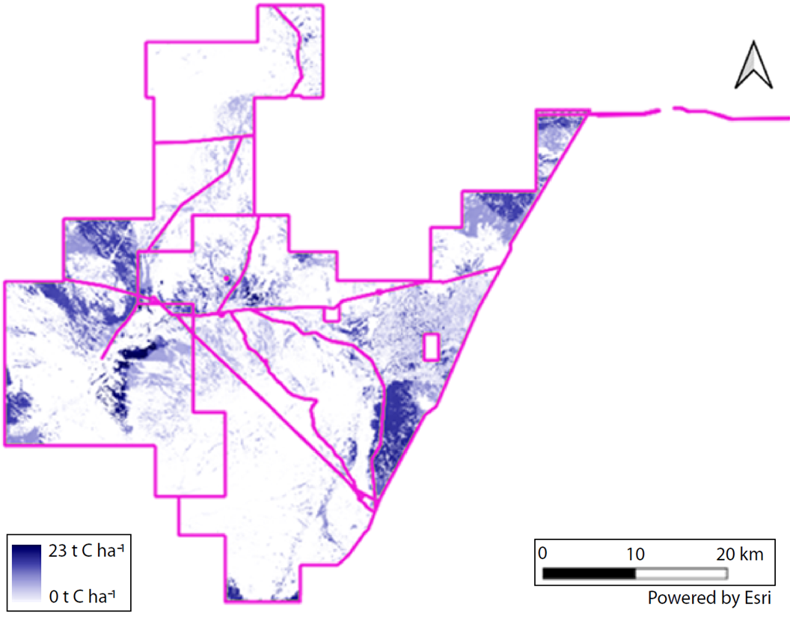
Supplementary Information Fig. S1. Spatially explicit baseline vegetation carbon stocks for farm C4 (Western Australia) in 2021. Carbon stocks were derived from dynamic vegetation modelling implemented in FLINTpro. See Methods and Supplementary Methods for further details.
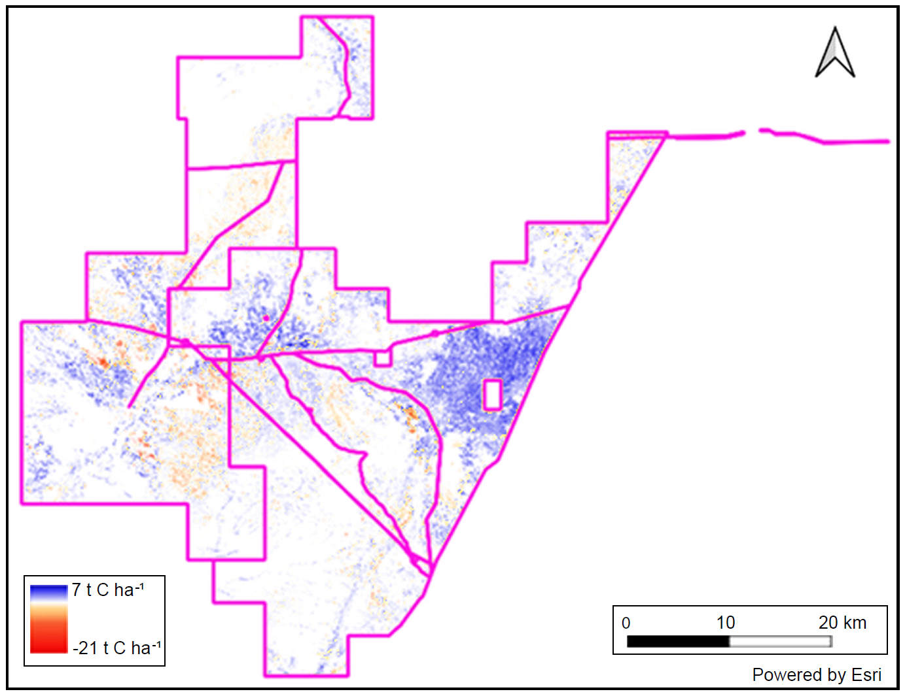
Supplementary information Fig. S2. Spatially explicit baseline carbon fluxes averaged over 2005–2021 for farm C4 (Western Australia). Positive values denote net carbon sequestration (carbon sinks), while negative values represent net carbon losses (carbon sources). Carbon fluxes were derived from dynamic vegetation modelling implemented in FLINTpro and reflect mean long-term changes in vegetation carbon stocks on the property. See Methods and Supplementary Methods for further details.
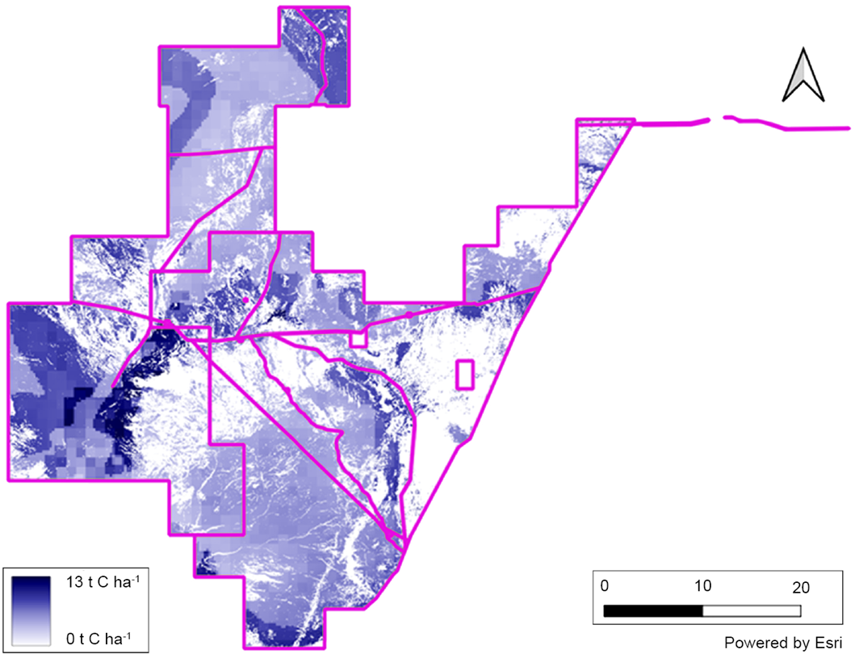
Supplementary information Fig. S3. Cumulative spatially explicit carbon abatement for farm C4 (Western Australia) over a 25-year period following establishment of native tree vegetation. Abatement was simulated using dynamic vegetation modelling implemented in FLINTpro, capturing both above- and below-ground carbon stock changes associated with tree growth and land-use change. See Methods and Supplementary Methods for further details.
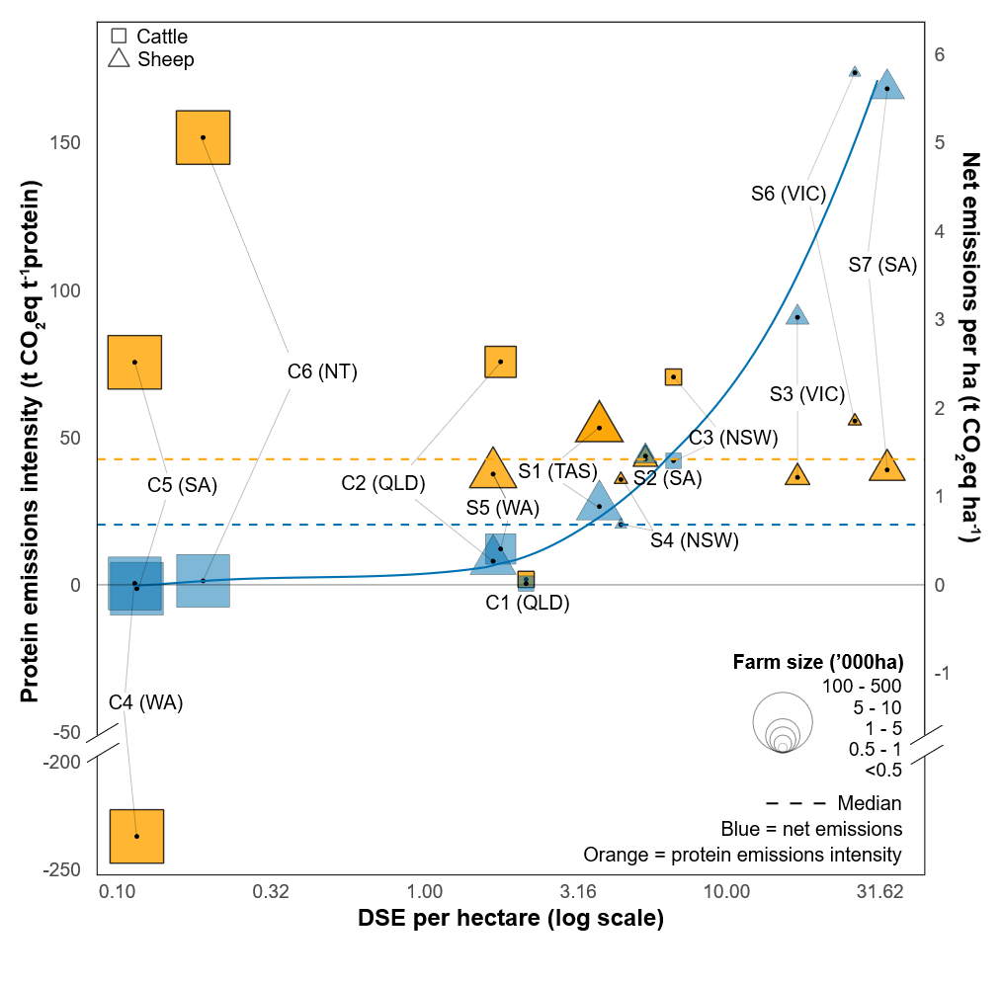
Supplementary information Fig. S4. Relationship among protein emissions intensity (EI; t CO₂ eq t protein⁻¹), net farm greenhouse gas (GHG) emissions (t CO₂ eq ha⁻¹), stocking rate (DSE ha⁻¹; log scale), and farm size for cattle (C1–C6) and sheep (S1–S7) farms. The blue curve shows a quadratic regression of net emissions (y) per hectare against log stocking rate (x) (y= -0.0028x² + 0.2964 x- 0.135; R² = 0.968; n = 13). Dashed lines indicate median net emissions per hectare (blue) and median protein EI (orange). Bubble size is scaled to farm area. Thin grey lines link farm net emissions to corresponding protein EI value for visual reference. Baseline emissions include CO₂-equivalent fluxes from vegetation carbon sequestration between 2004 and 2021. Greenhouse gas emissions are expressed using GWP₁₀₀; protein production includes wool and meat. DSE, dry sheep equivalents. State and Territory abbreviations: NSW, New South Wales; NT, Northern Territory; QLD, Queensland; SA, South Australia; TAS = Tasmania; VIC, Victoria; WA, Western Australia. See Methods and Supplementary Methods for further details.
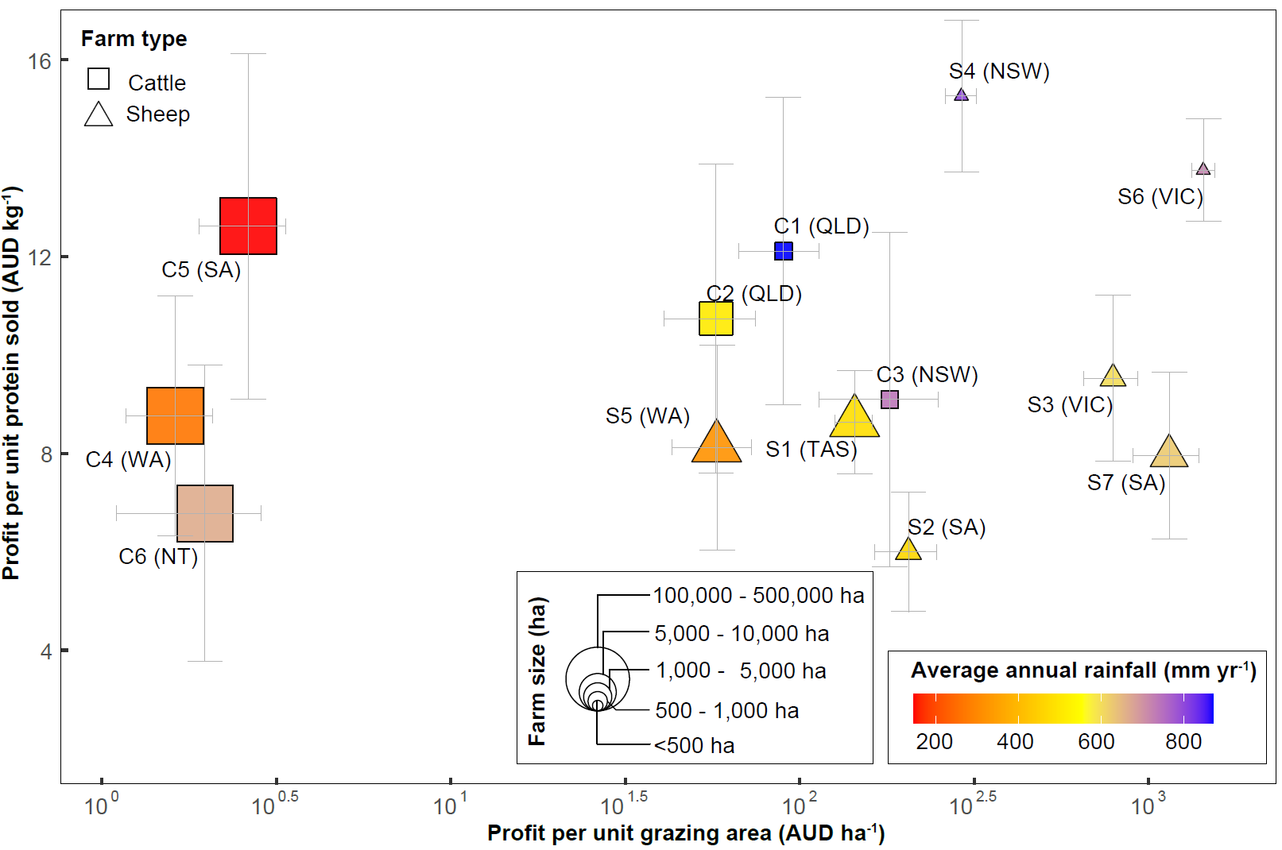Supplementary Information Fig. S5. Relationship between baseline gross margin per unit protein sold (AUD kg⁻¹) and per unit area (AUD ha⁻¹; log scale) across sheep (S1–S6; triangles) and cattle (C1–C7; squares) farms, shown in relation to rainfall and farm size. Horizontal error bars represent standard error of the area gross margin mean, while vertical error bars denote 25th and 75th percentile meat and wool price scenarios (n = 60). Bubble size is scaled in proportion to total farm area; point colour represents average annual rainfall. Greenhouse gas emissions are expressed using GWP₁₀₀; protein production includes wool and meat. State and Territory abbreviations: NSW, New South Wales; NT, Northern Territory; QLD, Queensland; SA, South Australia; TAS = Tasmania; VIC, Victoria; WA, Western Australia. See Methods and Supplementary Methods for further details.
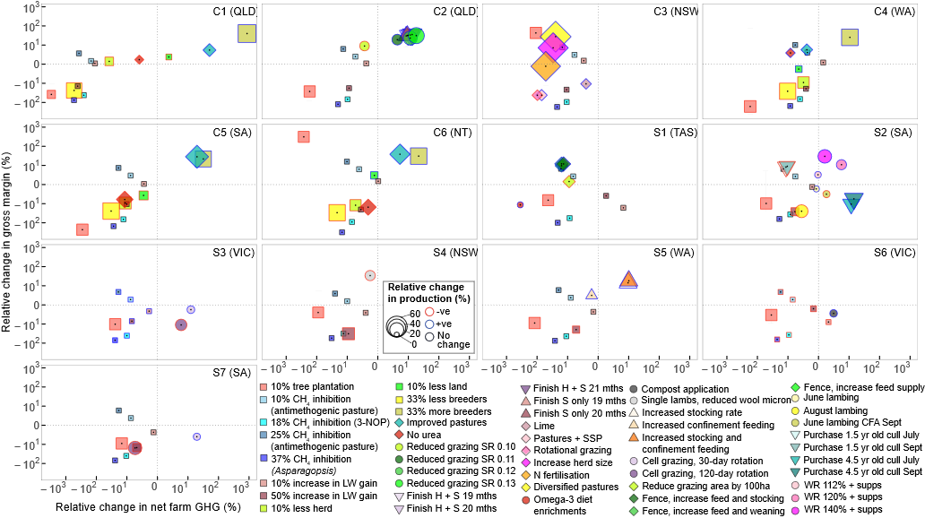
Supplementary information Fig. S6. Long-term average changes in profit, production, and net farm greenhouse gas (GHG) emissions relative to baseline conditions for 50 intervention scenarios. Data show relative changes in profit, production, and net farm GHG emissions for six cattle farms (C1–C6) and seven sheep farms (S1–S7) distributed across Australia. Bubble size represents the relative change in annual protein production compared with baseline conditions, while bubble outlines indicate the direction of change. Error bars indicate the range of profit outcomes under the 25th and 75th percentile price scenarios for wool and meat, while points represent mean outcomes based on average livestock and carbon prices across years (n = 60). Greenhouse gas emissions are expressed using GWP₁₀₀; protein production includes wool and meat. State and Territory abbreviations: QLD = Queensland; NSW = New South Wales; WA = Western Australia; SA = South Australia; NT = Northern Territory; VIC = Victoria; TAS = Tasmania. Other abbreviations: 3-NOP = 3-nitrooxypropanol; LW = liveweight; CFA = cast for age; Cull = culling month of old ewes; H = heifers; S = steers; SR = stocking rate; SSP = single superphosphate; supps = supplementary feeding; WR = weaning rate (average lambs born per ewe across the flock). See Table 1 and Supplementary Methods for further details.

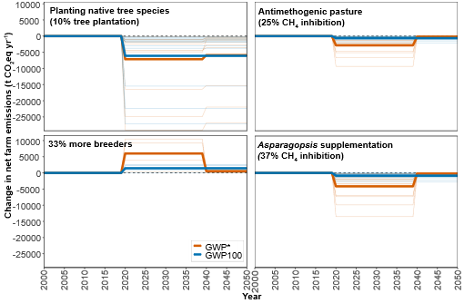
Supplementary Information Fig. S7. Net farm greenhouse gas (GHG) trajectories from 2000 to 2050 calculated using 100-year global warming potential metrics accounting for cumulative warming over 100 years (GWP₁₀₀; solid blue lines) and warming associated with short-lived climate pollutants (GWP*; solid orange lines) for four interventions commencing in 2020 and continuing thereafter. Thin lines depict GHG profiles of 13 individual farms, while bold lines show the arithmetic mean across all farms for each GWP metric. Panels show carbon dioxide removal interventions (planting native tree species, top left), enteric methane inhibition (top right and bottom right) and whole-farm methane reduction (bottom left). Farm operations were assumed as business-as-usual between 2000 and 2019. See Methods and Supplementary Methods for further details.
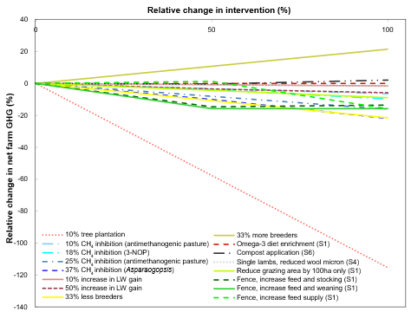
Supplementary Fig. S8. Sensitivity of interventions on net farm greenhouse gas (GHG) emissions for six cattle farms (C1–C6) and seven sheep farms (S1–S7) distributed across Australia. A relative change in an intervention of 100% corresponds to values reported in Table 1. Lines represent individual thematic and demand-driven interventions. Interventions include planting native tree species on 10% of grazing area, 10–50% improvement in liveweight gain, enteric methane inhibition via anti-methanogenic pasture or feed additives (10%, 18%, 25%, 37%), breeder adjustments (± 33% relative to baseline), and farm-specific practices including fencing off native vegetation, enrichment of pregnant ewe diets with omega-3 fatty acids, and substitution of synthetic fertilisers with organic compost application. Greenhouse gas emissions are expressed using GWP₁₀₀. Sample sizes were n = 360 for the first seven listed interventions (i.e. 10% Tree plantation through to 50% increase in LW gain), n = 90 for the two breeder adjustments, and n = 30 for remaining seven single-farm interventions (i.e. from omega-3 rich diets to Fence, increase feed supply). See Methods and Supplementary Methods for further details.

