Metabolic Reprogramming of Endothelial-Related Pathways in COVID-19 Patients Treated with Hyperbaric Oxygen Therapy: A Randomized Clinical Trial
Natalia Jermakow ¹; Klaudia Brodaczewska ²; Jacek Kot ³; Krzysztof Urbanowicz ⁴; Jacek Turyn ⁴; Ryszard T. Smoleński ⁴; Arkadiusz Lubas ⁵; Krzysztof Kłos ⁶; Jacek Siewiera ¹

¹ Department of Hyperbaric Medicine, Military Institute of Medicine – National Research Institute, Szaserow 128, 04-141 Warsaw, Poland
² The Laboratory of Molecular Oncology and Innovative Therapies, Military Institute of Medicine – National Research Institute, Szaserow 128, 04-141 Warsaw, Poland
³ National Centre for Hyperbaric Medicine, Institute of Maritime and Tropical Medicine, Medical University of Gdansk, Powstania Styczniowego 9B, 81-519 Gdynia, Poland
⁴ Department of Biochemistry Medical University of Gdańsk, Dębinki 1, 80-211, Gdańsk, Poland
⁵ Department of Internal Diseases Nephrology and Dialysis, Military Institute of Medicine – National Research Institute, Szaserow 128, 04-141 Warsaw, Poland
⁶ Department of Internal Medicine, Infectious Diseases and Allergology, Military Institute of Medicine – National Research Institute, Szaserow 128, 04-141 Warsaw, Poland

Corresponding author: Natalia Jermakow Department of Hyperbaric Medicine, Military Institute of Medicine – National Research Institute, Szaserow 128, 04-141 Warsaw, Poland
E-mail: njermakow@gmail.com

Supplementary Materials
On Fig. S1, panels A–B display Spearman correlation matrices for the HBOT and control groups (log₁₊p-transformed values). Under HBOT, the correlation structure was denser and more cohesive, especially among metabolites of the arginine–urea cycle, phosphatidylserines, and creatine-related compounds. Several cross-pathway correlations emerged, connecting guanidino and phospholipid metabolites, suggesting an integrated metabolic adjustment involving endothelial nitric-oxide regulation and membrane remodeling. In contrast, the control group exhibited a sparser, locally restricted correlation structure, dominated by intra-class lipid associations.
Panels C–D show the corresponding correlation networks (r > 0.5, p < 0.05). The HBOT network displayed a higher number of significant edges and more interconnected clusters, indicating enhanced coordination between energy- and membrane-related metabolism. Notably, new inverse correlations between redox and methylation pathways imply compensatory remodeling rather than uniformly beneficial regulation.

Fig. S2 summarizes log₁₊p Pareto-scaled metabolite intensities assigned to pathways based on KEGG and HMDB annotations as well as known biochemical interrelationships:
- Arginine & Urea Cycle / Guanidino Metabolism: DL-Arginine, Homo-L-Arginine, Homocitrulline, Glycocyamine
- Creatine & Derivatives: Creatine Riboside
- Choline / Glycerophospholipid Metabolism: Alpha-GPC, Choline, Glycerophospho-N-Palmitoyl Ethanolamine, PE (0:0/18:3(6Z,9Z,12Z))
- Phosphatidylserines / Membrane Turnover: PS (O-18:0/0:0), PS (O-16:0/0:0)
- Pterin & Folate Pathways: Xanthopterin, 7,8-Dihydroxanthopterin
- Purine Metabolism: Uric Acid, Succinyladenosine
- Tryptophan / Indole / Serotonin Pathways: 4-Hydroxytryptophan, N-Methyltryptamine, HIAA, Tryptophan, DL-Tryptophan
- Histidine / Imidazole Intermediates: Imidazolepropionic Acid, Imidazole-4-Pyruvic Acid
- Carnitine Shuttle & Fatty Acid Oxidation: Acetyl-L-Carnitine, Octadecenoylcarnitine, Linoleyl Carnitine, Gamma-Linolenyl Carnitine, Cervonyl Carnitine
- Amino Acids (Threonine / Methionine / Sulfur): L-Threonine, 2-Aminobutanoic Acid, Acetyl-L-Methionine
- Bile Acids / Steroid & Vitamin D Metabolism: Cortisone, 1α-Hydroxy-22-Oxavitamin D₃ / 1α-Hydroxy-22-Oxacholecalciferol (or similar isomer)
- Gut Microbiota Co-Metabolites: Hippuric Acid
At baseline (panel A), HBOT and control groups did not differ significantly.
By mid-treatment (panel B) and particularly by Day 10 (panel C), HBOT induced significant shifts within the arginine/urea-cycle, creatine, and phospholipid pathways, consistent with the main dataset results.
These changes reflect coordinated late-phase remodeling, whereas tryptophan/indole, histidine/imidzazole, and bile-acid–related pathways remained largely unchanged, indicating that HBOT selectively affects endothelial and mitochondrial metabolism rather than global amino-acid turnover. Overall, these supplementary results confirm that HBOT promotes a tighter metabolic network and targeted pathway coordination while preserving heterogeneity and evidence of compensatory redox responses.
Fig. S1. Pathway-level correlation structure and networks under HBOT and control conditions. (A–B) Spearman correlation matrices (log₁₊p values) for metabolites. White cells indicate non-significant correlations (p > 0.05). (C–D) Correlation networks showing only significant correlations (r > 0.5, p < 0.08). Edges represent significant correlations (green = positive, magenta = negative; HBOT demonstrates greater interconnectivity across arginine, creatine, and phospholipid metabolism compared to controls.
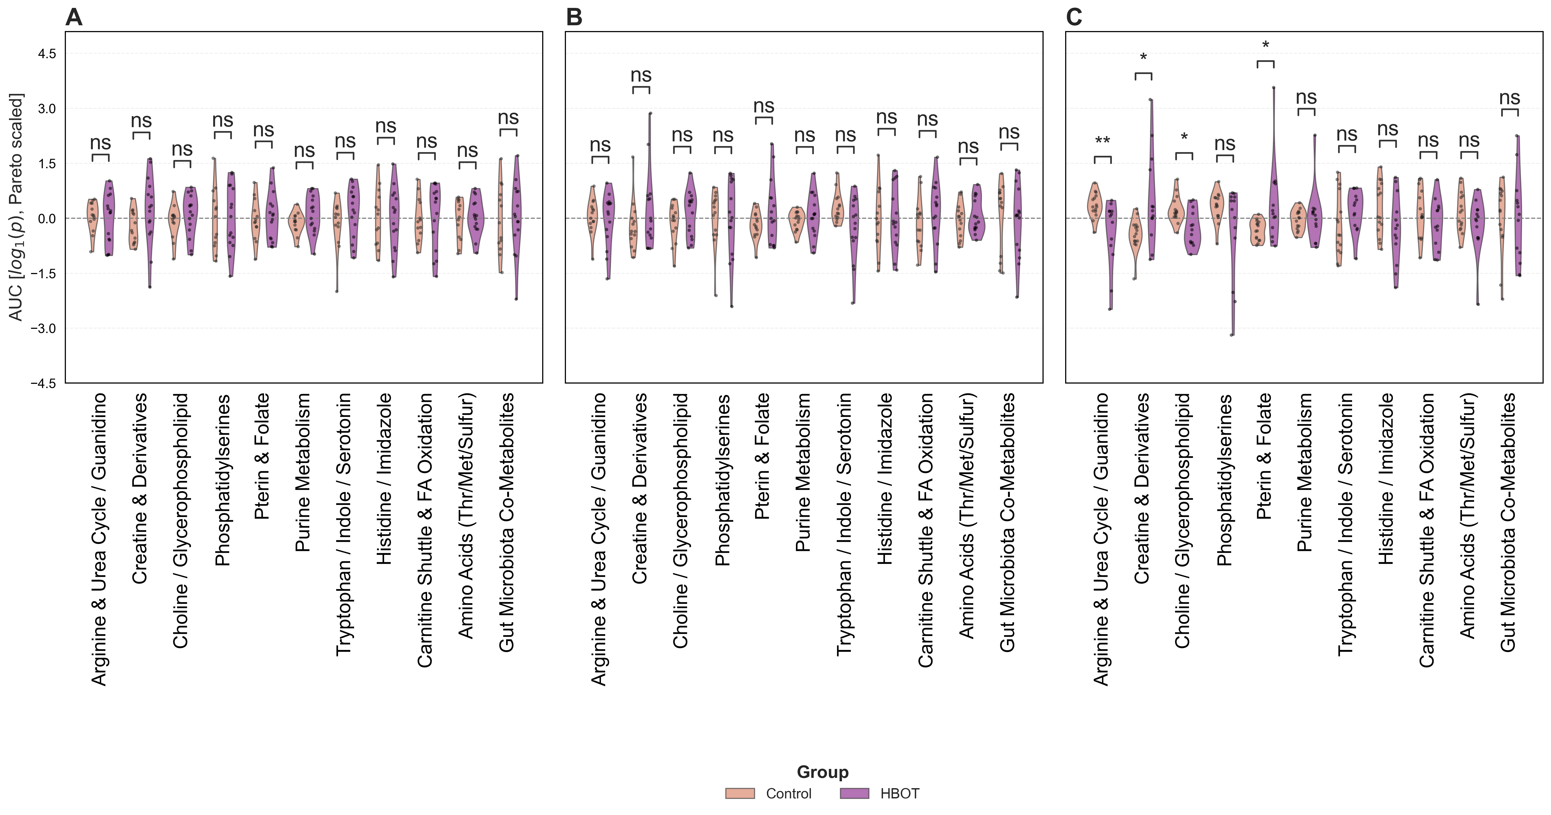

Fig. S2. Log₁₊p Pareto-scaled metabolite intensities in metabolic pathways at day 1 (A), 5 (B), 10 (C)

