Supplementary materials
Supplementary Methods S1. Feature Extraction of Radiomics
The traditional radiomics features were extracted using the PyRadiomics 2.2.0 toolkit. The features included 8 first-order features, 18 two-dimensional shape features, 24 gray-level co-occurrence matrix (GLCM) features, 16 gray-level size zone matrix (GLSZM) features, 16 gray-level run length matrix (GLRLM) features, 5 neighboring gray tone difference matrix (NGTDM) features, and 14 gray-level dependence matrix (GLDM) features. We selected nine filters, including wavelet, Laplacian of Gaussian (LoG), square, square root, logarithm, exponential, gradient, and local binary pattern of two dimensions (LBP2D). The sigma values of the selected Gaussian Laplacian filter were 1 and 5. In total, 1589 radiomics features were extracted for each sequence. The intra-class and inter-class correlation coefficients (ICC) were calculated between the same radiologist at two time points and between the two radiologists. Features with an ICC greater than 0.75 were included in subsequent analyses.

Supplementary Table S1. Summary of Multicenter MRI Scanning Sequence Parameters
Parameters | T2WI | T2-FLAIR | T1CE | DWI
MR scanner A（Center A, Siemens MAGNETOM Avanto 1.5T）
TR (ms) | 4400 | 8000 | 2300 | 3500
TE (ms) | 107 | 90 | 8 | 89
Flip angle (°) | 120 | 150 | 120 | NA
Slice thickness (mm) | 5 | 5 | 5 | 5
Slice gap (mm) | 1.5 | 1.5 | 1.5 | 1.5
Matrix | 256×256 | 256×256 | 320×320 | 192×192
FOV (mm²) | 230×230 | 230×230 | 230×230 | 230×230
b-value (s/mm²) | NA | NA | NA | 1000
MR scanner B（Center A, GE SIGNA Pioneer 3.0T）
TR (ms) | 4618 | 8000 | 3000 | 3739
TE (ms) | 120 | 90 | 24 | 80
Flip angle (°) | 111 | 160 | 111 | NA
Slice thickness (mm) | 5 | 5 | 5 | 5
Slice gap (mm) | 1.5 | 1.5 | 1.5 | 1.5
Matrix | 320×320 | 320×320 | 320×320 | 128×128
FOV (mm²) | 240×240 | 240×240 | 240×240 | 240×240
b-value (s/mm²) | NA | NA | NA | 1000
MR scanner C（Center B, Philips Achieva 1.5T）
TR (ms) | 4000 | 8000 | 2800 | 4000
TE (ms) | 120 | 100 | 20 | 80
Flip angle (°) | 110 | 140 | 120 | NA
Slice thickness (mm) | 5 | 5 | 5 | 5
Slice gap (mm) | 1.5 | 1.5 | 1.5 | 1.5
Matrix | 320×320 | 384×320 | 320×320 | 192×192
FOV (mm²) | 240×240 | 240×240 | 240×240 | 240×240
b-value | NA | NA | NA | 1000
Note: T2WI= T2-weighted imaging; T2-FLAIR= T2-weighted fluid-attenuated inversion recovery; T1CE= T1-weighted imaging with contrast enhancement; DWI= diffusion-weighted imaging; MR= magnetic resonance; TR= repetition time; TE= echo time; FOV= field of view

Supplementary Table S2. Summary of performance results for each model
Sets | Signature/Model | AUC (95% CI) | Acc, % | Sen, % | Spe, % | Pre, % | F1_{max}
Training | DLRN | 0.907 (0.867-0.946) | 82.3 | 79.7 | 88.3 | 94.2 | 0.900
 | Clinical | 0.688 (0.621-0.749) | 65.5 | 63.6 | 70.0 | 83.5 | 0.831
 | T2-FLARI signature | 0.598 (0.532-0.665) | 58.1 | 57.3 | 60.0 | 77.4 | 0.831
 | T1CE signature | 0.812 (0.759-0.862) | 69.0 | 57.3 | 96.7 | 97.6 | 0.849
 | ADC signature | 0.805 (0.749-0.857) | 69.5 | 62.2 | 86.7 | 91.8 | 0.859
 | Radiomics | 0.643 (0.576-0.709) | 70.9 | 80.4 | 48.3 | 78.8 | 0.827
 | DL | 0.810 (0.754-0.862) | 77.8 | 80.4 | 71.7 | 87.1 | 0.878
 | Rc | 0.588 (0.522-0.655) | 57.6 | 55.9 | 61.7 | 77.7 | 0.827
 | Rd | 0.708 (0.645-0.768) | 70.4 | 69.9 | 71.7 | 85.5 | 0.827
 | DLRN-assisted Rc | 0.776 (0.719-0.833) | 77.3 | 76.9 | 78.3 | 89.4 | 0.827
 | DLRN-assisted Rd | 0.826 (0.773-0.877) | 80.3 | 76.9 | 88.3 | 94.0 | 0.846
Test | DLRN | 0.873 (0.800-0.933) | 85.6 | 89.2 | 76.0 | 90.6 | 0.905
 | Clinical | 0.630 (0.533-0.733) | 73.3 | 84.6 | 44.0 | 79.7 | 0.844
 | T2-FLAIR signature | 0.562 (0.456-0.667) | 67.8 | 76.9 | 44.0 | 78.1 | 0.839
 | T1CE signature | 0.714 (0.622-0.800) | 71.1 | 67.7 | 80.0 | 89.8 | 0.846
 | ADC signature | 0.830 (0.744-0.900) | 67.8 | 58.5 | 92.0 | 95 | 0.881
 | Radiomics | 0.617 (0.511-0.711) | 66.7 | 64.6 | 72.0 | 85.7 | 0.844
 | DL | 0.814 (0.733-0.889) | 73.3 | 70.8 | 80.0 | 90.2 | 0.901
 | Rc | 0.660 (0.556-0.756) | 63.3 | 60.0 | 72.0 | 84.8 | 0.839
 | Rd | 0.686 (0.598-0.778) | 68.9 | 69.2 | 68.0 | 84.9 | 0.839
 | DLRN-assisted Rc | 0.775 (0.689-0.856) | 80.0 | 83.1 | 72.0 | 88.5 | 0.857
 | DLRN-assisted Rd | 0.825 (0.744-0.900) | 80.0 | 76.9 | 88.0 | 94.3 | 0.847
Note: DLRN=deep learning radiomics nomogram; T1CE=T1-weighted contrast-enhanced imaging; ADC=apparent diffusion coefficient; DL=deep learning; Rc=radiologist c; Rd=radiologist d; AUC=area under the curve; CI=confidence interval; Acc=accuracy; Sen=sensitivity; Spe=specificity; Pre=precision

Supplementary Table S3. Variables and coefficients of the clinical model
Variables | Univariate OR (95% CI) | Pa | Adjusted OR (95% CI) | Pb
Intercept | - |  | 0.639(0.121, 3.379) | 0.598
Age (per 1-year increase) | 1.018 (1.012, 1.024) | <0.001 | 1.035(1.002, 1.068) | 0.035
Grade
II | Ref. |  | Ref.
III | 0.825 (0.333, 2.045) | 0.678 | 0.574 (0.215, 1.527) | 0.266
IV | 1.986 (1.074, 4.260) | 0.038 | 1.431 (0.628, 3.261) | 0.394
IDH (wild-type vs. mutante) | 1.658(1.108, 2.480) | 0.014 | 0.484(0.255, 0.922) | 0.027
MGMT (unmethylated vs. methylated) | 1.545(1.030, 2.395) | 0.049 | 0.439(0.231, 0.835) | 0.012
Note: IDH=isocitrate dehydrogenase; MGMT=O⁶-methylguanine-DNA methyltransferase; OR=odds ratio; P_{a}:=P values from univariate logistic regression analysis; P_{b}=P values from multivariable logistic regression analysis (model adjusted for all variables listed in the table)

Supplementary Table S4. The numbers of features remained after each selection step
Step | T2WI | T2-FLAIR | T1CE | ADC
Before selection | 2357 | 2357 | 2357 | 2357
ICC | 1133 | 785 | 914 | 1833
SPCC | 923 | 712 | 317 | 680
LASSO | 0 | 3 | 12 | 16
Note: ICC=intraclass correlation coefficient; SPCC=Spearman rank correlation coefficient; LASSO=least absolute shrinkage and selection operator

Supplementary Table S5. Cross-validation accuracy of different classifiers
Classifiers | T2-FLAIR | T1CE | ADC
XGboost | 62.7% | 75.1% | 67.9%
RF | 58.0% | 73.1% | 76.9%
SVM | 61.2% | 75.3% | 77.2%
Note: XGboost=eXtreme Gradient Boosting; RF=random forest; SVM=support vector machine

Supplementary Table S6. Comparison of NRI between the DLRN model and other models across different datasets
Comparison models | Data set | NRI (95% CI) | P
DLRN vs. Clinical | Training | 1.228 (0.978-1.442) | <0.001
 | Test | 1.218 (0.836-1.538) | <0.001
DLRN vs. T1CE signature | Training | 1.088 (0.820-1.327) | <0.001
 | Test | 1.028 (0.628-1.387) | <0.001
DLRN vs. ADC signature | Training | 1.047 (0.787-1.320) | <0.001
 | Test | 0.665 (0.180-1.077) | 0.005
DLRN vs. Radiomics | Training | 1.219 (0.993-1.442) | <0.001
 | Test | 1.169 (0.763-1.551) | <0.001
DLRN vs. DL | Training | 0.567 (0.247-0.862) | <0.001
 | Test | 0.166 (-0.262-0.654) | 0.507
DLRN vs. Rc | Training | 1.289 (1.049-1.517) | <0.001
 | Test | 0.997 (0.578-1.378) | <0.001
DLRN vs. Rd | Training | 1.058 (0.802-1.294) | <0.001
 | Test | 0.806 (0.380-1.227) | <0.001
Note: DLRN: NRI= net reclassification index; DLRN=deep learning radiomics nomogram; T1CE=T1-weighted contrast-enhanced imaging; ADC=apparent diffusion coefficient; Rc=radiologist C; Rd=radiologist D

Supplementary Table S7. NRI Provided by the AI-Assisted DLRN to Individual Radiologists
 | Training set | P | Test set | P
Rc vs. DLRN assisted Rc
NRI (95% CI) | 1.299 (1.103-1.467) | <0.001 | 1.102 (0.685-1.490) | 0.002
Rd vs. DLRN assisted Rd
NRI (95% CI) | 1.305 (1.094-1.506) | <0.001 | 1.298 (0.943-1.625) | <0.001
Note: NRI=net reclassification improvement; Rc=radiologist C; Rd=radiologist D

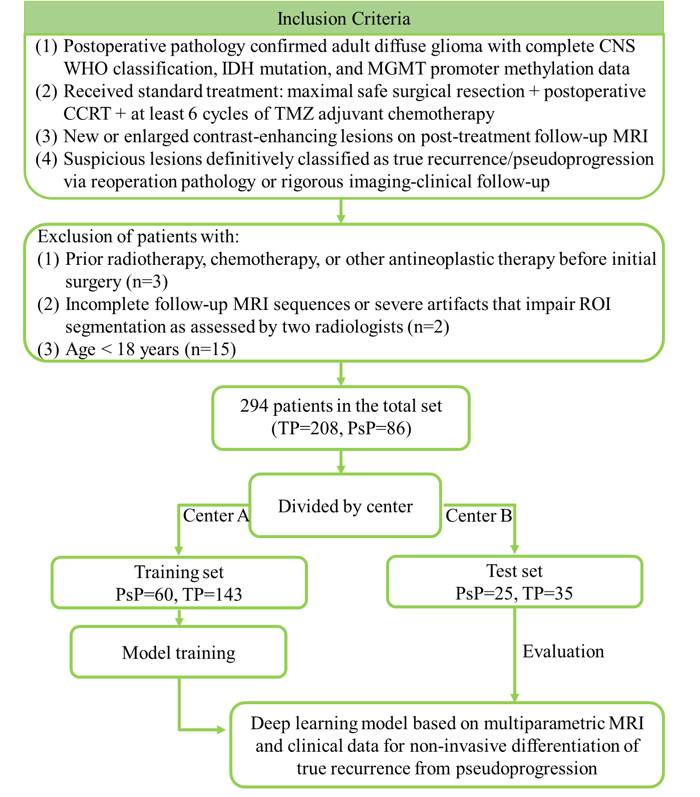

Supplementary Figure S1. The inclusion and exclusion flowchart of this study
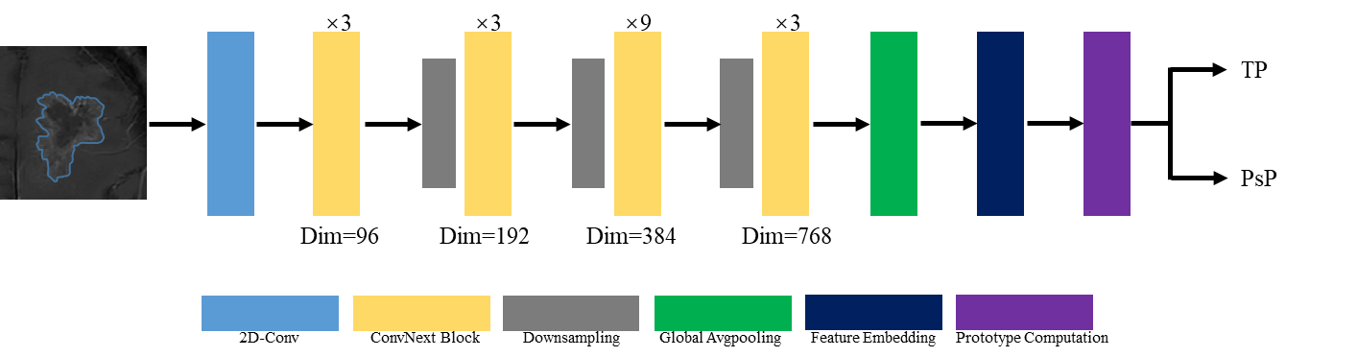
Supplementary Figure S2. The customized ConvNeXt-Tiny architecture for classification of 2D MR images. This architecture takes 224×224 pixel images as input, performs hierarchical feature extraction through 2D convolutional layers, ConvNeXt blocks (with dimensions progressively increasing from 96 to 768), and downsampling layers, and utilizes global average pooling to obtain feature embeddings. Finally, the prototypical network completes classification by computing the Euclidean distance between query embeddings and class prototypes.

