Supplementary tables and figures on malaria incidence, serial interval distributions, and climatic variables in Colombia (2014–2023)
This file includes supplementary tables and figures that support the main analyses. It features (i) descriptive statistics for the malaria serial interval by parasite species and region, (ii) annual malaria case counts and incidence rates across departments, (iii) additional incidence curves stratified by parasite species and region, (iv) distributions and temporal trends of the time-varying effective reproduction number (Rt), and (v) unadjusted relationships between Rt, temperature, and the Standardized Precipitation–Evapotranspiration Index (SPEI). These materials serve as supporting evidence for the results discussed in the main text.

Table S1. Central tendency and dispersion measures of the serial interval by parasite species and region in Colombia.
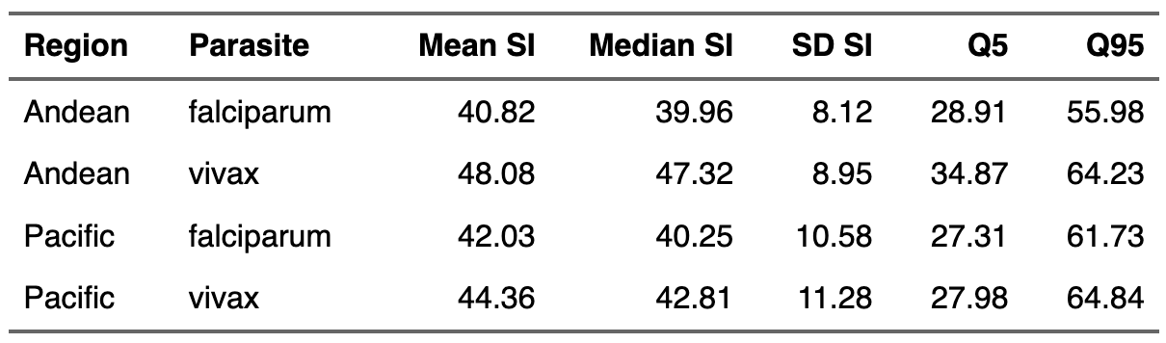

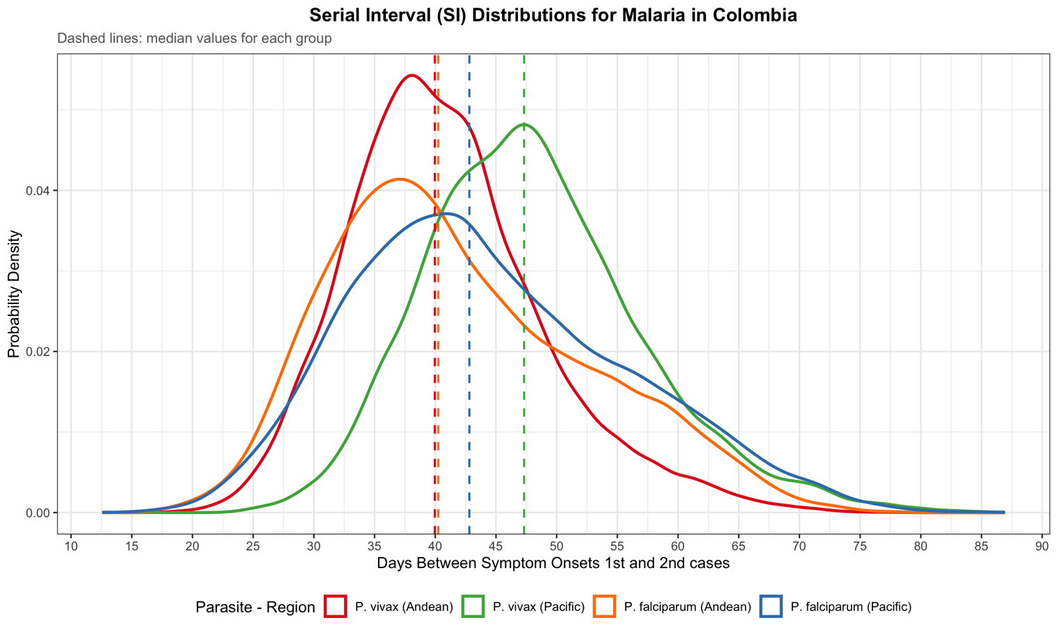

Figure S1. Serial interval (SI) distribution by species of parasite and region in Colombia. Dashed lines correspond to median values for each group

Territorial entity | 2014 | 2015 | 2016 | 2017 | 2018 | 2019 | 2020 | 2021 | 2022 | 2023 | Total
Antioquia | 9,282 (28.2%) | 6,552 (15.3%) | 7,141 (11.1%) | 4,782 (13.2%) | 5,502 (15.4%) | 7,392 (14.6%) | 7,611 (15.2%) | 6,400 (13.5%) | 7,562 (18.6%) | 16,771 (26.4%) | 78,995 (17.0%)
Cauca | 603 (1.8%) | 315 (0.7%) | 1,678 (2.6%) | 1,935 (5.3%) | 1,543 (4.3%) | 3,166 (6.3%) | 4,642 (9.3%) | 2,773 (5.8%) | 1,861 (4.6%) | 4,305 (6.8%) | 22,821 (4.9%)
Chocó | 18,010 (54.7%) | 29,431 (68.8%) | 44,981 (69.8%) | 15,898 (43.8%) | 16,340 (45.7%) | 24,390 (48.2%) | 21,960 (43.8%) | 24,246 (51.1%) | 23,826 (58.6%) | 35,800 (56.3%) | 254,882 (54.8%)
Nariño | 5,035 (15.3%) | 6,502 (15.2%) | 10,654 (16.5%) | 13,694 (37.7%) | 12,351 (34.6%) | 15,653 (30.9%) | 15,951 (31.8%) | 14,061 (29.6%) | 7,433 (18.3%) | 6,741 (10.6%) | 108,075 (23.3%)
Total | 32,930 (100.0%) | 42,800 (100.0%) | 64,454 (100.0%) | 36,309 (100.0%) | 35,736 (100.0%) | 50,601 (100.0%) | 50,164 (100.0%) | 47,480 (100.0%) | 40,682 (100.0%) | 63,617 (100.0%) | 464,773 (100.0%)
Table S2. Malaria cases by territorial entity and year, 2014-2023, Colombia.

Table S3. Incidence rate of malaria by selected territorial entities, Colombia, 2014 to 2023.
Territorial entity | 2014 | 2015 | 2016 | 2017 | 2018 | 2019 | 2020 | 2021 | 2022 | 2023 | Annual rate*
Antioquia | 153.01 | 106.80 | 114.97 | 75.94 | 85.88 | 112.85 | 114.48 | 95.14 | 111.54 | 258.94 | 115.84
Cauca | 44.86 | 25.56 | 120.88 | 137.70 | 108.64 | 218.48 | 311.79 | 185.01 | 125.09 | 291.71 | 125.30
Choco | 3,602.38 | 5,779.20 | 8,679.86 | 3,017.15 | 3,055.20 | 4,517.23 | 3,905.14 | 4,224.81 | 4,076.50 | 6,362.39 | 4,474.90
Nariño | 319.08 | 416.66 | 683.14 | 873.50 | 807.68 | 1,018.74 | 1,041.88 | 973.86 | 598.40 | 546.96 | 681.71
Total | 4,119.33 | 6,328.22 | 9,598.85 | 4,104.29 | 4,057.40 | 5,867.30 | 5,373.29 | 5,478.82 | 4,911.53 | 7,460.00 | 5,397.75

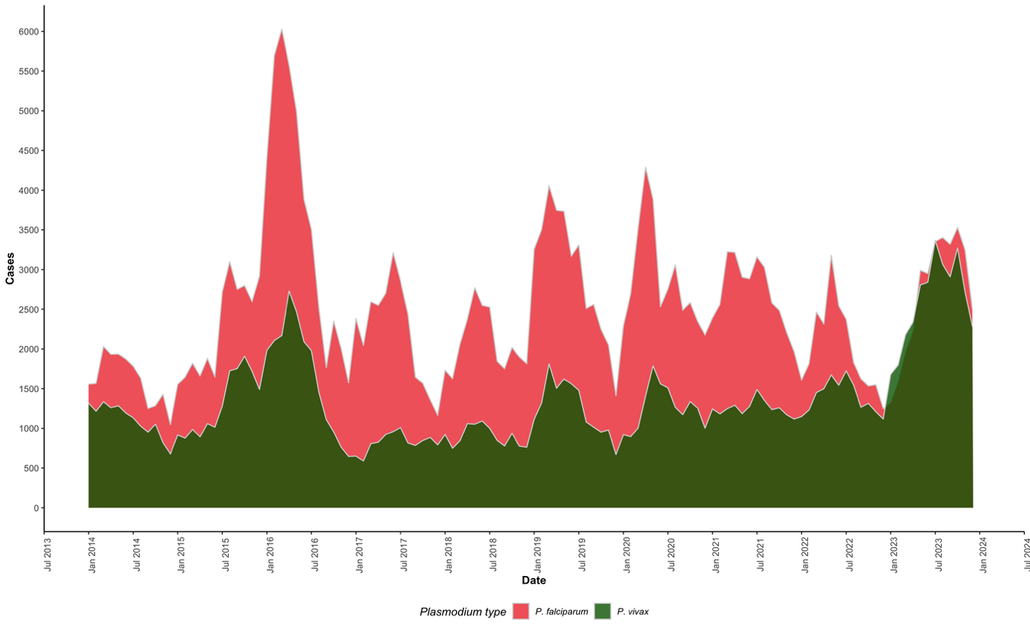

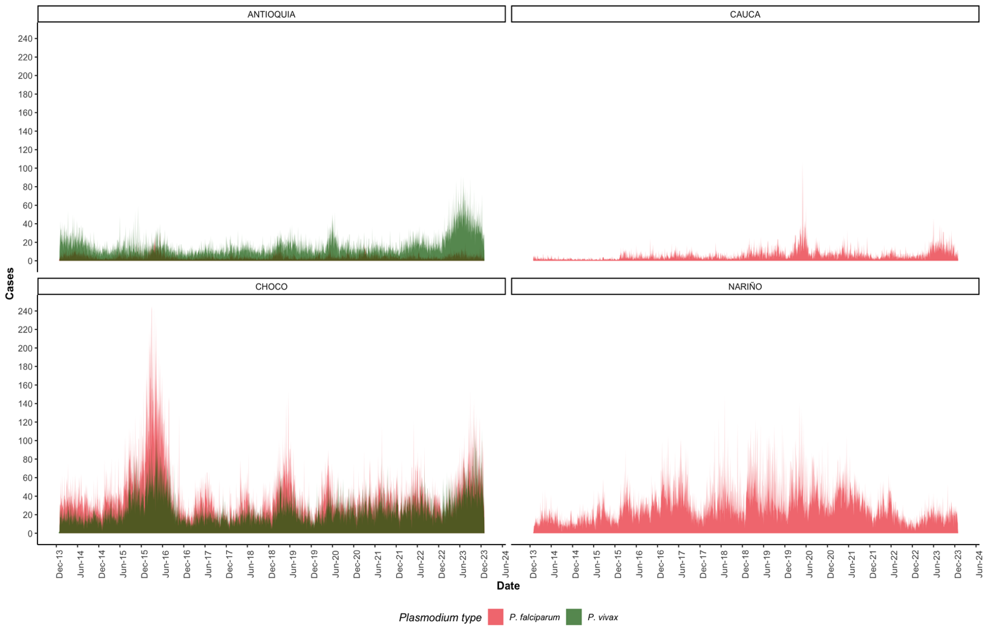
Figure S2. Incidence curves by parasite for all territorial entities selected

Figure S3. Incidence curves by parasite species and territorial entity selected
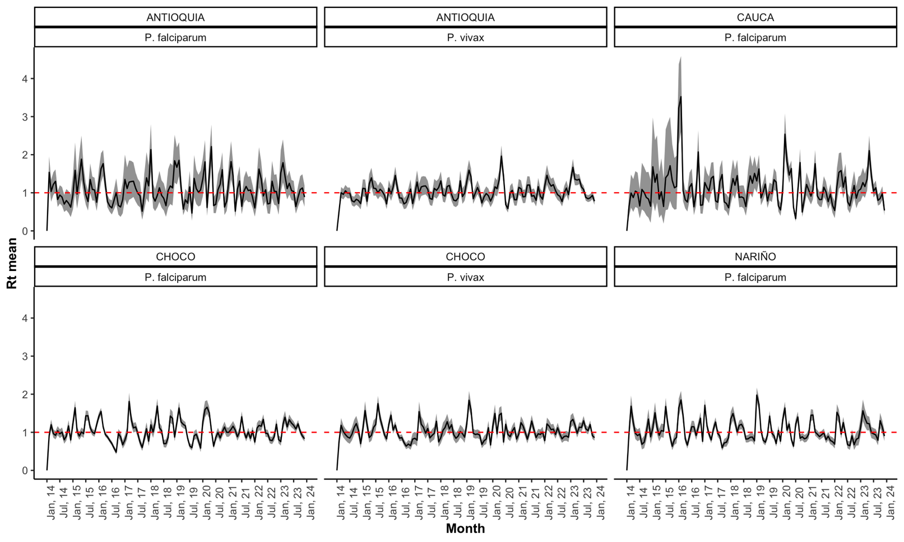

Figure S4. R_{t} distribution by species of parasite and territorial entity
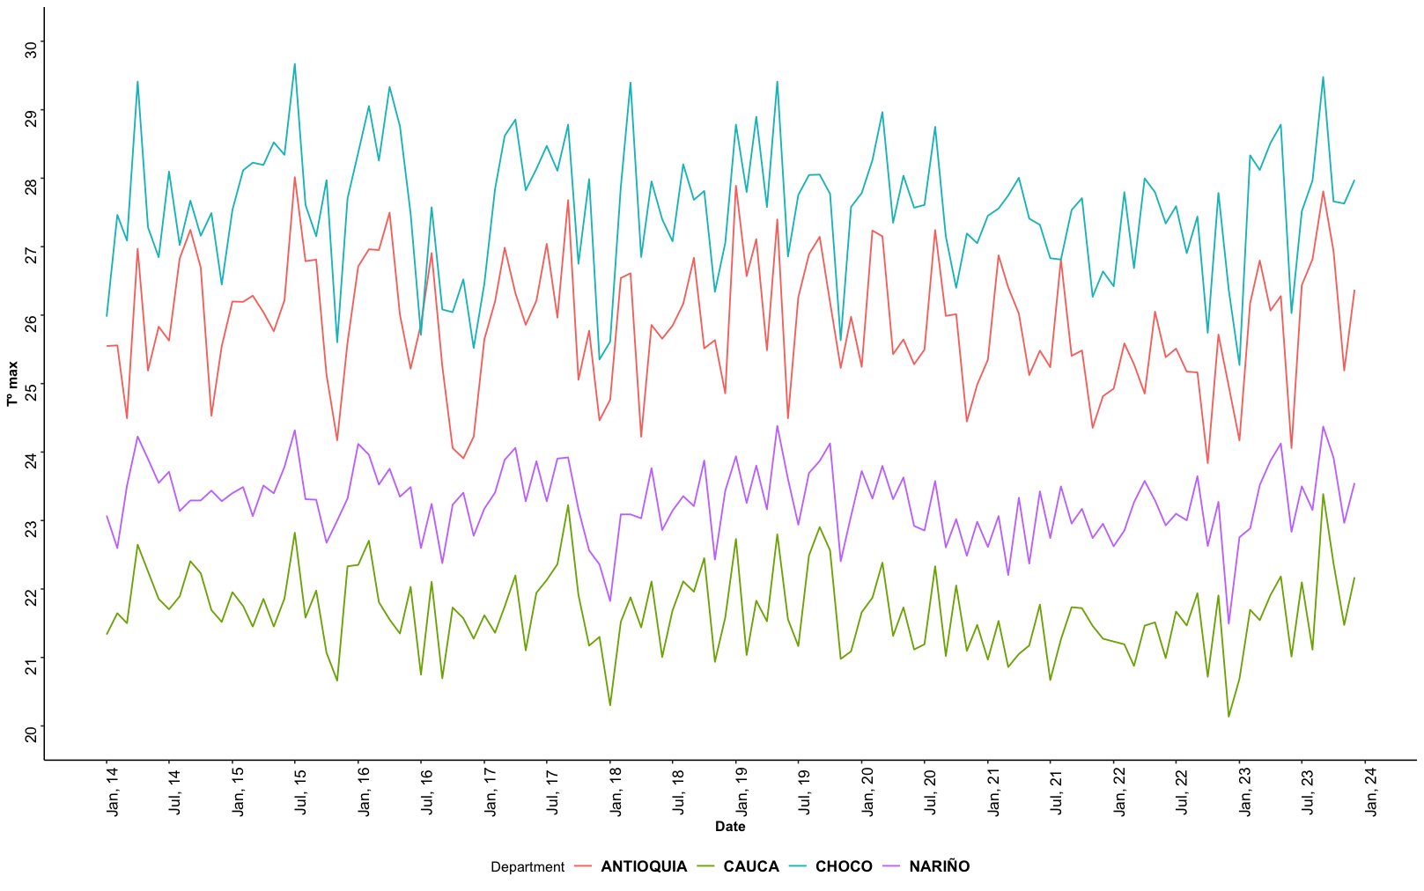

Figure S5. Behaviour R_{t} by species of parasite and territorial entities
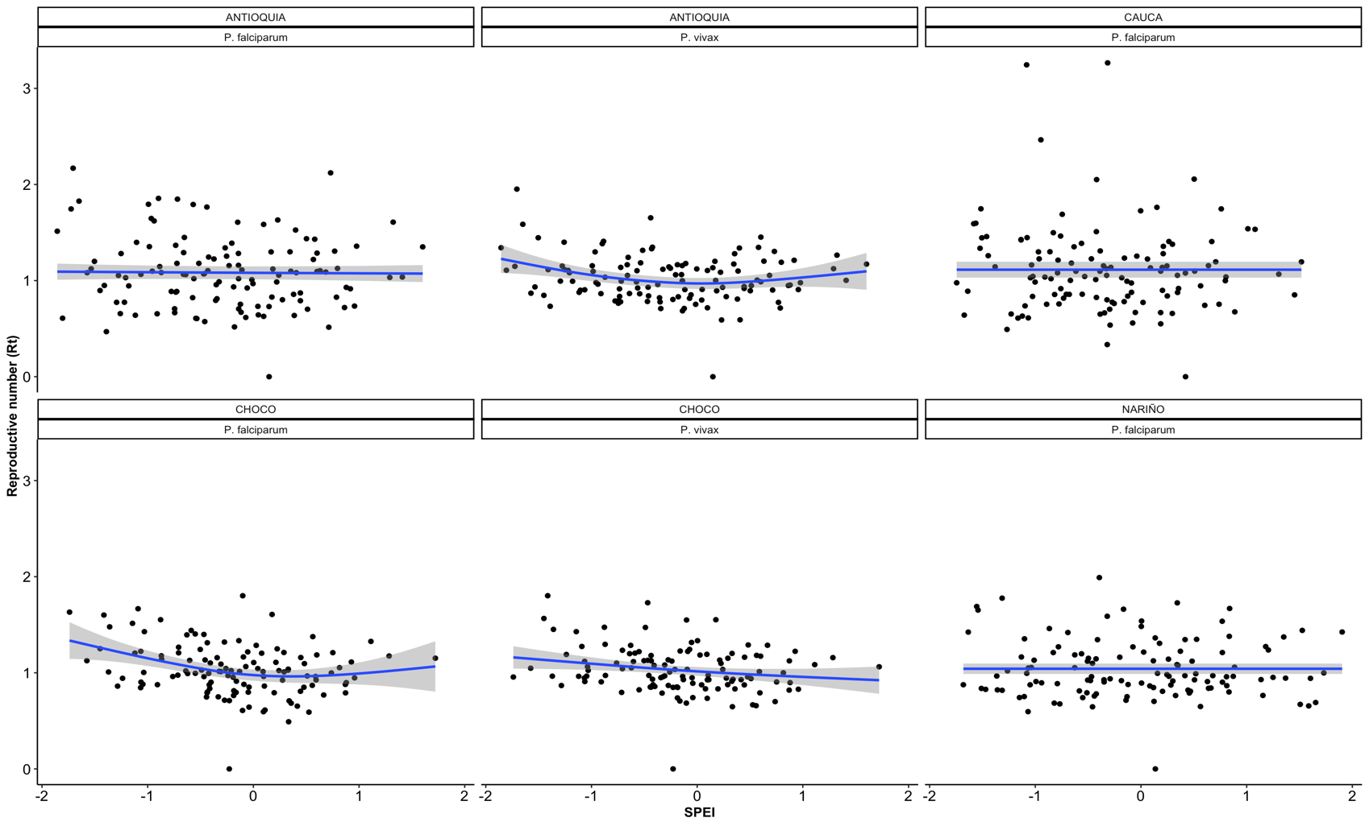

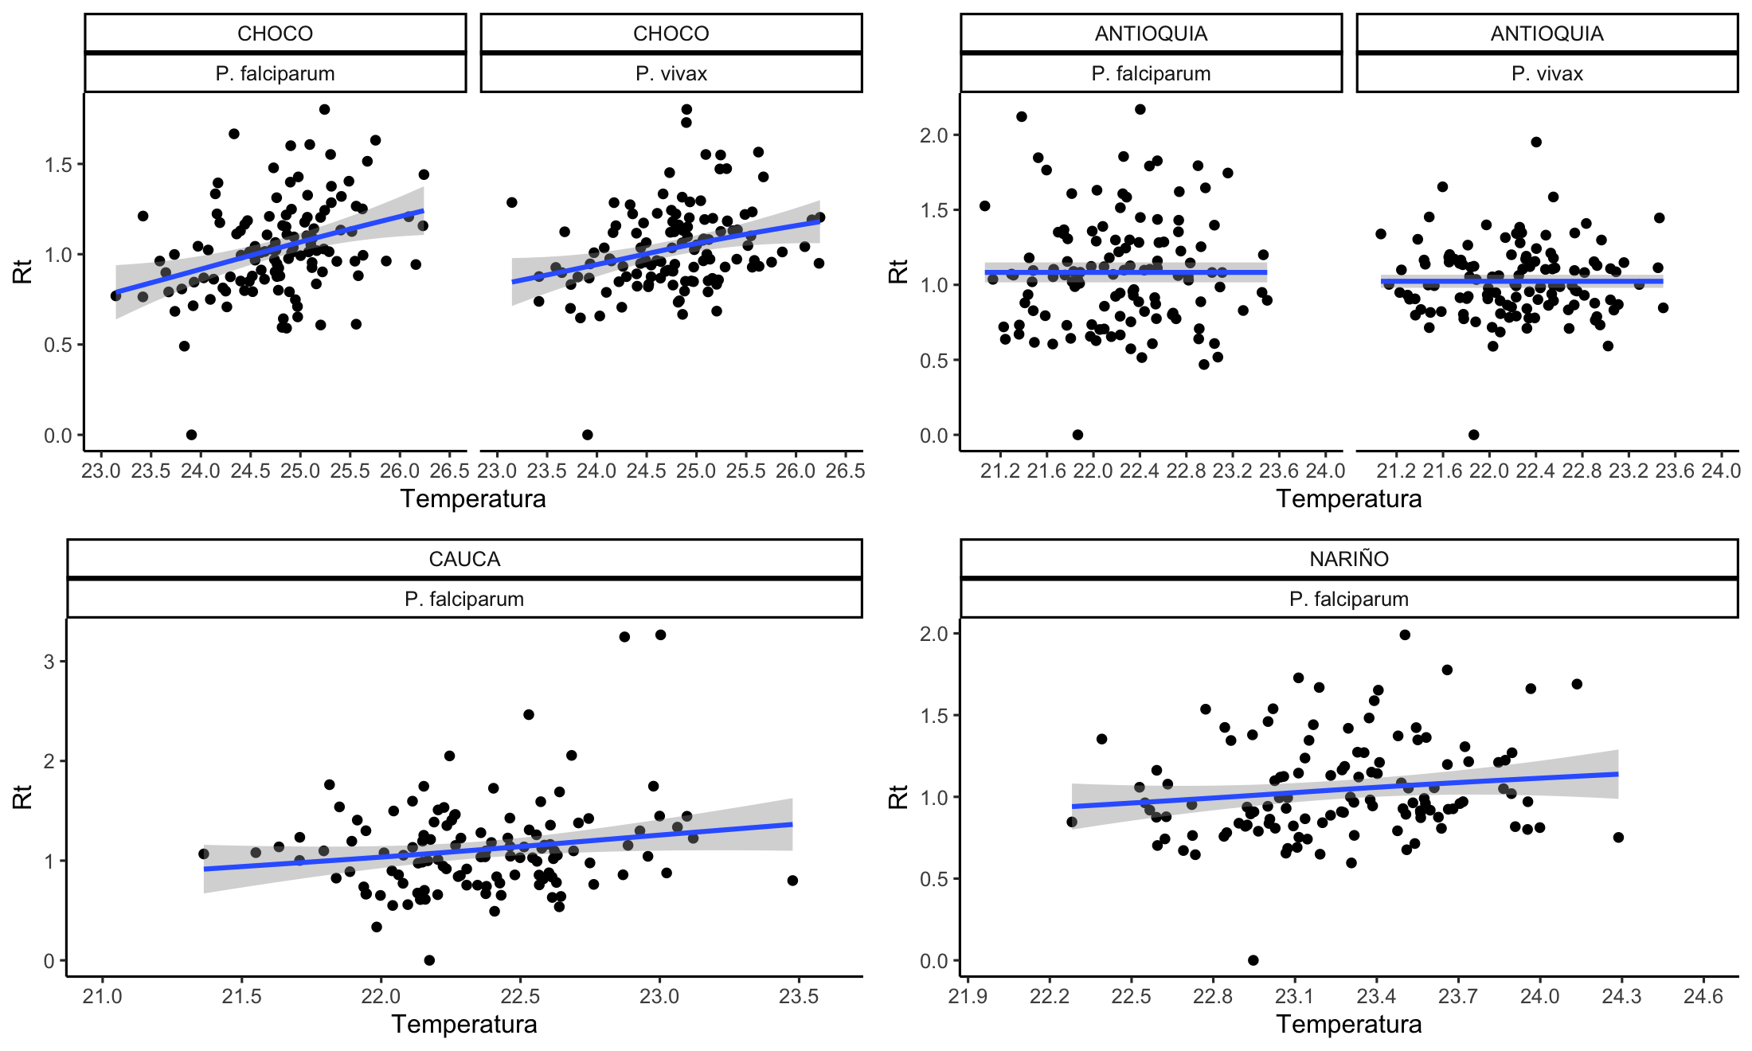
Figure S6. Maximum temperature behaviour by each territorial entities selected

Figure S7. Relationship between R_{t} and temperature not adjusted.

