Supplementary Information

Design, synthesis, drug likeness and molecular dynamics evaluations of monobrominated Amathamide G analogs as potential inhibitors of D2-like dopamine receptors

Angelica Navarrete-Gutiérrez¹, Octavio Frias-Aviña¹, Julio Montes-Ávila², Raúl Argüello-García³, Edar O. Pech-Santiago^{3,}*, Gerardo Aguirre-Hernández^{1,}*

ª Centro de Graduados e Investigación en Química, Tecnológico Nacional de México/IT de Tijuana, Tijuana, B.C., México
^{b} Facultad de Ciencias Químico Biológicas, Universidad Autónoma de Sinaloa, Culiacán, Sin., México
^{c} Departamento de Genética y Biología Molecular, Centro de Investigación y de Estudios Avanzados del Instituto Politécnico Nacional, Mexico City, Mexico.

Table of contents

Fig. S1. ¹H NMR spectrum of (E)-1,2-dimethoxy-3-(2-nitrovinyl)benzene (2a) | 3
Fig. S2. ¹³C NMR spectrum of (E)-1,2-dimethoxy-3-(2-nitrovinyl)benzene (2a) | 3
Fig. S3. ¹H NMR spectrum of (E)-1-bromo-3,4-dimethoxy-2-(2-nitrovinyl) benzene (2b) | 4
Fig. S4. ¹³C NMR spectrum of (E)-1-bromo-3,4-dimethoxy-2-(2-nitrovinyl) benzene (2b) | 4
Fig. S5. ¹H NMR spectrum of (E)-5-bromo-1,2-dimethoxy-3-(2-nitrovinyl) benzene (2c) | 5
Fig. S6. ¹³C NMR spectrum of (E)-5-bromo-1,2-dimethoxy-3-(2-nitrovinyl) benzene (2c) | 5
Fig. S7. ¹H NMR spectrum of (E)-1-bromo-2,3-dimethoxy-4-(2-nitrovinyl) benzene (2d) | 6
Fig. S8. ¹³C NMR spectrum of (E)-1-bromo-2,3-dimethoxy-4-(2-nitrovinyl) benzene (2d) | 6
Fig. S9. ¹H NMR spectrum of (1-(2,3-dimethoxyphenyl)-2-nitroethyl)(phenyl) sulfane (3a) | 7
Fig. S10. ¹³C NMR spectrum of (1-(2,3-dimethoxyphenyl)-2-nitroethyl)(phenyl) sulfane (3a) | 7
Fig. S11. ¹H NMR spectrum of (1-(6-bromo-2,3-dimethoxyphenyl)-2-nitroethyl) (phenyl)sulfane (3b) | 8
Fig. S12. ¹³C NMR spectrum of (1-(6-bromo-2,3-dimethoxyphenyl)-2-nitroethyl)(phenyl)sulfane (3b) | 8
Fig. S13. ¹H NMR spectrum of (1-(5-bromo-2,3-dimethoxyphenyl)-2-nitroethyl)(phenyl)sulfane (3c) | 9
Fig. S14. ¹³C NMR spectrum of (1-(5-bromo-2,3-dimethoxyphenyl)-2-nitroethyl)(phenyl)sulfane (3c) | 9
Fig. S15. ¹H NMR spectrum of (1-(4-bromo-2,3-dimethoxyphenyl)-2-nitroethyl)(phenyl)sulfane (3d) | 10
Fig. S16. ¹³C NMR spectrum of (1-(4-bromo-2,3-dimethoxyphenyl)-2-nitroethyl)(phenyl)sulfane (3d) | 10
Fig. S17. ¹H NMR spectrum of (2S)-N-(2-(2,3-dimethoxyphenyl)-2-(phenylthio)ethyl)-1-methylpyrrolidine-2-carboxamide (5a) | 11
Fig. S18. ¹³C NMR spectrum of (2S)-N-(2-(2,3-dimethoxyphenyl)-2-(phenylthio)ethyl)-1-methylpyrrolidine-2-carboxamide (5a) | 11
Fig. S19. ¹H NMR spectrum of (2S)-N-(2-(6-bromo-2,3-dimethoxyphenyl)-2-(phenylthio)ethyl)-1-methylpyrrolidine-2-carboxamide (5b) | 12
Fig. S20. ¹³C NMR spectrum of (2S)-N-(2-(6-bromo-2,3-dimethoxyphenyl)-2-(phenylthio)ethyl)-1-methylpyrrolidine-2-carboxamide (5b) | 12
Fig. S21. ¹H NMR spectrum of (2S)-N-(2-(5-bromo-2,3-dimethoxyphenyl)-2-(phenylthio)ethyl)-1-methylpyrrolidine-2-carboxamide (5c) | 13
Fig. S22. ¹³C NMR spectrum of (2S)-N-(2-(5-bromo-2,3-dimethoxyphenyl)-2-(phenylthio)ethyl)-1-methylpyrrolidine-2-carboxamide (5c) | 13
Fig. S23. ¹H NMR spectrum of (2S)-N-(2-(4-bromo-2,3-dimethoxyphenyl)-2-(phenylthio)ethyl)-1-methylpyrrolidine-2-carboxamide (5d) | 14
Fig. S24. ¹³C NMR spectrum of (2S)-N-(2-(4-bromo-2,3-dimethoxyphenyl)-2-(phenylthio)ethyl)-1-methylpyrrolidine-2-carboxamide (5d) | 14
Fig. S25. ¹H NMR spectrum of (S,E)-N-(2,3-dimethoxystyryl)-1-methylpyrrolidine-2-carboxamide (6a) | 15
Fig. S26. ¹³C NMR spectrum of (S,E)-N-(2,3-dimethoxystyryl)-1-methylpyrrolidine-2-carboxamide (6a) | 15
Fig. S27. ¹H NMR spectrum of (S,E)-N-(6-bromo-2,3-dimethoxystyryl)-1-methylpyrrolidine-2-carboxamide (6b) | 16
Fig. S28. ¹³C NMR spectrum of (S,E)-N-(6-bromo-2,3-dimethoxystyryl)-1-methylpyrrolidine-2-carboxamide (6b) | 16
Fig. S29. ¹H NMR spectrum of (S,E)-N-(5-bromo-2,3-dimethoxystyryl)-1-methylpyrrolidine-2-carboxamide (6c) | 17
Fig. S30. ¹³C NMR spectrum of (S,E)-N-(5-bromo-2,3-dimethoxystyryl)-1-methylpyrrolidine-2-carboxamide (6c) | 17
Fig. S31. ¹H NMR spectrum of (S,E)-N-(4-bromo-2,3-dimethoxystyryl)-1-methylpyrrolidine-2-carboxamide (6d) | 18
Fig. S32. ¹³C NMR spectrum of (S,E)-N-(4-bromo-2,3-dimethoxystyryl)-1-methylpyrrolidine-2-carboxamide (6d) | 18
Fig. S33. EI-MS spectrum of (E)-1,2-dimethoxy-3-(2-nitrovinyl)benzene (2a) | 19
Fig. S34. EI-MS spectrum of (E)-1-bromo-3,4-dimethoxy-2-(2-nitrovinyl) benzene (2b) | 19
Fig. S35. EI-MS spectrum of (E)-5-bromo-1,2-dimethoxy-3-(2-nitrovinyl) benzene (2c) | 20
Fig. S36. EI-MS spectrum of (E)-1-bromo-2,3-dimethoxy-4-(2-nitrovinyl) benzene (2d) | 20
Fig. S37. EI-MS spectrum of (1-(2,3-dimethoxyphenyl)-2-nitroethyl)(phenyl) sulfane (3a) | 21
Fig. S38. EI-MS spectrum of (1-(6-bromo-2,3-dimethoxyphenyl)-2-nitroethyl) (phenyl)sulfane (3b) | 21
Fig. S39. EI-MS spectrum of (1-(4-bromo-2,3-dimethoxyphenyl)-2-nitroethyl)(phenyl)sulfane (3d) | 22
Fig. S40. EI-MS spectrum of (2S)-N-(2-(2,3-dimethoxyphenyl)-2-(phenylthio)ethyl)-1-methylpyrrolidine-2-carboxamide (5a) | 22
Fig. S41. EI-MS spectrum of (2S)-N-(2-(6-bromo-2,3-dimethoxyphenyl)-2-(phenylthio)ethyl)-1-methylpyrrolidine-2-carboxamide (5b) | 23
Fig. S42. EI-MS spectrum of (2S)-N-(2-(5-bromo-2,3-dimethoxyphenyl)-2-(phenylthio)ethyl)-1-methylpyrrolidine-2-carboxamide (5c) | 23
Fig. S43. EI-MS spectrum of (2S)-N-(2-(4-bromo-2,3-dimethoxyphenyl)-2-(phenylthio)ethyl)-1-methylpyrrolidine-2-carboxamide (5d) | 24
Fig. S44. EI-MS spectrum of (S,E)-N-(2,3-dimethoxystyryl)-1-methylpyrrolidine-2-carboxamide (6a) | 24
Fig. S45. EI-MS spectrum of (S,E)-N-(6-bromo-2,3-dimethoxystyryl)-1-methylpyrrolidine-2-carboxamide (6b) | 25
Fig. S46. EI-MS spectrum of (S,E)-N-(5-bromo-2,3-dimethoxystyryl)-1-methylpyrrolidine-2-carboxamide (6c) | 25
Fig. S47. EI-MS spectrum of (S,E)-N-(4-bromo-2,3-dimethoxystyryl)-1-methylpyrrolidine-2-carboxamide (6d) | 26
Table S1. Physicochemical properties of AM-G, its monobrominated (M6B. M5B. M4B) and debrominated (AM-0) derivatives, the standard compound Eticlopride and the reference compound BMM. | 27
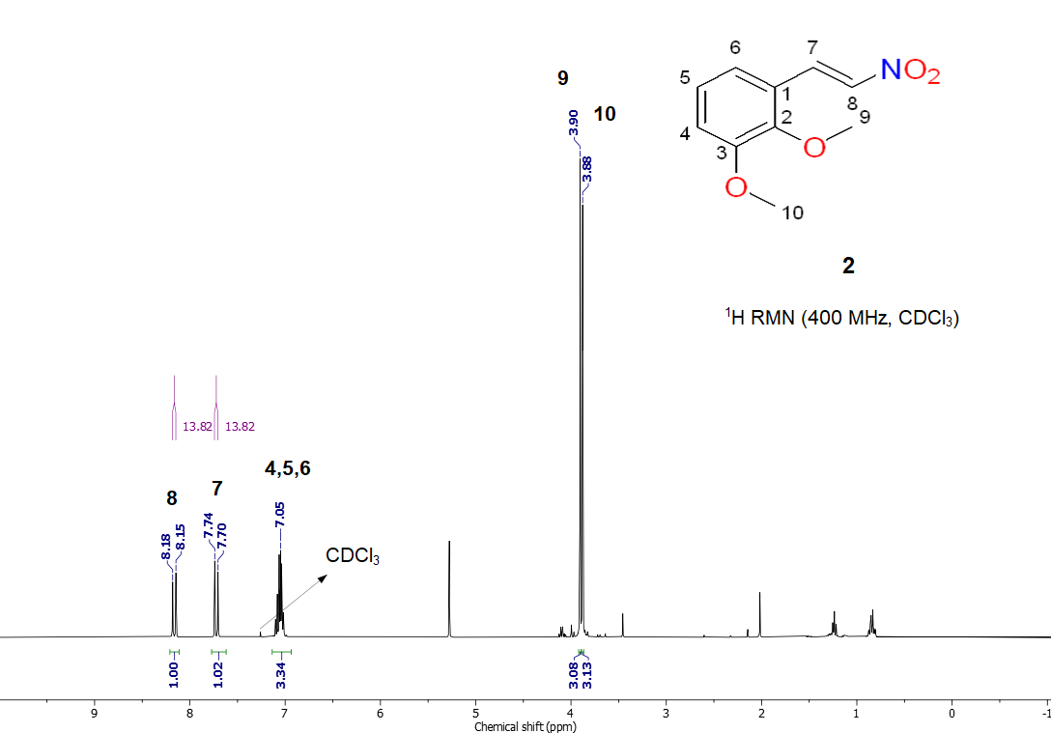
Fig. S1. ¹H NMR spectrum of (E)-1,2-dimethoxy-3-(2-nitrovinyl)benzene (2a)

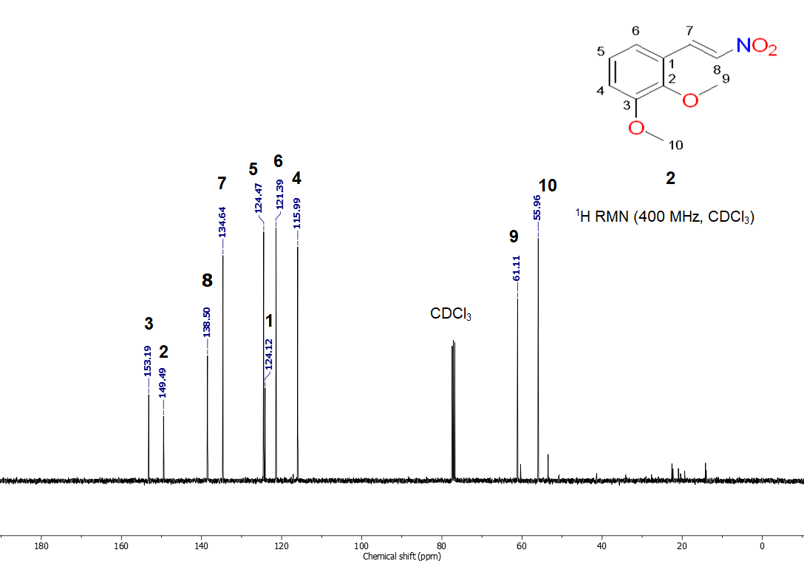
Fig. S2. ¹³C NMR spectrum of (E)-1,2-dimethoxy-3-(2-nitrovinyl)benzene (2a)
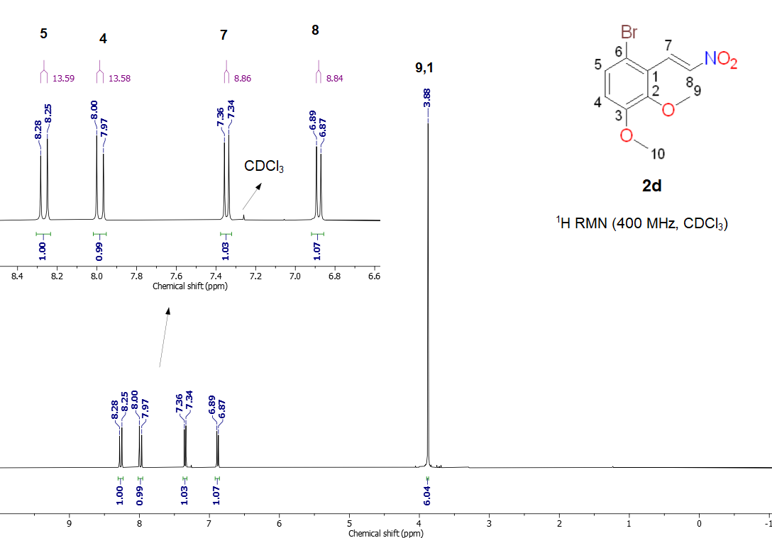
Fig. S3. ¹H NMR spectrum of (E)-1-bromo-3,4-dimethoxy-2-(2-nitrovinyl) benzene (2b)

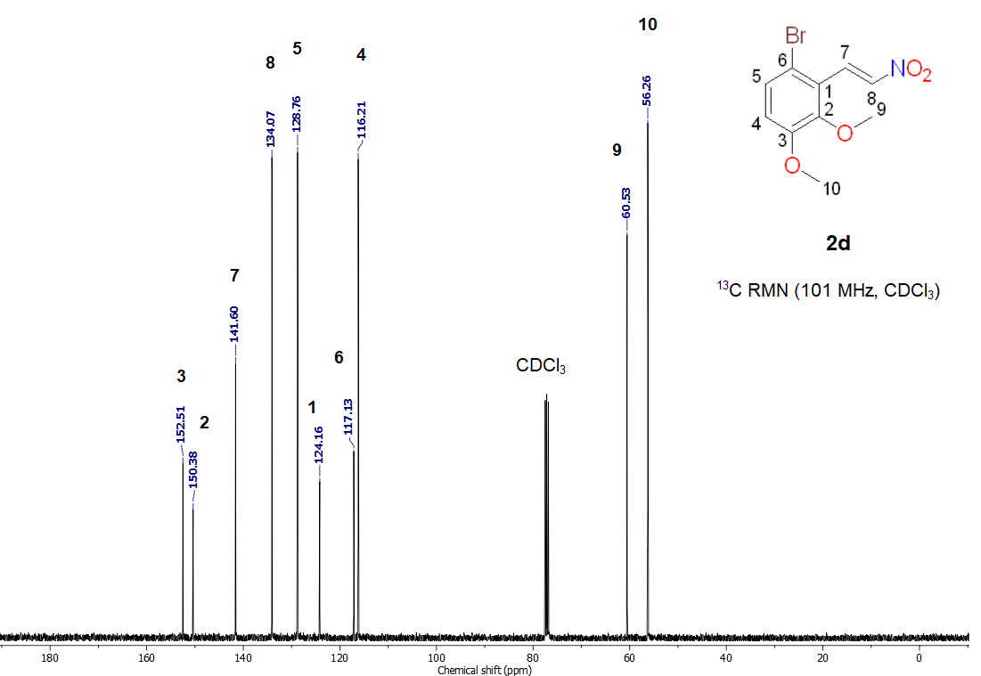
Fig. S4. ¹³C NMR spectrum of (E)-1-bromo-3,4-dimethoxy-2-(2-nitrovinyl) benzene (2b)
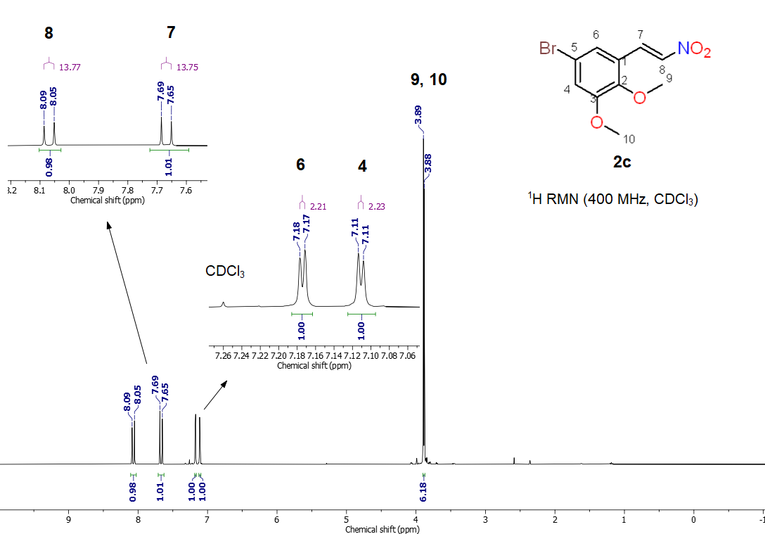
Fig. S5. ¹H NMR spectrum of (E)-5-bromo-1,2-dimethoxy-3-(2-nitrovinyl) benzene (2c)

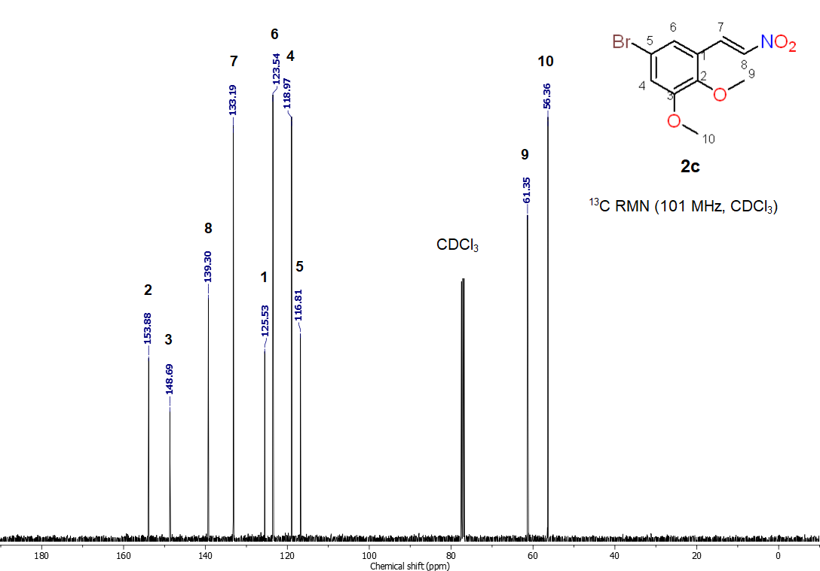
Fig. S6. ¹³C NMR spectrum of (E)-5-bromo-1,2-dimethoxy-3-(2-nitrovinyl) benzene (2c)
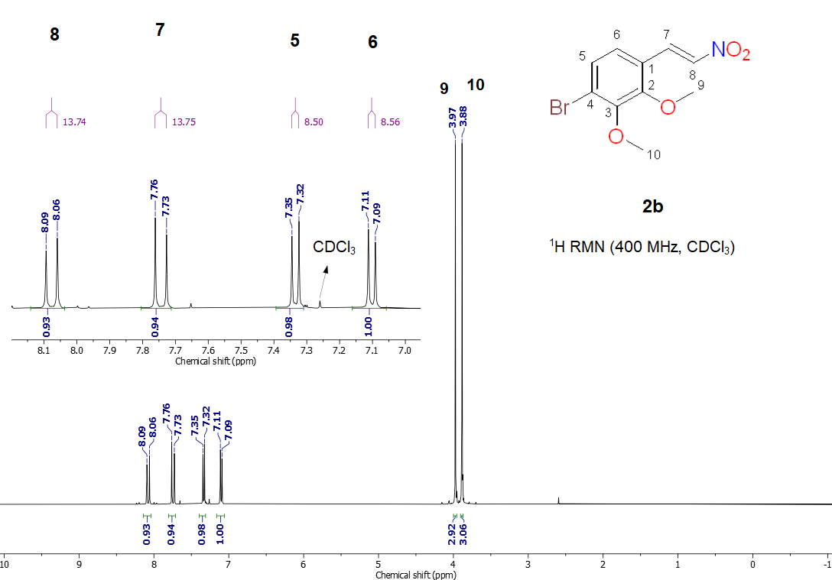
Fig. S7. ¹H NMR spectrum of (E)-1-bromo-2,3-dimethoxy-4-(2-nitrovinyl) benzene (2d)

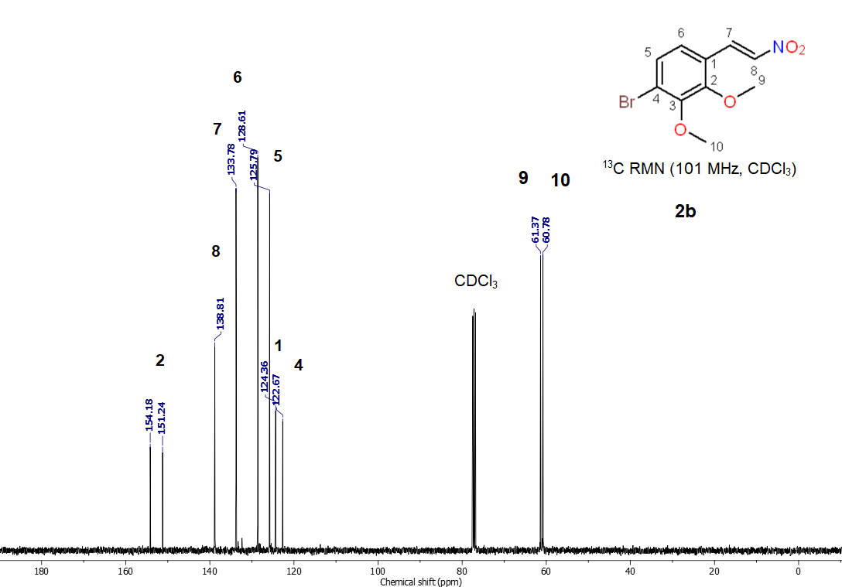
Fig. S8. ¹³C NMR spectrum of (E)-1-bromo-2,3-dimethoxy-4-(2-nitrovinyl) benzene (2d)
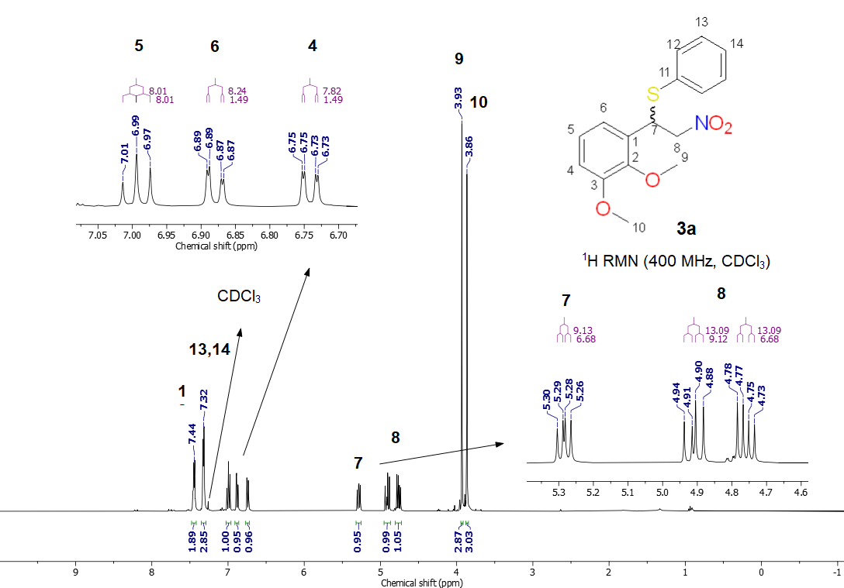
Fig. S9. ¹H NMR spectrum of (1-(2,3-dimethoxyphenyl)-2-nitroethyl)(phenyl) sulfane (3a)

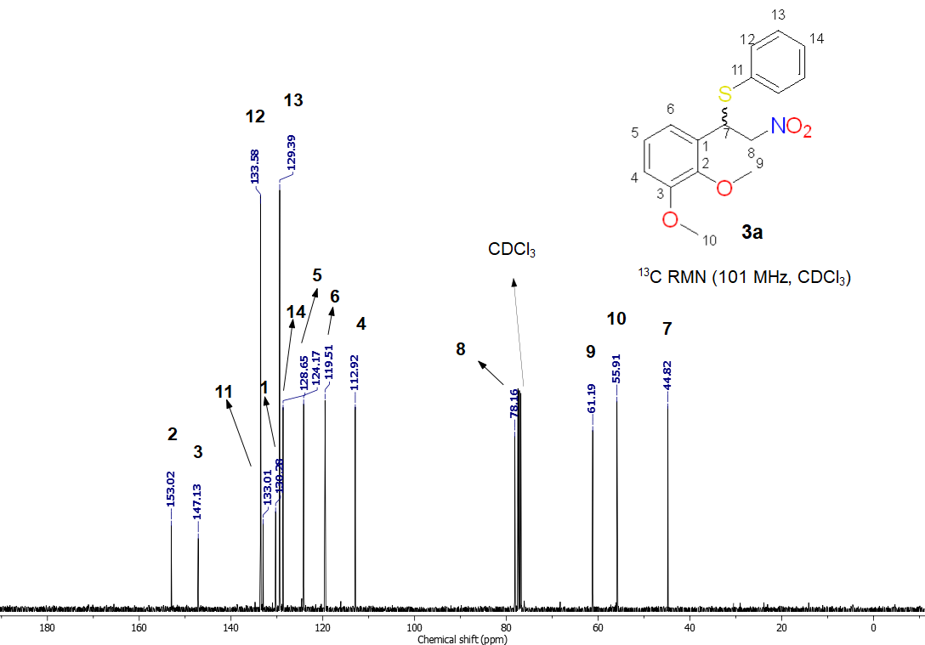
Fig. S10. ¹³C NMR spectrum of (1-(2,3-dimethoxyphenyl)-2-nitroethyl)(phenyl) sulfane (3a)
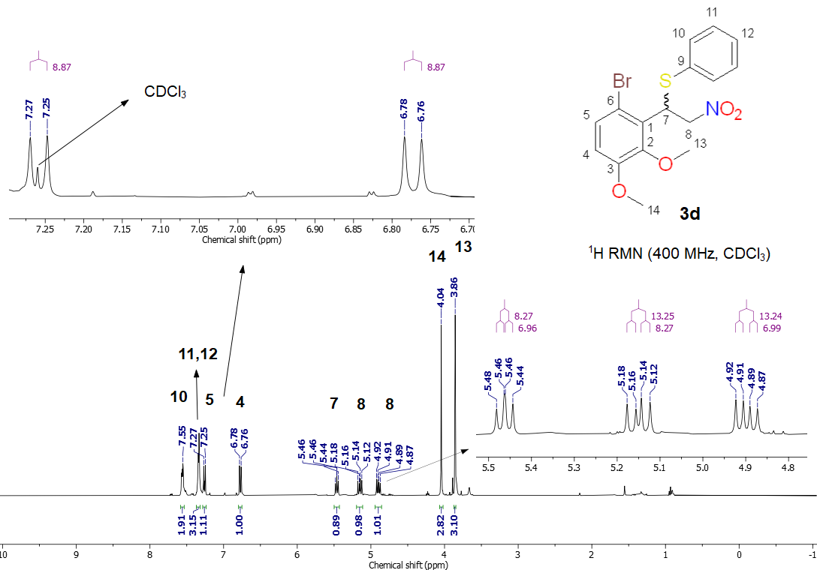
Fig. S11. ¹H NMR spectrum of (1-(6-bromo-2,3-dimethoxyphenyl)-2-nitroethyl) (phenyl)sulfane (3b)

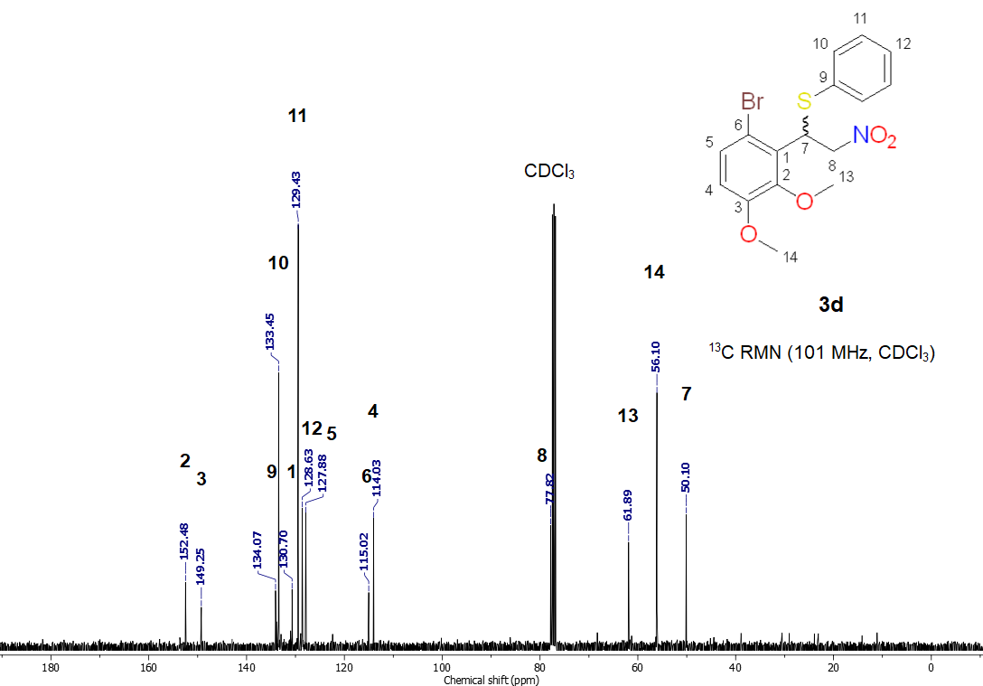
Fig. S12. ¹³C NMR spectrum of (1-(6-bromo-2,3-dimethoxyphenyl)-2-nitroethyl)(phenyl)sulfane (3b)
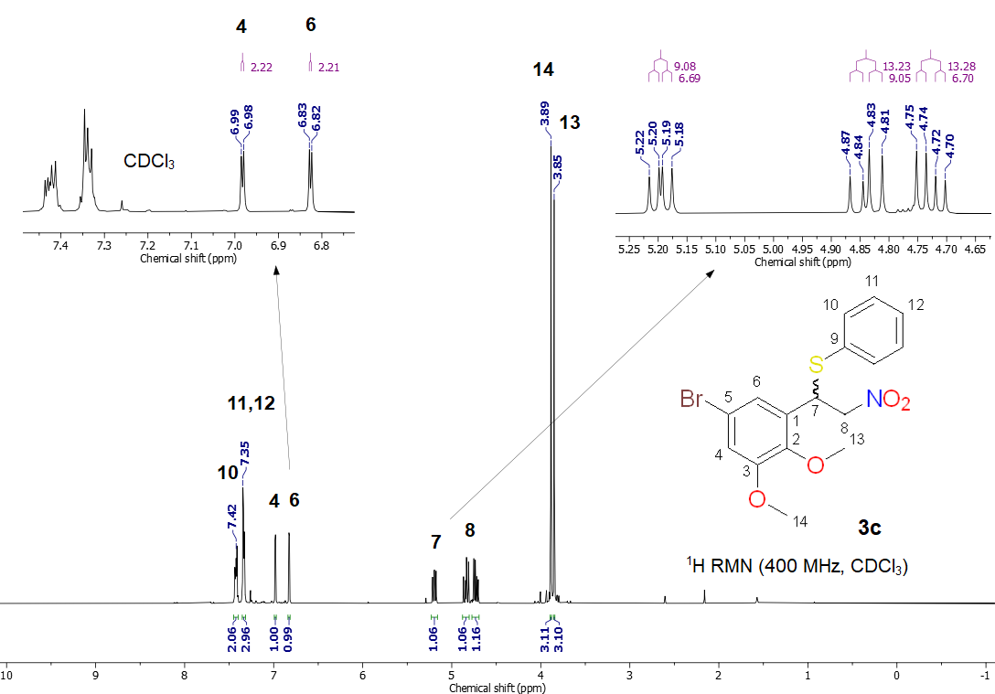
Fig. S13. ¹H NMR spectrum of (1-(5-bromo-2,3-dimethoxyphenyl)-2-nitroethyl)(phenyl)sulfane (3c)

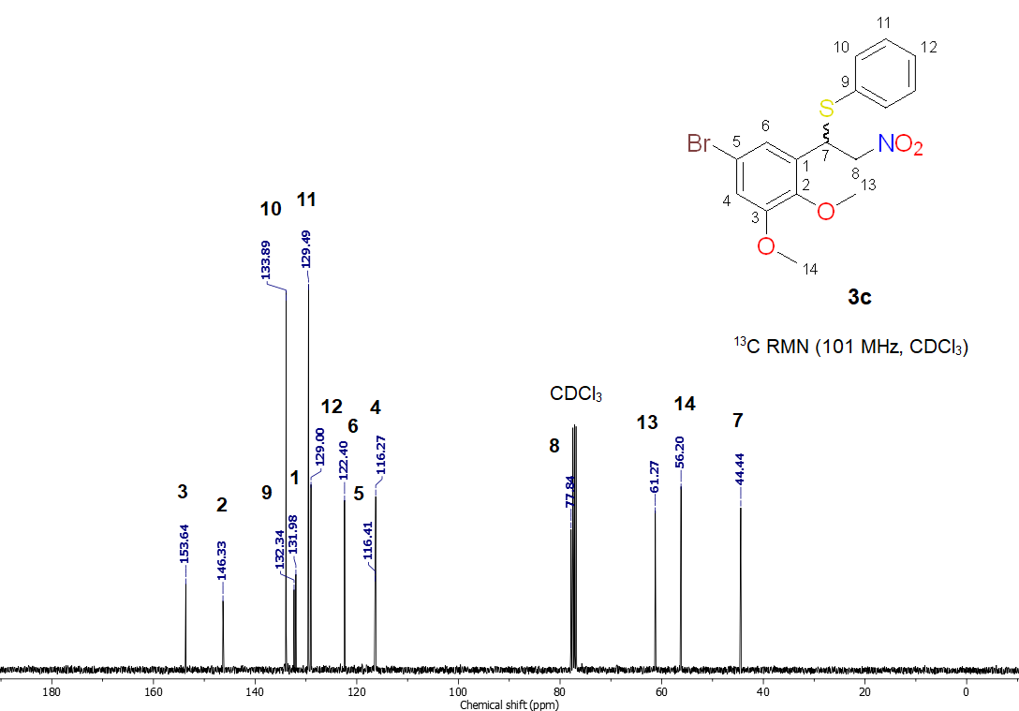
Fig. S14. ¹³C NMR spectrum of (1-(5-bromo-2,3-dimethoxyphenyl)-2-nitroethyl)(phenyl)sulfane (3c)
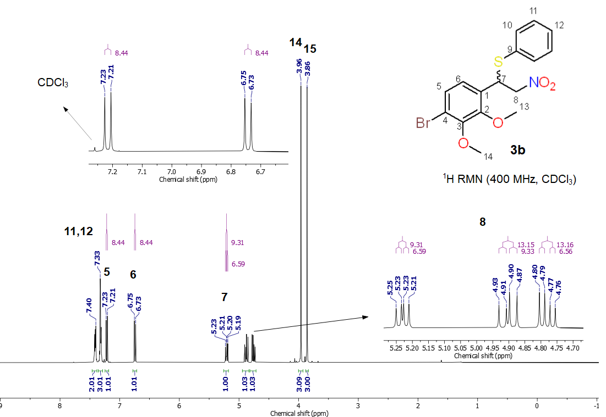
Fig. S15. ¹H NMR spectrum of (1-(4-bromo-2,3-dimethoxyphenyl)-2-nitroethyl)(phenyl)sulfane (3d)

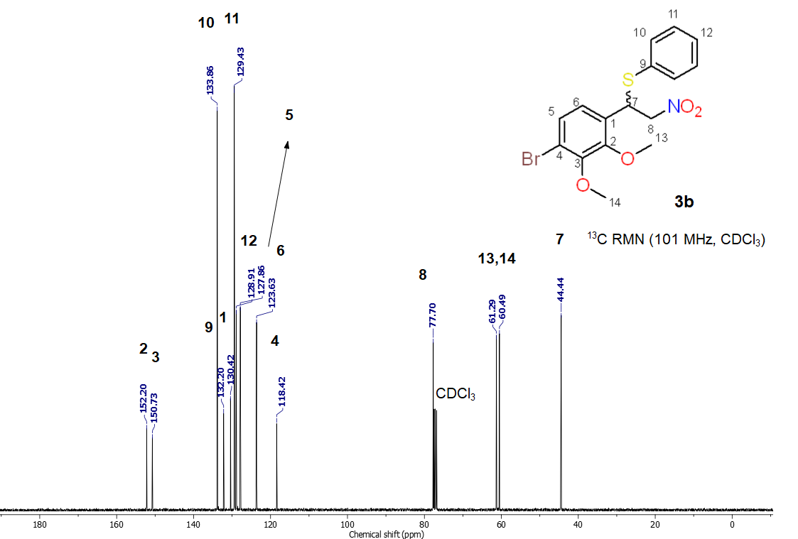
Fig. S16. ¹³C NMR spectrum of (1-(4-bromo-2,3-dimethoxyphenyl)-2-nitroethyl)(phenyl)sulfane (3d)
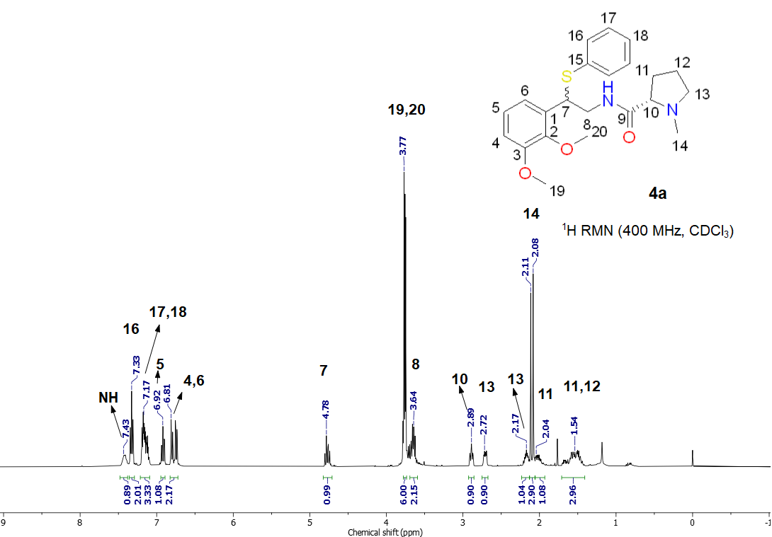
Fig. S17. ¹H NMR spectrum of (2S)-N-(2-(2,3-dimethoxyphenyl)-2-(phenylthio)ethyl)-1-methylpyrrolidine-2-carboxamide (5a)
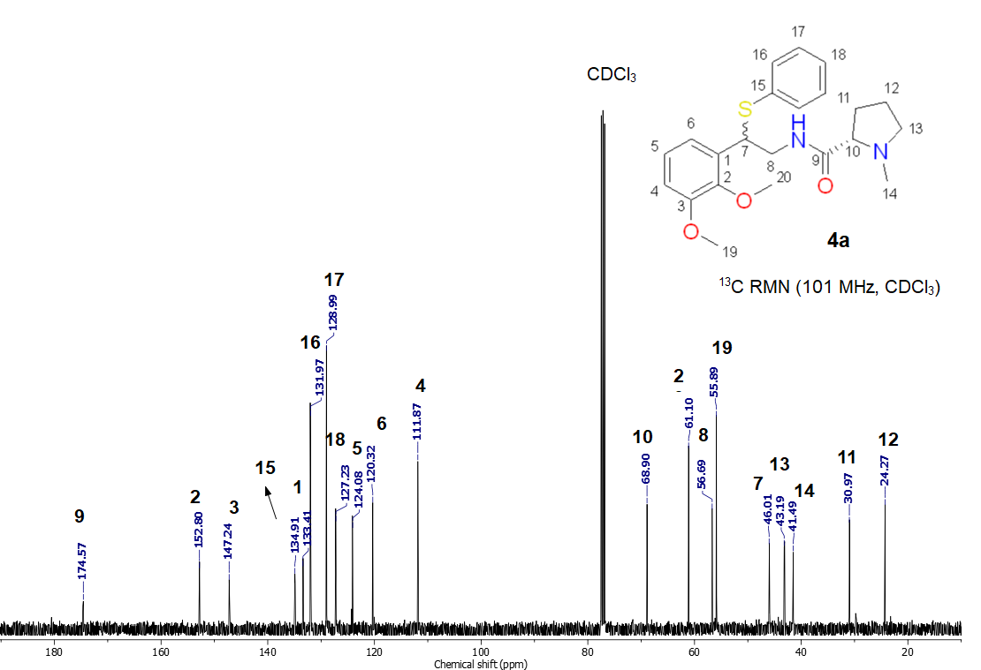
Fig. S18. ¹³C NMR spectrum of (2S)-N-(2-(2,3-dimethoxyphenyl)-2-(phenylthio)ethyl)-1-methylpyrrolidine-2-carboxamide (5a)
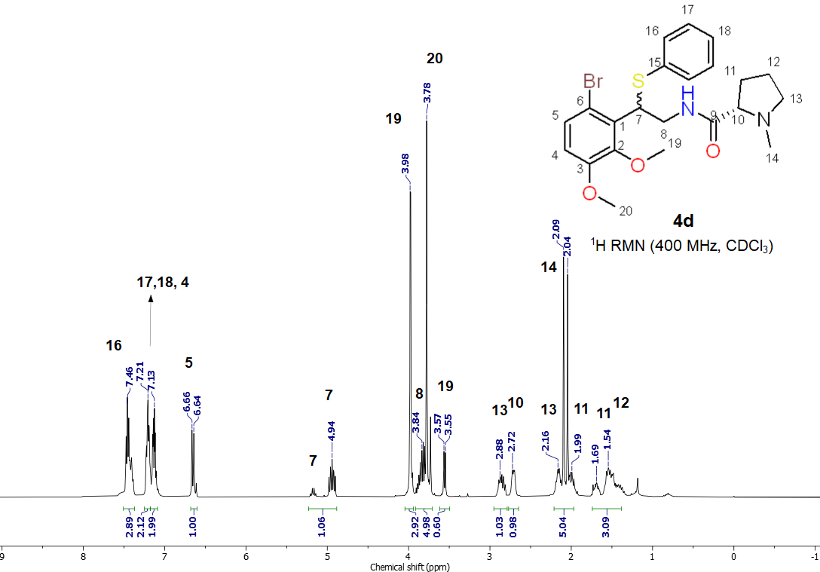
Fig. S19. ¹H NMR spectrum of (2S)-N-(2-(6-bromo-2,3-dimethoxyphenyl)-2-(phenylthio)ethyl)-1-methylpyrrolidine-2-carboxamide (5b)
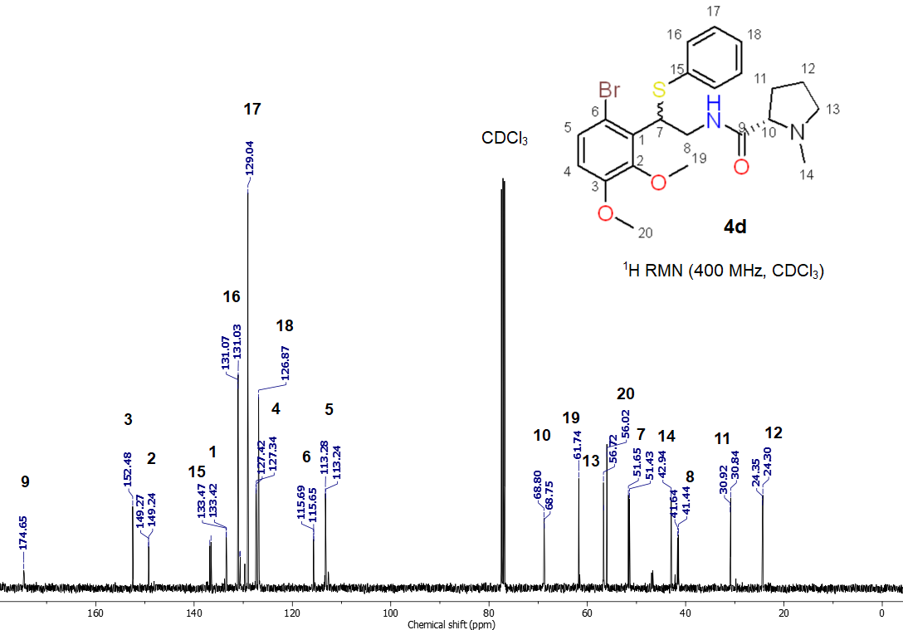
Fig. S20. ¹³C NMR spectrum of (2S)-N-(2-(6-bromo-2,3-dimethoxyphenyl)-2-(phenylthio)ethyl)-1-methylpyrrolidine-2-carboxamide (5b)
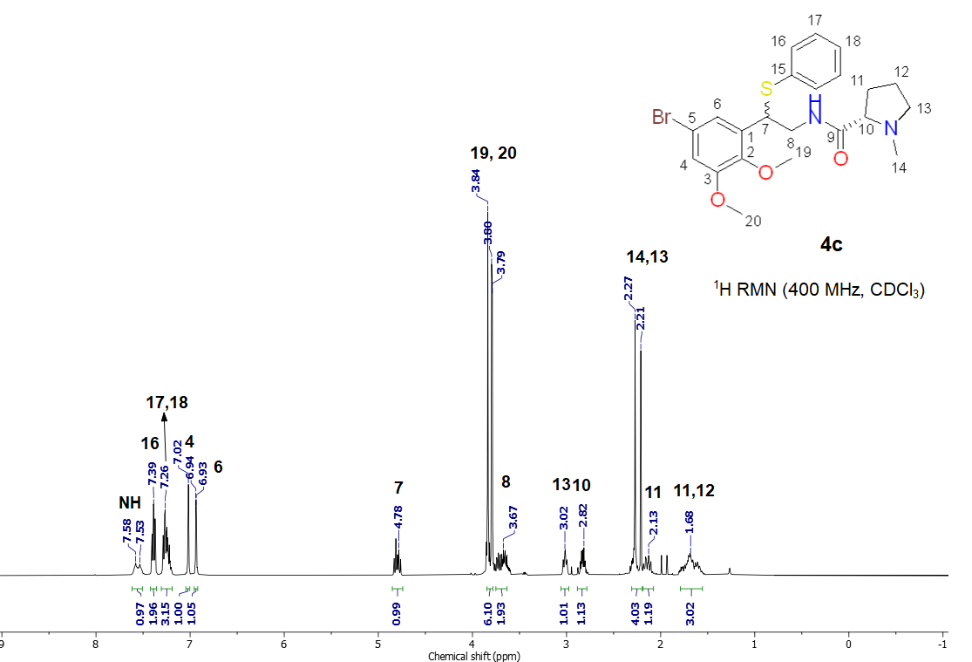
Fig. S21. ¹H NMR spectrum of (2S)-N-(2-(5-bromo-2,3-dimethoxyphenyl)-2-(phenylthio)ethyl)-1-methylpyrrolidine-2-carboxamide (5c)

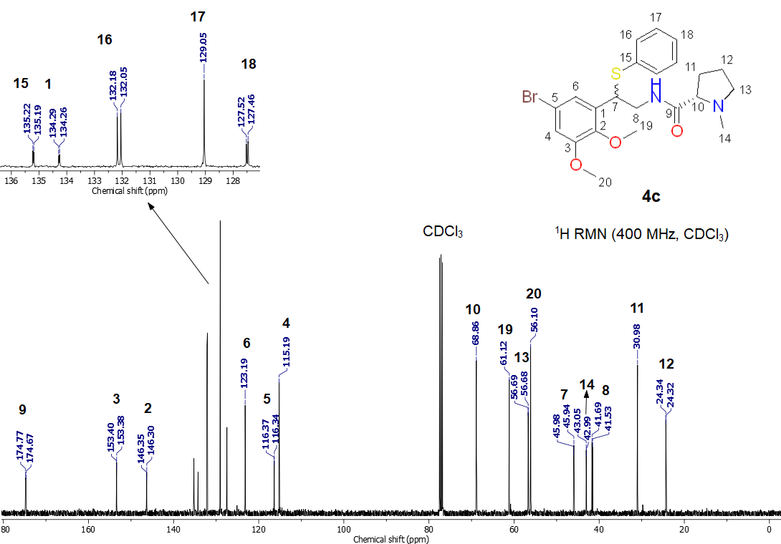
Fig. S22. ¹³C NMR spectrum of (2S)-N-(2-(5-bromo-2,3-dimethoxyphenyl)-2-(phenylthio)ethyl)-1-methylpyrrolidine-2-carboxamide (5c)
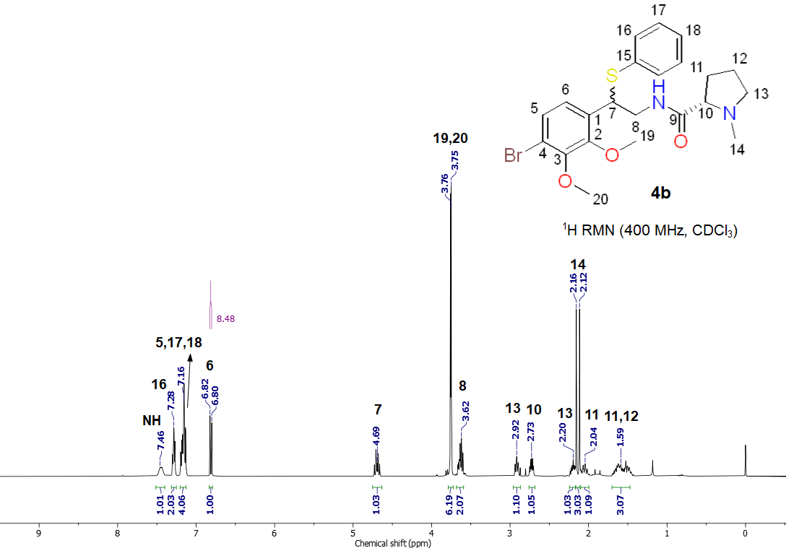
Fig. S23. ¹H NMR spectrum of (2S)-N-(2-(4-bromo-2,3-dimethoxyphenyl)-2-(phenylthio)ethyl)-1-methylpyrrolidine-2-carboxamide (5d)

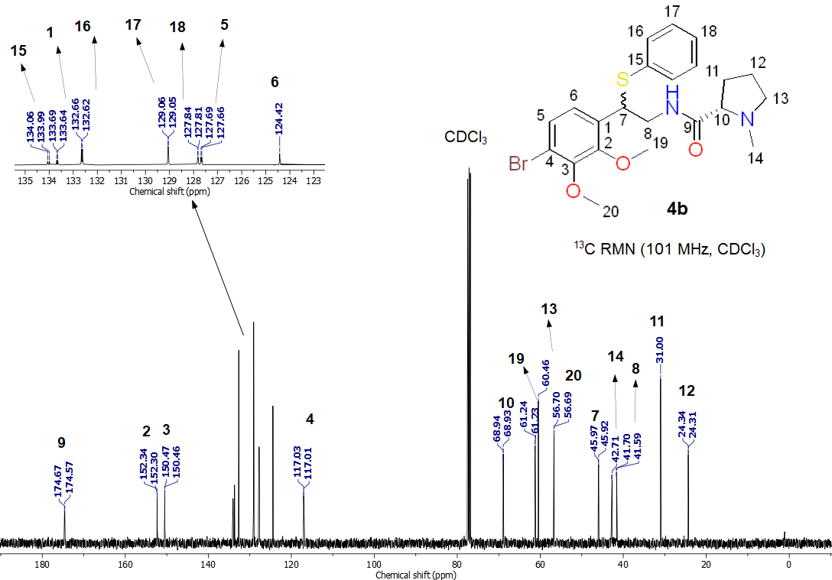
Fig. S24. ¹³C NMR spectrum of (2S)-N-(2-(4-bromo-2,3-dimethoxyphenyl)-2-(phenylthio)ethyl)-1-methylpyrrolidine-2-carboxamide (5d)
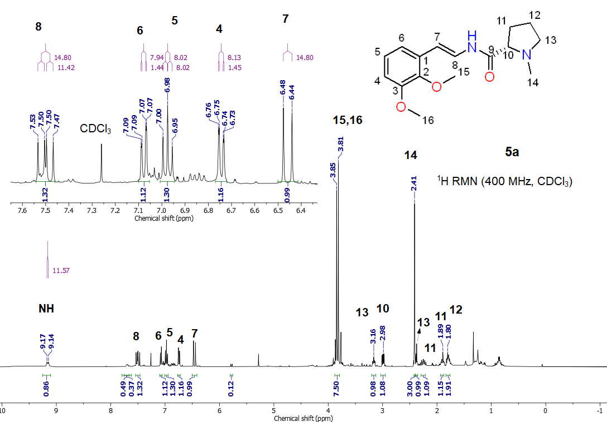
Fig. S25. ¹H NMR spectrum of (S,E)-N-(2,3-dimethoxystyryl)-1-methylpyrrolidine-2-carboxamide (6a)
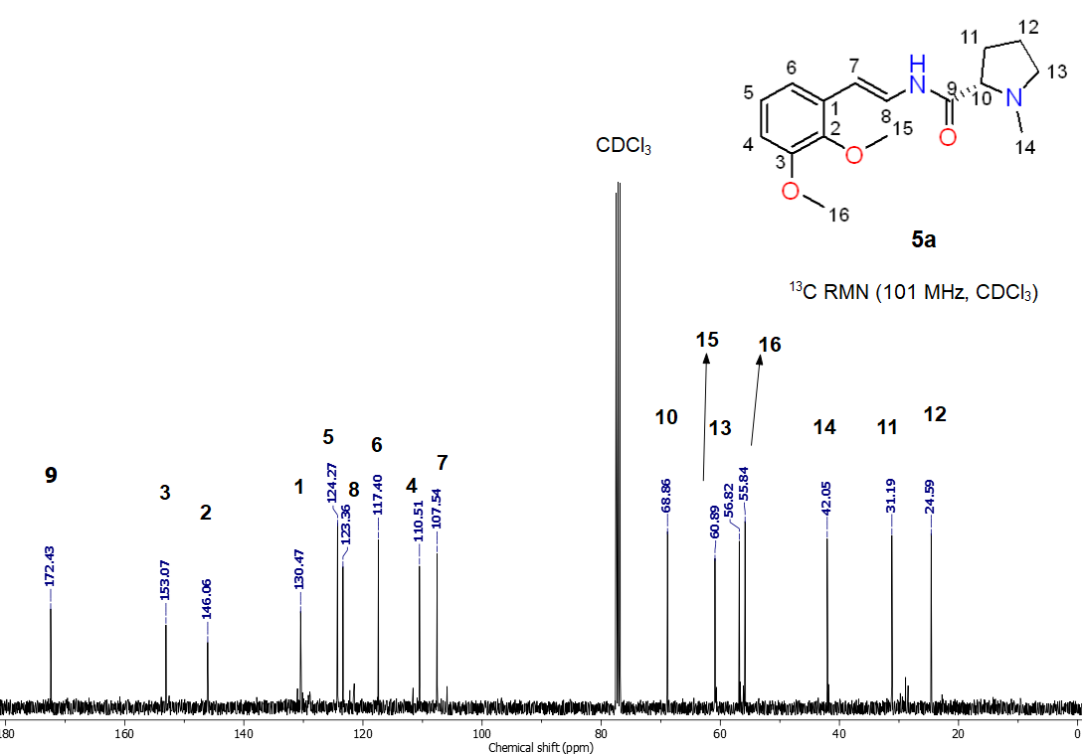
Fig. S26. ¹³C NMR spectrum of (S,E)-N-(2,3-dimethoxystyryl)-1-methylpyrrolidine-2-carboxamide (6a)
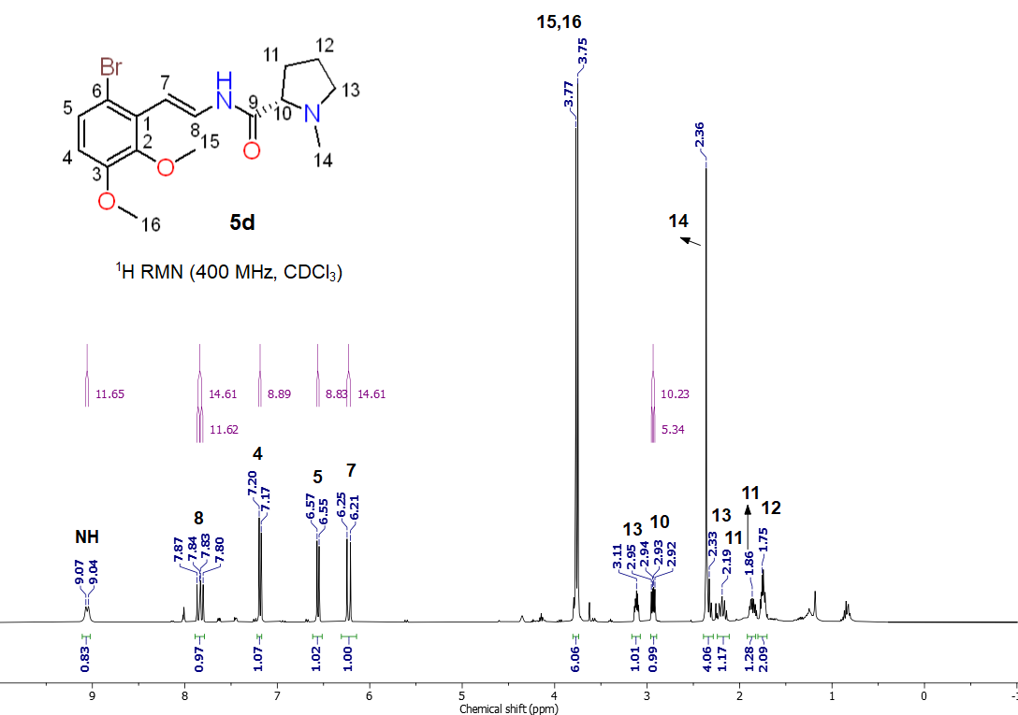
Fig. S27. ¹H NMR spectrum of (S,E)-N-(6-bromo-2,3-dimethoxystyryl)-1-methylpyrrolidine-2-carboxamide (6b)
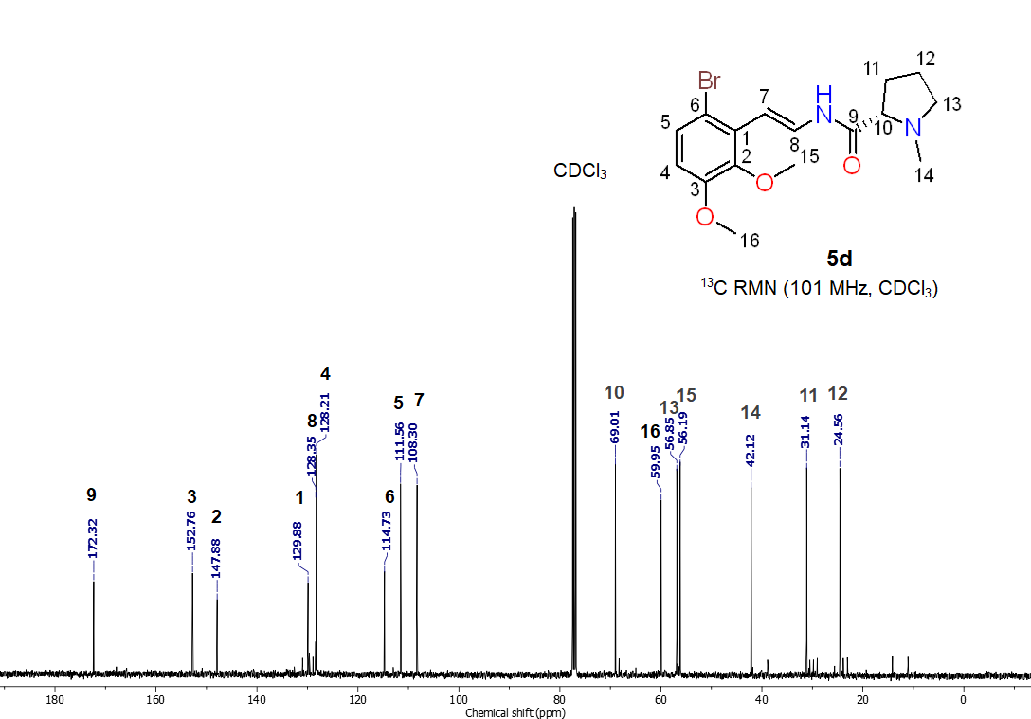
Fig. S28. ¹³C NMR spectrum of (S,E)-N-(6-bromo-2,3-dimethoxystyryl)-1-methylpyrrolidine-2-carboxamide (6b)
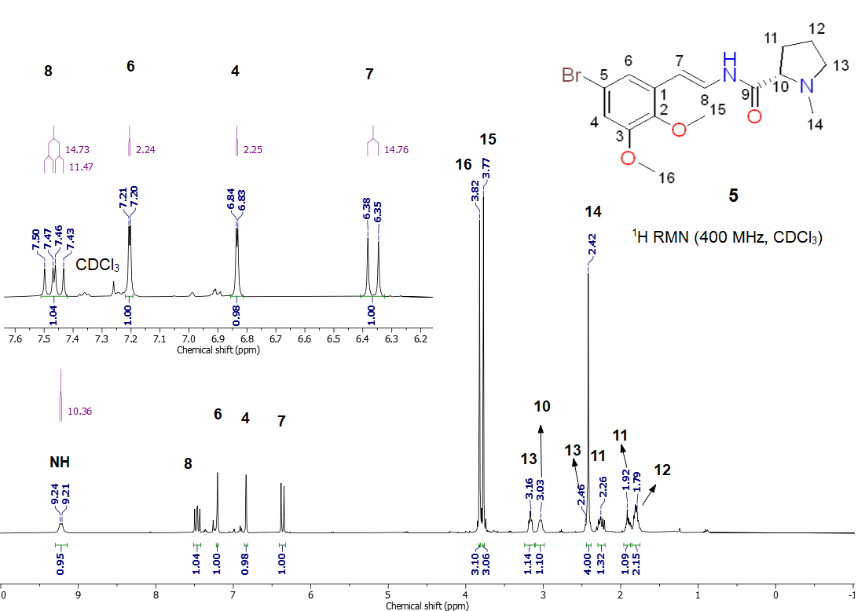
Fig. S29. ¹H NMR spectrum of (S,E)-N-(5-bromo-2,3-dimethoxystyryl)-1-methylpyrrolidine-2-carboxamide (6c)
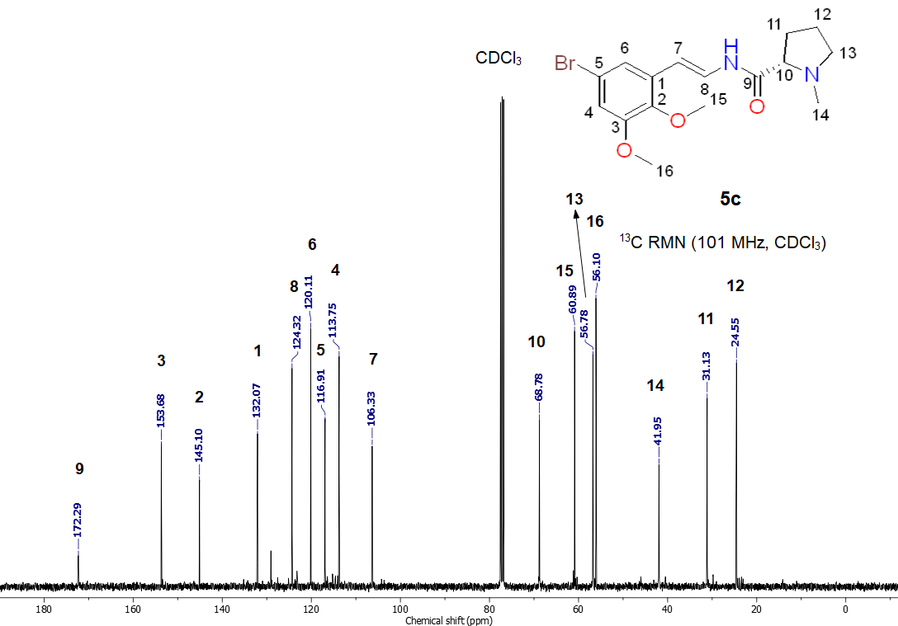
Fig. S30. ¹³C NMR spectrum of (S,E)-N-(5-bromo-2,3-dimethoxystyryl)-1-methylpyrrolidine-2-carboxamide (6c)
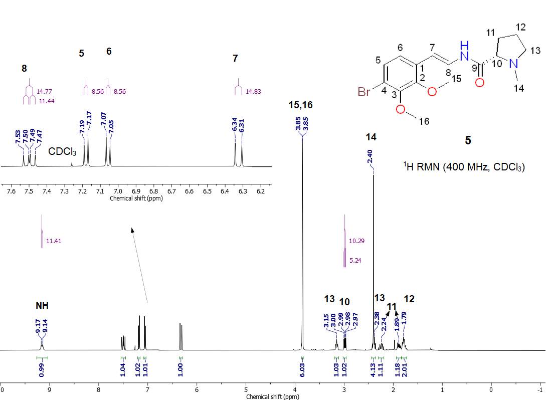
Fig. S31. ¹H NMR spectrum of (S,E)-N-(4-bromo-2,3-dimethoxystyryl)-1-methylpyrrolidine-2-carboxamide (6d)
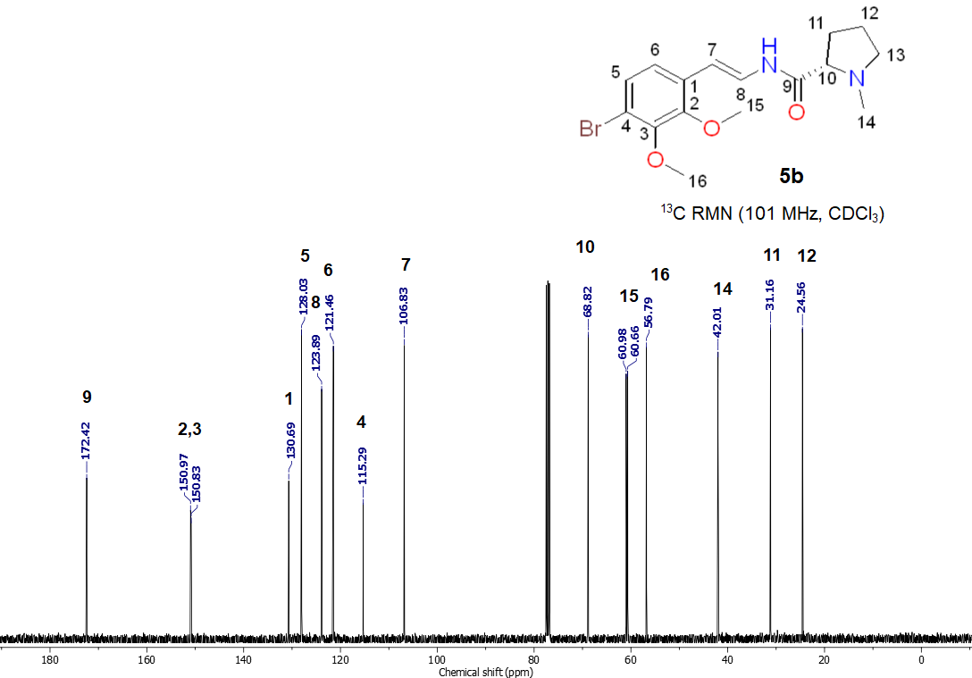
Fig. S32. ¹³C NMR spectrum of (S,E)-N-(4-bromo-2,3-dimethoxystyryl)-1-methylpyrrolidine-2-carboxamide (6d)
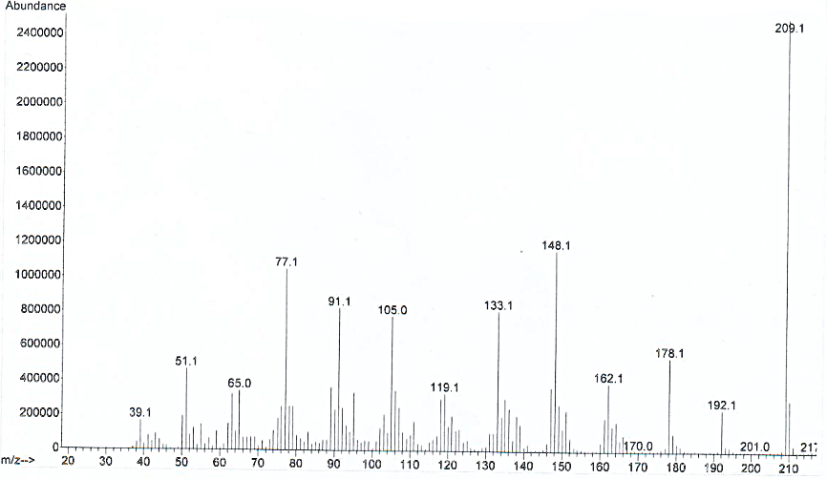Fig. S33. EI-MS spectrum of (E)-1,2-dimethoxy-3-(2-nitrovinyl)benzene (2a)

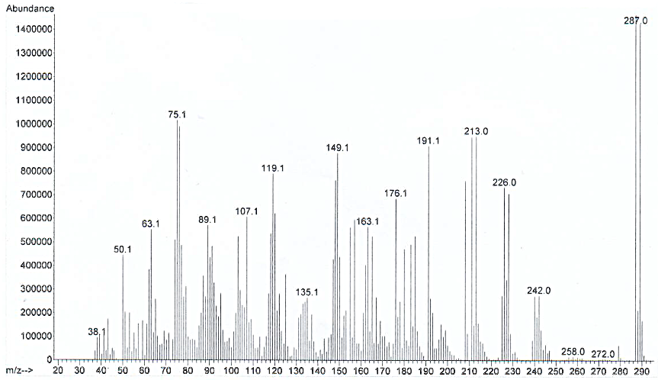
Fig. S34. EI-MS spectrum of (E)-1-bromo-3,4-dimethoxy-2-(2-nitrovinyl) benzene (2b)

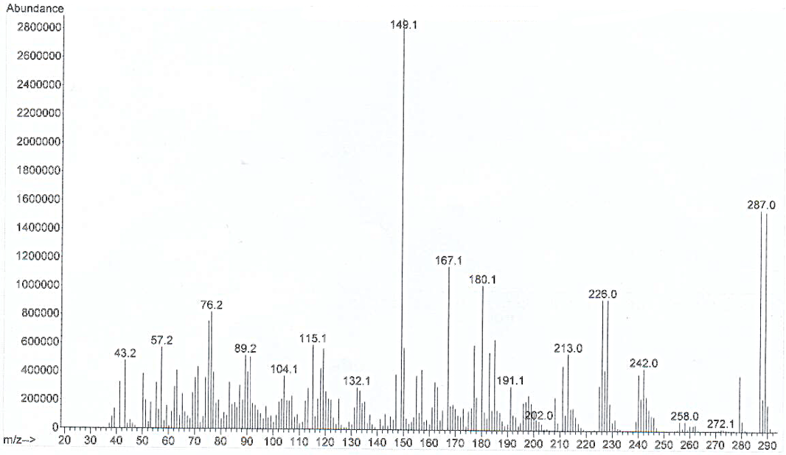
Fig. S35. EI-MS spectrum of (E)-5-bromo-1,2-dimethoxy-3-(2-nitrovinyl) benzene (2c)

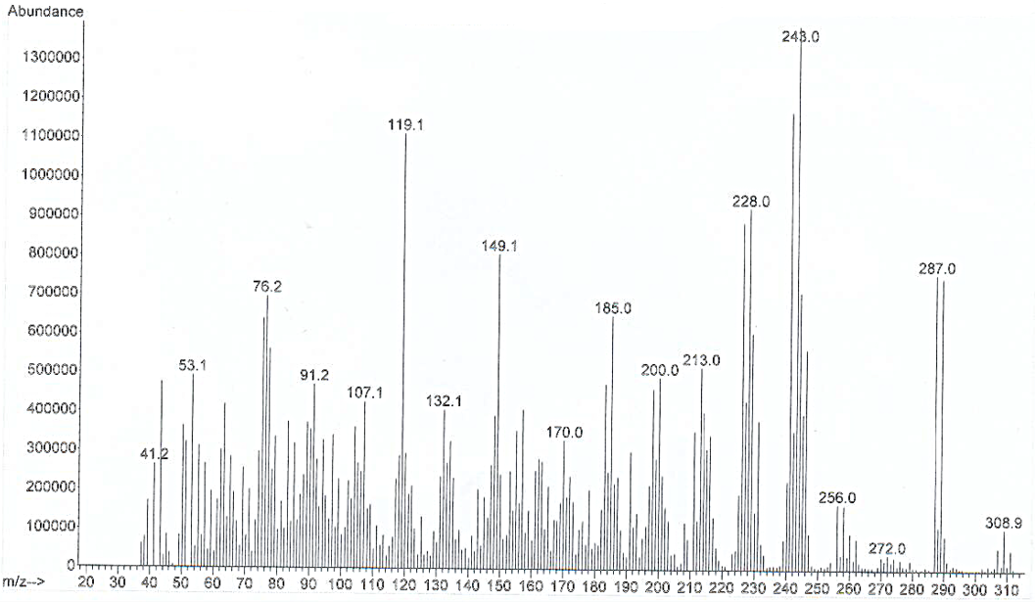
Fig. S36. EI-MS spectrum of (E)-1-bromo-2,3-dimethoxy-4-(2-nitrovinyl) benzene (2d)

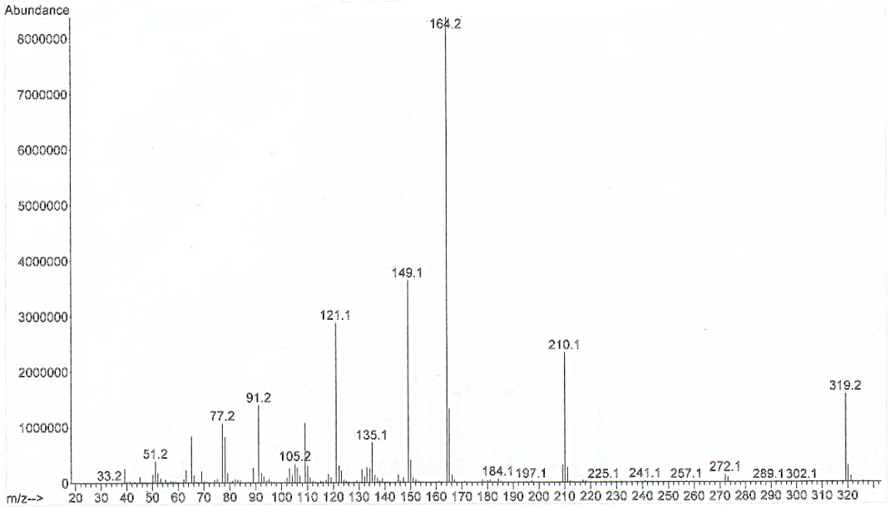
Fig. S37. EI-MS spectrum of (1-(2,3-dimethoxyphenyl)-2-nitroethyl)(phenyl) sulfane (3a)

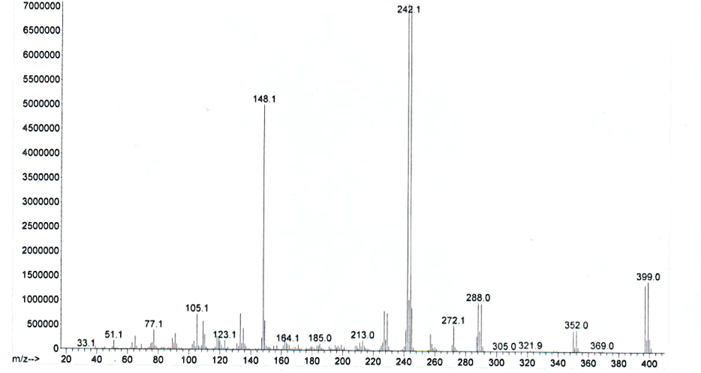
Fig. S38. EI-MS spectrum of (1-(6-bromo-2,3-dimethoxyphenyl)-2-nitroethyl) (phenyl)sulfane (3b)

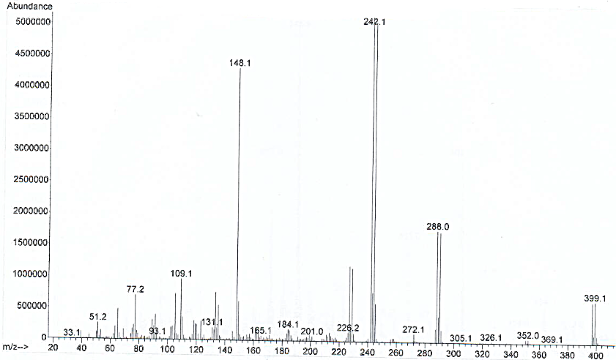
Fig. S39. EI-MS spectrum of (1-(4-bromo-2,3-dimethoxyphenyl)-2-nitroethyl)(phenyl)sulfane (3d)

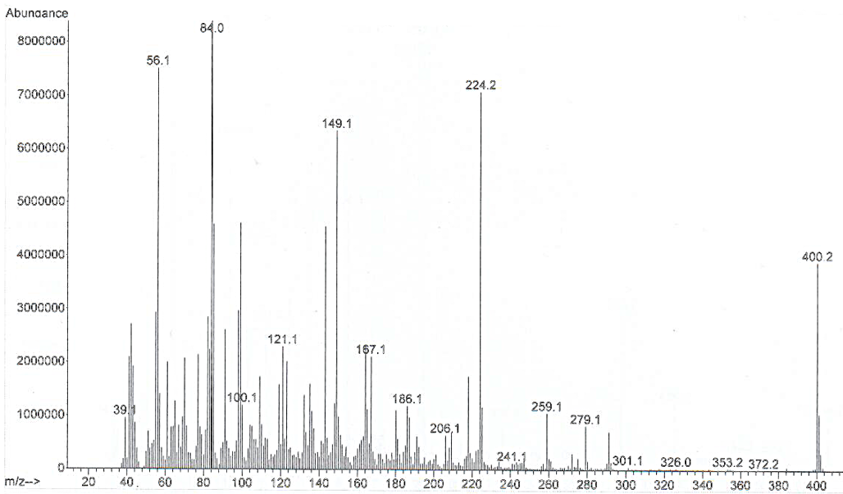
Fig. S40. EI-MS spectrum of (2S)-N-(2-(2,3-dimethoxyphenyl)-2-(phenylthio)ethyl)-1-methylpyrrolidine-2-carboxamide (5a)
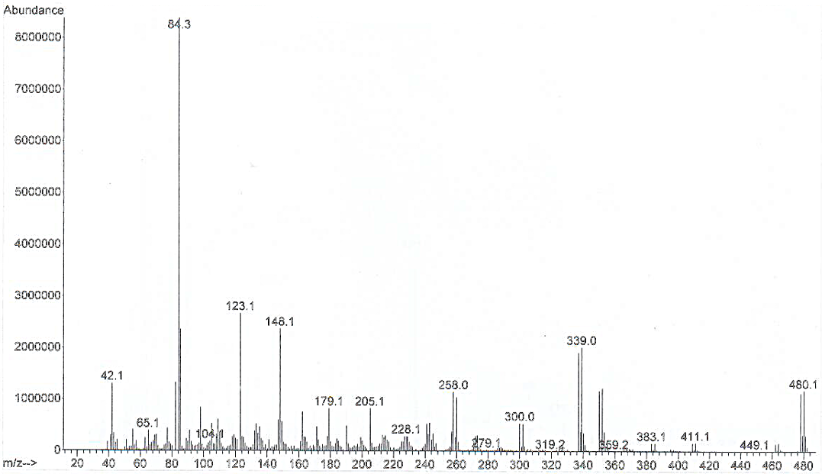
Fig. S41. EI-MS spectrum of (2S)-N-(2-(6-bromo-2,3-dimethoxyphenyl)-2-(phenylthio)ethyl)-1-methylpyrrolidine-2-carboxamide (5b)

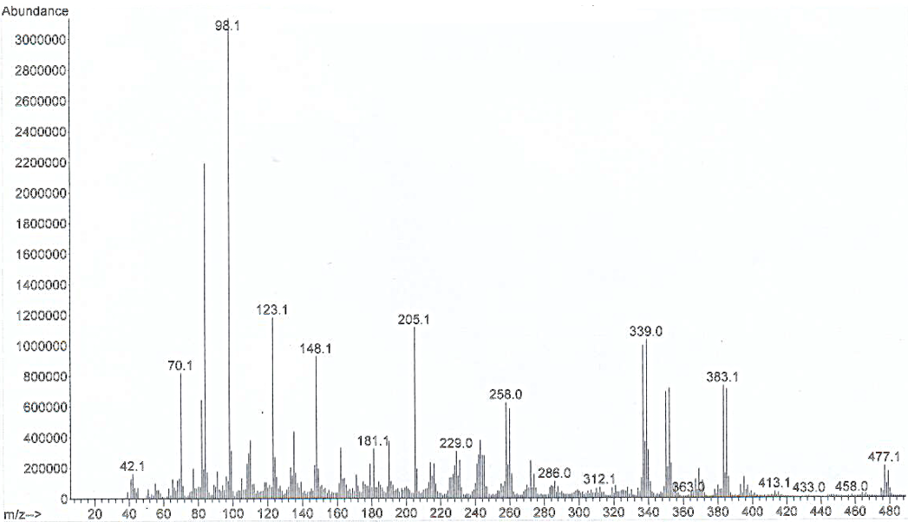
Fig. S42. EI-MS spectrum of (2S)-N-(2-(5-bromo-2,3-dimethoxyphenyl)-2-(phenylthio)ethyl)-1-methylpyrrolidine-2-carboxamide (5c)
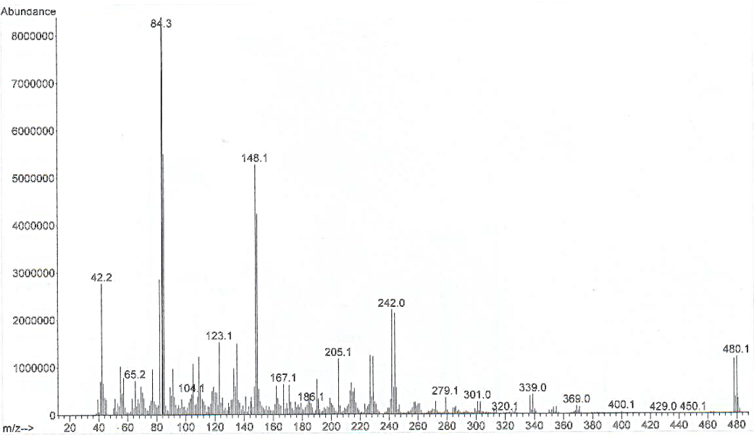
Fig. S43. EI-MS spectrum of (2S)-N-(2-(4-bromo-2,3-dimethoxyphenyl)-2-(phenylthio)ethyl)-1-methylpyrrolidine-2-carboxamide (5d)

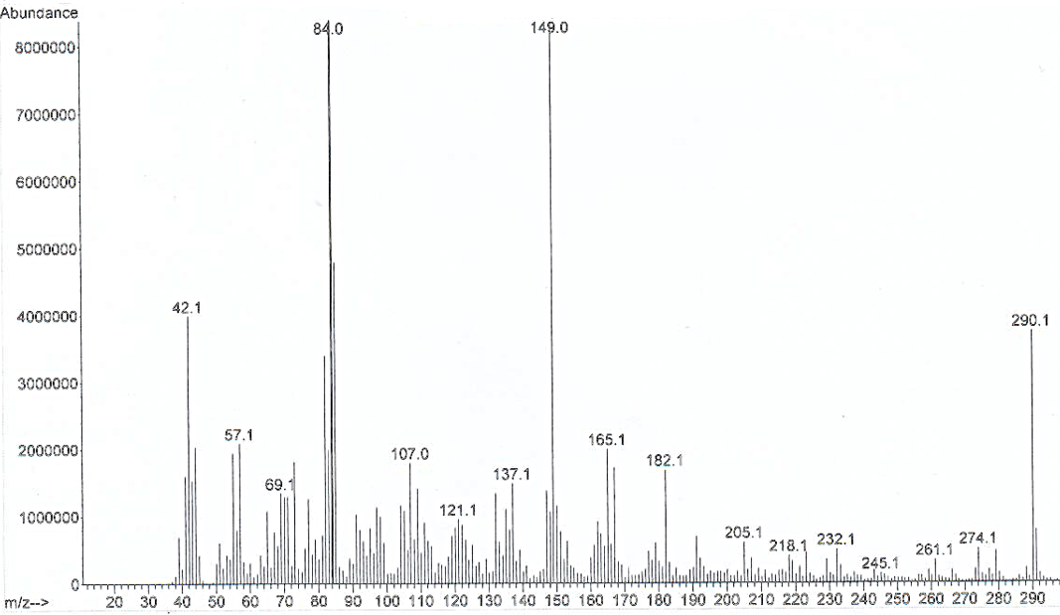
Fig. S44. EI-MS spectrum of (S,E)-N-(2,3-dimethoxystyryl)-1-methylpyrrolidine-2-carboxamide (6a)
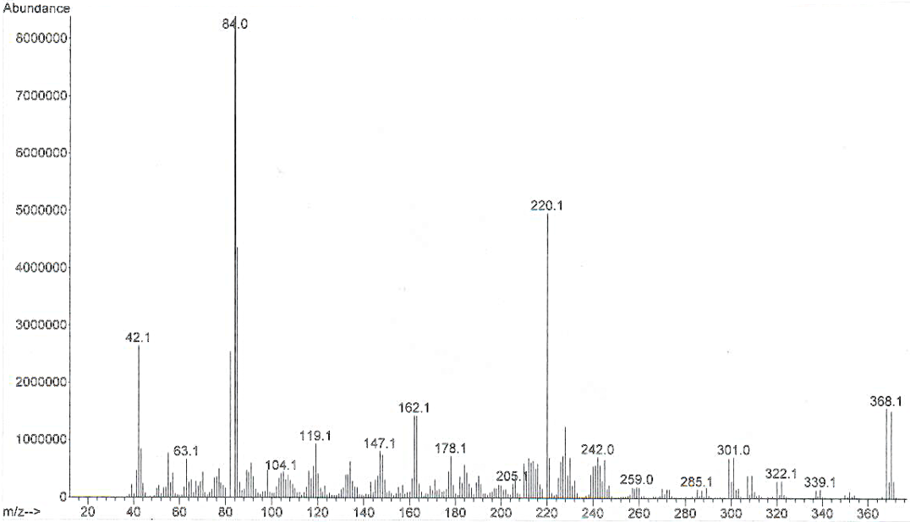
Fig. S45. EI-MS spectrum of (S,E)-N-(6-bromo-2,3-dimethoxystyryl)-1-methylpyrrolidine-2-carboxamide (6b)

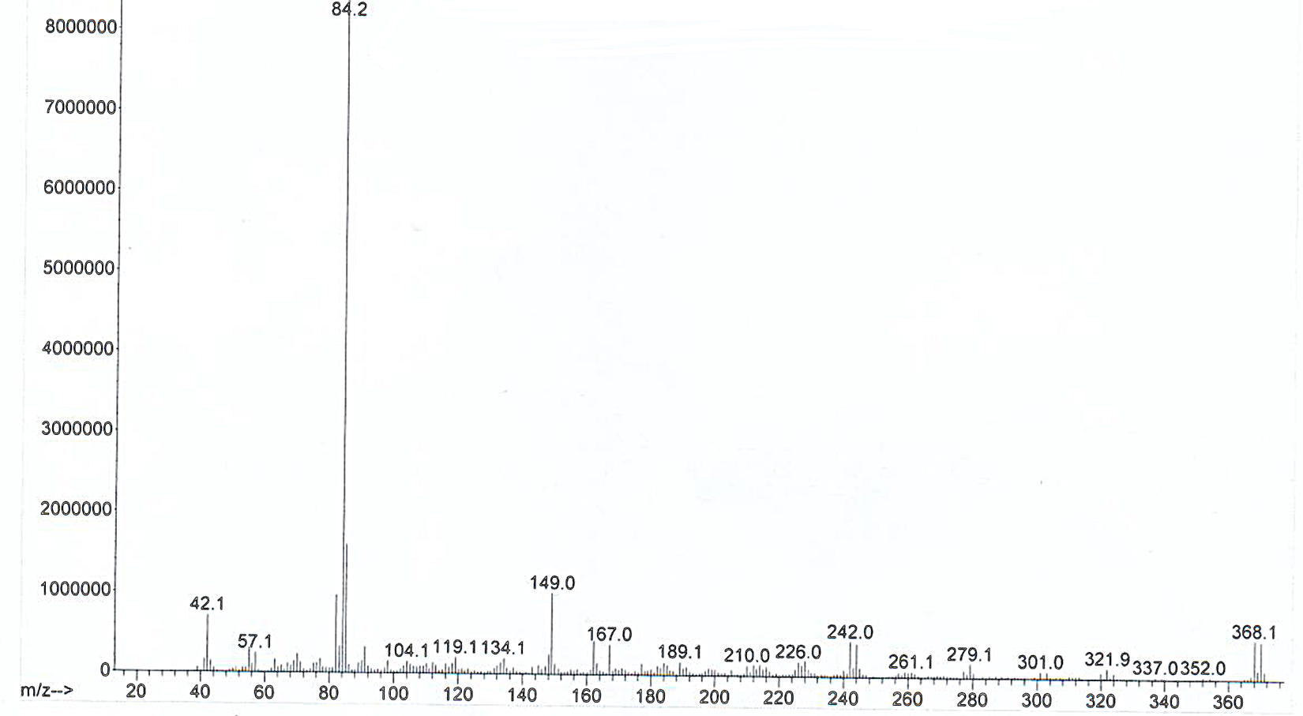
Fig. S46. EI-MS spectrum of (S,E)-N-(5-bromo-2,3-dimethoxystyryl)-1-methylpyrrolidine-2-carboxamide (6c)

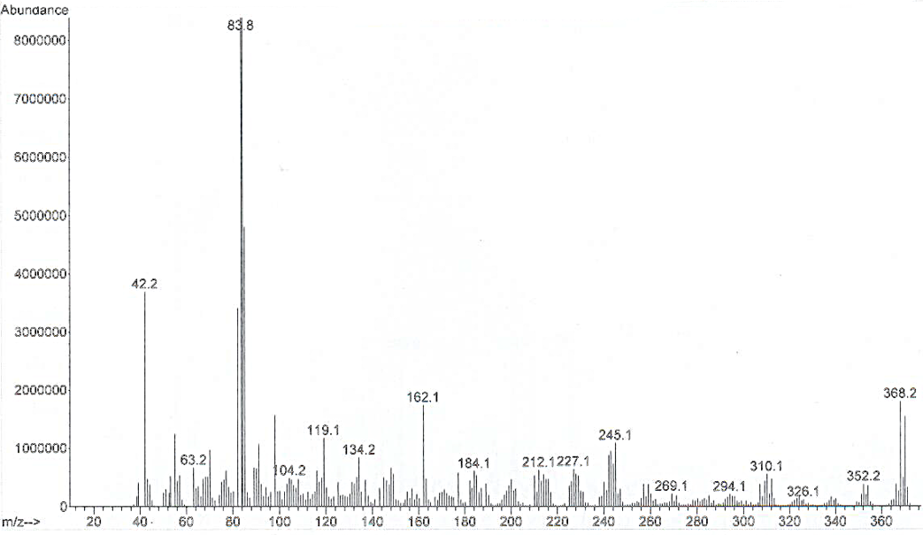
Fig. S47. EI-MS spectrum of (S,E)-N-(4-bromo-2,3-dimethoxystyryl)-1-methylpyrrolidine-2-carboxamide (6d)

Table S1. Physicochemical properties of AM-G, its monobrominated (M6B. M5B. M4B) and debrominated (AM-0) derivatives, the standard compound Eticlopride and the reference compound BMM.

Property | AM-G | M6B | M5B | M4B | AM-0 | ETI | BMM
Molecular Weight | 523.8 | 368.1 | 368.1 | 368.1 | 290.1 | 340.1 | 308.1
Volume | 361.2 | 322.6 | 322.6 | 322.6 | 303.3 | 338.5 | 266.3
Density | 1.45 | 1.14 | 1.14 | 1.14 | 0.95 | 1.01 | 1.15
nHA | 5 | 5 | 5 | 5 | 5 | 5 | 4
nHD | 1 | 1 | 1 | 1 | 1 | 2 | 2
nRot | 6 | 6 | 6 | 6 | 6 | 7 | 6
nRing | 2 | 2 | 2 | 2 | 2 | 2 | 2
maxRing | 6 | 6 | 6 | 6 | 6 | 6 | 6
nHet | 8 | 6 | 6 | 6 | 5 | 6 | 5
fChar | 0 | 0 | 0 | 0 | 0 | 0 | 0
nRig | 13 | 13 | 13 | 13 | 13 | 12 | 11
Flexibility | 0.46 | 0.46 | 0.46 | 0.46 | 0.46 | 0.58 | 0.54
Stereo centers | 1 | 1 | 1 | 1 | 1 | 1 | 0
TPSA | 50.8 | 50.8 | 50.8 | 50.8 | 50.8 | 61.8 | 41.8
logS | -3.66 | -2.58 | -2.50 | -2.33 | -1.58 | -3.14 | -0.45
logP | 3.80 | 2.34 | 2.48 | 2.25 | 1.52 | 3.62 | 1.84
logD | 3.56 | 2.53 | 2.75 | 2.59 | 1.84 | 2.81 | 1.16
MW: contains hydrogen atoms. Optimal 100-600; Volume: Van der Waals volumen; Density: MW/volumen; nHA: number of hydrogen bond acceptors. Optimal 0-12; nHD: number of hydrogen bond donors. Optimal 0-7; nRot: number of rotatable bonds. Optimal 0-11; nRing: number of ring. optimal 0-6; MaxRing: number of atoms in the biggest ring. optimal 0-18; nHet: number of heteroatoms. Optimal 0-15; fChar: formal charge. Optimal -4 to 4; nRig: number of rigid bonds. optimal 0-30; Flexibility: nRot/nRig; Stereo Centers: optimal ≤ 2; TPSA: topological polar surface area. Optimal 0-140; logS: log of the aqueous solubility. Optimal -4 to 0.5 log mol/L; logP: logof the octanol/water partition coefficient. Optimal 0-3; logD: logP at physiological pH 7.4. Optimal 1-3.

