Supplement for:
Low-density asymptomatic parasitemia in southern Zambia does not lead to clinical malaria and is not associated with household transmission: results from a two-year cohort study

Table of Contents
Main analysis 2
Table S1: Demographic characteristics of health center malaria cases 2
Figure S1. Parasite prevalence by qPCR by month and sex. 3
Random forest simulation experiment 4
Sensitivity Analysis 5
Table S3. Longitudinal cohort member demographics, stratified by never and ever positive (qPCR positives > 10 parasite per microliter) 5
Figure S4: Individual qPCR results of cohort members over time, restricted to those qPCR positives with parasite density at or above 10 parasite per microliter of blood. 6
Figure S5. No associations between individual qPCR positivity and clinical disease, restricted to those qPCR positives with parasite density at or above 10 parasite per microliter of blood. 7
Figure S6: No associations between individual qPCR positivity and clinical disease in household members, restricted to those qPCR positives with parasite density at or above 10 parasite per microliter of blood. 8

Main analysis

Table S1: Demographic characteristics of health center malaria cases
 | Percent (n)¹
Case count, N | 206
Age, median (IQR) | 15 (10, 25)
Female | 44.2% (91)
Pregnant | 7.7% (7)
Severe malaria diagnosis† | 14.1% (29)
Admitted to hospital | 9.7% (20)
Member of the cohort study | 1.9% (4)
Net used last night | 19.4% (40)
Net use frequency in past two weeks  14 nights  > 7 but < 14 nights  > 1 and < 7 nights  0 nights  Do not know/missed | 8.2% (17)  11.2% (23)  1.9% (4)  68.4% (141)  10.2% (21)
Travel in past month | 7.8% (16)

†Severe malaria as defined by Zambia Standard Treatment Guidelines. (Ministry of Health, Republic of Zambia. Zambia Standard Treatment Guidelines [Internet]. 2020. Available from: https://www.moh.gov.zm/?wpfb_dl=32)

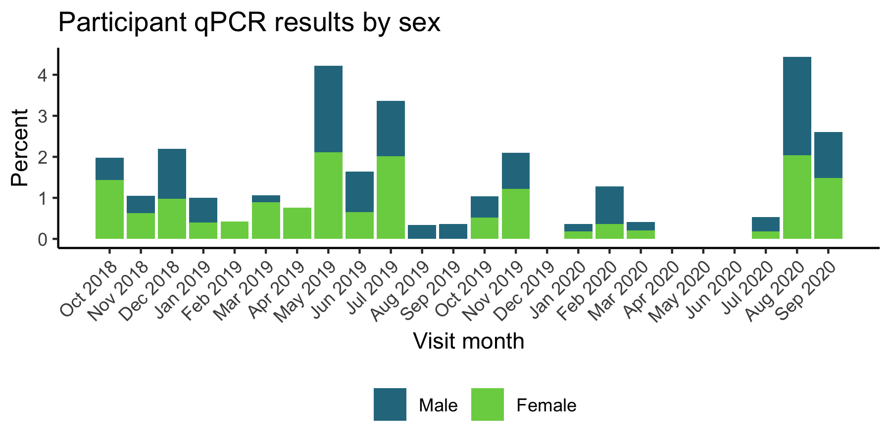

Figure S1. Parasite prevalence by qPCR by month and sex.
Cohort data collection was paused from April to July in 2020 in compliance with the Government of Zambia’s COVID-19 prevention measures.

Random forest simulation experiment
Methods: A random forest model was constructed to model qPCR positivity, selecting from a list of covariates including age, sex, net use, individual travel history, if a visitor was in the house during the past month, household member travel, household visitors, employment, recent visit to a health center, and month of year. To assess whether the model fit the observed outcome data better than randomly distributed data, 1000 simulations of an experiment were run that fit a random forest model to two versions of the dataset; 1) the actual data and 2) a version of the dataset where the qPCR outcomes were randomly redistributed across participants. All 1000 simulations compared the fit of the model on the actual data to the fit of the model to data with randomly redistributed outcomes. Then, a probability was computed as the probability that the actual model was better than the model based on random data as a proportion of experiments where the model with the actual data outperformed the model with the random data.
Results: The random forest model fit on randomly distributed episodes of parasitemia by qPCR outperformed the random forest model fit on the actual distribution of positives in only 10.2% of simulations. The model fit to randomly distributed qPCR positives with at least 10 parasite/µL data outperformed the model fit to the actual distribution in only two percent of the simulations. However, the fit was poor for both models fit on the actual data, with AUCs of 0.56 and 0.63.

Sensitivity Analysis Using >10 parasite per microliter

Table S3. Longitudinal cohort member demographics, stratified by never and ever positive (qPCR positives >10 parasite per microliter)
 | Overall | Never positive | Ever positive | p
Individual | n=1071 | n=1015 | n=56
Number of follow-up visits (median [IQR]) | 9.42 (7.10) | 9.10 (7.06) | 15.20 (5.15) | <0.001
Age (years) (median [IQR]) | 16.00 [8.00, 28.00] | 16.00 [9.00, 28.00] | 12.00 [7.00, 21.50] | 0.043
Female sex (n, %) | 133 (57.6) | 128 (57.7) | 5 (55.6) | 1
Visitor (n, %) | 149 (14.9) | 147 (15.6) | 2 ( 3.6) | 0.027
Years of education (median [IQR]) | 6.17 (4.45) | 6.23 (4.44) | 5.09 (4.44) | 0.068
Ever employed (n, %) | 369 (34.5) | 349 (34.4) | 20 (35.7) | 0.953
Ever travelled (n, %) | 572 (53.4) | 537 (52.9) | 35 (62.5) | 0.206
% nights using bednet (mean (SD)) | 0.34 (0.37) | 0.34 (0.37) | 0.37 (0.35) | 0.562
Household | n=201 | n=80 | n=87
Household size (median [IQR]) | 5.00 [3.00, 7.00] | 3.00 [2.00, 6.00] | 6.00 [4.00, 8.00] | <0.001
Household has at least one ITN (n, %) | 131 (76.6) | 54 (74.0) | 68 (81.9) | 0.314
IRS in household during study (n, %) | 4 ( 2.0) | 3 ( 3.8) | 1 ( 1.1) | 0.554
Household has more than one sleeping structure (n, %) | 49 (28.7) | 17 (23.3) | 31 (37.3) | 0.085

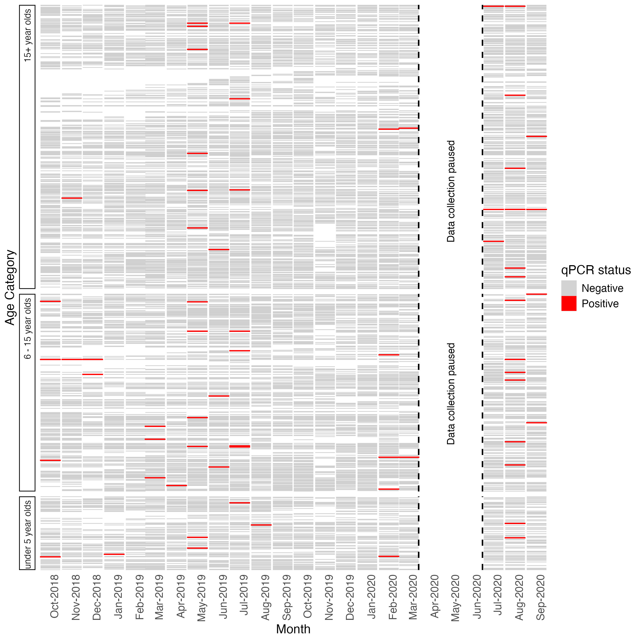

Figure S4: Individual qPCR results of cohort members over time, restricted to those qPCR positives with parasite density at or above 10 parasite per microliter of blood.

Each line represents one individual cohort participant ordered by age. Cohort data collection was paused from April to July in 2020 in compliance with the Government of Zambia’s COVID-19 prevention measures.

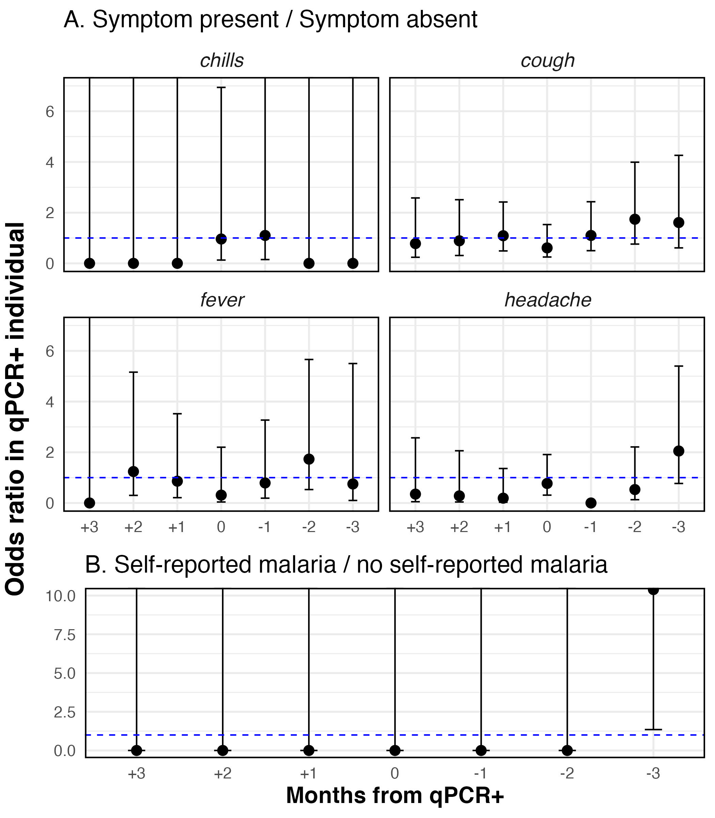

Figure S5. No associations between individual qPCR positivity and clinical disease, restricted to those qPCR positives with parasite density at or above 10 parasite per microliter of blood.
Univariate analysis examined the associations between qPCR positivity and clinical outcomes to examine evidence of clinical relevance of qPCR positivity. The alpha for the significance threshold was adjusted for multiple comparisons. A) qPCR positivity and symptoms of malaria; and B) qPCR positivity and self-reported malaria. Participants were asked to self-report any malaria diagnoses received at a health facility.

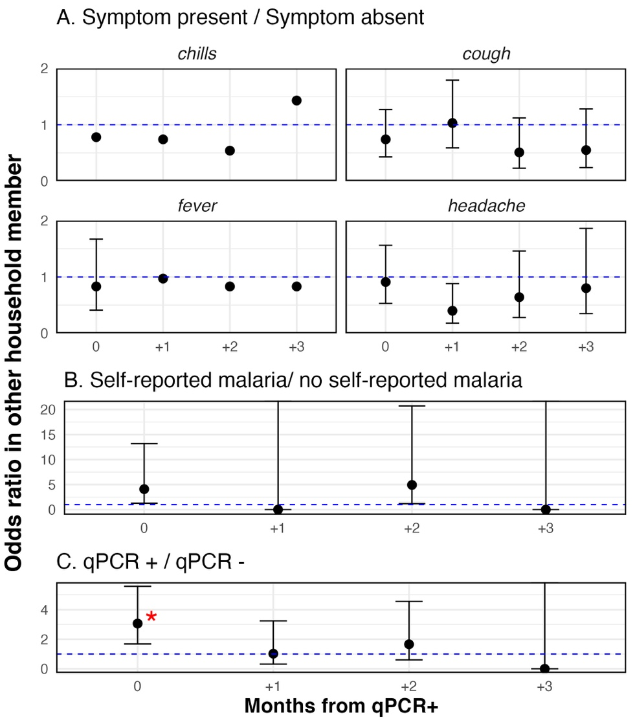

Figure S6: No associations between individual qPCR positivity and clinical disease in household members, restricted to those qPCR positives with parasite density at or above 10 parasite per microliter of blood.
Univariate analysis examined the associations between qPCR positivity and outcomes in other household members to examine evidence that qPCR positivity led to onward transmission. A) individual qPCR positivity and symptoms of malaria in household members; B) individual qPCR positivity and self-reported malaria; and C) individual qPCR positivity and qPCR positivity in household members.

