Table 1. Mcule results for small molecule binding to S100A4 (PDP Accession Code: 3CGA).
Bond-line representations are used to show the ligand structure of each molecule. The chemical formula and Mass (Da) were obtained using MCULE’s property calculator.

Name | Molecule | Chemical Formula | Mass (Da) | Docking Site
Molecule 1 | 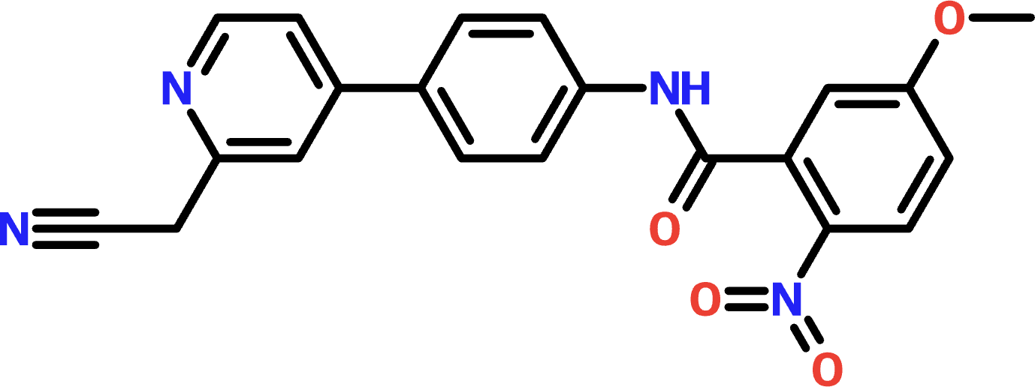 | C21H16N4O4 | 388.375 | N atom Lys28
Molecule 2 | 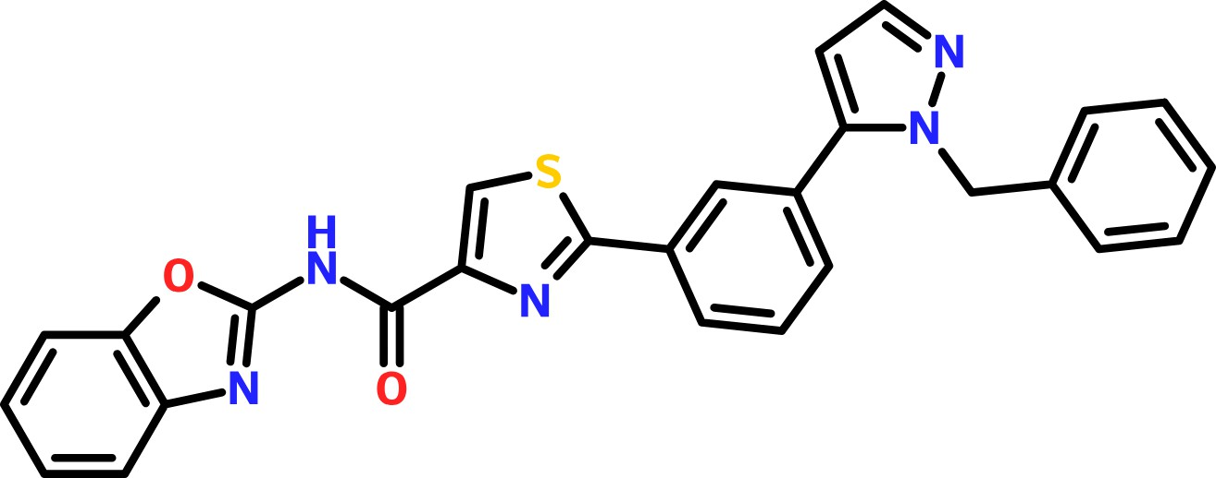 | C27H19N5O2S | 477.538 | N atom Lys28

Molecule 3 | 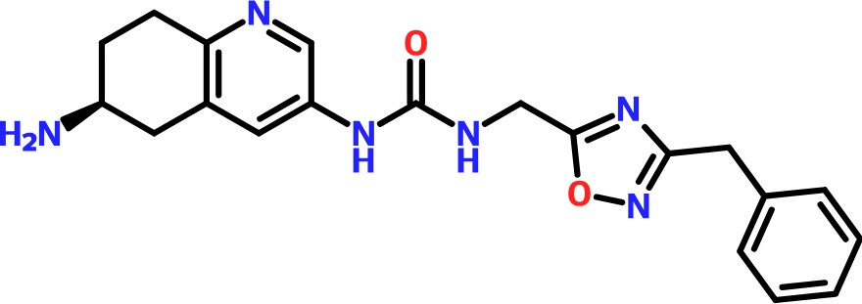 | C20H22N6O2 | 378.427 | OD2 atom Asp63

