Supplementary Results

Power-Law Distribution Fits
Detailed power-law fitting results for avalanche statistics are presented in Figure S1. Avalanche sizes were fit to P(S) ∝ S^{−τ} using maximum likelihood estimation with optimal lower bound selection via Kolmogorov-Smirnov minimization ¹. The fitted exponent was τ = 2.24 ± 0.04 with x_{min} = 28 spikes identifying the onset of power-law scaling. The KS statistic of 0.040 indicates excellent fit quality (n_{tail} = 919 avalanches; Supplementary Fig. 1a).
Avalanche durations similarly followed power-law distributions with fitted exponent α = 2.51 ± 0.06 and x_{min} = 22 time bins (KS = 0.062; Supplementary Fig. 1b). Both exponents fall within the range reported for critical neural systems, from in vitro cortical cultures to in vivo recordings.
The scaling relation between avalanche size and duration (S ~ D^{γ}) was assessed by linear regression in log-log space across all 585,437 individual avalanches, yielding γ = 1.13 (R² = 0.867). This exponent falls below mean-field predictions (γ = 2.0) but aligns with theoretical expectations for spatially-embedded networks with local connectivity structure.
Internal consistency was assessed via the crackling noise relation (α − 1)/(τ − 1) = 1.22, compared to the directly measured γ = 1.13. The close agreement (92.8%) provides validation of the criticality framework. Together with branching ratio σ = 1.099, these scaling analyses provide converging evidence that forebrain organoids self-organize to near-critical dynamics.

Scaling Relation
To provide additional evidence for critical dynamics, we examined the scaling relationship between avalanche size and duration. Log-log linear regression yielded γ = 1.13 with R² = 0.867 (Supplementary Fig. 2), consistent with the crackling noise prediction and supporting the criticality framework.

Age-Dependence of Functional Properties
To assess whether organoid maturation influenced functional properties, we correlated organoid age at recording with key network metrics (Supplementary Fig. 3; Supplementary Table 2). Organoids from 3 independent differentiation batches were distributed across the developmental window (75–367 days; mean ± SD: 161.9 ± 75.0 days), comprising 12 young (<120 days), 20 intermediate (120–180 days), and 13 mature (>180 days) organoids.
Branching ratio showed a modest negative correlation with age using both Pearson (r = −0.36, p = 0.015; n = 44) and Spearman (ρ = −0.56, p < 0.001) analyses, with younger organoids exhibiting slightly higher supercriticality (BR ≈ 1.13) and older organoids approaching exact criticality (BR ≈ 1.07; Supplementary Fig. 3b). While Pearson correlations between age and other functional metrics were not significant, Spearman correlations revealed significant monotonic relationships for all metrics examined (Supplementary Table S2). This systematic discrepancy suggests non-linear developmental trajectories or disproportionate influence from organoids at age extremes.
This developmental trajectory is consistent with recent observations during early organoid development, where branching ratio increased toward 1.0 from subcritical values over weeks 6–13 on HD-MEA. Our developmental window (75–367 days) extends beyond theirs with minimal overlap. One interpretation consistent with both datasets is that organoids initially approach criticality from subcritical values during early maturation, potentially overshoot to supercritical dynamics, and then gradually settle toward exact criticality at later stages, with BR = 1.0 serving as a developmental attractor. Notably, despite these age-related trends, all organoids operated within the near-critical regime (BR: 1.01–1.19), suggesting that self-organization to near-criticality is robust across this developmental window. Longitudinal studies spanning early through late development would be needed to confirm this trajectory.

Supplementary Methods

Power-Law Distribution Fitting
Avalanche size and duration distributions were fit to power laws P(x) ∝ x^{−α} using maximum likelihood estimation (MLE) with optimal lower bound (x_{min}) selection via Kolmogorov-Smirnov (KS) minimization ¹. The MLE estimator is:
$$α_{MLE}=1+n⋅{\left[\sum_{i}{\ln\left(\frac{x_{i}}{x_{min}}\right)}\right]}^{-1}$$
where n is the number of observations with x ≥ x_{min}. Standard errors were estimated as $SE(α) = (α - 1)/\sqrt{n}$. Internal consistency was assessed via the crackling noise relation, which predicts γ = (α − 1)/(τ − 1) for critical systems, where τ and α are the size and duration exponents respectively.

Scaling Relation Analysis
The scaling relationship between mean avalanche size ⟨S⟩ and duration D was assessed by log-log linear regression across all avalanches. At criticality, ⟨S⟩ ∝ D^{γ}, where the scaling exponent γ relates to power-law exponents via γ = (α − 1)/(τ − 1). Agreement between directly measured γ (from regression) and predicted γ (from power-law exponents) provides validation of the criticality framework.

Age-Dependence Analysis
Organoid age at recording was calculated as days from initial iPSC seeding to MEA recording. Pearson and Spearman correlations were computed between age and key functional metrics. For branching ratio analysis, one organoid was excluded due to sparse activity yielding fewer than 50 avalanche transitions, which produces unreliable estimates (n = 44 for age-BR correlations; n = 45 for all other metrics).
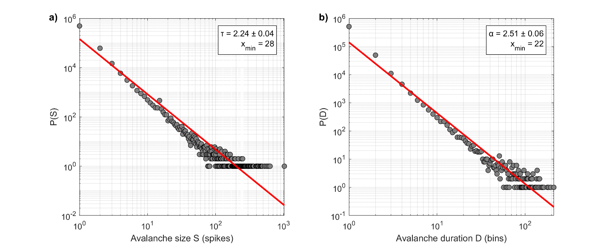
Supplementary Figure 1. Power-law distribution fits for avalanche statistics.
a Avalanche size distribution with power-law fit. Histogram shows probability P(S) of avalanche size S on log-log axes. Red line shows fitted power-law P(S) ∝ S^{−τ}, where τ is the size exponent. Vertical dashed line indicates x_{min}, the lower bound of the fitting range. Fitted exponent τ = 2.24 ± 0.04, x_{min} = 28 spikes, and KS = 0.040. b Avalanche duration distribution with power-law fit. Histogram shows probability P(D) of avalanche duration D. Red line shows fitted power-law P(D) ∝ D^{−α} and vertical dashed line indicates x_{min}. Fitted exponent α = 2.51 ± 0.06, x_{min} = 22 time bins, and KS = 0.062.

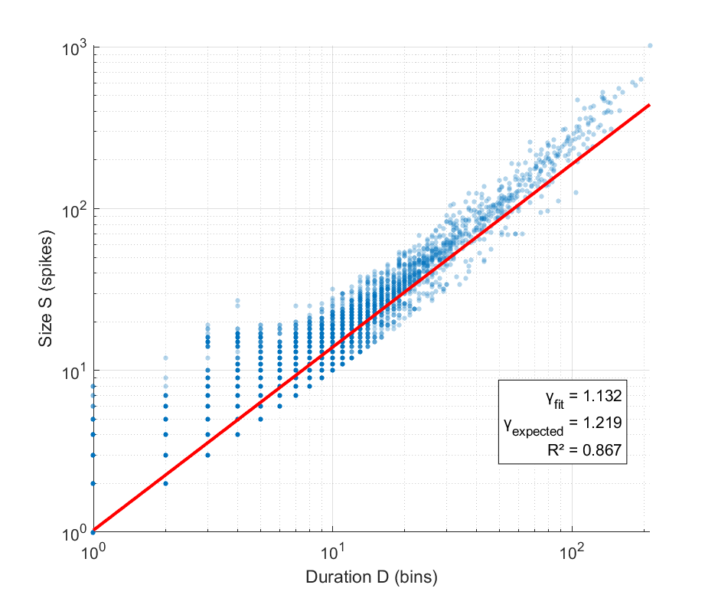
Supplementary Figure 2. Scaling relation of criticality.
Scaling relation between avalanche size S and duration D on log-log axes. At criticality, mean avalanche size scales with duration as ⟨S⟩ ∝ D^{γ}, where γ is the scaling exponent related to power-law exponents by γ = (α − 1)/(τ − 1). τ is the size distribution exponent and α is the duration distribution exponent. Each point represents one avalanche (n = 585,437). Red solid line shows power-law fit obtained by linear regression in log-log space.

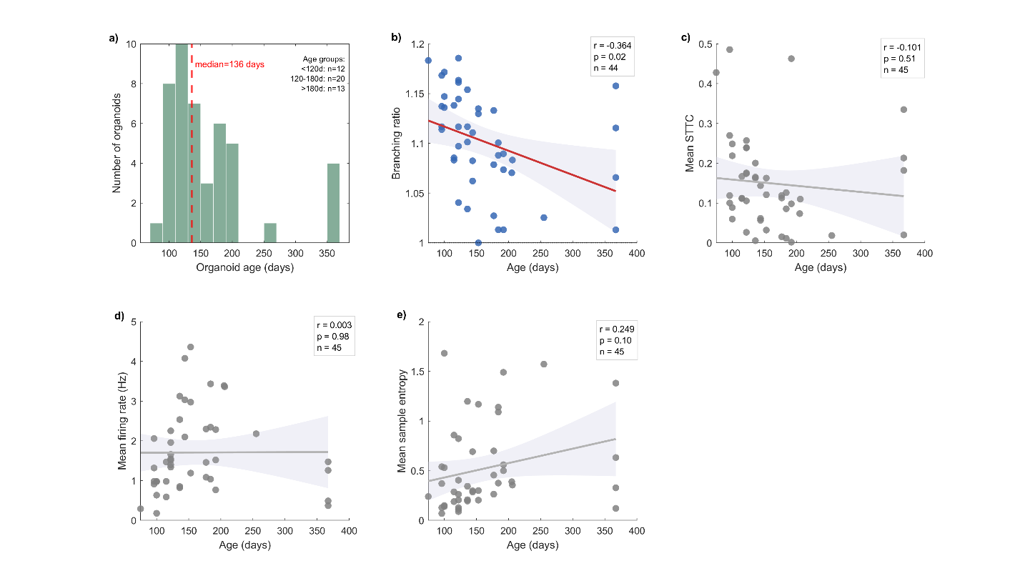
Supplementary Figure 3. Age-Dependence of Functional Properties.
a Age distribution of organoids at recording (n = 45) Dashed line indicates median age. b Branching ratio versus organoid age (n = 44). Solid red line shows linear regression. Shaded region indicates 95% confidence interval. c Mean STTC versus age. d Mean firing rate versus age. e Mean sample entropy versus age. Solid gray line and shaded region in each panel represent linear regression and 95% confidence interval, respectively.

Supplementary Tables
Supplementary Table 1 Dataset Summary Statistics
Metric | Mean | SD | Median | Range
Firing rate (Hz) | 1.71 | 2.09 | 1.09 | 0.001 – 15.8
Mean STTC | 0.149 | 0.115 | 0.119 | 0.000 – 0.49
Network density | 0.196 | 0.190 | 0.179 | 0.000 – 0.79
Clustering coefficient | 0.363 | 0.352 | 0.375 | 0.000 – 0.875
Burst rate (/min) | 2.20 | 1.73 | 1.77 | 0.30 – 8.13
Branching ratio | 1.099 | 0.052 | 1.101 | 1.00 – 1.19
Transfer entropy | 0.002 | 0.001 | 0.002 | 0.000 – 0.005
Mutual information | 0.047 | 0.044 | 0.032 | 0.000 – 0.194
Sample entropy | 0.481 | 0.546 | 0.233 | 0.011 – 2.216
Permutation entropy | 0.966 | 0.048 | 0.985 | 0.726 – 0.999

Supplementary Table 2 Age-Metric Correlations
Metric | n | Pearson r | p-value | Spearman ρ | p-value
Branching Ratio | 44 | −0.365 | 0.015* | −0.559 | <0.001***
Mean STTC | 45 | −0.101 | 0.508 | −0.297 | 0.048*
Firing Rate | 45 | −0.003 | 0.982 | 0.316 | 0.035*
Sample Entropy | 45 | 0.249 | 0.099 | 0.378 | 0.011*
Burst Rate | 45 | 0.126 | 0.411 | 0.310 | 0.038*
Clustering Coef. | 45 | −0.169 | 0.267 | −0.326 | 0.029*
Organoid age ranged from 75–367 days (median: 136 days). One organoid was excluded from branching ratio analysis due to insufficient avalanche transitions (<50) for reliable estimation. *p < 0.05, **p < 0.01, ***p < 0.001.

References
1. Clauset, A., Shalizi, C. R. & Newman, M. E. J. Power-Law Distributions in Empirical Data. SIAM Rev. 51, 661–703 (2009).
2. Alam El Din, D.-M. et al. Human neural organoid microphysiological systems show the building blocks necessary for basic learning and memory. Commun Biol 8, 1237 (2025).

