Appendix A
LOWESS is used to fit the annual and seasonal data series in order to minimize local oscillations. (Cleveland, 1979, Helsel & Hirsh). Regression curves are used to spot trends throughout time as seen in Fig 4 there is an increasing trend in temperature from 1980 onwards in annual temperature series and after 2010 became unnoticeable increase.
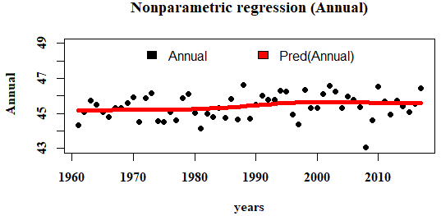
Fig. 1 LOWESS regression lines for annual Temperature in 29 stations (Pred means predictions)
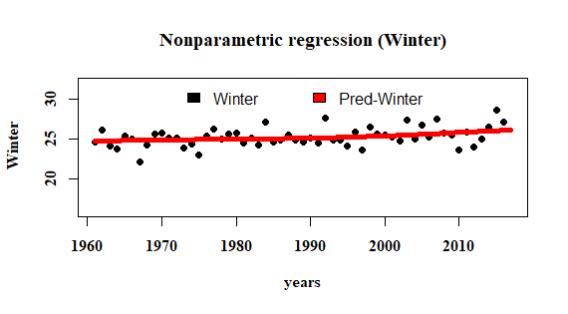
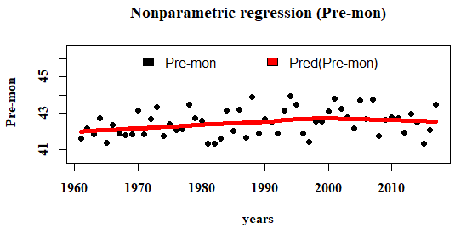
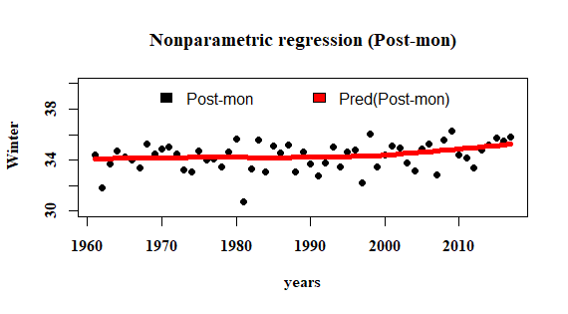
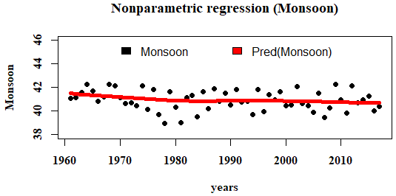

Fig.2 Lowess regression lines for seasonal Temperature in 29 stations (Pred means predictions)
Fig 2 shows decreasing trend in monsoon temperature, in post monsoon rise in temperature has been noticed after year 2000. Increase in temperature up to year 2000 and gradual decline till 2017 can be noticed in Pre-monsoon. Rise in temperature from year 1995 till 2017 during winter season reveals that cold weather is declining as a witness of climate change.
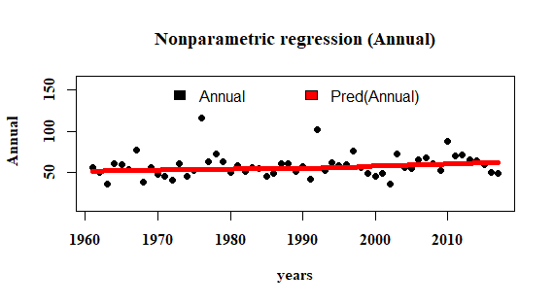
Appendix B
Fig. 3. LOWESS regression lines for annual Rainfall in 29 stations (Pred means predictions)

In Fig 3 there is steady increase in trend in rainfall during 1961-2017 annually.

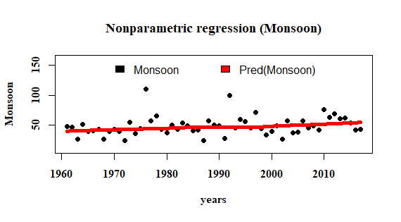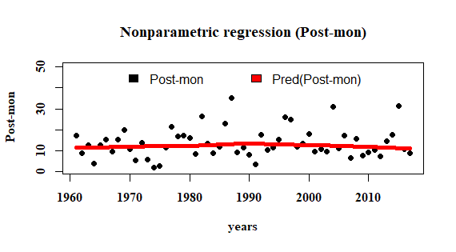

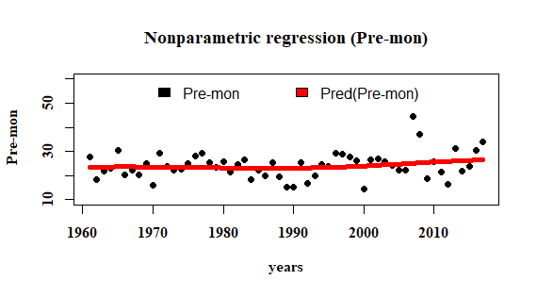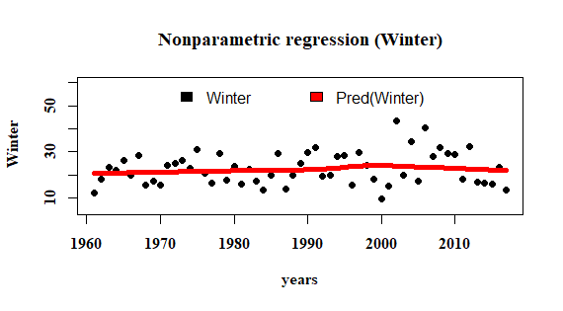
Fig. 4. LOWESS regression lines for seasonal Rainfall in 29 stations (Pred means predictions)
In Fig 4 there is a increase in change in rainfall trend after 1990 in monsoon decline in rainfall in post-monsoon after 1992, increase in rainfall trend in post-monsoon after1990. In winter season the increase in rainfall is between years 1995-2005.

