SUPPLEMENTARY
Supplementary Figures
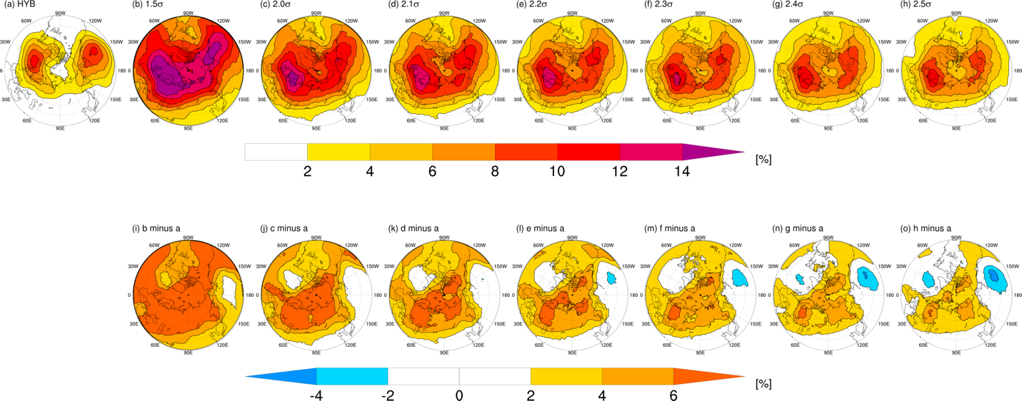
Figure S1. Sensitivity of winter (DJF) blocking detection to local standard deviations without considering a minimum threshold ${Z^{'}}_{min}$. (a) Climatological blocking frequency detected by the standard HYB method. (b–h) Blocking frequencies detected by various range of thresholds from 1.5σ to 2.5σ. (i–o) The difference in blocking frequency between each sensitivity experiment and the standard HYB method (Experiment minus HYB).
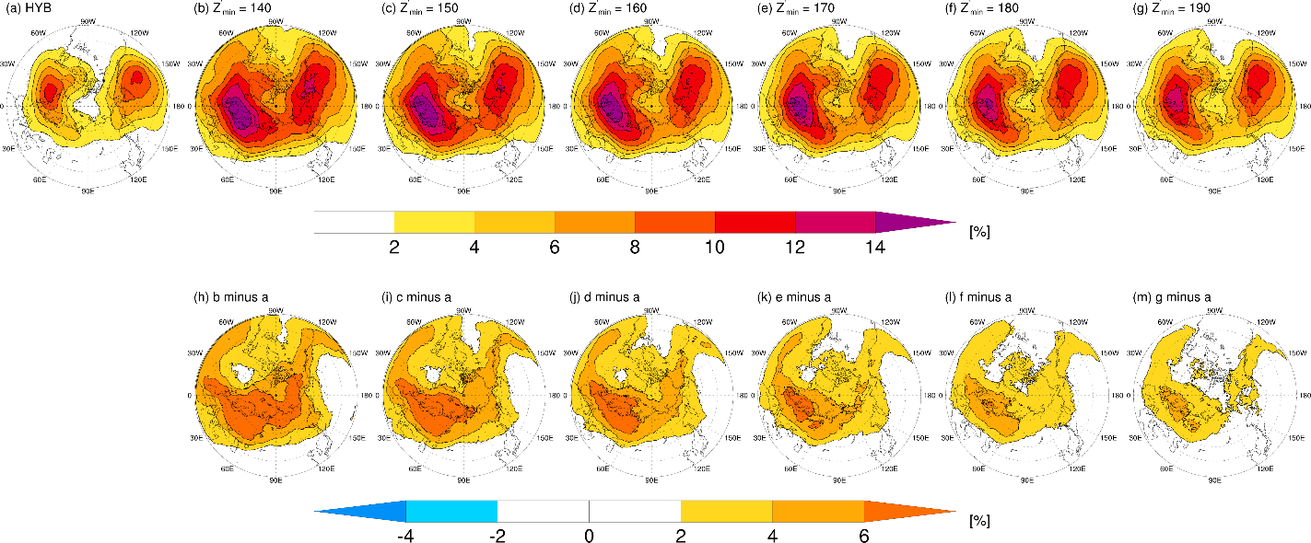

Figure S2. Sensitivity of winter (DJF) blocking detection to the minimum anomaly thresholds (${Z^{'}}_{min}$) under a fixed local 2σ condition. (a) Climatological blocking frequency detected by the standard HYB method. (b–g) Blocking frequencies detected by applying ${Z^{'}}_{min}$ values ranging from 140 gpm to 190 gpm (10 gpm increments) in addition to the 2σ criterion. (h–m) Differences in blocking frequency between each sensitivity experiment and the standard HYB method (Experiment minus HYB).

