Supplementary material
An advanced lyophilization toward intact lipid nanovesicles: Liquid-mediated freezing with cryoprotectant to retain the integrity of lipid nanovesicles
Eunhye Yang⁺, Hyunjong Yu⁺, SungHak Choi, Kyung-Min Park, Ho-Sup Jung*, and Pahn-Shick Chang*

⁺ These authors contributed equally to this work
Corresponding author
Ho-Sup Jung, jhs@snu.ac.kr; Pahn-Shick Chang, pschang@snu.ac.kr
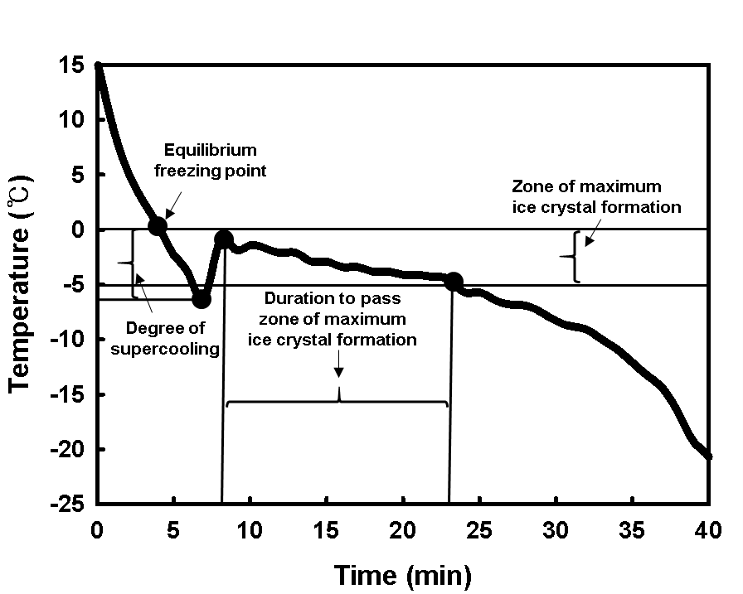
Supplementary Fig. S1. Freezing curve of a lipid nanovesicle solution obtained during conventional freezing, showing the supercooling and freezing rates.
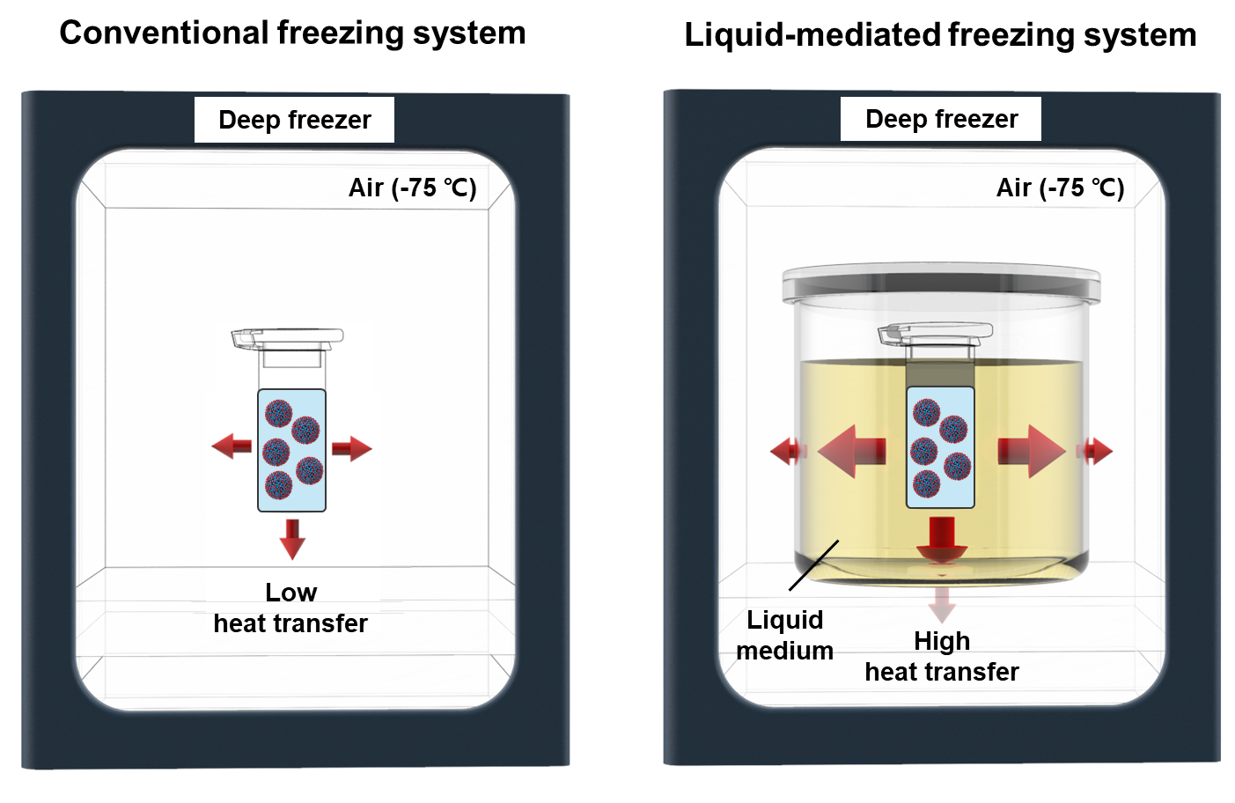 Supplementary Fig. S2. Schematic illustration of a conventional freezing system and a liquid-mediated freezing system.

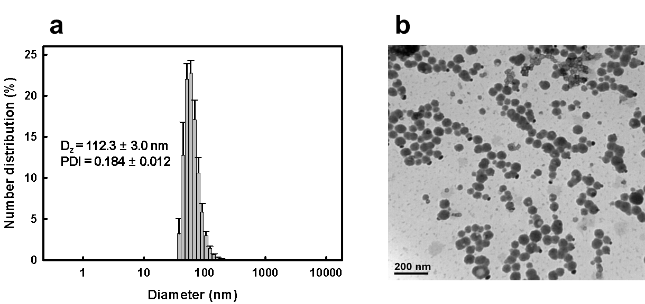
Supplementary Fig. S3. (a) Size distributions (Z-average diameter and polydispersity index) and (b) transmission electron microscopy of intact lipid nanovesicles.
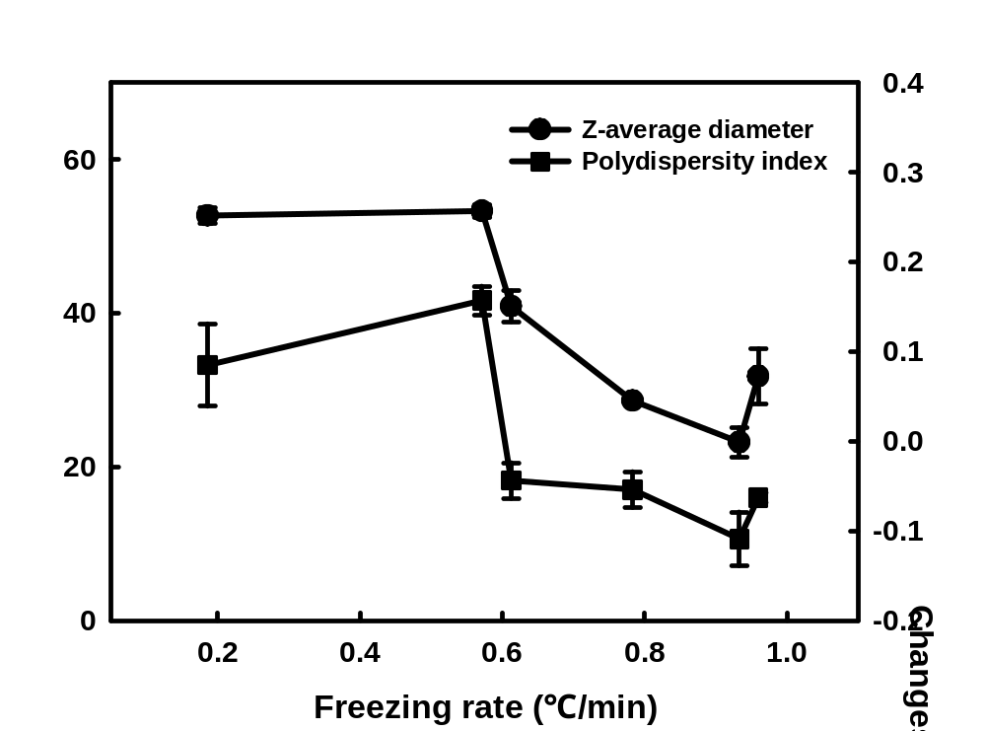
Supplementary Fig. S4. Changes in size distribution (Z-average diameter and polydispersity index) of lyophilized lipid nanovesicles at different freezing rate and intact lipid nanovesicles prior to lyophilization.

Supplementary Table S1. Specific heat capacity of various medium used in the LMF system at 0ºC and freezing rate of the CF and LMF system using each medium.
Freezing system (medium) | Specific heat capacity  of medium (J/℃∙g) | Freezing rate  (℃/min)
Conventional freezing (air) | 1.000 ¹ | 0.186 ± 0.076ª
LMF (acetone) | 2.114 ² | 0.571 ± 0.086^{b}
LMF (n-propanol) | 2.186 ³ | 0.613 ± 0.058^{b}
LMF (ethanol) | 2.270 ⁴ | 0.783 ± 0.024^{c}
LMF (isopropanol) | 2.475 ⁵ | 0.933 ± 0.016^{cd}
LMF (methanol) | 2.567 ⁵ | 0.966 ± 0.056^{d}
Data are presented as means with standard deviations (n=3). Different letters indicate significant differences at p < 0.05 based on Tukey post-hoc analysis.

References
1 Arroyo, M., Sánchez-Montero, J. M. a. & Sinisterra, J. V. Thermal stabilization of immobilized lipase B from Candida antarctica on different supports: Effect of water activity on enzymatic activity in organic media. Enzyme Microb. Technol. 24, 3-12, doi:10.1016/S0141-0229(98)00067-2 (1999).
2 Kelley, K. K. The heat capacities of isopropyl alcohol and acetone from 16 to 298 K. and the corresponding entropies and free energies. J. Am. Chem. Soc. 51, 1145-1150, doi:10.1021/ja01379a022 (1929).
3 van Miltenburg, J. C., Berg, v. d. & K., G. J. Heat capacities and derived thermodynamic functions of 1-propanol between 10 K and 350 K and of 1-pentanol between 85 K and 370 K. J. Chem. Eng. Data 49, 735-739, doi:10.1021/je0499768 (2004).
4 Miyazawa, T., Kondo, S., Suzuki, T. & Sato, H. Specific heat capacity at constant pressure of ethanol by flow calorimetry. J. Chem. Eng. Data 57, 1700-1707, doi:10.1021/je2013473 (2012).
5 Katayama, T. Heats of mixing, liquid heat capacities and enthalpy-concentration charts for methanol-water and iso-propanol-water systems. Chem. Eng. 26, 361-372, doi:10.1252/kakoronbunshu1953.26.361 (1962).

