Supporting Information

Deep Electro-chemical Modulation of Optical Activity at Chiral Polymer:PEDOT Nanointerface for Display Technology Advancement

Sonal Gupta¹, Jojo P. Joseph¹, Rahul Kumar Das¹, Dananjali Thathsarani Rathnayake¹, Andrey Kuzmin¹, Alexander Baev¹, and Paras N. Prasad^{1, *}
¹Department of Chemistry and The Institute for Lasers, Photonics, and Biophotonics,
University at Buffalo, SUNY, New York 14260, United States
*Corresponding author’s email: pnprasad@buffalo.edu

Table of contents
1. Preparation of a layer-by-layer film deposition using electroactive and chiral polymer S2
2. Chronoamperometry profiles for PEDOT S3
3. Chronoamperometry profiles for P* S4
4. Chronoamperometry profiles for P*/PEDOT S6
5. CD spectra of P* polymer film at different voltage S8
6. Dynamic voltage switching of the PEDOT, P*, and P*/PEDOT film S9
7. Electrochemical switching of P*/PEDOT S11
8. Scanning electron microscopy images S11
9. FT-IR spectra of polymers S12
10. Raman spectra of polymers S12
11. Raman spectro-electrochemistry set up used S13
12. P*/PEDOT based device characterizations S13
13. References S15

1. Preparation of a layer-by-layer film
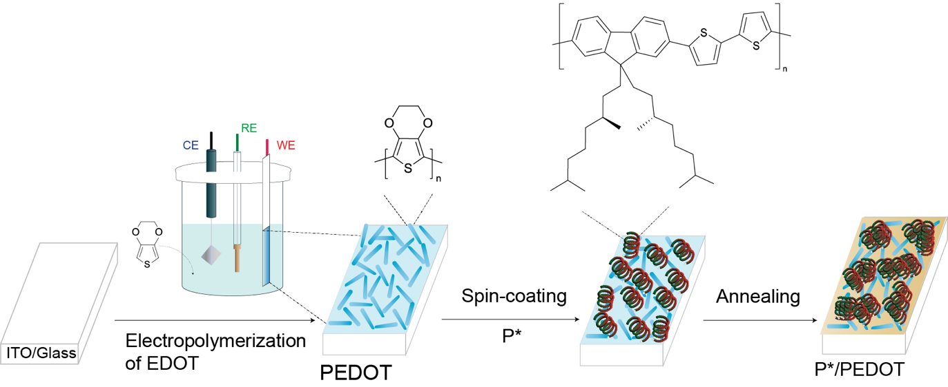
Figure S1: Step-by-step preparation of bi-layer film deposition using electroactive and chiral polymer simultaneously.
For the deposition of P*/PEDOT layer by layer films (Fig. S1), PEDOT, was first electrochemically deposited on ITO/glass using three electrodes electrochemical set up as demonstrated in Figs. S1,S2. ¹ Next, P* film was deposited by the spin coating technique and then the multilayer film was annealed at 100°C for 10 minutes.²
Figure S2: Electropolymerization of 0.01 M EDOT at a scan rate of 50 mV/s for 5 cycles at a voltage window of 1.4 to -1.5 V in MeCN containing 0.1M TBAPF₆.

2. Chronoamperometry profiles for PEDOT
Fig. S3 shows representative chronoamperometry profiles for PEDOT at different voltages, ranging from −1 V to 0.6 V. These profiles illustrate how PEDOT responds dynamically to potential steps during electrochemical measurements. At high negative potentials, -1V, the current is negative due to dominant reduction, while it becomes positive as we move towards less negative and positive voltages, indicating oxidation. PEDOT chronoamperometry profiles from −1 V to 0.6 V show rapid, exponentially decaying current transients reflecting fast, reversible redox switching and stable electrochemical behavior over a broad voltage range.
Figure S3: Chronoamperometry profiles of PEDOT at different voltages ranging from -1V to 0.6 V.

3. Chronoamperometry profiles for P*
In the case of P*, across all the voltages, the chronoamperometry profiles display low current values in comparison to PEDOT, indicating limited electrochemical activity. The consistently low currents and rapid decay to baseline indicate P* does not support appreciable bulk charge storage or redox chemistry in this range. (Fig. S4)
Figure S4: Chronoamperometry profiles of P* at different voltages ranging from -1V to 0.6 V.

4. Chronoamperometry profiles for P*/PEDOT
The fig. S5 displays chronoamperometry profiles for the P*/PEDOT composite at voltages from −1 V to 0.6 V, highlighting how the bilayer film responds electrochemically to applied potential steps. The composite demonstrates intermediate current responses relative to its individual components.

Figure S5: Chronoamperometry profiles of P*/PEDOT at different voltages ranging from -1V to 0.6V.
5. CD spectra of P* polymer film at different voltages
CD spectra recorded from –1.0 V to +0.6 V (Fig. S6) revealed a strong CD signal centered at 497 nm and a shoulder peak at 472 nm. However, there are no significant spectral changes observed across the whole voltage range, confirming the electrochemical inactivity of P*.
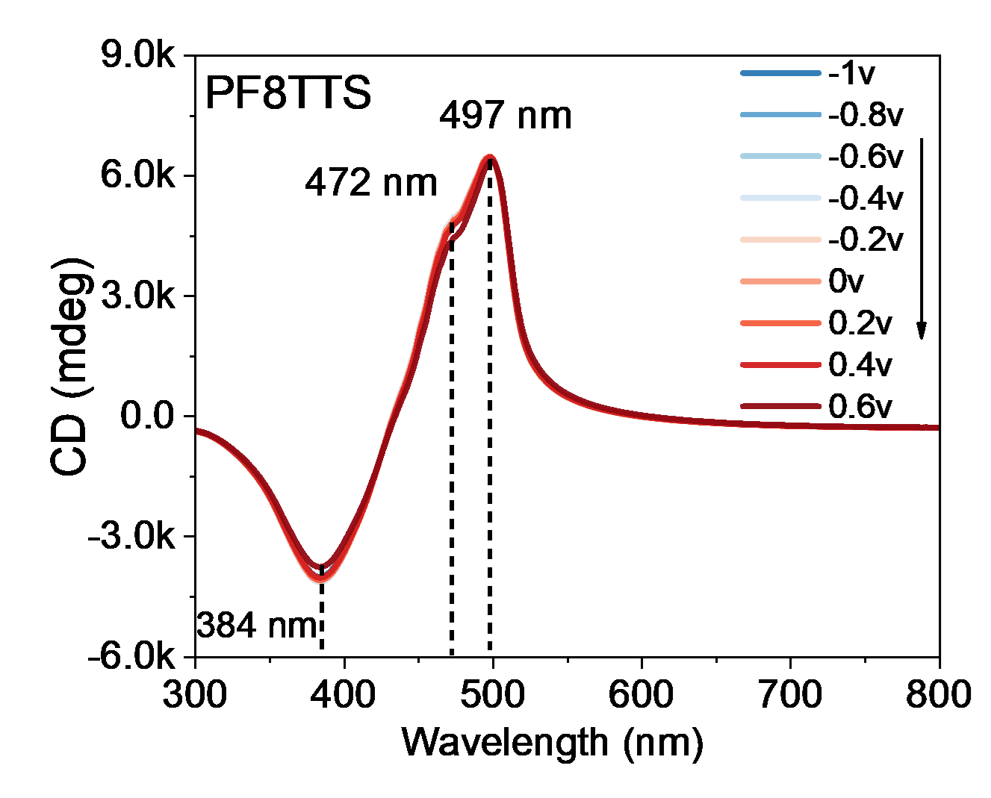
Figure S6: CD spectra of P* film on ITO-coated glass substrate, measured at different potentials ranging from -1 to 0.6 V.

6. Dynamic voltage switching of the PEDOT, P*, and P*/PEDOT film
Fig. S7- S9 display the CD behavior measured at 10 s intervals over 600 seconds during electrochemical switching between -1 V and 0.2 V for PEDOT, P*, and P*/PEDOT films respectively. Also, the current vs. elapsed time profile of polymers is demonstrated.
The current vs elapsed time profile of non-chiral PEDOT demonstrates highly reproducible current responses to the applied voltages steps over 600 s (Fig. S7). The chiral P* shows CD signal remains essentially constant and invariant indicating P* undergoes no change under applied voltage (Fig. S8).
P*/PEDOT film exhibits pronounced and periodic modulation of the CD signal with the applied voltage steps at 510 nm. This indicates effective voltage-driven chiroptical switching, attributable to the synergy between the electroactive PEDOT and the chiral P* layer in the multilayer structure. The current vs. elapsed time trace for P*/PEDOT reveals regular, reproducible current transients associated with each switching event, consistent with robust and reversible redox cycling. (Fig. S9)
Figure S7: a) CD intensity of PEDOT at 575 nm versus time interval of 10 s in 0.1 M of TBAPF₆/MeCN, electrochemical switching at potential of -1V and 0.2V measured for 600 s. b) Current vs elapsed time profile of PEDOT at 575 nm measured for 600 s.

Figure S8: a) CD spectra of P* film at 497 nm at a time interval of 10 s in 0.1 M of TBAPF₆/MeCN, electrochemical switching at potential of -1V and 0.2V measured for 600 s. b) Current vs elapsed time profile of P* at 497 nm measured for 600 s.

Figure S9: CD spectra of P*/PEDOT at 510 nm at a time interval of 10 s in 0.1 M of TBAPF₆/MeCN, electrochemical switching at potential of -1V and 0.2V measured for 600 s. b) Current vs elapsed time profile of P*/PEDOT at 509 nm measured for 600 s.

7. Electrochemical switching of P*/PEDOT
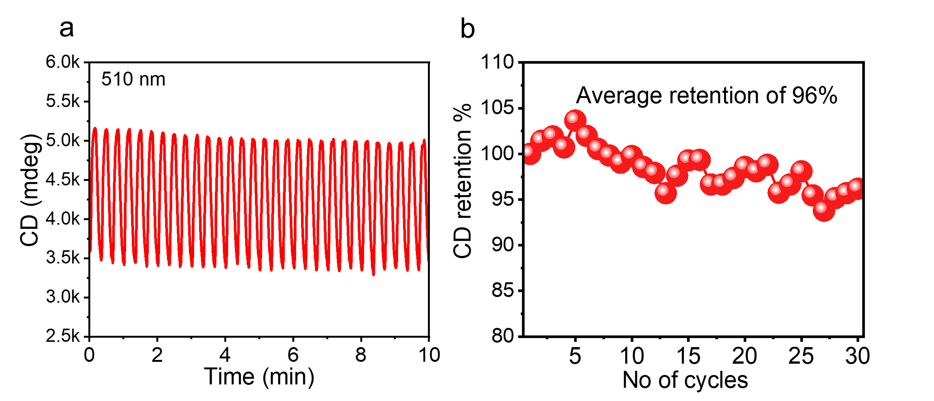
Figure S10: (a) Changes in CD intensity and (b) retention of CD% wrt to 30 cycles for P*/PEDOT at 510 nm at a time interval of 10 s in 0.1 M of TBAPF₆/ acetonitrile (MeCN), electrochemical switching at potential of -1.0 V and +0.2 V.

8. Scanning electron microscopy images
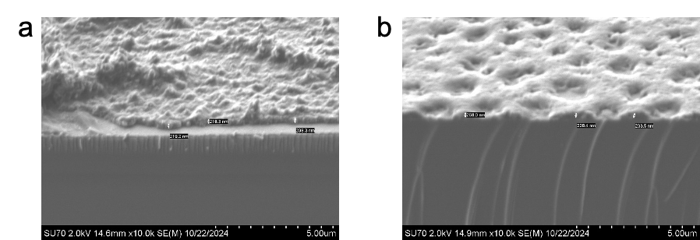

Figure S11: SEM images of a) PEDOT/ITO and b) P*/ITO showing the edge with a thickness of ~220 nm and ~230 nm, respectively.

9. FT-IR spectra of the polymers
Figure S12: FT -IR spectra of the PEDOT, P* and P*/PEDOT.

10. Raman spectra of the polymers
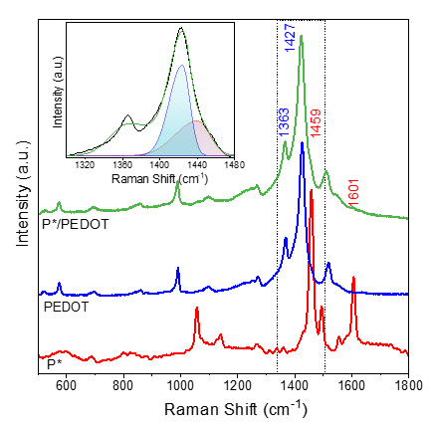
Figure S13: Raman spectra of the PEDOT, P* and P*/PEDOT films (inset: deconvoluted region of P*/PEDOT)

11. Raman spectroelectrochemistry set up used
For Raman spectroelectrochemistry, polymer film samples were prepared on ITO/glass electrode of size 75 × 7.5 mm² and assembled with a second ITO/glass electrode at an orthogonal position. Electrical contacts were established and filled with 0.1 M of TBAPF₆/MeCN. The assembly was connected to a potentiostat, enabling voltage application during Raman spectral acquisition. Raman measurements were recorded simultaneously with electrochemical stimulation, as depicted schematically in Fig.S14.
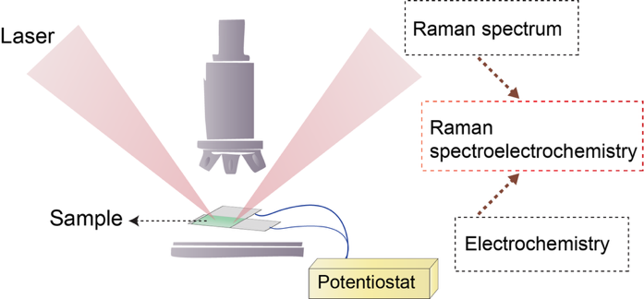
Figure S14: Illustration of the Raman spectro-electrochemistry setup used for the performance of polymer samples.

12. P*/PEDOT based device characteristics

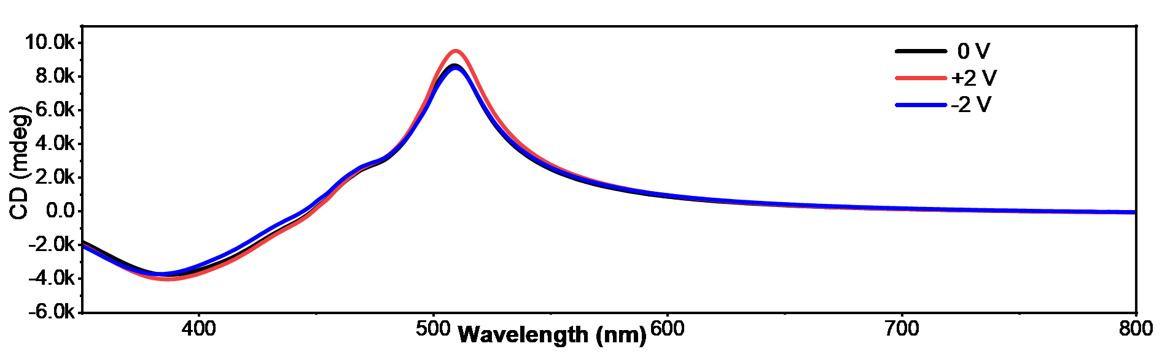
Figure S15: CD spectra of P*/PEDOT under 0V, 2V and -2V bias; 0.2 M TBAPF₆/MeCN.

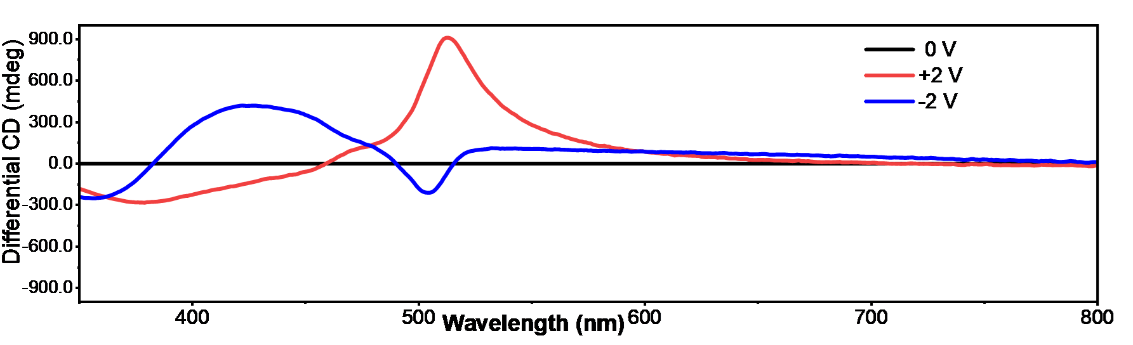

Figure S16: Differential CD spectra of P*/PEDOT under 2V and -2V bias; 0.2 M TBAPF₆/MeCN.

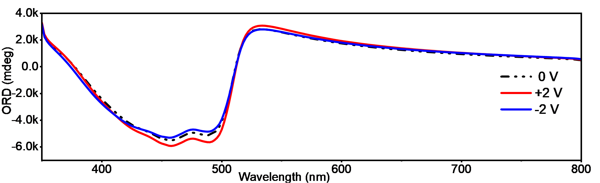
Figure S17: ORD spectra of P*/PEDOT under 0V, 2V and -2V bias; 0.2 M TBAPF₆/MeCN.

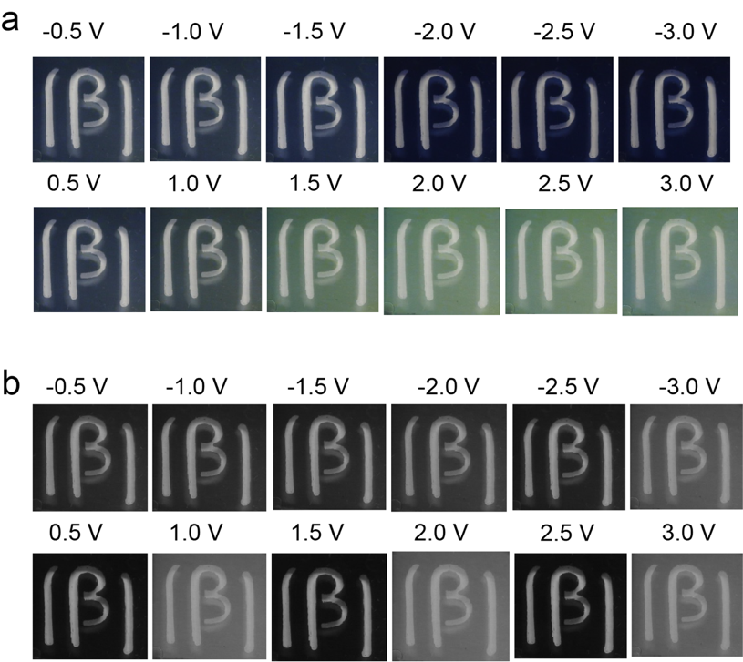

Figure S18: (a) Photographs of color intensity variation at voltage ranging from -0.5 V to 3 V and (b) Grayscale images corresponding to the green color channel at different voltages ranging from -0.5 V to 3 V for the P*/PEDOT device.

13. References
1 Poverenov, E., Li, M., Bitler, A. & Bendikov, M. Major effect of electropolymerization solvent on morphology and electrochromic properties of PEDOT films. Chemistry of Materials 22, 4019-4025 (2010).
2 Joseph, J. P. et al. Modulating the Chiroptical Response of Chiral Polymers with Extended Conjugation within the Structural Building Blocks. The Journal of Physical Chemistry Letters 13, 9085-9095 (2022). https://doi.org/10.1021/acs.jpclett.2c02498

