SUPPLEMENTARY MATERIAL

T-wave inversions in athletes: frequency and prognostic significance. A systematic review and meta-analysis.
Javier Sanmartin ª, Joan Cartanya-Bonvehi ^{a-c}, Helen Valenzuela ^{a,c,d}, Lidia Carballeira ^{a,c,d}, Silvia Montserrat ^{a,d,e,f}, Adrian Baranchuk ^{g}, Roberto Elosua ^{a,f,h}

Author affiliations:
a.-Faculty of Medicine. University of Vic-Central University of Catalonia. Vic, Spain.
b.-Primary Care Center Vic Nord, Catalan Health Institute. Vic, Spain.
c.-Instituto de Investigación e Innovación en Ciencias de la Vida y de la Salud en la Cataluña Central (IRIS-CC). Vic, Spain.
d.-Cardiology Department, Vic University Hospital. Vic, Spain
e.-August Pi i Sunyer Biomedical Research Institute (IDIBAPS). Barcelona, Spain
f.-CIBER Cardiovascular Diseases. Barcelona, Spain.
g.-Division of Cardiology, Kingston Health Science Center, Queen's University. Kingston, Ontario, Canada
h.-Hospital del Mar Research Institute. Barcelona, Spain.

Corresponding author:
Roberto Elosua
Hospital del Mar Research Institute. Faculty of Medicine University of Vic-Central University of Catalonia
Barcelona-Vic, Spain
Email: relosua@researchmar.net

Supplementary Table 1. PICOS format of the research questions of interest.
Question 1: a.-What is the prevalence of T-wave inversions (TWI) in athletes? ; b.-Is the prevalence of TWI higher in athletes than in non-athletes?
- P (Population): a.-professional and non-professional athletes; b.-general population.
- I (Intervention, Exposure): a.-non-applicable; b.-sport practice
- C (Comparison or control): a.-non-applicable; b.-non-sport practice
- O (Outcome): TWI in the ECG
- S (Study design): observational cross-sectional studies
Question 2: Are TWI related to structural cardiac diseases in athletes?
- P (Population): professional and non-professional athletes.
- I (Intervention, Exposure): presence of TWI.
- C (Comparison or control): absence of TWI.
- O (Outcomes): presence of structural cardiac disease.
- S (Study design): observational cross-sectional or follow-up studies.
Question 3: Are TWI related to a higher risk of cardiovascular events or sudden cardiac death?
- P (Population): professional and non-professional athletes.
- I (Intervention, Exposure): presence of TWI.
- C (Comparison or control): absence of TWI.
- O (Outcomes): cardiovascular events or death.
- S (Study design): observational follow-up studies.

Supplementary Table 2. Main characteristics and results of the studies assessing the prevalence of T-wave inversion in athletes.

(Excel File)



Supplementary Table 3. Results of the meta-regression analysis to identify variables related to the heterogeneity of the prevalence of T-wave inversion in athletes among studies.
 | Estimate | Standard error | p-value
Publication year | -0.005 | 0.003 | 0.059
Region
Arabic | 0.074 | 0.049 | 0.133
Asia | 0.185 | 0.049 | <0.001
Australia | 0.143 | 0.057 | 0.013
Europe | 0.137 | 0.046 | 0.003
UK | 0.150 | 0.049 | 0.002
USA | 0.108 | 0.044 | 0.013
Sex (% of women) | -0.000 | 0.000 | 0.124
Black ethnicity (% of black) | 0.001 | 0.000 | <0.001
Mean age | 0.008 | 0.002 | <0.001
R² (amount of heterogeneity accounted for): 40.47%

Supplementary Table 4. Analysis of the risk of bias of the 110 studies selected for the analysis of the prevalence of T-wave inversion in athletes.
 |  |  | 1. Were the criteria for inclusion in the sample clearly defined? | 2. Were the study subjects and the setting described in detail? | 3. Was the exposure measured in a valid and reliable way? | 4. Were confounding factors identified? | 5. Were strategies to deal with confounding factors stated? | 6. Were the outcomes measured in a valid and reliable way? | 7. Was appropriate statistical analysis used? | GLOBAL | External validity
Reference | Author | Year
20 | Van Ganse | 1970 | Yes | Yes | N/A | N/A | N/A | Yes | Yes |  | Professional cyclist
74 | Balady | 1984 | Yes | Yes | N/A | N/A | N/A | Yes | Yes |  | Professional soccer players
97 | Berdín | 1987 | Unclear | Unclear | N/A | N/A | N/A | Yes | Yes
19 | Bjornstad | 1993 | No | No | N/A | N/A | N/A | Yes | Yes |  | Elite competitive athletes and sedentary controls
21 | Bjørnstad | 1994 | Yes | Yes | N/A | N/A | N/A | Yes | Unclear |  | Collegiate athletes
22 | Stolt | 1997 | No | Unclear | N/A | N/A | N/A | Yes | Yes |  | Female competitive endurance athletes
23 | Sharma | 1999 | Yes | Yes | N/A | N/A | N/A | Yes | No |  | Competitive adolescent athletes
24 | Pelliccia | 2000 | Yes | Yes | N/A | N/A | N/A | Yes | Yes |  | Competitive athletes
98 | Ouldzein | 2007 | Yes | Yes | N/A | N/A | N/A | Yes | Yes |  | Professional football players
25 | Pelliccia | 2007 | Yes | Yes | N/A | N/A | N/A | Yes | Yes |  | Competitive athletes
26 | Pelliccia | 2008 | Yes | Yes | N/A | N/A | N/A | Yes | Yes |  | Competitive athletes
75 | Magalski | 2008 | Yes | Yes | N/A | N/A | N/A | Yes | Yes |  | Collegiate elite football players
27 | Macarie | 2009 | No | No | N/A | N/A | N/A | Yes | No |  | Athletes attended in referral cardiovascular centre
99 | Schmied | 2009 | Yes | Yes | N/A | N/A | N/A | Yes | Yes |  | Competitive adolescent athletes
28 | Papadakis | 2009 | Yes | Unclear | N/A | N/A | N/A | Yes | Yes |  | Competitive athletes (cardiac risk in the young 1996-2008)
76 | Crouse | 2009 | Yes | Yes | N/A | N/A | N/A | Yes | Yes |  | Collegiate football players
77 | Baggish | 2010 | Yes | Yes | N/A | N/A | N/A | Yes | Yes |  | Competitive collegiate
78 | Le | 2010 | Yes | Yes | N/A | N/A | N/A | Yes | Yes |  | Collegiate athletes
29 | Rawlins | 2010 | Yes | Yes | N/A | N/A | N/A | Yes | Yes |  | Highly trained female athletes
30 | Gómez-Puerto | 2011 | Yes | Unclear | N/A | N/A | N/A | Yes | Yes |  | Competitive athletes
31 | Papadakis | 2011 | Yes | Unclear | N/A | N/A | N/A | Yes | Yes |  | Competitive athletes (cardiac risk in the young (1996-2010)
79 | Weiner | 2011 | Yes | Unclear | N/A | N/A | N/A | Yes | Yes |  | Collegiate athletes
80 | Magalski | 2011 | Yes | Yes | N/A | N/A | N/A | Yes | Yes |  | Collegiate athletes
81 | Minns | 2011 | Unclear | Unclear | N/A | N/A | N/A | Yes | Yes |  | Amateur half marathon runners
100 | Farahani | 2012 | Yes | Unclear | N/A | N/A | N/A | Yes | Yes |  | Elite international athletes
32 | Migliore | 2012 | Yes | Unclear | N/A | N/A | N/A | Yes | Yes |  | Paediatric athletes
101 | Wilson | 2012 | Yes | Unclear | N/A | N/A | N/A | Yes | Yes |  | Male competitive elite athletes
33 | Di Paolo | 2012 | Yes | Yes | N/A | N/A | N/A | Yes | Yes |  | Competitive adolescent athletes
34 | Zaidi | 2013 | Yes | Yes | N/A | N/A | N/A | Yes | Unclear |  | Competitive athletes
35 | Kervio | 2013 | Unclear | Unclear | N/A | N/A | N/A | Yes | Yes |  | Japanese professional soccer players
36 | Erz | 2013 | Yes | Unclear | N/A | N/A | N/A | Yes | Yes |  | Competitive male endurance athletes
37 | Sheikh | 2013 | Yes | Unclear | N/A | N/A | N/A | Yes | Yes |  | Competitive adolescent athletes
38 | Chevalier | 2013 | Yes | Yes | N/A | N/A | N/A | Yes | Yes |  | Elite rugby players
39 | Bohm | 2013 | Yes | Unclear | N/A | N/A | N/A | Yes | Yes |  | Elite football players
40 | Biasco | 2013 | Yes | Yes | N/A | N/A | N/A | Yes | Yes |  | Male professional soccer players
41 | Gati | 2013 | Yes | No | N/A | N/A | N/A | Yes | Yes |  | Competitive athletes
102 | Riding | 2014 | Unclear | Unclear | N/A | N/A | N/A | Yes | Yes |  | High-level male athletes
42 | Chandra | 2014 | Yes | Yes | N/A | N/A | N/A | Yes | Yes |  | Competitive athletes (Cardiac risk in the young)
43 | Koch | 2014 | Yes | Yes | N/A | N/A | N/A | Yes | Yes |  | Paediatric elite athletes
4 | Sheikh | 2014 | Yes | Yes | N/A | N/A | N/A | Yes | Yes |  | Elite athletes (Cardiac risk in the young 2000-2012)
103 | Brosnan | 2014 | Yes | Unclear | N/A | N/A | N/A | Yes | Yes |  | Endurance and non-endurance athletes
12 | Jacob | 2015 | Yes | Yes | N/A | N/A | N/A | Yes | Yes |  | University athletes
44 | Berge | 2015 | Yes | No | N/A | N/A | N/A | Yes | Yes |  | Professional soccer players
13 | Kiss | 2015 | No | No | N/A | N/A | N/A | Yes | No |  | Healthy asymptomatic elite, non-elite and master athletes
14 | Schnell | 2015 | Unclear | Unclear | N/A | N/A | N/A | Yes | Yes |  | Competitive athletes
82 | Brosnan | 2015 | No | No | N/A | N/A | N/A | Yes | Unclear |  | Elite endurance athletes
104 | Angoorani | 2015 | Yes | Yes | N/A | N/A | N/A | Yes | Yes |  | Professional football players
83 | Wasfy | 2015 | Yes | Yes | N/A | N/A | N/A | Yes | Yes |  | Competitive rowers
45 | Bessem | 2015 | Yes | Yes | N/A | N/A | N/A | Yes | Yes |  | High level junior soccer players
105 | Malhotra | 2015 | Unclear | Unclear | N/A | N/A | N/A | Yes | Yes |  | Competitive endurance and strength athletes
46 | Calò | 2015 | Yes | Unclear | N/A | N/A | N/A | Yes | Yes |  | Paediatric athletes
47 | Dores | 2016 | Yes | Yes | N/A | N/A | N/A | Yes | Yes |  | Competitive athletes
84 | Fuller | 2016 | Yes | No | N/A | N/A | N/A | Yes | Yes |  | Collegiate athletes
48 | Tischer | 2016 | Yes | Yes | N/A | N/A | N/A | Yes | Yes |  | Competitive athletes
85 | Thompson | 2016 | Yes | Yes | N/A | N/A | N/A | Yes | No |  | Competitive high school athletes
86 | Drezner | 2016 | Yes | Unclear | N/A | N/A | N/A | Yes | Yes |  | Collegiate athletes
106 | Salehi | 2016 | Yes | Yes | N/A | N/A | N/A | Yes | Yes |  | Competitive athletes
107 | Bakken | 2016 | Yes | Yes | N/A | N/A | N/A | Yes | Yes |  | Professional football players
49 | Lazarevic | 2016 | Unclear | Unclear | N/A | N/A | N/A | Yes | Yes |  | Young competitive athletes
50 | Ghani | 2016 | Yes | Yes | N/A | N/A | N/A | Yes | Yes |  | Elite rugby players (CRY 2010-2012)
51 | Pelà | 2016 | Yes | Yes | N/A | N/A | N/A | Yes | Yes |  | Adolescent competitive athletes
52 | Karagjozova | 2017 | No | No | N/A | N/A | N/A | Yes | Yes |  | Recreational athletes
53 | Malhotra | 2017 | Yes | Yes | N/A | N/A | N/A | Yes | Yes |  | Young competitive athletes
108 | Omiya | 2017 | Yes | Yes | N/A | N/A | N/A | Yes | Yes |  | Young competitive athletes
54 | D'Ascenzi | 2017 | Yes | No | N/A | N/A | N/A | Yes | No |  | Paediatric competitive swimmers
55 | Molinari | 2017 | No | Yes | N/A | N/A | N/A | Yes | Yes |  | Paediatric non-competitive athletes
56 | Perrin | 2017 | Yes | Yes | N/A | N/A | N/A | Yes | Yes |  | Competitive athletes
109 | Gunes | 2017 | Yes | Yes | N/A | N/A | N/A | Yes | Yes |  | Professional divers
57 | Finocchiaro | 2017 | Yes | Unclear | N/A | N/A | N/A | Yes | Yes |  | Competitive athletes CRY (2010-2013)
58 | Kaleta | 2018 | No | Yes | N/A | N/A | N/A | Yes | Yes |  | Amateur male marathon runners
59 | Arroja | 2018 | Yes | No | N/A | N/A | N/A | Yes | Yes |  | Elite professional cyclist
60 | Tischer | 2018 | Unclear | Yes | N/A | N/A | N/A | Yes | Yes |  | Young competitive athletes
87 | Waase | 2018 | Yes | Yes | N/A | N/A | N/A | Yes | Yes |  | NBA basketball players
15 | McClean | 2019 | Unclear | Unclear | N/A | N/A | N/A | Yes | Yes |  | Paediatric competitive athletes
110 | Riding | 2019 | No | Yes | N/A | N/A | N/A | Yes | Yes |  | Male competitive athletes
111 | Ben Rejeb | 2019 | No | No | N/A | N/A | N/A | Yes | Yes |  | Professional black athletes
61 | D'Ascenzi | 2019 | Yes | Yes | N/A | N/A | N/A | Yes | Yes |  | Paediatric competitive athletes
112 | Verrall | 2019 | Yes | No | N/A | N/A | N/A | Yes | Yes |  | Competitive athletes
62 | Beale | 2019 | Yes | No | N/A | N/A | N/A | Yes | Yes |  | Elite professional cyclist
113 | Amougou | 2019 | Yes | Yes | N/A | N/A | N/A | Yes | Yes |  | Collegiate athletes
114 | Plana | 2019 | Yes | Unclear | N/A | N/A | N/A | Yes | Yes |  | Competitive young athletes
88 | Hyde | 2019 | Yes | Yes | N/A | N/A | N/A | Yes | Yes |  | Collegiate athletes
89 | D'Ascenzi | 2020 | Yes | Yes | N/A | N/A | N/A | Yes | Yes |  | Olympic athletes
63 | Albiński | 2020 | Yes | No | N/A | N/A | N/A | Yes | Yes |  | Competitive paediatric athletes
64 | Malhotra | 2020 | Yes | Yes | N/A | N/A | N/A | Yes | Yes |  | Competitive adolescent athletes
115 | Affangla | 2020 | No | No | N/A | N/A | N/A | Yes | Yes |  | Competitive basketball players
116 | Cosio-Lima | 2020 | Yes | Yes | N/A | N/A | N/A | Yes | Yes |  | Collegiate competitive athletes
65 | Lasocka | 2021 | No | Yes | N/A | N/A | N/A | Yes | Yes |  | Amateur marathon runners
90 | Malhotra | 2021 | Yes | Unclear | N/A | N/A | N/A | Yes | Yes |  | Mixed-race adolescent soccer players
66 | Pambo | 2021 | Yes | Yes | N/A | N/A | N/A | Yes | Yes |  | Elite male soccer players
67 | Halasz | 2021 | Yes | Yes | N/A | N/A | N/A | Yes | Yes |  | Paediatric athletes
117 | Hamid | 2021 | No | No | N/A | N/A | N/A | Yes | Yes |  | Unclear
68 | Pambo | 2021 | Yes | Yes | N/A | N/A | N/A | Yes | Yes |  | Competitive female soccer players
118 | Wen | 2021 | Yes | Yes | N/A | N/A | N/A | Yes | Yes |  | Chinese amateur marathon runners
91 | Harris | 2022 | Unclear | No | N/A | N/A | N/A | Yes | Yes |  | Competitive student athletes
119 | Raman | 2022 | Yes | Yes | N/A | N/A | N/A | Yes | Yes |  | Professional male athletes
92 | Cosio-Lima | 2022 | Yes | Yes | N/A | N/A | N/A | Yes | Yes |  | Female collegiate athletes
93 | Willard | 2022 | No | No | N/A | N/A | N/A | Yes | Yes |  | American athletes, different levels
69 | Morrison | 2022 | Yes | Yes | N/A | N/A | N/A | Yes | Yes |  | Elite female football players
94 | Conway | 2022 | Yes | Yes | N/A | N/A | N/A | Yes | Yes |  | Collegiate athletes
120 | Tee Joo | 2022 | Yes | Yes | N/A | N/A | N/A | Yes | Yes |  | Asian elite athletes
70 | Abela | 2023 | No | No | N/A | N/A | N/A | Yes | No |  | Adolescent athletes
121 | Ho | 2023 | Unclear | Unclear | N/A | N/A | N/A | Yes | Yes |  | Unclear
71 | Idiazabal | 2023 | Yes | Unclear | N/A | N/A | N/A | Yes | Yes |  | Paediatric athletes
123 | Orchard | 2023 | Unclear | Yes | N/A | N/A | N/A | Yes | Yes |  | Elite athletes in New Zealand
72 | Tranchita | 2024 | Yes | Yes | N/A | N/A | N/A | Yes | Yes |  | Paedriatic athletes
122 | Ferrari | 2024 | Yes | Yes | N/A | N/A | N/A | Yes | Yes |  | Brasilian football players
73 | McHugh | 2024 | Yes | Yes | N/A | N/A | N/A | Yes | Yes |  | Professional rugby players
95 | Lander | 2024 | Yes | Yes | N/A | N/A | N/A | Yes | Yes |  | Female professional basketball
96 | Corsi | 2025 | Yes | Yes | N/A | N/A | N/A | Yes | Yes |  | Male African-American basketball players

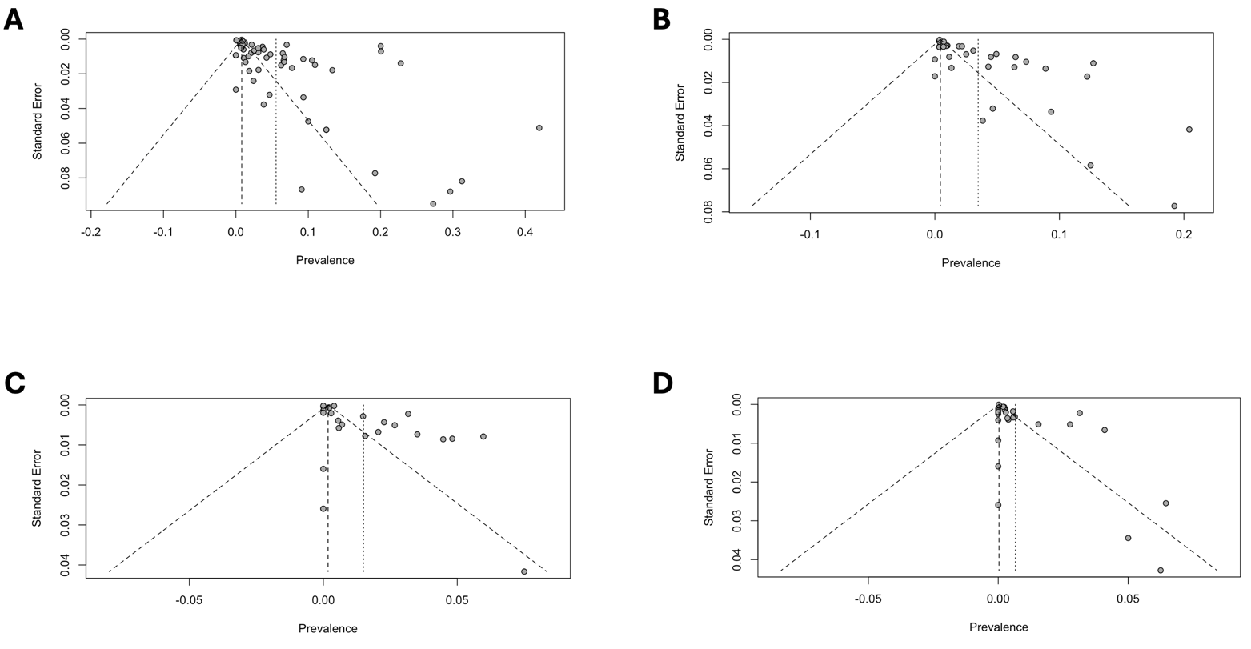
Supplementary Figure 1. Funnel plots corresponding to the meta-analyses of the prevalence of T-wave inversions in athletes >16 years: A) Overall prevalence; B) Anterior leads; C) Inferior leads; D) Lateral leads.

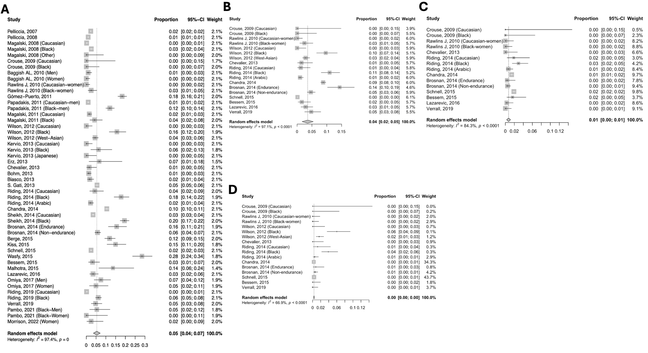
Supplementary Figure 2.- Forest plots displaying the pooled prevalence of T wave inversion (TWI) in athletes aged >16 years, based on lead distribution and following the European Society of Cardiology criteria for ECG interpretation: A) Overall TWI prevalence across all leads; B) Anterior TWI (leads V2-V4); C) Inferior TWI (leads II, aVF); D) Lateral TWI (leads I, aVL, V5-V6).
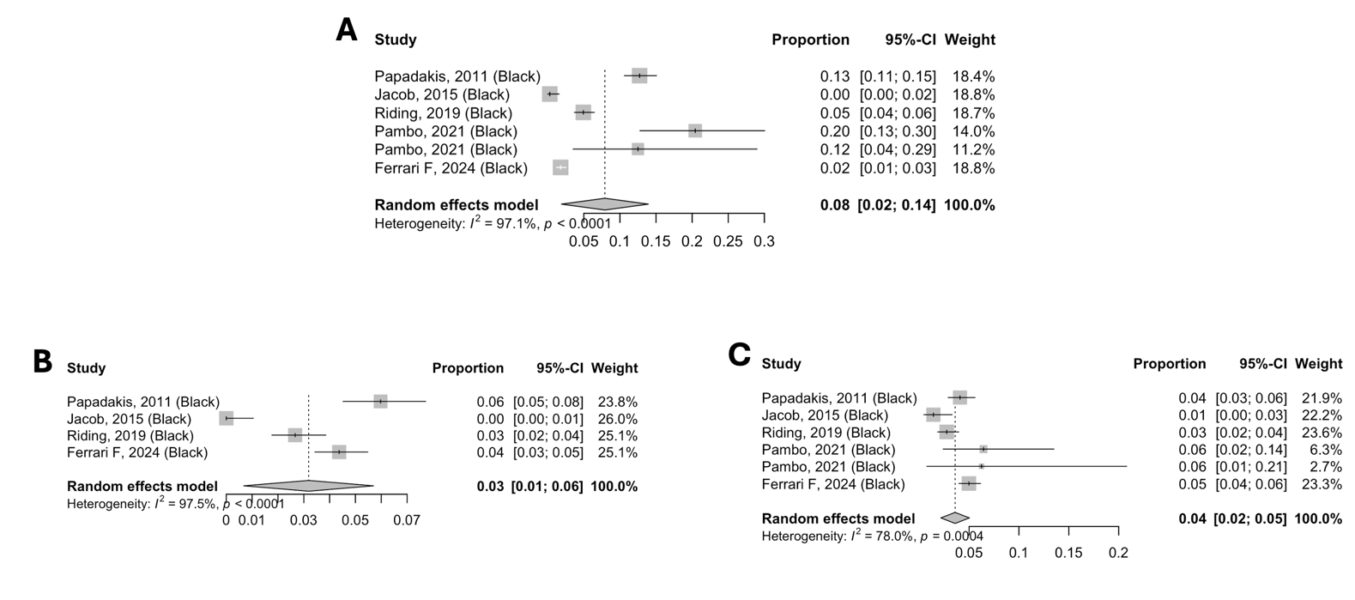
Supplementary Figure 3.- Forest plots displaying the pooled prevalence of T wave inversion (TWI) in Black athletes aged >16 years, based on lead distribution and following the Seattle criteria for ECG interpretation: A) Anterior TWI (leads V2-V4); B) Inferior TWI (leads II, aVF); C) Lateral TWI (leads I, aVL, V5-V6).

Supplementary Figure 4.- Forest plots displaying the pooled prevalence of T wave inversion (TWI) in Caucasian athletes aged >16 years, based on lead distribution and following the Seattle criteria for ECG interpretation: A) Anterior TWI (leads V2-V4); B) Inferior TWI (leads II, aVF); C) Lateral TWI (leads I, aVL, V5-V6).
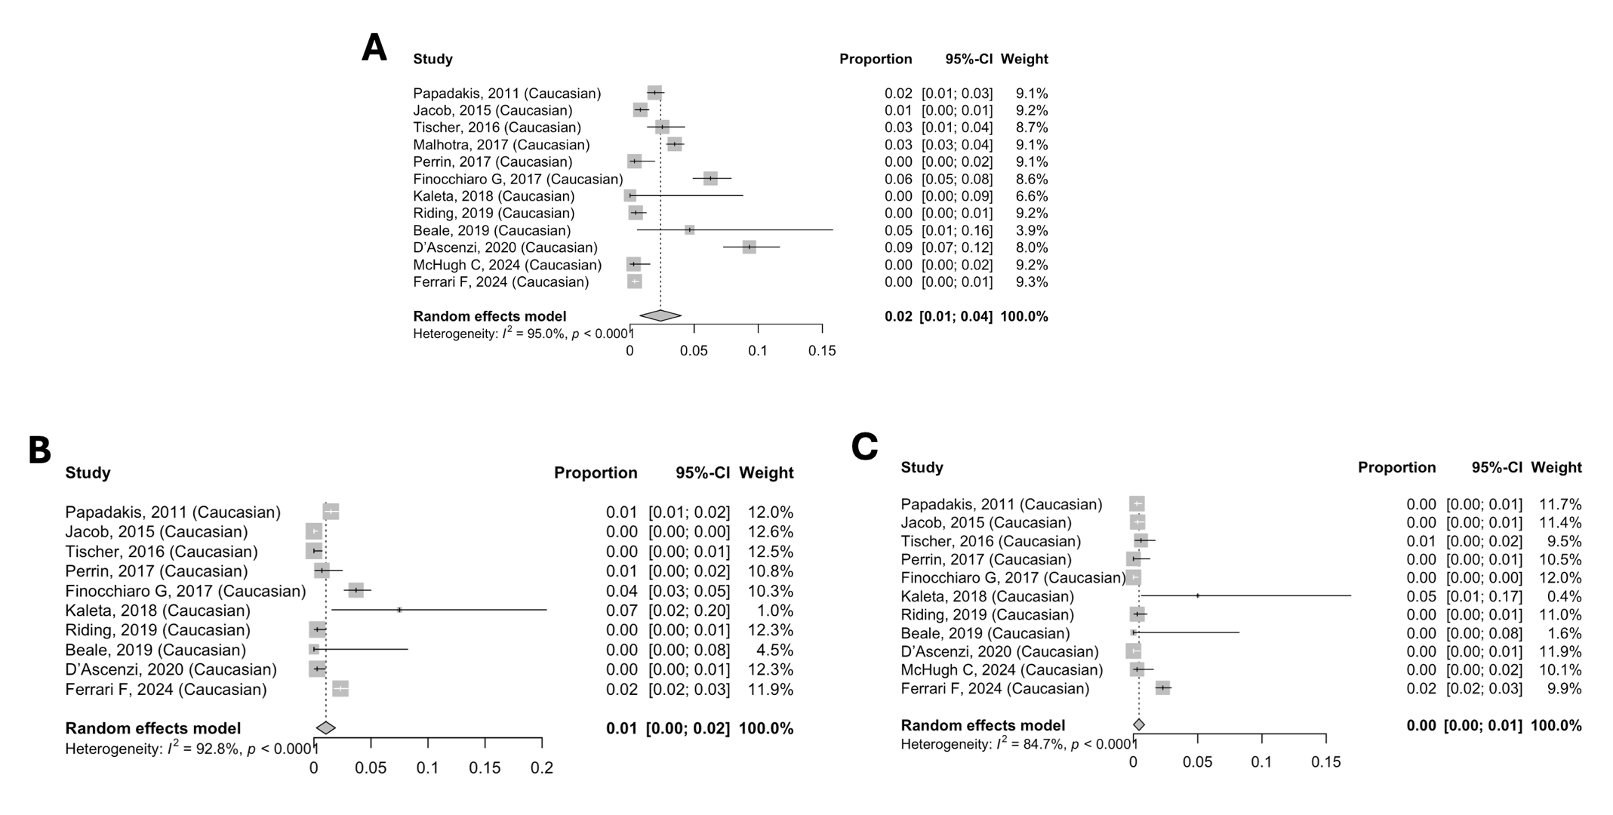
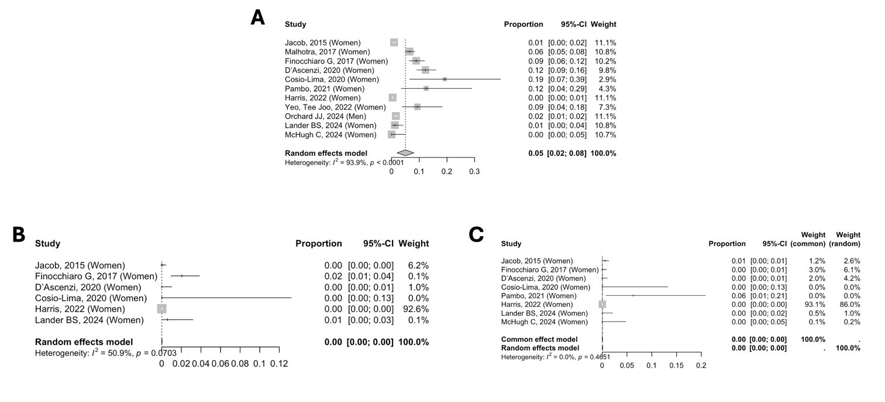
Supplementary Figure 5.- Forest plots displaying the pooled prevalence of T wave inversion (TWI) in female athletes aged >16 years, based on lead distribution and following the Seattle criteria for ECG interpretation: A) Anterior TWI (leads V2-V4); B) Inferior TWI (leads II, aVF); C) Lateral TWI (leads I, aVL, V5-V6).

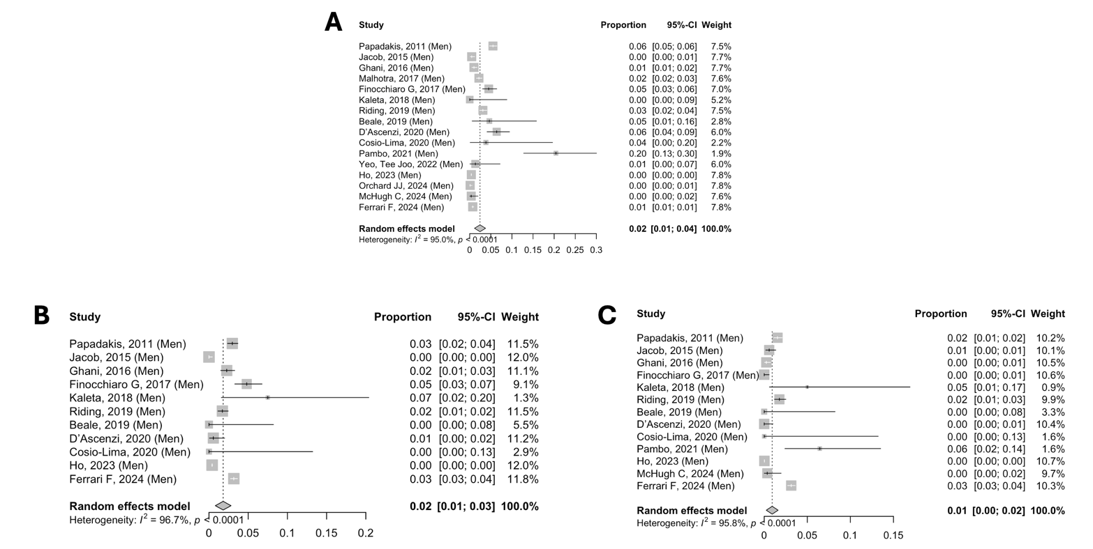
Supplementary Figure 6.- Forest plots displaying the pooled prevalence of T wave inversion (TWI) in male athletes aged >16 years, based on lead distribution and following the Seattle criteria for ECG interpretation: A) Anterior TWI (leads V2-V4); B) Inferior TWI (leads II, aVF); C) Lateral TWI (leads I, aVL, V5-V6).

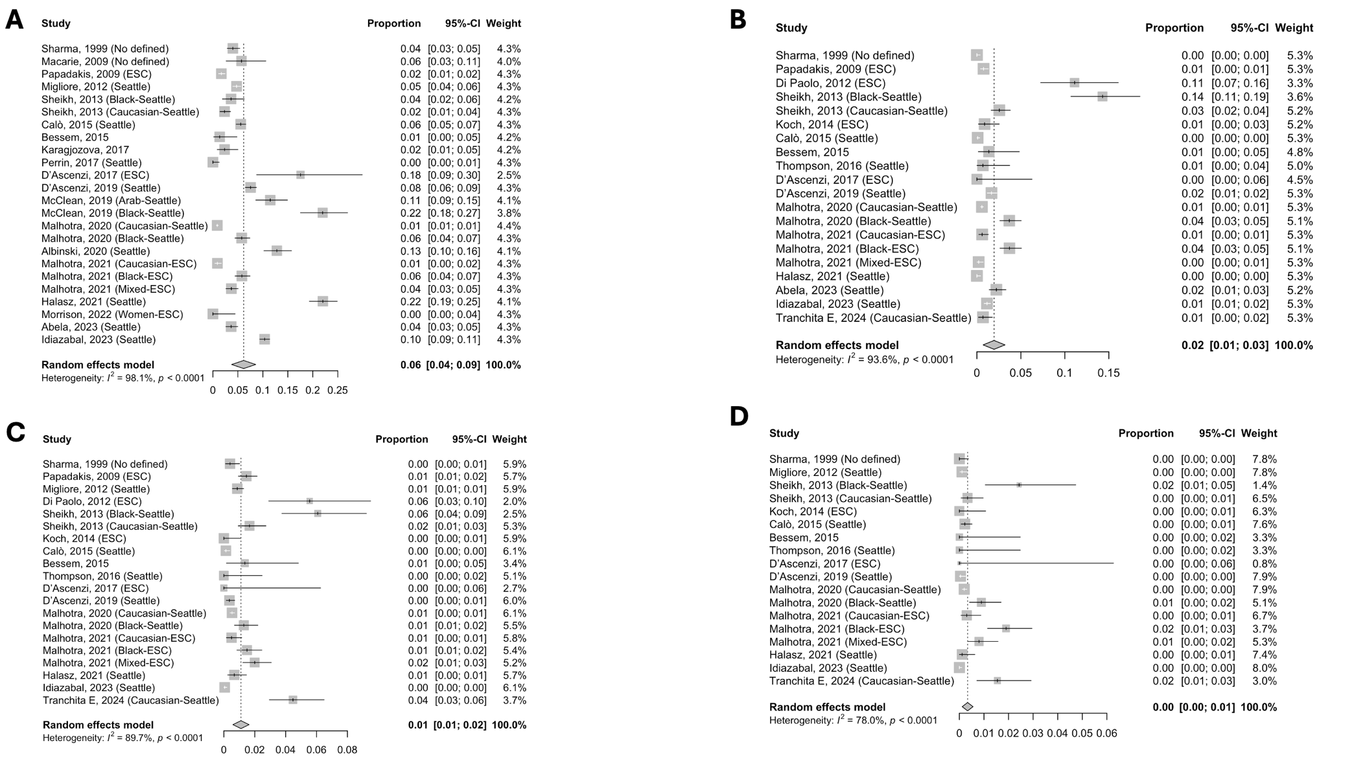
Supplementary Figure 7.- Forest plots displaying the pooled prevalence of T wave inversion (TWI) in athletes aged ≤16 years. A) Juvenile TWI prevalence. B) Anterior TWI (leads V1-V4). C) Inferior TWI (leads II, aVF). D) Lateral TWI (leads I, aVL, V5-V6).

