Identification of Perturbed Pathways Rendering Susceptibility to Tuberculosis in Type 2 Diabetes Mellitus Patients Using BioNSi Simulation of Integrated Network of Implicated Human Genes
Jyoti Rani^{1,2}, Anasuya Bhargav^{2,3}, Malabika Datta^{3,4}, Urmi Bajpai¹, Srinivasan Ramachandran^{2,3*}
¹Department of Biomedical Science, Acharya Narendra Dev College, University of Delhi, New Delhi 110019, India
²Informatics and Big Data, CSIR – Institute of Genomics and Integrative Biology (CSIR-IGIB), Room No. 130, Mathura Road, New Delhi, 110025 India
³Academy of Scientific and Innovative Research (AcSIR), Ghaziabad- 201002, India
⁴Council of Scientific and Industrial Research – Institute of Genomics and Integrative Biology (CSIR-IGIB), Mall Road, New Delhi, 110007 India

*Corresponding Author, Email: ramuigib@gmail.com

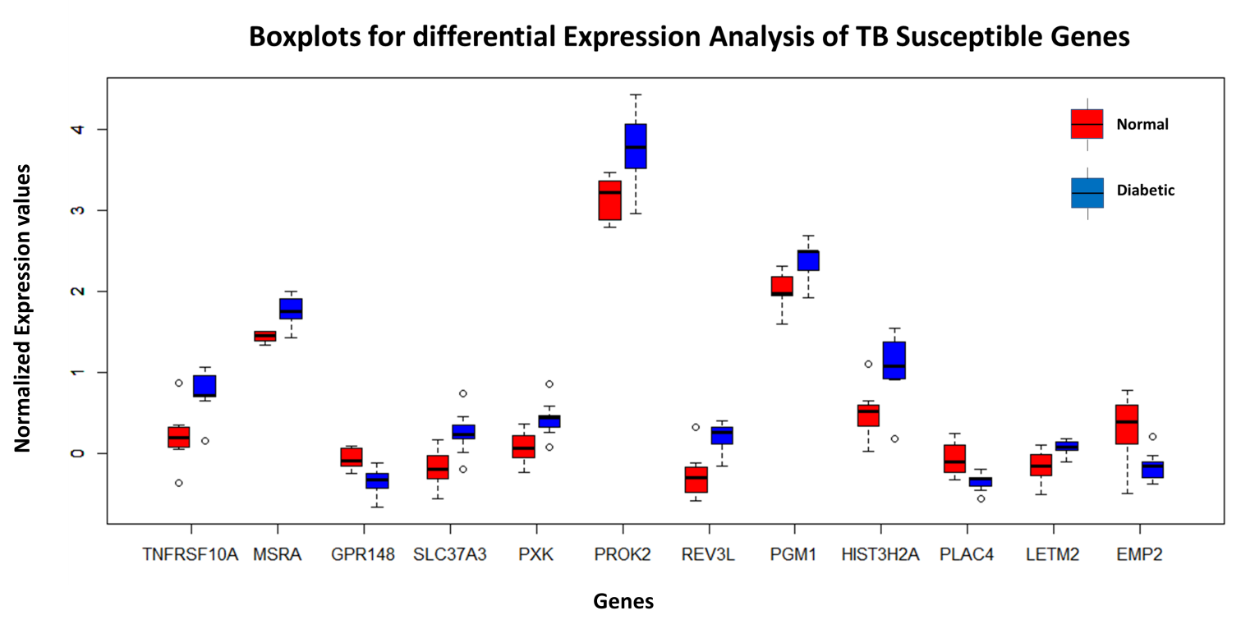
Supplementary Figure S1: Gene expression of the TB susceptible genes
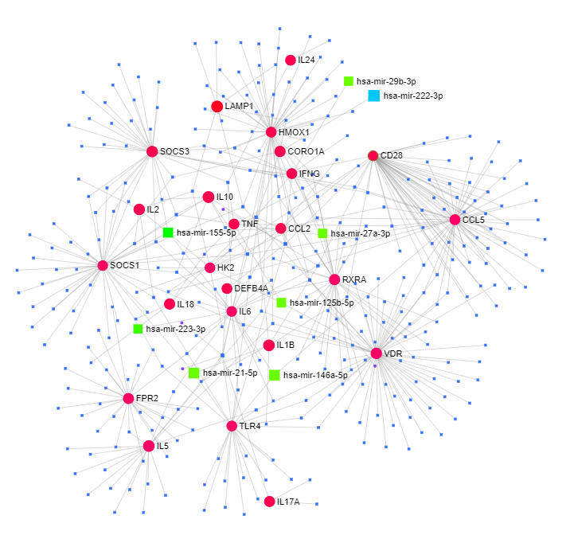
Supplementary Figure S2: Gene-miRNA interaction using NetworkAnalyst. Red circles represent the TBT2DM genes and green squares represent the miRNAs.

a
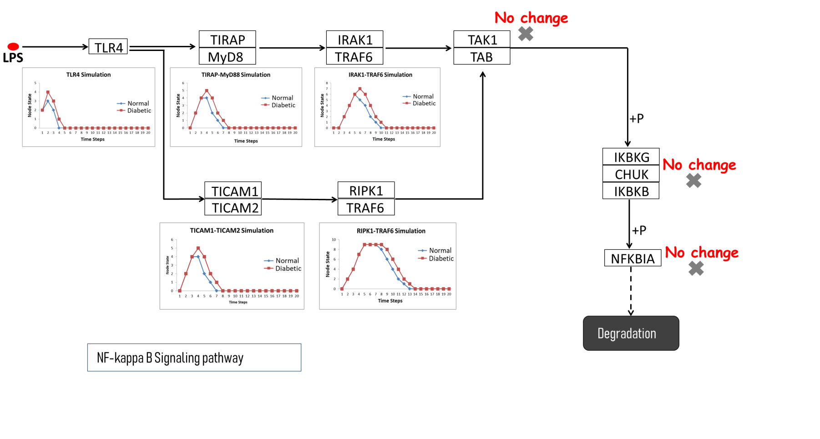

b
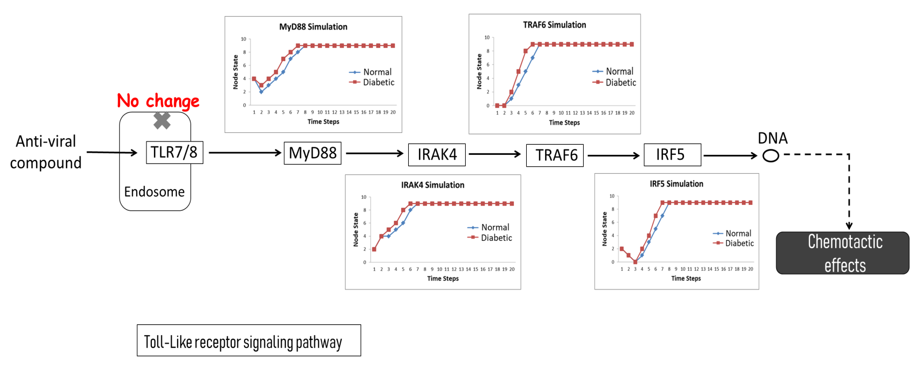

c
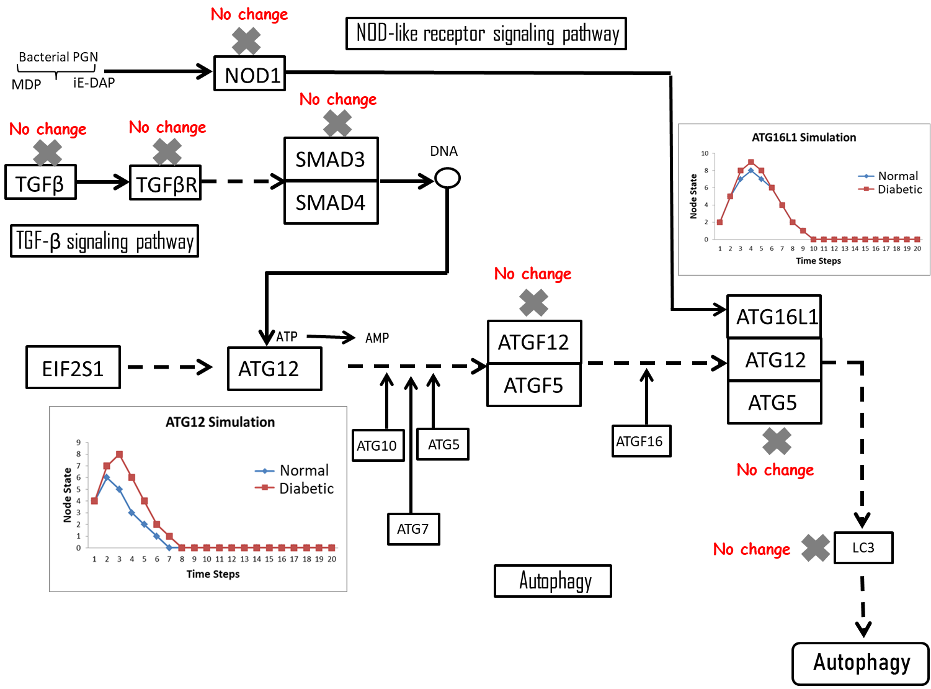

Supplementary Figure S3: Pathways with fewer alterations throughout the BioNSi Simulation.

Supplementary Table S1 : Genes showing association in TBT2DM co-morbidity.
Genes | Genes Name | Evidences | PMIDs
CAMP | Cathelicidin antimicrobial peptide | In this study we analyzed the expression of CAMP, DEFA1, DEFB4, and DEFB103A in patients with latent TB and progressive TB with and without comorbidity with diabetes mellitus type 2. When CAMP gene expression was analyzed between the DM2 and NoDM2 groups, all the DM2 subgroups showed significant lower CAMP gene expression when compared with the NoDM2 group (p 0.001). These results may suggest that these antimicrobial peptides, mainly cathelicidin, could be used as a biomarker to indicate TB progression in bothDM2and NoDM2 patients | 21539878
CCL2 | C-C motif chemokine ligand 2 | Lung leukocyte aggregates at the initial sites of M. tuberculosis infection developed later in diabetic than in nondiabetic mice, possibly related to reduced levels of leukocyte chemoattractant factors including CCL2 and CCL5 at early time points postinfection | 20421645
CCL5 | C-C motif chemokine ligand 5 | Lung leukocyte aggregates at the initial sites of M. tuberculosis infection developed later in diabetic than in nondiabetic mice, possibly related to reduced levels of leukocyte chemoattractant factors including CCL2 and CCL5 at early time points postinfection | 20421645
CD14 | CD14 molecule | Alveolar macrophages from diabetic mice had reduced expression of CD14 and macrophage receptor with collagenous structure (MARCO), which recognize the bacterial cell wall component trehalose 6,6′-dimycolate (TDM). Reduced MARCO and CD14 expression contributes to defective sentinel function of alveolar macrophages, promoting tuberculosis susceptibility in diabetic hosts at a critical early step in the immune response to aerosol infection | 27630197
CD28 | CD28 molecule | The gene CD28 encodes T-cell antigen CD28. Th1 response plays a key role in activating macrophages in immunity against TB. Decreased CD28 expression in diabetes may thus impair CD4+ T-cell activation and the Th1 response, thus increase TB susceptibility. | 22230325
CORO1A (TACO) | Coronin 1A | Repression of RXR gene could hamper VDR-RXR heterodimer formation and thus would up regulate TACO gene expression which may predispose the type-2 DM patients to tuberculosis. It was reported that VitaminD3–Retinoic acid combination via VDR-RXR heterodimer formation down regulate TACO gene expression and can confer protection against tuberculosis. | 26089620
DEFA1 | Defensin alpha 1 | When DEFA1 gene expression was analyzed, we found differences only between the DM2-LTB and NoDM2-LTB individuals the other groups did not show statistical difference. DEFA1 gene expression analysis showed that expression was augmented only in the PTB reaching fold changes 60 and showing statistical significance when compared with control group and LTB group | 21539878
DEFB4A | defensin beta 4A | levels of DEFB4 were lower in DM2 individuals with latent infection than inNoDM2 patients, which may suggest that these patients could be more susceptible to developing active TB, as previous experimental results suggest that -defensin-2 may contribute to maintain latency probably by the binding and inactivation of ftsZ factor, a crucial protein involved in the control of bacterial proliferation | 21539878
FPR2 | Formyl peptide receptor 2 | FPR2 promises to be a good biomarker for the PTB detection in subjects with NIDDM | 26628192
GZMB | Granzyme B | Cytotoxic markers analysed were perforin, granzyme B and CD107a. We observed significantly decreased frequencies of CD8+ T cells expressing either perforin or granzyme B or CD107a in TB-DM compared with TB-NDM individuals at baseline and in response to CFP-10, ESAT-6 and anti-CD3. | 25363329
HK2 | Hexokinase 2 | Two genes HK2 and CD28, were identified as having statistically significant reduction in expression in all nine participants as they transitioned to diabetes. The gene HK2 encodes hexokinase 2 which is a critical mediator of aerobic glycolysis. Decreased expression of HK2 may impair macrophage function, thus increasing the risk of tuberculosis. | 22230325
HMOX1 | Heme oxygenase 1 | Plasma levels of HO-1 but not of other acute phase proteins were higher in patients with TB and T2DM than in patients without diabetes, independent of bacillary sputum loads. | 24458266
IFNG | Interferon gamma | 1) Diabetes patients without tuberculosis, however, showed strongly reduced non-specific IFNgamma production, which is essential for inhibition of the initial growth of M. tuberculosis. 2) Our data suggest that a defective non-specific immune response  in diabetes may contribute to an increased susceptibility to  develop tuberculosis. | 17962984, 23987505
IL10 | Interleukin 10 | Tuberculosis with Diabetes Is Associated with Increased Circulating Levels of IL-5 and IL-10 | 23987505
IL12B | Interleukin 12B | Cytokines that are responsible for controlling M. tb infection at the cellular and granuloma level such as tumor necrosis factor alpha (TNF-α), interleukin-1β (IL-1β), interleukin-2 (IL-2), interferon-gamma (IFN-γ), and interleukin-12 (IL-12), were found to be compromised in plasma samples isolated from individuals with T2DM. | 25790445
IL17A | Interleukin 17A | Tuberculosis with diabetes is associated with heightened levels of type 1 cytokines and IL-17A at the time of presentation of active pulmonary tuberculosis. | 23987505
IL17F | Interleukin 17F | Two other cytokines associated with the Th17 response—IL-17F and IL-22 were found be present at significantly lower levels in diabetic compared with nondiabetic individuals with tuberculosis. | 23987505
IL18 | Interleukin 18 | Tuberculosis with Diabetes Is Associated with Increased Circulating Levels of IL-1 (IL-1β and IL-18) Family and Other Proinflammatory Cytokines | 23987505
IL19 | Interleukin 19 | Our data show that with the exception of IL-10 and IL-22, most of the other cytokines examined, including IL-19, IL-20 and IL-24 are diminished in both PTB and LTB with coincident DM | 26354610
IL1B | Interleukin 1 Beta | Tuberculosis with Diabetes Is Associated with Increased Circulating Levels of IL-1 (IL-1β and IL-18) Family and Other Proinflammatory Cytokines | 23987505
IL2 | Interleukin 2 | We found that TB-DM is characterized by elevated frequencies of mycobacterial antigen-stimulated CD8(+) T cells expressing type 1 [interferon-gamma and interleukin-2 (IL-2)] and type 17 (IL-17F) cytokines | 24907382
IL20 | Interleukin 20 | Our data reveal that coincident diabetes in either PTB or LTB is characterized by decreased production of the IL-20 subfamily of cytokines and suggest that these cytokines might play an important role in pathogenesis or protection. | 26354610
IL22 | Interleukin 22 | Two other cytokines associated with the Th17 response—IL-17F and IL-22 were found be present at significantly lower levels in diabetic compared with nondiabetic individuals with tuberculosis. | 23987505
IL24 | Interleukin 24 | Our data show that with the exception of IL-10 and IL-22, most of the other cytokines examined, including IL-19, IL-20 and IL-24 are diminished in both PTB and LTB with coincident DM | 26354610
IL5 | Interleukin 5 | Tuberculosis with Diabetes Is Associated with Increased Circulating Levels of IL-5 and IL-10 | 23987505
IL6 | Interleukin 6 | More recently, IL-6 has been shown to mediate inhibition of disease progression. The systemic levels of IL-6 but not IL-12 or GM-CSF were also significantly higher in diabetic compared with nondiabetic individuals | 23987505
LAMP1 | Lysosomal associated membrane protein 1 | Cytotoxic markers analysed were perforin, granzyme B and CD107a. We observed significantly decreased frequencies of CD8+ T cells expressing either perforin or granzyme B or CD107a in TB-DM compared with TB-NDM individuals at baseline and in response to CFP-10, ESAT-6 and anti-CD3. | 25363329
MARCO | Macrophage receptor with collagenous structure | Reduced MARCO and CD14 expression contributes to defective sentinel function of alveolar macrophages, promoting tuberculosis susceptibility in diabetic hosts at a critical early step in the immune response to aerosol infection | 27630197
PRF1 | Perforin 1 | Cytotoxic markers analysed were perforin, granzyme B and CD107a. We observed significantly decreased frequencies of CD8+ T cells expressing either perforin or granzyme B or CD107a in TB-DM compared with TB-NDM individuals at baseline and in response to CFP-10, ESAT-6 and anti-CD3. | 25363329
RXRA | Retinoid X receptor alpha | VDR, RXR and TACO are key players in tuberculosis. It has been reported that VDR expression decreases in pulmonary tuberculosis patients. In this study, we checked the expression of RXR, VDR, TACO and Interferon-γ (IFNγ) genes in type-2 DM patients for understanding the link between the two diseases. we observed that in a group of diabetic patients, there is a significant reduction of RXR gene. | 26089620
SOCS1 | Suppressor of cytokine signaling 1 | MTB antigen-stimulated mRNA levels of IFN-γ was 10-fold higher, SOCS1 was 4 times greater, TNFα was 10-fold higher, and IL-6 was 2-fold greater in patients with DM than in Ecs. Increased proinflammatory cytokine production in response to MTB antigens in diabetes would lead to exacerbated pathology and reduced inflammatory control at the site of MTB infection. This would in turn hamper the resolution of inflammation, resulting in unfavorable disease outcomes. | 28043584
SOCS3 | Suppressor of cytokine signaling 3 | Mitogen-induced mRNA levels of IFN-γ were 30-fold higher, SOCS3 was 20 fold higher, and SOCS1 was 4-fold higher in patients with DM than in ECs. Increased proinflammatory cytokine production in response to MTB antigens in diabetes would lead to exacerbated pathology and reduced inflammatory control at the site of MTB infection. This would in turn hamper the resolution of inflammation, resulting in unfavorable disease outcomes. | 28043584
TIMP4 | TIMP metallopeptidase inhibitor 4 | Moreover, patients with coincident TB and T2DM exhibited increased plasma levels of TIMP-4 and elevated peripheral blood neutrophil counts, which, when considered together with HO-1, resulted in increased power to discriminate individuals with active TB with and without T2DM. | 24458266
TLR4 | Toll like receptor 4 | Results showed that the serum TLR4 content of the T2DMTB group was significantly lower than that of the T2DM group (p < 0.05). | 27123010
TNF | Tumor necrosis factor | There was a five-fold decrease in the levels of TNF-α (implicated in the formation of granuloma and activating the macrophages) in plasma samples from individuals with T2DM with HbA1c>8. In summary, there was an increase in the immunosuppressive cytokine, IL-10 while there was a notable decrease in the levels of protective cytokines, TNF- α, IL-1β, IL-2, IL-12, and IFN-γ in individuals with T2DM | 25790445
VDR | Vitamin D receptor | In this study we evaluated the vitamin D serum levels, CYP27B1-hydroxylase enzyme, vitamin D receptor (VDR) and AMPs gene expression in Healthy donors, DM2 and TB patients. Results showed that DM2 group has lower VDR and AMPs expression levels. | 25016144

Supplementary Table S2: Non-redundant Gene Ontologies (GO) for T2DMTB genes
Term | Genes | PValue
GO:0005615~extracellular space | IL6, TNF, CCL2, IL5, CAMP, IL18, GIF, TIMP4, CCL5, IL10, IL20, IL17A, HMOX1, IFNG, IL17F, IL1B, DEFA1, IL2 | 8.77E-14
GO:0005576~extracellular region | PRF1, IL6, TNF, CCL2, IL5, CAMP, IL18, GIF, CCL5, IL10, IL20, IL17A, IFNG, IL17F, IL1B, DEFA1, IL2 | 2.89E-11
GO:0006955~immune response | IL6, TNF, CCL2, IL5, IL18, TLR4, CCL5, IL10, IL20, IL17A, IFNG, IL1B, DEFA1, IL2 | 9.95E-15
GO:0045944~positive regulation of transcription from RNA polymerase II promoter | VDR, IL17A, IL6, TNF, IL18, IL17F, IFNG, IL1B, TLR4, IL10, IL2, CD28 | 8.78E-08
GO:0006954~inflammatory response | IL17A, IL6, TNF, IL5, CCL2, IL18, IL17F, IL1B, TLR4, CCL5, IL10 | 1.17E-10
GO:0005125~cytokine activity | IL17A, IL6, TNF, IL5, IL18, IL17F, IFNG, IL1B, IL10, IL2, IL20 | 2.02E-14
GO:0000165~MAPK cascade | TNF, IL5, CCL2, PSMA6, IL18, IL1B, CCL5, IL2 | 1.06E-07
GO:0071222~cellular response to lipopolysaccharide | IL6, TNF, CCL2, CAMP, IFNG, TLR4, IL10 | 1.68E-08
GO:0010628~positive regulation of gene expression | VDR, IL6, TNF, IFNG, IL1B, TLR4, CD28 | 2.41E-06
GO:0009897~external side of plasma membrane | LAMP1, IL17A, IL6, TNF, IFNG, TLR4, CD28 | 4.50E-07
GO:0031663~lipopolysaccharide-mediated signaling pathway | TNF, CCL2, IL18, IL1B, TLR4, CCL5 | 1.16E-09
GO:0045429~positive regulation of nitric oxide biosynthetic process | IL6, TNF, IFNG, IL1B, TLR4 | 5.35E-07
GO:0032729~positive regulation of interferon-gamma production | TNF, IL18, IL1B, TLR4, IL2 | 7.05E-07
GO:0006959~humoral immune response | IL6, TNF, CCL2, IFNG, CD28 | 1.69E-06
GO:0071407~cellular response to organic cyclic compound | TNF, CCL2, IL18, IL1B, CCL5 | 1.94E-06
GO:0048661~positive regulation of smooth muscle cell proliferation | IL6, TNF, IL18, HMOX1, CCL5 | 2.08E-06
GO:0071347~cellular response to interleukin-1 | IL17A, IL6, CCL2, CAMP, CCL5 | 4.09E-06
GO:0050729~positive regulation of inflammatory response | CCL2, IL18, TLR4, CCL5, IL2 | 4.57E-06
GO:0051091~positive regulation of sequence-specific DNA binding transcription factor activity | IL6, TNF, IL5, IL1B, IL10 | 1.94E-05
GO:0045080~positive regulation of chemokine biosynthetic process | TNF, HMOX1, IFNG, IL1B | 3.93E-07
GO:0044130~negative regulation of growth of symbiont in host | TNF, CAMP, IFNG, IL10 | 1.82E-06
GO:0042346~positive regulation of NF-kappaB import into nucleus | TNF, IL18, IL1B, TLR4 | 4.30E-06
GO:0046427~positive regulation of JAK-STAT cascade | IL6, IL5, CCL5, IL10 | 4.98E-06
GO:0043491~protein kinase B signaling | TNF, CCL2, IL1B, CCL5 | 1.74E-05
GO:0060559~positive regulation of calcidiol 1-monooxygenase activity | TNF, IFNG, IL1B | 6.91E-06

Supplementary Table S3 : List of differential expressed genes (An Excel File)

Supplementary Table S4: Differentially expressed T2DMTB genes
Genes | P.Value | adj.P.Val | Fold Change
DEFA1 | 0.0004 | 0.04 | 2.68
CAMP | 0.002 | 0.05 | 1.80
CD14 | 0.004 | 0.06 | 1.33
CORO1A | 0.026 | 0.13 | 1.56
LAMP1 | 0.030 | 0.14 | 1.55
TLR4 | 0.036 | 0.15 | 1.20
IL17F | 0.039 | 0.15 | 1.22
SOCS3 | 0.047 | 0.17 | 1.11

Supplementary Table S5: The list of miRNAs deregulated in both conditions was extracted from literature.
miRNAs | TBT2DM Target Gene | Evidence for T2DM | Evidence for TB
hsa-miR-146a-5p | CCL5, TLR4 | Decreased serum level of miR-146a as sign of chronic inflammation in type 2 diabetic patients. [PMID: 21249428] | RT-qPCR validated that miR-1, miR-155, miR-31, miR-146a, miR-10a, miR-125b and miR-150 were down-regulated in while miR-29 was upregulated in children with TB compared with uninfected children.  [PMID: 27082104]
hsa-miR-155-5p | SOCS1, SOCS3, IL2, CCL2, and IL6 | Down-regulated levels of miR-155 could play an important role in the pathogenesis of T2D due to their relationship with metabolic control. [PMID: 23616185] | miR-155 were significantly reduced in serum of TB patients as compared to uninfected controls  [PMID: 28061948]
hsa-miR-125b-5p | VDR, HK2 | miR-125b are up-regulated in peripheral blood mononuclear cells from patients with type 2 diabetes mellitus. [PMID: 29285097] | RT-qPCR validated that miR-1, miR-155, miR-31, miR-146a, miR-10a, miR-125b and miR-150 were down-regulated [PMID: 27082104]
hsa-miR-21-5p | TLR4, IL1B | Circulating angiogenic cells (CACs) from T2DM patients expressed higher miR-21-5p and lower miR-126-3p levels than CACs from CTR. Furthermore, CACs from T2DM + MACE showed the highest levels of miR-21-5p. [PMID: 26498351] | Decreased Expression of miR-21, miR-26a, miR-29a, and miR-142-3p in CD4+ T Cells and Peripheral Blood from Tuberculosis Patients  [PMID: 23613882]
hsa-miR-27a-3p | IFNG | Five miRs were aberrantly down-regulated in EPCs from DM patients. These miRs included miR-126, miR-21, miR-27a, miR-27b and miR-130a.[PMID: 22525256] | Here, we show that miR-27a is abundantly expressed in active TB patients, Mtb-infected mice and macrophages. [PMID: 30327467]
hsa-miR-29b-3p | IFNG | Their results suggest that miR-29b up-regulation at the early stages of diabetes in this model may have protective effects against apoptosis of the retinal cells by the PKR pathway. [22552970] | Consistent with previous studies, miR-141, miR-32 and miR-29b were over-expressed in the TB group of the present study. [PMID: 27082104]
hsa-miR-223-3p | IL6 | miR-223-3p expression in PBMCs was significantly lower in DM patients than in healthy controls [26717922] | miR-223 is up-regulated in monocytes from patients with tuberculosis and regulates function of monocyte-derived macrophages.[PMID: 26296289]

Supplementary Table S6. Genes either negatively or positively regulating miR-146a and genes negatively or positively regulated by miR-146a obtained from literature text mining.
 | Genes | References | Action performed
Genes regulating  miR-146a | HEY2, HOXA9*, MEIS1*, MCPIP1, and SOD2. | 30125982, 28399410, 28399410, 27913625, 27131313, | Inhibits the miR-146a
Genes regulating  miR-146a | HDAC1, NF-KB, NO, STAT3, TLR2, TGFB1, and TNFA | 26224317, 24472607, 24092752, 25607648, 29269299, 29101123, 30300399 | Positively Regulate the miR-146a
Genes regulated by miR-146a | TLR4, iNOS,PGE2, NF-KB, MyD88, IL-12, CD86, TNFA, IL-6, IL-1B, IL-8, TRAF6, IRAK1,CASP3, FBXL10**, CXCR4, NUMB, BCL11A**, CCL5, EGR1, SUMO1**, SMAD4, MMP9, FOS, CASP7, BCLAF, SOD2, and CARD10 | 30233729, 27541693, 30378773, 30224945, 28202285, 29183039, 24302991, 30077189, 29717615, 30362610, 30355233, 29101123, 29861845, 26112171, 27449900, 27931283, 24863965 | Inhibited by miR-146a
Genes regulated by miR-146a | FOXO3, CCND2, FOXL2**, PAK1, RAC1, STAT1, JNK2, UHRF1^, ERBB4, and IL-10 | 28841705, 28407626, 24562503, 29344219, 23982143, 30224945, 26526003 | Positively Regulated by miR-146a

Notes: Genes in bold face were differentially expressed in blood between diabetic patients and normal (GSE26168). ** = Pathways not found in KEGG database. * = These genes are involved in micro-regulation in cancer and therefore they were excluded from this analysis.

Supplementary Table S7 List of STRING pathways (an Excel File)

Supplementary Table S8a: Genes from non-diabetics with a minimum Euclidean distance of 2 reached a steady state either prior to or coincident with diabetics and mapped to KEGG pathways.
Pathway | Genes (Euclidean Distance) | Score¹
Cellular senescence | TRPM7 (4), FOXO3A (3), CHEK2 (2), CHEK1 (2) | 4
Apoptosis | DNM1L (4), CASP6 (4), RIPK1-TRAF6 (4), CASP7 (2) | 4
TNF-signaling pathway | DNM1L (4), PGAM5 (4), MLKL (4) | 3
Cell Cycle | FZR1-ANAPC10 (4), CHEK2 (2), CHEK1 (1) | 3
Autophagy | ATG12 (5), ATG16L1 (2) | 2
FoxO signaling Pathway | ATG12 (5), FOXO3A (3) | 2
RIG-I-like receptor signaling pathway | ATG12 (5), RIPK1-TRAF6 (4) | 2
p53 signaling pathway | CHEK1 (2), CHEK1 (2) | 2
Mineral absorbtion | TRPM7 (4) | 1
Cytosolic DNA sensing pathway | RIPK3 (4) | 1
MAPK signaling pathway | IRAK1-TRAF6 (4) | 1
Neutrotrophin signaling pathway | IRAK1-TRAF6 (4) | 1
Vascular smooth muscle contraction | CALCRL (4) | 1
Longevity regulating pathway | FOXO3A | 1
GnRH signaling pathway | EGR1 (2) | 1
AGE-RAGE signaling pathway in diabetic complications | EGR1 (2) | 1
HIF-1 signaling Pathway | TLR4 (2) | 1

Supplementary Table 8b: Pathway distribution of genes exhibited differences and reached steady state before or together with non-diabetic.
Pathway | Genes (Distance) | Score¹
Neutrotrophin signaling pathway | IRAK1 (5), TRAF6 (4), IRAK4 (3), IRAK1-IRAK4 (3) | 4
Fc gamma R-mediated phagocytosis | DOCK1 (4), DOCK2 (3), WAS (2) | 3
IL-17 signaling pathway | TRAF6 (4), IRAK4(3), IRAK1-IRAK4 (3), | 3
ErbB signaling pathway | ABL1 (5) | 1
Ras signaling pathway | ABL1 (5) | 1
Cell Cycle | ABL1 (5) | 1
Chemokine signaling pathway | PXN (3) | 1
VEGF signaling pathway | PXN (3) | 1
Insulin signaling pathway | WAS (2) | 1
AGE-RAGE signaling pathway in diabetic complications | WAS (2) | 1

¹: Score is the number of genes in a given pathway with minimum Euclidean distance of 2.

