“Microbial Synergy: Fungal Laccase-Mediated Optimized Bio-detoxification and Extremophile-Driven Bio-devulcanization of Ground Tire Rubber for Sustainable Recycling”
Journal name: Biodegradation
Harmen Shah^{a, d*}, FaridahYusof^{a,b}, Md Zahangir Alam^{a,c}
ª Department of Chemical Engineering and Sustainability, International Islamic University Malaysia (IIUM), P.O. Box 10, 50728, Kuala Lumpur, Malaysia.
^{b} Bioprocess and Molecular Engineering Research Unit (BPMERU), IIUM, P.O. Box 10, 50728, Kuala Lumpur, Malaysia.
^{c} Bioenvironmental Engineering Research Center (BERC), IIUM, P.O. Box 10, 50728, Kuala Lumpur, Malaysia.
^{d} Vidya Vihar Institute of Technology, BIADA, Maranga, Purnea, PIN – 854301, India.

* Corresponding author
Email address: harmenshah1@gmail.com

SUPPLEMENTARY MATERIAL

Figure S2. GTR particles entrapped in mycelia of R. bicolor

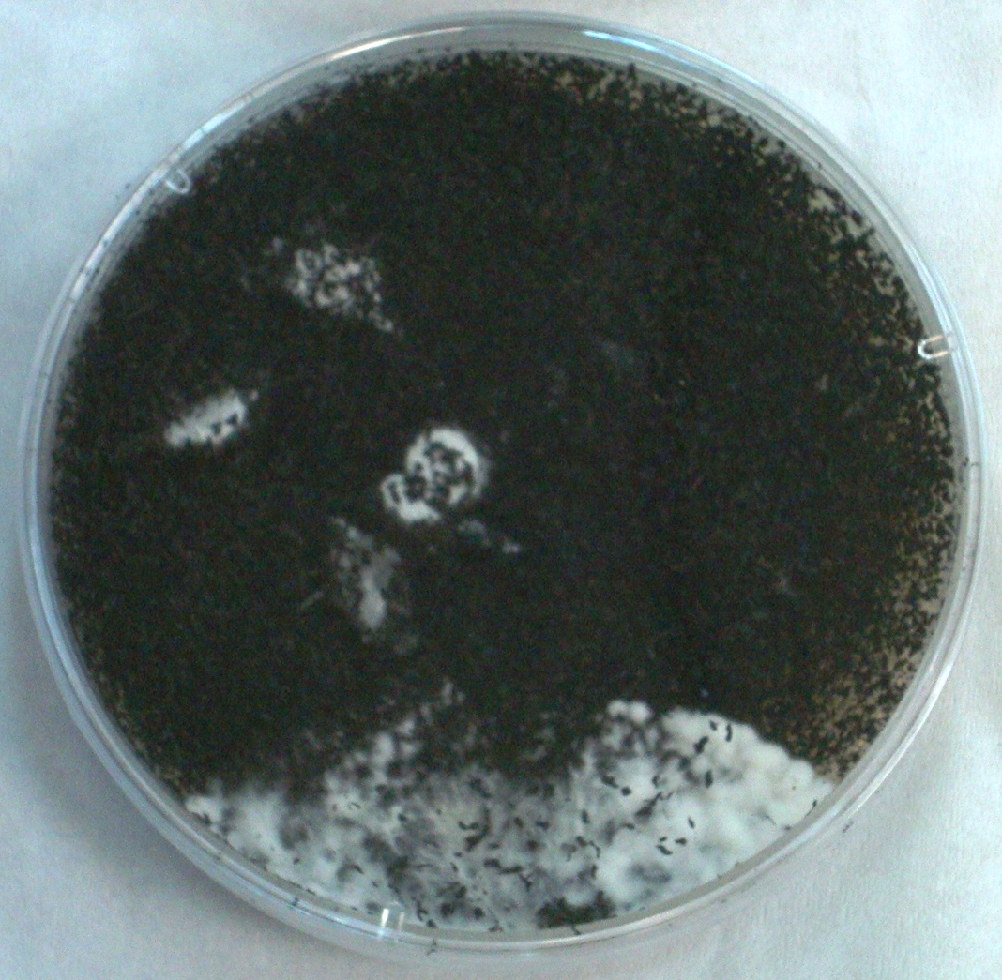
Figure S2 R. bicolor growing on Malt-extract agar plate in the presence of GTR crumb. The figure clearly shows the expanding mycelial mat of R. bicolor entangling GTR particles within irrespective of its toxicity.

