Supplementary Material
A UV-vis-fluorescence-smartphone-assisted hydrogel “three-in-one” platform based on light-responsive carbon dot nanozyme for multimodal glyphosate detection
Wanqi Yangª, Haodong Yangª, Yaxin Maª, Ao Houª, Xiangyu Yangª, Pengjuan Niª*, Yizhong Luª*
ªSchool of Materials Science and Engineering, University of Jinan, Jinan 250022, P. R. China
*Corresponding Author:
E-mail address: mse_nipj@ujn.edu.cn (Pengjuan Ni)
E-mail address: mse_luyz@ujn.edu.cn (Yizhong Lu)
Chemicals and materials
3,3′,5,5′-tetramethylbenzidine (TMB) was obtained from Sigma-Aldrich (USA). tartaric acid, 3-aminophenol, glyphosate were obtained from Aladdin Industrial Corporation (Shanghai, China). Urea, CuNO₃, sodium acetate (NaAc), acetic acid (HAc), acetonitrile, tryptophan (TRP), catalase (CAT), nitrotetrazolium blue chloride (NBT), edetate disodium (EDTA-2Na), CuCl₂, acetamiprid, thiamethoxam, clothianidin, dimethoate, imidacloprid, NaCl, KCl, MgCl_{2,} methylviologen were obtained from Macklin-Biochemical Technology (Shanghai, China). All chemical reagents were purchased and used directly without undergoing any further purification.
Apparatus
UV-vis absorption spectra were recorded on a UV-8000 spectrophotometer (Shanghai, Metash Instruments Co., Ltd., China). Transmission electron microscopy (TEM) images were obtained on JEM-2100Plus. The fluorescence spectra were collected using an RF-6000 fluorescence spectrometer (Shimadzu, Japan). The fluorescence emissions spectra were obtained at an excitation wavelength of 390 nm. The slit width of excitation and emission was both set as 5 nm. Fourier-transform infrared (FT-IR) spectra were obtained on a Nicolet 380 FTIR spectrophotometer (Thermo Fisher Scientific, USA) The light source is provided by a 300 W xenon lamp (PLS-SXE300D) (Beijing Perfectlight Technology Co., Ltd., China).
Experimental section

1. The visible light-driven oxidase-like activity of C-dots
3,3',5,5'-tetramethylbenzidine (TMB) was chosen as the chromogenic substrate to evaluate the light-responsive oxidase activity of C-dots. Typically, 800 μL of acetic acid-sodium acetate buffer solution (HAc-NaAc, 0.1 M, pH 4.0), 100 μL of C-dots and 100 μL of TMB (5 mM) were successively introduced into a 1.5 mL centrifuge tube and mixed thoroughly. Subsequently, the mixture underwent irradiation from a 300 W xenon lamp (λ≥420 nm) for 1 min. Finally, the UV-vis absorption spectrum of the obtained solution was measured. As a control, the UV-vis absorption spectra of TMB solution under the irradiation of a Xe lamp, C-dots-TMB under dark were also recorded.

2. Steady-state kinetic analysis
Steady-state kinetic analysis were conducted by modulating the TMB concentration and recording absorbance changes at 652 nm. Typically, a total volume of 1 mL solution comprised of 800 μL of HAc-NaAc (0.1 M, pH 4.0), 100 μL of TMB with different concentrations (1-8 mM) and 100 μL of C-dots was under the illumination of a Xe lamp for various time to obtain the relationship between the concentration of TMB and the absorbance at 652 nm. Using the Michaelis-Menten equation, Michaelis constant (K_{m}) and the maximal reaction rate (V_{max}) were computed.

3. Effects of diverse scavengers on the catalytic behavior of C-dots
100 μL of different scavengers were respectively introduce into the solution containing 700 μL of HAc-NaAc (0.1 M, pH 4.0), 100 μL of C-dots and 100 μL of TMB (5 mM), and irradiated by a 300 W Xe lamp (λ≥420 nm) for 1 min and 2 min. Final concentrations of the scavengers were set as follows: 1 mM nitrotetrazolium blue chloride (NBT), 0.2 mM tryptophan, 5 mM mannitol, 0.1 mM ethylenediaminetetraacetic acid disodium salt (EDTA-2Na), and 0.4 mM CuCl₂.

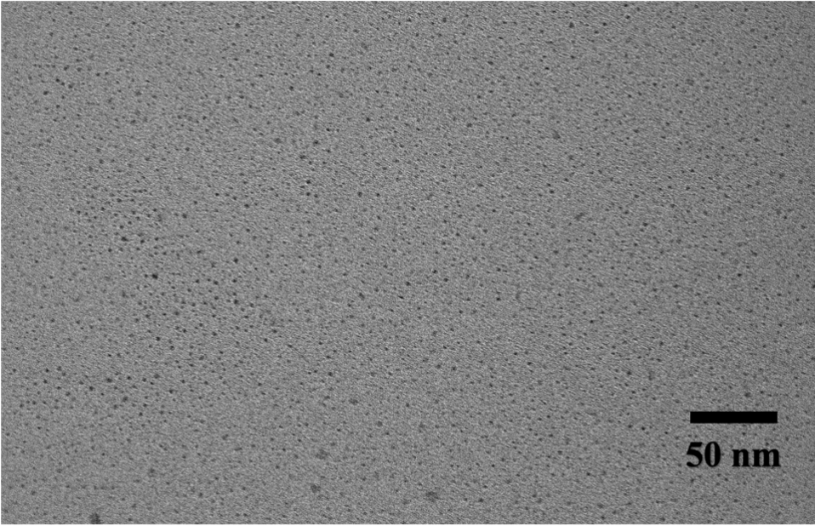
Fig. S1 TEM images of C-dots.
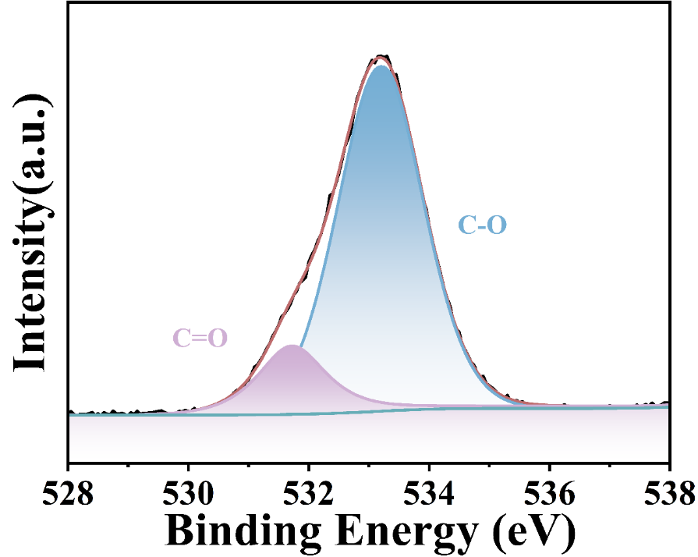
Fig. S2 The O 1s spectrum of C-dots.
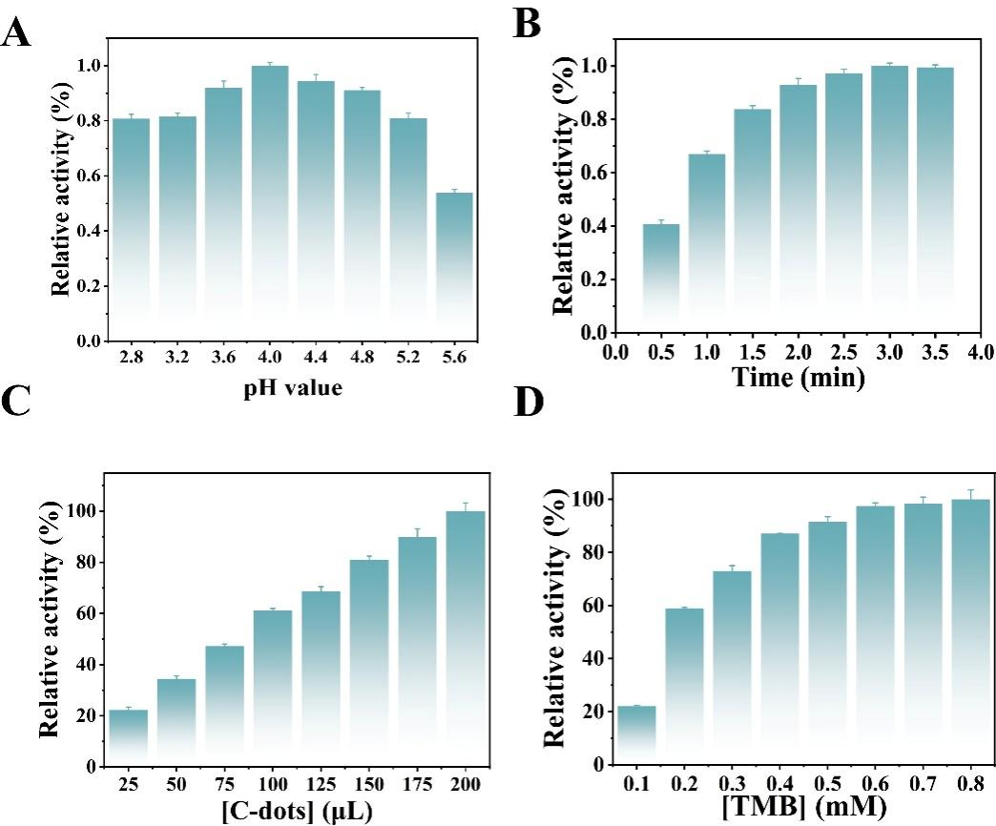
Fig. S3 Effects of pH value of buffer solutions (A), the irradiation time (B), the volume of C-dots (C), the concentration of TMB (D) on the light-responsive oxidase-like activity of C-dots.
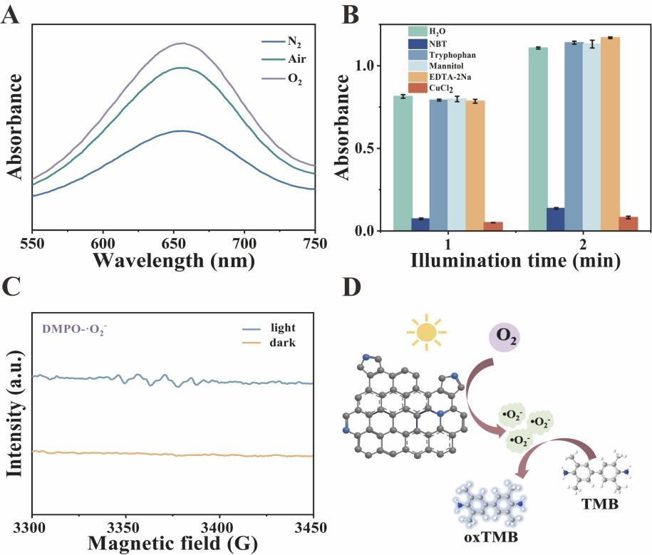
Fig. S4 (A) UV-vis absorption spectra of reaction systems under air, nitrogen and oxygen atmosphere. (B) The absorbance of oxTMB at 652 nm after the introduction of various scavengers. (C) EPR spectra of C-dots with DMPO spin trapping. (D) The catalytic mechanism of C-dots as light-responsive nanozymes.
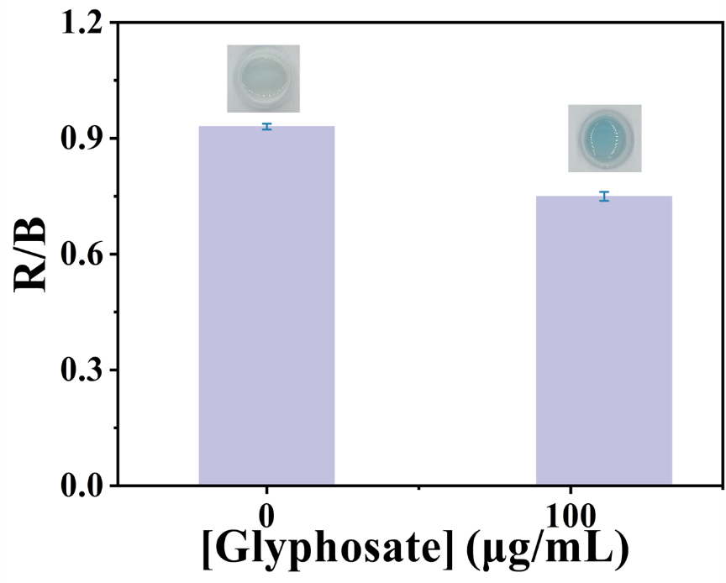
Fig. S5 The feasibility of smartphone-assisted hydrogel for glyphosate detection.
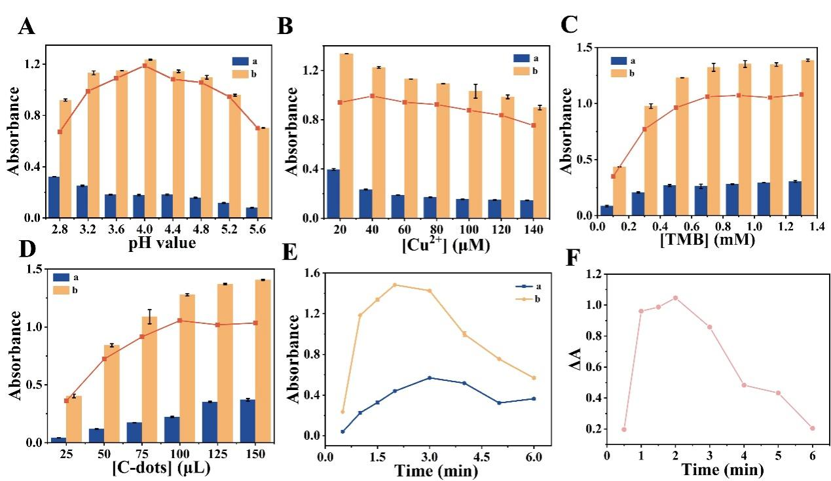
Fig. S6 Effects of pH value of buffer solutions (A), the concentrations of Cu²⁺ (B) and TMB (C), the volume of C-dots (D) and the irradiation time (E) on the absorbance of the detection system before and after the introduction of glyphosate. (F) The effect of irradiation time on the ∆A .
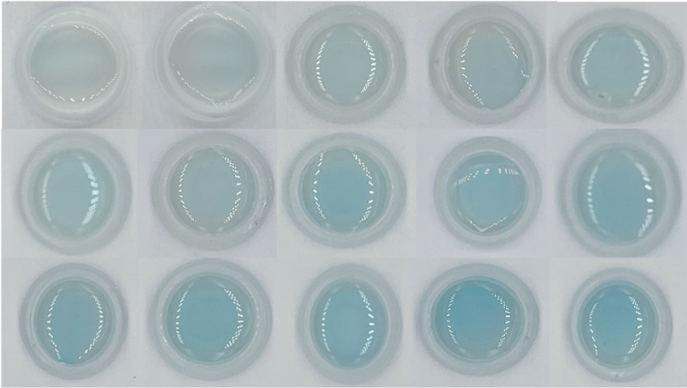
Fig. S7 The color change of hydrogel after adding different contents of glyphosate.
Table S1 Comparison of analytical performance of different methods for detecting glyphosate.
Method | Materials | Detection time (min) | Linear range (μg/mL) | LOD  (μg/mL) | Reference
Colorimetry | AuNPs | 15 | 1-23 | 0.27 | [1]
Colorimetry | P4R-Cuª | - | 0.17-15.22 | 0.02367 | [2]
Colorimetry | Dithiocarbamate | 3 | 1-70 | 1.1 | [3]
Colorimetry | CuCeTA | 10 | 0-0.5 | 0.025 | [4]
Colorimetry | Fe-FcMOF | 5 | 0-7 | 0.0676 | [5]
Fluorescence | N, S-CQDs-NFP | 5 | 0.005-10 | 2.88 | [6]
Fluorescence | G-CDs | 10 | 0.56-8.45 | 7.439 | [7]
Fluorescence | Carbon dots | 3 | 0.03-10 | 0.016 | [8]
Fluorescence | NPA^{b} | 5 | 1.7-18.6 | 0.32 | [9]
Colorimetry  Fluorescence | C-dots | 1 | 1-100 1-50 | 0.31 0.12 | This work

ªPonceau 4R-copper
^{b}N-n-butyl-4-(3-pyridin)yl methylidene hydrazine-1,8-naphthalimide.
References
- G.-B. Hong, J.-P. Hsu, K.-J. Chuang, C.-M. Ma, Colorimetric detection of 1-naphthol and glyphosate using modified gold nanoparticles. Sustainability 14 (2022) 10793.
- B.-C. Hsieh, Y.-T. Li, Colorimetric detection of glyphosate by its competitive reaction against Ponceau 4R for copper ion, Sens. Actuators B: Chem. 401 (2024) 135052.
[3] M.R. Jan, J. Shah, M. Muhammad, B. Ara, Glyphosate herbicide residue determination in samples of environmental importance using spectrophotometric method, J. Hazard. Mater. 169 (2009) 742-745.
[4] C. Jiang, H. Zhong, J. Zou, G. Zhu, Y. Huang, CuCeTA nanoflowers as an efficient peroxidase candidate for direct colorimetric detection of glyphosate, J. Mater. Chem. B 11 (2023) 9630-9638.
[5] F. Zhang, Y. Wang, X. Luo, Y. Zhang, M. Li, X. Yang, H. Zhao, W. Tang, J. Huang, Z. Li, Iron-ferrocenedicarboxylic nanozyme based colorimetric and photothermal dual-modal signal catalytic inhibition for detection of glyphosate, Microchim. Acta 192 (2025) 343.
[6] L. Zhang, R. Zhang, J. Wang, J. Chen, R. Yu, A ratiometric fluorescence sensing system for rapid detection of glyphosate in miscellaneous beans, J. Food Compos. Anal. 133 (2024) 106457.
[7] T. Sasikumar, J.S. Packialakshmi, S.J. Hong, S.Y. Ha, G.H. Shin, J.T. Kim, Multifunctional green-emitting fluorescent carbon dots: A versatile fluorometric probe for glyphosate detection and applications in food, J. Environ. Chem. Eng. 12 (2024) 113356.
[8] L. Wang, Y. Bi, J. Gao, Y. Li, H. Ding, L. Ding, Carbon dots based turn-on fluorescent probes for the sensitive determination of glyphosate in environmental water samples, RSC Adv. 6 (2016) 85820-85828.
[9] F. Sun, X.-L. Ye, Y.-B. Wang, M.-L. Yue, P. Li, L. Yang, Y.-L. Liu, Y. Fu, NPA-Cu²⁺ complex as a fluorescent sensing platform for the selective and sensitive detection of glyphosate, Int. J. Mol. Sci. 22 (2021) 9816.

