Electronic Supplementary Information
Adsorption of Pb²⁺ ion using coal fly ash/g-C₃N₄/Bi₂O₂CO₃ and re-use of spent adsorbent for photocatalytic and forensic applications

Table S1. Experimental design and results of removal Pb²⁺ ion by the as-prepared CFA/g-C₃N₄/Bi₂O₂CO₃ composite sample.

Experiment No. | A:Contact time  (min) | B:Dosage of adsorbent  (mg) | C:pH | Actual value (%) | Predicted value (%)
1 | 70 | 10 | 3 | 10.57 | 10.26
2 | 125 | 20 | 8.36 | 87.54 | 95.72
3 | 180 | 10 | 3 | 16.10 | 15.34
4 | 125 | 20 | 5 | 91.32 | 97.52
5 | 125 | 20 | 1.64 | 24.71 | 23.83
6 | 125 | 3.18 | 5 | 42.13 | 45.44
7 | 70 | 30 | 7 | 94.03 | 89.62
8 | 125 | 36.8 | 5 | 99.97 | 103.97
9 | 125 | 20 | 5 | 95.46 | 97.52
10 | 125 | 20 | 5 | 99.85 | 97.52
11 | 180 | 30 | 3 | 87.47 | 86.87
12 | 70 | 30 | 3 | 82.76 | 81.72
13 | 217.5 | 20 | 5 | 99.95 | 103.6
14 | 125 | 20 | 5 | 99.86 | 97.52
15 | 70 | 10 | 7 | 96.13 | 91.56
16 | 180 | 10 | 7 | 97.05 | 92.93
17 | 125 | 20 | 5 | 99.94 | 97.52
18 | 32.5 | 20 | 5 | 52.78 | 56.43
19 | 180 | 30 | 7 | 95.92 | 91.07
20 | 125 | 20 | 5 | 99.92 | 97.52

Table S2. Experimental design and results of the degradation efficiency (%) of Rh B by the CFA/g-C₃N₄/Bi₂O₂CO₃@Pb²⁺ composite

Experiment No | A:Exposure time (min) | B:Dosage of photocatalyst  (mg) | C:pH | Actual value (%) | Predicted value (%)
1 | 80 | 15 | 3 | 87.8 | 84.89
2 | 190 | 32.5 | 9.70 | 96.91 | 98.96
3 | 300 | 15 | 3 | 85.8 | 84.79
4 | 190 | 32.5 | 5.5 | 92.55 | 88.6
5 | 190 | 32.5 | 1.3 | 98.53 | 101.35
6 | 190 | 3.07 | 5.5 | 94.81 | 97.43
7 | 80 | 50 | 8 | 91.2 | 88.77
8 | 190 | 61.9 | 5.5 | 93.83 | 96.08
9 | 190 | 32.5 | 5.5 | 88.12 | 88.6
10 | 190 | 32.5 | 5.5 | 85.29 | 88.6
11 | 300 | 50 | 3 | 83.8 | 81.04
12 | 80 | 50 | 3 | 92.6 | 91.74
13 | 374.9 | 32.5 | 5.5 | 100 | 102.43
14 | 190 | 32.5 | 5.5 | 88.73 | 88.6
15 | 80 | 15 | 8 | 87.3 | 88.62
16 | 300 | 15 | 8 | 87.5 | 84.92
17 | 190 | 32.5 | 5.5 | 89.12 | 88.6
18 | 5.0 | 32.5 | 5.5 | 12 | 14.43
19 | 300 | 50 | 8 | 77 | 76.47
20 | 190 | 32.5 | 5.5 | 88.64 | 88.6

Table S3. Analysis of variance for removal Pb²⁺ ion by CFA/g-C₃N₄/Bi₂O₂CO₃ composite
Sum of Mean F p-value
Source Squares df Square Value Prob > F
Model 17700.24 10 1770.02 59.06 < 0.0001 significant
A-Contact time 1112.51 1 1112.51 37.12 0.0002
B- Amount of adsorbent 4134.13 1 4134.13 137.95 < 0.0001
C-pH 6239.00 1 6239.00 208.19 < 0.0001
AB 3.34×10⁻³ 1 3.34×10⁻³ 1.11×10⁻⁴ 0.9918
AC 6.89 1 6.89 0.23 0.6431
BC 2693.84 1 2693.84 89.89 < 0.0001
A2 551.84 1 551.84 18.41 0.0020
B2 937.50 1 937.50 31.28 0.0003
C2 2565.69 1 2565.69 85.61 < 0.0001
AB 2 508.96 1 508.96 16.98 0.0026
Residual 269.71 9 29.97
Lack of Fit 204.69 4 51.17 3.93 0.0827 not significant
Pure Error 65.02 5 13.00
Cor Total 17969.96 19
R² = 0.9850 Adj R² = 0.9683 C.V. % = 6.96 Adeq Precision = 23.081
Table S4. Selected optimal solutions using desirability test for removal Pb²⁺ ion by CFA/g-C₃N₄/Bi₂O₂CO₃ composite
No. | Contact time  (min) | Dosage (mg) | Initial pH | Pb²⁺ removal (%)  Actual Calculated |  | RSD
1 | 107.62 | 24.35 | 6.62 | 99.99 ± 0.52 | 101.58 | 1.124
2 | 126.02 | 28.93 | 4.12 | 99.99 ± 0.52 | 101.92 | 1.365
3 | 104.44 | 28.38 | 4.44 | 78.62 ± 4.21 | 100.76 | 15.655
4 | 168.77 | 24.06 | 4.20 | 42.46 ± 0.03 | 101.47 | 41.726
5 | 175.22 | 11.99 | 6.90 | 65.20 ± 2.06 | 100.20 | 24.749
6 | 111.79 | 25.60 | 5.98 | 86.85 ± 3.83 | 104.28 | 12.325
7 | 172.67 | 28.67 | 6.73 | 56.32 ± 4.35 | 100.01 | 30.894
8 | 132.33 | 21.33 | 5.27 | 84.70 ± 2.96 | 103.69 | 13.428

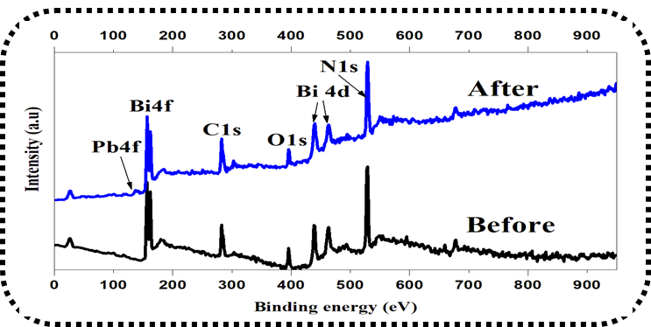

Fig. S1. XPS Survey spectrum of CFA/g-C₃N₄/Bi₂O₂CO₃ before and after Pb²⁺ adsorption.

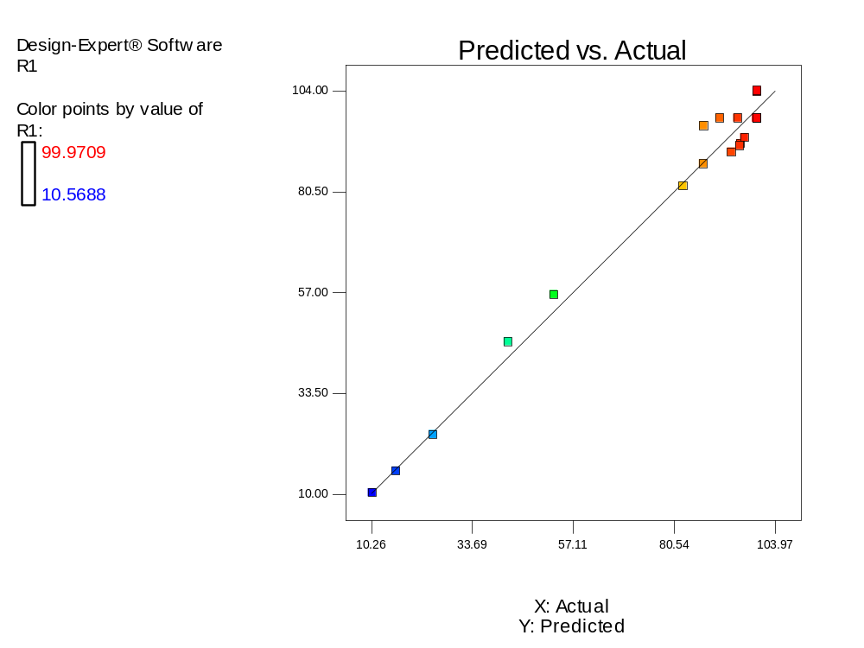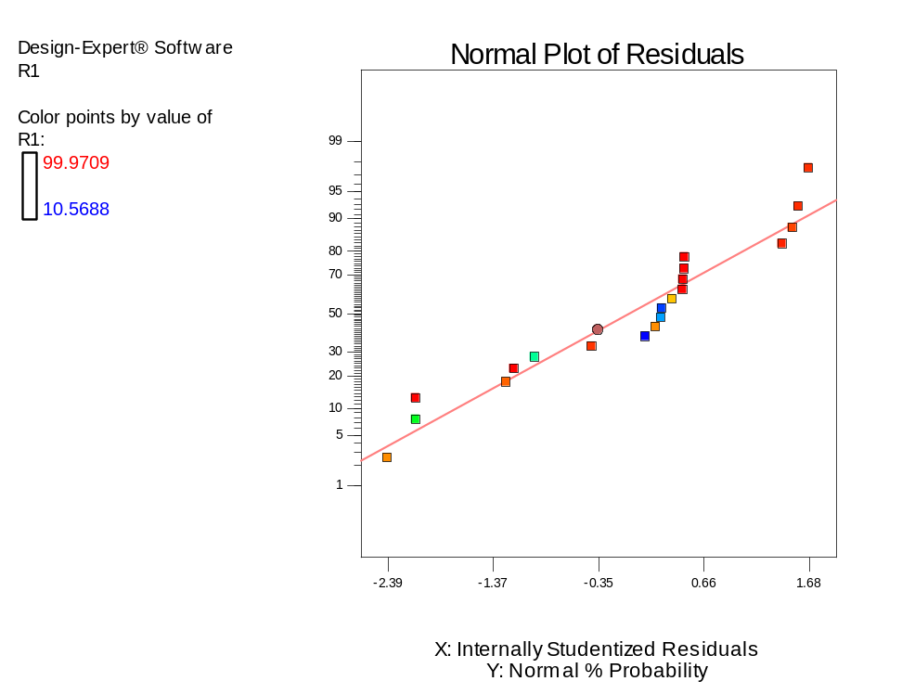
(B)
(A)
Fig. S2. (A) Predicted vs actual values and (B) Normal plot vs residual for removal Pb²⁺ ion by CFA/g-C₃N₄/Bi₂O₂CO₃ composite.

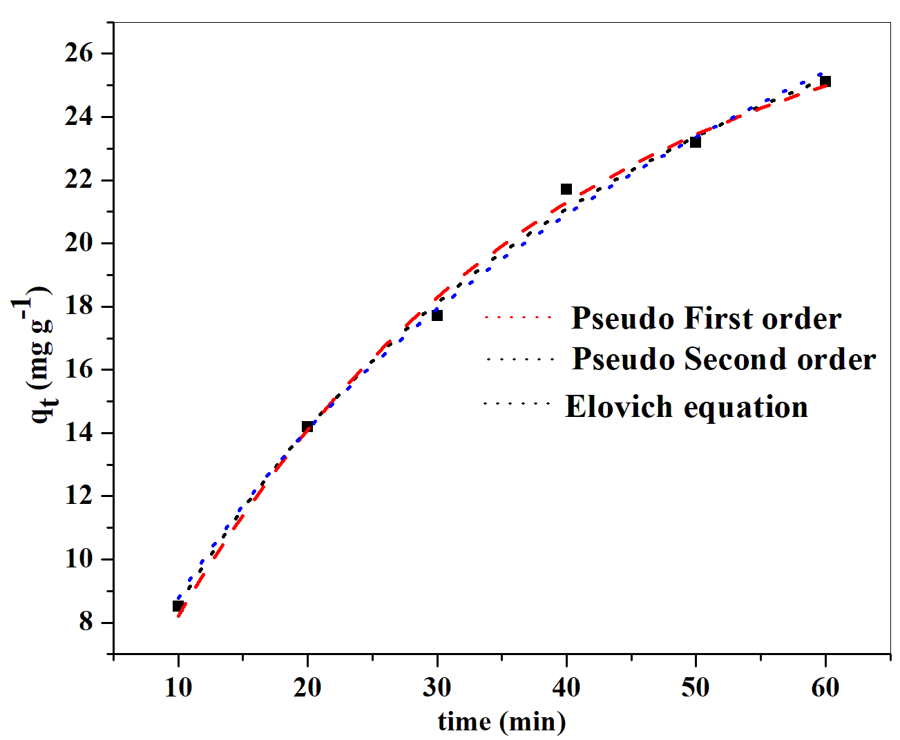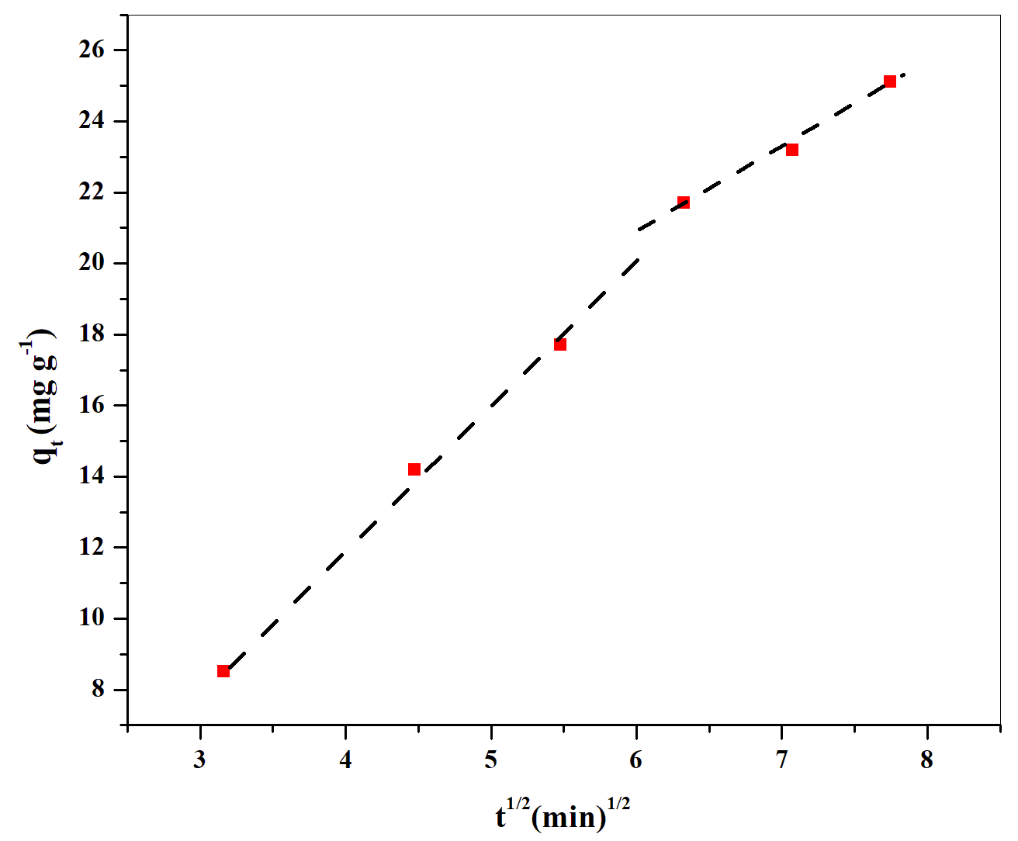
(B)
(A)
Fig. S3. Nonlinear Pseudo first order kinetic, Pseudo second order equations, and (B) Intra particle diffusion model of adsorption of Pb²⁺ ions by CFA/g-C₃N₄/Bi₂O₂CO₃ composite.
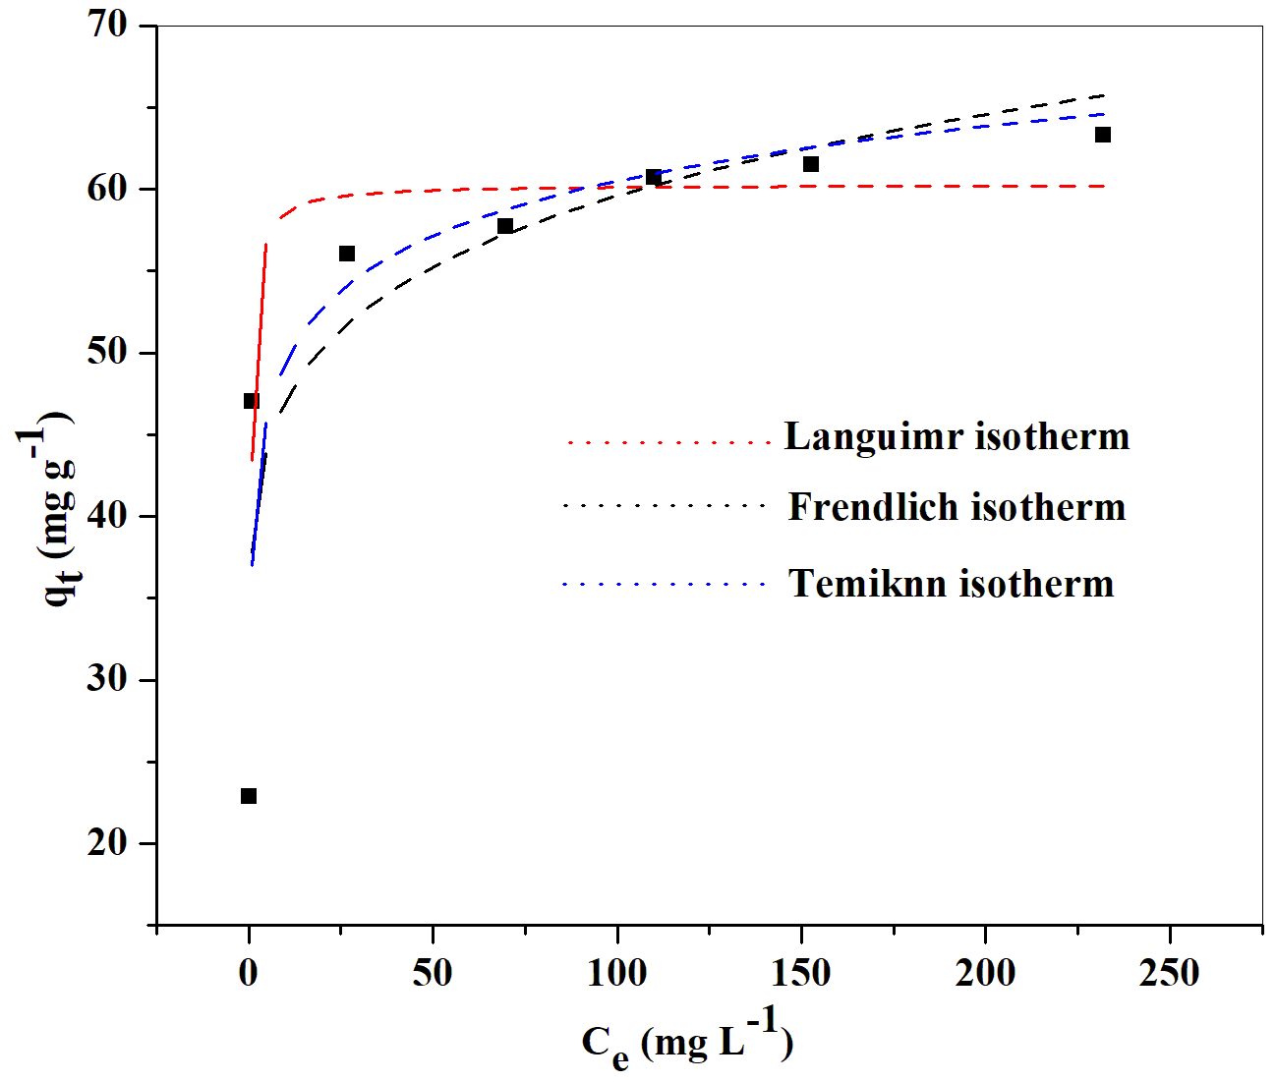
(A)
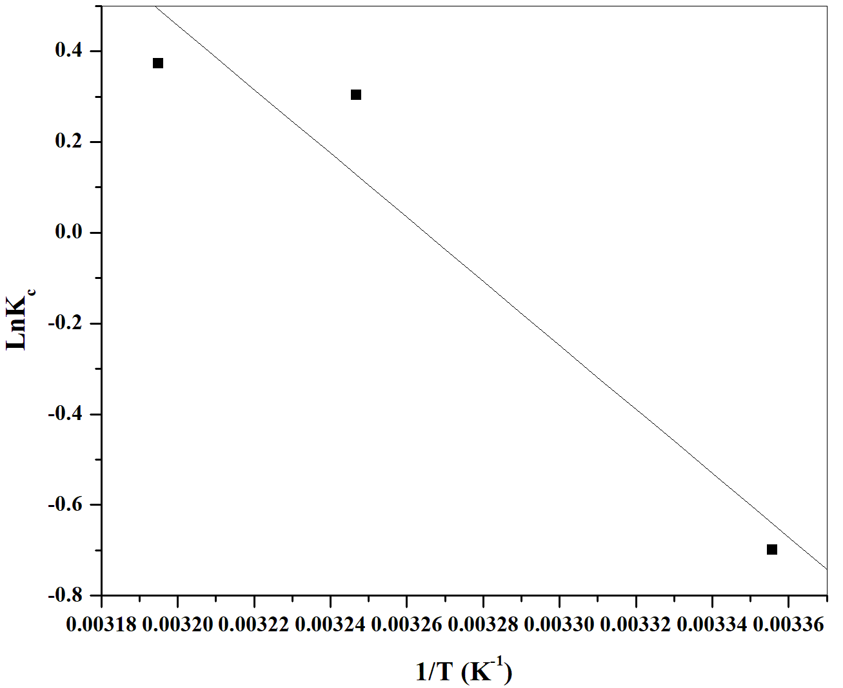
(B)
Fig. S4. (A) Nonlinear equations of Langmuir, Freundlich, and Temkin. (B) adsorption thermodynamic model of adsorption of Pb²⁺ ions by CFA/g-C₃N₄/Bi₂O₂CO₃ composite (Experimental conditions: 126 min, 200 rpm, pH 4.12 and at 25 ºC).

