Supplementary Information

TITLE
Growing Cropland, Shrinking Food Security in Southeast Asia

AUTHORS
Shifeng Fang^{a,*}, Changqing Huang^{a,b}, Yichen Yang^{a,b}, Hua Wu^{a,c}, Vincent Lyne^{d}, Junyi Zhang^{a,b}, Jinke Yang^{a,b}, Fenzhen Su ^{a,*}

ª State Key Laboratory of Resources and Environmental Information Systems, Institute of Geographic Sciences and Natural Resources Research, Chinese Academy of Sciences, Beijing 100101, China
^{b} University of Chinese Academy of Sciences, Beijing 100049, China
^{c} School of Resources and Environment, University of Electronic Science and Technology of China, Chengdu 611731, China
^{d} IMAS-Hobart, University of Tasmania, Hobart, TAS, Australia

*Correspondence: fangsf@igsnrr.ac.cn，sufz@lreis.ac.cn

Supplementary Figures

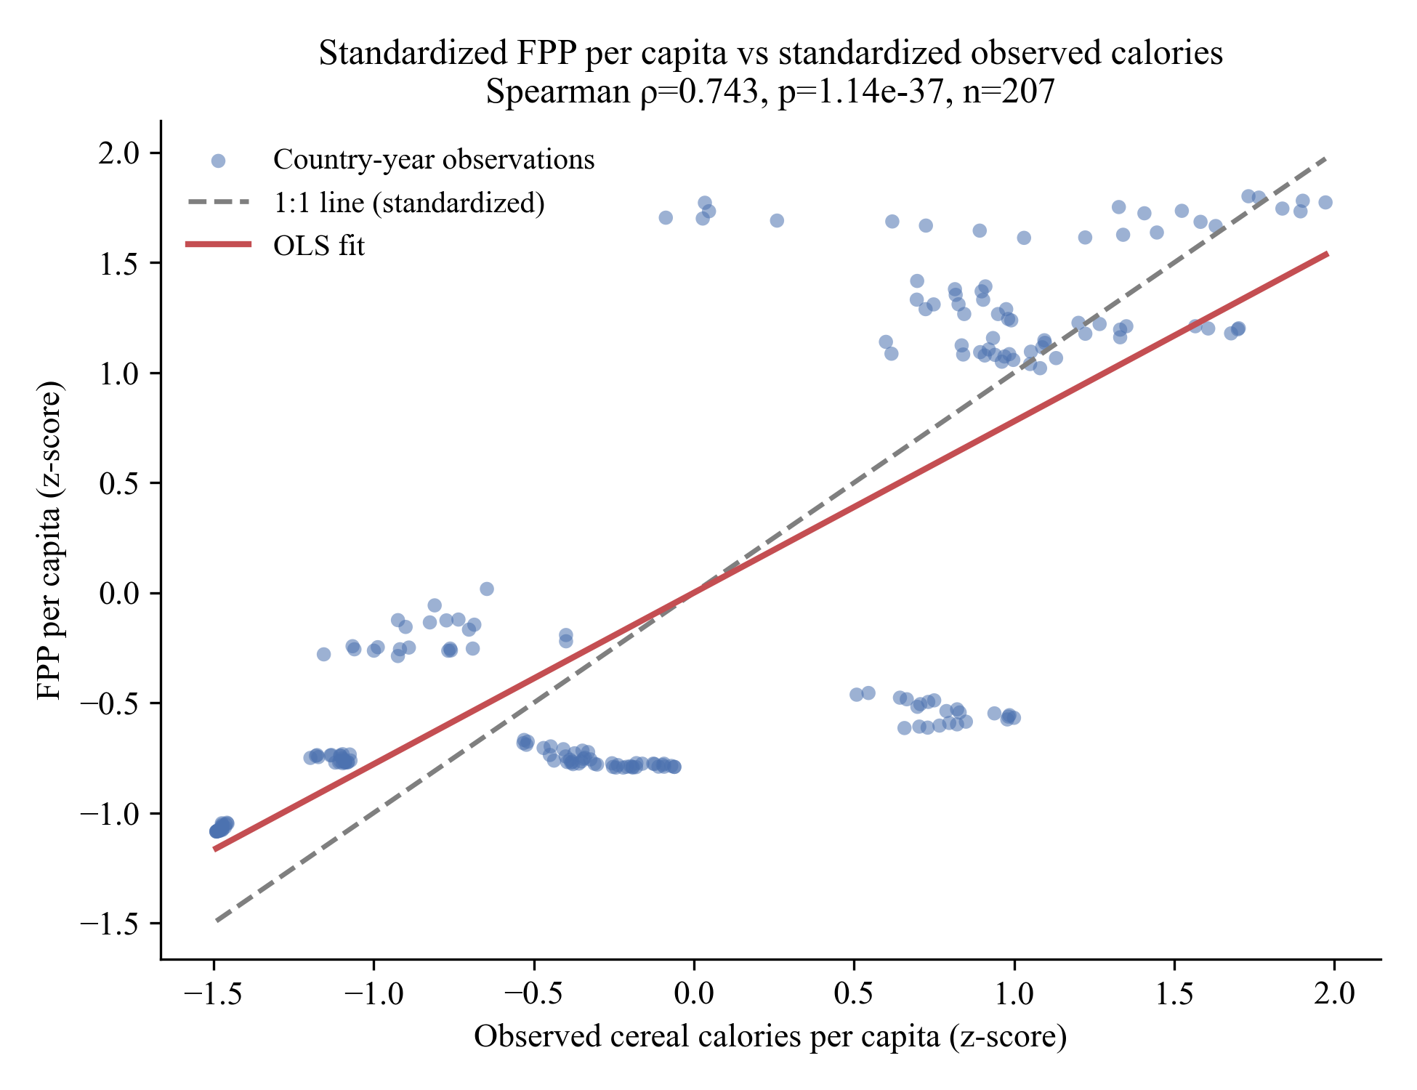
Supplementary Fig. 1 Validation of the study-developed FPP metric against externally validated production statistics. (Scatterplot comparing standardized (z-scored) country-year FPP per capita with standardized observed cereal calories per capita derived from FAOSTAT production statistics (rice, maize, wheat). The dashed line indicates the 1:1 relationship under standardization, and the solid line shows the OLS fit. Correlations are computed across all country-years (Spearman ρ = 0.743; n = 207).)

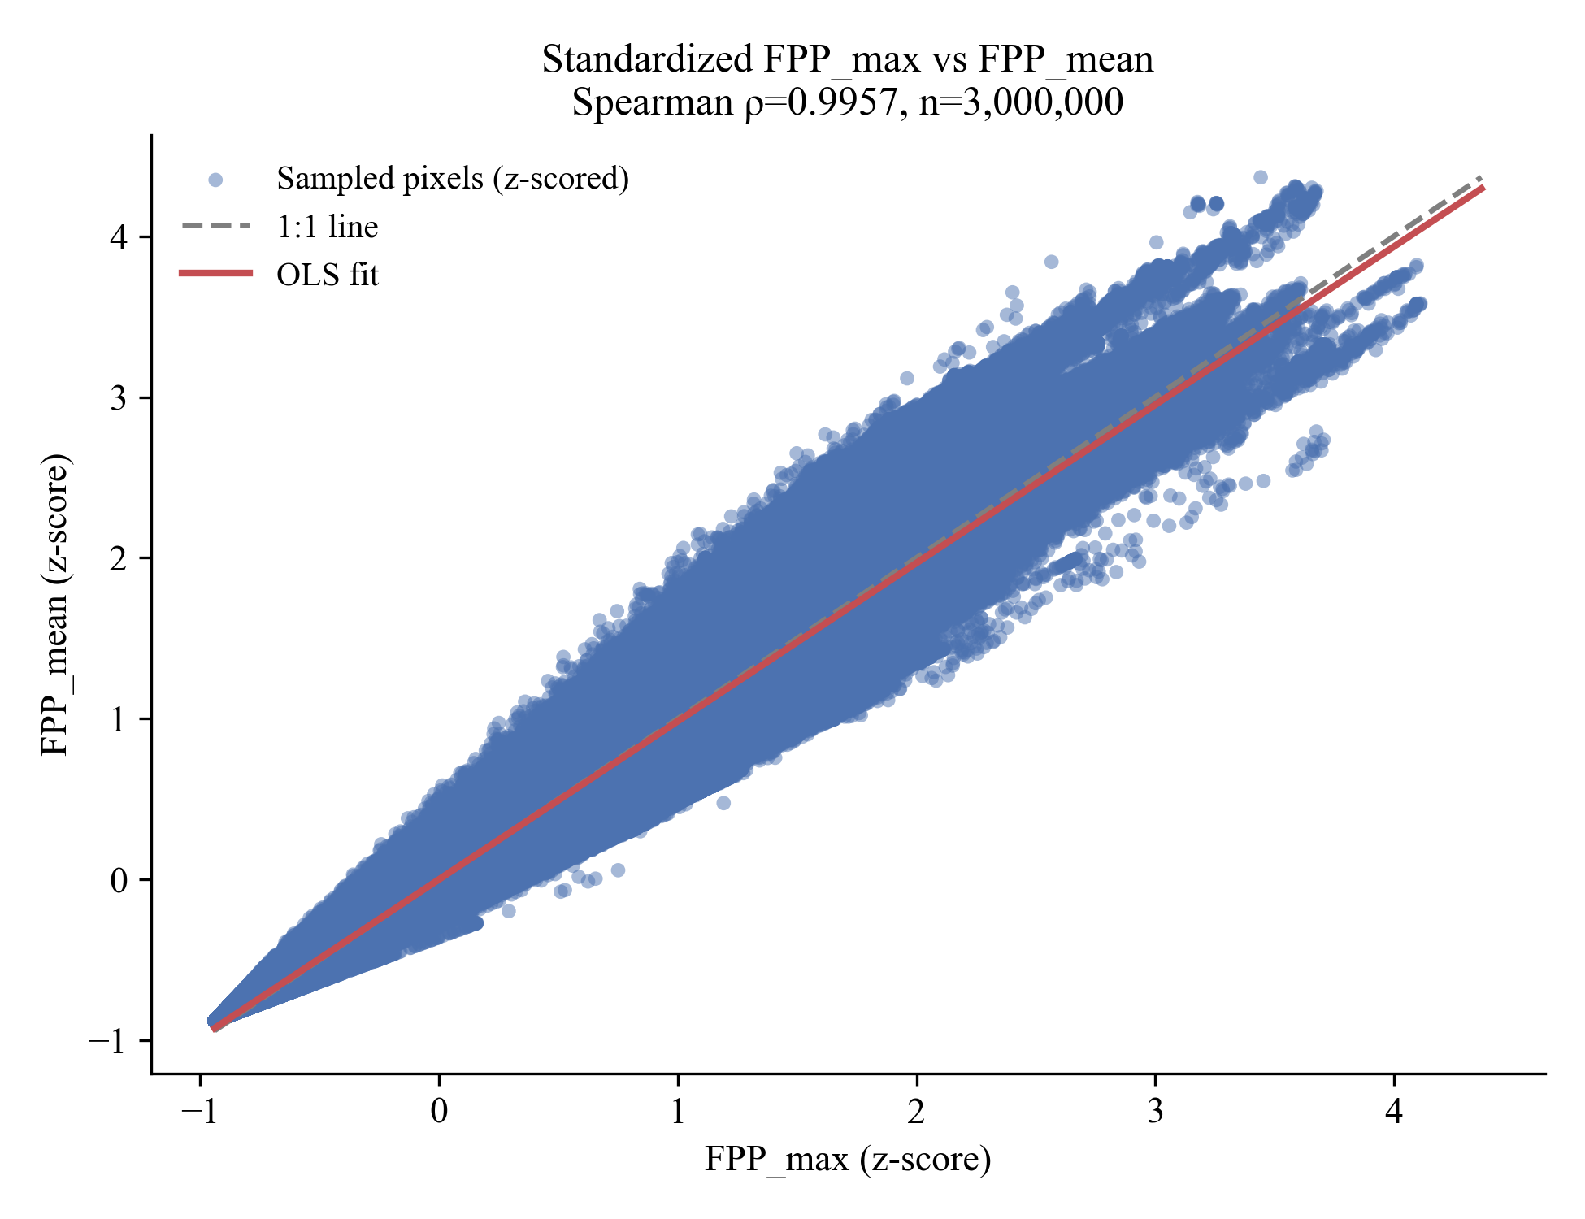
Supplementary Fig. 2Sensitivity of FPP to the crop-aggregation rule (max vs mean).
Standardized (z-scored) scatterplot comparing FPP_max (maximum caloric attainable yield across rice, maize, and wheat) and FPP_mean (arithmetic mean across the same crops) over the study region. Points represent a uniform random sample of pixels; the dashed line indicates the 1:1 relationship and the solid line shows the OLS fit. Spatial ordering is highly consistent (Spearman ρ = 0.9957; n = 3,000,000 sampled pixels).

Supplementary Text 1
Sensitivity to crop-aggregation rule (max vs mean).
To assess sensitivity to the crop-aggregation rule used in constructing the Food Production Potential (FPP) metric, we compared the baseline definition that takes the maximum caloric attainable yield across rice, maize, and wheat (FPP_max) with an alternative definition using the arithmetic mean across the same crops (FPP_mean). Across the study region, the two formulations exhibit near-identical spatial ordering (Spearman ρ = 0.9957; computed from a uniform sample of 3,000,000 pixels drawn from 5,334,047 valid pixels), indicating that results are not driven by the choice of aggregation rule. As expected, FPP_max yields higher absolute values because it represents an upper-bound capacity: the relative difference Δ = (FPP_max − FPP_mean)/FPP_max has a median of 0.4776 (IQR = 0.1303; 95th percentile = 0.5679), implying FPP_mean is typically about 52% of FPP_max. Together, these tests show that the primary spatial patterns captured by FPP are robust, while absolute magnitudes vary consistently with the conceptual distinction between upper-bound and average potential.
Supplementary Table 1
Supplementary Table 1. Data description.
Data type | Time range | Spatial resolution | Source | Data Access
GLC-FCS30d | 2000-2022 | 30m | CAS | https://doi.org/10.5281/zenodo.8239305
Agro-ecological attainable yield | 2000-2022 Average | 1km | GAEZ v5 | https://data.apps.fao.org/gaez/?lang=en
Statistical data | 2000-2022 |  | FAOSTAT | https://www.fao.org/faostat/en/
Population | 2000-2022 |  | UN WPP | https://population.un.org/wpp
Administrative boundary | version 4.1 |  | GADM | https://gadm.org/

