Supporting Information
For: Electron-Donating Capability: A Unified Descriptor Expanding the Concept of Basicity in Catalysis

S1. Introduction to Supporting Information
This Supporting Information file provides additional experimental data, characterization results, and methodological details that support the findings reported in the main manuscript, “Electron-Donating Capability: A Unified Descriptor for Solid Base Catalysis.” The data herein, including catalytic performance screening, stability tests, and CO₂-TPD profiles, further validate the proposed unifying principle that the electron-donating capability of the active center serves as a fundamental descriptor transcending traditional material classifications. This document is organized to correspond with the discussion in the main text for ease of reference.
S2. Experimental Details
S2.1. Catalyst Preparation
All catalysts were prepared via incipient wetness impregnation. Specifically, a calculated amount of metal precursor (e.g., Mg(NO₃)₂·6H₂O for MgO/AC, Cu(NO₃)₂·3H₂O for Cu/AC) was dissolved in deionized water. The solution was added dropwise to 5.0 g of coconut shell-derived activated carbon (AC, Fujian Xinsen Carbon Co., Ltd., SBET ≈ 1100 m²/g) to achieve a nominal metal loading of 1~5 wt%. The mixture was aged at room temperature for 24 h, dried at 120 °C for 12 h, and subsequently calcined in a tube furnace under a N₂ flow (50 mL/min) at 500 °C~800 °C for 5 h (ramp rate: 5 °C/min).
S2.2. Catalytic Activity Tests
Transesterification Reaction:​ The reaction was performed in a batch reactor. Typically, 50 g of a mixture of dimethyl carbonate (DMC) and ethylene glycol (EG) (molar ratio 2:1) and 1.0 g of catalyst were charged into the reactor. The reaction proceeded at 120 °C for 4 h with stirring. Products were analyzed by gas chromatography (GC-2014, Shimadzu) equipped with a FID and a DB-WAX capillary column.
Methyl Formate (MF) Decomposition:​ The reaction was carried out in a continuous-flow fixed-bed reactor. 1.0 g of catalyst was loaded and activated in situ. MF was fed by a syringe pump and vaporized into a N₂ carrier gas stream. The reaction temperature was maintained at 240 °C. Effluents were analyzed online by a gas chromatograph (GC-7900, Tianmei) equipped with TCD and FID detectors.
S2.3. Catalyst Characterization
CO₂-TPD:​ Measurements were performed on a Micromeritics AutoChem II 2920. About 100 mg of catalyst was pretreated at 300 °C in He flow, then saturated with 10% CO₂/He at 50 °C. After puring with He, the desorption was carried out by heating to 800 °C at a rate of 10 °C/min.
X-ray Diffraction (XRD):​ Patterns were recorded on a Rigaku MiniFlex600 diffractometer with Cu Kα radiation (λ = 1.5406 Å) over a 2θ range of 5° to 80°.
Additional characterization, including N₂ physisorption for textural properties, XPS for surface composition, and TEM for morphology, was also performed on selected samples. The primary focus of the main text, however, remains on the correlation between activity and the alkaline properties determined by CO₂-TPD, supported by XRD for phase identification.

S3. Performance Screening of Catalysts for Methyl Formate (MF) Decomposition
S3.1 Metal Oxide Catalysts
The catalytic performance of metal oxides supported on activated carbon (AC) was evaluated under standard conditions (2 wt% loading, 240°C, 1 bar, LHSV=0.7 h⁻¹).
Table S1. Catalytic Performance of Metal Oxide/AC Catalysts
Catalyst | MF Conv. (%) | CO Select. (%) | MeOH Select.(%)
ZnO/AC | 99.7 | 94.2 | 91.5
Al2O3/AC | 34.6 | 94.8 | 92.3
CaO/AC | 2.8 | 98.8 | 98.0
MgO/AC | 5.7 | 97.0 | 97.7

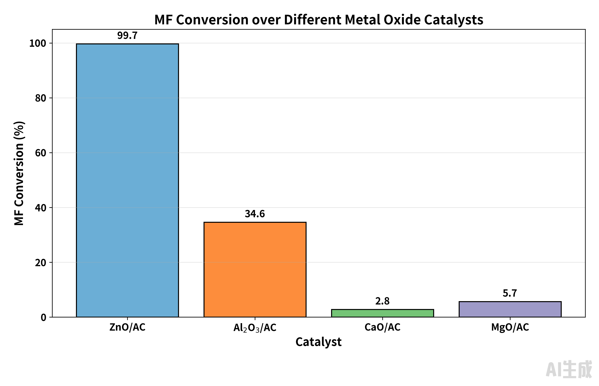
Fig S1. Comparative MF Conversion Performance of Metal Oxide Catalysts

Table S2. Support Effects on ZnO Performance
Catalyst | MF Conv. (%) | CO Select. (%) | MeOHSelect. (%)
ZnO/AC | 99.7 | 94.2 | 91.5
ZnO/Zeolite | 66.4 | 98.4 | 10.4
ZnO/Al₂O₃ | 20.9 | 99.1 | 57.7*
ZnO/SiO₂ | 2.1 | 95.4 | 97.5
*Methanol dehydration due to support acidity

S3.2 Potassium Modification Effects
Potassium modification significantly enhanced catalyst performance and stability:

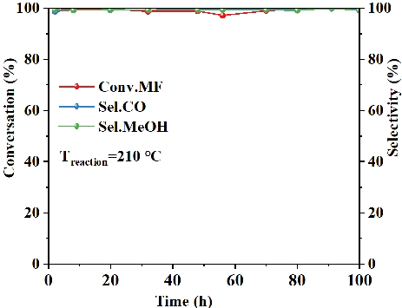
Figure S2. Time-on-stream stability of the K-ZnO/AC catalyst for MF decomposition.
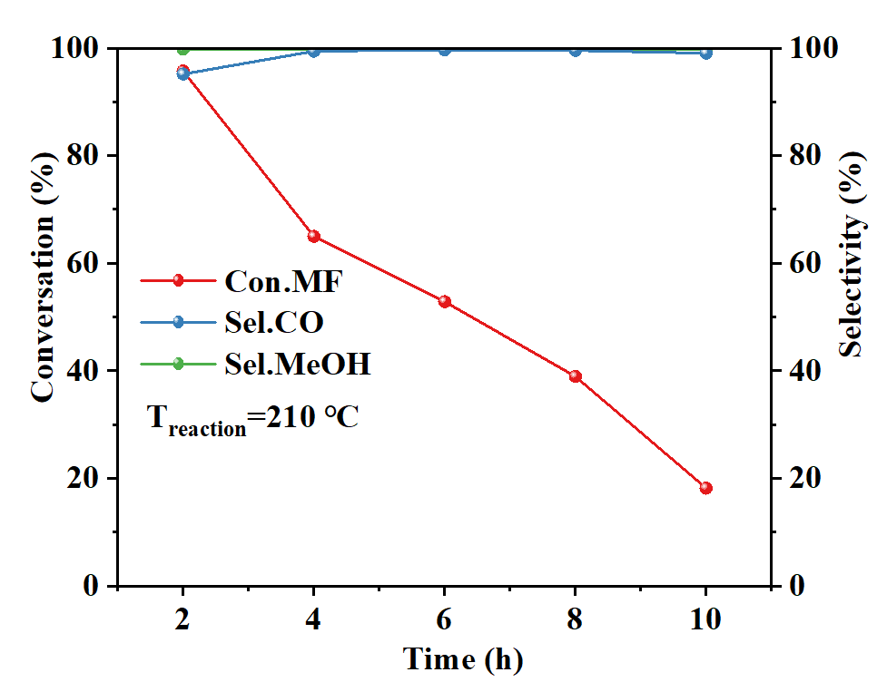
Figure S3. Rapid deactivation profile of the KOH/AC catalyst during MF decomposition.

S3.3 Metallic Catalysts
Various metal/AC catalysts were evaluated for MF decomposition:
Table S3. Comparison of Catalytic Performance for MF Decomposition at 250°C
Catalyst​ | MF Conversion (%)​ | CO Selectivity (%)​
Co-AC​ | 99.04 | 96.15
Ni-AC​ | 94.17 | 95.04
Pd-AC​ | 71.50 | 94.41
Cu-AC​ | 3.92 | N/A
Ag-AC​ | 1.96 | N/A

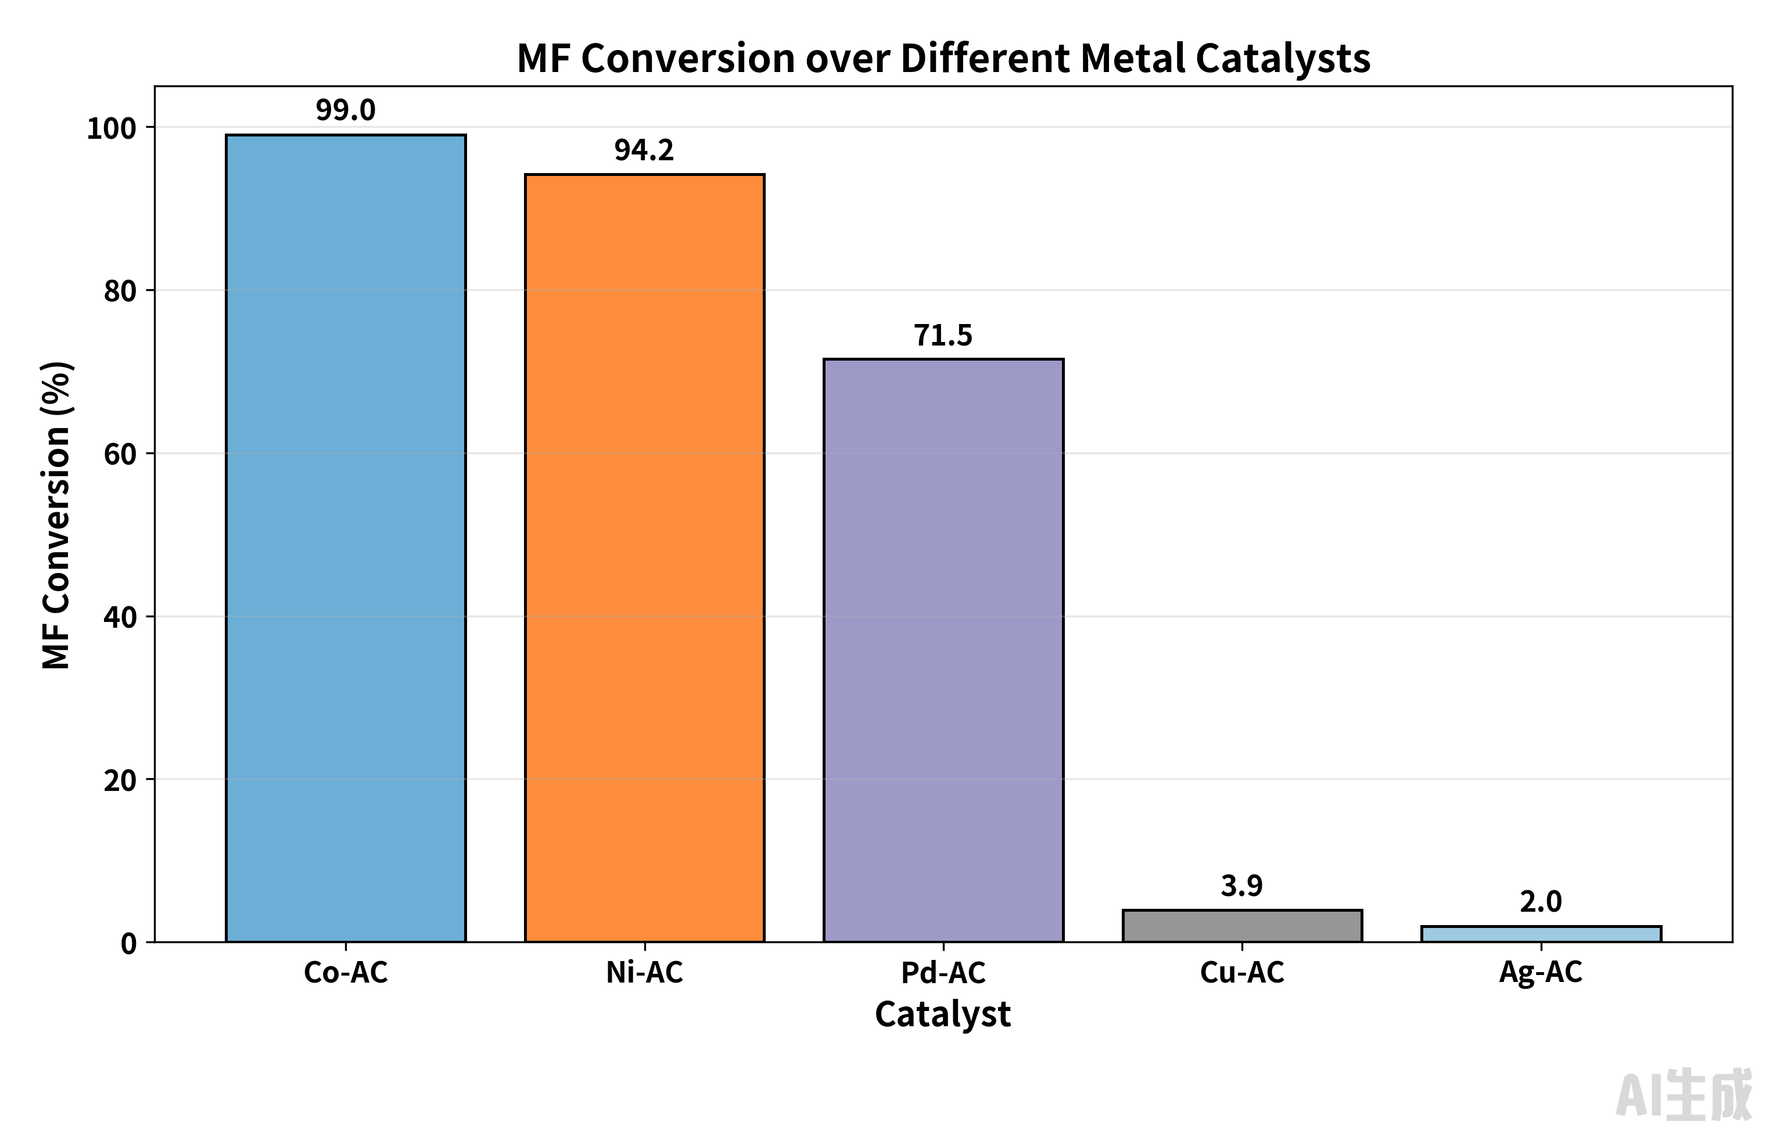
Figure S4. Performance of different metal catalysts

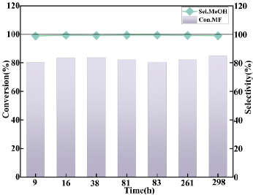
Figure S5. Long-term stability of Pd/AC catalyst
S4. Catalyst Performance in the Transesterification of Dimethyl Carbonate (DMC) and Ethylene Glycol (EG)
S4.1 Oxide Catalysts Performance
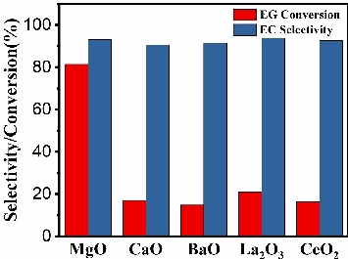
FigureS6. Support effects on MgO catalytic activity
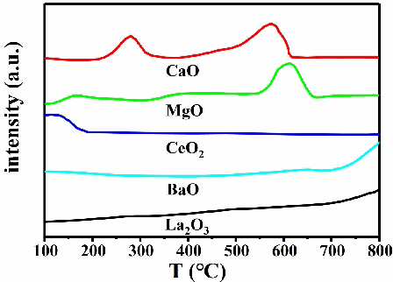
Figure S7. CO₂-TPD profiles of supported MgO catalysts

S4.2 Metallic Catalysts Performance
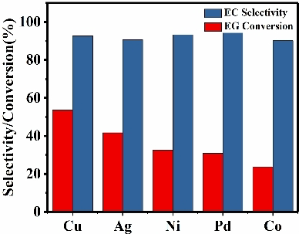
Figure S8. Transesterification activity of metal/AC catalysts
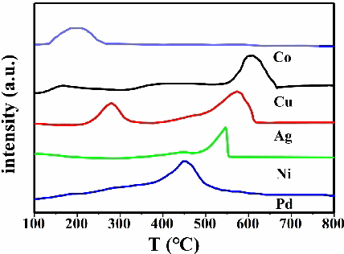
Figure S9. CO₂-TPD profiles of metal/AC catalysts

S4.3 Performance in a Thermodynamically Constrained Reaction: DMC + Phenol
The transesterification of DMC with phenol is notoriously challenging due to a low thermodynamic equilibrium conversion (~10⁻⁴). Conventional processes rely on reactive distillation. Using our standard catalyst series in a batch reactor, materials with high electron-donating capability (e.g., Ag/AC) achieved ~10% single-pass conversion without process intensification. This result not only surpasses the thermodynamic limit but also confirms that the electron-donating capability descriptor remains valid even for highly unfavorable reactions, underscoring its broad applicability. Data are shown in Table S4.
Table S4. Catalytic Performance of Various Catalysts in the Transesterification of DMC with Phenol
Catalyst​ | Phenol Conv.(%) | MPC Selectivity (%)​
Co/AC | 3.9% | 78.1%
Ni/AC | 4.1% | 63.2%
Cu/AC | 5.9% | 64.8%
Ag/AC | 6.8% | 75.5%
Pd/AC | 6.1% | 63.0%
*Mg(OH)₂ nanoflakes | 1.6% | 59.257%
*Mg-Al hydrotalcite | 1.8% | 54.453%
*AC | 0.5% | _
Reaction conditions: n(phenol) : n(DMC) = 1:1, Reaction temperature: 170 °C; LHSV :0.5.
Catalytic performance data. Metal/AC catalysts show markedly higher activity in a single pass compared to standard reference catalysts like hydrotalcite and the AC support itself.

S5. Additional Characterization: XRD and XPS Analysis
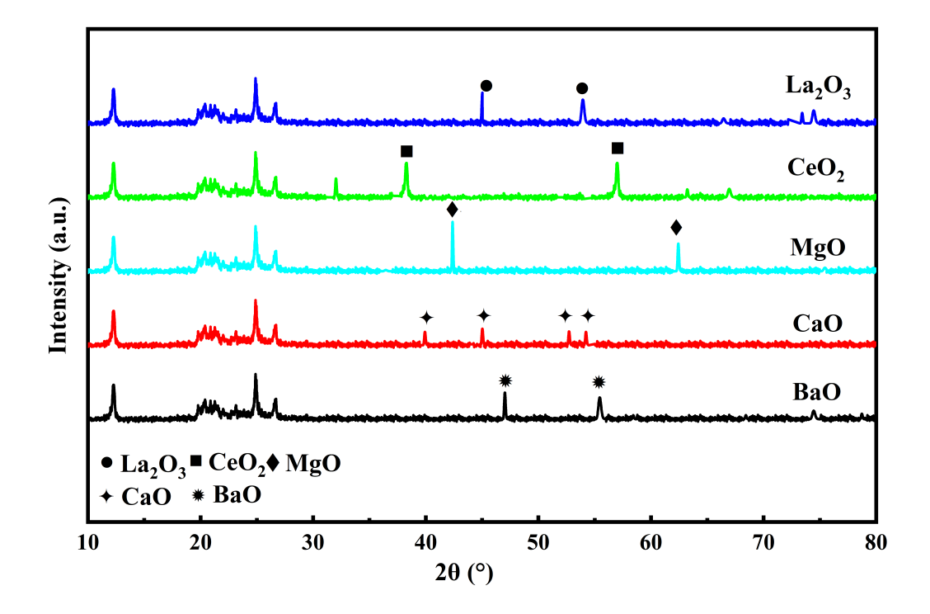
Figure S10. Structural Identification of Supported Metal Oxide Catalysts.​​

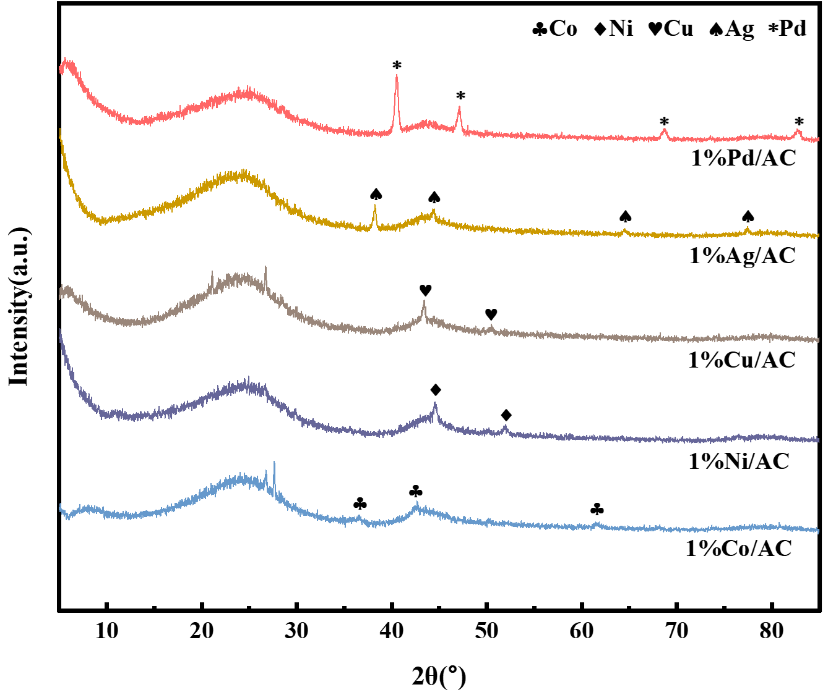
Figure S11. Structural Verification of Reduced Metal Catalysts
The XRD patterns unequivocally identify the zero-valent metallic state of the active components, confirming the structural basis for comparing their electron-donating capability.
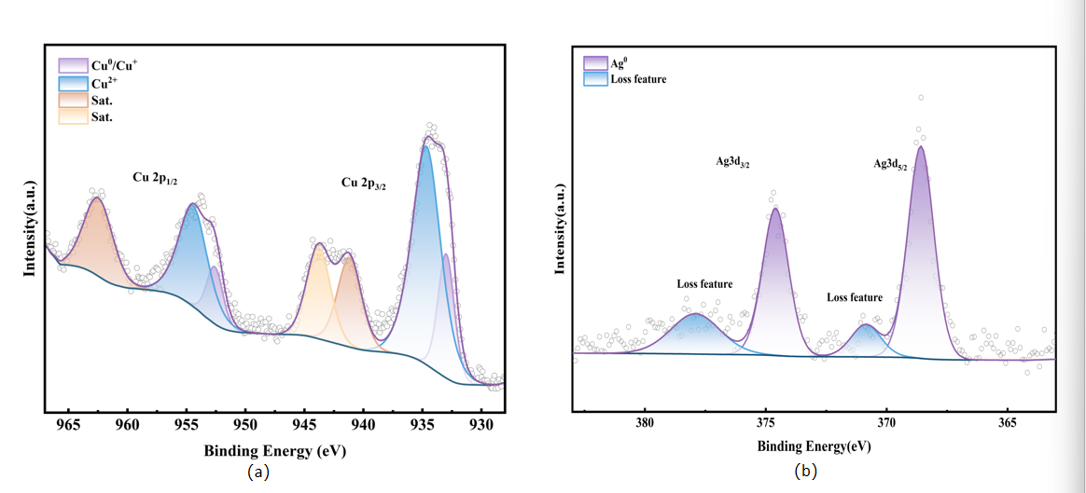
Fig S12. XPS spectra of selected reduced metal catalysts supported on activated carbon: (a) Cu/AC and (b) Ag/AC.
Figure 12 shows the XPS spectra for (a) Cu/AC and (b) Ag/AC. The spectrum of Cu/AC indicates the coexistence of multiple oxidation states (Cu⁰, Cu⁺, and Cu²⁺), while that of Ag/AC is characteristic of predominantly zero-valent silver (Ag⁰).

- Summary of Key Findings
The comprehensive data presented in this Supporting Information provide robust experimental validation for the unified descriptor of electron-donating capability proposed in the main text. The key findings, derived from consistent methodological protocols, are summarized as follows: (1) Significant catalytic activity is observed across traditionally distinct material families (metal oxides and zero-valent metals) when optimized, demonstrating material-independent functionality. (2) A consistent correlation is established between catalytic performance and the strength of electron-donating capability, probed by CO₂-TPD. (3) Potassium modification is shown to be an effective strategy for enhancing catalyst stability while maintaining high activity. (4) The critical role of the support material in modulating the active center's properties is clearly demonstrated. (5) Collectively, these findings converge to establish the electron-donating capability as a universal descriptor that transcends traditional material classifications. The systematic evidence herein firmly supports the paradigm shift from a material-centric view to an electron-centric understanding of solid-base catalysis.capability.
Note: All experimental procedures and characterization methods followed standard protocols with appropriate controls and reproducibility checks. Detailed experimental sections are available upon request.

